**作业2（10.24）**

自动化6班吴俊达 210320621

**6-18代码：**

**第一个乘法表：（for语句）**

#include <stdio.h>

int main()

{

int i21,j21,s21;

for (i21=1;i21<=9;i21++) printf("%-4d",i21);

printf("\n");

for (i21=1;i21<=9;i21++) printf("- ");

printf("\n");

for (i21=1;i21<=9;i21++)

{

for (j21=1;j21<=9;j21++)

{

s21=i21*j21;

printf("%-4d",s21);

}

printf("\n");

}

return 0;

}

**截图：**

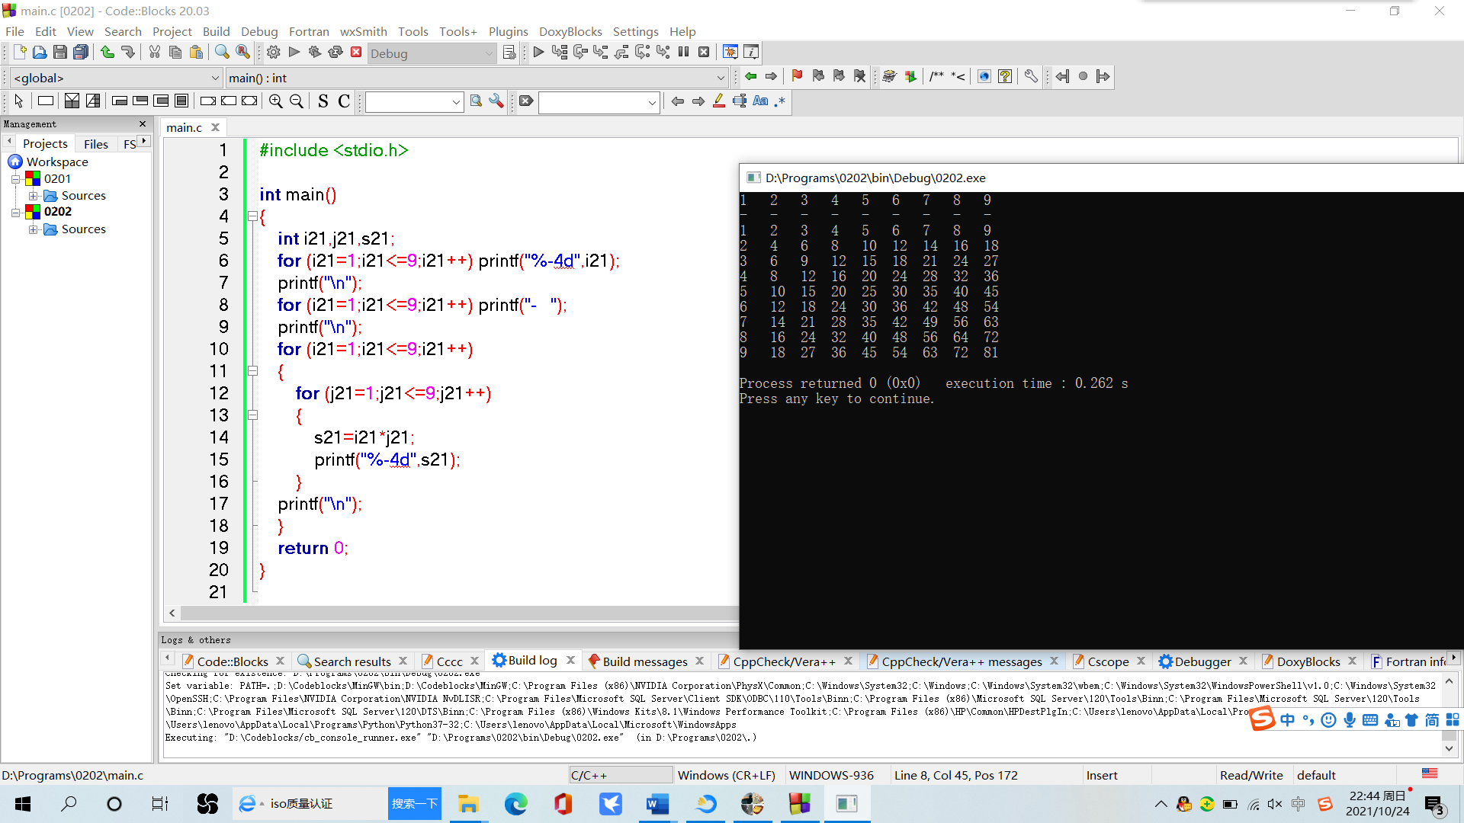

**第2个乘法表：（while语句）**

#include <stdio.h>

int main()

{

int i21=1,j21,s21;

while (i21<=9)

{

printf("%-4d",i21);

i21++;

}

printf("\n");

i21=1;

while (i21<=9)

{

printf("- ");

i21++;

}

i21=1;

printf("\n");

while (i21<=9)

{

j21=1;

while (j21<=i21)

{

s21=i21*j21;

printf("%-4d",s21);

j21++;

}

printf("\n");

i21++;

}

return 0;

}

**截图：**

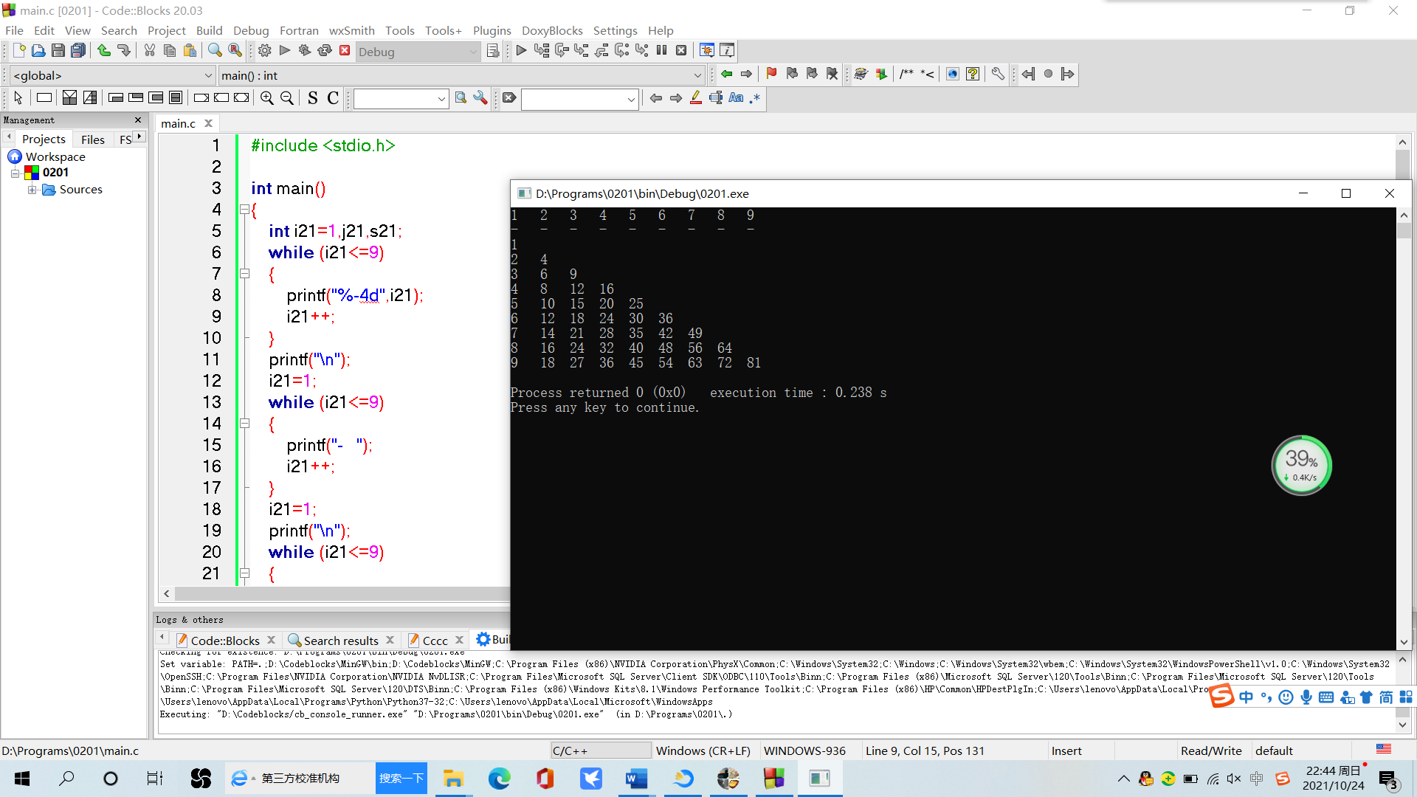**第3个乘法表：（do-while语句）**

#include<stdio.h>

int main()

{

int i21=1,j21=1,s21;

do

{

printf("%-3d",i21);

i21++;

}while (i21<=9);

printf("\n");

do

{

printf("- ");

j21++;

}while (j21<=9);

printf("\n");

i21=1;

j21=1;

do{

j21=1;

do{

if(j21<i21) printf(" ");

else

{

s21=i21*j21;

printf("%-3d",s21);

}

j21++;

}while(j21<=9);

printf("\n");

i21++;

}while (i21<=9);

return 0;

}

**截图：**

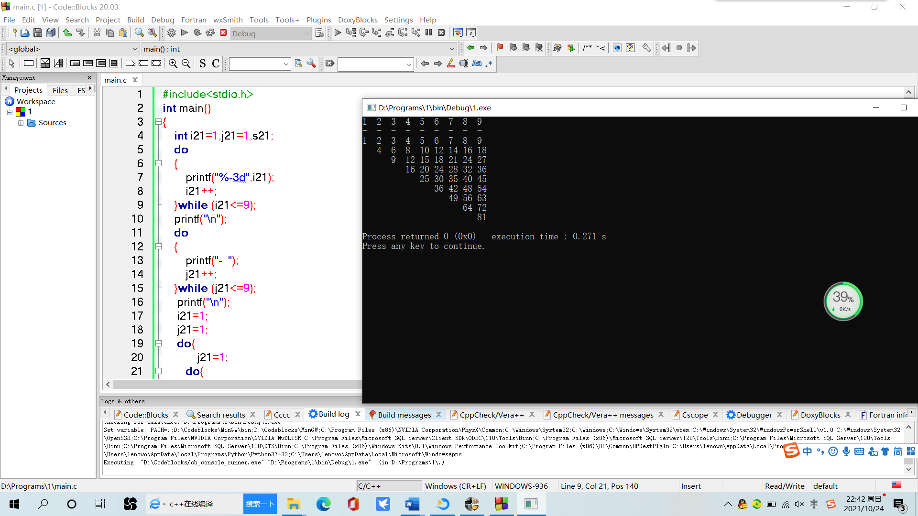

**6-21代码：**

#include <stdio.h>

#include <stdlib.h>

int main()

{

int flag,counter,sum=0,suma=0,sumb=0,sumc=0;

for (counter=1;counter<=300;counter++)

{

flag=0;

if (counter%5==0&&suma<=21)

{

suma++;

flag=1;

}

if (counter%6==0&&sumb<=21)

{

sumb+=1;

flag=1;

}

if (counter%7==0&&sumc<=21)

{

sumc+=1;

flag=1;

}

if (flag==0) continue;

else sum+=1;

if(suma+sumb+sumc==63) break;

}

printf("%d",sum);

return 0;

}

**输出答案为54.**

**截图：**

