**作业5（矩阵乘法）**

自动化6班吴俊达 210320621

**代码：**

#include <stdio.h>

#include <stdlib.h>

void InputMatrix(double *A,int m,int n);

void PrintMatrix(double *A,int m,int n);

void MulMatrix(int m,int n,int k,double *A,double *B,double *C);

int main()

{

double *A=NULL,*B=NULL,*C=NULL;

int m21,n21,p21,q21,ret;

printf("Please input the dimension of the matrix(4 numbers separated by a space):");

ret=scanf("%d %d %d %d",&m21,&n21,&p21,&q21);

if (ret!=4||n21!=p21)

{

printf("ERROR!");

return 0;

}

A=(double*)calloc(m21*n21,sizeof(double));

B=(double*)calloc(p21*q21,sizeof(double));

C=(double*)calloc(m21*q21,sizeof(double));

printf("Input the first matrix:\n");

InputMatrix(A,m21,n21);

printf("Input the second matrix:\n");

InputMatrix(B,p21,q21);

MulMatrix(m21,n21,q21,A,B,C);

printf("The origin matrix A is:\n");

PrintMatrix(A,m21,n21);

printf("The origin matrix B is:\n");

PrintMatrix(B,p21,q21);

printf("The result is:\n");

PrintMatrix(C,m21,q21);

free(A);

free(B);

free(C);

return 0;

}

void InputMatrix(double *A,int m,int n)

{

int i,j;

for (i=0;i<m;i++)

for(j=0;j<n;j++)

scanf("%lf",&A[i*n+j]);

}

void PrintMatrix(double *A,int m,int n)

{

int i,j;

for (i=0;i<m;i++)

{

for(j=0;j<n;j++) printf("%.3lf\t",A[i*n+j]);

printf("\n");

}

}

void MulMatrix(int m,int n,int k,double *A,double *B,double *C)

{

int i,j,s;

for(i=0;i<m;i++)

{

for(j=0;j<k;j++)

{

for (s=0;s<n;s++) C[i*k+j]+=A[i*n+s]*B[s*k+j];

}

}

}

**截图：**

情况1：前一个矩阵的列数不等于后一个矩阵的行数，输出ERROR!并退出程序

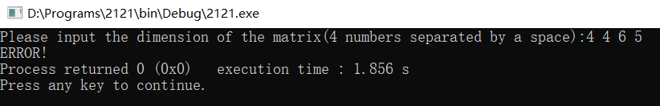

情况2：合法情况，输出矩阵

