Experiment No:11

**Aim:** Perform File Transfer and Access using FTP

# Theory:

## Configuration of ftp server

File Transfer Protocol (FTP) is a TCP protocol for uploading and downloading files between computers. FTP works on a client/server model. The server component is called an*FTP daemon*. It continuously listens for FTP requests from remote clients. When a request is received, it manages the login and sets up the connection. For the duration of the session it executes any of commands sent by the FTP client.

Access to an FTP server can be managed in two ways:

* Anonymous
* Authenticated

In the Anonymous mode, remote clients can access the FTP server by using the defaultuseraccount called "anonymous" or "ftp" and sending an email address as the password.

In the Authenticated mode a user must have an account and a password. User access to theFTPserver directories and files is dependent on the permissions defined for the account used atlogin.As a general rule, the FTP daemon will hide the root directory of the FTP server and change ittothe FTP Home directory. This hides the rest of the file system from remote sessions.

## Steps

1.  vsftpd is an FTP daemon available in Ubuntu. To install**vsftpd**we can run the following command in root mode:
2. User authenticated FTP Configuration

To configure **vsftpd** to authenticate system users and allow them to upload files. To make a copy of the original config file, we use cp command. Configure vsftpd using gedit.

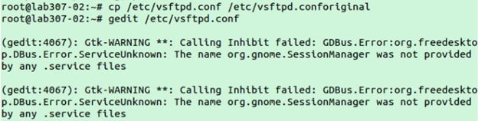

Uncomment the following lines in “vsftpd.conf” configurationfile#Uncomment thistoallow local usersto log in.local_enable=YES

#

#Uncomment thistoenableanyformof FTPwritecommand.write_enable=YES

#

1. Now restart vsftpd

To start or stop the service use command:

#service vsftpd start #service vsftpd stop

1. add new user

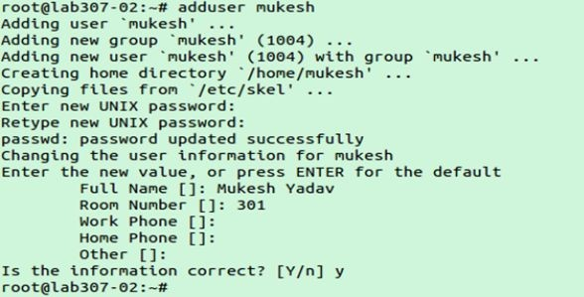

1. In your browser type:ftp://localhostand enter login username and password.

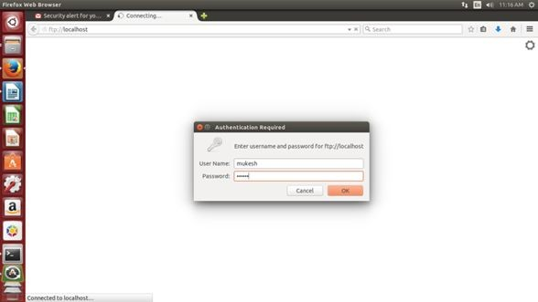

1. 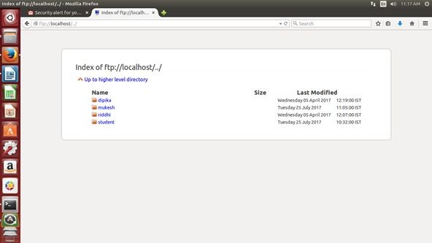After authentication, we can transfer and access files using ftp

Some common ftp commands:

|  |  |
| --- | --- |
| ? | to request help or information about the FTP commands |
| ascii | to set the mode of file transfer to ASCII |
| binar y | to set the mode of file transfer to binary |
| bye | to exit the FTP environment (same as quit) |
| cd | to change directory on the remote machine |
| close | to terminate a connection with another computer |
| delete | to delete (remove) a file in the current remote directory (same as rm in UNIX) |
| get | to copy one file from the remote machine to the local machine  **get ABC DEF**  This copies file ABC in the current remote directory to (or on top of) a filenamed DEF in your current local directory.  **get ABC**  This copies file ABC in the current remote directory to (or on top of) a file withthe same name, ABC, in your current local directory. |
| help | to request a list of all available FTP commands |
| lcd | to change directory on your local machine (same as UNIX cd) |
| ls | to list the names of the files in the current remote directory |
| mkdir | to make a new directory within the current remote directory |
| mget | to copy multiple files from the remote machine to the local machine;  you are prompted for a y/n answer before transferring each file  **mget \***  This copies all the files in the current remote directory to your current local directory, using the same filenames. Notice the use of the wild card character, *. |
| mput | to copy multiple files from the local machine to the remote machine;  you are prompted for a y/n answer before transferring each file |
| open | to open a connection with another computer |
| put | to copy one file from the local machine to the remote machine |

|  |  |
| --- | --- |
| pwd | to find out the pathname of the current directory on the remote machine |
| quit | to exit the FTP environment (same as bye) |
| rmdir | to remove (delete) a directory in the current remote directory |

# Output:

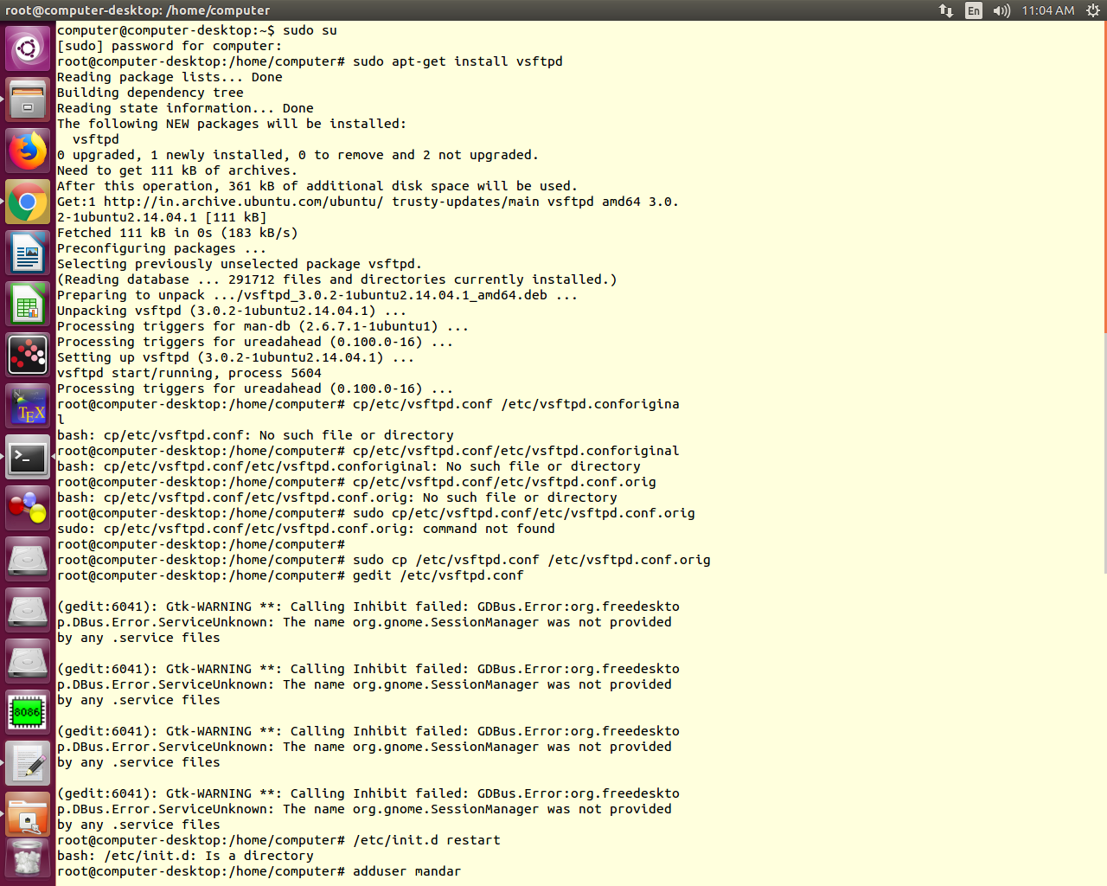

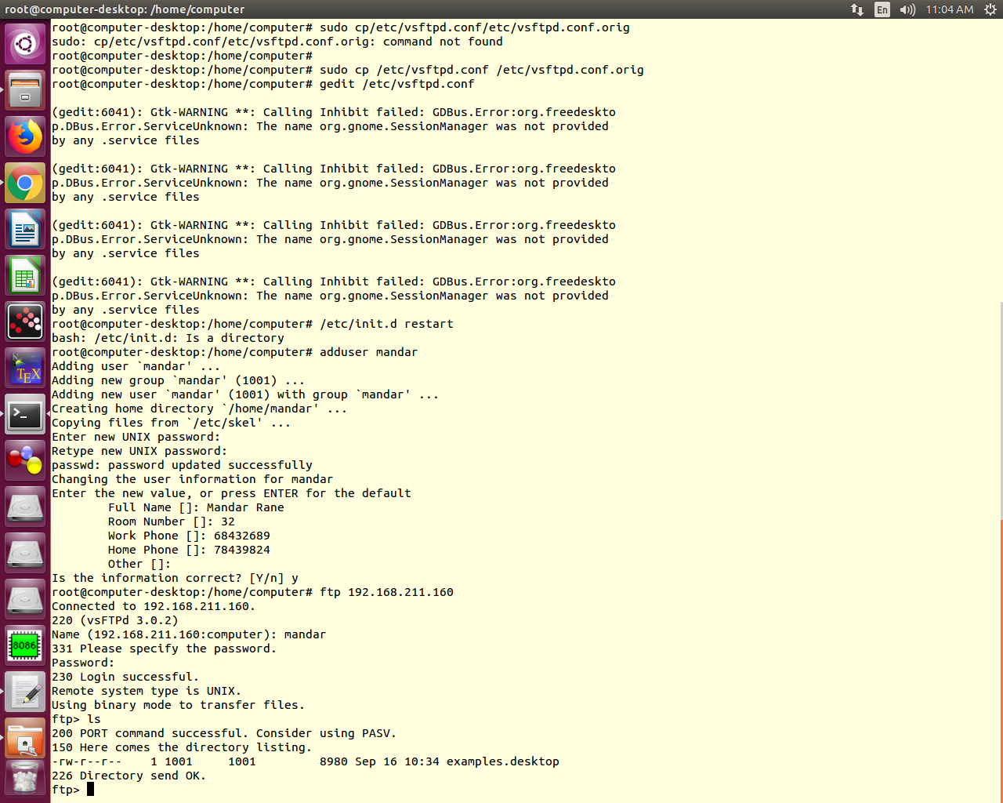**Conclusion:** Hence we successfully performed file transfer and studied the program of FTP.