1. Design a Web Page in HTML to show Admission form in LTCOE

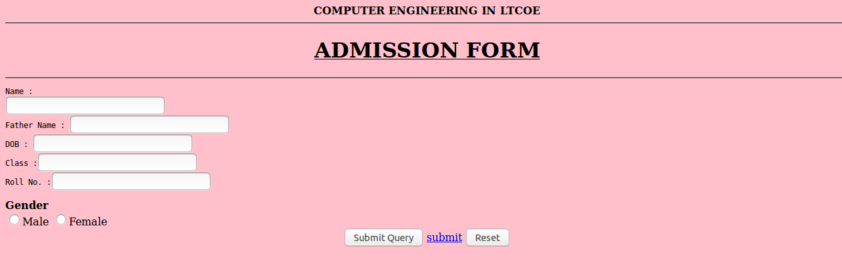

<html>

<body bgcolor="pink">

<center><b> COMPUTER ENGINEERING IN LTCOE<hr>

<h1><u>ADMISSION FORM</b></u></h1></center>

<form><hr><pre> Name :

<input type="text">

Father Name : <input type="text"> DOB : <input type="text">

Class :<input type="text"> Roll No. :<input type="text">

</pre>

<b>Gender</b>

</br>

<input type="radio" name=sex value="Male">Male

<input type="radio" name=sex value="Female">Female

</br>

<center>

<input type="submit">

<a href="E:\html\form1.html">submit</a>

<input type="reset">

</center>

</form>

</body>

</html>

1. Develop and demonstrate a HTML5 file that includes JavaScript script that uses functions for the following problems:
2. Parameter: A number
3. Output: The number with its digits in the reverse order

<html>

<body>

<script type="text/javascript">

var str = prompt("Enter the Input","");

var num,rev=0,remainder; num = parseInt(str); while(num!=0) { remainder = num%10; num = parseInt(num/10); rev = rev * 10 + remainder;

}

alert("Reverse of "+str+" is "+rev);

</script>

</body>

</html>

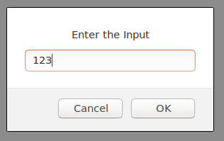

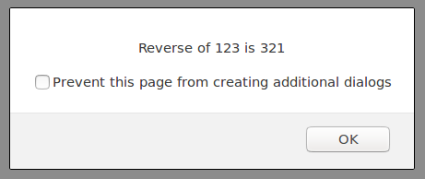

1. Develop and demonstrate a HTML5 file that includes JavaScript script that uses functions for the following problems:
2. Parameter: A string
3. Output: The position in the string of the left-most vowel

<html>

<body>

<script type="text/javascript">

var str = prompt("Enter the Input",""); if(isNaN(str))

{

str = str.toUpperCase();

for(var i = 0; i < str.length; i++)

{

var chr = str.charAt(i);

if(chr == 'A' || chr == 'E' || chr == 'I' || chr == 'O' || chr == 'U')break;

}

if( i < str.length )

alert("The position of the left most vowel is "+(i+1)); else

alert("No vowel found in the entered string");

}

</script>

</body>

</html>

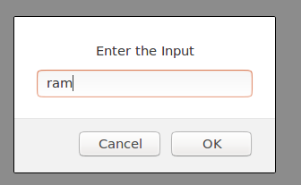

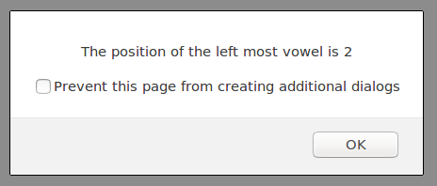

1. Write a JavaScript that calculates the squares and cubes of the numbers from 0 to 10 and outputs HTML text that displays the resulting values in an HTML table format.

<html>

<head>

</head>

<body>

<table align="center" border=1>

<tr><td>number</td><td>square</td><td>cube</td></tr>

<script type="text/javascript"> for(var n=0; n<=10; n++)

{

document.write( "<tr><td>" + n + "</td><td>" + n*n + "</td><td>" + n*n*n

+ "</td></tr>" ) ;

}

</script>

</table>

</body>

</html>

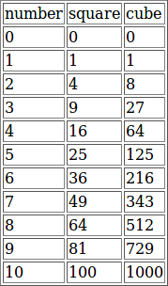

1. Design a web page using CSS (Cascading Style Sheets) which includes the following:

Use different font, styles: In the style definition you define how each selector should work (font, color etc.). Then, in the body of your pages, you refer to these selectors to activate the styles.

# styles.css

h1

{

color:red;

font-family:caStellar; font-size:22pt;

text-decoration:underline;

}

h2

{

color:blue;

font-family:Chiller; font-size:18pt;

text-decoration:overline;

}

p

{

color:magenta;

font-family:Trebuchet MS; font-size:14pt;

font-style:italic;

}

# fontstyles.html

<html>

<head>

<title>Usage of different font,styles and colors </title>

<link rel="stylesheet" type="text/css" href="styles.css"/>

</head>

<body>

<h1>This header is in red</h1>

<h2>This header is in blue</h2>

<p>This is normal text</p>

</body>

</html>

1. Write a program to Develop student registration form and display all the submitted data on another page(PHP)

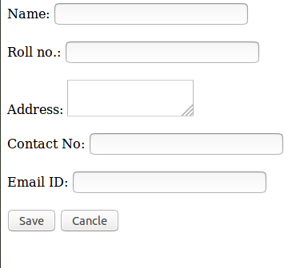

# f.php

<html>

<head>

<title>insert data in form</title>

</head>

<body>

<form action = "getdata.php" method = "POST"> Name:

<input type = "text" name = "txtname">

<br><br> Roll no.:

<input type = "text" name = "txtr_no">

<br><br> Address:

<textarea name = "add" type = "textarea"></textarea>

<br><br> Contact No:

<input type = "text" name = "txtc_no">

<br><br> Email ID:

<input type = "text" name = "txteid">

<br><br>

<input type = "Submit" name = "insert" value = "Save">

<input type = "Reset" value = "Cancle">

</form>

</body>

</html>

# getdata.php

<html>

<head>

<title>get data from another page</title>

</head>

<body>

<?php

echo "Name:" .$_POST["txtname"]."</br>";

echo "Roll no.:".$_POST["txtr_no"]."</br>";

echo "Address:".$_POST["add"]."</br>";

echo "Contact No.:".$_POST["txtc_no"]."</br>"; echo "Email ID:".$_POST["txteid"]."</br>";

?>

</body>

</html>

1. Write a program that displays a different message based on time of day. For example page should display “Good Morning” if it is accessed in the morning.

<?PHP

//Change the messages to what you want.

$afternoon = "Good afternoon! ";

$evening = "Good evening! ";

$late = "Working late? ";

$morning = "Good morning! ";

$friday= "Get ready for the weekend! ";

//Get the current hour

$current_time = date('G');

//Get the current day

$current_day = date('l');

//12 p.m. - 4 p.m.

if ($current_time >= 12 && $current_time <= 16) { echo $afternoon;

}

// 5 p.m. to 11 p.m.

elseif ($current_time >= 17 && $current_time <= 24) { echo $evening;

}

//12 a.m. - 5 a.m.

elseif ($current_time >= 1 && $current_time <= 5) { echo $late;

}

// 6 a.m. to 11 a.m.

elseif ($current_time >= 6 && $current_time <= 11) { echo $morning;

}

//If it's Friday, display a message if ($current_day == "Friday")

{

echo $friday;

}

?>

1. Display student information using XML and XSLT.

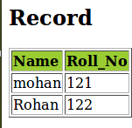

# xml

<?xml version="1.0" encoding="UTF-8"?>

<?xml-stylesheet type="text/xsl" href="4.xsl"?>

<students>

<student>

<name >mohan</name>

<Roll_no>121</Roll_no>

</student>

<student>

<name >Rohan</name>

<Roll_no>122</Roll_no>

</student>

</students>

# xslt

<?xml version="1.0" encoding="UTF-8"?>

<xsl:stylesheet version="1.0" xmlns:xsl=["ht](http://www.w3.org/1999/XSL/Transform)t[p://www.w3.org/1999/XSL/Transform](http://www.w3.org/1999/XSL/Transform)">

<xsl:template match="/">

<html>

<body>

<h2>Record</h2>

<table border="1">

<tr bgcolor="#9acd32">

<th style="text-align:left">Name</th>

<th style="text-align:left">Roll_No</th>

</tr>

<xsl:for-each select="students/student">

<tr>

<td><xsl:value-of select="name"/></td>

<td><xsl:value-of select="Roll_no"/></td>

</tr>

</xsl:for-each>

</table>

</body>

</html>

</xsl:template>

</xsl:stylesheet>

10.Write a php program to find maximum of three numbers.

<html>

<head>

<title> Max out of three </title>

</head>

<body>

<?php

$a = 1;

$b = 4;

$c = 3; if($a > $b)

{

if($a > $c)

echo "Maximum num a = $a"; else

echo "Maximum num c = $c";

}

else

{

if($c > $b)

echo "Maximum num c = $c"; else

echo "Maximum num b = $b";

}

?>

</body>

</html>