Victorian Energy Upgrades ceiling insulation activity: frequently asked questions

Version 1.0 – 23 September 2026
This document provides general guidance and should be read with the relevant legislation, regulations and VEU Specifications. If there is any inconsistency, the underlying requirements prevail. You should seek professional advice if you have a specific concern.

Q1: Why does the ceiling insulation activity have different requirements from other Victorian Energy Upgrades activities?
The ceiling insulation activity has a higher safety and compliance risk profile than many other Victorian Energy Upgrades (VEU) program activities. For this reason, the activity has been designed with additional safeguards to support safe, quality installations and protect consumers.
These include requirements for accredited persons to:
- demonstrate they have relevant industry experience and quality assurance processes before participating (competency and capability requirements)
- notify the Essential Services Commission (commission) before each installation begins
- have a contract in place with the consumer before the installation starts
- ensure installations are only undertaken by Energy Efficiency Council certified installers
- take responsibility for ensuring the upgrade meets VEU requirements.

Engaging third party installers
Accredited persons may still engage third parties to support delivery of installations, such as through subcontracting, but must follow these requirements for each installation.

Potential for future changes
Feedback from industry on implementation issues, including delivery timeframes and participation models will also help inform future consideration of program settings.

Q2: How do activity timeframes operate, including the period between pre-installation requirements and installation?

The activity has requirements that must be completed before an installation can proceed. Some requirements have specific timeframes (see process at Figure 1 below):
- Before installation: the accredited person must have a contract with the energy consumer.
- Within 30 days before installation: a licensed electrician employed by a Registered Electrical Contractor must complete the pre-installation electrical safety assessment. Any electrical hazards must be rectified before installation.
- At least 24 hours before installation: the accredited person must provide the completed electrical safety assessment to the installer and property owner, and obtain the property owner’s written consent to information sharing.
- Between 5 days and 24 hours before installation: the accredited person must submit pre-installation notification to the commission.
- Before installation: the installer must complete the pre-installation installer safety assessment, based on the electrical safety assessment.
These timeframes help to identify and address electrical and other safety risks before installation and gives the commission and other regulators visibility of planned installations and information to conduct inspections. Some steps may need to be re-completed, for example; if the installation needs to be re-scheduled an updated notification will be required, and if the installation date is beyond 30 days from the completion of the pre installation electrical safety assessment a new electrical safety assessment will be required.
Figure 1 - VEU ceiling insulation installation process
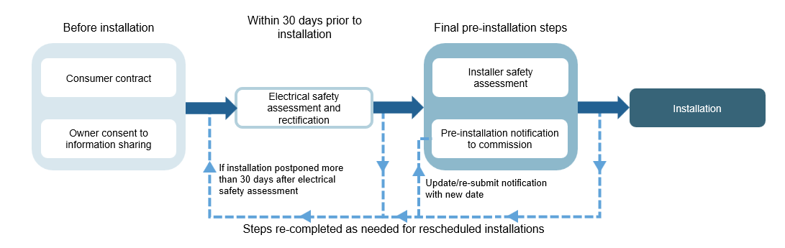

Q3: Why are accredited persons required to notify the commission before work begins and hold a contract?
Accredited persons are required to notify the commission before VEU ceiling insulation work commences to support stronger safety oversight and more timely inspections. We use the information in notifications to:
- monitor compliance in relation to installations as they occur
- coordinate VEU, WorkSafe, Energy Safe Victoria inspections
Notifications also provide a means of holding accredited persons accountable for meeting important pre-installation safety requirements for this activity.

Q4: Why do accredited persons need a contract with the consumer?
A direct contractual relationship between the accredited person and the consumer for the provision of the activity supports our administration and assurance of the VEU program, including inspections of installations as they occur. It also establishes clear responsibility for the activity where third parties are involved in delivery.
This requirement creates clear accountability under the VEU program. It does not prevent businesses from managing customer relationships, quoting and scoping, or delivering installations, provided the accredited person has a genuine contractual role in providing the activity.

Q5: Can an installer engage an accredited person for compliance and certificate creation after an installation has occurred?
No. For the VEU ceiling insulation activity, accreditation conditions require the accredited person to contract with the consumer for the provision of the activity. In practice, businesses that want to deliver VEU ceiling insulation activities must either become an accredited person or work with an accredited person from the beginning of the process.
This does not prevent installers from working with multiple VEU accredited persons for this activity.
While all accredited persons, are expected to have an ongoing relationship with scheme participants, in most other VEU activities, an aggregator accredited person may not be involved in a particular activity until they create Victorian energy efficiency certificates (VEECs). Models like this, sometimes known as the aggregator model , are not permitted for the VEU ceiling insulation activity due to its higher safety and compliance risk profile.
This means the ceiling insulation activity operates differently from the common delivery model for other VEU activities. For this activity the accredited person must be involved before installation begins and cannot be engaged only after completion for certificate creation.

Q6: How does an insulation business become an accredited person?
An insulation business seeking to become an accredited person must meet our accreditation requirements. Applicants should refer to the Application Guide for Accredited Persons and general accreditation conditions for ceiling insulation activity on our website.
Businesses with relevant insulation experience, trained staff, established quality systems and appropriate compliance capability may consider accreditation if it aligns with their business model.

Q7: Can installers manage all aspects of marketing, including direct marketing, lead generation and ownership of customer relationships?
Yes. Similar to other VEU activities, installation businesses can retain control and responsibility for all marketing and customer relationship management for ceiling insulation activities.
This could involve the installation business:
- advertising installation services with VEEC-related discounts and generating leads itself
- being the day-to-day contact for the customer
- arranging works scoping, site visits and quotes, including on its own branding
- holding ownership and control of customer data
- arranging the process of the accredited person contracting with the consumer
- managing payment and invoicing including on its own branding, provided the invoice identifies the accredited person as the business contracted for the activity.
However, the accredited person must have a contract in place with the consumer for the provision of the activity before the upgrade begins. In practice, an installation business could:
- become accredited and contract with the consumer as an accredited person
- contract with the consumer as agent for a specific accredited person if identified in this way in the contract
- provide the activity as a subcontractor to an accredited person which has contracted with the consumer for providing the activity
- contract with the consumer alongside the accredited person in a three-party contract, provided the accredited person is contracting for providing the activity.
Although there must be a genuine contract between the accredited person and the consumer for the activity, these provide options for installation businesses to support delivery of installations.
Just as for other activities, accredited persons, installers and other businesses involved in marketing VEU activities must comply with the VEU Code of Conduct. Businesses cannot contact consumers by phone or through doorknocking to promote VEU activities, unless the consumer has given their express prior consent.

Q8: If an installer partners with an accredited person, who is responsible for warranties and rectification?
Installers and accredited persons are responsible for allocating responsibility for warranties and rectification between each other.
Where subcontracting or other third party delivery arrangements are used, parties should ensure contractual responsibilities for installation quality, defects, rectification, customer service and warranty support are clearly documented.
For the ceiling insulation activity, a product warranty must be provided, for example, for the insulation product to be covered by a warranty against defects for at least five years from the date of installation. Consumer law requirements also apply.

