|  |  |  |  |
| --- | --- | --- | --- |
| **Logic Circuit Design Homework #03** | | | |
| Due date | May 10th, 2024 | Instructor | Yoo, Younghwan |
| Student ID | 202355517 | Name | 권민규 |

1. Using binary state encodings, complete a state transition table and output table for the following FSM. Write Boolean equations for the next state and output and sketch a schematic of the FSM.



|  |  |  |
| --- | --- | --- |
| BiNary State encoding | $$S_{0}$$ | $$S_{1}$$ |
| S0 | 0 | 0 |
| S1 | 0 | 1 |
| S2 | 1 | 0 |

|  |  |  |  |  |  |  |
| --- | --- | --- | --- | --- | --- | --- |
| Current State | | Input | | Next State | | Output |
| $$S_{0}$$ | $$S_{1}$$ | A | B | $${S'}_{0}$$ | $${S'}_{1}$$ | Q |
| 0 | **0** | 0 |  | **0** | **0** | 0 |
| 0 | **0** | 1 |  | **0** | **1** | 0 |
| 0 | **1** |  | 0 | **0** | **0** | 0 |
| 0 | **1** |  | 1 | **1** | **0** | 0 |
| 1 | **0** | 0 | 0 | **0** | **0** | 0 |
| 1 | **0** | 0 | 1 | **0** | **0** | 0 |
| 1 | **0** | 1 | 0 | **0** | **0** | 0 |
| 1 | **0** | 1 | 1 | **1** | **0** | 1 |

$$S_{0}^{'}=\overline{S_{0}}S_{1}B+S_{0}\overline{S_{1}}AB$$

$$S_{1}^{'}=\overline{S_{0}}\overline{S_{1}}A$$

$$Q=\overline{S_{0}}S_{1}AB$$

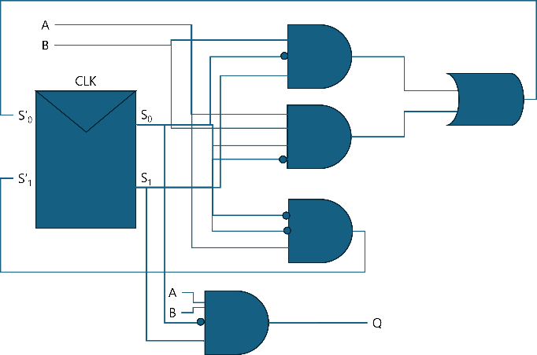

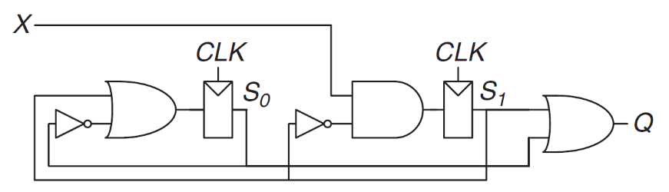2. Analyze the circuit in the figure. Write a state transition table and an output table; and sketch the FSM for the circuit. The reset state is $S_{1}S_{0}=00$.

|  |  |  |
| --- | --- | --- |
| BiNary State encoding | $$S_{0}$$ | $$S_{1}$$ |
| S0 | 0 | 0 |
| S1 | 0 | 1 |
| S2 | 1 | 0 |
| S3 | 1 | 1 |

|  |  |  |  |  |  |
| --- | --- | --- | --- | --- | --- |
| Current State | | Input | Next State | | Output |
| $$S_{0}$$ | $$S_{1}$$ | X | $${S'}_{0}$$ | $${S'}_{1}$$ | Q |
| 0 | **0** | 0 | **0** | **0** | 0 |
| 0 | **0** | 1 | **1** | **0** | 0 |
| 0 | **1** | 0 | **0** | **0** | 1 |
| 0 | **1** | 1 | **1** | **0** | 1 |
| 1 | **0** | 0 | **0** | **1** | 1 |
| 1 | **0** | 1 | **0** | **1** | 1 |
| 1 | **1** | 0 | **0** | **0** | 1 |
| 1 | **1** | 1 | **0** | **0** | 1 |

