Table of Contents
HireLink - Local Service Provider Platform 1
Academic Project Documentation 1
HireLink 1
Table of Contents 1
1. Executive Summary 1
Key Highlights 1
Project Objectives 1
2. Introduction 1
2.1 Problem Statement 1
2.2 Proposed Solution 1
2.3 Scope of the Project 1
2.4 Target Audience 1
3. Software Requirements Specification (SRS) 1
3.1 Functional Requirements 1
3.2 Non-Functional Requirements 1
3.3 Use Case Specifications 1
4. System Architecture 1
4.1 High-Level Architecture 1
4.2 Technology Stack 1
5. Data Flow Diagrams (DFD) 1
5.1 Context Diagram (Level 0 DFD) 1
5.2 Level 1 DFD 1
5.3 Level 2 DFD - Booking Management 1
6. Entity-Relationship Diagrams 1
6.1 Complete ER Diagram 1
6.2 Entity Descriptions 1
6.3 Relationship Summary 1
7. Database Design 1
7.1 Data Dictionary 1
7.2 Booking Status State Machine 1
8. Workflow Diagrams 1
8.1 User Registration Workflow 1
8.2 Service Booking Workflow 1
9. Technical Specifications 1
9.1 Frontend Architecture 1
9.2 Backend Architecture 1
10. API Documentation 1
10.1 API Overview 1
10.2 Authentication Endpoints 1
10.3 Booking Endpoints 1
10.4 API Error Responses 1
11. User Interface Design 1
11.1 Design Principles 1
11.2 Color Palette 1
11.3 Key Pages 1
12. Security Implementation 1
12.1 Authentication Flow 1
12.2 Security Measures 1
12.3 Role-Based Access Control 1
13. Testing Strategy 1
13.1 Testing Pyramid 1
13.2 Test Categories 1
14. Deployment Architecture 1
14.1 Deployment Diagram 1
14.2 Docker Configuration 1
14.3 Environment Configuration 1
15. Conclusion 1
15.1 Project Summary 1
15.2 Future Enhancements 1
15.3 Lessons Learned 1
Appendices 1
Appendix A: Glossary 1
Appendix B: Demo Accounts 1
Appendix C: API Endpoints Summary 1

HireLink - Local Service Provider Platform

Academic Project Documentation

UIT,ADOOR,Academic Year 2025-2026
Academic Year 2025-2026

HireLink
A Full-Stack Web Application for Connecting Customers with Local Service Providers

Submitted in partial fulfillment of the requirements for the BCA ,Graduate Academic Project
Project Team: HireLink Development Team
Submission Date: January 2026

Table of Contents
- Executive Summary
- Introduction
- Software Requirements Specification (SRS)
- System Architecture
- Data Flow Diagrams (DFD)
- Entity-Relationship Diagrams
- Database Design
- Workflow Diagrams
- Technical Specifications
- API Documentation
- User Interface Design
- Security Implementation
- Testing Strategy
- Deployment Architecture
- Conclusion

1. Executive Summary
HireLink is a comprehensive full-stack web application designed to bridge the gap between customers seeking home services and verified local service providers. The platform facilitates seamless booking, tracking, and management of services such as electrical work, plumbing, carpentry, cleaning, painting, and more.

Key Highlights
Aspect | Description
Platform Type | Web-based Service Marketplace
Target Users | Customers, Service Providers, Administrators
Primary Services | Electrical, Plumbing, Carpentry, Cleaning, Painting, AC & Appliances
Technology Stack | React.js, Spring Boot, MySQL, Docker
Architecture | Microservices-ready Monolith

Project Objectives
- Create a user-friendly platform for booking home services
- Implement a robust verification system for service providers
- Enable real-time booking management and tracking
- Provide transparent pricing and rating mechanisms
- Ensure secure authentication and data protection

2. Introduction

2.1 Problem Statement
The home services industry faces significant challenges in connecting customers with reliable service providers:
- Lack of transparency in pricing and service quality
- Difficulty in verifying provider credentials
- Inefficient scheduling and booking processes
- No standardized feedback mechanisms
- Trust deficit between customers and providers

2.2 Proposed Solution
HireLink addresses these challenges by providing a centralized digital platform that:
- Verifies Service Providers through KYC documentation and background checks
- Standardizes Pricing with transparent cost structures
- Enables Easy Booking with intuitive scheduling interfaces
- Implements Rating Systems for quality assurance
- Provides Real-time Tracking of service status

2.3 Scope of the Project
In Scope: - User registration and authentication (Customers, Providers, Admins) - Service category management - Booking creation, tracking, and management - Provider profile and service management - Review and rating system - Location-based service discovery - Multi-role dashboard interfaces
Out of Scope (Future Enhancements): - Payment gateway integration - Real-time chat/messaging - Mobile native applications - AI-based service recommendations

2.4 Target Audience
User Type | Description
Customers | Individuals seeking home services for residential needs
Service Providers | Skilled professionals offering home services
Administrators | Platform managers overseeing operations and verification

3. Software Requirements Specification (SRS)

3.1 Functional Requirements

3.1.1 User Management Module
ID | Requirement | Priority
FR-001 | Users shall be able to register with email/phone and password | High
FR-002 | Users shall be able to login using credentials | High
FR-003 | System shall support OTP-based verification | High
FR-004 | Users shall be able to update their profile information | Medium
FR-005 | Users shall be able to manage multiple addresses | Medium
FR-006 | System shall support role-based access (Customer, Provider, Admin) | High

3.1.2 Service Provider Module
ID | Requirement | Priority
FR-007 | Providers shall be able to create and manage service listings | High
FR-008 | Providers shall submit KYC documents for verification | High
FR-009 | Providers shall set availability schedules | Medium
FR-010 | Providers shall define service areas by pincode/radius | Medium
FR-011 | Providers shall accept/reject booking requests | High
FR-012 | System shall track provider statistics (ratings, bookings, earnings) | High

3.1.3 Service Category Module
ID | Requirement | Priority
FR-013 | System shall support hierarchical service categories | High
FR-014 | Categories shall have configurable pricing structures | Medium
FR-015 | Featured categories shall be highlighted on homepage | Low
FR-016 | Categories shall support multiple pricing units | Medium

3.1.4 Booking Module
ID | Requirement | Priority
FR-017 | Customers shall be able to create service bookings | High
FR-018 | System shall generate unique booking numbers | High
FR-019 | Bookings shall support multiple status states | High
FR-020 | Customers shall track booking status in real-time | High
FR-021 | System shall prevent duplicate active bookings | Medium
FR-022 | Bookings shall support cancellation with reason tracking | Medium

3.1.5 Review and Rating Module
ID | Requirement | Priority
FR-023 | Customers shall rate completed services | High
FR-024 | System shall support multi-dimensional ratings | Medium
FR-025 | Reviews shall be visible on provider profiles | High
FR-026 | System shall calculate and display average ratings | High

3.2 Non-Functional Requirements

3.2.1 Performance Requirements
ID | Requirement | Metric
NFR-001 | Page load time shall be under 3 seconds | < 3s
NFR-002 | API response time shall be under 500ms | < 500ms
NFR-003 | System shall support 1000 concurrent users | 1000 users
NFR-004 | Database queries shall execute under 100ms | < 100ms

3.2.2 Security Requirements
ID | Requirement | Implementation
NFR-005 | Passwords shall be encrypted using bcrypt | BCrypt hashing
NFR-006 | API endpoints shall be secured with JWT tokens | JWT Authentication
NFR-007 | Sensitive data shall be encrypted at rest | AES Encryption
NFR-008 | System shall implement role-based access control | Spring Security RBAC

3.2.3 Usability Requirements
ID | Requirement
NFR-009 | UI shall be responsive across devices (mobile, tablet, desktop)
NFR-010 | System shall provide clear error messages
NFR-011 | Navigation shall be intuitive with maximum 3 clicks to any feature

3.3 Use Case Specifications

Use Case UC-001: User Registration
Field | Description
Use Case ID | UC-001
Name | User Registration
Actors | Customer, Service Provider
Precondition | User has valid email/phone number
Main Flow | 1. User navigates to registration page 2. User selects account type 3. User enters required details 4. System validates input 5. System sends OTP verification 6. User verifies OTP 7. Account is created
Postcondition | User account is created and verified

Use Case UC-002: Book a Service
Field | Description
Use Case ID | UC-002
Name | Book a Service
Actors | Customer
Precondition | Customer is logged in
Main Flow | 1. Customer browses/searches services 2. Customer selects a service 3. Customer views service details 4. Customer clicks “Book Now” 5. Customer selects date and time 6. Customer enters service address 7. Customer describes the issue 8. System creates booking
Postcondition | Booking is created with unique booking number

4. System Architecture

4.1 High-Level Architecture
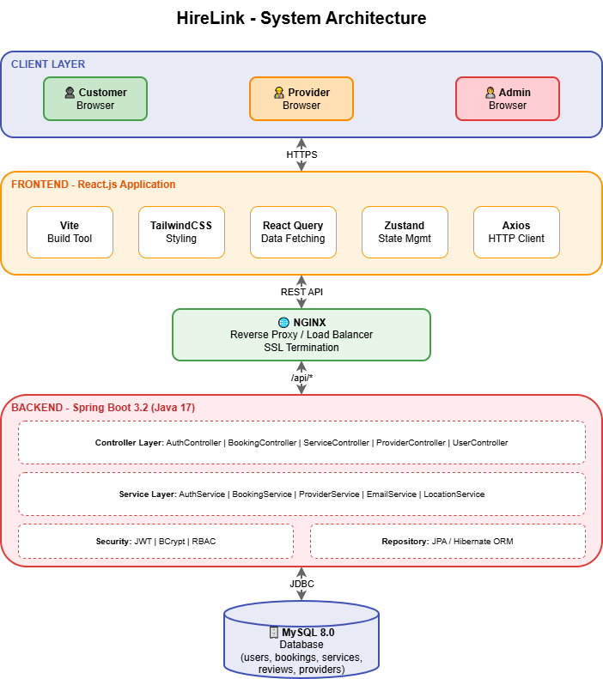Figure 4.1: High-Level System Architecture showing the three-tier architecture with Client Layer (React.js), Application Layer (Spring Boot), and Data Layer (MySQL)
The HireLink system follows a three-tier architecture:
Client Layer: - React.js single-page application - Vite build tool for fast development - TailwindCSS for styling - Zustand for state management - React Query for data fetching
Application Layer: - Spring Boot 3.2 REST API - Spring Security for authentication - JWT token-based authorization - JPA/Hibernate for ORM
Data Layer: - MySQL 8.0 relational database - Optimized indexes for performance - Stored procedures for complex operations

4.2 Technology Stack
Layer | Technology | Version | Purpose
Frontend Framework | React.js | 18.x | UI Component Library
Build Tool | Vite | 5.x | Fast Development & Build
Styling | TailwindCSS | 3.x | Utility-First CSS
State Management | Zustand | 4.x | Lightweight State Store
API Client | React Query | 5.x | Data Fetching & Caching
Backend Framework | Spring Boot | 3.2.x | REST API Framework
Language | Java | 17 | Backend Programming
Security | Spring Security | 6.x | Authentication & Authorization
ORM | Hibernate/JPA | 6.x | Object-Relational Mapping
Database | MySQL | 8.0 | Relational Database
Containerization | Docker | 24.x | Application Containers

5. Data Flow Diagrams (DFD)

5.1 Context Diagram (Level 0 DFD)
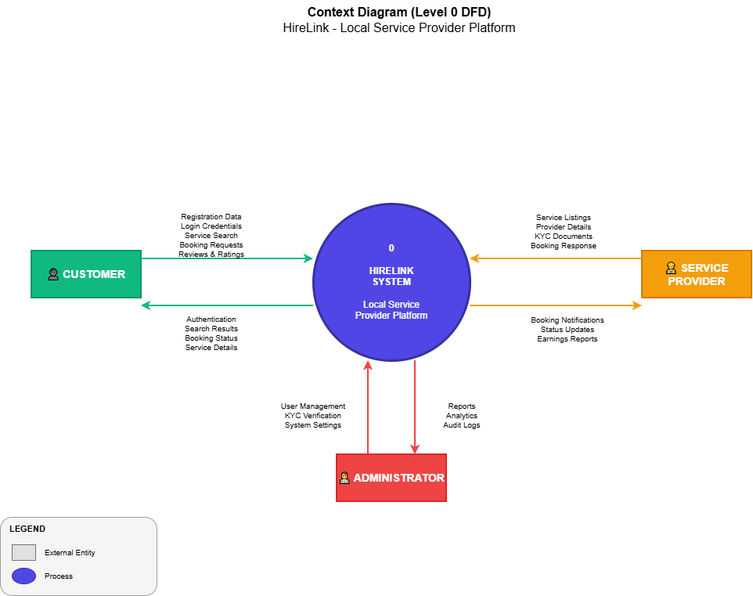Figure 5.1: Context Diagram showing the HireLink system as a single process with three external entities: Customer, Service Provider, and Administrator
External Entities: - Customer: Sends registration data, login credentials, service search queries, booking requests, and reviews - Service Provider: Sends service listings, KYC documents, and booking responses - Administrator: Manages users, verifies KYC, and configures system settings

5.2 Level 1 DFD
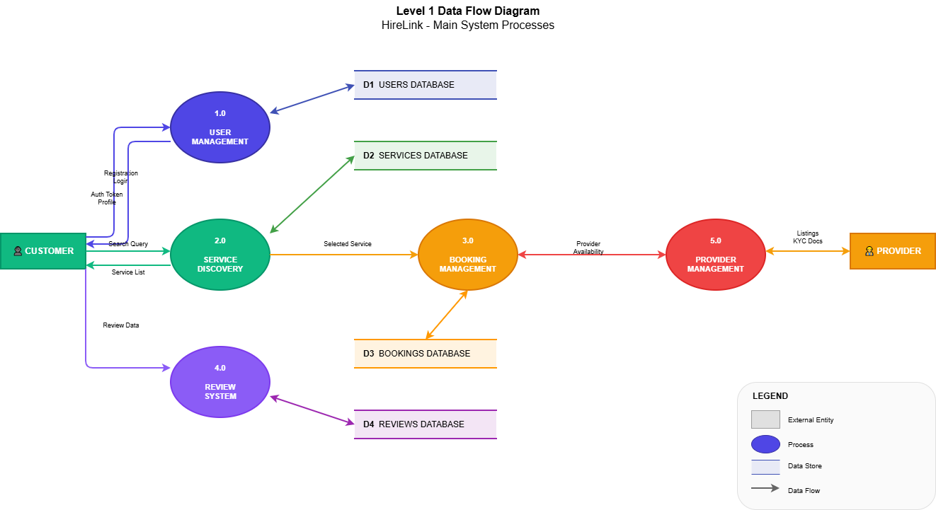Figure 5.2: Level 1 DFD showing the main processes: User Management, Service Discovery, Booking Management, Review System, and Provider Management
Main Processes:
Process | Description
1.0 User Management | Handles registration, authentication, and profile management
2.0 Service Discovery | Manages service search and category browsing
3.0 Booking Management | Creates and manages service bookings
4.0 Review System | Handles ratings and reviews
5.0 Provider Management | Manages provider profiles and verification
Data Stores:
Data Store | Description
D1: Users Database | Stores user accounts and provider information
D2: Services Database | Stores service categories and listings
D3: Bookings Database | Stores booking records and status history
D4: Reviews Database | Stores customer reviews and ratings

5.3 Level 2 DFD - Booking Management
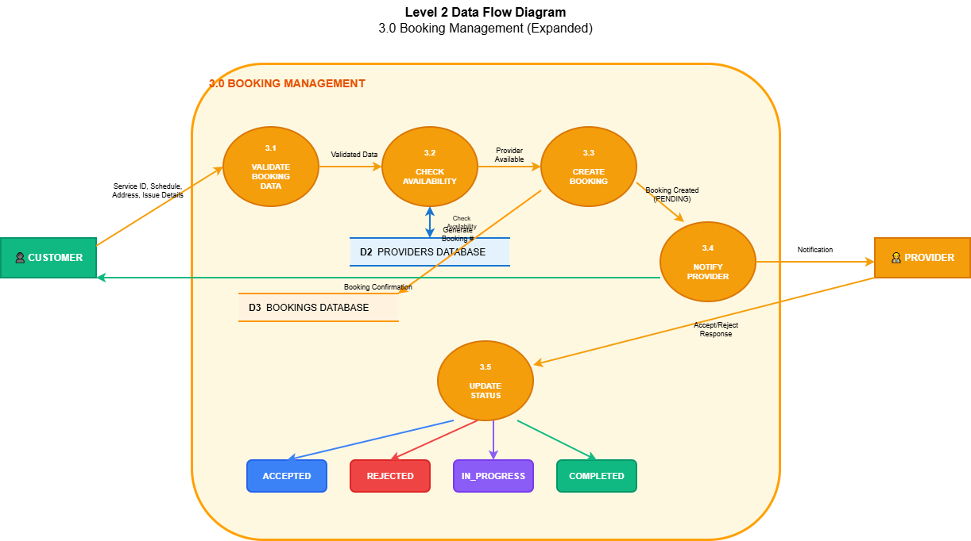Figure 5.3: Level 2 DFD for Booking Management showing sub-processes: Validate Booking Data, Check Availability, Create Booking, Notify Provider, and Update Status
Sub-Processes:
Process | Description
3.1 Validate Booking Data | Validates customer input for booking
3.2 Check Availability | Verifies provider availability
3.3 Create Booking | Generates booking record with unique number
3.4 Notify Provider | Sends notification to assigned provider
3.5 Update Status | Manages booking status transitions

6. Entity-Relationship Diagrams

6.1 Complete ER Diagram
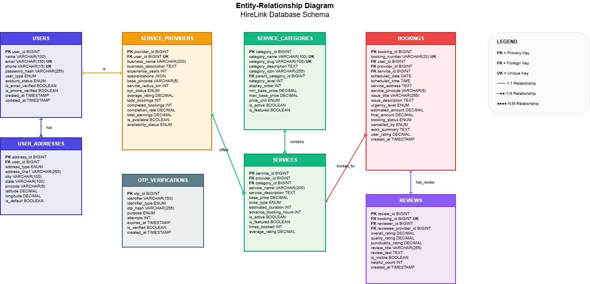Figure 6.1: Entity-Relationship Diagram showing all database entities and their relationships

6.2 Entity Descriptions
Entity | Description | Key Attributes
USERS | All system users | user_id (PK), name, email, phone, user_type
USER_ADDRESSES | User address records | address_id (PK), user_id (FK), city, pincode
SERVICE_PROVIDERS | Provider business profiles | provider_id (PK), user_id (FK), business_name
SERVICE_CATEGORIES | Hierarchical categories | category_id (PK), category_name, parent_id
SERVICES | Service listings | service_id (PK), provider_id (FK), base_price
BOOKINGS | Service bookings | booking_id (PK), booking_number, status
REVIEWS | Customer reviews | review_id (PK), booking_id (FK), rating
OTP_VERIFICATIONS | OTP records | otp_id (PK), identifier, otp_hash

6.3 Relationship Summary
Parent Entity | Child Entity | Relationship | Cardinality
Users | UserAddresses | Has | 1:N
Users | ServiceProviders | Is | 1:1
Users | Bookings | Makes | 1:N
Users | Reviews | Writes | 1:N
ServiceProviders | Services | Offers | 1:N
ServiceProviders | Bookings | Receives | 1:N
ServiceCategories | Services | Contains | 1:N
Services | Bookings | BookedFor | 1:N
Bookings | Reviews | HasReview | 1:1

7. Database Design

7.1 Data Dictionary

Table: users
Column | Data Type | Constraints | Description
user_id | BIGINT | PK, AUTO_INCREMENT | Unique user identifier
name | VARCHAR(100) | NOT NULL | User’s full name
email | VARCHAR(150) | UNIQUE | Email address
phone | VARCHAR(15) | UNIQUE | Phone number
password_hash | VARCHAR(255) |  | BCrypt hashed password
user_type | ENUM | NOT NULL | CUSTOMER, PROVIDER, ADMIN
account_status | ENUM |  | ACTIVE, INACTIVE, SUSPENDED
is_email_verified | BOOLEAN | DEFAULT FALSE | Email verification status
is_phone_verified | BOOLEAN | DEFAULT FALSE | Phone verification status
created_at | TIMESTAMP | NOT NULL | Record creation time

Table: service_providers
Column | Data Type | Constraints | Description
provider_id | BIGINT | PK, AUTO_INCREMENT | Unique provider identifier
user_id | BIGINT | FK, UNIQUE | Reference to users table
business_name | VARCHAR(200) |  | Business/brand name
business_description | TEXT |  | Detailed description
experience_years | INT | DEFAULT 0 | Years of experience
base_pincode | VARCHAR(6) |  | Primary service pincode
service_radius_km | INT | DEFAULT 10 | Service coverage radius
kyc_status | ENUM |  | NOT_SUBMITTED, PENDING, VERIFIED
average_rating | DECIMAL(3,2) | DEFAULT 0 | Average service rating
total_bookings | INT | DEFAULT 0 | Total booking count
completed_bookings | INT | DEFAULT 0 | Completed booking count
is_available | BOOLEAN | DEFAULT TRUE | Current availability

Table: bookings
Column | Data Type | Constraints | Description
booking_id | BIGINT | PK, AUTO_INCREMENT | Unique booking identifier
booking_number | VARCHAR(20) | UNIQUE, NOT NULL | Human-readable booking ID
user_id | BIGINT | FK, NOT NULL | Customer reference
provider_id | BIGINT | FK, NOT NULL | Provider reference
service_id | BIGINT | FK, NOT NULL | Service reference
scheduled_date | DATE | NOT NULL | Scheduled service date
scheduled_time | TIME | NOT NULL | Scheduled start time
service_address | TEXT | NOT NULL | Service location address
service_pincode | VARCHAR(6) | NOT NULL | Service location pincode
issue_title | VARCHAR(255) |  | Brief issue summary
issue_description | TEXT |  | Detailed issue description
urgency_level | ENUM | DEFAULT ‘MEDIUM’ | LOW, MEDIUM, HIGH
estimated_amount | DECIMAL(10,2) |  | Initial cost estimate
final_amount | DECIMAL(10,2) |  | Final billing amount
booking_status | ENUM | DEFAULT ‘PENDING’ | Current booking status
created_at | TIMESTAMP | NOT NULL | Booking creation time

7.2 Booking Status State Machine
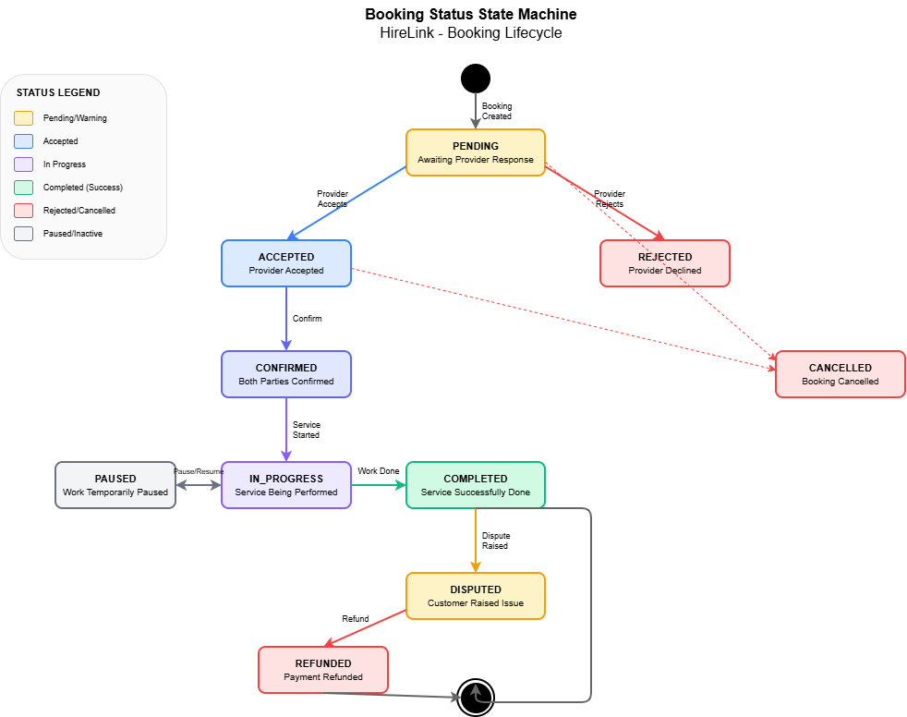
Figure 7.1: Booking Status State Machine showing all possible status transitions
Status Definitions:
Status | Description
PENDING | Initial state, awaiting provider response
ACCEPTED | Provider accepted the booking
REJECTED | Provider declined the booking
CONFIRMED | Booking confirmed by both parties
IN_PROGRESS | Service is currently being performed
PAUSED | Work temporarily paused
COMPLETED | Service successfully completed
CANCELLED | Booking cancelled by any party
DISPUTED | Customer raised a dispute
REFUNDED | Payment refunded after dispute

8. Workflow Diagrams

8.1 User Registration Workflow
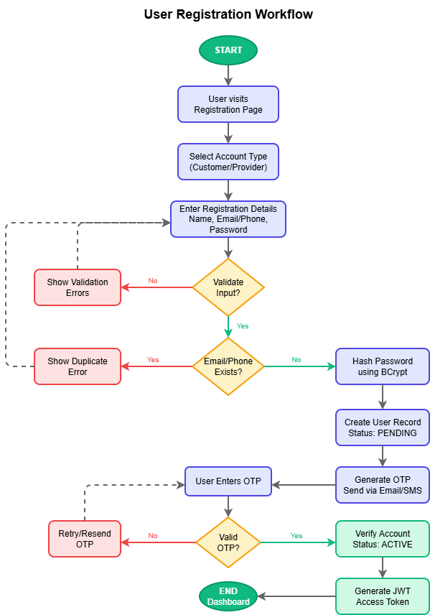Figure 8.1: User Registration Flowchart showing the complete registration process from start to dashboard redirect
Workflow Steps:
- User visits registration page
- User selects account type (Customer/Provider)
- User enters registration details (Name, Email/Phone, Password)
- System validates input data
- System checks for existing email/phone
- System hashes password using BCrypt
- System creates user record with PENDING status
- System generates and sends OTP
- User enters OTP
- System verifies OTP
- System activates account
- System generates JWT token
- User is redirected to dashboard

8.2 Service Booking Workflow
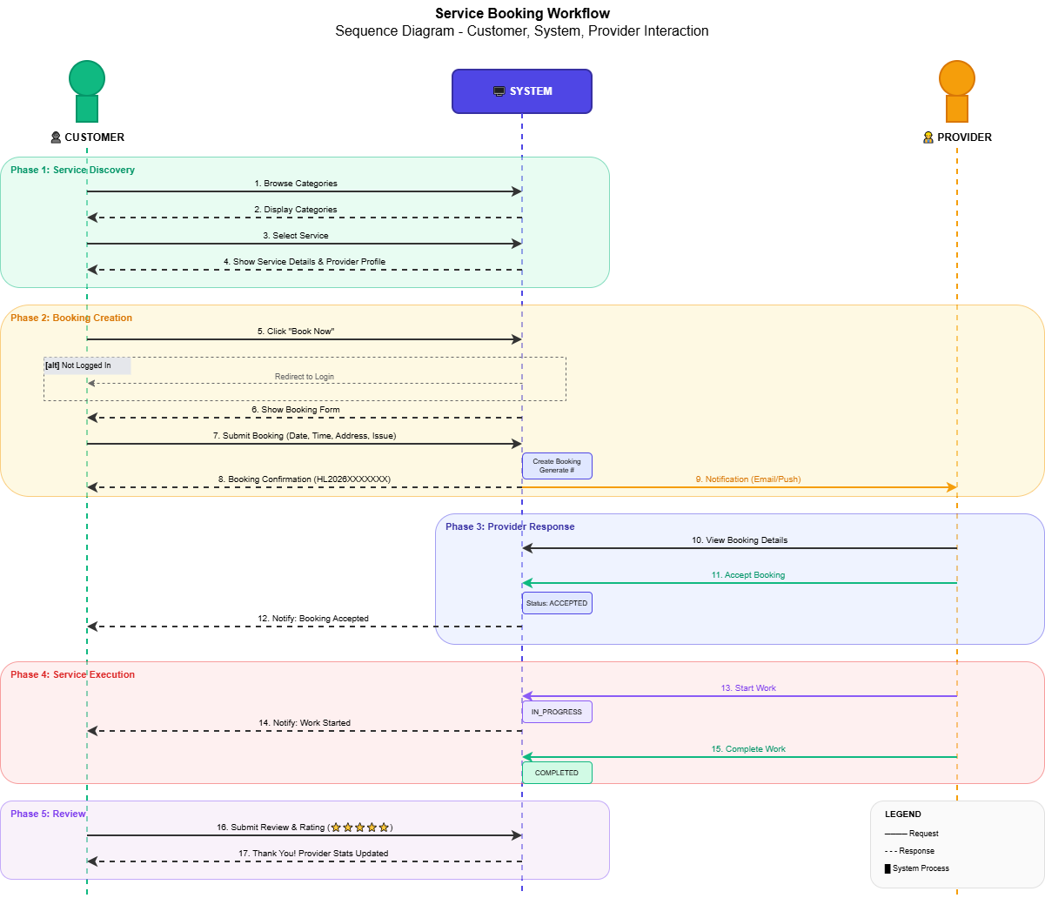Figure 8.2: Service Booking Sequence Diagram showing interactions between Customer, System, and Provider
Workflow Phases:
Phase 1: Service Discovery - Customer browses categories - System displays available services - Customer selects service and views details
Phase 2: Booking Creation - Customer initiates booking - System validates login status - Customer enters booking details - System creates booking with PENDING status - System generates booking number (HL2026XXXXXXX) - Provider receives notification
Phase 3: Provider Response - Provider reviews booking request - Provider accepts or rejects - System updates status - Customer receives notification
Phase 4: Service Execution - Provider starts work (IN_PROGRESS) - Provider completes work (COMPLETED) - Customer receives completion notification
Phase 5: Review - Customer submits review and rating - System updates provider statistics

9. Technical Specifications

9.1 Frontend Architecture
Project Structure:
frontend/
├── src/
│ ├── components/ # Reusable UI components
│ ├── pages/ # Page components (routes)
│ ├── services/ # API service layer
│ ├── context/ # State management
│ ├── styles/ # Styling configuration
│ ├── App.jsx # Main application
│ └── main.jsx # Entry point
├── public/ # Static assets
└── package.json # Dependencies
Key Dependencies:
Package | Purpose
react | UI Component Library
react-router-dom | Client-side Routing
@tanstack/react-query | Data Fetching & Caching
zustand | State Management
axios | HTTP Client
tailwindcss | CSS Framework

9.2 Backend Architecture
Project Structure:
backend/
├── src/main/java/com/hirelink/
│ ├── controller/ # REST API controllers
│ ├── service/ # Business logic
│ ├── repository/ # Data access
│ ├── entity/ # JPA entities
│ ├── dto/ # Data transfer objects
│ ├── security/ # Security components
│ └── exception/ # Exception handling
└── pom.xml # Maven dependencies
Key Dependencies:
Dependency | Purpose
spring-boot-starter-web | REST API Framework
spring-boot-starter-data-jpa | Data Access Layer
spring-boot-starter-security | Authentication
mysql-connector-j | Database Driver
jjwt-api | JWT Token Generation
lombok | Boilerplate Reduction

10. API Documentation

10.1 API Overview
Base URL | Format | Authentication
/api | JSON | JWT Bearer Token

10.2 Authentication Endpoints

POST /api/auth/register
Request:
{
"name": "John Doe",
"email": "john@example.com",
"phone": "9876543210",
"password": "securePassword123",
"userType": "CUSTOMER"
}
Response (201 Created):
{
"success": true,
"message": "Registration successful",
"data": {
"userId": 1,
"name": "John Doe",
"userType": "CUSTOMER"
}
}

POST /api/auth/login
Request:
{
"identifier": "john@example.com",
"password": "securePassword123"
}
Response (200 OK):
{
"success": true,
"data": {
"accessToken": "eyJhbGciOiJIUzI1NiIs...",
"refreshToken": "eyJhbGciOiJIUzI1NiIs...",
"tokenType": "Bearer",
"expiresIn": 86400
}
}

10.3 Booking Endpoints

POST /api/bookings
Request:
{
"serviceId": 1,
"providerId": 1,
"scheduledDate": "2026-02-15",
"scheduledTime": "10:00:00",
"serviceAddress": "42, Shanti Nagar",
"servicePincode": "560001",
"issueTitle": "Ceiling Fan Not Working",
"urgencyLevel": "MEDIUM"
}
Response (201 Created):
{
"success": true,
"data": {
"bookingId": 1,
"bookingNumber": "HL2026021500001",
"bookingStatus": "PENDING",
"estimatedAmount": 300.00
}
}

10.4 API Error Responses
HTTP Code | Error Type | Description
400 | Bad Request | Invalid input or validation failure
401 | Unauthorized | Missing or invalid authentication
403 | Forbidden | Insufficient permissions
404 | Not Found | Resource does not exist
500 | Internal Server Error | Server-side error

11. User Interface Design

11.1 Design Principles
- Responsive Design: Mobile-first approach with breakpoints for tablet and desktop
- Consistent Visual Language: Unified color palette, typography, and spacing
- Accessibility: WCAG 2.1 compliant with proper contrast ratios
- Intuitive Navigation: Maximum 3 clicks to reach any feature
- Feedback & Loading States: Clear visual feedback for all user actions

11.2 Color Palette
Color Name | Hex Code | Usage
Primary-600 | #4F46E5 | Primary actions, links
Primary-700 | #4338CA | Primary hover states
Accent-500 | #F59E0B | CTA buttons, highlights
Success-500 | #22C55E | Success states
Warning-500 | #EAB308 | Warning messages
Error-500 | #EF4444 | Error states
Gray-900 | #111827 | Primary text
Gray-500 | #6B7280 | Secondary text

11.3 Key Pages
Page | Description
Home | Hero section, service categories, featured providers
Categories | Grid of all service categories
Service Detail | Service information, provider profile, booking button
Booking Form | Date/time selection, address input, issue description
My Bookings | List of customer’s bookings with status filters
Booking Detail | Complete booking information, status timeline
Provider Profile | Business info, services offered, reviews
Profile | User settings, addresses, preferences

12. Security Implementation

12.1 Authentication Flow
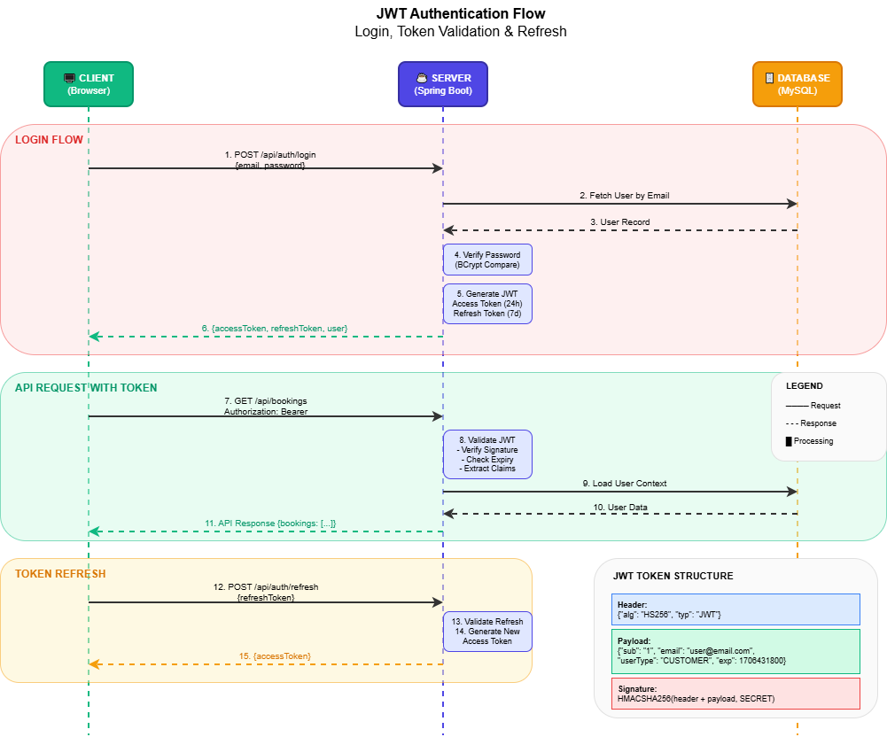
Figure 12.1: JWT Authentication Flow showing the login process and token validation

12.2 Security Measures
Aspect | Implementation
Password Storage | BCrypt with 12 rounds
Token Type | JWT (JSON Web Token)
Access Token Expiry | 24 hours
Refresh Token Expiry | 7 days
Input Validation | Jakarta Bean Validation
SQL Injection Prevention | JPA Parameterized Queries
XSS Prevention | React automatic escaping

12.3 Role-Based Access Control
Role | Permissions
CUSTOMER | View services, Create bookings, Write reviews
PROVIDER | Manage services, Accept/reject bookings
ADMIN | User management, KYC verification
SUPER_ADMIN | All permissions + System settings

13. Testing Strategy

13.1 Testing Pyramid
Level | Coverage | Framework
Unit Tests | 80% | JUnit 5, Jest
Integration Tests | 15% | Spring Boot Test
E2E Tests | 5% | Cypress

13.2 Test Categories
Unit Tests: - Backend service methods - Repository operations - Frontend components - Utility functions
Integration Tests: - API endpoint testing - Database operations - Authentication flow
End-to-End Tests: - Complete user workflows - Cross-browser testing

14. Deployment Architecture

14.1 Deployment Diagram
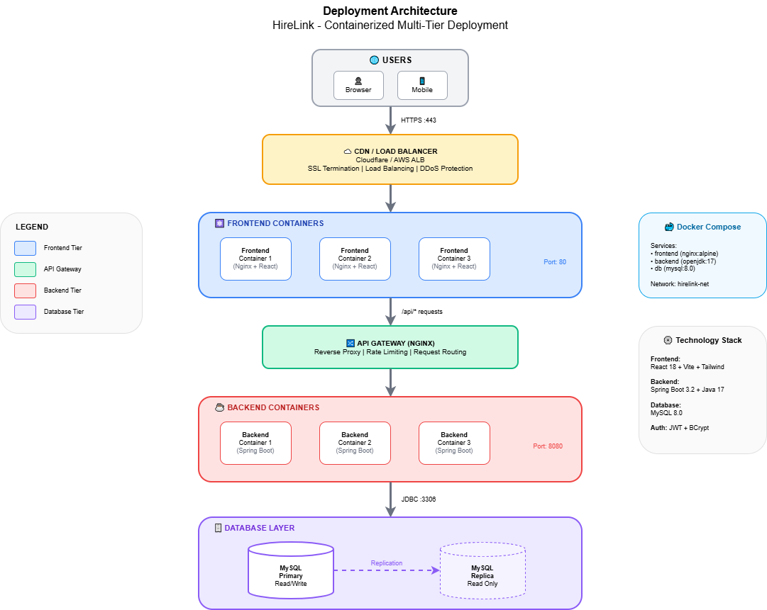Figure 14.1: Deployment Architecture showing containerized services with load balancing

14.2 Docker Configuration
Services:
Service | Technology | Port
Frontend | Nginx + React | 80
Backend | Spring Boot | 8080
Database | MySQL 8.0 | 3306

14.3 Environment Configuration
Environment | URL | Purpose
Development | localhost:3000 | Local development
Staging | staging.hirelink.in | Pre-production testing
Production | www.hirelink.in | Live application

15. Conclusion

15.1 Project Summary
HireLink successfully addresses the challenges in the home services industry by providing a comprehensive digital platform that connects customers with verified local service providers.
Key Achievements:
Objective | Status
User Registration & Authentication | ✓ Complete
Service Category Management | ✓ Complete
Booking System | ✓ Complete
Provider Management | ✓ Complete
Review System | ✓ Complete
Location-Based Discovery | ✓ Complete
Responsive UI | ✓ Complete

15.2 Future Enhancements
- Payment Gateway Integration (Razorpay/Stripe)
- Real-Time Notifications (WebSocket)
- Mobile Applications (iOS/Android)
- AI Recommendations
- Multi-Language Support
- Analytics Dashboard

15.3 Lessons Learned
- Spring Boot + React provides excellent developer productivity
- Zustand offers simpler state management than Redux
- Proper database normalization prevents scalability issues
- Security should be implemented from the start
- Docker significantly simplifies deployment

Appendices

Appendix A: Glossary
Term | Definition
JWT | JSON Web Token for authentication
KYC | Know Your Customer verification
OTP | One-Time Password
API | Application Programming Interface
CRUD | Create, Read, Update, Delete
ORM | Object-Relational Mapping

Appendix B: Demo Accounts
Role | Email | Password
Customer | priya.sharma@email.com | password123
Provider | ramesh.electrician@email.com | password123
Admin | admin@hirelink.in | password123

Appendix C: API Endpoints Summary
Method | Endpoint | Description
POST | /api/auth/register | User registration
POST | /api/auth/login | User login
GET | /api/categories | List categories
GET | /api/services/{id} | Service details
POST | /api/bookings | Create booking
GET | /api/bookings/my-bookings | User’s bookings
PUT | /api/bookings/{id}/status | Update status
GET | /api/providers/{id} | Provider profile
POST | /api/bookings/{id}/review | Add review

Document Version: 1.0 Last Updated: January 2026 Academic Institution: UIT,ADOOR
This document is submitted as part of the academic project requirements for the Graduate Academic Project at ENSATE, Academic Year 2025-2026.

