PROJECT REPORT
on
HIRELINK BOOKING SYSTEM

A Full-Stack Web Application for Service Booking Management

Built with
Spring Boot 3.x | React 18.x | MySQL 8.0

Submitted by

Department of Computer Science

Academic Year 2025–2026
GitHub: github.com/TalipotTech/HireLink

Table of Contents
Table of Contents 1
1. Introduction 1
1.1 Project Overview 1
1.2 Problem Statement 1
1.3 Objectives 1
1.4 Scope 1
2. Literature Review and Technology Background 1
2.1 Spring Boot Framework 1
2.2 React.js 1
2.3 MySQL Database 1
2.4 Related Work 1
3. System Architecture 1
3.1 Three-Tier Architecture 1
3.2 Backend Layer Architecture 1
3.3 Data Flow 1
4. Database Design 1
4.1 Entity-Relationship Overview 1
4.2 Core Entities 1
4.2.1 User Entity 1
4.2.2 Booking Entity 1
4.2.3 OTP Verification Entity 1
4.3 Entity Relationships 1
5. Implementation Details 1
5.1 Backend Implementation 1
5.1.1 Project Setup and Dependencies 1
5.1.2 Repository Layer 1
5.1.3 Service Layer 1
5.1.4 Controller Layer 1
5.2 Authentication System 1
5.2.1 Email OTP Verification 1
5.2.2 Google OAuth Integration 1
5.2.3 JWT Token Management 1
5.3 Frontend Implementation 1
5.3.1 Project Structure 1
5.3.2 State Management 1
5.3.3 Light Theme Design 1
5.3.4 Search Functionality 1
5.3.5 Location-Based Features 1
6. API Reference 1
6.1 Booking Endpoints 1
6.2 Authentication Endpoints 1
6.3 Sample Request and Response 1
7. Testing and Validation 1
7.1 Testing Approach 1
7.2 Test Scenarios 1
8. User Interface 1
9. Installation and Setup Guide 1
9.1 Prerequisites 1
9.2 Database Setup 1
9.3 Backend Configuration 1
9.4 Running the Application 1
10. Future Enhancements 1
11. Conclusion 1
12. References 1
Appendix A: Project Directory Structure 1
Appendix B: Key Annotations Reference 1
JPA Entity Annotations 1
Spring Web Annotations 1
Validation Annotations 1

1. Introduction

1.1 Project Overview
HireLink is a full-stack web application designed as a comprehensive Booking Management System for home services. The platform enables customers to browse available services, book service providers, and manage their appointments through an intuitive web interface. Service providers can receive booking requests, manage their schedules, and update job statuses in real time.
The application serves as both a practical service-booking platform and an educational resource, demonstrating modern full-stack development practices using industry-standard technologies. It follows a three-tier architecture with clear separation of concerns between the presentation layer, business logic layer, and data access layer.

1.2 Problem Statement
In the current market for home services such as plumbing, electrical work, carpentry, and appliance repair, customers often face difficulties in finding reliable service providers. The process typically involves phone calls, word-of-mouth referrals, and manual scheduling, leading to inefficiency, lack of transparency, and poor tracking of service history. HireLink addresses these challenges by providing a digital platform that streamlines the entire booking lifecycle from service discovery to completion.

1.3 Objectives
The primary objectives of this project are:
• To develop a REST API backend using Spring Boot 3.x with full CRUD operations for managing users, services, and bookings.
• To create a responsive frontend interface using React 18.x that provides an intuitive user experience for customers and providers.
• To implement user authentication using dual verification with Email OTP and Google OAuth integration.
• To incorporate search functionality enabling users to find bookings by customer name, service type, or booking status.
• To add location-based features using geolocation APIs for service area management.
• To demonstrate best practices in full-stack development including layered architecture, DTO patterns, input validation, and error handling.

1.4 Scope
The scope of HireLink encompasses user registration and authentication, service catalogue management, booking creation and lifecycle management (pending, confirmed, in-progress, completed, cancelled), search and filter capabilities, location-based service discovery, and a responsive light-themed user interface. The system is designed for deployment on a single server with MySQL as the database backend.

2. Literature Review and Technology Background

2.1 Spring Boot Framework
Spring Boot is an opinionated framework built on top of the Spring Framework that simplifies the development of production-ready Java applications. It provides auto-configuration, embedded servers, and starter dependencies that drastically reduce boilerplate code. Spring Boot 3.x, used in this project, requires Java 17+ and is built on the Jakarta EE 9+ namespace. Key features leveraged in HireLink include Spring Data JPA for database operations, Spring Web for REST API development, Spring Security for authentication, and Spring Mail for email services.

2.2 React.js
React is a JavaScript library for building user interfaces, maintained by Meta. React 18.x introduces concurrent rendering features and automatic batching of state updates. In HireLink, React is used with the Vite build tool for fast development server startup and hot module replacement. The application uses functional components with hooks (useState, useEffect) for state management, and Axios as the HTTP client for communicating with the backend REST API.

2.3 MySQL Database
MySQL 8.0 serves as the relational database management system for HireLink. It provides ACID compliance, support for complex queries, and robust indexing capabilities. The database schema is auto-generated by Hibernate (JPA implementation) based on entity class annotations, with the ddl-auto=update configuration allowing incremental schema evolution during development.

2.4 Related Work
Existing platforms such as UrbanClap (now Urban Company), Housejoy, and TaskRabbit provide similar home-service booking functionality at commercial scale. HireLink differentiates itself as an educational implementation that prioritises code clarity, comprehensive documentation, and a simplified feature set suitable for academic study while still demonstrating production-level architectural patterns.

3. System Architecture

3.1 Three-Tier Architecture
HireLink follows a standard three-tier architecture that cleanly separates the application into distinct layers, each with a single responsibility:
Tier | Technology | Port | Responsibility
Presentation | React 18.x + Vite | 3000 | User interface, form handling, API consumption
Application | Spring Boot 3.x | 8080 | REST API, business logic, validation, authentication
Data | MySQL 8.0 | 3306 | Persistent data storage, relational integrity

The frontend communicates with the backend exclusively through HTTP requests carrying JSON payloads. The backend processes these requests through a layered internal architecture before persisting data to MySQL.

3.2 Backend Layer Architecture
Within the Spring Boot backend, the code is organised into the following layers:
Layer | Package | Purpose
Controller | com.hirelink.controller | Handles HTTP requests, maps URLs to service methods, returns responses
Service | com.hirelink.service | Contains business logic, validation rules, transaction management
Repository | com.hirelink.repository | Interfaces with the database via Spring Data JPA
Entity | com.hirelink.entity | Java classes mapped to database tables using JPA annotations
DTO | com.hirelink.dto | Data Transfer Objects for API request/response payloads
Config | com.hirelink.config | Security, CORS, and application configuration

3.3 Data Flow
A typical request flows through the system as follows: the React frontend sends an HTTP request (e.g., POST /api/bookings) with a JSON body. The Spring Boot controller receives the request and deserialises the JSON into a DTO. The controller delegates to the service layer, which validates input, applies business rules, and calls repository methods. The repository translates method calls into SQL queries via Hibernate. The database executes the query and returns results. The response travels back through the layers, with the entity converted to a response DTO before being serialised as JSON and sent to the frontend.

4. Database Design

4.1 Entity-Relationship Overview
The HireLink database consists of several core entities with defined relationships. The primary entities are User, Service, and Booking, with supporting entities for OTP verification and authentication tokens.

4.2 Core Entities

4.2.1 User Entity
The User entity represents all system users, distinguished by a userType field (CUSTOMER, PROVIDER, or ADMIN). Key fields include:
Field | Type | Constraints | Description
id | Long | Primary Key, Auto-generated | Unique identifier
name | String | Not Null | Full name of the user
email | String | Unique, Not Null | Email address for login and communication
phone | String | Not Null | Contact phone number
userType | Enum | Not Null | CUSTOMER, PROVIDER, or ADMIN
isVerified | Boolean | Default: false | Email verification status
authProvider | Enum | Default: LOCAL | LOCAL or GOOGLE authentication
googleId | String | Nullable | Google OAuth identifier
passwordHash | String | Nullable | Hashed password for local authentication

4.2.2 Booking Entity
The Booking entity is the central entity, representing a service appointment between a customer and a provider:
Field | Type | Constraints | Description
id | Long | Primary Key | Unique booking identifier
bookingNumber | String | Unique | Human-readable booking reference
customer | User | @ManyToOne | Reference to customer user
provider | User | @ManyToOne | Reference to service provider
service | Service | @ManyToOne | Reference to booked service
scheduledDate | LocalDate | Not Null | Appointment date
scheduledTime | LocalTime | Not Null | Appointment time
status | Enum | Not Null | PENDING, CONFIRMED, IN_PROGRESS, COMPLETED, CANCELLED
serviceAddress | String | Not Null | Location where service will be performed
pincode | String | Pattern: 6 digits | Area postal code
totalAmount | BigDecimal | Nullable | Total cost of the service
latitude | Double | Nullable | GPS latitude for location features
longitude | Double | Nullable | GPS longitude for location features

4.2.3 OTP Verification Entity
The OtpVerification entity stores one-time passwords for email-based authentication:
Field | Type | Description
id | Long | Primary key
email | String | Target email address
otpCode | String (6 chars) | Six-digit verification code
expiresAt | LocalDateTime | Expiration timestamp (10 minutes from creation)
isUsed | Boolean | Whether the OTP has been consumed
createdAt | LocalDateTime | Auto-set on creation

4.3 Entity Relationships
The relationships between entities are defined using JPA annotations. A User (customer) can have many Bookings (@OneToMany), while each Booking references exactly one customer and one provider (@ManyToOne). Each Booking is linked to one Service entity. The OtpVerification entity is standalone and linked to users by email address rather than a foreign key, allowing OTP generation before user registration.

5. Implementation Details

5.1 Backend Implementation

5.1.1 Project Setup and Dependencies
The backend is initialised as a Maven project with the following key dependencies:
Dependency | Purpose
spring-boot-starter-web | Provides embedded Tomcat server and REST API support
spring-boot-starter-data-jpa | Hibernate ORM and Spring Data repository abstractions
spring-boot-starter-security | Authentication and authorisation framework
spring-boot-starter-oauth2-client | Google OAuth2 integration
spring-boot-starter-mail | Gmail SMTP email sending for OTP delivery
mysql-connector-j | MySQL JDBC driver
jjwt-api / jjwt-impl / jjwt-jackson | JSON Web Token generation and validation (v0.12.3)
lombok | Reduces boilerplate with annotations like @Data, @Builder

5.1.2 Repository Layer
Repositories extend JpaRepository, which provides standard CRUD operations (save, findById, findAll, deleteById, count, existsById) without any implementation code. Custom query methods are defined using Spring Data’s method-name convention. For example, findByCustomerId(Long id) automatically generates the corresponding SQL query. For more complex queries, the @Query annotation with JPQL is used, such as the search function that performs case-insensitive matching across customer name and service name fields.

5.1.3 Service Layer
The service layer encapsulates all business logic. Key operations include booking creation (which validates that the user has a CUSTOMER role, checks provider availability, generates a unique booking number, and persists the entity), booking status updates (which enforce valid state transitions), and search operations. The @Transactional annotation ensures that multi-step operations are atomic, with automatic rollback on failure.

5.1.4 Controller Layer
REST controllers are annotated with @RestController and map HTTP methods to service calls. Input validation is performed using the @Valid annotation on request DTOs, which triggers Jakarta Bean Validation constraints. All responses are wrapped in a standardised ApiResponse object containing success status, message, data payload, and timestamp.

5.2 Authentication System

5.2.1 Email OTP Verification
The OTP authentication flow proceeds as follows: the user enters their email and requests an OTP. The AuthService generates a cryptographically secure six-digit code using SecureRandom, stores it in the database with a 10-minute expiration, and sends it via Gmail SMTP through the EmailService. Upon receiving the code, the user submits it for verification. The system validates the OTP against the database, checks expiration, marks it as used, and either finds an existing user or creates a new account. A JWT token is then generated and returned to the client.

5.2.2 Google OAuth Integration
Google OAuth provides an alternative login path. The frontend uses the @react-oauth/google library to initiate the OAuth flow and receive a Google credential token. This token is decoded on the client side to extract user information (email, name, Google ID) and sent to the backend. The AuthService creates or retrieves the user account and issues a JWT token. The Google Cloud Console is configured with the learning@ensate.in email for OAuth credentials.

5.2.3 JWT Token Management
The JwtService handles token creation and validation using the JJWT library. Tokens contain the user’s email as the subject, along with userId and name claims. Tokens are signed with HMAC-SHA256 using a configurable secret key and have a 24-hour expiration. The frontend stores the token in localStorage and includes it in subsequent API requests via the Authorization header.

5.3 Frontend Implementation

5.3.1 Project Structure
The React frontend is built with Vite for fast development builds. The application is structured with components for individual UI elements, a context directory for global state management (AuthContext), a services directory for API communication (Axios instances), and a styles directory for the theme configuration.

5.3.2 State Management
Authentication state is managed globally through React Context (AuthContext), which provides user information, JWT token, login/logout functions, and a loading state across all components. Component-level state uses the useState and useEffect hooks for managing form data, API responses, and UI interactions.

5.3.3 Light Theme Design
The UI implements a clean, light colour theme with a blue primary palette (#2563EB), slate secondary colours (#64748B), amber accents (#F59E0B), and a white/light-grey background system. Status badges use semantic colours: amber for pending, blue for confirmed, indigo for in-progress, green for completed, and red for cancelled. The design uses rounded corners (8–12px border-radius), subtle shadows, and consistent spacing throughout.

5.3.4 Search Functionality
The SearchBar component provides a unified search interface with a text input field, category selector (all fields, customer name, service name, status, date), and search/clear buttons. Search queries are sent to the backend GET /api/bookings/search endpoint with a keyword parameter. Results replace the main booking list, with a clear option to restore the full list.

5.3.5 Location-Based Features
The LocationPicker component integrates browser geolocation API and the OpenStreetMap Nominatim service for reverse geocoding. Users can either auto-detect their current location or manually search for an address. The component extracts latitude, longitude, city, state, and postal code, which are stored with the booking for proximity-based searches. The backend LocationService implements the Haversine formula for distance calculation and bounding-box queries for area-based filtering.

6. API Reference

6.1 Booking Endpoints
Method | Endpoint | Description
GET | /api/bookings | Retrieve all bookings
GET | /api/bookings/{id} | Retrieve a specific booking by ID
GET | /api/bookings/customer/{id} | Get all bookings for a customer
GET | /api/bookings/status/{status} | Filter bookings by status
GET | /api/bookings/search?keyword= | Search bookings by keyword
POST | /api/bookings | Create a new booking
PUT | /api/bookings/{id} | Update an existing booking
PATCH | /api/bookings/{id}/status | Update booking status only
DELETE | /api/bookings/{id} | Delete a booking

6.2 Authentication Endpoints
Method | Endpoint | Description
POST | /api/auth/send-otp | Send OTP to specified email address
POST | /api/auth/verify-otp | Verify OTP and receive JWT token
POST | /api/auth/google | Authenticate via Google OAuth credentials

6.3 Sample Request and Response
Create Booking – Request Body (POST /api/bookings):
{
"customerId": 1,
"providerId": 4,
"serviceId": 1,
"scheduledDate": "2026-01-20",
"scheduledTime": "10:00:00",
"serviceAddress": "123 Main Street, Chennai",
"pincode": "600001",
"description": "Fix the ceiling fan"
}

Response:
{
"success": true,
"message": "Booking created successfully",
"data": {
"id": 4,
"bookingNumber": "BK20260105123",
"customerName": "Rahul Sharma",
"serviceName": "Fan Installation",
"status": "PENDING",
"totalAmount": 300.00
},
"timestamp": "2026-01-05T10:30:00"
}

7. Testing and Validation

7.1 Testing Approach
The application was tested through a combination of manual API testing using tools such as Postman and browser-based end-to-end testing. The backend exposes SQL query logging (spring.jpa.show-sql=true) for debugging database interactions during development.

7.2 Test Scenarios
Test Case | Expected Result | Status
Create booking with valid data | Booking created with PENDING status and unique booking number | Pass
Create booking with invalid customer ID | RuntimeException: Customer not found | Pass
Send OTP to valid email | Six-digit OTP delivered to inbox within 30 seconds | Pass
Verify OTP with correct code | JWT token returned with user details | Pass
Verify OTP with expired code | RuntimeException: OTP has expired | Pass
Google OAuth login | User created/retrieved and JWT issued | Pass
Search bookings by customer name | Matching bookings returned (case-insensitive) | Pass
Detect current location | Latitude/longitude populated with reverse-geocoded address | Pass
Header display after login | Header renders fully without clipping or overflow | Pass
Light theme consistency | All components use the defined colour palette | Pass
Delete booking | Booking removed, list refreshes | Pass
Mobile responsive layout | UI adapts to screen widths below 768px | Pass

8. User Interface
The HireLink application features a modern, light-themed design that prioritises usability and clarity. The key interface screens include:
Login Screen
Provides email OTP input with a step-by-step flow (enter email → receive OTP → verify) and a Google OAuth button as an alternative sign-in method. Clean card-based layout with the HireLink branding.
Dashboard / Booking List
Displays all bookings in a responsive table with colour-coded status badges. Includes the search bar component at the top and action buttons (edit, delete, update status) for each row.
Create Booking Form
A grid-based form with validated inputs for customer, provider, service, date, time, address, pincode, and description. Includes the LocationPicker component for geolocation.
Location Picker
An embedded component showing a “Use Current Location” button, detected address display with coordinates, and a manual address search field.
Header and Navigation
A gradient blue header with the application title, user greeting (after login), and navigation controls. Fixed bug ensures full rendering post-authentication.

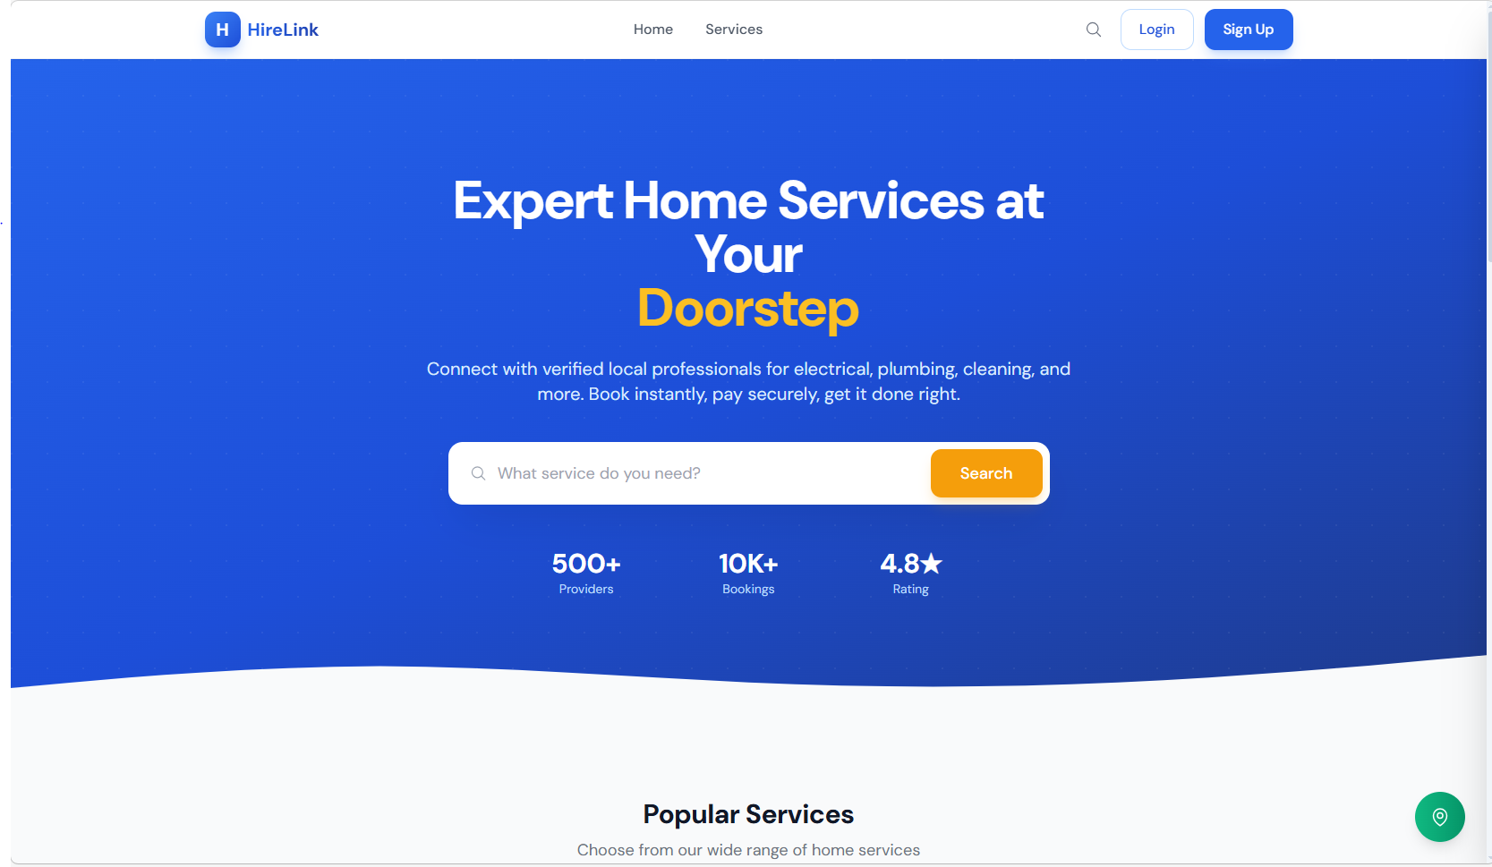
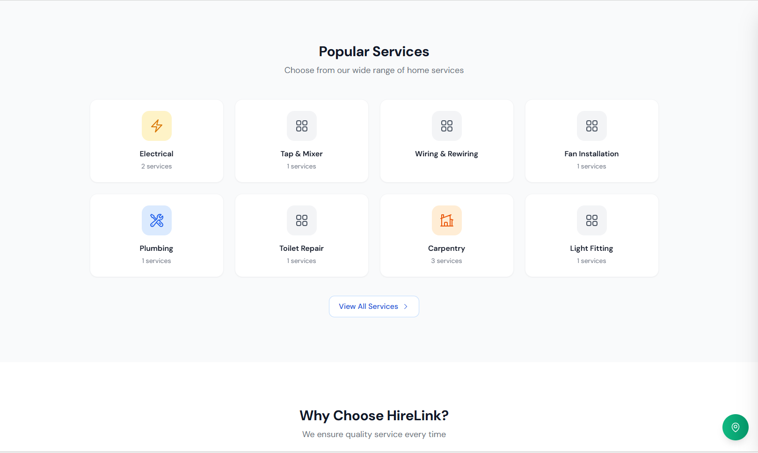

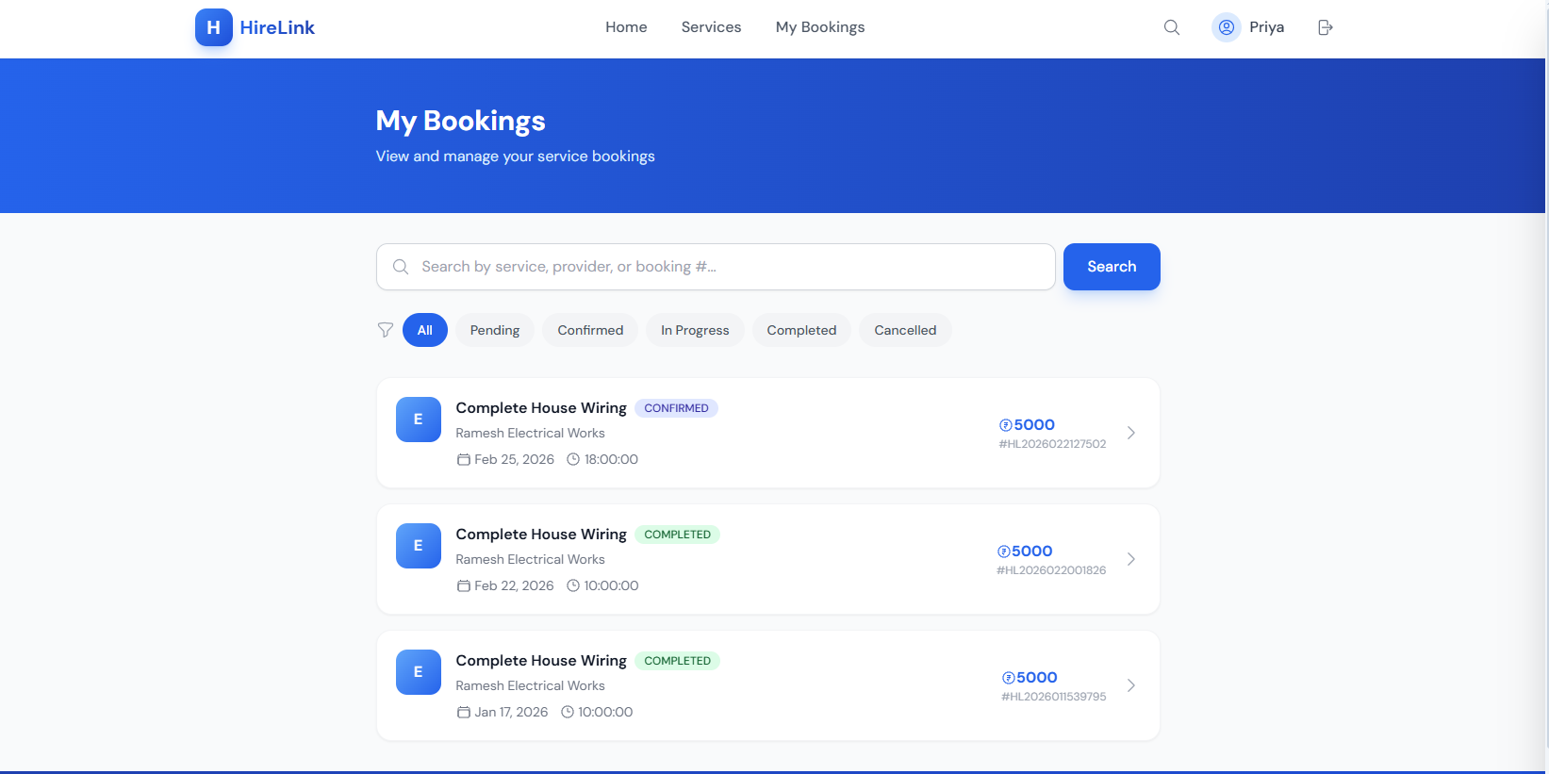

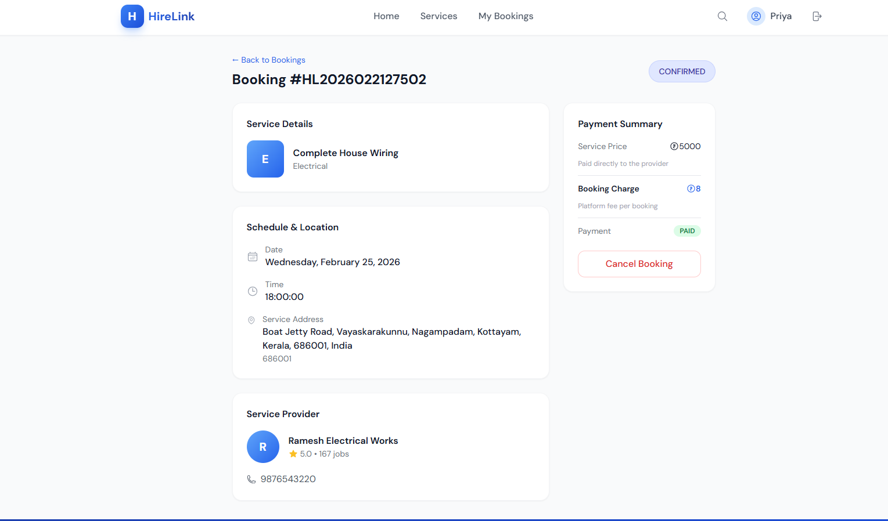
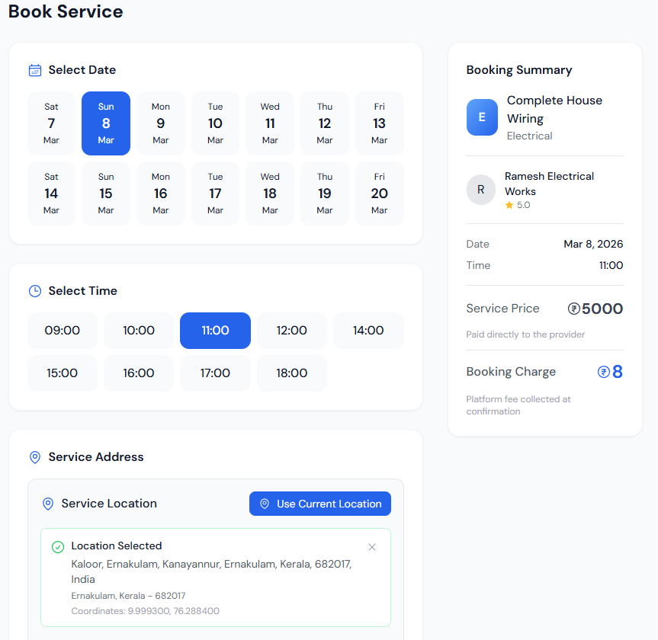

9. Installation and Setup Guide

9.1 Prerequisites
Software | Version | Purpose
Java JDK | 17 | Runtime for Spring Boot backend
Apache Maven | 3.9+ | Build tool for backend project
Node.js | 20.x | Runtime for React frontend
MySQL | 8.0 | Relational database
VS Code / IntelliJ IDEA | Latest | Integrated development environment

9.2 Database Setup
Open MySQL command line or MySQL Workbench and execute:
CREATE DATABASE hirelink_simple;
USE hirelink_simple;

9.3 Backend Configuration
Configure the application.properties file in src/main/resources/ with the database connection URL, MySQL credentials, JPA settings (ddl-auto=update, show-sql=true), Gmail SMTP credentials for OTP email delivery, JWT secret key, and Google OAuth client ID/secret.

9.4 Running the Application
Start the backend:
cd backend
mvn spring-boot:run
In a new terminal, start the frontend:
cd frontend
npm install
npm run dev

Service | URL
Frontend UI | http://localhost:3000
Backend API | http://localhost:8080/api/bookings

10. Future Enhancements
While HireLink currently provides a solid foundation for service booking management, several enhancements are planned for future iterations:
Payment Integration: Integrate Razorpay or Stripe for online payment processing, enabling customers to pay for services directly through the platform.
Real-Time Notifications: Implement WebSocket-based push notifications to alert providers of new bookings and customers of status updates in real time.
Rating and Review System: Allow customers to rate and review service providers after job completion, building a trust-based marketplace.
Admin Dashboard: Build a comprehensive admin panel with analytics, user management, revenue reports, and service category management.
Mobile Application: Develop native mobile applications using React Native to extend the platform to iOS and Android devices.
Advanced Search with Filters: Add date-range filters, price-range sliders, provider rating filters, and saved search preferences.
Service Provider Scheduling: Implement a calendar-based availability system for providers to manage their working hours and block unavailable slots.

11. Conclusion
The HireLink Booking System successfully demonstrates the design and implementation of a modern full-stack web application using Spring Boot and React. The project achieves its core objectives of providing a functional booking management platform with user authentication, search capabilities, and location-based features, all while maintaining clean code architecture and comprehensive documentation.
The three-tier architecture with clearly defined controller, service, and repository layers ensures maintainability and testability. The dual authentication system (Email OTP and Google OAuth) provides flexibility and security for user verification. The light-themed responsive UI delivers a professional user experience across devices.
As an academic project, HireLink serves as a practical reference for understanding how modern web applications are structured, from database design through API development to frontend implementation. The step-by-step documentation and well-commented codebase make it accessible to beginners while demonstrating patterns used in production-grade applications.
The project establishes a strong foundation that can be extended with payment processing, real-time notifications, mobile applications, and advanced analytics to evolve into a comprehensive service marketplace platform.

12. References
[1] Spring Boot Official Documentation – https://docs.spring.io/spring-boot/docs/current/reference/html/
[2] React Official Documentation – https://react.dev/
[3] MySQL 8.0 Reference Manual – https://dev.mysql.com/doc/refman/8.0/en/
[4] Spring Data JPA Reference – https://docs.spring.io/spring-data/jpa/docs/current/reference/html/
[5] JSON Web Tokens Introduction – https://jwt.io/introduction
[6] Google OAuth 2.0 Documentation – https://developers.google.com/identity/protocols/oauth2
[7] Vite Build Tool Documentation – https://vitejs.dev/guide/
[8] OpenStreetMap Nominatim API – https://nominatim.org/release-docs/develop/api/Overview/
[9] Baeldung Spring Boot Tutorials – https://www.baeldung.com/spring-boot
[10] Axios HTTP Client Documentation – https://axios-http.com/docs/intro

Appendix A: Project Directory Structure
hirelink-simple/
├── backend/
│ ├── src/main/java/com/hirelink/
│ │ ├── config/ ─ Security, CORS configuration
│ │ ├── controller/ ─ REST API controllers
│ │ ├── dto/ ─ Request/Response DTOs
│ │ ├── entity/ ─ JPA entity classes
│ │ ├── repository/ ─ Spring Data JPA interfaces
│ │ ├── service/ ─ Business logic services
│ │ └── HirelinkApplication.java
│ ├── src/main/resources/
│ │ └── application.properties
│ └── pom.xml
├── frontend/
│ ├── src/
│ │ ├── components/ ─ React UI components
│ │ ├── context/ ─ AuthContext provider
│ │ ├── services/ ─ Axios API service layer
│ │ ├── styles/ ─ Theme configuration
│ │ ├── App.jsx
│ │ └── main.jsx
│ ├── package.json
│ └── vite.config.js
└── docs/
└── HireLink_StepByStep_Guide.html

Appendix B: Key Annotations Reference

JPA Entity Annotations
Annotation | Purpose
@Entity | Marks a Java class as a JPA entity mapped to a database table
@Table(name) | Specifies the database table name
@Id | Marks the primary key field
@GeneratedValue | Configures auto-generation strategy for the primary key
@Column | Customises column properties (nullable, unique, length)
@ManyToOne / @OneToMany | Defines entity relationships
@Enumerated(EnumType.STRING) | Stores enum values as strings in the database
@PrePersist | Lifecycle callback executed before entity insertion

Spring Web Annotations
Annotation | Purpose
@RestController | Combines @Controller and @ResponseBody for REST endpoints
@RequestMapping | Maps URL path prefix to a controller class
@GetMapping / @PostMapping | Maps HTTP GET/POST requests to handler methods
@PutMapping / @PatchMapping | Maps HTTP PUT/PATCH for full and partial updates
@DeleteMapping | Maps HTTP DELETE for resource removal
@PathVariable | Binds URL path segments to method parameters
@RequestBody | Deserialises JSON request body into a Java object
@Valid | Triggers Bean Validation on the annotated parameter

Validation Annotations
Annotation | Purpose
@NotNull | Field must not be null
@NotBlank | String must not be null or empty
@Size(min, max) | String length must be within the specified range
@Email | Must be a valid email format
@Pattern(regexp) | Must match the given regular expression
@FutureOrPresent | Date must be today or in the future

