Reproducible data analysis: thesis data analysis and visualization

Pacific Maritime forWater Masters Project (NSERC forWater)

Hannah J McSorley

2020-01-31

# Sample Analyses

Water samples were collected and transported via coolers (on ice) to UBC’s EcoHydrology Lab for analysis of dissolved organic carbon (DOC) concentrations and indicators of NOM character. Samples were also measured for phosphate concentration using a field portable colourmetric test kit (HACH); each sample had phosphate concentrations below detectable limits (XXXXXX mg/L).

## Quantifying dissolved organic carbon (DOC)

For quantification of DOC, samples were analyzed for non-purgeable organic carbon (NPOC) via High-Temperature Combustion Method (5310-B) on a Shimadzu TOC-V (Eaton, A. D., Clesceri, L. S., Greenberg, A. E., Franson 2000). For this method, samples were filtered with 0.45-micron PES filters, acidified to bring pH below 2, then sparged with hydrocarbon-free air to drive off inorganic carbon. Following sparging, samples were combusted to convert all organic carbon to carbon dioxide which was measured with a non-dispersive infrared gas detector to quantify the DOC content of the sample. This method represents a direct method of measuring DOC, as all natural organic carbon in the sample is measured. Although small volatile organic compounds would be removed in the sparging process, most NOM compounds are of higher molecular weight and it is unlikely that NOM DOC analytes would be lost (Eaton, A. D., Clesceri, L. S., Greenberg, A. E., Franson 2000; Matilainen et al. 2011).

## Qualifying dissolved organic matter (proxy measures of DOC)

Spectral properties of sample NOM were analyzed using a “Spectro::lyser” spectrophotometer (S::can, Vienna, Austria) which measures turbidity and the chromophoric portion of organic matter to estimate concentrations of total organic carbon (TOC), dissolved organic carbon (DOC), as well as nitrate-nitrogen (NO3--N). A caveat to interpreting the Spectrolyser results is that, for NOM to be detected by UV-Vis absorption the molecules must absorb UV or Visible light (not all molecules do). UV-Vis absorption occurs only if the applied energy (light) can be absorbed by the molecule; in general, this required the presence of aromatic bonds (i.e. conjugated pi-bond systems in the molecule, a.k.a chromophore). Therefore, UV-Vis absorption is proportional to the molecule’s degree of aromaticity and is a measure of chromophoric DOM (CDOM).

The Spectrolyser outputs a fingerprint file containing absorbance values at all of the wavelengths monitored. These absorbance values can provide information about the character of NOM. For example, the ratio of the slope between 275-295nm and the slope from 350-400nm (“slope ratio (SR)”), is commonly used as an indicator of molecular weight. Based on full scan data from the Spectrolyser (250-700nm), several indices of NOM character were determined {*in progress*}:

* SUVA254 — Specific UV absorbance at 254nm is the ratio of UV absorption (spectral absorbance coefficient, SAC, m-1) at 254nm, normalized to DOC concentration (mgL-1). SUVA254 correlates strongly with DOM aromaticity (Helms et al. 2008).
* Spectral slopes — it has been shown that UV spectral slopes are useful semi quantitative indicators for assessing NOM molecular weights (Helms et al. 2008):
* *Spectral slopes 1 & 2 — the slope of spectral intensity over the shorter wavelength range of 275-295nm (1) and longer wavelength range of 350-400nm (2).* Slope Ratio — The ratio of spectral slopes 1 and 2, correlates well with CDOM molecular weight (Helms et al. 2008)

# Data Visualization & Summaries

## Leech DOC concentrations overview

Table 1 and Figure 1 show DOC concentrations were highest at Weeks Creek, the headwaters monitoring point for a sub-basin which included Weeks Lake and surrounding wetlands. On average, Chris Creek DOC concentration was 51% lower than Weeks creek. Below the confluence of Weeks and Chris Creek, the head of Leech River had a mean DOC concentration slightly less than the average of the two headwater tributaries. West Leech River had higher DOC than Cragg Creek by about 20%. Below the confluences of West Leech and Cragg Creek, the Leech Tunnel site had DOC concentrations that were 54% lower than the average at the Leech head, and closer to those of Cragg Creek.

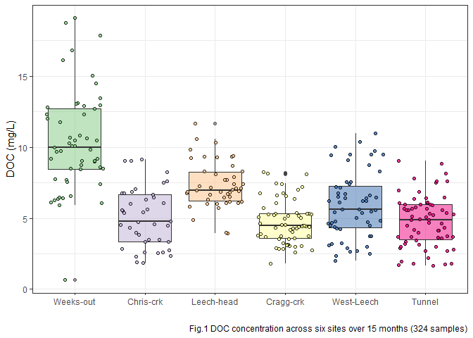

Table 1: summary of DOC concentrations at the six main sites

|  |  |  |  |
| --- | --- | --- | --- |
| site | mean DOC (mg/L) | std.dev. (± mg/L) | RSD (%) |
| Weeks-out | 10.4 | 3.6 | 34.4 |
| Chris-crk | 5.1 | 2.1 | 40.9 |
| Leech-head | 7.3 | 1.6 | 22.1 |
| Cragg-crk | 4.7 | 1.5 | 32.4 |
| West-Leech | 5.9 | 2.3 | 39.2 |
| Tunnel | 4.8 | 1.8 | 37.7 |

At the six sub-basin monitoring sites, vertical racks were installed to collect samples as the rivers rose in response to precipitation events.

These vertical racks collected samples on the rising hydrograph limb, which has been shown to have higher DOC concentration that non-storm flow (Yang et al. 2015; Raymond et al. 2016, 2010). As the vertical racks require a hydrologic response to collect samples, they are only applicable during the wet season. Comparing wet season Grab samples to those collected on Racks confirms that the rack samplers were able to capture more samples, and many during periods with higher DOC concentrations (Fig.2).

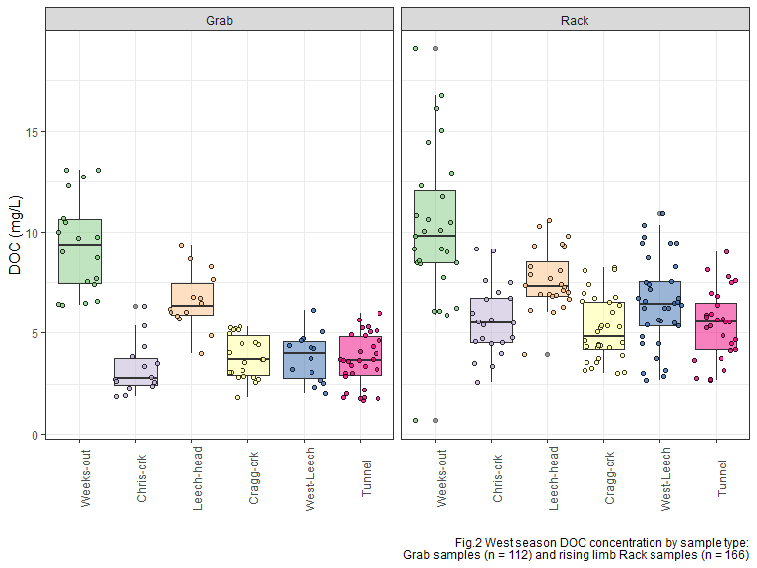

## Sampling campaign

Four hundred water sample were collected and analyzed for DOC over a 16 month study period (October 2018 to February 2020). The synoptic grab-sampling program was enhanced by the collection of stormflow on the six vertical sampling racks. In total, 171 samples were collected on vertical Racks, 215 Grab samples were collected at 15 synoptically sampled sites (which included the six installation sites), and an additional 14 Grab samples were collected opportunistically at one-off sites across the water supply area. Figure 3 shows DOC concentrations across the 15 synoptically sampled sites over the study period (n=386).

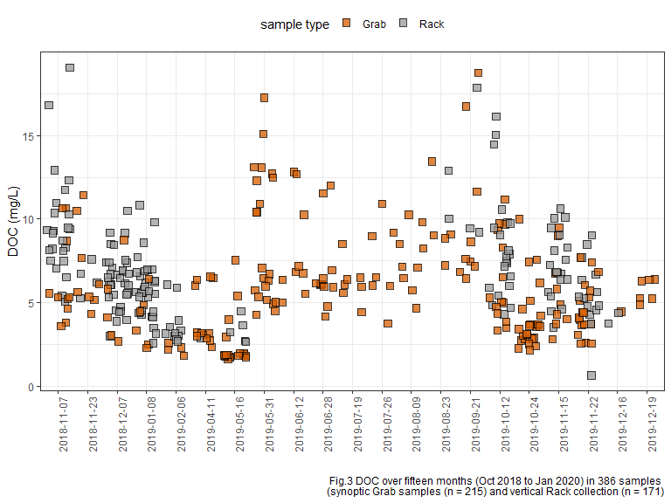 Over the study period, DOC concentrations decreased throughout the wet season, and increased again during the dry summer months (Fig.3). This seasonal DOC concentration pattern was clear at each of the six installation locations in the LWSA (Fig.4).

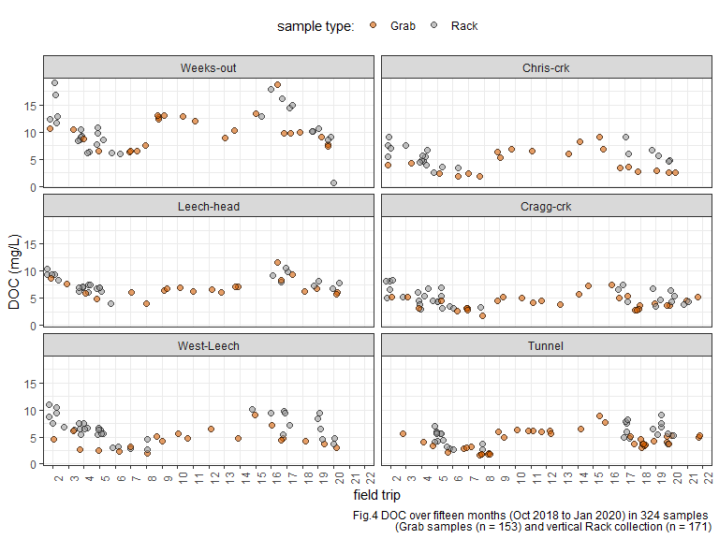

## Seasonal examination of DOC & DOM dynamics

In this section, a categorical season ID was used to assess temporal variations in DOC. Seasons were separated based on months of the year: the wet season was October through May, and the dry season was June until October.

* Precipitation data will be employed to operationally separate season (data obtained January 31, 2020 from CRD).

These seasonal plots show data from both Rack and Grab samples in order to include the full available range of concentrations.

In the wet season, DOC concentrations generally increased during stormflow (relative to between-storm peaks) *{data not shown here}*, and progressively dropped over the course of the wet season. During dry season baseflow, DOC concentration was elevated compared to late wet season DOC (Fig.5).

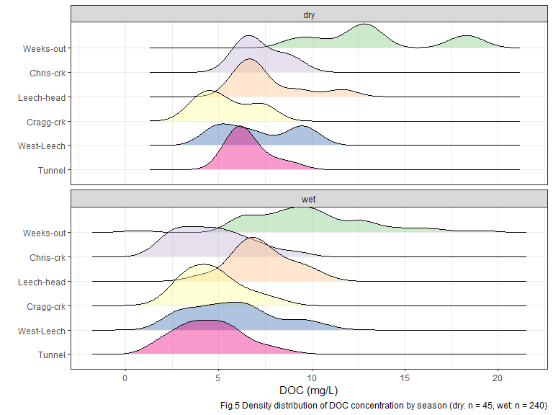

At each of the six sub-basin monitoring locations, mean DOC was higher during the dry season than during the wet season (Table 2, Fig.8). There was less variation in dry season DOC concentrations at each site also (Table 2), which could be due to actual reduction in variance in the absence of stormflow pulses and also due to fewer dry season samples (n = 46) compared to wet season samples (n = 278).

|  |  |  |  |  |
| --- | --- | --- | --- | --- |
| season | site | mean DOC (mg/L) | std.dev. (± mg/L) | RSD (%) |
| Weeks-out | dry | 13.4 | 3.4 | 25.3 |
| Weeks-out | wet | 9.8 | 3.4 | 34.2 |
| Chris-crk | dry | 7.2 | 1.2 | 16.0 |
| Chris-crk | wet | 4.7 | 2.0 | 42.0 |
| Leech-head | dry | 7.6 | 1.9 | 25.3 |
| Leech-head | wet | 7.3 | 1.6 | 21.6 |
| Cragg-crk | dry | 5.4 | 1.5 | 27.2 |
| Cragg-crk | wet | 4.7 | 1.5 | 33.0 |
| West-Leech | dry | 7.1 | 2.1 | 29.9 |
| West-Leech | wet | 5.7 | 2.3 | 40.4 |
| Tunnel | dry | 6.6 | 1.0 | 15.6 |
| Tunnel | wet | 4.5 | 1.7 | 38.7 |

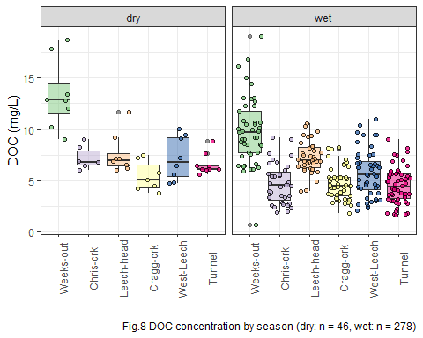

To remove the variance of stormflow DOC concentrations, Table 2-B and Figure 9 shows seasonal concentrations based only on Grab samples (excludes 166 stormflow samples collected by Racks).

|  |  |  |  |  |
| --- | --- | --- | --- | --- |
| season | site | mean DOC (mg/L) | std.dev. (± mg/L) | RSD (%) |
| Weeks-out | dry | 12.7 | 3.4 | 26.6 |
| Weeks-out | wet | 9.3 | 2.4 | 25.4 |
| Chris-crk | dry | 7.2 | 1.2 | 16.0 |
| Chris-crk | wet | 3.3 | 1.3 | 39.9 |
| Leech-head | dry | 7.3 | 1.9 | 26.5 |
| Leech-head | wet | 6.6 | 1.5 | 22.2 |
| Cragg-crk | dry | 5.4 | 1.5 | 27.2 |
| Cragg-crk | wet | 3.8 | 1.1 | 27.8 |
| West-Leech | dry | 6.3 | 1.7 | 26.6 |
| West-Leech | wet | 3.8 | 1.2 | 31.5 |
| Tunnel | dry | 6.6 | 1.0 | 15.6 |
| Tunnel | wet | 3.6 | 1.3 | 35.6 |

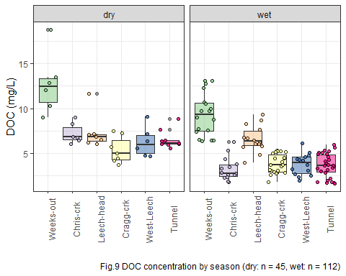

### Plots of DOC & proxy

DOC was quantified as non-purgeable organic carbon (NPOC) on the Shimadzu TOC auto analyzer, and samples were also measured on a Spectrolyser spectrophotometer. A spectrophotometer can only measure the fraction of organic matter that is able to absorb UV or Visible light, and therefore DOC measured on the Spectrolyser was a measure of CDOM and an indicator of aromaticity (molecular character).

Figure 6 shows results from all samples comparing DOC concentrations (as NPOC, direct measure) to CDOM concentrations (UV-Vis, proxy measure of DOC). There was a strong seasonal separation of the relationship between these two measurements. These results indicate a seasonally-driven physiochemical difference in the aquatic NOM in this drinking water supply area.

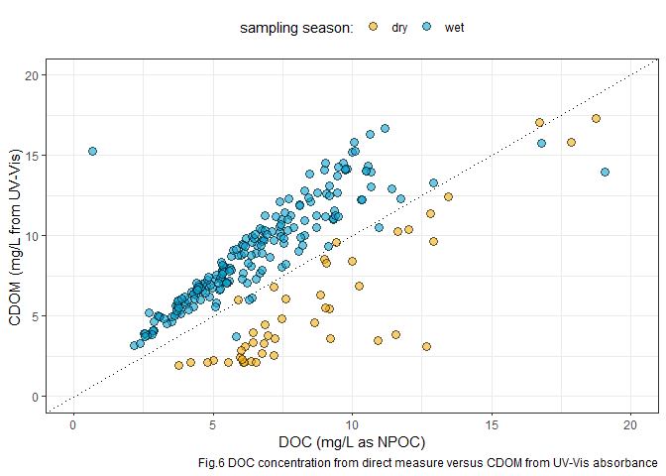

Figure 7 shows the same DOC-CDOM comparison from Figure 6, isolated to the six sub-basin monitoring sites. The seasonal relationship appears similar for the six sites.

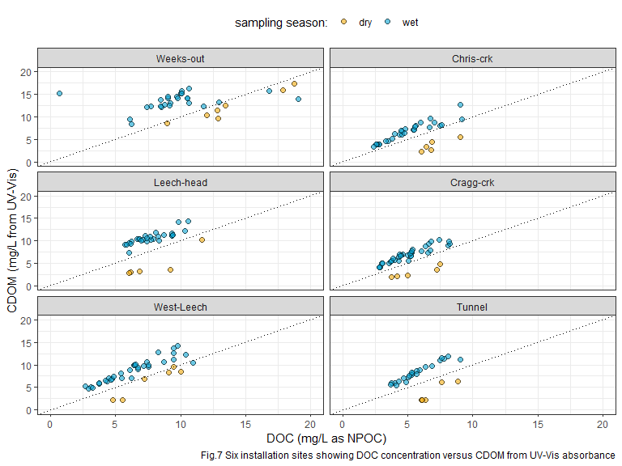

In progress: analysis of spectral fingerprint data for slope ratio indices, which will help to elucidate seasonal DOM character shifts.

# References

Eaton, A. D., Clesceri, L. S., Greenberg, A. E., Franson, M. A. H. 2000. “Total Organic Carbon (TOC) - 5310 A.” In *Standard Methods for the Examination of Water and Wastewater*, 6th ed., 19–20. Washington, DC: American Public Health Association. <http://www.standardmethods.org/>.

Helms, John R, Avon Stubbins, Jason D Ritchie, Elizabeth C Minor, and Kenneth Mopper. 2008. “Absorption Spectral Slopes and Slope Ratios as Indicators of Molecular Weight , Source , and Photobleaching of Chromophoric Dissolved Organic Matter Author ( s ): John R . Helms , Aron Stubbins , Jason D . Ritchie , Elizabeth C . Minor , David J . Kieber.” *Limnology and Oceanography* 53 (3): 955–69. <https://www.jstor.org/stable/40058211>.

Matilainen, Anu, Egil T. Gjessing, Tanja Lahtinen, Leif Hed, Amit Bhatnagar, and Mika Sillanpää. 2011. “An overview of the methods used in the characterisation of natural organic matter (NOM) in relation to drinking water treatment.” *Chemosphere* 83 (11): 1431–42. <https://doi.org/10.1016/j.chemosphere.2011.01.018>.

Raymond, Peter A, James E Saiers, Source Biogeochemistry, No September, Peter A Raymond, and James E Saiers. 2010. “Event controlled DOC export from forested watersheds.” *Biogeochemistry* 100 (1): 197–209. <https://doi.org/10.1007/sl0533-010-9416-7>.

Raymond, Peter A, James E Saiers, William V Sobczak, and E James. 2016. “Hydrological and biogeochemical controls on watershed dissolved organic matter transport: pulse-shunt concept.” *Ecology* 97 (1): 5–16. <https://www.jstor.org/stable/24702986>.

Yang, Liyang, Jin Hur, Sonmin Lee, Soon Woong Chang, and Hyun Sang Shin. 2015. “Dynamics of dissolved organic matter during four storm events in two forest streams: source, export, and implications for harmful disinfection byproduct formation.” *Environmental Science and Pollution Research* 22 (12): 9173–83. <https://doi.org/10.1007/s11356-015-4078-6>.