Quantifying variability and synchrony in source water quality across nested catchments of a protected second growth forested water supply area

*\* Draft \**

Hannah J. McSorley

2020

Table of Contents

Abstract 3

Lay Summary 5

Preface 6

Acknowledgments 8

Dedication 9

1 Introduction 10

1.1 Forested source water supplies and drinking water treatment 10

1.2 Aqueous natural organic matter 12

1.3 Watershed processes and water quality 13

1.4 forWater & CRD GVWSA 15

1.4.1 The forWater Network 15

1.4.2 Greater Victoria Water Supply Areas 16

1.5 Research Objectives 18

2 Methods 19

2.1 Study Site: Leech River Watershed 19

2.1.1 Climate, Weather, Forests 20

2.1.2 Synoptic sampling sites 21

2.1.3 Subbasin monitoring sites 22

2.1.4 forWater Coordinated Treatability Analyses Sites 27

2.2 Analytical techniques & data 28

2.2.1 Quantifying dissolved organic carbon (DOC, as NPOC) 28

2.2.2 Qualifying organic matter through spectrophotometry 29

2.2.3 Sampling for Metals & CRD Analytical Results 31

Results 32

Weather 32

CRD F-Wx stations 32

Leech River Responses 35

Rain events 37

River samples for DOC analysis 39

DOC in association with other water quality parameters 39

Synoptic Sampling 45

Leech watershed and nested sub-catchments 49

Temporal patterns 52

Seasonal trends 52

Rising limb – hydrologic versus supply controls on export 57

Quality Control 59

Vertical Rack Hold-Time Experiments 59

Laboratory 62

Discussion 63

Conclusions 64

References 65

# Abstract

*(max 350 words) - roman numeral TOC*

This research contributes to understanding the “natural” variability in DOM and DOC across a forested riverine watershed: the Leech River watershed on Vancouver Island, British Columbia, Canada. Land-use impacts are minimal in this research area as 96% of the watershed is protected as drinking water supply area (Leech Water Supply Area). Like most forested areas on Vancouver Island, the Leech watershed is second-growth softwood forest with a history of extensive harvest (nearly 96% cleared).

The purpose of this master’s research project was to establish a baseline understanding of hydrologic responses and water quality variability in rivers across the LWSA. The approach includes advanced synoptic sampling within stormflow, supplemented with standard grab samples between storm events and during summer baseflow. Discrete samples of river water were collected passively during the rising limb of stormflow (falling limb prototype in progress) using low-powered, low-cost, custom-built vertical rack samplers including water level loggers (Odyssey) and observational reference staff gauges. By collecting samples during stormflow, a more robust understanding of water quality dynamics was achieved than basic grab sampling alone. Using low-powered passive sampling techniques allowed for multiple (six) sites to be equipped with monitoring/sampling racks, providing fairly good spatial resolution of hydrochemical variability across the watershed.

**CGU poster abstract:**

Most drinking water in Canada originates in forested headwaters, therefore forest management is intimately tied to the quality and quantity of water supply for many communities. However, without a baseline understanding of a watershed’s hydrochemical dynamics, it is difficult to determine if observations indicate a departure from natural variance due to forest treatments, or if observations fall within baseline variation. This research was conducted in the Leech River Watershed (~96 km2, elevation 215 to 870 m a.s.l) which experienced extensive forest harvesting prior to 2007 and is designated as a future supplemental drinking water supply area for Greater Victoria, British Columbia, Canada. The primary objective of this study was to characterize the range of hydrochemical dynamics and the synchrony of rainfall responses among sub-basins ranging in size from 9.6 to 37 km2. Six sites were equipped with vertical racks to passively collect water samples on the rising limb of the hydrograph while measuring stream stage every 10 minutes with capacitance level loggers. Synoptic water sampling was completed every two to four weeks from November 2018 to February 2020. A total of 458 samples (204 Rack and 254 Synoptic Grab samples) were collected and analyzed for dissolved organic carbon (DOC) and dissolved organic matter (DOM) through high temperature combustion and UV-Vis spectroscopy (respectively). Additionally, a subset of 42 samples were analyzed for a suite of total metals to assess aqueous DOM transport relationships. Mean sub-basin DOC concentrations ranged from 7.4 ± 1.5 mg L-1 to 10.4 ± 3.6 mg L-1 (DOC range spanned 2.5 - 29.75 mg L-1). Across the Leech watershed, there was an overall reduction in DOC concentration from low to high order streams, and DOC concentrations decreased throughout the wet season (Oct-Mar). Concentrations of DOC exhibited a positive relationship with concentrations of several metals (R2 values for Hg: 0.99; Al: 0.81; Fe: 0.72; Cu: 0.47; Ba: 0.25; Mn: 0.21). We observed a seasonal difference in DOM character assessed by SUVA254 and other spectral indices derived from UV-Vis absorbance full-scan data. DOC concentration patterns during stormflow will be used to indicate whether DOC flux was driven by DOM supply limitation or hydrologic controls. Rainfall response will be discussed on a per-storm basis regarding response synchrony among sub-basins. This research establishes a baseline of hydrochemical dynamics across a water supply area where commercial forest management ceased more than a decade ago. These data may also be useful for future assessment of forest management strategies to reduce wildfire risk. Furthermore, results from this work will aid source water protection strategies when the Leech Water Supply Area becomes an active source for the Greater Victoria water supply via inter-basin transfer. objective

# Lay Summary

* (max 150 words) - roman numeral TOC
* include plain-language summary

# Preface

* roman numeral TOC

see: <https://www.grad.ubc.ca/sites/default/files/doc/page/thesis_sample_prefaces.pdf>

* TOC follows, then LOT, LOF, List of Illustrations, list of abbreviations

**List of Abbreviations**

|  |  |  |
| --- | --- | --- |
| Acronym | Term | Definition |
| NOM | natural organic matter | diverse carbon-based compounds found in natural, engineered, terrestrial and aquatic environments |
| DOM | dissolved organic matter | organic compounds operationally defined as finer than 0.45 um in diameter |
| DOC | dissolved organic carbon | organic carbon compounds operationally defined as finer than 0.45 um in diameter. The majority of DOM is DOC. |
| NPOC | non-purgeable organic carbon | instrumental parameter measured to quantify organic carbon (e.g. on a Shimadzu TOC-V analyzer). An aqueous sample is acidified to below pH 2 to convert inorganic carbon (e.g. carbonates) to carbon dioxide (CO2), the sample is then sparged with hydrocarbon-free air to drive off CO2, then the sample is combusted at high temperatures to convert the remaining organic carbon to CO2 which is detected with a non-dispersive infrared gas analyzer. |
| DBP-FP | Disinfection By-Product Formation Potential | The likelihood of creating DBPs(e.g. trihalomethanes, halogenic acetic acids, Haloacetonitrils, haloketons) when natural source water is chlorinated |
| LWSA | Leech Water Supply Area | Future water supply area anticipated to supplement the primary water supply (Sooke Reservoir) for the Greater Victoria Area via inter-basin transfer. LWSA is the research site for this thesis’ field work. |
| CRD | Capital Regional District | The governing/municipal body for the Greater Victoria Area, and the managing group for water supply and watershed management. The CRD are partners in the forWater Network and hosted this thesis research in the Leech Water Supply Area. |
| GVWSA | Greater Victoria Water Supply Area | 20,549 hectares of protected drinking water catchment lands owned and operated by the Capital Regional District. Includes the Sooke Lake watershed and reservoir (primary supply source), Goldstream watershed and reservoir system (secondary supply) and the Leech River watershed (future water supply area, and the study site of this thesis research) |

# Acknowledgments

This research work would not have been possible without the support and accommodation of the Capital Regional District (CRD) Watershed Protection and Management Division, Integrated Water Services (IWS) (Victoria, BC). I would like to acknowledge the help, support and assistance provided by the following CRD folks: Tobi Gardner, Annette Constabel, Kathy Haesevoats, Joel Ussery, Patrick McCoubrey, Ryan Biggs, Burn Hemus, Christoph Moch, Jessica Dupuis, Devon Barnes, and Athina Connor. I’m grateful to have been supported by the entire CRD Field Operations Staff, thanks for making me feel welcome on site and including me daily field operations.

This research also would not have been possible without the support and encouragement from academic supervisors and partners from the NSERC forWater Network for Forested Drinking Water Source Protection Technologies: Bill Floyd, Mark Johnson, Suzanne Tank, Mike Stone, Dana Harriman, Monica Emelko, Uldis Silins, Axel Anderson. I would like to acknowledge the support from Vancouver Island University and University of British Columbia - thank you for taking me on as a master’s student.

For help with field installations and streamflow gauging, a big thanks to my friend and former field partner, Stewart Butler, of Bill Floyd’s Coastal Hydrology Research Lab; thanks Stew. Thanks also to Alison Bishop for field assistance during the winter of 2019/2020.

Last but certainly not least, thanks to my incredibly wonderful friends and family for supporting me in my scientific and academic pursuits. I really appreciate all the love and support, dinners and coffees, bike rides and beers, proof-reading and encouragement.

# Dedication

To each person who reads this thesis in its entirety.

To the love of data science: I’m grateful for Jenny Byran’s online resources, [StackOverflow](http://stackoverflow.com) for the solution to so many coding challenges. To RStudio for making a functional and friendly IDE for the R programming language and to GitHub for making version control streamlined and reproducible. Cheers to Hadley Wickham for the tidyverse and Yihui Xie for the bookdown package (in which I generated this thesis).

# 1 Introduction

## 1.1 Forested source water supplies and drinking water treatment

Surface water is the primary source of drinking water for over 85% of the Canadian population and in the province of British Columbia, approximately 80% of drinking water originates from forested headwaters (Pike et al. 2010). Forests offer a variety of ecosystem services (e.g. biodiversity) and also slow and filter runoff, resulting in high quality source water supply (Dudley and Stolton 2003). Surface water quality varies over time and space due to climate, weather, and physical characteristics of the watershed (such as topography, land cover and geology), and runoff processes introduce terrestrial material, sediments, nutrients, and organic matter into surface waters (Pike et al. 2010; Johnson et al. 1997; Delpla and Rodriguez 2016; Health Canada 2019; Yang et al. 2015; Matilainen, Vepsäläinen, and Sillanpää 2010).

In Canada, all drinking source water is treated to meet Health Canada drinking water quality guidelines, which specify allowable levels of biological, physical and chemical parameters that are safe for human use and consumption (British Columbia Ministry of Environment 2017; HealthLinkBC 2018). Drinking water treatment processes vary from simple chlorination to combinations of physical filtration, chemically assisted filtration, reverse osmosis, and or advanced oxidative processes (Critten, John C. Trussell, Rhodes. Hand, David. Howe, Kerry. Tchobanoglous 2014; Emelko et al. 2011). Drinking water treatment technologies differ between communities by infrastructure design and operation, which may be guided by source water quality, infrastructure capabilities, budget, regional size and water quality regulations (Emelko et al. 2011). All drinking water treatment processes share the same goal: ensure public health by providing a continuous supply of pathogen-free water. Therefore, disinfection - the inactivation of potentially harmful microorganisms - is the most important step in the treatment process (Critten, John C. Trussell, Rhodes. Hand, David. Howe, Kerry. Tchobanoglous 2014). In BC, chlorination remains the most widely used method of disinfection, whether it is used alone or in combination with other treatment processes (HealthCanada 2006; HealthLinkBC 2018).

In addition to treated drinking water quality guidelines, there are source water quality guidelines in place because drinking water treatment requirements vary with source water quality (HealthLinkBC 2018; British Columbia Ministry of Environment 2017). Stable source water conditions lead to predictable treatment procedures, while fluctuating source water quality creates treatment challenges (Emelko et al. 2011). Treatment effectiveness is influenced, for example, by high turbidity levels (i.e., suspended solids), varying temperature, dissolved oxygen, pH and natural organic matter, which can create aesthetic issues (i.e. taste, odour, colour) and effect coagulation efficiency and oxidative processes (British Columbia Ministry of Environment 2017; Matilainen, Vepsäläinen, and Sillanpää 2010; Health Canada 2019). Colour is primarily an aesthetic concern for drinking water, but the natural organic matter that creates colour can interfere with effective disinfection and treatment, and thus there are water quality guidelines in place for source water colour (British Columbia Ministry of Environment 2017; Health Canada 2019).

While objectionable aesthetics (i.e., taste, odour, colour) caused by aqueous natural organic matter (NOM) do not directly impact human health, source water NOM can be problematic for effective drinking water treatment. NOM reduces treatment effectiveness by interfering with ultraviolet (UV) disinfection and/or increasing chlorination demand, and because NOM promotes biological growth, can lead to fouling of treatment and distribution infrastructure (Matilainen, Vepsäläinen, and Sillanpää 2010; Health Canada 2019; Jacangelo et al. 1995). Depending on the infrastructure design and operation of a drinking water treatment plant, elevated levels of NOM in source water can increase coagulant and disinfectant demand which increase the production of sludge (to be disposed of) and formation of disinfection byproducts (Matilainen, Vepsäläinen, and Sillanpää 2010; Health Canada 2019).

In addition to operational impediments, NOM is partly responsible for unintended chemical contaminants in treated drinking water. When source water is chlorinated, chemical reactions with NOM can form a variety of chlorinated organic compounds which are broadly classified as disinfection byproducts (DBPs) (Richardson et al. 2007; Delpla and Rodriguez 2016; Health Canada 2019; Yang et al. 2015; Hua, Reckhow, and Abusallout 2015; Eaton, A. D., Clesceri, L. S., Greenberg, A. E., Franson 2000). A number of chlorinated carbonaceous DBPs are included in Health Canada’s drinking water quality guidelines, and have maximum allowable concentrations in treated water due to their possible or known health affects (i.e., possible genotoxicity or carcinogenicity) (Richardson et al. 2007; British Columbia Ministry of Environment 2017; Health Canada 2019).

## 1.2 Aqueous natural organic matter

Natural organic matter (NOM) concentration and character vary widely in source water depending on source material, hydrology, and biogeochemical factors (Aiken, Hsu-Kim, and Ryan 2011; Abbott et al. 2018; Zarnetske et al. 2018; Matilainen, Vepsäläinen, and Sillanpää 2010). Molecular composition and physical structure influence NOM reactivity, therefore different types of aqueous NOM have different disinfection byproduct formation potentials (DBP-FPs) (Delpla and Rodriguez 2016; Yang et al. 2015; Health Canada 2019; Chow et al. 2008). Furthermore, different species of NOM vary in molecular size, structure and charge distribution, which determine requirements for effective treatment and removal (Jacangelo et al. 1995; Matilainen, Vepsäläinen, and Sillanpää 2010).

NOM comprises a dynamic collection of molecules that originate from a variety of sources, and aqueous NOM exists in complex and diverse combinations of particulate, colloidal and dissolved fractions. NOM can be introduced to a water body from terrestrial sources or generated through in-stream processes which are often associated with autotrophic organisms like algae and cyanobacteria (i.e., autochthonous NOM). Terrestrial organic matter (allochthonous NOM) includes humic and fluvic acids, tannins, and a wide variety of other compounds (e.g. phenols and lignin, hydrocarbons, proteins, carbohydrates, etc.), which enter fresh water through runoff processes (Zarnetske et al. 2018; Health Canada 2019).

Molecular structures of NOM can contain nitrogen, silica, oxygen and hydrogen and are composed primarily of carbon; thus, organic carbon (OC) is often quantified as a proxy for NOM concentration (Health Canada 2019; Matilainen, Vepsäläinen, and Sillanpää 2010; Critten, John C. Trussell, Rhodes. Hand, David. Howe, Kerry. Tchobanoglous 2014). Total organic carbon (TOC) is operationally divided into particulate and dissolved fractions (POC and DOC, respectively) which are typically distinguished based on separation by a 0.45-micron filter (Eaton, A. D., Clesceri, L. S., Greenberg, A. E., Franson 2000; Aiken, Hsu-Kim, and Ryan 2011). Generally, DOC is the predominant fraction of aqueous TOC in forested headwater environments, and the amount of DBPs in treated water is proportional to raw water DOC concentration (Weishaar et al. 2003; Chow et al. 2008).

In addition to acting as a precursor for DBPs, DOC has been called a master variable due to it’s terrestrial-aquatic linkages, influence on water chemistry and role in contaminant transport (Zarnetske et al. 2018). NOM is an energy source for aquatic heterotrophic microbes, it has the ability to bind and transport contaminants in solution (e.g. metals, hydrophobic organic pollutants, nutrients), can influence stream pH and aquatic light and temperature regimes (which, in turn, effect aquatic microbial communities) (Matilainen, Vepsäläinen, and Sillanpää 2010; Oni et al. 2013; Aiken, Hsu-Kim, and Ryan 2011; Weishaar et al. 2003; LaZerte 1991; Palleiro et al. 2013; Stanley et al. 2012). DOC is an important source water quality parameter to monitor. In fact, guidelines in British Columbia specify that source water TOC should remain below 4 mg/L, primarily to reduce the production of trihalomethanes (e.g., chloroform, a common DBP) in treated drinking water (British Columbia Ministry of Environment 2017). Aside from DBPs, monitoring source water DOC is important for addressing the other operational issues associated with NOM. Stable source water conditions lead to predictable treatment procedures, while fluctuating source water quality creates treatment challenges. Within a watershed, the characteristics and concentrations of NOM (and therefore DOC) naturally fluctuate over space and through time, creating dynamic treatability conditions (Li et al. 2014; Yang et al. 2015).

## 1.3 Watershed processes and water quality

Streams are intrinsically linked to their watersheds through dynamic biotic-abiotic interactions and hydroclimatic relationships; as a result, aqueous biogeochemicals represent an important link between ecosystem processes, hydrology, and water resources. Biogeochemical signatures are useful tracers to better understand catchment processes and regional hydrology, as they are indicative of flow paths, sources, chemical origins and transport pathways (Abbott et al. 2018; Meyer and Tate 1983; Vidon, Wagner, and Soyeux 2008; Rautu 2019). The origins, transport and fate of biogeochemicals in source waters is important for drinking water treatment, because the quality of source water (physiochemical composition and concentrations) governs treatment requirements and, with respect to DBPs, dictates the quality of treated water (Weishaar et al. 2003; Chow et al. 2008).

Water quality parameters exhibit natural variability across a river network due to dynamic biotic and abiotic interactions. For example, the river continuum concept (RCC) predicts a temporal shift in DOM character, including seasonal shifts between autotrophic generation of NOM and heterotrophic processing of detritus (i.e. autochthonous to allochthonous DOM) (Vannote et al. 1980; Meyer and Tate 1983). The RCC also predicts a spatial reduction in DOM molecular diversity from headwaters (entry point for majority of solutes) to river mouth (i.e., reduced DOM diversity from low to high order streams) (Vannote et al. 1980; Mosher et al. 2015; Abbott et al. 2018; Creed et al. 2015). The longitudinal attenuation of DOM diversity can be explained by a combination of hydrological processes; geomorphic variables and physical impoundments; organic matter inputs and sources; sediment transport; solar inputs; and processing by aquatic invertebrates and microbes (Vannote et al. 1980; Stanley et al. 2012; Aiken, Hsu-Kim, and Ryan 2011; Zarnetske et al. 2018).

On a finer temporal scale, hydrologic pulses can cause temporal variability in DOM characteristics; for example, the character of DOM has been shown to vary during hydrologic response to precipitation, which indicates a change in DOM source over the course of an event (Vidon, Wagner, and Soyeux 2008; Abbott et al. 2018). The Pulse Shunt Concept (PSC) supplements the temporal aspects of RCC by considering how major hydrologic events drive regional DOM metabolism and the magnitude, timing and spatial extent of DOM flux (Raymond et al. 2016). While the link between mobilization of source material and biogeochemical processes govern the character of aqueous NOM, the PSC shows that it is hydrologic processes that govern NOM concentrations in streams (Abbott et al. 2018; Creed et al. 2015; Zarnetske et al. 2018). Where the RCC relies on in-stream biogeochemical processing to explain longitudinal alteration of NOM character, intense hydrologic pulses (related to precipitation or melt events) override the rate of biogeochemical processing and force mass transport events. Discharge determines the magnitude of DOC flux (i.e., concentration transport) and under pluvial regime, precipitation and discharge are the primary controls on stream DOC concentrations (Zarnetske et al. 2018; Vidon, Wagner, and Soyeux 2008). Indeed, brief flood events are often responsible for most of the fluvial DOC transport in a watershed (Raymond et al. 2010). This variability is also a concern for water treatment engineers.

Through a large and geographically diverse data study in the United States, Zarnetske *et al* (2018) found that increasing flows systematically increased DOC fluxes in 80% of watersheds (n=1006) across ecoregions. Proportional increases in DOC flux and discharge indicates that the flux is not limited by organic matter supply, but rather by hydrologic connectivity and mobilization (Creed et al. 2015; Zarnetske et al. 2018). Watershed size and stream order were determined to be weak indicators of DOC flux-discharge relationship while watershed slope and mean precipitation were strong predictors of DOC flux (Zarnetske et al. 2018). Zarnetske *et al* (2018) also found that wetland area exerted non-linear control over whether DOC flux was limited by supply or hydrologic transport.

Aspects of both the RCC and PSC were illustrated in a recent nested catchment study by Abbott *et al* (2018) which found greater DOM chemical diversity in headwaters relative to downstream, but not greater temporal variance in headwaters biogeochemistry. Despite longitudinal differences in molecular character, solute concentrations varied synchronously among upstream and downstream sites, leading to temporal stability in relative biogeochemical signatures (Abbott et al. 2018). The temporal extent to which water quality changes echo across nested subcatchments depends on the synchrony (i.e. mean covariance) of the hydrologic pulse generation among subcatchments (Abbott et al. 2018).

As changing climatic conditions are likely to lead to increases in hydrologic pulse generation - whether through increased precipitation, earlier or more intense freshet conditions, or changes in subsurface flow conditions and connectivity - it follows that drinking water treatment challenges could arise in response to more variable source water conditions. For forested source water supply areas, developing a better understanding of hydrochemical dynamics and their responses to landscape changes (e.g. wildfire, forest management strategies, mass wasting events) could bolster drinking water security by developing source water protection plans to facilitate more predictable treatment requirements. Understanding water supply area source water quality, variability and response patterns is an important part of the multi-barrier approach to safe drinking water (Canadian Council of Ministers of the Environment 2004).

Forest management and landscape disturbances can also affect water quality by altering material inputs, biogeochemical processes and stream ecology, as well as changing preferential flow-paths and the mobilization, transport and dilution of biogeochemcial components (Meyer and Tate 1983). For example, wildfire combined with post-fire salvage logging in the slopes of Alberta’s southern rockies resulted in higher turbidity and DOC compared to basins that experienced fire without salvage logging, and both disturbed basins had elevated suspended solids and DOC compared to unburned catchments (Emelko et al. 2011). In other studies, it was shown that two to three years post-harvest, baseflow DOC concentrations were higher in forested catchments than in clear-cut catchments; however, these studies also showed variable stormflow DOC responses in harvested and forested catchments (Meyer and Tate 1983; Mistick 2019). In the absence of long-term baseline data (i.e., pre- and post-disturbance data sets), the natural variability in fluvial processes complicates land-use studies and anthropogenic climate change can further confound our interpretations. Overall, DOC trends related to land-use are highly dependent on catchment attributes and hydrologic forces. Understanding the hydrochemistry of a water supply area is key to conducting informed preventative forest management applications.

### Subheading here – Water quality considerations in the water supply are of Victoria, BC

The Capital Regional District (CRD) encompassing Victoria, BC and surrounding areas, is committed to the multiple barrier approach to clean drinking water and has taken control of source water protection by purchasing and privatizing the water supply areas for Greater Victoria. Located on southeastern Vancouver Island, British Columbia, Canada, the Greater Victoria Water Supply Area (GVWSA) includes 20,549 hectares (205.49 km2) of protected drinking water catchment lands. Currently, Greater Victoria’s water supply is sourced from five surface water reservoirs in the Sooke and Goldstream watersheds. In 2007 and 2010, the CRD purchased and additional 96.28 km2 (9,628 hectares) of land which included the majority of the Leech River watershed (a major sub-catchment of the Sooke River watershed). In anticipation of future water demands, this area was designated as a supplemental water supply for Greater Victoria, and is known as the Leech Water Supply Area (LWSA). In the future (possibly by 2050), inter-basin transfer of water from the LWSA will supplement the primary drinking water supply by moving Leech River water through a diversion tunnel to Sooke Reservoir. Approximately 92% of the Leech River watershed above the point of diversion (Leech Tunnel) is protected as WSA.

Overall, the hydrology of the LWSA is poorly understood, as are its water quality dynamics. In the mid-1980’s, some water was transfered from the Leech River into Deception Gulch and Reservoir (adjacent to but physically separated from Sooke Reservoir), and the mixing resulted in biological water quality problems that included odour and raised concerns about the operational usage of the existing tunnel. Before work is done on inter-basin transfers, the hydrology and water quality of the Leech River system need to be better understood.

The LWSA was privately managed forest land which was extensively harvested over the past 70 years (nearly 96% clearcut); as a result, a large portion of the WSA is densely forested with softwood stands less than 35 years of age as of 2020. The second growth forests of the LWSA are no longer managed for timber supply, they are now managed to improve drinking source water quality and to reduce the risk of landscape level wildfire. Due to prior harvest, reforestation and active fire suppression, forest fire fuels have accumulated and pose a threat in the event that a fire occurs. In the Sooke WSA, the CRD implements forest treatments designed to foster healthy forest stands capable of reducing fire intensity, such as reducing fuel hazards and creating conditions that are safe for crews to action a fire. Similarly, preventative fire treatments will be applied in the LWSA prior to inter-basin transfers. Developing an understanding of baseline water quality dynamics and hydrologic forces in the LWSA will help to inform forest management strategies by evaluating the effects of fire fuel management on water supply.

The provincial Drinking Water Protection Act and Drinking Water Protection Regulation frameworks were developed to implement Health Canada’s drinking water quality guidelines and set out requirements for drinking water operators & suppliers to ensure the provision of safe drinking water. Treatment of source water from the Greater Victoria Water Supply Area consists only of disinfection: raw water (unfiltered) is treated with ultraviolet light as primary disinfection, chlorination is secondary, and finally ammonia is added to produce chloramine (NH2Cl, a long-lasting disinfectant that persists throughout the distribution system). Understanding dynamics and variability of hydrochemistry in the LWSA is needed to anticipate possible treatment challenges that may accompany future inter-basin transfer from the LWSA.

## 1.5 Research Objectives

This research was conducted in partnership with the CRD to contribute to their pursuit of characterizing the Leech Water Supply Area, while contributing to our understanding of “natural” variations in source water quality (primarily with respect to DOM and DOC) across nested catchments in a second growth forested watershed. The objectives of this research were to quantify spatial and temporal patterns in DOC concentrations, and to explore the hydrochemical synchrony of nested catchments across the LWSA. Ideally, results of this research will contribute to baseline understanding for further exploration of forest management strategies, such as fire fuel management, and their impacts on source water quality and supply. Understanding source water quality, as well as the timing and magnitude of flows, is an essential component to multiple barrier approach to ensuring clean drinking water.

# 2 Methods

## 2.1 Study Site: Leech River Watershed

The Leech River watershed is a sub-catchment of the Sooke River watershed, located west of Sooke Reservoir (primary water supply for the Greater Victoria Area). In anticipation of future water demands and uncertainty related to rainfall and climate change, the Capital Regional District (CRD) purchased about 92% of the Leech River watershed in 2007 (84%) and 2010 (additional 8%) and designated the Leech Water Supply Area (LWSA) for future supplemental source water. Figure 1 shows the Leech and Sooke Water Supply areas with elevation.

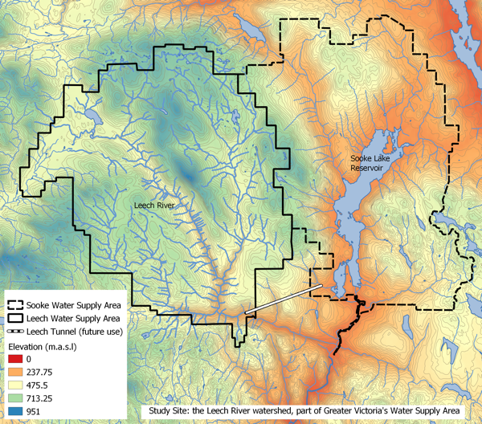

Figure 1: *The Leech and Sooke Water Supply Areas (Greater Victoria, CRD)*

While monitoring programs began in 2017, the hydrology and water quality in the LWSA are poorly understood. The Leech River watershed includes three mainstem rivers (Cragg Creek, Leech River, and West Leech River) as well as several small headwater lakes (Weeks, Jarvis, and Worley) and wetlands (Jordan Meadows surrounding Weeks Lake and Lazar meadows north of Jarvis Lake). Runoff peaks in the winter under saturated conditions when rivers respond rapidly to precipitation events, rising and falling dramatically. Across the watershed, elevation ranges from approximately 200 m above sea level (asl), near the Leech Tunnel, to 941 m asl in the centre of the watershed, at the top of Survey Mountain.

### 2.1.1 Climate, Weather, Forests

The Leech River watershed is in the Coastal Western Hemlock biogeoclimatic zone (CWH), with forests dominated by Douglas-fir (Pseudotsuga menziesii), western hemlock (Tsuga heterophylla) and western red cedar (Thuja plicata); subspecies include white pine (Pinus monticola), amabalis fir (Abies amabilis), alder (Alnus rubra), broad-leaf maple (Acer macrophyllum) and arbutus (Arbutus menziesii). The watershed also includes the moist and dry maritime sub-zones of the CWH (Montane moist 43%, submontane moist 38%, xeric 19%) (Ussery and AECOM 2015). While some precipitation occurs as snow at higher elevations, the majority of the ~2500 mm per year is rain (i.e., pluvial hydroclimatic regime). The water year can be broadly divided into wet and dry seasons where approximately 90% of precipitation falls from October to April, and May through September are relatively dry.

There are two weather stations which operated during the study period: Chris Creek station is located in the headwaters of the LWSA and Martin’s Gulch station is located near the future diversion point (Tunnel). The CRD provided weather station data from Chris Creek and Martin’s Gulch weather stations from January 2018 to March 2020. Rainfall and air temperature from each of the two LWSA weather stations is shown in Figure 2. Slightly more precipitation was recorded at Martin’s Gulch than Chris Creek station. Annual weather data from each of the LWSA weather stations are summarized in Table 1.

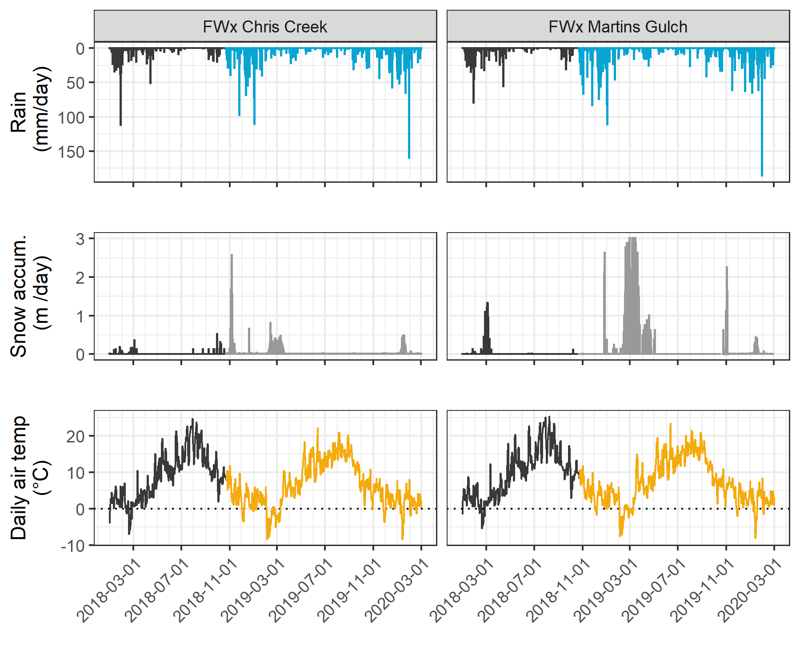

Figure 2: *Weather from two stations in the Leech water supply area. Coloured sections of plots highlight the field study period of this project.*

Table 1: *Two years of weather from CRD stations in Leech water supply area*

|  |  |  |  |  |  |  |  |
| --- | --- | --- | --- | --- | --- | --- | --- |
| year | station name | annual precip. (mm) | max snow (m) | mean air temp. (°C) | stdev (± °C) | mean max. temp. (°C) | mean min. temp. (°C) |
| 2018 | FWx Chris Creek | 1967.83 | 3.09 | 8.1 | 7.5 | -11.9 | 34.8 |
| 2018 | FWx Martins Gulch | 2042.35 | 3.01 | 8.9 | 7.3 | -9.5 | 32.9 |
| 2019 | FWx Chris Creek | 1429.13 | 3.09 | 7.5 | 7.2 | -13.7 | 31.9 |
| 2019 | FWx Martins Gulch | 1490.68 | 3.01 | 8.4 | 6.9 | -12.7 | 30.5 |

### 2.1.2 Synoptic sampling sites

Fifteen sites were selected for synoptic water sampling and water quality analysis. Sampling was conducted from October 2018 to February 2020. Figure 3 shows the locations of the synoptically sampled sites as well as the two weather stations.

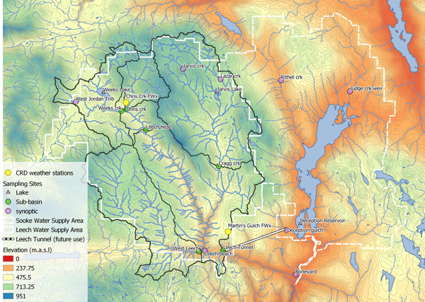

Figure 3: *Sample sites across the Greater Victoria Water Supply Areas*

Synoptic sampling involved collecting grab samples in triple-rinsed acid-washed 250 mL amber HDPE bottles. Samples were capped with minimal headspace and transported on ice. Synoptic samples were collected bi-weekly to monthly. Results from synoptic sampling help to inform spatiotemporal patterns in water quality.

### 2.1.3 Subbasin monitoring sites

Six sites were selected for continuous water level monitoring across the Leech Water Supply Area which represent five nested catchments and the entire water supply area basin defined from the point of (future) diversion, the Leech Tunnel. Figure 4 shows a map of the sub-basin monitoring sites. The sub-basin sites represent important portions of the Leech River system: two headwater streams (Weeks and Chris Creek), the head of Leech River (below the confluence of the two headwaters), two mainstem rivers that feed the Leech (Cragg Creek and West Leech) and the Leech River at the Tunnel).

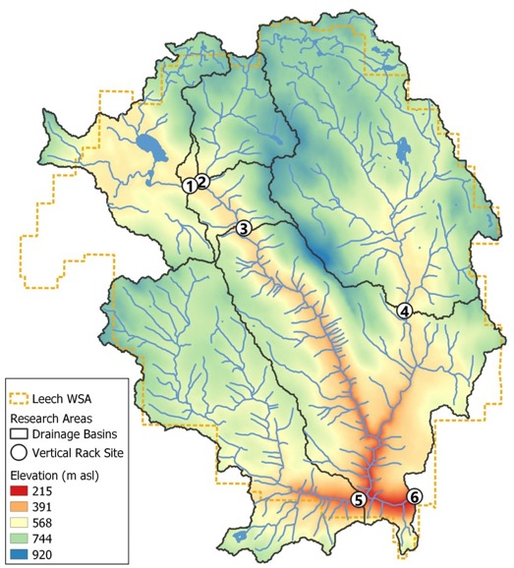

Figure 4: *Subbasin monitoring sites in the Leech Water Supply Area*

Table 2 includes watershed characteristic data for each sub-basin.

* TO DO: update with GIS data (needs to be distilled/summarized)

Table 2: *Sub-basin characteristics*

|  |  |  |  |  |  |  |  |  |  |
| --- | --- | --- | --- | --- | --- | --- | --- | --- | --- |
| Site # | Site Name | Latitude | Longitude | Characteristic | Drainage Area (km2) | Elevation (m a.s.l) | Percent Forest | Percent Wetland | Parent Material |
| 1 | Weeks | 48.57568 | -123.8456 | Wetland-draining headwaters | 16.1 | 521 | NA | NA | NA |
| 2 | Chris Creek | 48.57739 | -123.8403 | Headwaters | 9.6 | 522 | NA | NA | NA |
| 3 | Leech Head | 48.56647 | -123.8257 | Mainstem river head | 26.2 | 476 | NA | NA | NA |
| 4 | Cragg Creek | 48.54783 | -123.7711 | Mainstem river | 37.1 | 509 | NA | NA | NA |
| 5 | West Leech | 48.50688 | -123.7847 | Mainstem river | 35.2 | 248 | NA | NA | NA |
| 6 | Leech Tunnel | 48.50701 | -123.7674 | Future diversion point | 98.7 | 207 | NA | NA | NA |

#### 2.1.3.1 Subbasin sampling and installations

At each of the six subbasin water level monitoring sites, a vertical sampling rack was installed. These racks collect discrete water samples during the rising limb of stormflow without employing costly pump-samplers. These were accompanied by data loggers that provided continuously recorded stage (i.e., river water level), while recording continuous stage measurements (at ten minute intervals). Vertical sampling racks supplemented the synoptic sampling program by providing synchronized spatial resolution that would otherwise be difficult to achieve (i.e., multiple sites across the watershed), while collecting samples during flows that would otherwise be difficult or unsafe to access. Simultaneous stormflow sample collection can provide insights about relative hydrologic pulse responses across nested catchments (Abbott et al. 2018).

The passive sampling bottles employ principles of a siphon design to collect river water as it reaches pre-determined levels on a vertical sampling rack. Siphon sampler bottles were based on a USGS single stage sediment sampler design (US U-59, 1961) which passively collect discrete water samples at a fixed stage on the rising limb of the hydrograph (Graczyk et al. 2000). The siphon samplers built for this research were 250 mL amber HDPE widemouth bottles with augmented screw caps. The caps were fit with two 1/4" (OD) stainless steel tubes, one longer than the other, both with a 180 bend at the top end.

Each rack included a central stilling well (3.81cm (1.5“) PCV pipe with 1.27 cm (1/2”) holes along the length) with a measuring tape affixed to the front. Inside the stilling well was an Odyssey Capacitance water level logger (model, company, city); and on either side of the central stilling well was a slotted offset angle bar onto which hose clamps held sample bottles fit with custom siphon lids (Figure 5). By combining the height at which each siphon bottle filled with observed stage from the stilling-well tape and logger data, the date and time for each rising-stage sample collection was determined.

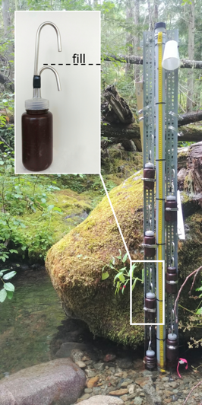

Figure 5: *Vertical sampling rack and siphon sampler bottle, illustrative of instalations at six sub-basin locations across the LWSA (shown here is Chris Creek (site 2).*

These vertical racks collected whole water samples on the rising limb of the hydrograph. The rising limb has been shown to have higher DOC concentration than low flows between storm pulses (Yang et al. 2015; Raymond et al. 2016, 2010; Zarnetske et al. 2018). Increasing DOC on the rising limb indicates that source material is not limited and flux is driven by hydrologic connectivity; whereas source limited conditions likely drive DOM dynamics if DOC concentration decreases on the rising limb (Zarnetske et al. 2018). Analysis of rack samples clarifies the magnitude and direction of water quality changes in response to precipitation relative, which provides information about solute supply and hydrologic connectivity (Vidon, Wagner, and Soyeux 2008; Abbott et al. 2018; Creed et al. 2015; Zarnetske et al. 2018).

##### 2.1.3.1.1 Vertical rack sampling QA/QC: Siphon sampler assumptions

Rising level siphon samplers collect water from approximately 5cm below the surface (top of intake tube to inlet orifice). Data related to rack samples relies on two key assumptions: the water column is well mixed (no stratification) therefore the sample is representative of water quality at each sampling stage; and the sample is discrete such that there is no infiltration or mixing after the sample is collected. Based on the velocity and turbulence associated with flows in the step-pool formation of the subbasins, the assumption of unstratified waters seems very reasonable. The assumption of sample discretion was validated in lab using food colouring and a flow-through bucket system (tap water sample collected by siphon sample bottle, food colouring added to flow system after sample collection and circulated for ~15 minutes, sample bottle removed from dye chamber and sample colour compared to surrounding dyed water: no dye present in sample).

##### 2.1.3.1.2 Vertical rack sampling QA/QC: Sample hold-times and temperatures

Every effort was made to retrieve rack samples as quickly as possible from the racks, none the less they sometimes remained on the racks for several days (up to a week) due to logistical and safety considerations. Hobo TidbiT temperature sensors (model, company, city) were deployed at each subbasin vertical rack to monitor air and water temperature in order to assess sample stability between sample collection and retrieval.

Hold-time experiments were performed to assess sample stability. The hold-time experiments included replicate (n = 10) sample collection at a site, where half the samples were placed out of water on the vertical rack with siphon lids and the other half were returned to the lab for immediate analysis. Four hold-time experiments were completed such that the rack samples were left in the field for one, two, three, and four weeks before being retrieved and analyzed for comparison to their counterpart replicates.

##### ~~2.1.3.1.3 Prototype for falling limb passive sampling~~

~~In keeping with goals of low-cost, low-powered passive sampling, a falling-limb sampler was designed based on principles of the rising limb siphon sampler. The rising limb sampler collects a discrete water sample when river stage exceeds the crown of the inlet tube, so long as the vent is unobstructed; obstruction of the siphon sampler vent was the key component of the falling limb sampler prototype design. There were a half-dozen iterations in design prior to the model which was field-deployed in the Leech WSA (winter 2019). Each design iteration included a valve on the siphon vent which remained closed as the river rose, and opened when stream stage dropped below a certain point (allowing air to exit the sample bottle and a water sample to be collected). A number of valve options were explored, including: an external tube plug, in internal tube plug, and a self-sealing silicone bite-valve (i.e. Camelback Big Bite~~~~TM~~ ~~for hydration packs). The final design iteration used a tube pinch valve (SP Science) to close and open the air vent. The mechanism that triggers the vent valve to open is a simple fixed pulley, where the valve is connected to a weighted-cup by a wire that passes through two loops which alter the direction of force. The river rises and fills the cup with stream water, the cup remains full when the river recedes, and when the stream drops low enough that the full cup is no longer buoyant, the weight of water in the cup exerts a force on the lever of the pinch-valve, causing it to release the vent tube and triggering sample collection. The vent valve and trigger mechanism are contained in a 4" sewer pipe (a “filling well”), which was attached to supplemental support bars on the vertical rack. One prototype was field deployed at Cragg Creek (subbasin site 4) as a proof of concept and work will continue to improve the design and operation.~~

### ~~2.1.4 forWater Coordinated Treatability Analyses Sites~~

~~Four of the synoptic sampling sites were selected to collect source water treatability data in collaboration with researchers in the forWater Network. The sites were:~~

1. ~~the Leech River at the future point of diversion~~
2. ~~Deception Reservoir~~
3. ~~Rithet Creek (2nd largest tributary to Sooke Reservoir)~~
4. ~~Judge Creek (largest tributary to Sooke Reservoir)~~

~~These sites were selected to represent the future supplemental source water, the terminus or future balancing reservoir between Leech and Sooke water supply areas, and the current tributary source waters in the Sooke WSA (respectively).~~

~~Replicate samples were collected November 12, 2019 and January 18, 2020 and were shipped to the Universities of Alberta and Waterloo for treatability analyses. At the University of Waterloo, samples were analyzed for treatability parameters including: maximum potential disinfection byproduct formation potential (for trihalomethanes and haloacetic acids, (μg/L)), pH, UV~~~~254~~~~(cm~~~~-1~~~~), DOC (mg/L), Turbidity (NTU), Zeta Potential (mV), THM-FP(μg/L), HAA-FP (μg/L). At the University of Alberta, field-filtered samples were analyzed using a spectrofluorometer (for excitation emission matrices spectra), as well as an fourier transform ion cyclotron resonance mass spectrometer to determine molecular characteristics of the DOM.~~

## 2.2 Analytical techniques & data

Water samples were collected and transported via coolers (on ice) to UBC’s EcoHydrology Lab for analysis of dissolved organic carbon (DOC) concentrations and indicators of NOM character. Samples were also measured for phosphate concentration using a colourmetric (ascorbic acid) orthophosphate test kit (HACH PO-19); each sample had phosphate concentrations below detectable limits (0.1 mg/L). All data were analyzed with R (3.6.2) using RStudio IDE (Version 1.3.820).

### 2.2.1 Dissolved organic carbon (DOC) concentration and characterization

For quantification of DOC, samples were analyzed for non-purgeable organic carbon (NPOC) via High-Temperature Combustion (Method 5310-B) on a Shimadzu TOC-V (Eaton, A. D., Clesceri, L. S., Greenberg, A. E., Franson 2000). For this method, samples were filtered with 0.45-micron PES filters, acidified to bring pH below 2, then sparged with hydrocarbon-free air to drive off inorganic carbon. Following sparging, samples were combusted to convert all organic carbon to carbon dioxide which was measured by non-dispersive infrared gas detector to quantify the DOC content of the sample. This method represents a direct measure of DOC; although small volatile organic compounds would be removed in the sparging process, most NOM compounds are of higher molecular weight and it is unlikely that NOM analytes would be lost (Eaton, A. D., Clesceri, L. S., Greenberg, A. E., Franson 2000; Matilainen et al. 2011).

Spectral properties of sample NOM were analyzed using a ‘spectro::lyser’ spectrophotometer (s::can, Vienna, Austria) which measures turbidity and the chromophoric portion of organic matter to estimate concentrations of total organic carbon (TOC), dissolved organic carbon (DOC), as well as nitrate-nitrogen (NO3--N). For NOM to be detected by UV-Vis absorption, the molecules must absorb ultraviolet (UV) or visible (Vis) light, which relies on the electronic structure of the molecules. UV-Vis absorption requires the presence of conjugated pi-bond systems (i.e., chromophore) in the molecule, which are common in aromatic systems. Therefore, DOC quantified by the spectro::lyser is a proxy measure that represents the chromophoric component of DOM (CDOM), which is proportional to the samples’ average aromaticity. The suite of molecules that comprise NOM generally have an aromatic character (Weishaar et al. 2003). Increasing aromaticity will lead to greater absorbance at longer wavelengths, therefore an absorbance spectrum can provide information about a samples molecular character. For example, absorption of near-UV wavelengths (i.e., 200-380 nm) is indicative of conjugated systems that are common to aromatic compounds; as such, specific UV absorbance at 254nm (SUVA254) has been adopted as a surrogate for DOM aromaticity and, to some extent, its reactivity (Weishaar et al. 2003; Chow et al. 2008). The spectro::lyser measures absorbance from 200 nm to 750 nm wavelengths, across which several spectral indicies can be calculated.

#### 2.2.2.1.1 Quality control note

The spectro::lyser has been shown to effectively determine DOC content and character on unfiltered samples (Avagyan, Runkle, and Kutzbach 2014). However, suspended matter may bias absorbance values due to non-DOC light absorption or scattering. Therefore, spectral indices were not calculated for several unfiltered water samples that had detectable turbidity (greater than 0.000 FTU); this reduced the spectral dataset by 9.5%, from 347 to 314 spectral samples.

#### 2.2.2.2 SUVA254

Specific ultraviolet absorbance at 254nm (SUVA254) is the ratio of UV absorption (spectral absorbance coefficient, SAC, m-1) at 254nm wavelength, normalized to DOC concentration (mgL-1) (i.e., SAC254 divided by mgL-1-DOC) (Weishaar et al. 2003). SUVA254 correlates strongly with DOM aromaticity, and loosely with reactivity (Weishaar et al. 2003; Helms et al. 2008; Chow et al. 2008). A higher SUVA value indicates greater aromaticity, and a lower SUVA value indicates more alliphatic DOM. Because humic substances are more aromatic, SUVA254 is a good indicator of DOM from humic sources (i.e., allochthonous NOM) (Weishaar et al. 2003; Vidon, Wagner, and Soyeux 2008; Abbott et al. 2018).

With respect to SUVA254 and drinking water treatability, it’s important to consider the diversity of DOM and DBP species and the heterogeneous character contained in a water sample. While SUVA254 may indicate reactivity, it is not necessarily a strong indicator of DBP-FPs (Weishaar et al. 2003; Chow et al. 2008). This is because some DBP precursor NOM components (e.g., alliphatics), which have negligible absorptivities in the UV-Vis range, may contribute to DBPs but not SUVA254; additionally, not all NOM with measurable SUVA254 will create DBPs (Weishaar et al. 2003).

SUVA254 is reported in units of liter per milligram carbon per meter (Lmg-C-1m-1) and was determined by dividing the UV absorbance measured at wavelength 254 nm by the DOC concentration (from NPOC on the Shimadzu TOC-V).

#### 2.2.2.3 Spectral indices of NOM character

Based on full scan data from the Spectrolyser (250-700nm), several indices of NOM character were determined. In the absence of fluorescence excitation-emission matrices, or high resolution spectrometric methods, spectral slopes are a simple tool for getting at molecule character. Spectral slopes (i.e., the change in absorbance intensity over a range of wavelengths) are semi-quantitative indicators for assessing DOM molecular weights (Helms et al. 2008). Spectral slopes over the wavelength range of 275-295 nm (S275-295, likely range for absorption by poly-aromatic hydrocarbons with 2 or more rings) and 350-400 nm (S350-400) were calculated from linear regression of loge-transformed spectra (spectral absorbance coefficients, m-1) as indicated by Helms (2008, p 958). Slope ratio (SR) is a unitless value equal to the slope of spectral intensity over the wavelength range of 275-295 nm relative to the slope of spectral intensity over 350-400 nm. SR is inversely proportional to CDOM molecular weight (Helms et al. 2008).  
The ratio of absorbances at wavelengths 250 nm and 365 nm provides a quotient called E2:E3 which is inversely related to aromaticity and molecular size of aquatic humic solutes (Peuravuori and Pihlaja 1997; Helms et al. 2008). E2:E3 values were calculated, along with SR , to try to elucidate molecular character of DOM in samples.

### ~~2.2.3 Sampling for Metals & CRD Analytical Results~~

~~Aquatic NOM can play an important role in the transport of metals because it has the physiochemical ability to act as a ligand to create coordinated complexes with metals. From November 2018 to July 2019, I collected eight sets of samples for metals analysis from the six sub-basin monitoring sites. Metals samples were collected on behalf of the CRD and were analyzed at Bureau Veritas Laboratories in Sidney, BC (BL Labs, formerly Maxxam Analytics Inc.). For each metals sample collected, a parallel Grab sample was analyzed for DOC (at UBC). Reports from BL Labs were provided by the CRD for the samples collected in association with this research. Reports were pdf format which was exported to Excel and converted to .csv for analysis in R.~~

# Results

The primary objectives of this project were to characterize the range of hydrochemical dynamics and synchrony during rainfall response among sub-basins ranging in size from 9.6 to 37 km2. To understand spatial and temporal patterns in hydrochemical dynamics, this research was tackled in two key ways: (1) six sub-basin sites were equipped with vertical racks which logged river stage, air and water temperature at 10-minute intervals and passively collected whole water samples during stormflow on rising limbs of the hydrograph; and (2) thirteen sites, including the six sub-basin sites, were sampled synoptically every two to four weeks. Results of both the synoptic sampling and sub-basin monitoring were used to characterize the temporal and spatial range of DOC concentrations and DOM character. In addition to spatiotemporal dynamics, the sub-basin monitoring sites were used to evaluate hydrologic responses based on river rise (stream stage) and local precipitation. The vertical racks installed at the sub-basin sites enhanced the synoptic sampling program by collecting samples during rainfall-induced hydrologic surges – samples which would have been challenging and dangerous to collect manually at locations across the watershed. DOC concentration trends in stormflow were indicative of whether aqueous DOM was supply-limited or governed by hydrologic forcing. The data collected were used to elucidate spatiotemporal synchrony among sub-catchments.

## Weather

### CRD F-Wx stations

The Capital Regional District (CRD) provided data from two fire-weather stations they operate within the Leech water supply area (LWSA). Chris Creek weather station is located in the headwaters of the Leech watershed and Martin’s Gulch is located near the future point of diversion (Leech River Tunnel). With two weather stations, there were insufficient data points to estimate sub-basin precipitation via Theissen polygons or isohyetal lines; therefore, arithmetic means were calculated based on data from Chris Creek and Martin’s Gulch stations. It was assumed that the arithmetic means of precipitation and temperatures were representative of conditions across the Leech watershed. Figure 6 shows average precipitation and air temperature over 2018 and 2019 with the study period highlighted, and Table 3 summarizes weather data by calender year. Not included here was rainfall for January 2020, which saw an average of 512 mm of rain.

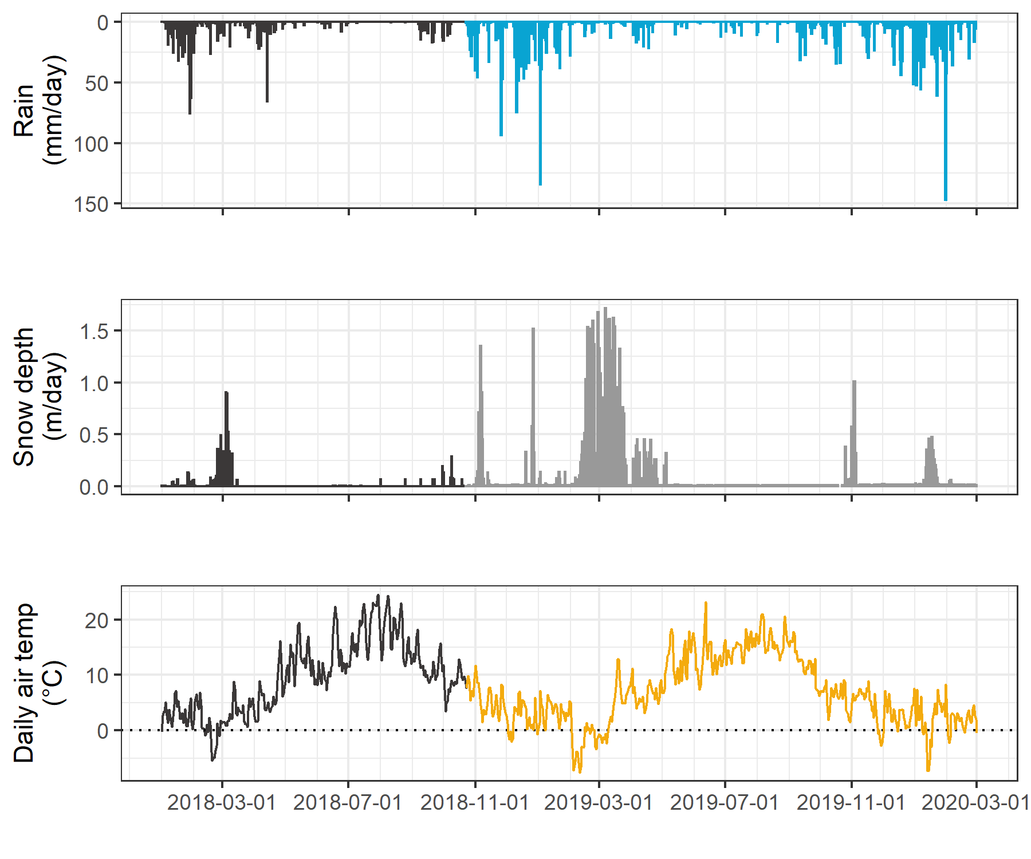

Figure 6: *Average weather from two stations in the Leech water supply area, where the highlighted section indicates the study period.*

Table 3: *Average of weather data from CRD stations in Leech water supply area in 2018 and 2019*

|  |  |  |  |  |  |  |  |
| --- | --- | --- | --- | --- | --- | --- | --- |
| year | mean annual rain (mm) | stdev rain. (±mm) | mean snow accum. (m) | mean temp. (°C) | st.dev temp. (±°C) | min. temp. (°C) | max. temp. (°C) |
| 2018 | 2005.1 | 52.7 | 3.05 | 8.50 | 0.59 | -10.7 | 33.8 |
| 2019 | 1459.9 | 43.5 | 3.05 | 7.94 | 0.63 | -13.2 | 31.2 |

#### ~~Malahat 5 year weather~~

~~The LWSA weather stations were recently installed and therefore data during the study period could not be compared to a record from previous years. A nearby weather station operated by the BC Ministry of Transportation and Infrastructure (Malahat, station ID 62091) had data available from late 2013 which was used to check if weather during the study period departed from previous year trends. Figure 7 shows Malahat weather data, which are summarized in Table 4.~~

~~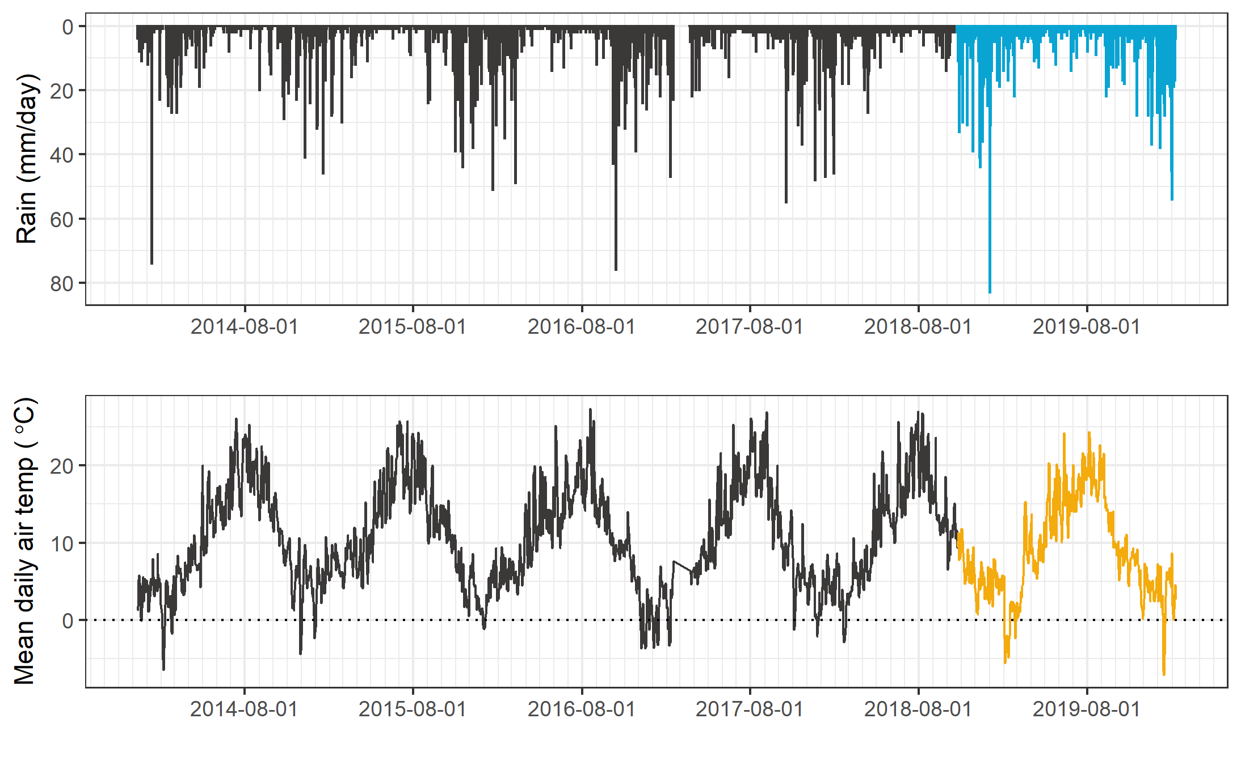~~

~~Figure 7:~~ *~~Five year weather from nearby Malahat station.~~*

~~Table 4:~~ *~~Annual weather data from Malahat station~~*

|  |  |  |  |
| --- | --- | --- | --- |
| ~~year~~ | ~~annual precip. (mm)~~ | ~~mean air temp. (°C)~~ | ~~std.dev. (± °C)~~ |
| ~~2014~~ | ~~1260~~ | ~~10.6~~ | ~~6.7~~ |
| ~~2015~~ | ~~1281~~ | ~~11.3~~ | ~~6.3~~ |
| ~~2016~~ | ~~1526~~ | ~~10.6~~ | ~~6.2~~ |
| ~~2017~~ | ~~1331~~ | ~~10.5~~ | ~~7.1~~ |
| ~~2018~~ | ~~1636~~ | ~~10.6~~ | ~~6.6~~ |
| ~~2019~~ | ~~1494~~ | ~~10.1~~ | ~~6.3~~ |

### Leech River Responses

River stage was continuously recorded at six locations across the LWSA. Figure 8 shows weather and stream response over the study period.

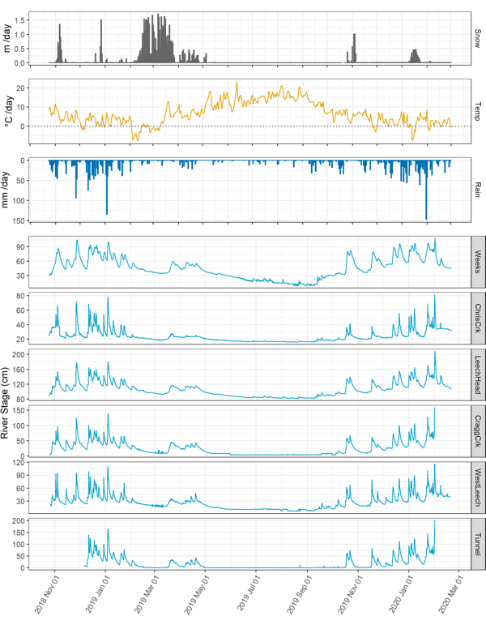

Figure 8: *Weather and stream rise response at six locations across the Leech water supply area.*

* TO DO: ADD summary of connectivity / synchronisity among subbasins

### Rain events

Rain events were defined using the USGS Rainmaker package in R with 15-minute rain measurements (average of the two CRD LWSA stations). Major events were defined by cumulative precipitation in excess of 50 mm, and separated by a period of 14 hours between events. Table 5 summarizes the eighteen rain events which occurred during the study period, and Figure 9 shows stream level at each monitored sub-basin along with events and samples collected. Eight of these events were captured in the 2019 water year (2018-2019 wet season), the other ten in the 2020 water year.

Table 5: *Rain events defined based on precipitation intensity*

|  |  |  |  |
| --- | --- | --- | --- |
| Event ID | Rain (mm) | Start | End |
| 1 | 124.435 | 2018-10-27 09:15:00 | 2018-11-02 12:45:00 |
| 2 | 54.805 | 2018-11-03 11:30:00 | 2018-11-04 10:15:00 |
| 3 | 156.055 | 2018-11-25 19:45:00 | 2018-11-29 09:00:00 |
| 4 | 205.080 | 2018-12-09 12:15:00 | 2018-12-14 10:30:00 |
| 5 | 181.635 | 2018-12-15 00:45:00 | 2018-12-21 05:00:00 |
| 6 | 54.515 | 2018-12-22 09:45:00 | 2018-12-24 20:15:00 |
| 7 | 227.595 | 2019-01-02 19:45:00 | 2019-01-07 00:30:00 |
| 8 | 68.730 | 2019-01-17 07:45:00 | 2019-01-20 08:00:00 |
| 9 | 58.400 | 2019-09-12 18:00:00 | 2019-09-15 20:45:00 |
| 10 | 136.220 | 2019-10-15 18:15:00 | 2019-10-22 03:30:00 |
| 11 | 67.595 | 2019-11-15 10:00:00 | 2019-11-17 17:45:00 |
| 12 | 70.450 | 2019-12-10 17:00:00 | 2019-12-13 19:00:00 |
| 13 | 112.065 | 2019-12-18 11:45:00 | 2019-12-22 13:00:00 |
| 14 | 57.135 | 2019-12-31 00:00:00 | 2020-01-01 23:30:00 |
| 15 | 180.025 | 2020-01-02 17:30:00 | 2020-01-08 09:45:00 |
| 16 | 238.315 | 2020-01-18 18:15:00 | 2020-01-28 16:30:00 |
| 17 | 208.765 | 2020-01-30 17:15:00 | 2020-02-01 14:15:00 |
| 18 | 75.925 | 2020-02-05 07:30:00 | 2020-02-08 16:45:00 |

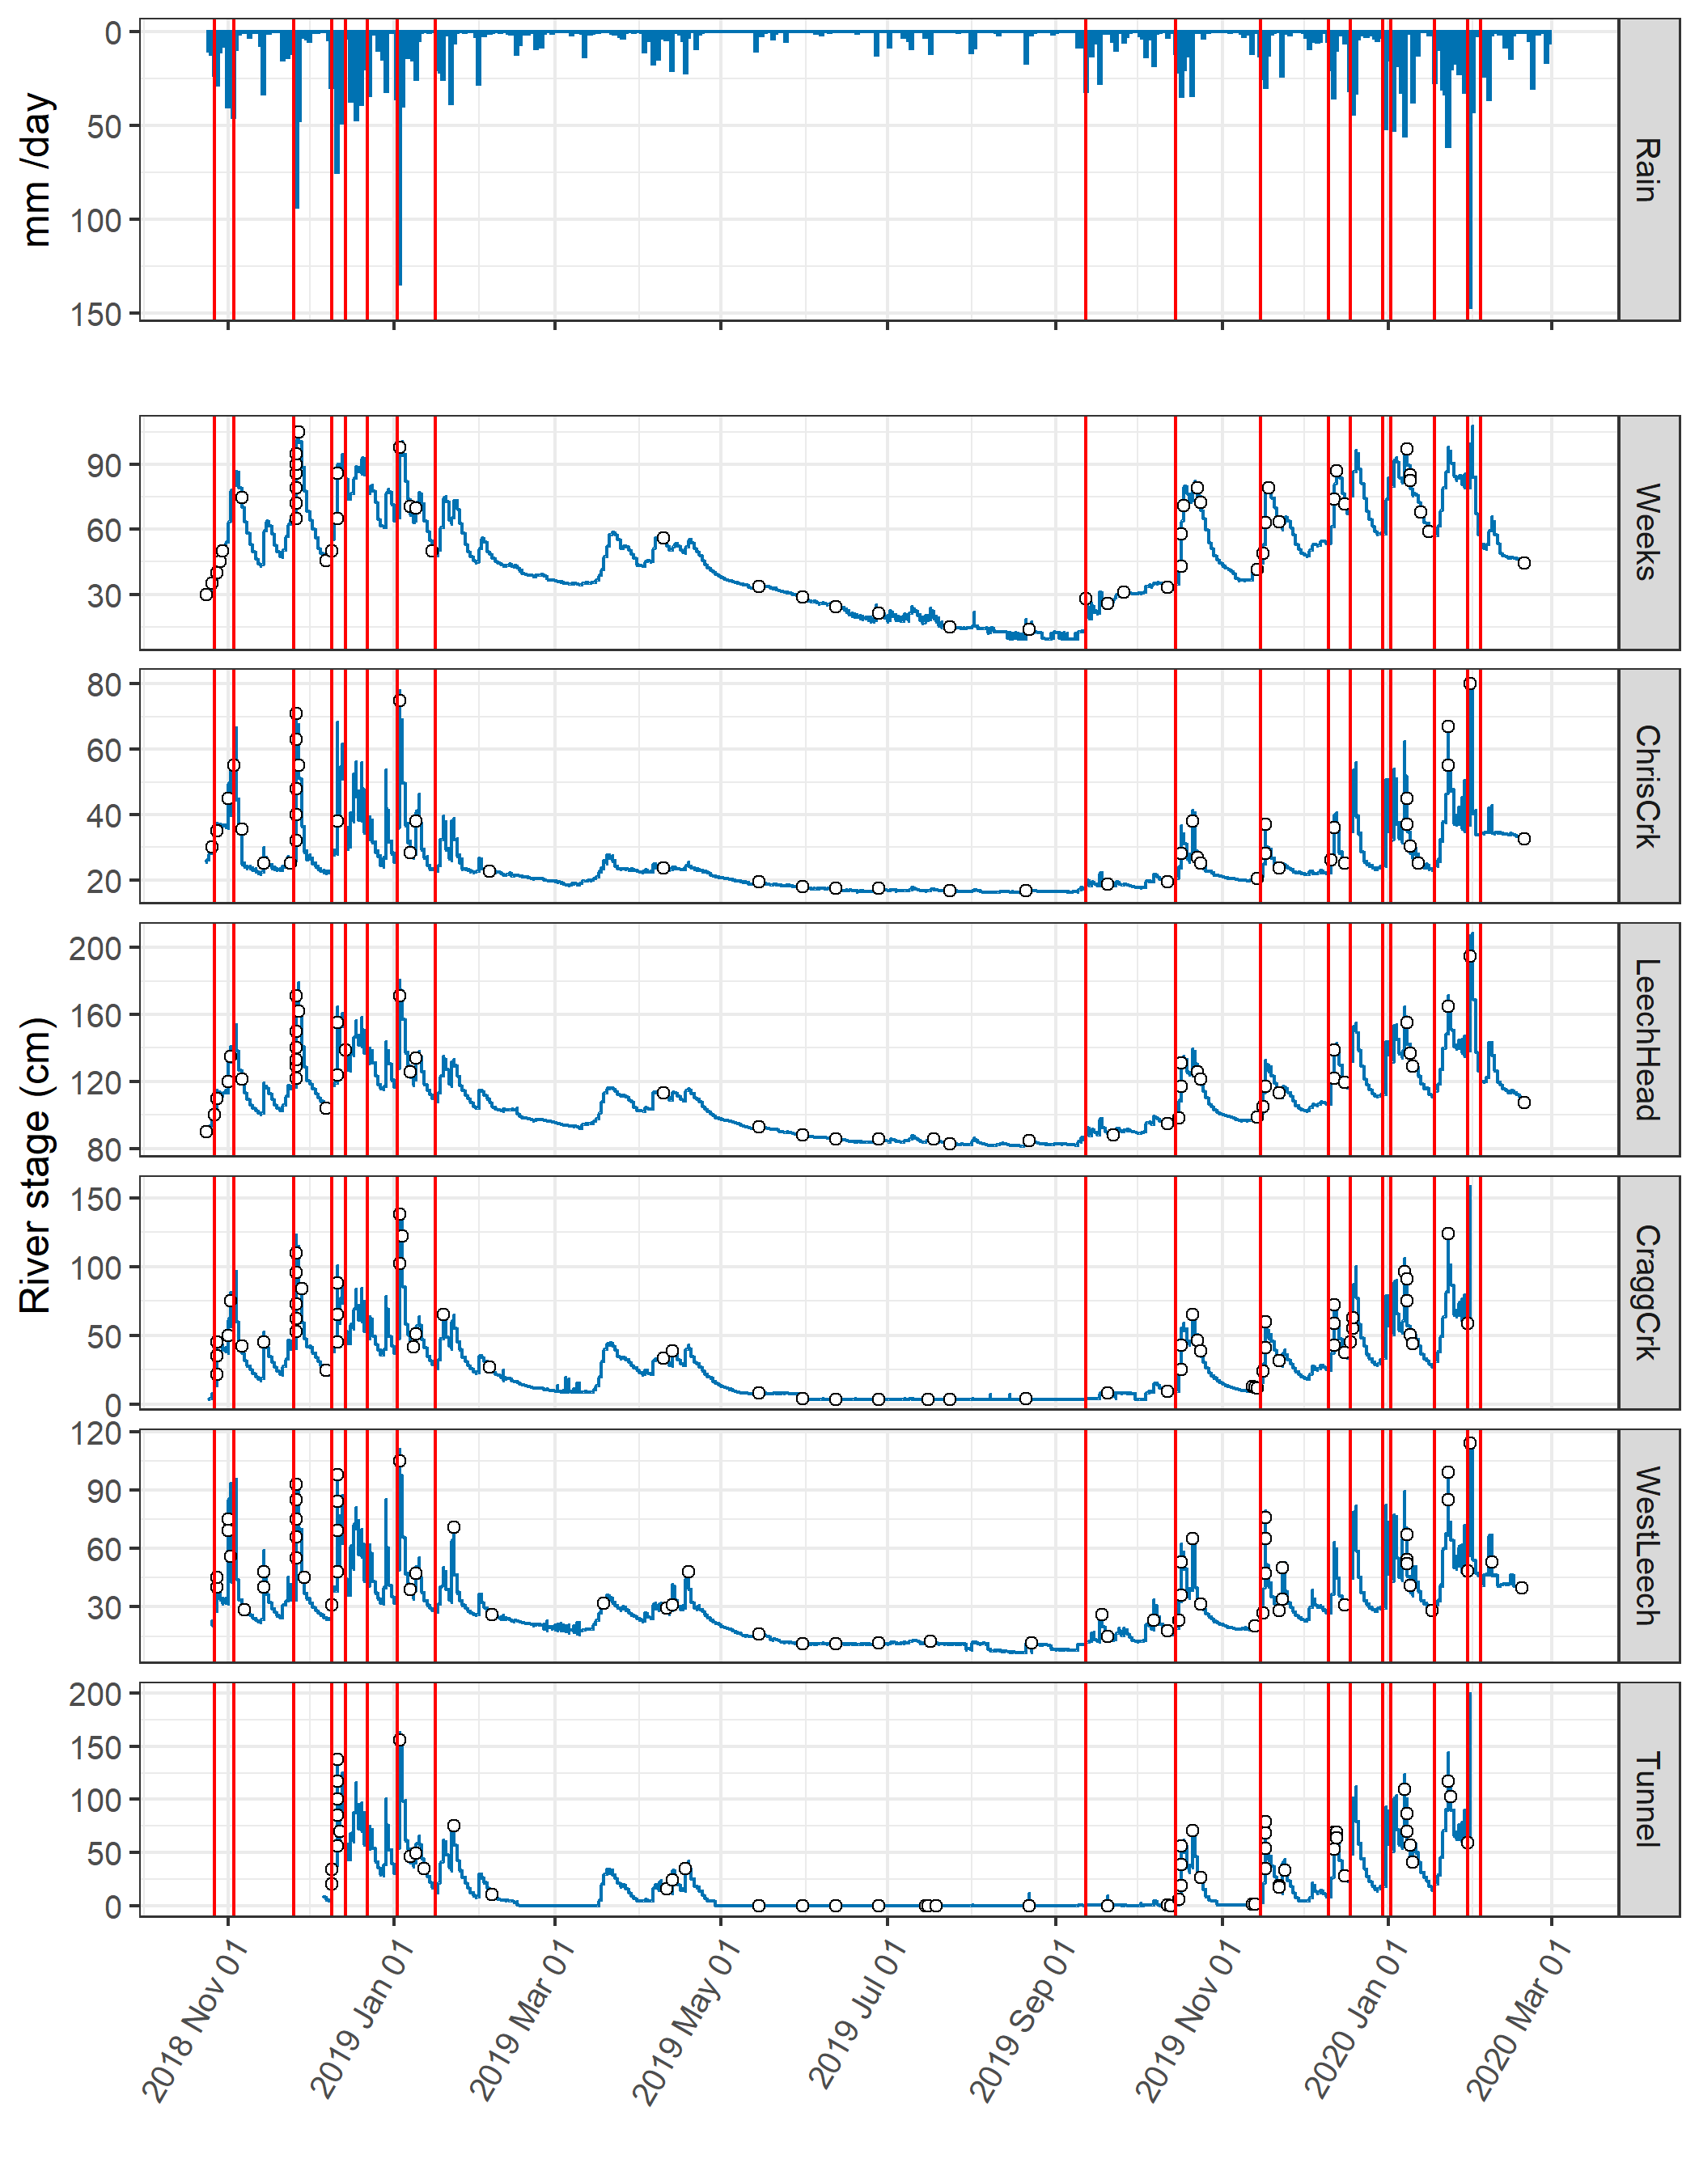  Figure 9: *Rain events and sample collection at six sub-basin sites across the LWSA.*

## River samples for DOC analysis

Sixteen months of bi-weekly field work was completed with the goals of contributing to the characterization of the Leech Water Supply Area (LWSA) while furthering our understanding of the variability of dissolved organic matter (DOM) dynamics in hydrologic response across a second growth forested watershed. From November 2018 to February 2020, 445 samples (Table 6) were collected and analyzed at UBC for DOC concentration and DOM character via high temperature combustion and UV-Vis spectroscopy (respectively). In addition, two sets of replicate samples from four sites were sent to _for_Water partners at the University of Waterloo for source water analyses of drinking water treatability metrics; and an additional 42 samples were collected on behalf of the CRD for analysis of a suite of total metals at an external laboratory.

Table 6: *Summary of samples collected*

|  |  |
| --- | --- |
| sample category | count |
| synoptic samples outside of subbasin sites | 61 |
| opportunistic grab samples | 17 |
| sub-basin synoptic grab samples | 166 |
| sub-basin rack samples | 201 |
| total | 445 |

### DOC in association with other water quality parameters

#### Metals & DOC

Aqueous natural organic matter (NOM) can play an important role in transportation of metals in solution because it has the physiochemical ability to act as a ligand and create coordinated complexes with metals. From November 2018 to July 2019, seven sets of samples were collected from six sites in the LWSA for metals analysis. Metals samples were collected on behalf of the CRD and were analyzed at Bureau Veritas Laboratories in Sidney, BC (formerly Maxxam Analytics Inc.). For each metals sample collected, a parallel Grab sample was collected and analyzed for DOC at UBC. A suite of total metals were included in the analyses, many of which were below detection limits.

I suggest moving everything related to metals to the Appendix

Samples which had detectable metals concentrations were plotted against parallel sample DOC concentrations (Figure 10 shows DOC with total metals in μg/L, and Figure 11 shows metals in mg/L).

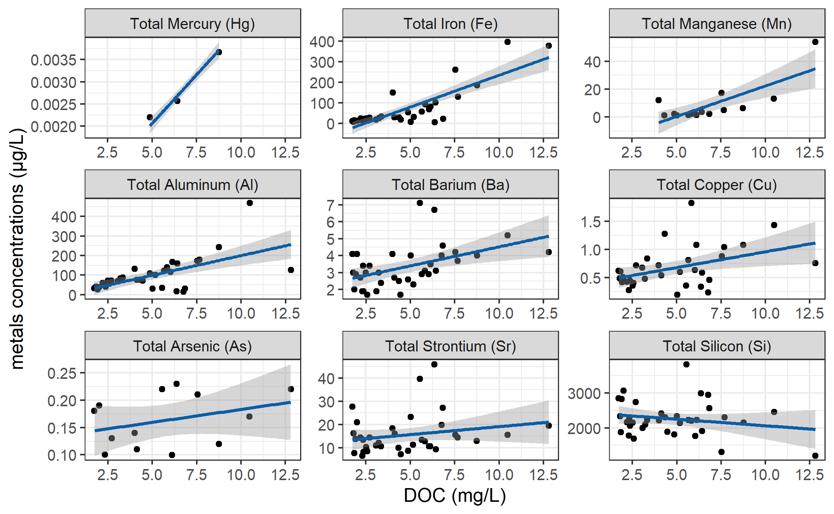

Figure 10: *Concentrations of total metals (in µg/L) and dissolved organic carbon.*

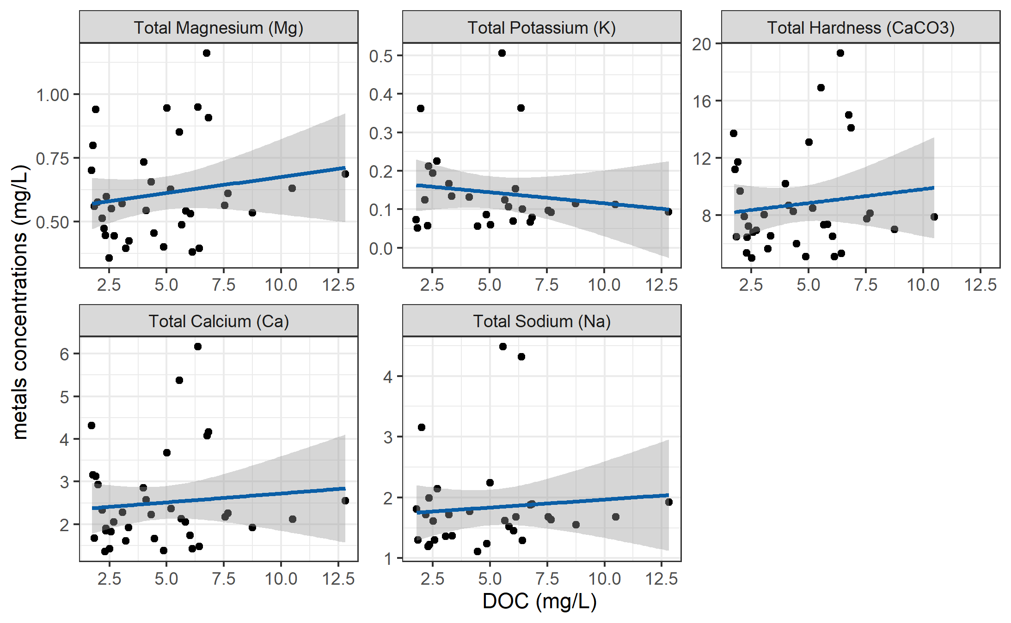

Figure 11: *Concentrations of total metals (in mg/L) and dissolved organic carbon.*

DOC concentrations had strong positive relationships with total mercury, iron, manganese, aluminum. While the relationships were not as strong, DOC was also positively related to concentrations of barium, copper, and arsenic. There was a weak inverse relationship between DOC with silicon and potassium (Table 7). All metals concentrations were below maximum allowable concentrations and aesthetic objectives for drinking source water quality guidelines (British Columbia Ministry of Environment 2017).

Table 7: *Relationships between total metals with dissolved organic carbon*

|  |  |  |  |  |  |
| --- | --- | --- | --- | --- | --- |
| Metal | unit | count | slope | Y intercept | R squared |
| Total Mercury (Hg) | ug/L | 3 | 0.00 | 0.00 | 0.9998 |
| Total Iron (Fe) | ug/L | 40 | 30.86 | -74.47 | 0.6933 |
| Total Manganese (Mn) | ug/L | 18 | 4.38 | -21.41 | 0.5939 |
| Total Aluminum (Al) | ug/L | 42 | 20.13 | -1.21 | 0.3965 |
| Total Barium (Ba) | ug/L | 42 | 0.22 | 2.28 | 0.2251 |
| Total Copper (Cu) | ug/L | 39 | 0.06 | 0.40 | 0.1762 |
| Total Arsenic (As) | ug/L | 14 | 0.00 | 0.14 | 0.1112 |
| Total Strontium (Sr) | ug/L | 42 | 0.69 | 12.21 | 0.0445 |
| Total Silicon (Si) | ug/L | 42 | -37.45 | 2433.98 | 0.0383 |
| Total Magnesium (Mg) | mg/L | 42 | 0.01 | 0.55 | 0.0298 |
| Total Potassium (K) | mg/L | 32 | -0.01 | 0.17 | 0.0216 |
| Total Hardness (CaCO3) | mg/L | 41 | 0.19 | 7.87 | 0.0153 |
| Total Calcium (Ca) | mg/L | 42 | 0.04 | 2.30 | 0.0095 |
| Total Sodium (Na) | mg/L | 37 | 0.03 | 1.70 | 0.0081 |

#### Nitrate & DOC

Each sample that was analyzed on the Spectrolyser resulted in an estimate of DOC and nitrate concentrations based on sample UV-Vis light absorption. Estimated concentrations of nitrate were positively related to DOC concentration (Figure 12).

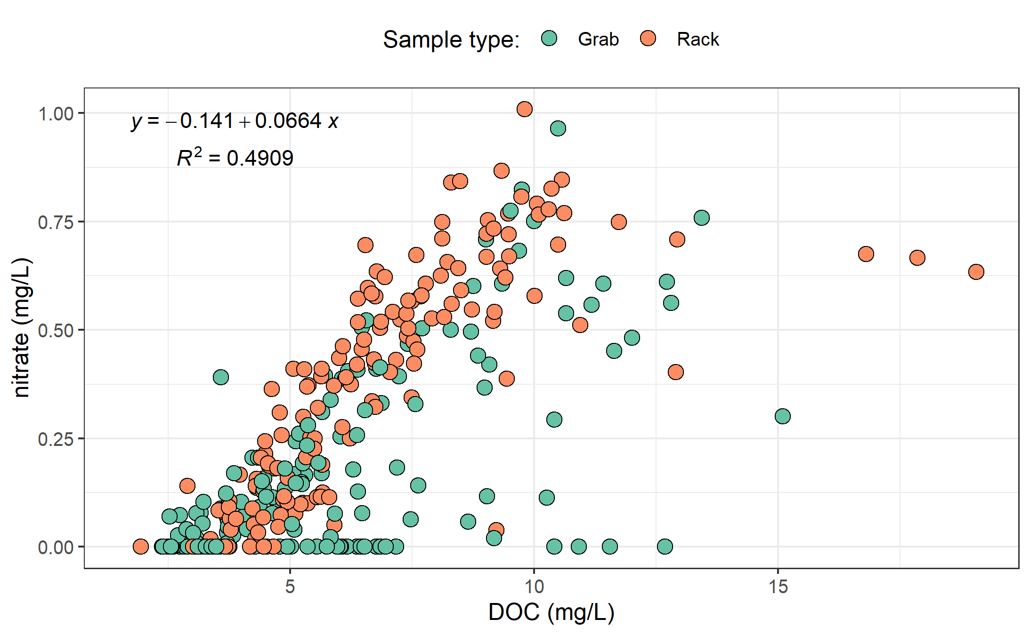

Figure 12: *Concentration of nitrate (estimated via UV-Vis absorption) and dissolved organic carbon.*

UV absorbance based estimations of DOC concentration were more strongly correlated to nitrate estimates (Figure 13).

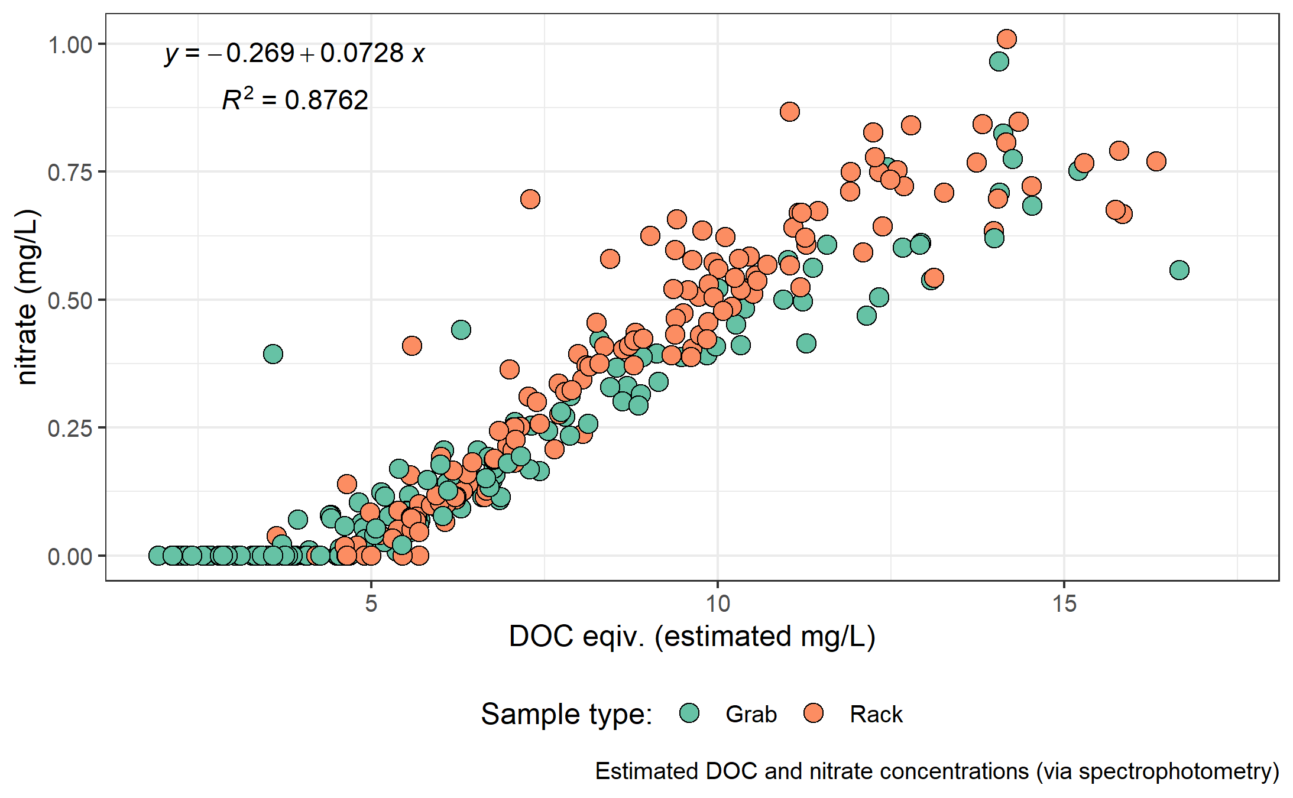

Figure 13: *Concentration of nitrate and dissolved organic carbon, both estimated via UV-Vis absorption.*

#### Treatability & DOC

Dissolved organic matter – particularly high molecular weight aromatic compounds – are precursors to disinfection by-products (DBPs), which are formed during chlorination of source drinking water. Drinking water supply for the CRD is treated simply by chlorinating raw source water, and therefore source water NOM could have important implications for treatability. To assess the potential of source water to form potentially harmful DBPs, samples were collected from four locations and sent to partners at the University of Waterloo for treatability analyses (specifically, DBP formation potentials (DBP-FPs)). Results from two sets of samples at four selected sites showed positive correlations between DOC concentrations and DBP-FPs, and even stronger relationships between DBP-FPs and UV absorbance at 254-nm – an indicator of NOM aromaticity (Figure 14). The relatively stronger correlation between DBP-FPs and UV-254 indicates that while DOM concentration is an important indicator of source water treatability challenges, the aromaticity of source water NOM may be an even more important driver.

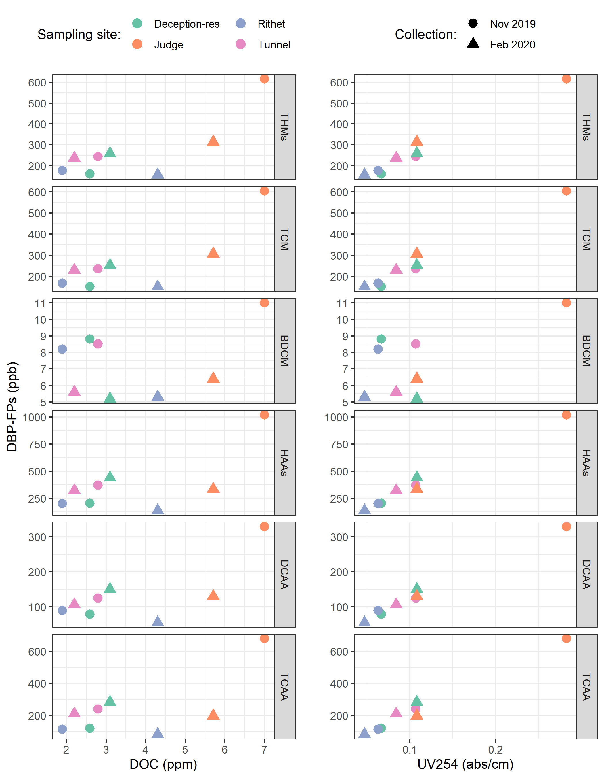

Figure 14: *Plots of disinfection by-product formation potentials (DBP-FPs) with dissolved organic carbon (left column) and UV absorbance at 254 nm (right column). Samples collected at four sites on two occasions.*

While UV-254 is a good indicator of NOM aromaticity and also appears to be correlated to DBP-FPs, naturally occurring aqueous chemicals (such as nitrate and iron) can interfere with spectroscopic analyses and lead to positive bias in DOM estimates. While aqueous nitrate may lead to an over estimate absorbance-based DOM concentrations, aqueous nitrogen can also play an important roll as a precursor to nitrogenous-DBPs when in combination with NOM, which could make UV{254} an even better indicator of DBP-FP.

* TO DO: add comparison of treatability metrics at Tunnel versus Sooke Tribs

### Synoptic Sampling

Over the sixteen month study period, 227 samples were collected at thirteen river sites across the Leech and Sooke water supply areas. Figure 15 shows DOC concentrations across each synoptically samples site, and Table 8 summarized the range of DOC concentrations.

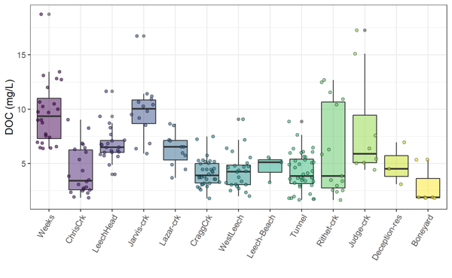

Figure 15: *Synoptic sampling results of dissolved organic carbon concentrations from 13 sites over 16 months (227 grab samples).*

Table 8: *Summary of dissolved organic carbon across thirteen synoptically sampled river sites*

|  |  |  |  |  |  |  |
| --- | --- | --- | --- | --- | --- | --- |
| site | count | DOCmean | DOCsd | DOCmin | DOCmedian | DOCmax |
| Weeks | 24 | 9.7 | 3.0 | 6.38 | 9.35 | 18.74 |
| ChrisCrk | 22 | 4.3 | 2.2 | 1.84 | 3.42 | 9.04 |
| LeechHead | 22 | 6.8 | 1.6 | 3.99 | 6.49 | 11.64 |
| Jarvis-crk | 14 | 9.8 | 2.7 | 5.92 | 10.03 | 16.73 |
| Lazar-crk | 11 | 6.3 | 1.6 | 3.69 | 6.53 | 8.65 |
| CraggCrk | 34 | 4.2 | 1.2 | 1.79 | 3.90 | 7.47 |
| WestLeech | 24 | 4.3 | 1.7 | 2.00 | 4.25 | 9.08 |
| Leech-Beach | 3 | 4.7 | 1.2 | 3.27 | 5.12 | 5.57 |
| Tunnel | 40 | 4.2 | 1.7 | 1.65 | 3.86 | 8.85 |
| Rithet-crk | 15 | 6.2 | 4.2 | 1.64 | 3.85 | 12.68 |
| Judge-crk | 8 | 8.3 | 5.0 | 4.42 | 5.90 | 17.25 |
| Deception-res | 3 | 4.9 | 2.0 | 3.10 | 4.51 | 6.96 |
| Boneyard | 7 | 2.9 | 1.7 | 1.83 | 1.88 | 5.36 |
| total summary | 227 | 5.8 | 3.1 | 1.64 | 5.18 | 18.74 |

Figure (16) shows the density distribution of DOC concentrations at each of the synoptically sampled sites. DOC concentrations were typically higher in headwater streams, particularly those associated with wetlands.

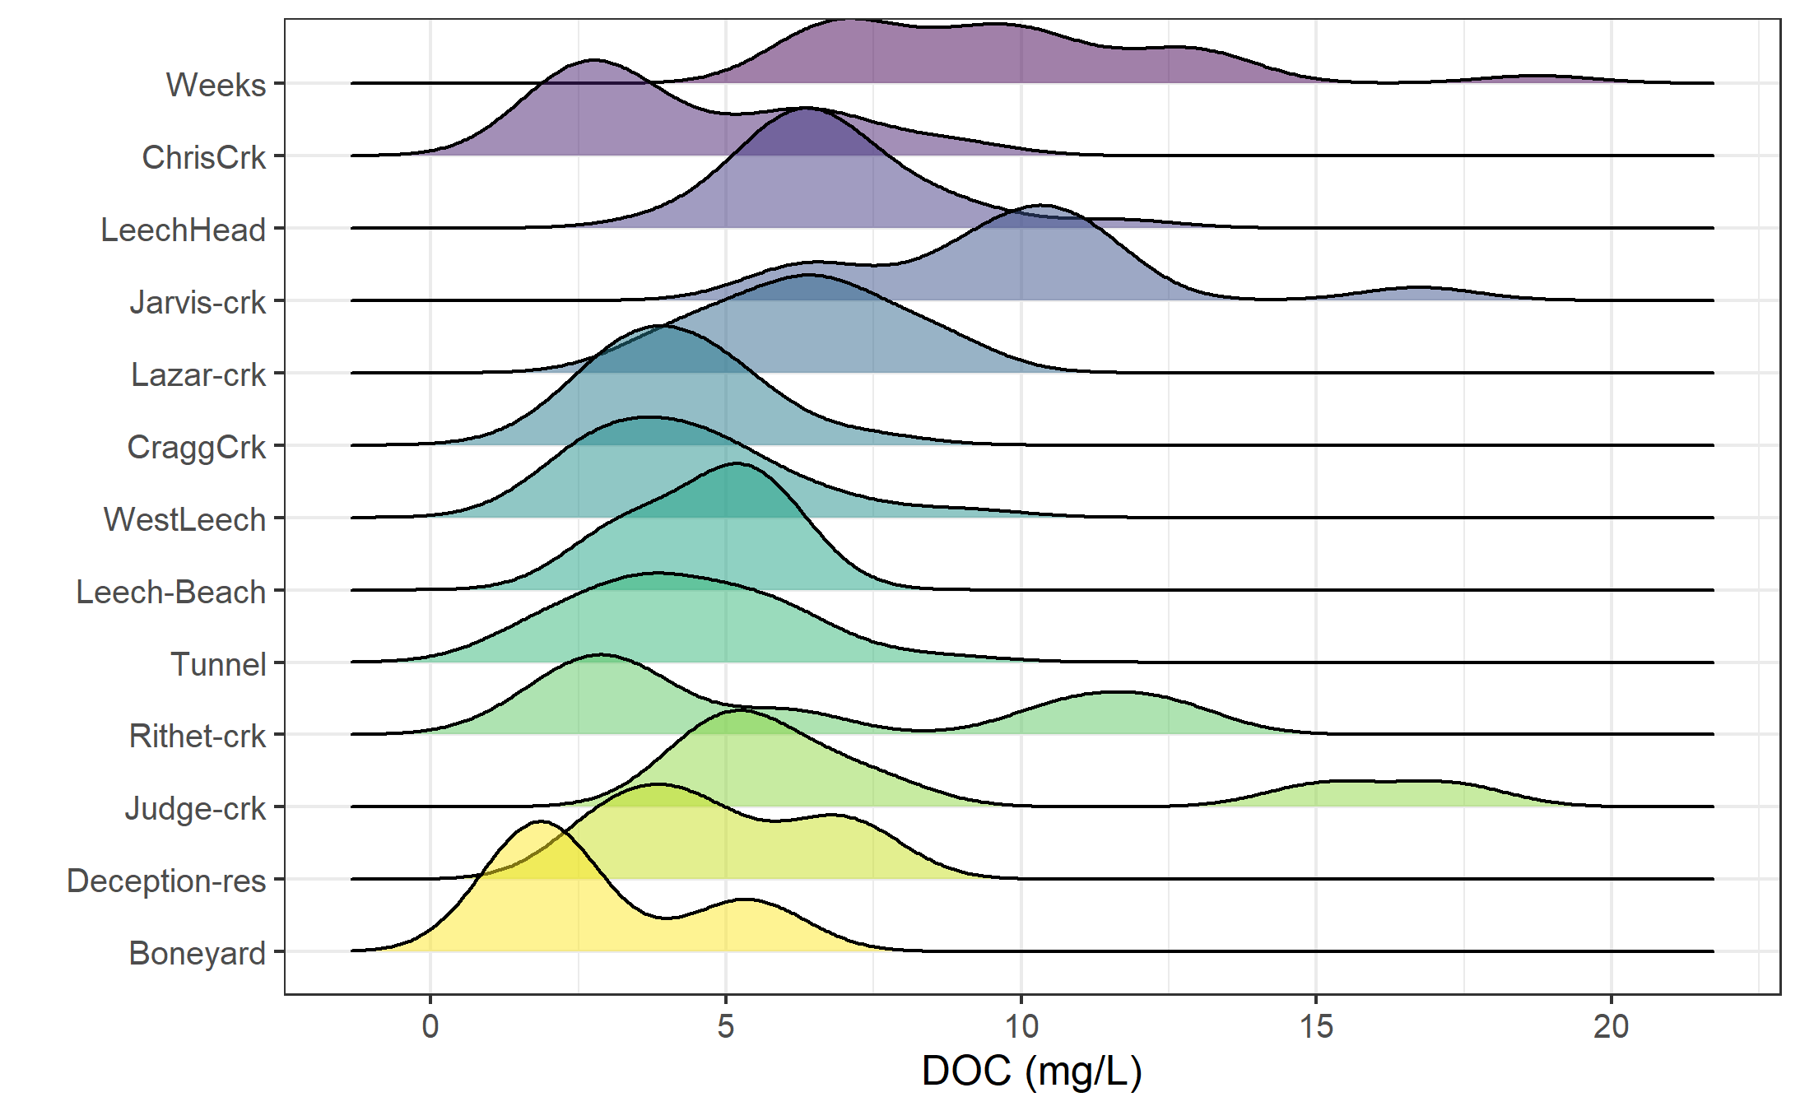

Figure 16: *Density distribution of dissolved organic carbon concentrations resulting from synoptic sampling at 13 sites over 16 months (227 grab samples).*

#### Seasonal patterns: UV-absorption as indicator of molecular character

With samples collected over sixteen months, a seasonal assessment of source water character was possible. NOM molecules with greater aromaticity will absorb more UV energy at wavelength 254-nm than non-aromatic molecules; therefore, spectroscopic methods of estimating DOM are proxy measures of sample aromaticity (e.g., humic substances). Figure 17 shows DOC concentrations plotted against DOC estimates based on UV-Vis absorbance. The seasonal separation of wet an dry season samples suggests that river water during the wet-season (fall and winter) has more aromatic character than during the dry-season (summer).

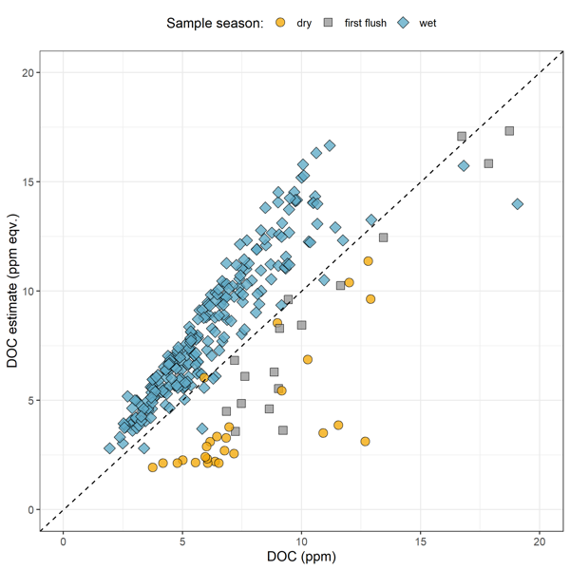

Figure 17: *Dissolved organic carbon measured directly (as NPOC) plotted against concentrations estimated via UV-Vis spectroscopy, with a dashed lined indicating best fit (1:1). The 282 samples are grouped by season (n{wet} = 237, n{first-flush} = 18, n{dry} = 27).*

Figure 17 showed that characteristics of wet-season samples caused positive bias in absorbance-based DOC estimates, while dry-season samples showed negative bias in DOC estimated by UV-Vis absorption.

While an aromatic NOM sample will have stronger absorbance at 254-nm relative to a non-aromatic sample, the concentration of NOM also effects the intensity of absorbance (based on the Beer-Lambert law). Because UV-Vis absorbance is proportional to both the aromaticity and the concentration of NOM in a sample, SUVA254 is a widely adopted indicator of a sample’s aromaticity. Specific UV absorbance at 254-nm (SUVA254) is calculated by dividing a sample’s absorbance at 254-nm by its DOC concentration; a greater SUVA254 value indicates a sample with more aromatic character than a sample with low SUVA254. Figure 18 shows seasonally grouped samples’ DOC plotted against SUVA254, which indicates a greater aromatic character of river water during the wet season compared to dry season.

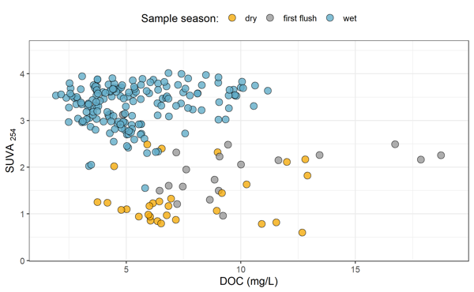

Figure 18: *Dissolved organic carbon plotted against specific UV absorbance at 254 nm (SUVA{254}) with samples (n = 282) grouped by season (n{wet} = 237, n{first-flush} = 18, n{dry} = 27) showing greater aromaticity (more humic-like organic matter) in wet season samples.*

## Leech watershed and nested sub-catchments

Six locations across the LWSA were set up as monitoring sites where vertical racks were installed to measure continuous stage and collect water samples as the rivers rose in response to precipitation events. These vertical racks collected samples on the rising hydrograph limb, which has been shown to have higher DOC concentration that non-storm flow (Yang et al. 2015; Raymond et al. 2016, 2010). Table 9 summarizes the number of samples collected manually (Grab samples) and via siphon bottles on the vertical racks (Rack samples) at each of the six monitoring sites. Figure 19 shows the range of DOC concentrations at each of the six sites.

Table 9: *Sample counts at the six LWSA monitoring sites*

|  |  |  |
| --- | --- | --- |
| Site | Sample type | Count |
| Weeks | Grab | 24 |
| Weeks | Rack | 32 |
| ChrisCrk | Grab | 22 |
| ChrisCrk | Rack | 27 |
| LeechHead | Grab | 22 |
| LeechHead | Rack | 30 |
| CraggCrk | Grab | 34 |
| CraggCrk | Rack | 35 |
| WestLeech | Grab | 24 |
| WestLeech | Rack | 43 |
| Tunnel | Grab | 40 |
| Tunnel | Rack | 34 |

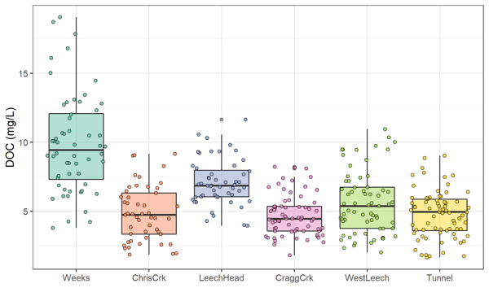

Figure 19: *Dissolved organic carbon concentrations across the Leech watershed over sixteen months (367 samples).*

The Leech River Tunnel site (*‘Tunnel’*) is the effective outlet of the water supply area, as the tunnel will act as the point of diversion in future inter-basin transfer. Each of the five monitored sub catchments are effectively integrated at the tunnel site. Table 10 summarizes the range and variability in DOC within each site and among all sites.

Table 10: *Summary of DOC samples collected across the LWSA sub-basins*

|  |  |  |  |  |  |  |  |  |
| --- | --- | --- | --- | --- | --- | --- | --- | --- |
| Site | sub-basin type | sample count | mean DOC (mg/L) | std.dev. (± mg/L) | RSD (±%) | min DOC | median DOC | max DOC |
| Weeks | headwater | 56 | 9.9 | 3.6 | 36 | 3.78 | 9.44 | 19.07 |
| ChrisCrk | headwater | 49 | 4.9 | 2.0 | 41 | 1.84 | 4.74 | 9.16 |
| LeechHead | headwater | 52 | 7.1 | 1.7 | 24 | 3.95 | 6.85 | 11.64 |
| CraggCrk | mainstem | 69 | 4.7 | 1.5 | 31 | 1.79 | 4.45 | 8.22 |
| WestLeech | mainstem | 67 | 5.6 | 2.3 | 41 | 2.00 | 5.36 | 10.95 |
| Tunnel | outlet | 74 | 4.8 | 1.7 | 36 | 1.65 | 4.94 | 9.02 |
| summary | headwater | 157 | 7.4 | 3.3 | 45 | 1.84 | 6.84 | 19.07 |
| summary | mainstem | 136 | 5.1 | 2.0 | 38 | 1.79 | 4.72 | 10.95 |
| Total | all | 367 | 6.0 | 2.9 | 47 | 1.65 | 5.58 | 19.07 |

Sample results from each nested sub-basin were compared to those of the Tunnel site to determine if there were significant differences between variances. Levene’s test was used to test for homogeneity of variance (homoscedasticity), and the results are summarized in Table 11. There was significant difference between the Tunnel (site 6) and Weeks (site 1), which is a headwater creek that drains Weeks Lake and it’s surrounding wetlands in the northwest of the watershed (p < 0.001). Variance in DOC was also significantly different between the Tunnel and West Leech (site 5), which is a mainstem river that drains the west side of the watershed (p < 0.05). Variance at Cragg Creek (site 4) was different (p < 0.10), while variances at Chris Creek and the Head of Leech River (below the confluence of Weeks and Chris Crk) were not found to differ significantly from the Tunnel site.

Table 11: *Results of Levene’s test compairing nested catchments to the outlet*

|  |  |
| --- | --- |
| sub-basin site compared to outlet | p-value |
| Weeks *** | 0.0000006 |
| ChrisCrk | 0.2103788 |
| LeechHead | 0.4593409 |
| CraggCrk | 0.0945058 |
| WestLeech * | 0.0153358 |

### Temporal patterns

Over time, DOC concentrations followed similar trends across each of the six LWSA sites (Figure 20). DOC was highest early in the wet season and progressively decreased through the fall and winter, reaching minimum concentrations in the spring before progressively increasing again through the summer. Based on spectroscopic indications that dry season NOM was less aromatic in character, it’s quite possibly that the increase in summer DOC was due to autochthonous sources such as algae and cyanobacteria, while fall DOC was likely sources from autochthonous terrestrial sources (e.g., humic and fluvic acids).

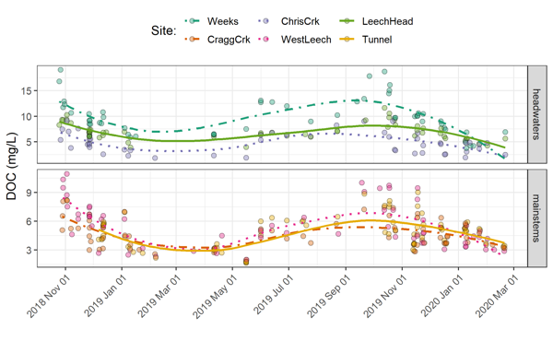

Figure 20: *Trends in dissolved organic carbon concentrations over sixteen months (Oct 2018 to Feb 2020) at six sites across the Leech water supply area (n = 367: 166 grab samples, 201 vertical rack samples.*

### Seasonal trends

Overall, DOC concentrations were higher through the wet season compared to the dry season (Figure 21 & Figure 22). Sample results across the LWSA catchments are summarized by season in Table 12.

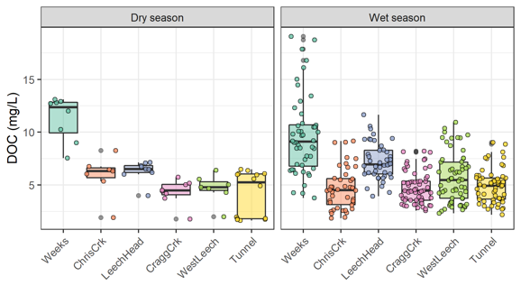

Figure 21: *Boxplots of DOC concentrations at six LWSA sites during dry season (n = 53) and wet season (n = 314).*

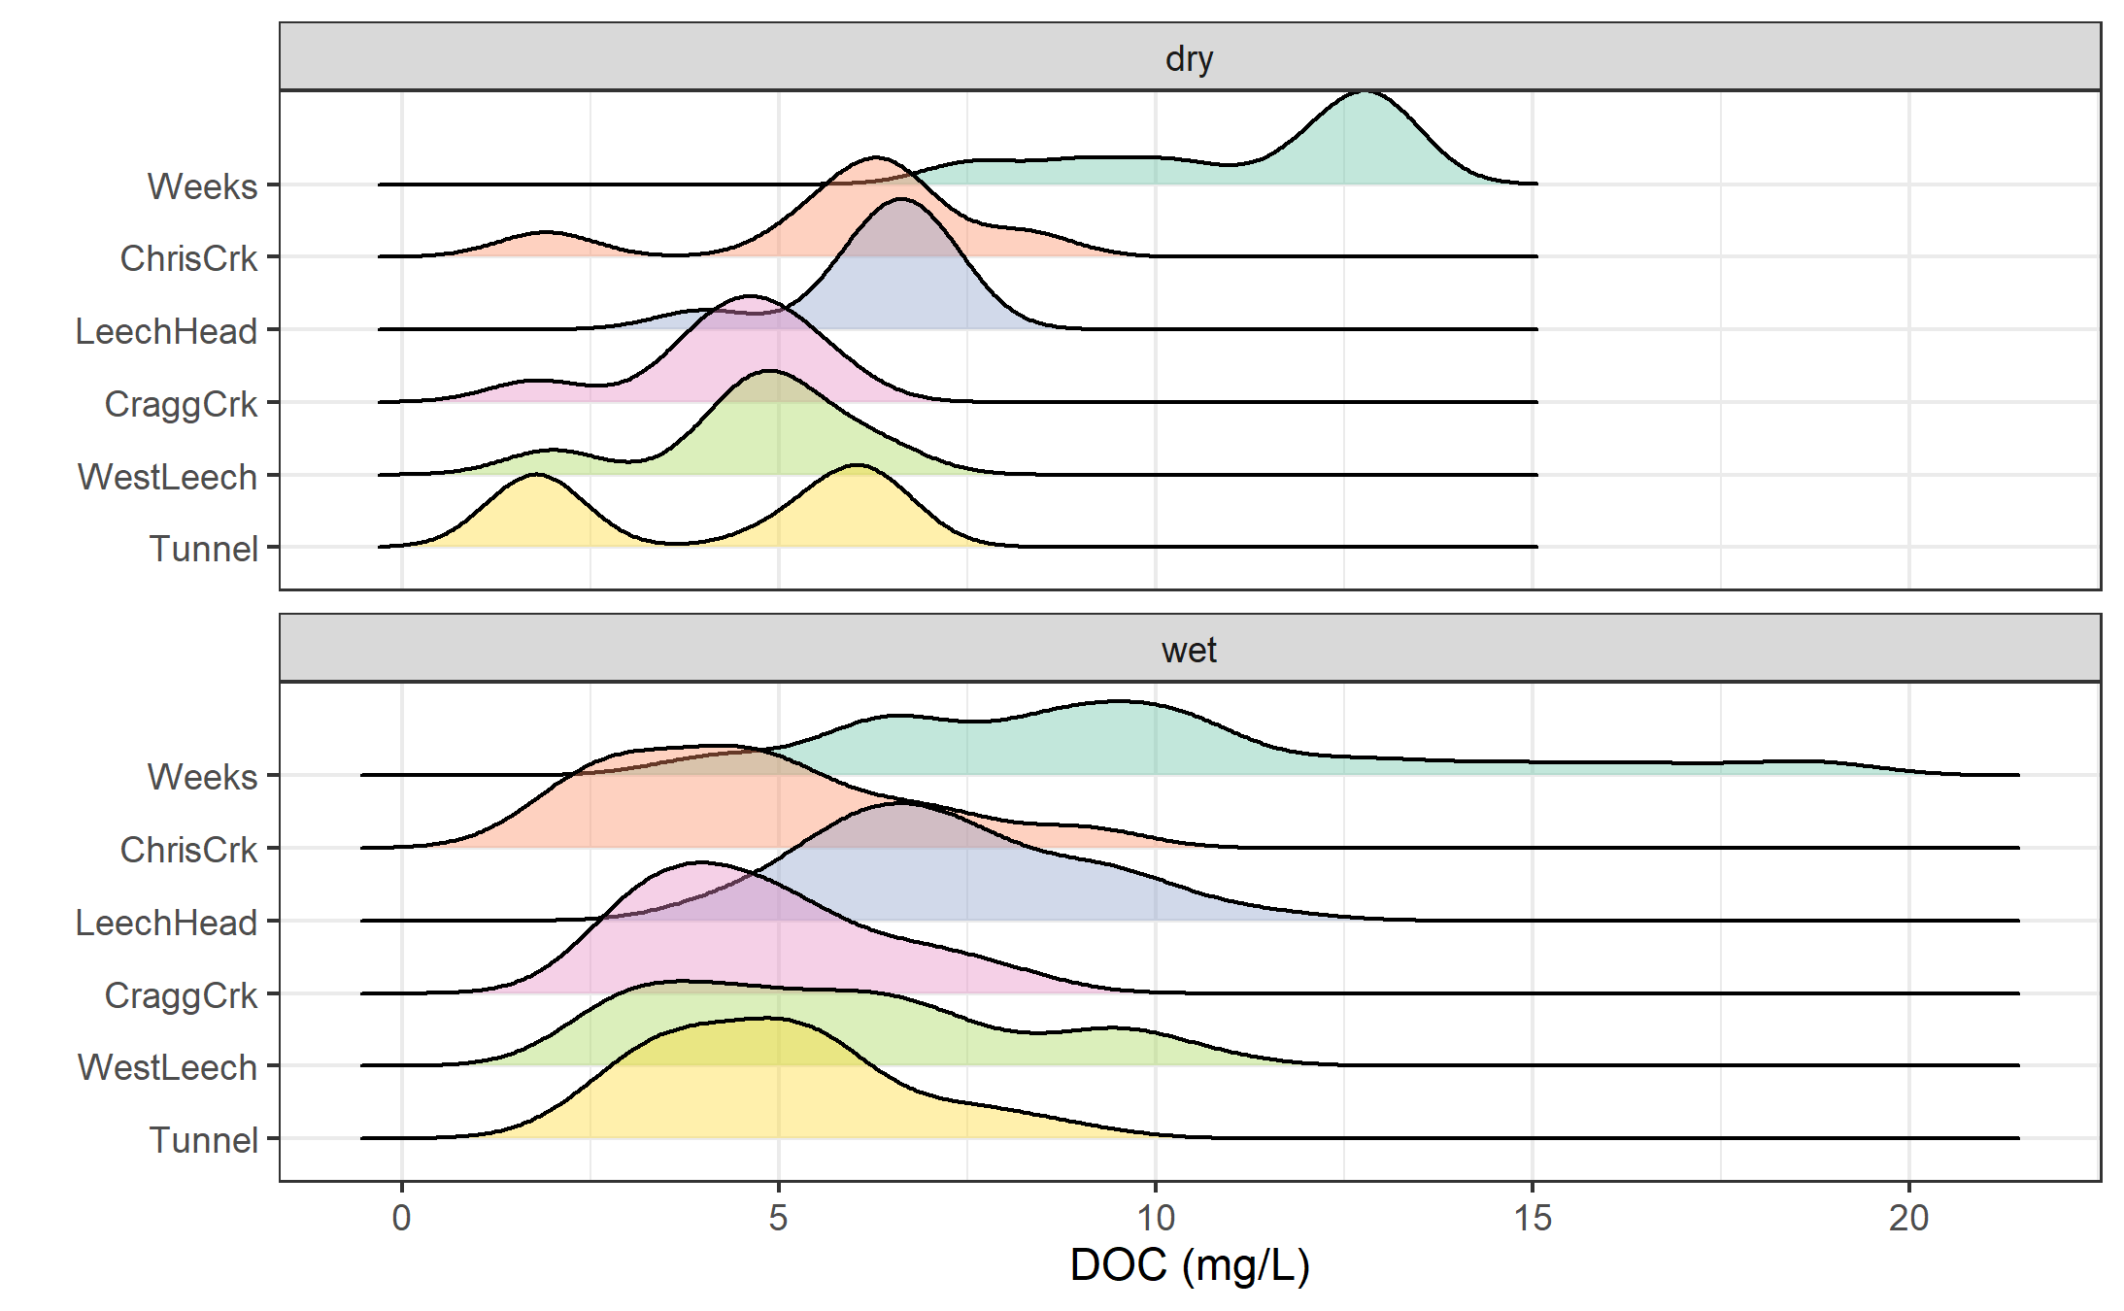

Figure 22: *Density distribution of dissolved organic carbon concentrations at six sites over sixteen months across the Leech water supply area, where sample results are grouped by dry season (n = 53) and wet season (n = 314).*

 Table 12: Seasonal summary of samples collected across LWSA subbasin sites

|  |  |  |  |  |  |
| --- | --- | --- | --- | --- | --- |
| Site | Season | Sample count | mean DOC (mg/L) | std.dev. (± mg/L) | RSD (±%) |
| Weeks | Dry | 8 | 11.3 | 2.1 | 19 |
| Weeks | Wet | 48 | 9.7 | 3.8 | 39 |
| ChrisCrk | Dry | 7 | 5.9 | 2.0 | 33 |
| ChrisCrk | Wet | 42 | 4.7 | 2.0 | 42 |
| LeechHead | Dry | 9 | 6.3 | 1.0 | 15 |
| LeechHead | Wet | 43 | 7.2 | 1.8 | 24 |
| CraggCrk | Dry | 8 | 4.3 | 1.2 | 28 |
| CraggCrk | Wet | 61 | 4.7 | 1.5 | 32 |
| WestLeech | Dry | 7 | 4.7 | 1.4 | 29 |
| WestLeech | Wet | 60 | 5.7 | 2.3 | 41 |
| Tunnel | Dry | 14 | 4.2 | 2.2 | 52 |
| Tunnel | Wet | 60 | 4.9 | 1.6 | 33 |

#### Stormflow representation

During the wet season, rain events are the dominant hydrologic forcing. Table 13 summarizes the number of samples collected across the LWSA sub-basin sites by sample type.

Table 13: *Summary of wet-season samples collected across LWSA subbasin sites from Oct 2018 to Feb 2020*

|  |  |  |
| --- | --- | --- |
| Site | Sample type | Count |
| Weeks | Grab | 17 |
| Weeks | Rack | 31 |
| ChrisCrk | Grab | 15 |
| ChrisCrk | Rack | 27 |
| LeechHead | Grab | 13 |
| LeechHead | Rack | 30 |
| CraggCrk | Grab | 26 |
| CraggCrk | Rack | 35 |
| WestLeech | Grab | 17 |
| WestLeech | Rack | 43 |
| Tunnel | Grab | 26 |
| Tunnel | Rack | 34 |
| TOTAL | Grab | 114 |
| TOTAL | Rack | 200 |

Stormflow samples collected during stream rise via vertical Racks showed higher DOC than Grab samples manually collected across wet seasons (Figure 23 & 24). Results of wet-season sample analysis are summarized in Table 14.

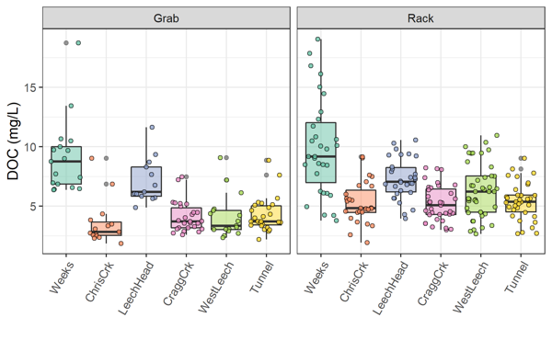

Figure 23: *Wet-season dissolved organic carbon concentrations grouped by site and sample collection method, where Grab samples were manually obtained (n = 114) and Rack samples were collected passively on vertical racks fit with siphon sampler bottles (n = 200).*

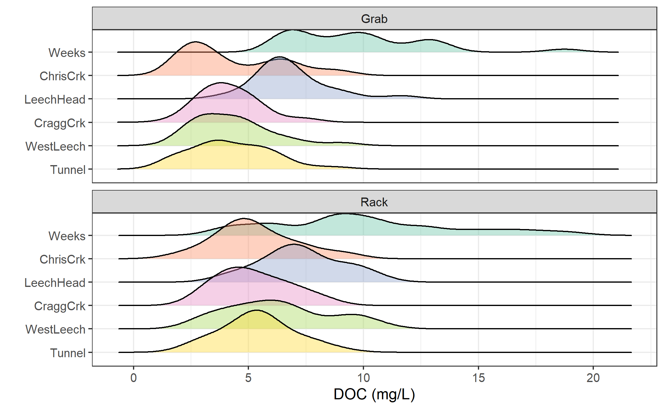

Figure 24: *Density distribution of dissolved organic carbon concentrations grouped by site and sample collection method, where Grab samples were manually obtained (n = 114) and Rack samples were collected passively on vertical racks fit with siphon sampler bottles (n = 200).*

Table 14: *Results of wet-season samples collected across LWSA subbasin sites from Oct 2018 to Feb 2020*

|  |  |  |  |  |  |  |
| --- | --- | --- | --- | --- | --- | --- |
| Site | Sample type | DOC mean (mg/L) | std.dev. (± mg/L) | RSD (±%) | min DOC | max DOC |
| Weeks | Grab | 9.13 | 3.16 | 35 | 6.38 | 18.74 |
| Weeks | Rack | 9.97 | 4.08 | 41 | 3.78 | 19.07 |
| ChrisCrk | Grab | 3.58 | 1.93 | 54 | 1.85 | 9.04 |
| ChrisCrk | Rack | 5.29 | 1.76 | 33 | 1.94 | 9.16 |
| LeechHead | Grab | 7.13 | 1.91 | 27 | 4.87 | 11.64 |
| LeechHead | Rack | 7.28 | 1.73 | 24 | 3.95 | 10.57 |
| CraggCrk | Grab | 4.10 | 1.27 | 31 | 2.58 | 7.47 |
| CraggCrk | Rack | 5.22 | 1.51 | 29 | 3.00 | 8.22 |
| WestLeech | Grab | 4.13 | 1.82 | 44 | 2.33 | 9.08 |
| WestLeech | Rack | 6.30 | 2.25 | 36 | 2.66 | 10.95 |
| Tunnel | Grab | 4.28 | 1.46 | 34 | 2.19 | 8.85 |
| Tunnel | Rack | 5.40 | 1.55 | 29 | 2.69 | 9.02 |

### Rising limb – hydrologic versus supply controls on export

Figure 25 shows rising limb sample DOC concentrations across rain events at the LWSA sub-basins. While there was a typically some increase in DOC with increasing river stage, seasonality appeared to have a greater influence on DOC concentrations than river rise (highest DOC early in the wet season).

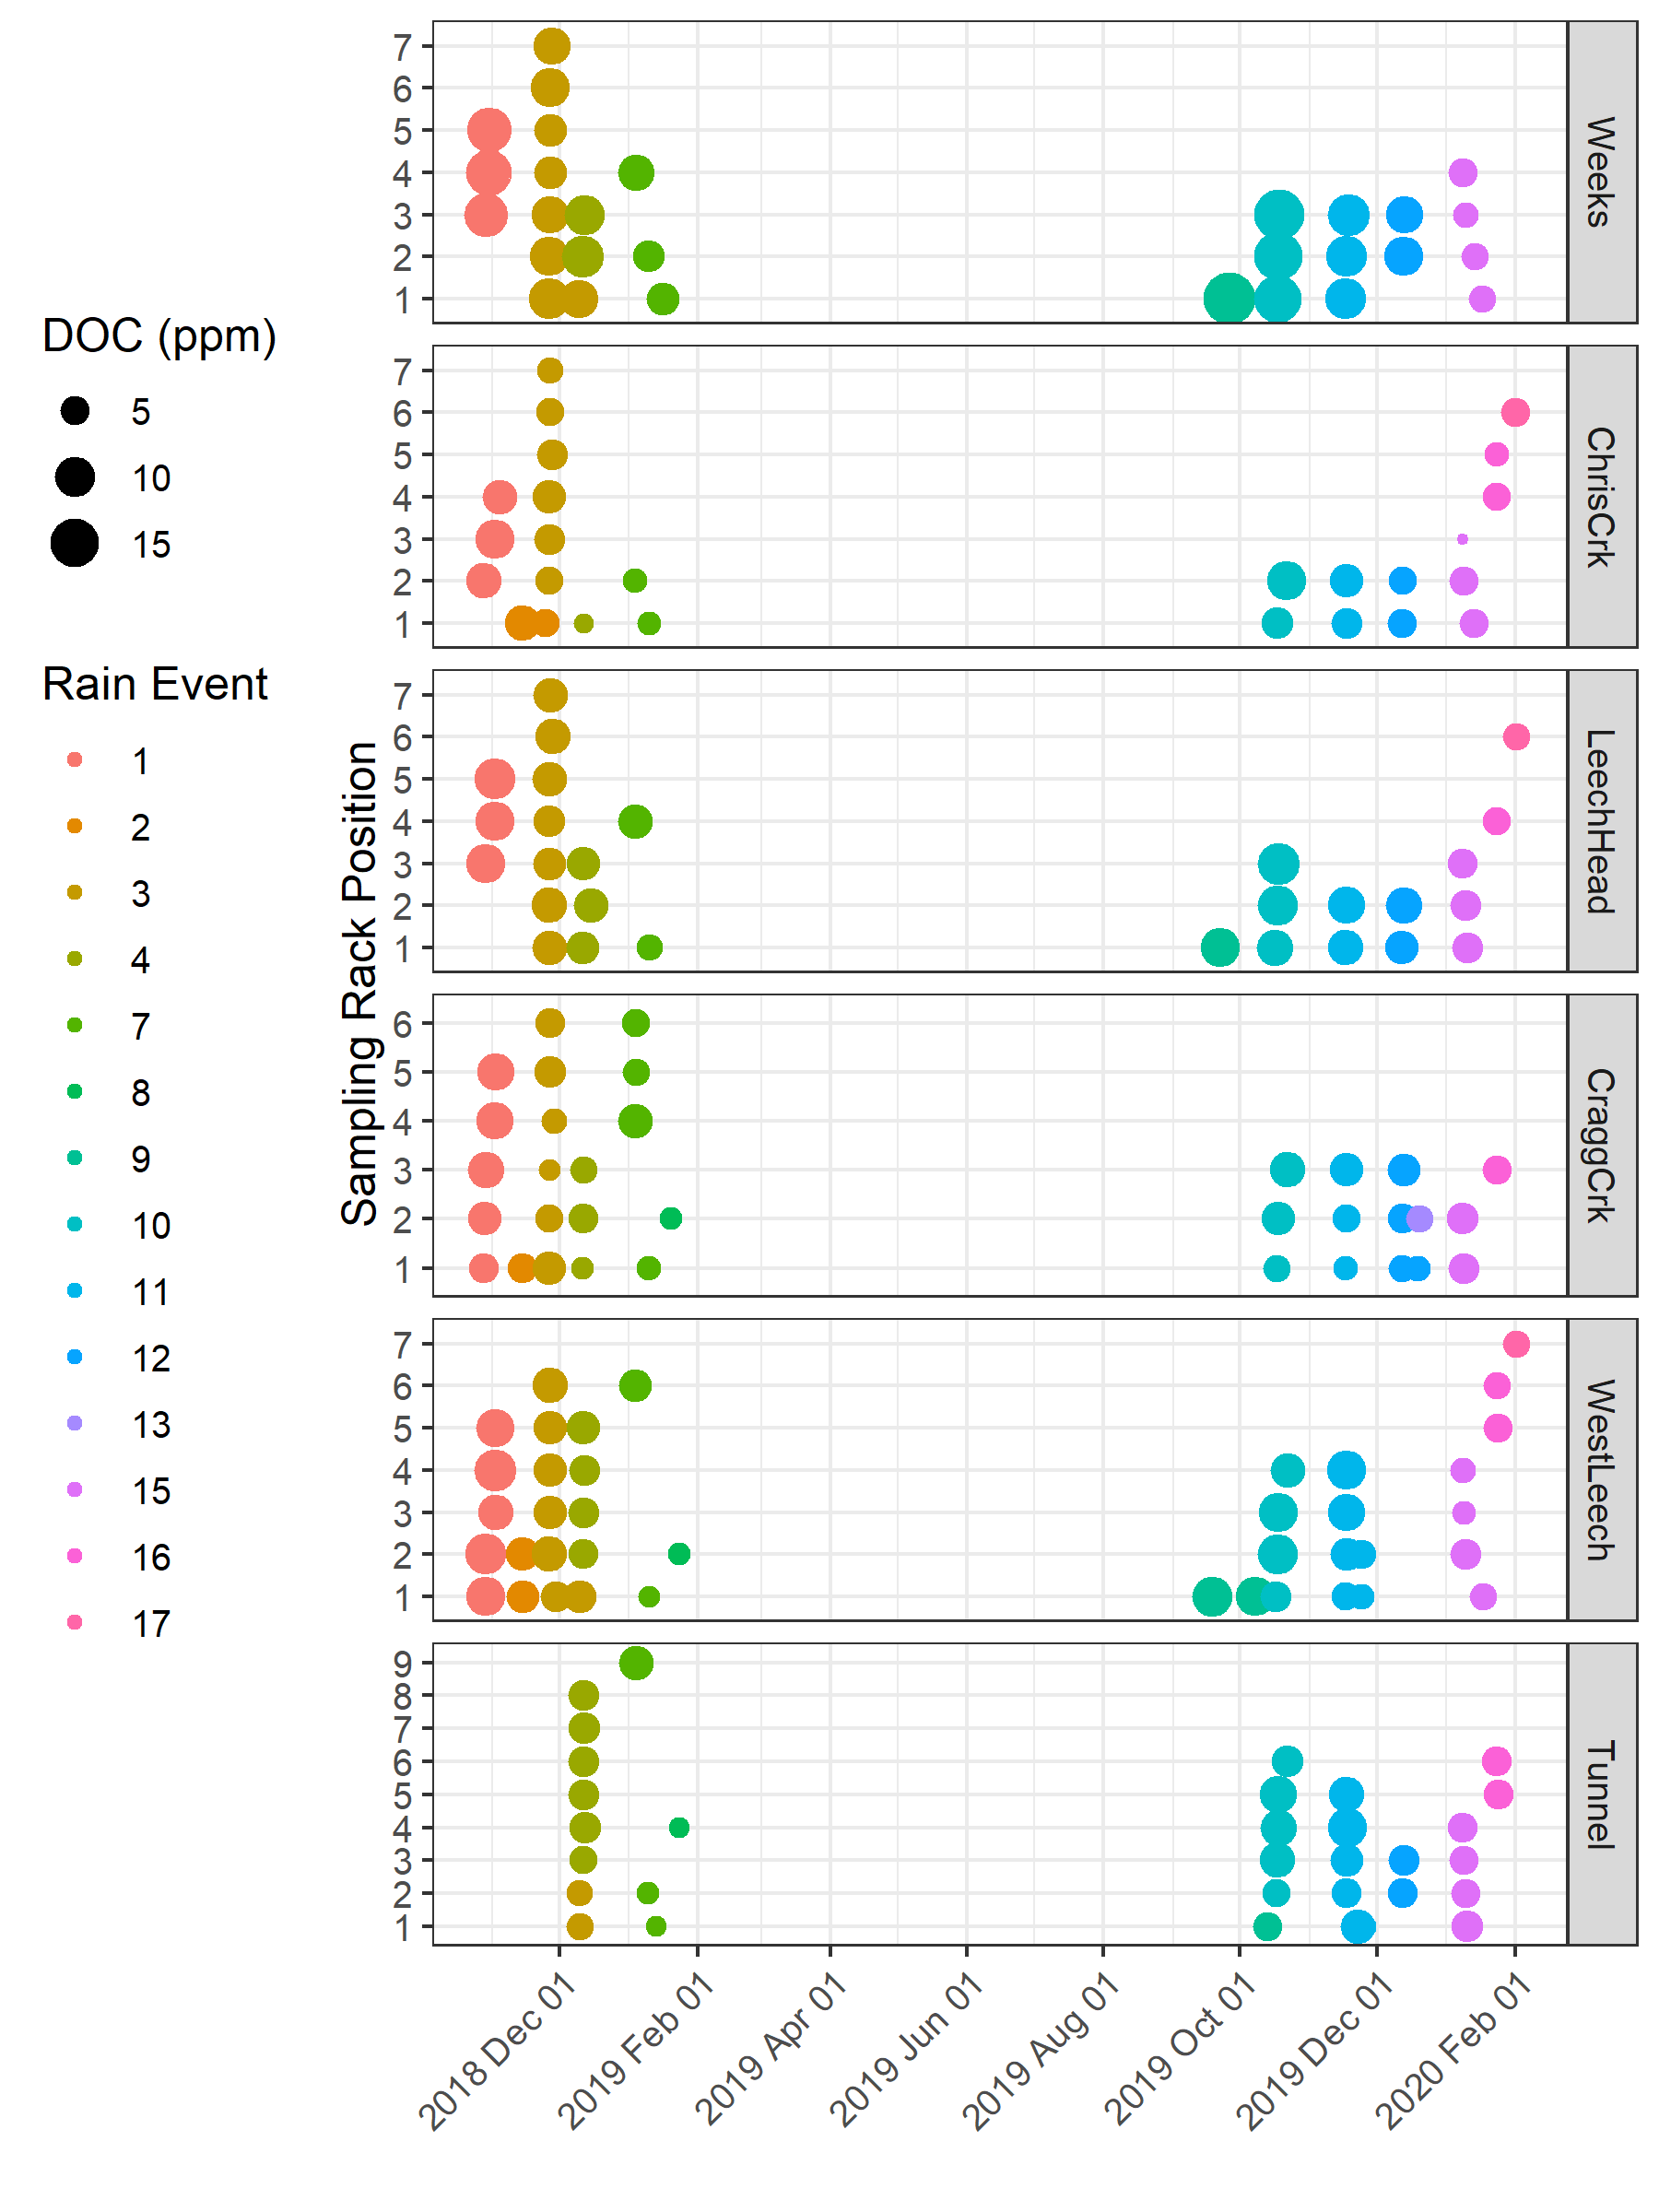

Figure 25: *DOC concentration trends in rising limb samples categorized by rain events*

## Quality Control

### Vertical Rack Hold-Time Experiments

Hold-time experiments were conducted to assess sample stability on the vertical racks, Figure 26 summarizes air temperature and timing of hold-time sets.

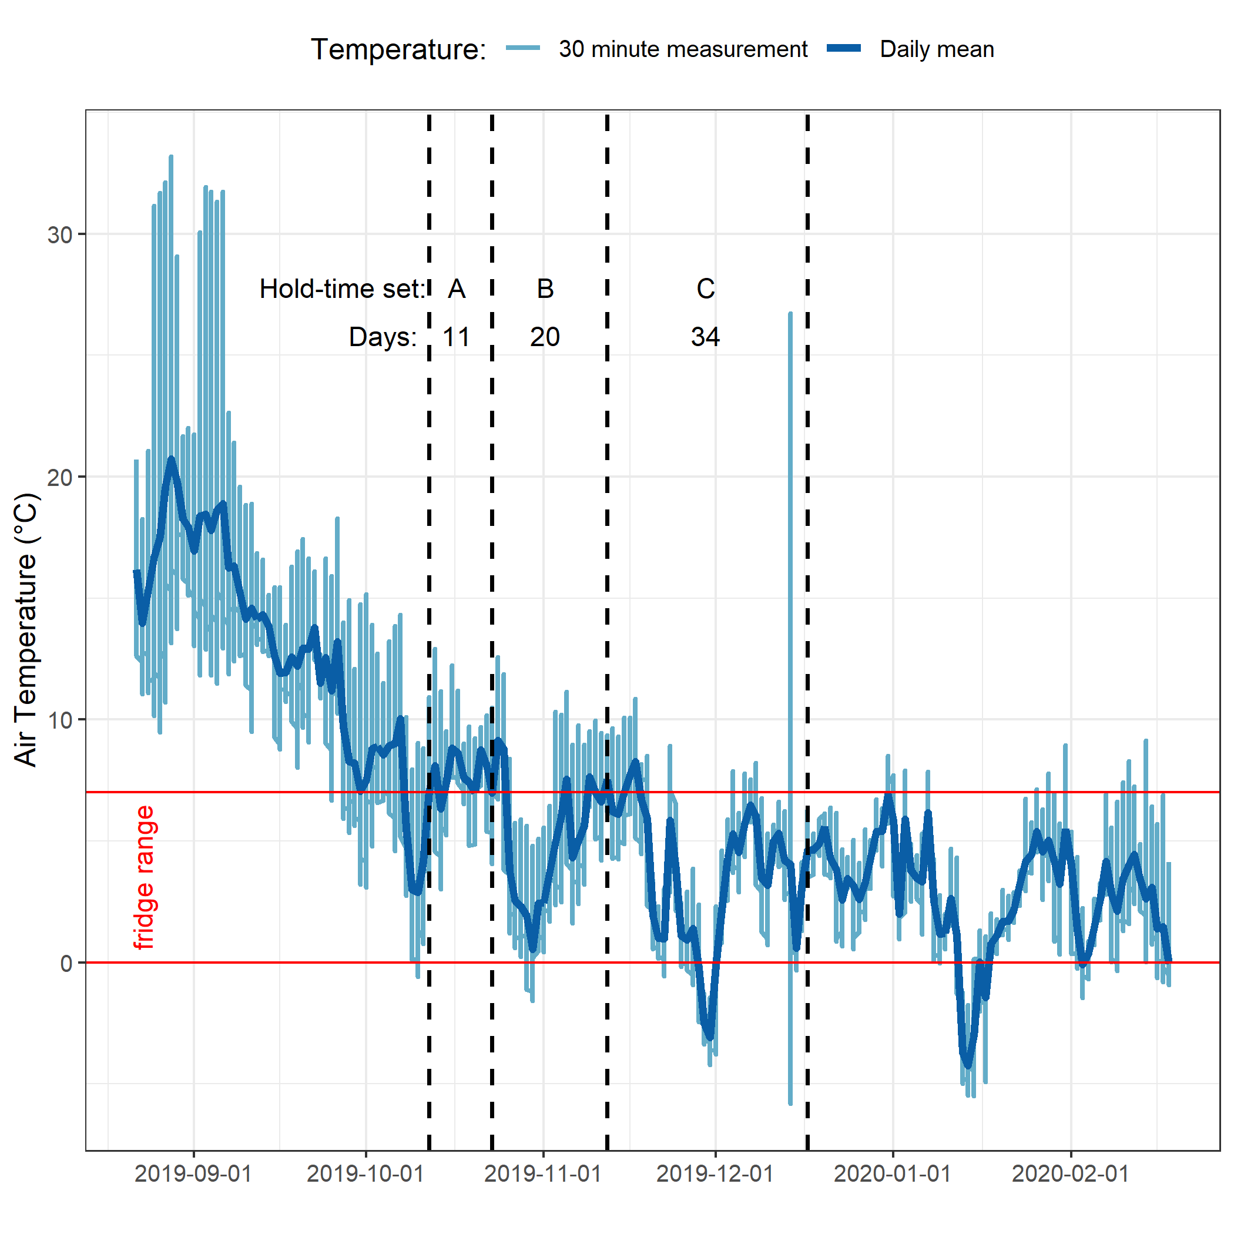

Figure 26: *Plot of air temperature during vertical rack hold-time experiments. Red horizontal lines indicate the 0-7°C range of a typical laboratory refrigerator and dashed vertical lines separate the three sets of hold-time samples.*

Results of t-tests are summarized in Table 15. There was a significant change in DOC concentration during hold-time set A, in which DOC-rich “first flush” samples were held for 11 days at average temperature of 7.3°C. Sets B and C did not show significant changes in DOC concentrations. Changes to UV absorbance at 254nm were observed for set C, which was held for 34 days at an average of 4.4°C with a period of sub-zero temperatures. These results suggest that freezing did not alter DOC concentrations but did effect DOM character (reduction in aromaticity).

* TO DO: calculate average temperatures & hold-times for rack samples during each event collection.

Table 15: *Results of t-tests comparing hold-time samples*

|  |  |  |  |  |  |  |  |  |  |
| --- | --- | --- | --- | --- | --- | --- | --- | --- | --- |
| Hold-time Set | Sample season | Days held | Mean temp. | DOC (mg/L): fresh // held | p-value (DOC) | DOC change | UV254 (mg/L): fresh // held | p-value (UV254) | UV254 change |
| A | first flush | 11 | 7.3°C ± 2.1°C | 7.54 ± 0.04 // 4.17 ± 0.13 | 0.0000010 | sig. | 14.59 ± 0.01 // 14.52 ± 0.08 | 0.1118622 | NA |
| B | wet | 20 | 6.1°C ± 2.7°C | 5.37 ± 0.1 // 5.49 ± 0.04 | 0.1342784 | NA | 19.14 ± 0.07 // 17.62 ± 3.08 | 0.3254723 | NA |
| C | wet | 34 | 4.4°C ± 3.2°C | 3.31 ± 0.16 // 2.56 ± 1.11 | 0.1727405 | NA | 13.52 ± 2.99 // 8.91 ± 2.15 | 0.0147941 | sig. |

### Laboratory

UBC-based laboratory analysis of samples resulted in an overall accuracy of 3.7% based on analysis of 20 calibration verification standards.

***Random Forests***

* in progress

# Discussion

# Conclusions

# References

Abbott, Benjamin W., Gérard Gruau, Jay P. Zarnetske, Florentina Moatar, Lou Barbe, Zahra Thomas, Ophélie Fovet, et al. 2018. “Unexpected spatial stability of water chemistry in headwater stream networks.” *Ecology Letters* 21 (2): 296–308. <https://doi.org/10.1111/ele.12897>.

Aiken, George R., Heileen Hsu-Kim, and Joseph N. Ryan. 2011. “Influence of dissolved organic matter on the environmental fate of metals, nanoparticles, and colloids.” *Environmental Science and Technology* 45 (8): 3196–3201. <https://doi.org/10.1021/es103992s>.

Avagyan, Armine, Benjamin R. K. Runkle, and Lars Kutzbach. 2014. “Application of high-resolution spectral absorbance measurements to determine dissolved organic carbon concentration in remote areas.” *Journal of Hydrology* 517: 435–46. <https://doi.org/10.1016/j.jhydrol.2014.05.060>.

British Columbia Ministry of Environment. 2017. “Source Drinking Water Quality Guidelines: Guideline Summary.” Victoria, B.C.: Prov. B.C. <https://www2.gov.bc.ca/gov/content/governments/organizational-structure/ministries-organizations/ministries/environment-climate-change>.

Canadian Council of Ministers of the Environment. 2004. “From source to tap : guidance on the multi-barrier approach to safe drinking water.”

Chow, Alex T., Randy A. Dahlgren, Qian Zhang, and P. K. Wong. 2008. “Relationships between specific ultraviolet absorbance and trihalomethane precursors of different carbon sources.” *Journal of Water Supply: Research and Technology - AQUA* 57 (7): 471–80. <https://doi.org/10.2166/aqua.2008.064>.

Creed, IF Irena F, DM Diane M Mcknight, Brian A Pellerin, Mark B Green, Brian A Bergamaschi, George R Aiken, Douglas A Burns, et al. 2015. “The river as a chemostat : fresh perspectives on dissolved organic matter flowing down the river continuum.” *Canadian Journal of Fisheries and Aquatic Sciences* 14 (April): 1–14. <https://doi.org/10.1139/cjfas-2014-0400>.

Critten, John C. Trussell, Rhodes. Hand, David. Howe, Kerry. Tchobanoglous, George. 2014. *MWH Water Treatment Principles and Design*. <https://doi.org/10.1016/B978-0-12-382092-1.00019-1>.

Delpla, Ianis, and Manuel J. Rodriguez. 2016. “Experimental disinfection by-product formation potential following rainfall events.” *Water Research* 104: 340–48. <https://doi.org/10.1016/j.watres.2016.08.031>.

Dudley, N, and S Stolton. 2003. “Running Pure: The importance of forest protected areas to drinking water.” World Bank / WWF Alliance for Forest Conservation; Sustainable Use. [http://scholar.google.com/scholar?hl=en{\&}btnG=Search{\&}q=intitle:Running+Pure{\#}1](http://scholar.google.com/scholar?hl=en%7B\&%7DbtnG=Search%7B\&%7Dq=intitle:Running+Pure%7B\#%7D1).

Eaton, A. D., Clesceri, L. S., Greenberg, A. E., Franson, M. A. H. 2000. “Total Organic Carbon (TOC) - 5310 A.” In *Standard Methods for the Examination of Water and Wastewater*, 6th ed., 19–20. Washington, DC: American Public Health Association. <http://www.standardmethods.org/>.

Emelko, Monica B., Uldis Silins, Kevin D. Bladon, and Micheal Stone. 2011. “Implications of land disturbance on drinking water treatability in a changing climate: Demonstrating the need for " source water supply and protection" strategies.” *Water Research* 45 (2): 461–72. <https://doi.org/10.1016/j.watres.2010.08.051>.

Graczyk, David J., Dale M. Robertson, William J. Rose, and Jeffrey J. Steur. 2000. “Comparison of water-quality samples collected by siphon samplers and automatic samplers in Wisconsin.” Middleton, Dane County, Wisconsin: U.S. Department of the Interior U.S. Geological Survey. <https://doi.org/10.3133/fs06700>.

Health Canada. 2019. “Guidance on Natural Organic Matter in Drinking Water.” <https://www.canada.ca/content/dam/hc-sc/documents/programs/consultation-organic-matter-drinking-water/NOM20190129-eng.pdf>.

HealthCanada. 2006. “Drinking Water Chlorination.” <https://www.canada.ca/en/health-canada/services/healthy-living/your-health/environment/drinking-water-chlorination.html>.

HealthLinkBC. 2018. “Drinking Water Chlorination,” no. 49. <https://www.healthlinkbc.ca/healthlinkbc-files/drinking-water-chlorination>.

Helms, John R, Avon Stubbins, Jason D Ritchie, Elizabeth C Minor, and Kenneth Mopper. 2008. “Absorption Spectral Slopes and Slope Ratios as Indicators of Molecular Weight , Source , and Photobleaching of Chromophoric Dissolved Organic Matter Author ( s ): John R . Helms , Aron Stubbins , Jason D . Ritchie , Elizabeth C . Minor , David J . Kieber.” *Limnology and Oceanography* 53 (3): 955–69. <https://www.jstor.org/stable/40058211>.

Hua, Guanghui, David A. Reckhow, and Ibrahim Abusallout. 2015. “Correlation between SUVA and DBP formation during chlorination and chloramination of NOM fractions from different sources.” *Chemosphere* 130: 82–89. <https://doi.org/10.1016/j.chemosphere.2015.03.039>.

Jacangelo, Joseph G., Jack DeMarco, Douglas M. Owen, and Stephen J. Randtke. 1995. “Selected processes for removing NOM: An overview.” *Journal / American Water Works Association* 87 (1): 64–77. <https://doi.org/10.1002/j.1551-8833.1995.tb06302.x>.

Johnson, Lucinda, Carl Richards, George Host, and John Arthur. 1997. “Landscape influences on water chemistry in Midwestern stream ecosystems.” *Freshwater Biology* 37: 193–208. <https://doi.org/doi:10.1046/j.1365-2427.1997.d01-539.x>.

LaZerte, Bruce. 1991. “Metal transport and retention: the role of dissolved organic carbon.” December. Ontario: Dorset Research Centre, for Ontario Ministry of the Environment. <https://archive.org/details/metaltransportre00lazeuoft/mode/2up>.

Li, Angzhen, Xu Zhao, Ran Mao, Huijuan Liu, and Jiuhui Qu. 2014. “Characterization of dissolved organic matter from surface waters with low to high dissolved organic carbon and the related disinfection byproduct formation potential.” *Journal of Hazardous Materials* 271: 228–35. <https://doi.org/10.1016/j.jhazmat.2014.02.009>.

Matilainen, Anu, Egil T. Gjessing, Tanja Lahtinen, Leif Hed, Amit Bhatnagar, and Mika Sillanpää. 2011. “An overview of the methods used in the characterisation of natural organic matter (NOM) in relation to drinking water treatment.” *Chemosphere* 83 (11): 1431–42. <https://doi.org/10.1016/j.chemosphere.2011.01.018>.

Matilainen, Anu, Mikko Vepsäläinen, and Mika Sillanpää. 2010. “Natural organic matter removal by coagulation during drinking water treatment: A review.” *Advances in Colloid and Interface Science* 159 (2): 189–97. <https://doi.org/10.1016/j.cis.2010.06.007>.

Meyer, Judy L., and Cathy M . Tate. 1983. “The Effects of Watershed Disturbance on Dissolved Organic Carbon Dynamics of a Stream.” *Ecology* 64 (1): 33–44. <https://www.jstor.org/stable/1937326>.

Mistick, Emily. 2019. “Forest harvest and water treatability: Analysis of dissolved organic carbon in headwater streams of contrasting forest harvest history during base flow and storm flow.” PhD thesis, UNIVERSITY OF BRITISH COLUMBIA.

Mosher, Jennifer J., Louis A. Kaplan, David C. Podgorski, Amy M. McKenna, and Alan G. Marshall. 2015. “Longitudinal shifts in dissolved organic matter chemogeography and chemodiversity within headwater streams: a river continuum reprise.” *Biogeochemistry* 124 (1-3): 371–85. <https://doi.org/10.1007/s10533-015-0103-6>.

Oni, S. K., M. N. Futter, K. Bishop, S. J. Köhler, M. Ottosson-Löfvenius, and H. Laudon. 2013. “Long-term patterns in dissolved organic carbon, major elements and trace metals in boreal headwater catchments: Trends, mechanisms and heterogeneity.” *Biogeosciences* 10 (4): 2315–30. <https://doi.org/10.5194/bg-10-2315-2013>.

Palleiro, L., M. L. Rodríguez-Blanco, M. M. Taboada-Castro, and M. T. Taboada-Castro. 2013. “The influence of discharge, pH, dissolved organic carbon, and suspended solids on the variability of concentration and partitioning of metals in a rural catchment.” *Water, Air, and Soil Pollution* 224 (8). <https://doi.org/10.1007/s11270-013-1651-9>.

Peuravuori, Juhani, and Kalevi Pihlaja. 1997. “Molecular size distribution and spectroscopic properties of aquatic humic substances.” *Analytica Chimica Acta* 337 (2): 133–49. <https://doi.org/10.1016/S0003-2670(96)00412-6>.

Pike, R., M. Feller, J. Stednick, K Rieberger, and M Carver. 2010. “Water Quality and Forest Management.” In *Compendium of Forest Hydrology and Geomorphology in British Columbia: Volume 2 of 2*, 400–439. [https://www.for.gov.bc.ca/hfd/pubs/docs/lmh/Lmh66/LMH66{\_}volume2of2.pdf](https://www.for.gov.bc.ca/hfd/pubs/docs/lmh/Lmh66/LMH66%7B_%7Dvolume2of2.pdf).

Rautu, Roxana. 2019. “Linking Seasonal and Spatial Stream Carbon Dynamics to Landscape Characteristics in Selected Watersheds on the Olympic Peninsula.” PhD thesis, University of Washington.

Raymond, Peter A, James E Saiers, Source Biogeochemistry, No September, Peter A Raymond, and James E Saiers. 2010. “Event controlled DOC export from forested watersheds.” *Biogeochemistry* 100 (1): 197–209. <https://doi.org/10.1007/sl0533-010-9416-7>.

Raymond, Peter A, James E Saiers, William V Sobczak, and E James. 2016. “Hydrological and biogeochemical controls on watershed dissolved organic matter transport: pulse-shunt concept.” *Ecology* 97 (1): 5–16. <https://www.jstor.org/stable/24702986>.

Richardson, Susan D., Michael J. Plewa, Elizabeth D. Wagner, Rita Schoeny, and David M. DeMarini. 2007. “Occurrence, genotoxicity, and carcinogenicity of regulated and emerging disinfection by-products in drinking water: A review and roadmap for research.” *Mutation Research - Reviews in Mutation Research* 636 (1-3): 178–242. <https://doi.org/10.1016/j.mrrev.2007.09.001>.

Stanley, Emily H., Stephen M. Powers, Noah R. Lottig, Ishi Buffam, and John T. Crawford. 2012. “Contemporary changes in dissolved organic carbon (DOC) in human-dominated rivers: Is there a role for DOC management?” *Freshwater Biology* 57 (SUPPL. 1): 26–42. <https://doi.org/10.1111/j.1365-2427.2011.02613.x>.

Ussery, Joel, and AECOM. 2015. “Leech Water Supply Area: An Assessment for Source Water Protection and Land Management.” April. Victoria, B.C.: Capital Regional District, Watershed Protection Division, Integrated Water Services.

Vannote, Robin L., G. Wayne Minshall, Kenneth W. Cummins, James R. Sedell, and Colbert E. Cushing. 1980. “The River Continuum Concept.” *Canadian Journal of Fisheries and Aquatic Sciences* 30 (1): 130–37.

Vidon, Philippe, Laura E. Wagner, and Emmanuel Soyeux. 2008. “Changes in the character of DOC in streams during storms in two Midwestern watersheds with contrasting land uses.” *Biogeochemistry* 88 (3): 257–70. <https://doi.org/10.1007/s10533-008-9207-6>.

Weishaar, James L., George R. Aiken, Brian A. Bergamaschi, Miranda S. Fram, Roger Fujii, and Kenneth Mopper. 2003. “Evaluation of specific ultraviolet absorbance as an indicator of the chemical composition and reactivity of dissolved organic carbon.” *Environmental Science and Technology* 37 (20): 4702–8. <https://doi.org/10.1021/es030360x>.

Yang, Liyang, Jin Hur, Sonmin Lee, Soon Woong Chang, and Hyun Sang Shin. 2015. “Dynamics of dissolved organic matter during four storm events in two forest streams: source, export, and implications for harmful disinfection byproduct formation.” *Environmental Science and Pollution Research* 22 (12): 9173–83. <https://doi.org/10.1007/s11356-015-4078-6>.

Zarnetske, Jay P., Martin Bouda, Benjamin W. Abbott, James Saiers, and Peter A. Raymond. 2018. “Generality of Hydrologic Transport Limitation of Watershed Organic Carbon Flux Across Ecoregions of the United States.” *Geophysical Research Letters* 45 (21): 11, 702–11, 711. <https://doi.org/10.1029/2018GL080005>.