**Hardik Patel HW9**

**Data Modeling**

[https://app.quickdatabasediagrams.com/#/d/jbfftI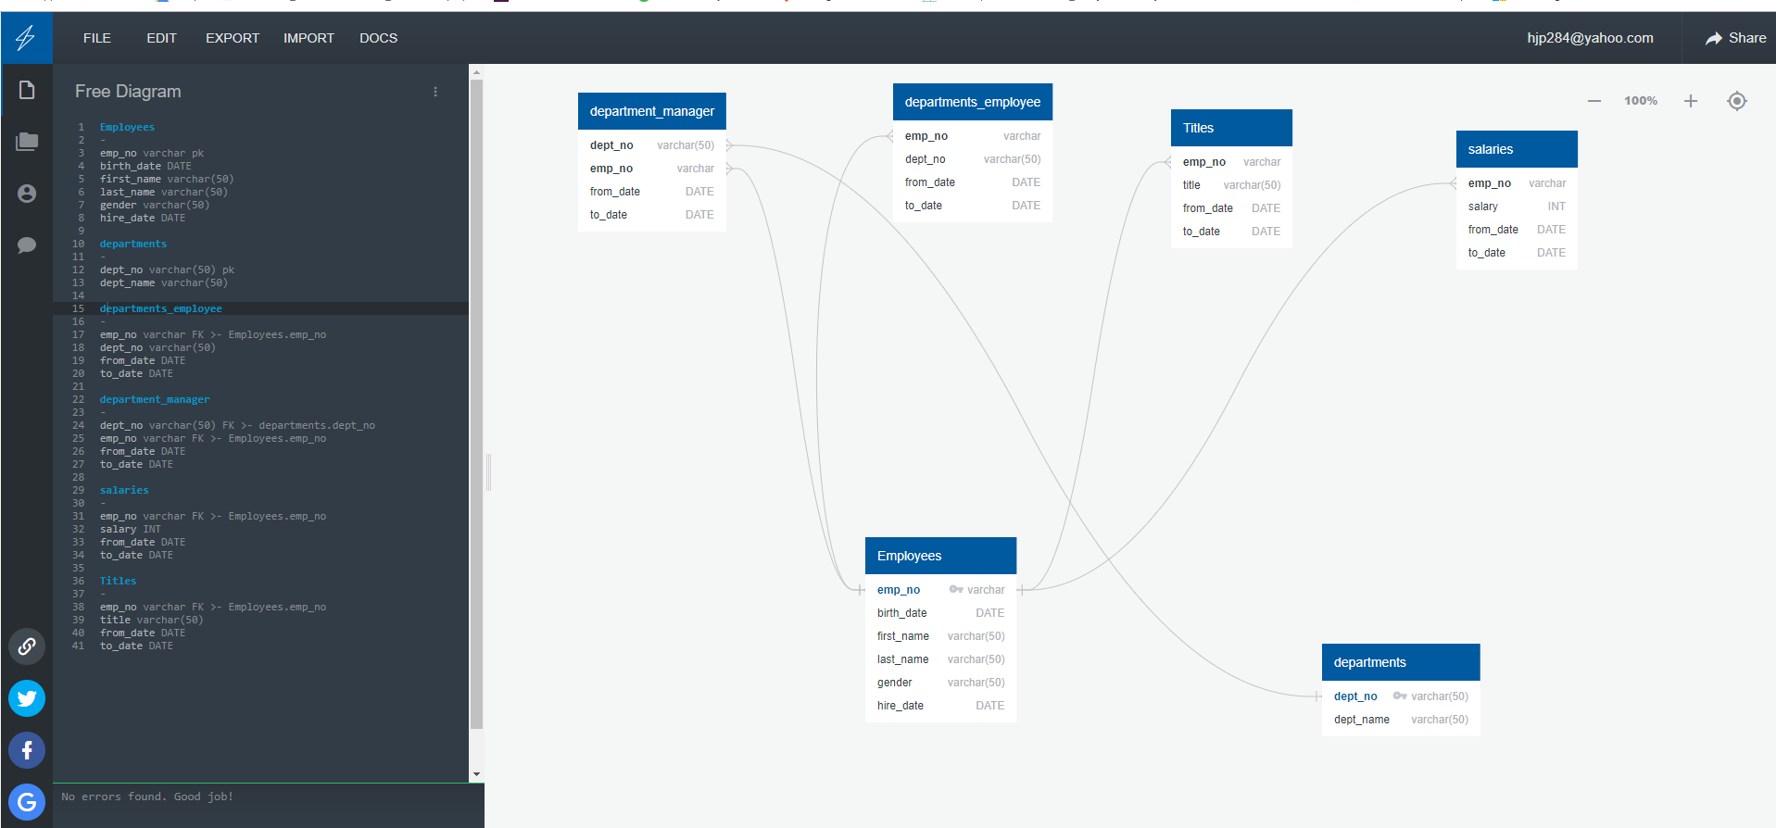](https://app.quickdatabasediagrams.com/#/d/jbfftI)

**Data Engineering**

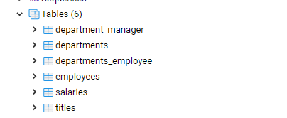

**Data Analysis**

1. List the following details of each employee: employee number, last name, first name, gender, and salary.

Select emp.emp_no, emp.last_name, emp.first_name, emp.gender, sal.salary

from employees as emp

Join salaries as sal

On emp.emp_no = sal.emp_no;

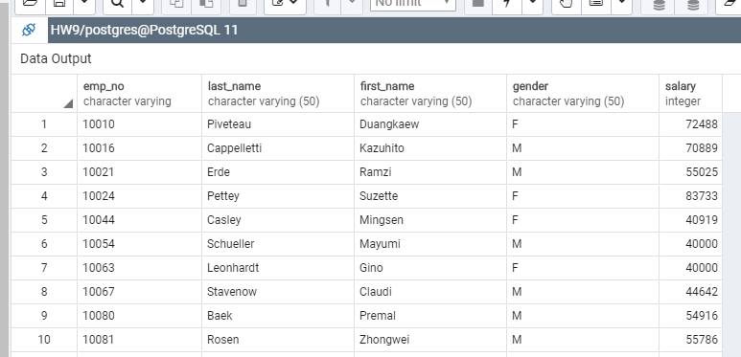

1. List employees who were hired in 1986.

Select *

from employees as emp

where extract (year from emp.hire_date)=1986

order by hire_date;

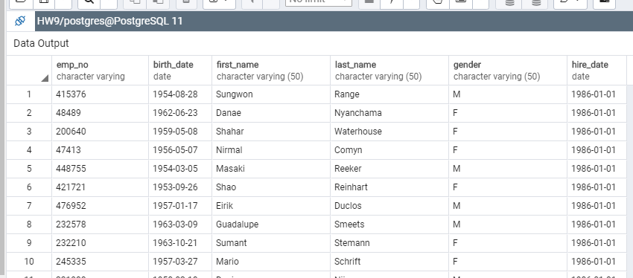

1. List the manager of each department with the following information: department number, department name, the manager's employee number, last name, first name, and start and end employment dates.

Select emp.emp_no, emp.first_name, emp.last_name, dept.dept_no, dept.dept_name, dm.from_date, dm.to_date

from employees as emp

Join department_manager as dm

On emp.emp_no = dm.emp_no

Join departments as dept

on dept.dept_no = dm.dept_no;

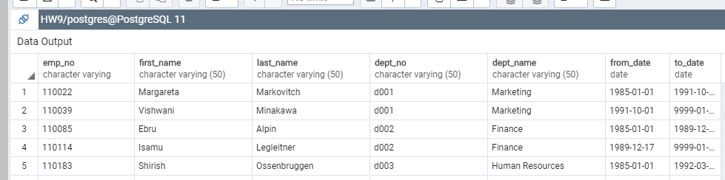

1. List the department of each employee with the following information: employee number, last name, first name, and department name.

Select de.emp_no, emp.last_name, emp.first_name, dept.dept_name

from employees as emp

join departments_employee as de

On emp.emp_no = de.emp_no

Join departments as dept

on dept.dept_no = de.dept_no

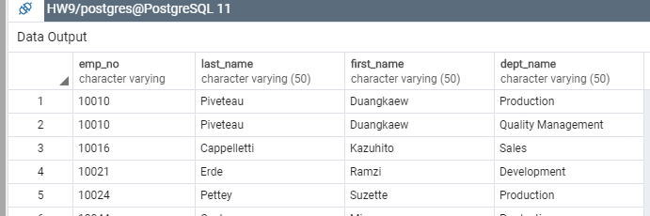

1. List all employees whose first name is "Hercules" and last names begin with "B."

select * from employees

where first_name = 'Hercules'

and last_name like 'B%'

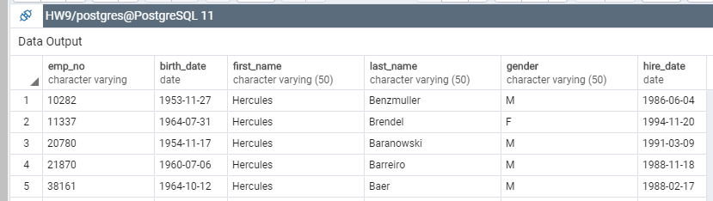

1. List all employees in the Sales department, including their employee number, last name, first name, and department name.

Select de.emp_no, emp.last_name, emp.first_name, dept.dept_name

from employees as emp

join departments_employee as de

On emp.emp_no = de.emp_no

Join departments as dept

on dept.dept_no = de.dept_no

where dept_name = 'Sales'

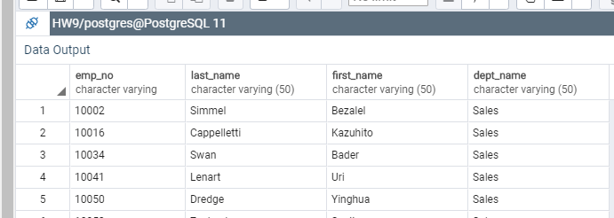

1. List all employees in the Sales and Development departments, including their employee number, last name, first name, and department name.

Select de.emp_no, emp.last_name, emp.first_name, dept.dept_name

from employees as emp

join departments_employee as de

On emp.emp_no = de.emp_no

Join departments as dept

on dept.dept_no = de.dept_no

where dept_name = 'Sales'

OR dept_name = 'Development'

order by dept_name

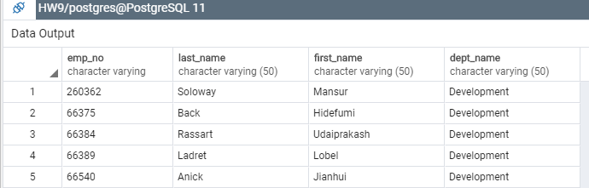

1. In descending order, list the frequency count of employee last names, i.e., how many employees share each last name.

Select last_name, count(last_name) as lastname_count

from employees

group by last_name

order by lastname_count desc

