Monthly Progress Report

for

NAS2-03144

University Affiliated Research Center (UARC)

Task TO.101-S.0.PK.A

Fundamental Research for UAS Traffic Management Challenges

March 2015

Prepared for

NASA Ames Research Center
Moffett Field, California 94035

By

University of California – Santa Cruz




March 2015

SUMMARY DESCRIPTION OF ACTIVITY
The proposed research aims to investigate methods for leveraging concepts from probabilistic optimal control to improve the robustness of human-engineered rules used previously. The goal is to apply these probabilistic methods to adapting rules from the Advanced Airspace Concept (AAC) for use with UAS Traffic Management (UTM). Work under this task will constitute conducting cutting-edge research on automating portions of the nation’s air transportation system under NASA’s Airspace Operations and Safety Program. The researchers will work closely with NASA researchers, contractors, and outside researchers to conceptualize and prototype new technologies for an air traffic management system tailored to low-altitude, class G airspace.

GENERAL STATUS:
For the month of March, we developed a decomposition algorithm that solves the multi-threat encounter problem to local optimization, and stress tested our algorithm against several other baseline algorithms, demonstrated the validity and performance of our approach. We also submitted two papers to the 54th IEEE Conference on Decision and Control, one on exact reconstruction of high-dimensional reachability computations from low-dimensional computations, and the other on using reachability to synthesize liveness and safety controllers in quadrotor platoons.

ACCOMPLISHMENTS
Developed an algorithm that decomposes the multi-threat encounter problem
We formulated the multi-threat encounter problem as a multi-agent Markov decision process (MMDP) and applied decomposition and local optimization techniques to it. In general, obtaining a globally optimal policy to the multi-threat problem as a full MMDP is computationally intractable. As such, we used a strategy that first decomposes the MMDP into pairwise encounters between all aircraft, and then used the pairwise solutions to get a locally optimal solution to the MMDP.
The pairwise solution was explained in the previous monthly report. The local optimization procedure is an online operation as follows. Each aircraft
- Broadcasts its positional information in quantized levels (e.g., range, bearing)
- Computes initial local solution to observed problem: a local solution is derived using utility fusion and the joint equilibrium search for policy (JESP) local optimization technique
- Broadcasts its coordination message: message includes own action and suggested turn sense for each aircraft; turn sense can be go straight, turn left or right, or do anything
- Incorporates coordination messages to offline solution: convert suggested turn sense into online costs and run JESP again using each aircraft's broadcast actions and online costs to obtain final solution.
Note that because positional information obtained by each aircraft from other aircraft is quantized, the global picture that each aircraft has is slightly different, and the coordination messages help improve the estimation.
To aid visualization, the locally optimal policy using utility fusion is shown below. The aircraft have a 500 m minimum separation requirement, and positive and negative angles on the heatbar correspond to left and right turns by the indicated degrees. The left inset indicates what ownship should do given the xy position, and the remaining 2 indicate what intruders should do if ownship is at the shown xy position. Notice that there is a slight asymmetry due to local optima convergence, and the “patches” in the middle and right insets indicate that both intruder aircraft should turn to the left or right in a synchronized fashion. This agrees with intuition.
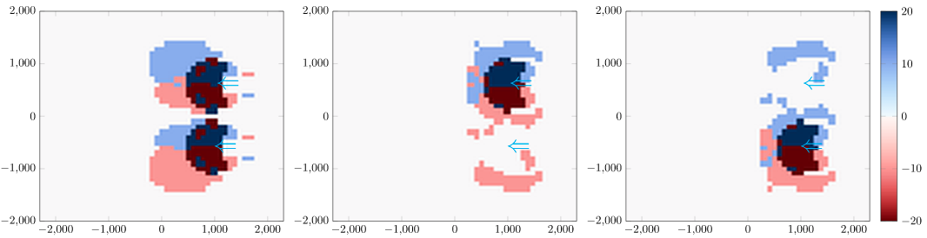

Stress tested approach against baselines
To validate our algorithm, we stress tested it against 3 other policies. We randomly initialized 2-9 aircraft in an annulus on the horizontal plane. All started with 10 m/s speed for simplicity, pairwise minimum separation of at least 750 m, and all headed towards the center of annulus. Measurement imperfection was modeled with position and heading quantization, the dynamics of each aircraft were simulated using an ODE solver with Gaussian noise in acceleration and turning, with each aircraft generating PID control policies from the resolution advisory during simulation. The stress test policies are as follows.
- Naive, closest-pair solution (no utility fusion): simply finds the closest intruder and execute the best action based on the pairwise encounter MDP look-up table
- Decentralized, uncoordinated with utility fusion: assumes all white noise intruders and executes best JESP action based on assumption
- Decentralized, coordinated with utility fusion: follows our algorithm described in previous section
- Centralized with utility fusion: executes JESP solution for all aircraft, with measurement uncertainty (quantization of state variables)
An example initial configuration of all aircraft is shown below on the left, and an example simulation result is shown below on the right.
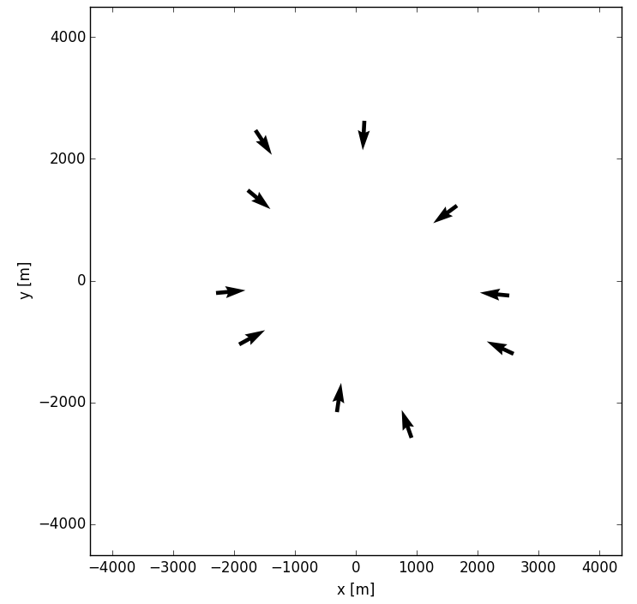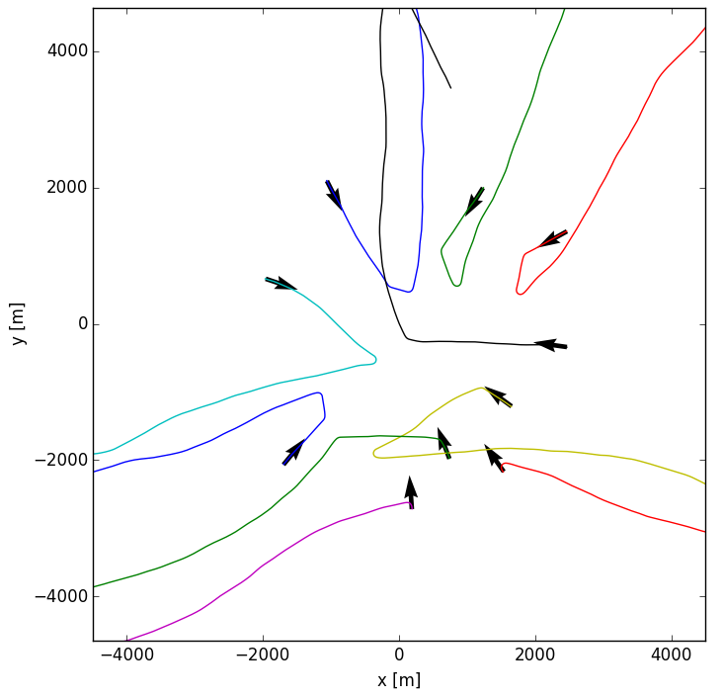

The simulation results show that our algorithm performs significantly better than all other baseline policies. Below is the result.
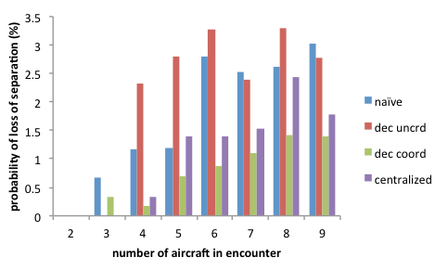
Developed a decoupled Hamilton-Jacobi reachability formulation and applied the theory to safe platooning of UAVs
Hamilton-Jacobi (HJ) reachability is a powerful framework for providing conditions under which these requirements can be met, and for synthesizing the optimal controller for meeting them. However, due to the curse of dimensionality, HJ reachability is only tractable for a small number of vehicles if their set of maneuvers is unrestricted.

We defined a platoon to be a group of UAVs in a single-file formation. We modeled each vehicle as a hybrid system with modes corresponding to its role in the platoon, and specified the set of allowed maneuvers in each mode to make the analysis tractable. We consider the following essential cooperative maneuvers:
- Safely merging onto an air highway
- Safely joining and platoon
- Reacting to a malfunctioning vehicle in the platoon
- Reacting to an intruder vehicle

We proposed several liveness controllers based on HJ reachability, and wrapped a safety controller, also based on HJ reachability, around the liveness controllers. For a single altitude range, our approach guarantees safety for one safety breach; in the unlikely event of multiple safety breaches, safety can be guaranteed over multiple altitude ranges.

In order to achieve the above, we proposed the following controllers for UAVs:
Reachability-based liveness controllers
- Merging onto an air highway
- Merging into a platoon

Other liveness controllers
- Traveling along an air highway
- Following a platoon

Safety controller wrapped around liveness controllers
- Ensures pairwise safety at the same altitude range among all vehicles

Liveness controllers are used unless a safety breach occurs; when this occurs, the affected UAVs switch to the safety controller. In principle, our scheme requires multiple altitude ranges to resolve multiple conflicts, but in simulations, multiple conflicts appear unlikely given the single-file platoon formation.

Reachability computations were performed using the decoupled HJ formulation, which enable exact reconstruction of the reachable sets in decoupled systems by combining lower-dimensional reachable sets in each of the decoupled components. This allowed us to compute the 4D liveness reachable sets in real time (via two 2D computations), and made 6D safety reachable set computations tractable.

Simulations
- Joining highway and platoon: Figure 2 shows the use of liveness reachable sets (dotted boundaries) to “lock-in” a target position or relative position (circles) in order for the red UAV to merge onto a highway (black dotted line), and for the blue UAV to join the platoon. The dashed boundaries are the safety reachable sets that the vehicle of the same color must stay out of. Figure 3 shows the resulting behavior from 5 UAVs merging onto the highway and forming a platoon.
- Malfunctioning vehicle within the platoon: Figure 4 shows the black vehicle malfunctioning, and begins following the highway in the reverse direction. As a result, the green vehicle comes near the boundary of the safety reachable set (dashed boundary) and a safety breach occurs. By applying the safety controller, the last two vehicles (purple and green) smoothly avoid the black vehicle and rejoins the platoon afterwards.
- Intruder vehicle: an intruder (red) across the highway and crosses the path of the platoon. The platoon leader (black) is unaffected, but the remaining members must use the safety controller when they are near the safety reachable set boundary. Two of the vehicles avoid the intruder with minimal deviation in their intended path; however, the last vehicle is delayed significantly before rejoining with the platoon. Figure 5 shows only the trajectories, and figure 6 shows the safety reachable sets for the blue vehicle.

DELIVERABLES
- None

Papers and Presentations
Author | Title | Form (paper or presentation) | Name of Journal or Conference | Anticipated Date of Publication or Presentation | Status
Mo Chen, Qie Hu, Casey Mackin, Jaime Fisac, Claire Tomlin | Safe Platooning of Unmanned Aerial Vehicles via Reachability | Conference Paper | 54th IEEE Conference on Decision and Control | December 15-18, 2015 | Submitted
Mo Chen, Claire Tomlin | Exact and Efficient Hamilton-Jacobi Reachability for Decoupled Systems | Conference Paper | 54th IEEE Conference on Decision and Control | December 15-18, 2015 | Submitted

SCHEDULE CONFORMANCE
- On schedule

PROBLEM AREAS AND MITIGATIONS
- None

TECHNOLOGY REPORTING
- None.

OTHER ISSUES (e.g., security/safety)

No security/safety issues to report

ACTIVITIES PLANNED FOR NEXT PERIOD
Improve local optimization technique
We can extend the JESP local optimization technique with tabu search for better local optimization, and use finer state discretization for pairwise encounter MDP to potentially obtain better performance.

Incorporate return-to-path actions
We will also explore techniques for aircraft to return to path after following the resolution advisory and getting out of a potential conflict. Potentially, we can include some switching logic between conflict resolution and return-to-path advisory generation when the aircraft is clear of conflict.

Refine platooning proposal

We will continue to explore UAV platooning by investigating platoon-platoon interactions, refining our previous safety guarantees, and considering highway intersections. We intend to use HJ reachability for providing liveness and safety guarantees by treating each platoon as a single unit, as opposed to a number of UAVs.

UPCOMING DELIVERABLES
- None

TRAVEL

Traveler | Date (From/To) | Destination | Reason

COST DATA
The 533M for this task will be provided via a separate submission by the tenth working day of the month following the reporting period.

APPROVED:

Approved via e-mail |  |  |  | Approved via e-mail
Bassam Musaffar |  | Date |  | Angela Wray |  | Date
Task Manager |  |  |  | Managing Director

