**Monthly Progress Report**

for

**NAS2-03144**

**University Affiliated Research Center (UARC)**

**Task TO.101-S.0.PK.A**

**Fundamental Research for UAS Traffic Management Challenges**

**July 2015**

Prepared for

NASA Ames Research Center

Moffett Field, California 94035

By

University of California – Santa Cruz



# 

# July 2015

# SUMMARY DESCRIPTION OF ACTIVITY

First, the proposed research aims to investigate methods for leveraging concepts from probabilistic optimal control to improve the robustness of human-engineered rules used previously. The goal in this context is to apply these probabilistic methods to adapting rules from the Advanced Airspace Concept (AAC) for use with UAS Traffic Management (UTM). In parallel, the structure of air highway systems and platooning of vehicles is investigated using optimal control theory. The second goal is to find novel ways to use existing optimal control theory as well as develop new theory for the UTM application. Work under this task will constitute conducting cutting-edge research on automating portions of the nation’s air transportation system under NASA’s Airspace Operations and Safety Program. The researchers will work closely with NASA researchers, contractors, and outside researchers to conceptualize and prototype new technologies for an air traffic management system tailored to low-altitude, class G airspace.

**GENERAL STATUS:**

For the month of July, we continued implementation of the distributed conflict resolution server that will serve as a conflict detection and resolution system alongside the UTM client server. We also tested several extensions to the original MDP-based algorithm exploring the implications of computation and communication constraints. Finally, we extended our investigation of platooning to the situation of multiple highways.

# ACCOMPLISHMENTS

*Implemented conflict resolution algorithm on worker nodes*

Based on the system description in the previous report, we implemented the conflict resolution algorithm on the worker nodes and conducted unit tests on the software to check validity against our existing Julia implementation. As a recapitulation, the distributed system consists of a driver node and multiple worker nodes. The driver schedules work for the multiple worker nodes, which in our case determines if there is potential conflict and generates resolution advisories accordingly. The code is written in Scala and the repository can be found at

<https://bitbucket.org/sisl/utm-alpha/>.

*Explored impact of limited computation and communication resources*

For clarity, our results follow a question-and-answer format.

Q: How much does restricting the maximum number of iterations for the JESP search heuristic impact performance?

A: General trend suggests that conflict probability decreases with larger iteration number limits with diminishing returns, as expected. (Simulations were ran with maxmin utility fusion.)

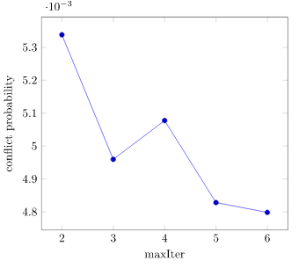

Q: How does changing the type of coordination messages and, subsequently, the way coordination messages are used impact performance?

A: Consider the following two types of coordination messages.

1. First type is to average message to get overall consensus on what ownship should do; consensus is given as the net direction of the sum of angles, which is used to reward actions chosen in the same direction (left, right, straight). This scheme is what we have been using previously.
2. Second type is to use messages to decide what ownship should not do; restriction is derived from the messages received. For instance, the reward function encourages an aircraft to not turn left when it receives only "no left" messages. A more complex case is when the reward function encourages an aircraft to go straight when it receives both "no left" and "no right" messages. This scheme is the new one that tries to address the case where the size of messages sent is more limited (less bits to transmit negative messages and messages with specific resolution advisories).

The second method slightly outperforms the first with more aircraft.

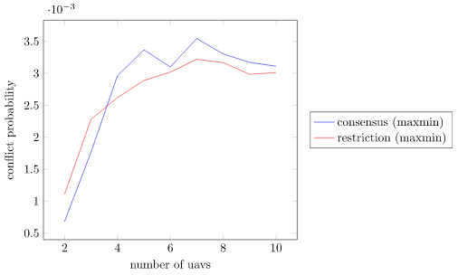

*Investigated the platooning concept in multi-highway situations*

We extended our platooning analysis to consider the situation where multiple air highways are present, and vehicles belonging to a platoon on a highway splits into two groups: one group joins a nearby platoon on another highway, and the other group continues on the same highway. In the example scenario below, we have two highways; one with a 3-vehicle platoon and the other with a 4-vehicle platoon. 2 of the vehicles in the 4-vehicle platoon changes highways and joins the 3-vehicle platoon. The remaining 2 vehicles remain on the same highway.



# DELIVERABLES

* None

**Papers and Presentations**

| **Author** | **Title** | **Form (paper or presentation)** | **Name of Journal or Conference** | **Anticipated Date of Publication or Presentation** | **Status** |
| --- | --- | --- | --- | --- | --- |
|  |  |  |  |  |  |

# SCHEDULE CONFORMANCE

* On schedule

**PROBLEM AREAS AND MITIGATIONS**

* None

**TECHNOLOGY REPORTING**

* None.

## OTHER ISSUES (e.g., security/safety)

No security/safety issues to report

## ACTIVITIES PLANNED FOR NEXT PERIOD

*Continue work on system implementation*

We will continue our work in developing the software required for the system. Components include implementing the driver node that schedules conflict resolution work for the worker compute nodes and the server software that interacts with the UTM client server.

*Continue work on the platooning concept*

We will continue to explore the platooning concept, eventually extending our analysis to other vehicle types as well as platoons containing multiple types of vehicles.

**UPCOMING DELIVERABLES**

* None

**TRAVEL**

|  |  |  |  |
| --- | --- | --- | --- |
| **Traveler** | **Date (From/To)** | **Destination** | **Reason** |
|  |  |  |  |

**COST DATA**

*The 533M for this task will be provided via a separate submission by the tenth working day of the month following the reporting period.*

**APPROVED:**

|  |  |  |  |  |  |  |
| --- | --- | --- | --- | --- | --- | --- |
| Approved via e-mail |  |  |  | Approved via e-mail |  |  |
| Bassam Musaffar |  | Date |  | Angela Wray |  | Date |
| *Task Manager* |  |  |  | *Managing Director* |  |  |