**Monthly Progress Report**

for

**NAS2-03144**

**University Affiliated Research Center (UARC)**

**Task TO.101-S.0.PK.A**

**Fundamental Research for UAS Traffic Management Challenges**

**August 2015**

Prepared for

NASA Ames Research Center

Moffett Field, California 94035

By

University of California – Santa Cruz



# 

# August 2015

# SUMMARY DESCRIPTION OF ACTIVITY

First, the proposed research aims to investigate methods for leveraging concepts from probabilistic optimal control to improve the robustness of human-engineered rules used previously. The goal in this context is to apply these probabilistic methods to adapting rules from the Advanced Airspace Concept (AAC) for use with UAS Traffic Management (UTM). In parallel, the structure of air highway systems and platooning of vehicles is investigated using optimal control theory. The second goal is to find novel ways to use existing optimal control theory as well as develop new theory for the UTM application. Work under this task will constitute conducting cutting-edge research on automating portions of the nation’s air transportation system under NASA’s Airspace Operations and Safety Program. The researchers will work closely with NASA researchers, contractors, and outside researchers to conceptualize and prototype new technologies for an air traffic management system tailored to low-altitude, class G airspace.

**GENERAL STATUS:**

For the month of August, we implemented a parallel solver for the conflict avoidance problem and incorporated a pilot response model.

# ACCOMPLISHMENTS

*Parallel solver implementation*

To speed up the process of computing a lookup table for the conflict avoidance problem, we used a parallel implementation of the QMDP algorithm. The code can be found in the repository at

https://github.com/sisl/ConflictAvoidanceDASC.

Specifically, everything in the src/parallel and src/pilot directories make use of the parallel solver contained in src/dvi.

*Pilot response model*

To better capture the response of unmanned aircraft, be it remotely or autonomously piloted, we incorporated a pilot response model for the pairwise encounter policy generation. When responding, the pilot executes the advisory for the total length of the period between decisions. In the model, the advisory response is determined stochastically based on the new advisory via a Bernoulli process. Specifically,

* The pilot always response to a clear of conflict status "advisory"
* Once the pilot responds, it will continue to respond for the duration of the advisory
* The average response delay for initial advisories is 5 seconds (from ICAO recommended practices for responding to resolution advisories [1])
* When the pilot is not responding, the aircraft follows a white noise model.

Implementation details can be found in the src/pilot directory at the URL above.

Example policy plots of head-on conflicts below suggest that advisories agree with intuition (figures are interpreted the same way as previous reports): In a pairwise encounter, when a pilot is non-responsive, both planes are given more aggressive maneuvers to execute than when responsive. Furthermore, the non-responsive aircraft is given the more aggressive maneuver of the two over the conflict period in order to compensate for the response delay of the non-responsive aircraft.

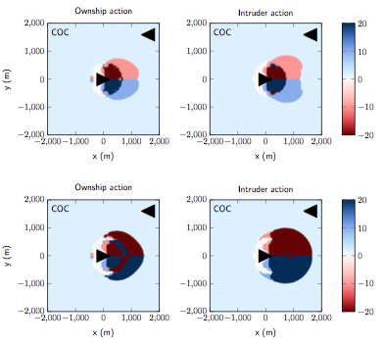

Fig. 1: Both pilots responsive (top) and non-responsive (bottom).

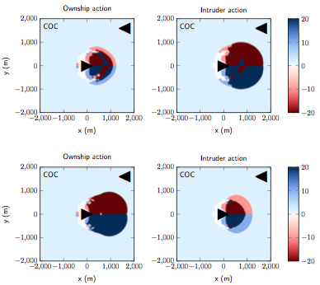

Fig. 2: Ownship responsive (top) and intruder responsive (bottom).

[1] International Civil Aviation Organization, “Surveillance, radar and collision avoidance,” in International Standards and Recommended Practices, 4th, vol. IV, annex 10, 2007.

*Preliminary presentation*

A preliminary set of slides have been prepared and presented to Professor Heinz Erzberger for feedback. The feedback will be taken into account for future presentations (see activities planned for next period).

Optimized simulations of platooning scenarios

We made a series of optimizations in reachable set computations and simulation code to substantially speed up our code, so that debugging is fast and that more simulation experiments can be done. These code optimizations include

* taking advantage of the translation-invariant and rotational symmetry of vehicle dynamics to pre-compute reachable sets and transform them online,
* computing time-to-reach value functions for more efficient storage, and
* using an LQR controller instead of MPC controller where possible whenever vehicles have arrived at their desired states using an optimal controller derived from reachable sets.

# DELIVERABLES

* None

**Papers and Presentations**

| **Author** | **Title** | **Form (paper or presentation)** | **Name of Journal or Conference** | **Anticipated Date of Publication or Presentation** | **Status** |
| --- | --- | --- | --- | --- | --- |
|  |  |  |  |  |  |

# SCHEDULE CONFORMANCE

* On schedule

**PROBLEM AREAS AND MITIGATIONS**

* None

**TECHNOLOGY REPORTING**

* None.

## OTHER ISSUES (e.g., security/safety)

No security/safety issues to report

## ACTIVITIES PLANNED FOR NEXT PERIOD

*Presentation to stakeholders and technical conference*

Results of the research will be presented to relevant stakeholders at NASA. Another presentation will be prepared for the IEEE/AIAA Digital System Avionics System Conference. Both presentations will be prepared based on the existing set of slides mentioned previously.

*Demonstration of distributed resolution advisory system*

A demonstration of the distributed resolution advisory system will be prepared with dummy aircraft and servers. The demonstration will illustrate how the system may operate with future iterations of the UTM client server. Note that the current system does not yet support features required by the resolution advisory system, such as an API for pushing advisories to aircraft in conflict.

**UPCOMING DELIVERABLES**

* None

**TRAVEL**

|  |  |  |  |
| --- | --- | --- | --- |
| **Traveler** | **Date (From/To)** | **Destination** | **Reason** |
|  |  |  |  |

**COST DATA**

*The 533M for this task will be provided via a separate submission by the tenth working day of the month following the reporting period.*

**APPROVED:**

|  |  |  |  |  |  |  |
| --- | --- | --- | --- | --- | --- | --- |
| Approved via e-mail |  |  |  | Approved via e-mail |  |  |
| Bassam Musaffar |  | Date |  | Angela Wray |  | Date |
| *Task Manager* |  |  |  | *Managing Director* |  |  |