**Capstone Design**

**User Manual**

Subject : Capstone Design

Professor : Prof. Park Sang Oh

Team : Team 6

Member : Nam, Geun Woo 20132915

: Kim, Myeong Gyu 20134695

: Sung, Ho Joon 20130895

1. **Login & Sign-up**
   1. Registration

To use this application, user needs to register.  
1) If user does not use the automatic login function, the login page is displayed.  
2) On the login page, user can enter to Registration page by clicking Registration button.  
스크린샷이(가) 표시된 사진

매우 높은 신뢰도로 생성된 설명 스크린샷이(가) 표시된 사진

매우 높은 신뢰도로 생성된 설명

3) For ID, duplication check should be done. If duplicate ID exists, a toast message which shows 'Duplicate ID exists' is displayed. If there is no duplicate ID, 'ID available' is displayed.

4) In case of password, user should input password 2 times to confirm. If the password input values are different, a toast message 'Please check password again' appears when user clicks Done button.

스크린샷이(가) 표시된 사진

매우 높은 신뢰도로 생성된 설명 스크린샷이(가) 표시된 사진

매우 높은 신뢰도로 생성된 설명 스크린샷이(가) 표시된 사진

매우 높은 신뢰도로 생성된 설명

5) After user fills out the form, user can register by clicking the Done button.

6) If the form is fit to the user data format, 'Registration is completed' is displayed. If the form has empty field, 'Please fill all items' message is displayed.

스크린샷이(가) 표시된 사진

매우 높은 신뢰도로 생성된 설명 스크린샷이(가) 표시된 사진

매우 높은 신뢰도로 생성된 설명 스크린샷이(가) 표시된 사진

매우 높은 신뢰도로 생성된 설명

* 1. Login  
     1) When user finishes Registration, user will be automatically directed to the login page.

2) User needs to enter his ID and password to log in. If the input matches, 'Login Successful' message appears. If the input does not match, 'Login failed' message appears.

3) If user wants to log in automatically, user can click the Auto Login check box before log in. Then, when user starts the application next time, automatic log in will be done and user can go to main page directly.

* 1. Logout
     + - 1. User can log out by clicking Logout button at the main page.
         2. If user logs out from the automatic login state, the automatic login will be canceled.

스크린샷이(가) 표시된 사진

매우 높은 신뢰도로 생성된 설명스크린샷이(가) 표시된 사진

매우 높은 신뢰도로 생성된 설명스크린샷이(가) 표시된 사진

매우 높은 신뢰도로 생성된 설명 스크린샷이(가) 표시된 사진

매우 높은 신뢰도로 생성된 설명

1. **Blood Glucose management function**
2. Blood glucose record
3. To use the blood glucose record function, user should click the blood glucose management button on the main page.
4. After clicking the button, the blood glucose list page appears. To record blood glucose, user should click the new blood glucose button.
5. User can record blood glucose and notes at blood glucose record page.
6. To save, user needs to fill out both his blood glucose and notes.
7. If user misses any of them, user will get the message 'Please fill out the form'.
8. User can see all of the previous blood glucose at the blood glucose list page.

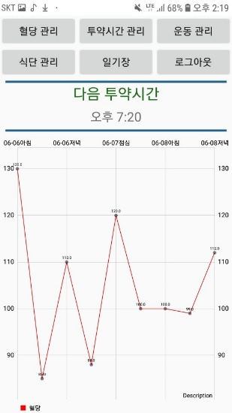 스크린샷이(가) 표시된 사진

매우 높은 신뢰도로 생성된 설명 스크린샷이(가) 표시된 사진

매우 높은 신뢰도로 생성된 설명

1. Blood glucose graph
2. The graph on the main page is a line graph using the stored blood glucose values.
3. The graph is based on blood glucose values for only last three days.

(Today, Yesterday, the day before yesterday)

1. 24 hours are divided into three time zones.

(Morning, Lunch, Dinner)

1. If several blood glucose values are recorded at the same time zone, the average of the recorded values is plotted.



1. **Exercise management function**
2. Exercise record
   * + - 1. To use the exercise record function, user should click the exercise management button on the main page.
         2. After clicking the button, the exercise list page appears. To record exercise, user should click new exercise button.
         3. User can record type of exercise and value at the exercise record page.
         4. To save, user needs to fill out both type of exercise and value.
         5. If user misses any of them, user will get the message 'Please put all values'.
         6. User can see all of the recorded exercise values on the exercise list page.

 스크린샷이(가) 표시된 사진

매우 높은 신뢰도로 생성된 설명 스크린샷이(가) 표시된 사진

매우 높은 신뢰도로 생성된 설명

1. **Diet management function**

A. Diet record

* + - * 1. To use the diet record function, user should click diet management button on the main page.
        2. After clicking the button, the diet list page appears. To record diet, user should click new diet button.
        3. User can record 5 kinds of foods at the diet record page.
        4. To save, user needs to fill out one or more foods.
        5. When recording food, user should fill in the blanks in order.
        6. If user does not fill in the first blank, user will get the message ‘Please fill in the first food’.
        7. If user does not fill in sequentially and there is a blank in the middle, user will see the message ‘Please fill in the number of meals’ that corresponds to the blank.

Ex) ‘Please fill in the third food’

* + - * 1. User can see all of the recorded diet values on the diet list page.

 스크린샷이(가) 표시된 사진

매우 높은 신뢰도로 생성된 설명 스크린샷이(가) 표시된 사진

매우 높은 신뢰도로 생성된 설명 스크린샷이(가) 표시된 사진

매우 높은 신뢰도로 생성된 설명

1. **Diary function**

A. Diary show

B. Diary search

* + - * 1. If user selects ‘Content’ and inputs specific contents, only diaries with the input contents will be shown.

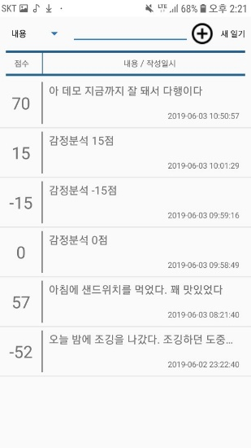 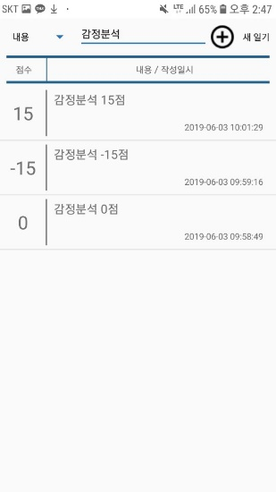

* + - * 1. If user selects ‘Time’, user can see a calendar when clicks ‘select date’ button. After

user selects a date on the calendar, only diaries written in the selected date will be

shown.

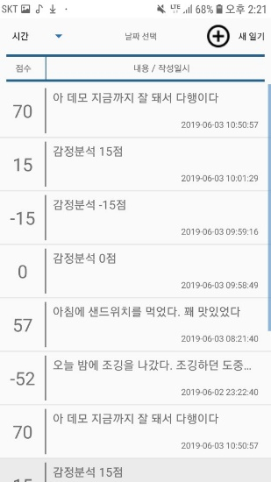 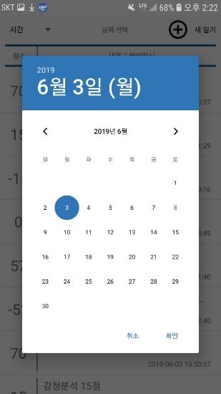 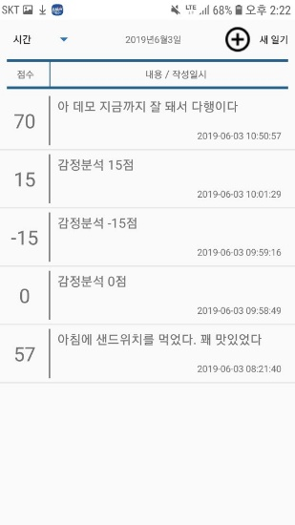

* + - * 1. If user selects ‘Score’, user can click either ‘positive’ or ‘negative’ buttons. When user clicks ‘positive’ button, user can see diaries with score of 0 or more. Or user can see diaries with score under 0 by clicking ‘negative’ button.

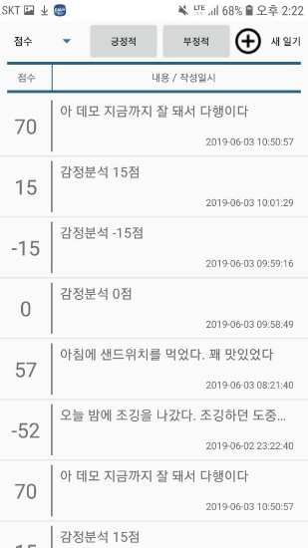 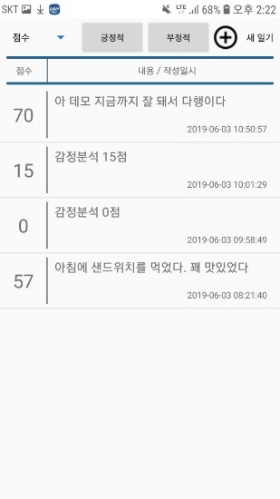 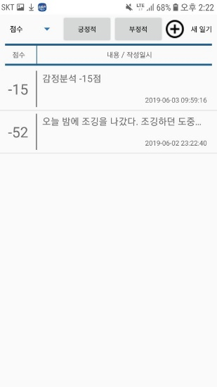

1. **Write new Diary function**

A. Write new diary

* + - * 1. User can write a new diary. User can either type texts or use voice recognition

function.

* + - * 1. After finishing voice recognition, the text will be typed automatically.
        2. User may see ‘Please speak again’ message, if any kinds of error occurs.

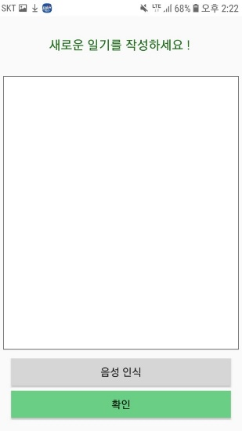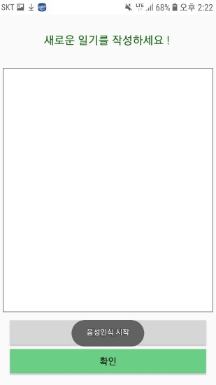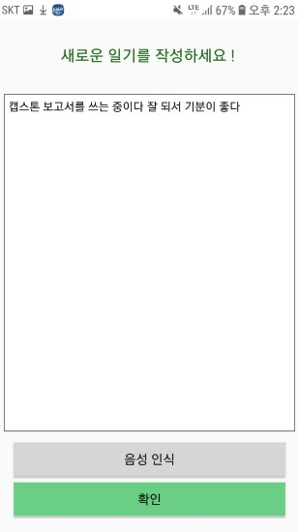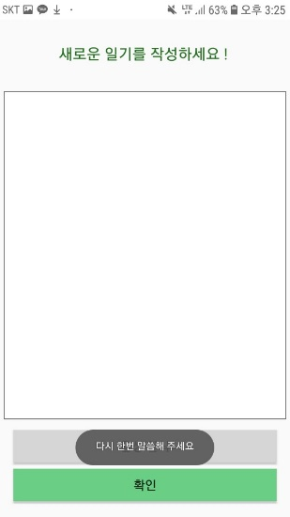

B. Sending to database and add to listview

1) When user clicks ‘done’ button, written diary will be saved and sentiment analysis

about the written diary will be done automatically.

2) User may see ‘fill out the form’ message, if user tries to save an empty diary.

 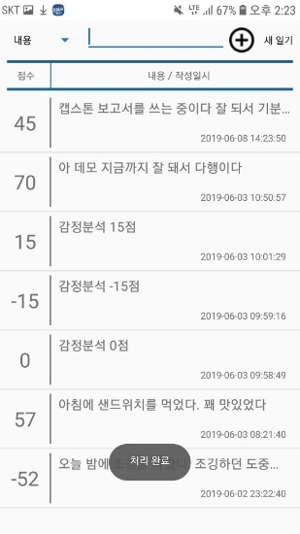 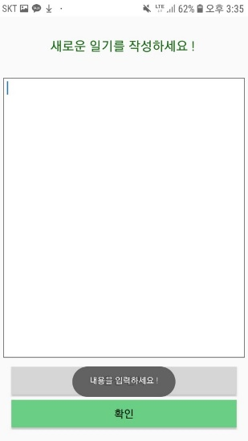

1. **Dosing time management function**

A. Show next dosing time at main page

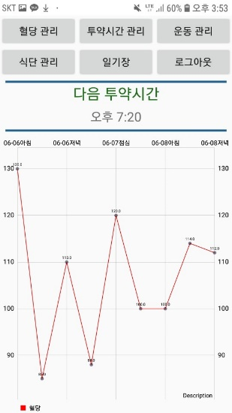 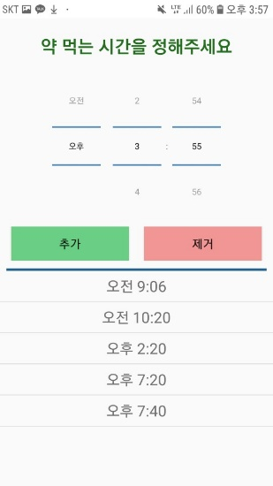

B. Dosing time list

C. Adding / Deleting dosing time

1. User can add a new dosing time, by clicking ‘add’ button after setting time on the time Picker.
2. User may see ‘same value exists’ message, if user tries to add a same dosing

time in the list.

1. After adding a new alarm, next dosing time will be calculated again, and

new next dosing time will be shown on the main page.

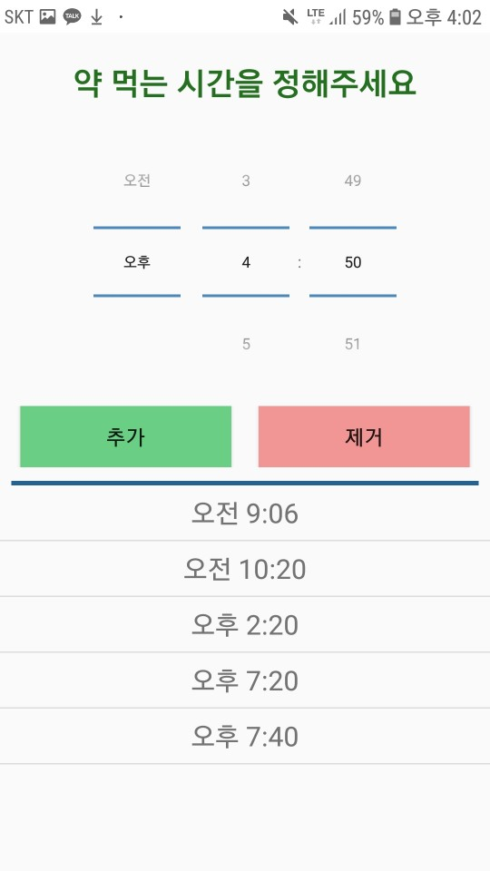 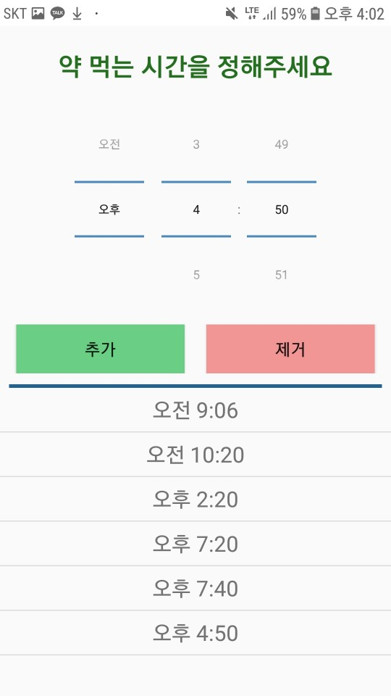 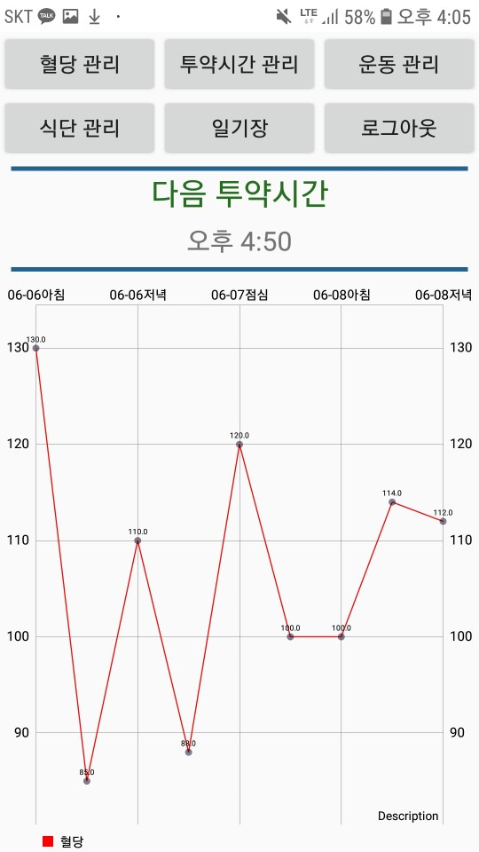 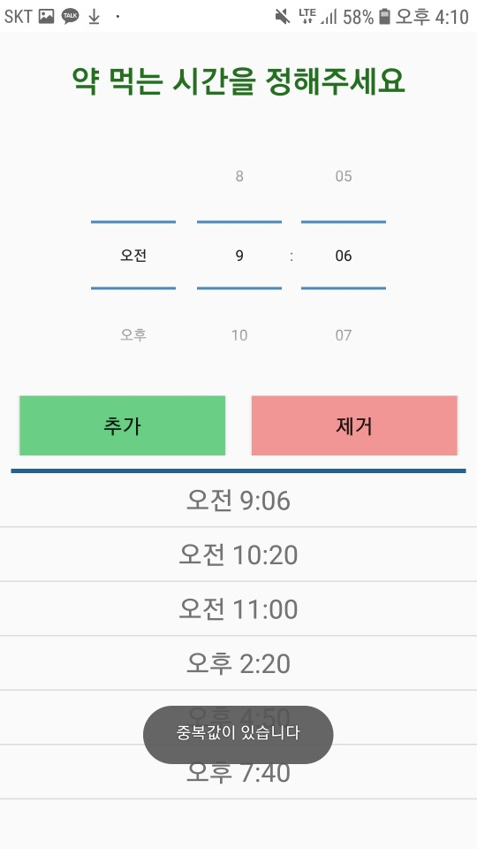

1. User can delete existing dosing time by clicking ‘delete’ button after selecting an alarm to delete.
2. User may see ‘select the alarm to delete’ message, if user clicks ‘delete’ button

without selecting alarm to delete.

1. After deleting an alarm, next dosing time will be calculated again, and

new next dosing time will be shown on the main page.

 