**Capstone Design**

**Project proposal**



Subject : Capstone Design

Professor : Park Sang-oh

Team : Team 6

Member : 20134695 Kim Myung Gyu

20132915 Nam Geun Woo

20130895 Sung Ho Joon

**1. Project Overview**

The project is to develop android-based diabetes management application with basic psychological analysis function.

Diabetes is a group of metabolic diseases in which high blood glucose levels last for a long time. According to ‘Diabetes Fact Sheet 2018’ which is published by Korean Diabetes Association, the number of diabetes patients is about 5 million which is 10% of the total population, and the number is steadily increasing.

However, unlike other diseases, diabetes is not a fatal disease, so patient can keep fit by managing himself continuously. One of the effective ways for this is using diabetes application. Many studies have shown that using diabetes apps is effective in controlling blood sugar.

Also, depression is closely related to diabetes. Studies have shown that diabetes and depression affect each other's development, and depression has a negative effect on the treatment of diabetes. Therefore, treatment for depression should be considered for diabetes management.

However, existing diabetes apps only focus on diabetes management such as blood glucose management and diet management, and do not consider psychological treatment such as depression. With this idea, we are going to develop a diabetes management application that includes basic psychological analysis functions that can be used for psychotherapy

**2. Background**

Smartphone application development has been one of the areas that have been in constant demand. There is a growing demand for application development for smart phones and tablet PCs, and various devices to be developed in the future are also likely to require application development.

Natural language processing (NLP) is also a sub-field of artificial intelligence that enables computers to understand human language. Speaking computer, and computer-related technology for communicating with humans are related to this field.

With this project, we expect to experience a smartphone application development and related contents like database and server-client system. Also, we expect to learn basic part of natural language processing and get experience of development in this field

**3. Objectives**

Development of android-based diabetes management application with basic psychological analysis function

* 1. Registration / Log-in function
* Store user’s information in a database.
* Manage each user’s information separately.
  1. Blood glucose level controlling function
* When the patient measures blood glucose level and inputs it into the application, the value is stored in a database.
* Show graph the of the trend of blood glucose level.
  1. Diet management function
* When the patient inputs the menu, it is stored in a database.
  1. Medication administration function
* Show the amount of medication or the time for administration.
  1. Text based psychological analysis function
* When a patient writes a situation or thought as a text, the patient's psychological state is analyzed based on algorithm, and stored in a database.

**4. Environment**

- Android Studio

- Python 3

- html / php

- mysql

**5. Project schedule**

* Proceed with github
* Several meetings per week to share the progress and idea

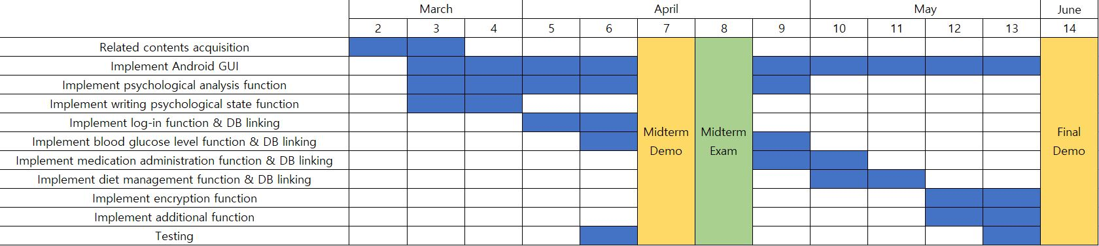

Kim Myung Gyu

* Android UI
* Implementation of visual elements such as graph function

Nam Geun Woo

* Implementation of text based psychological analysis function

Sung Ho Joon

* Implementation of server-client communication function
* Implementation of database

Git address : https://github.com/HJSUNG/capstone-design_2019