**Capstone Design**

**Project proposal**



Subject : Capstone Design(2)

Professor : Park, Sang-oh

Team : Team #6

Member : 20134695 Kim, Myung Gyu

20132915 Nam, Geun Woo

20130895 Sung, Ho Joon

**1. Project Overview**

This project is to develop an Android application for managing diabetes with mood-tracking feature.

Diabetes Mellitus, commonly referred to as diabetes, is a group of metabolic diseases in which high blood glucose levels last for a long time. According to ‘Diabetes Fact Sheet 2018’ which is published by Korean Diabetes Association, the number of patients with diabetes is about 5 million, 10% of the total national population, and it is steadily increasing.[1]

It is a chronic disease, which means that it cannot be cured. It has to be managed for the rest of the life. Otherwise, it may lead to complications, such as diabetic ketoacidosis, diabetic comas in the short-term, or blindness due to diabetic retinopathy, chronic renal failure, heart attack, etc.

Therefore, it is very important to manage it continuously. The patient should track his own blood glucose(BG) and medication record such as insulin injection. One of the convenient ways for this is using a mobile application. Many studies have shown that using a mobile application to manage diabetes is effective in manage diabetes.

Also, depression is strongly correlated to diabetes.[2] It is known that patients with diabetes is at twice the risk of developing depression. Depression interferes with managing diabetes because it drains the energy. As mentioned above, to treat diabetes self-management such as diet, exercise, medication, tracking blood glucose is important. Also, depression itself can exacerbate the diabetes. It stimulates the endocrine system to release insulin-resistant hormones and inflammatory cytokines to cause insulin-resistance or cause dysfunction in beta cells in pancreas.

However, existing diabetes apps only focus on managing diabetes in physiological perspective such as blood glucose and diet, and do not consider psychological perspective such as depression. With this idea, we are going to develop a diabetes management application that includes managing depression comorbid with diabetes.

**2. Background**

Cognitive-Behavioral Therapy(CBT) is a psycho-social intervention approach to manage depression. It aims to handle cognitive distortions, which causes maladaptive behaviors. For example, people with overgeneralization, will think they have Alzheimer’s even though they just skipped only one dose of insulin.

By keeping track of one’s thoughts and feelings, they can change their cognitive distortions and get adaptive behaviors.

It can be done more conveniently by using a smarphone application. With this feature integrated with diabetes management module, patients can manage both diabetes and depression. The working model is already presented by T. M. Alanzi, et al. [3]

In this project, we will develop a mobile application that can track moods automatically. In the previous model, the patient should manually select their moods. But in this application, moods can be tracked automatically. With a sentiment analysis with NLP, moods can be extracted from the diary.

**3. Objectives**

Development of android-based diabetes management application with basic psychological analysis function

* 1. Registration / Log-in function
* Store user’s information in a database.
* Manage each user’s information separately.
  1. Blood glucose level controlling function
* When the patient measures blood glucose level and inputs it into the application, the value is stored in a database.
* Show graph the of the trend of blood glucose level.
  1. Diet management function
* When the patient inputs the menu, it is stored in a database.
  1. Medication administration function
* Show the amount of medication or the time for administration.
  1. Text based psychological analysis function
* When a patient writes a situation or thought as a text, the patient's psychological state is analyzed based on algorithm, and stored in a database.

**4. Environment**

- Android Studio

- Python 3

- HTML5/CSS

- PHP

- MySQL

**5. Project schedule**

* Proceed with github
* Several meetings per week to share the progress and idea

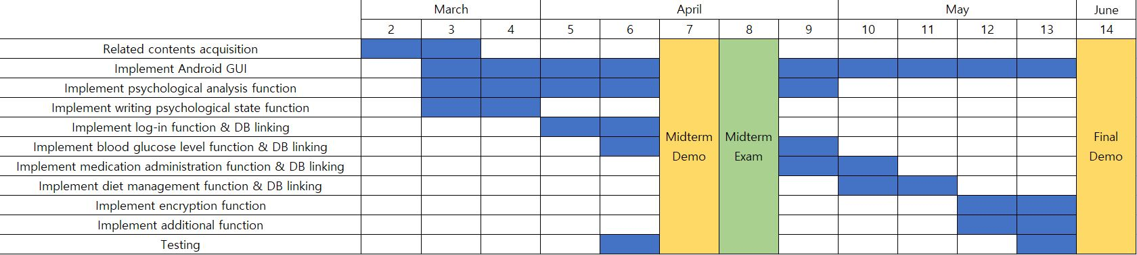

Kim Myung Gyu

* Android UI
* Implementation of visual elements such as graph function

Nam Geun Woo

* Implementation of text based psychological analysis function

Sung Ho Joon

* Implementation of server-client communication function
* Implementation of database

GitHub address : <https://github.com/HJSUNG/capstone-design_2019>

**6. References**

[1] 김대중, 이재혁, 원종철, 김보연, 김헌성, 박정환 (2018). Diabetes Fact Sheet in Korea 2018. 대한당뇨병학회.

[2] 김수연, 이재호, 김하늘, 김동규, 나영, 김길선, 김미경, 백기현, 강무일, 이광우, 송기호 (2009). 당뇨병환자의 우울증과 자가 관리. 대한당뇨병학회지, 33, 432-438.

[3] Alanzi, T. M., Istepanian, R.S., & Philip, N.Y. (2014). An interated model for Cognitive Behavioral Therapy for mobile diabetes self-management system. 2014 36th Annual International Conference of the IEEE Engineering in Medicine and Biology Society, 5393-5396