Code:

str = extractFileText('thirukkural.pdf');

w=wordcloud(str)

Explaining the code:

* extractFileText command extracts the text data from the file and stores it as a string in str.
* wordcloud takes an string array as input in this condition and creates a word cloud.

Output:

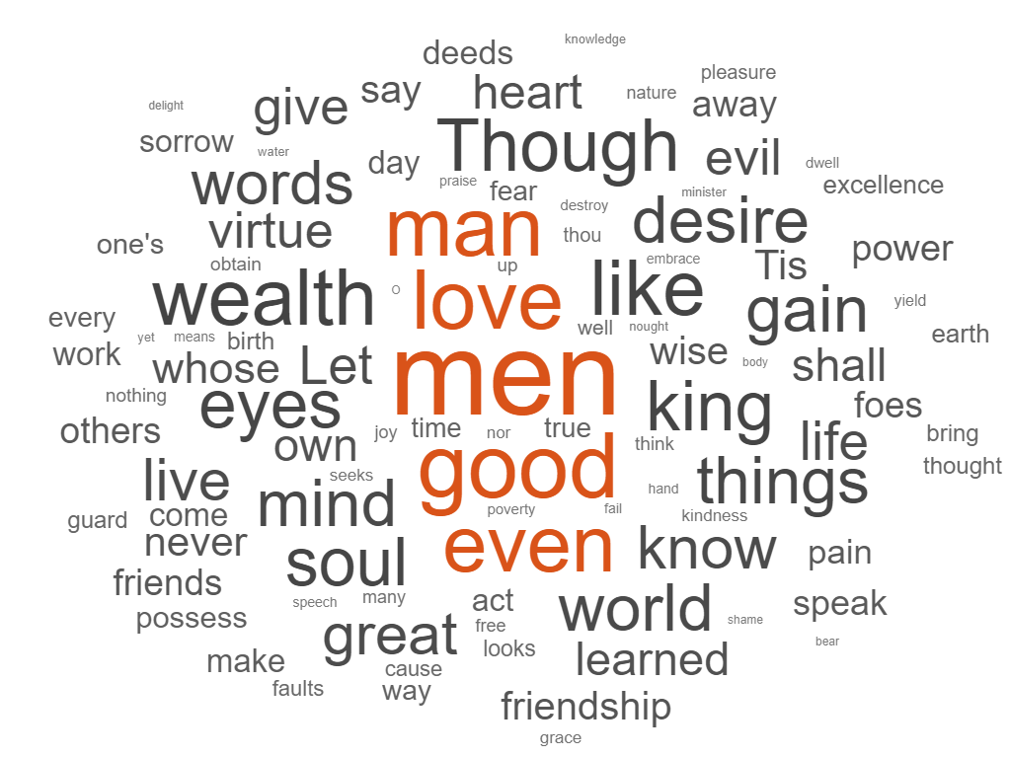

w =

**WordCloudChart** with properties:

WordData: ["men" "good" "love" "man" "even" "wealth" "like" "Though" "king" "eyes" "soul" "things" "desire" "gain" "mind" "world" … ]

SizeData: [322 224 201 198 190 186 184 169 164 158 157 151 150 150 150 150 140 138 136 135 123 121 119 116 116 111 107 107 106 101 96 95 92 91 91 87 86 85 85 85 84 83 81 78 78 78 78 77 76 … ]

MaxDisplayWords: 100

Show all properties

Inference:

The wordCloud command creates a wordcloud chart by identifying the frequently used words in the string array passed. The more frequently used words are displayed big and the less frequent ones are displayed comparatively smaller. The word cloud function only takes the top 100 frequent words when plotting the chart.

The wordCloud chart infers that the author talks mostly about how men can be good and keep his mind and soul healthy.An all-inclusive ethical guide, the *Tirukkural* has as its foremost moral imperatives the avoidance of killing and the avoidance of falsehood. It also commends to the reader a feeling of compassion for all individuals, regardless of caste or creed.