Publishing .NET Application
Self-Contained & Framework-Dependent Deployment

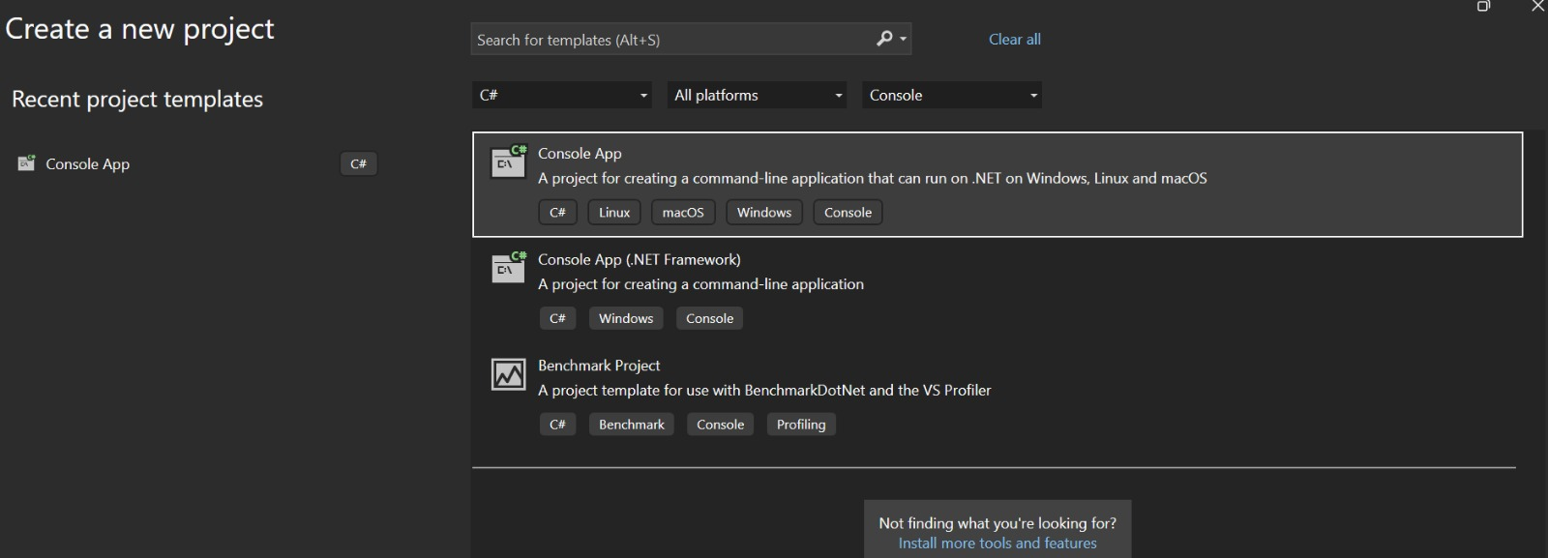
Screenshot 1: Creating new project in Visual Studio 2026

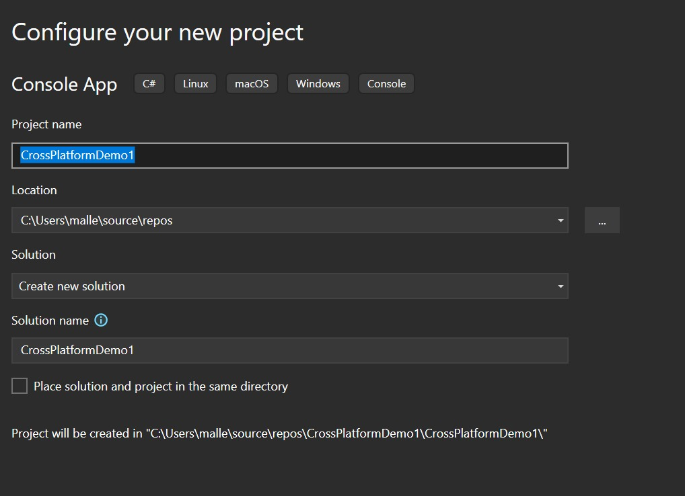
Screenshot 2: Name the Project

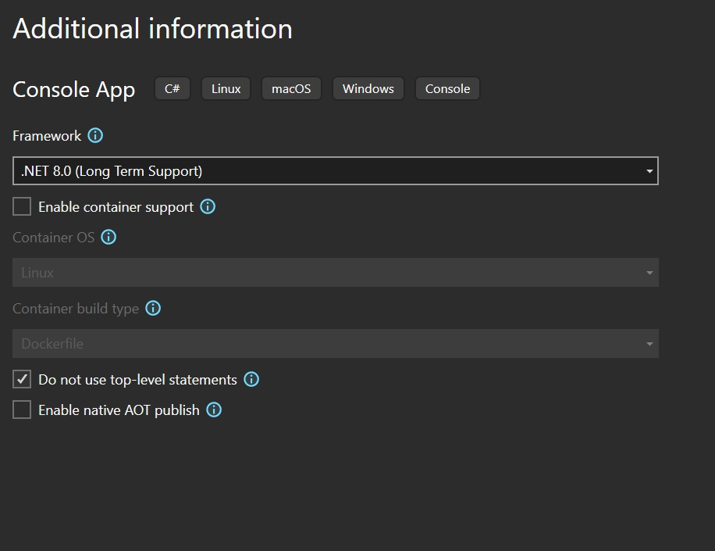
Screenshot 3: Enable this option

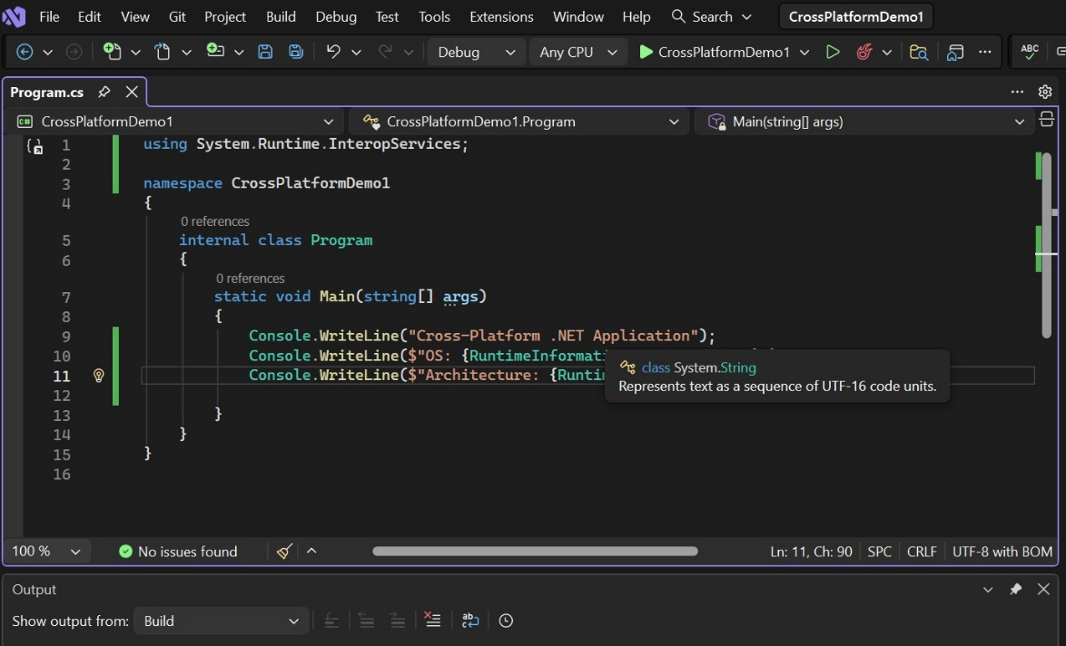
Screenshot 4: Write the code the OS code to see OS description and Code

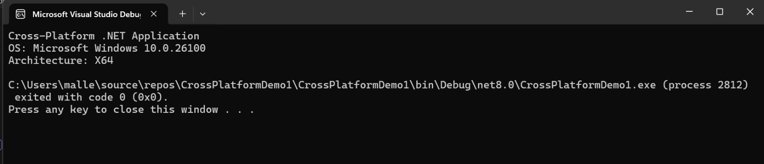
Screenshot 5: Output Window

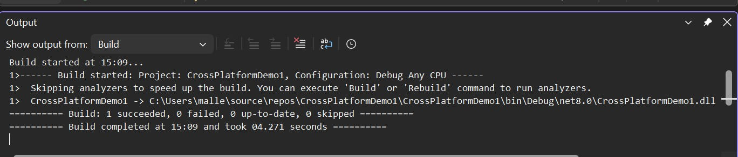
Screenshot 6: Build Successful

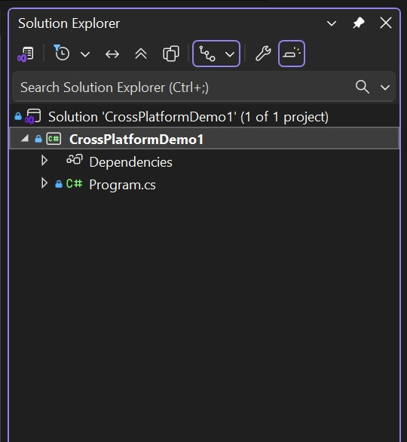
Screenshot 7: Right click on the project
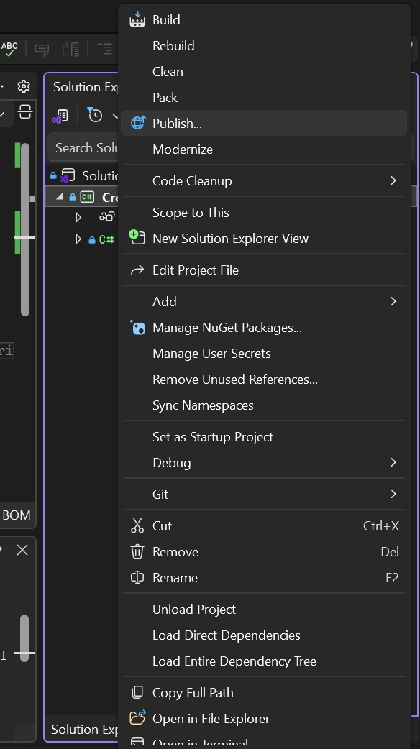
Screenshot 8: Click on “Publish” option

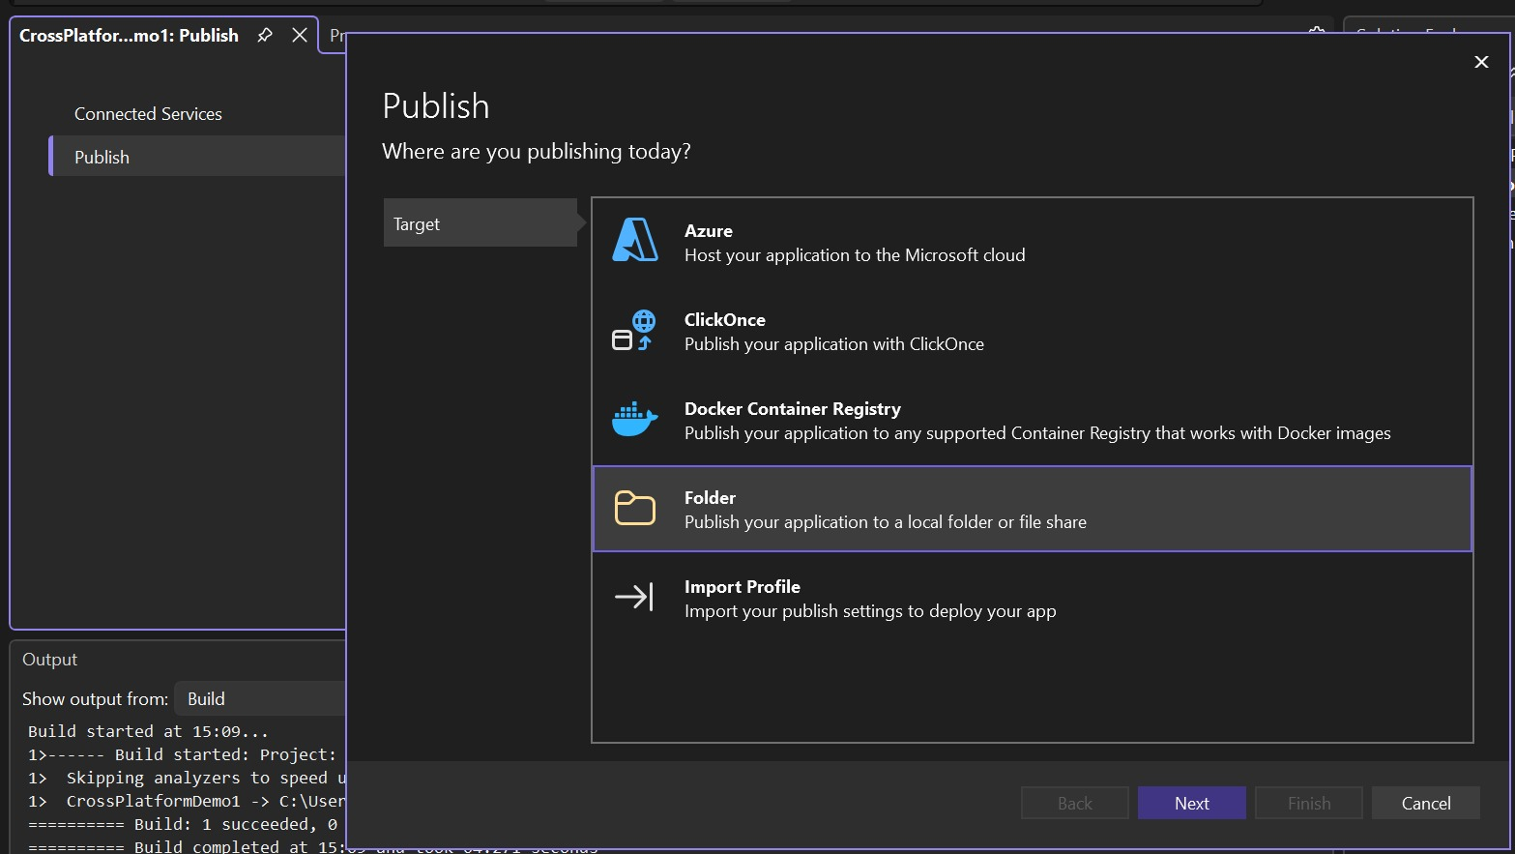
Screenshot 9: Select target: Folder

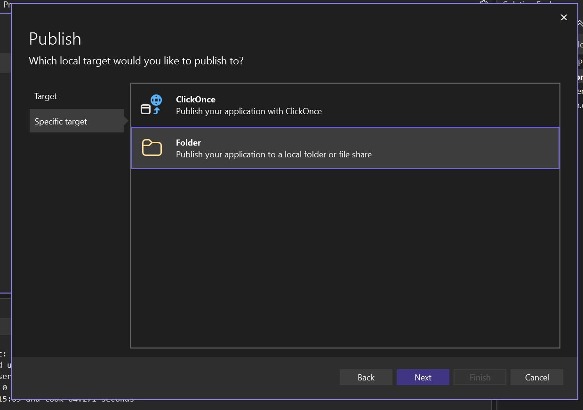
Screenshot 10: Select specific target

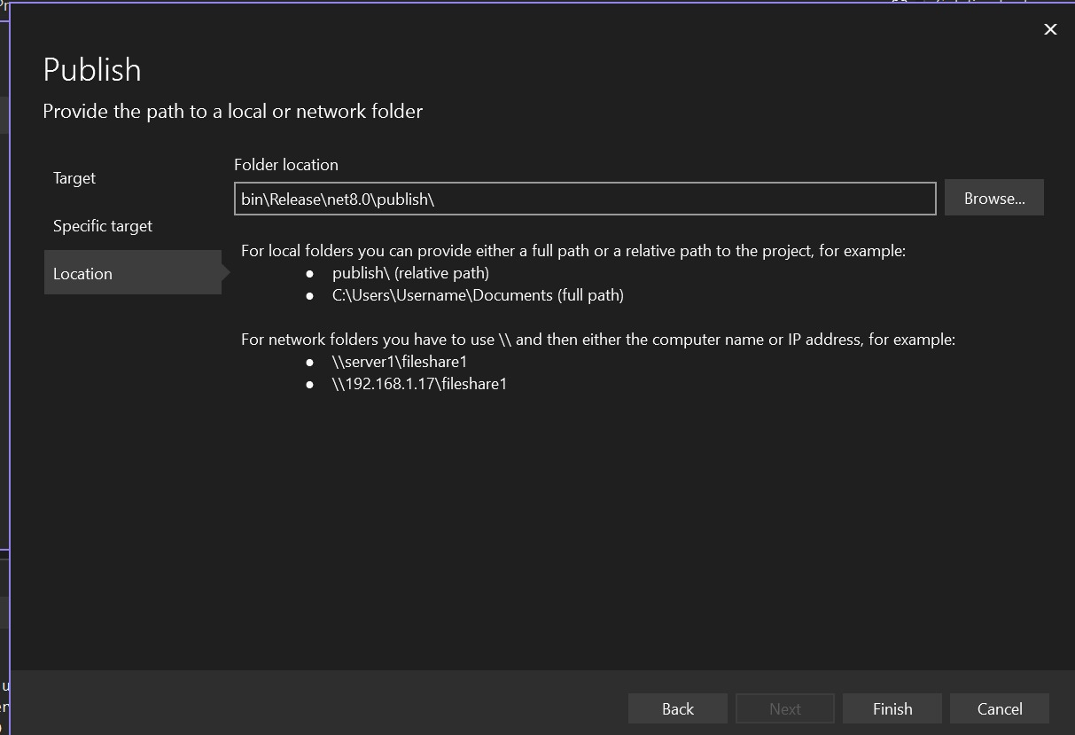
Screenshot 11: Browse folder location

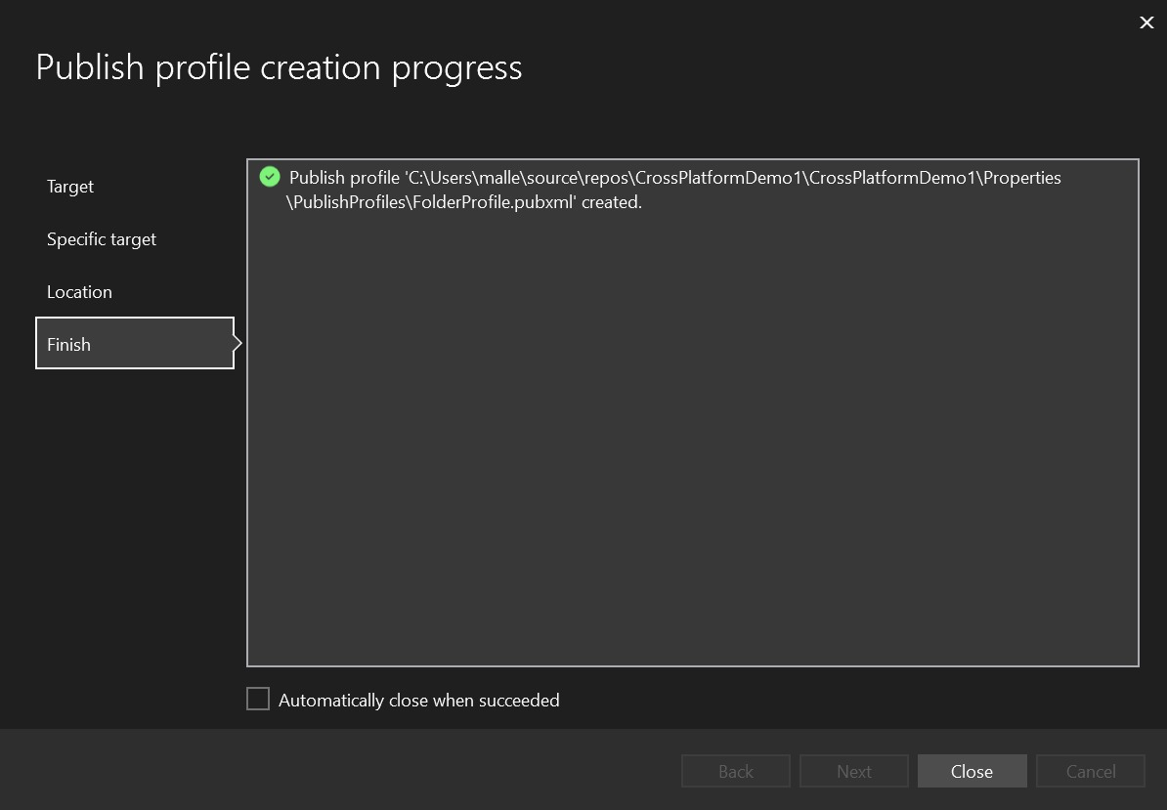
Screenshot 12: Close
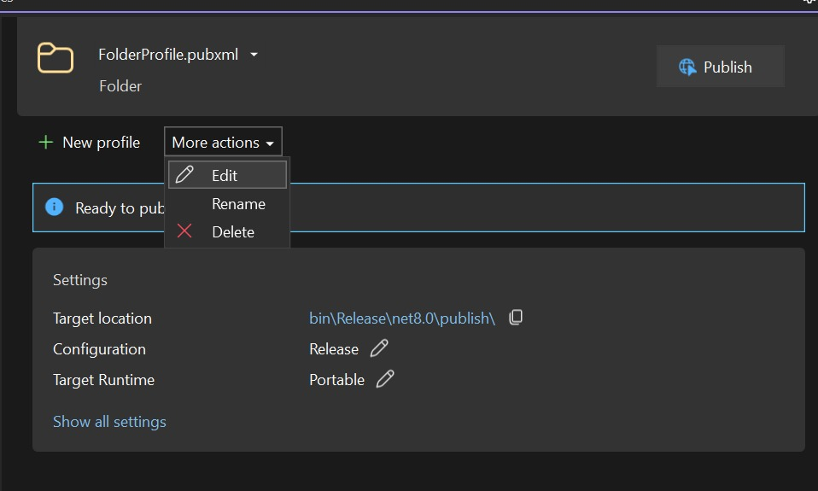
Screenshot 13: Edit profile using More actions

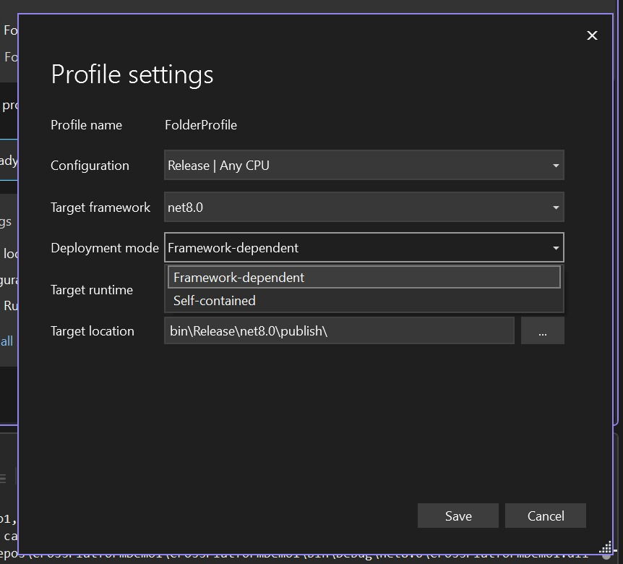
Screenshot 14: Select Deployment Mode: Framework-dependent or Self-contained

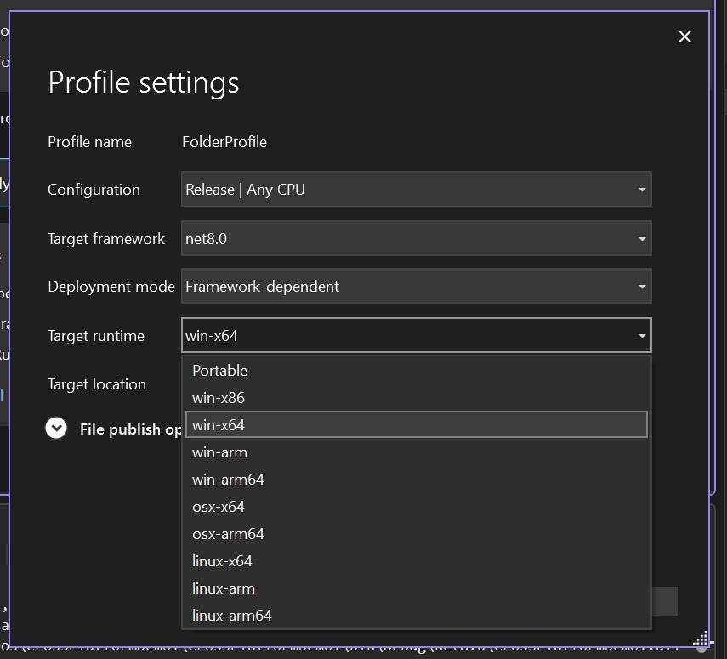
Screenshot 15: Select the target runtime OS

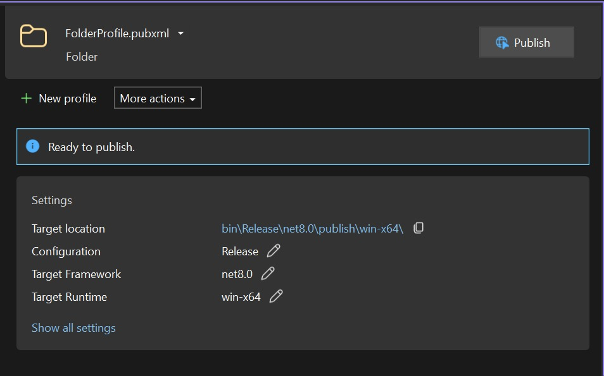
Screenshot 16: Click on Publish

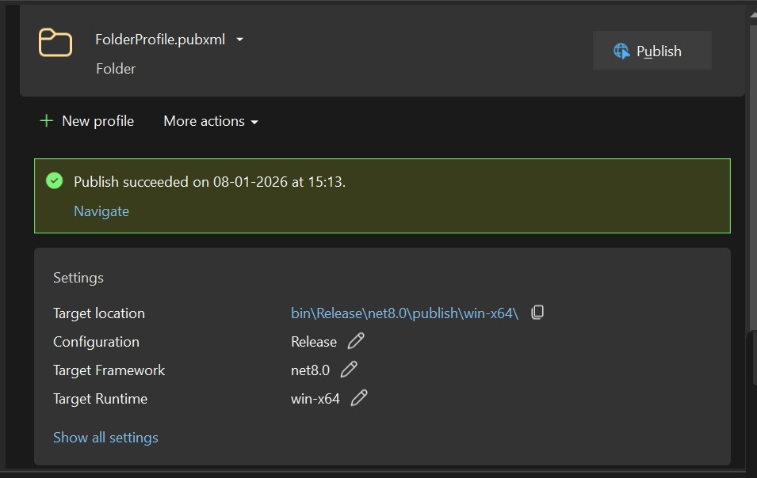
Screenshot 17: Successfully Published

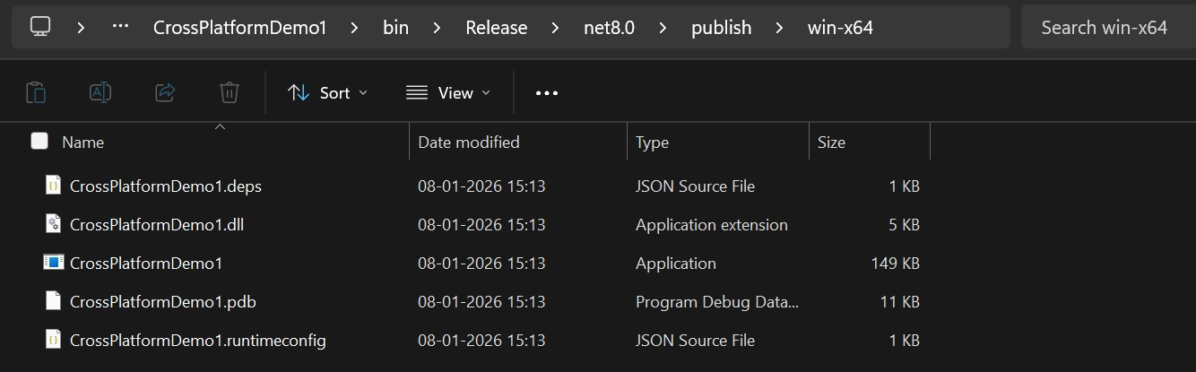
Screenshot 18: Location where published project is saved

Harsh Kumar

