Lab : 3

NAME:Ajay Sanjeevaiah Gonepuri ROLLNO: 02

CLASS: TY-IT-A BATCH: B1

___________________________________________________________________________

PROGARM: Simple and Steepest Hill Climb

Simple Hill Climb:

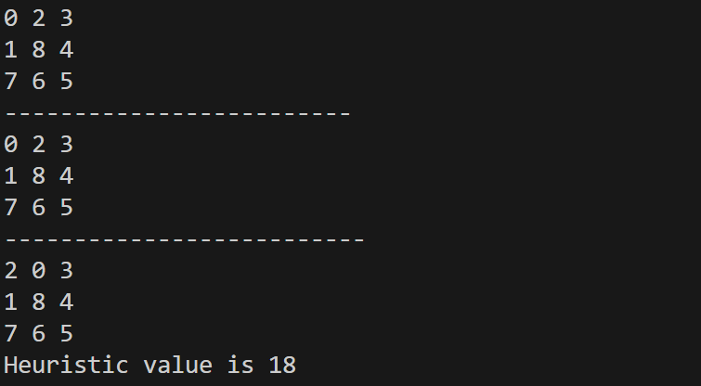

Steepest Hill Climb:

