Notes – ML Project 1

Data
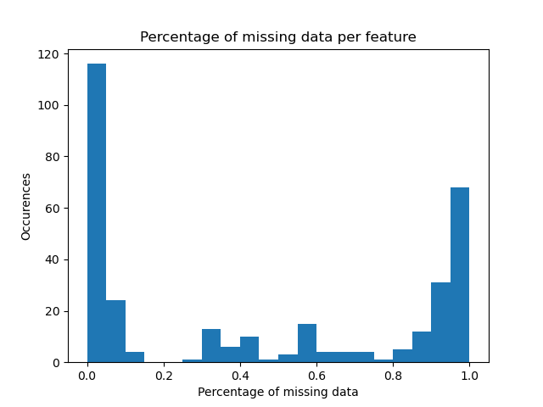
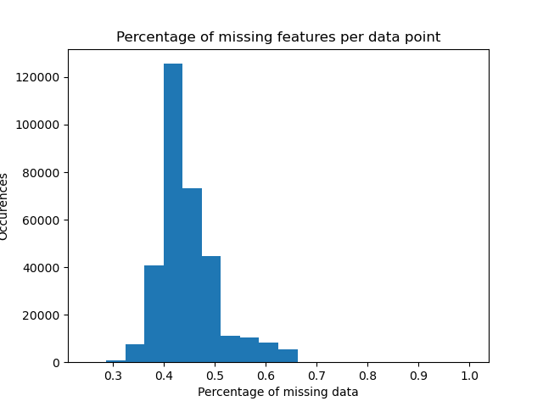

Missing data:
Data points with many missing features (plot on the left) → remove datapoints with more than e.g. 60% of data missing?
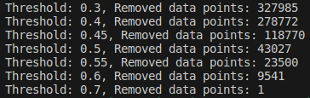

Features with many missing data (plot on the right) → reomove features absent in more than e.g. 95% of the data points?
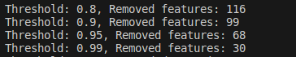

Fill missing features: either with 0 or mode, do not use mean or median as the data values are encoded, not proportional (e.g. 1 → yes, 2→ no etc) https://www.cdc.gov/brfss/annual_data/2015/pdf/codebook15_llcp.pdf

TO DO ? :
1) Remove data points with too many missing values (e.g. they answered “wrong phone number” to 1st question, all is empty → removed). Threshold : 0.6 ?
2) Remove the features with too high NaN values. Threshold: 0.95 ?
3) Fill remaining NaN values with the mode of the column

