# 单元一 需求分析

### 学习目标

本单元主要学习目标：

(1)了解该项目需要开发的结构和功能

(2)创建项目所需相关文件

(3)下载和引入jquery和bootstrap相关文件

## 任务1.1 功能介绍

#### 任务描述

了解项目需要开发的页面结构和功能

#### 任务实施

1.导航栏

1.1 pc端网页顶部是导航栏区块，如图所示



1.2 pc端导航栏左边是网页标题或logo区块，右边是4个导航项，sign up为按钮，点击该按钮弹出注册模态框。模态框如下图所示

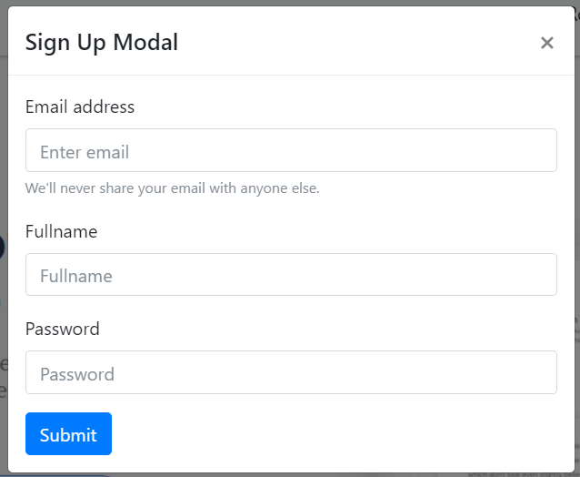

1.3 移动端网页顶部为折叠式导航栏，如图所示

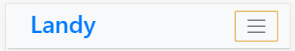

1.4 点击移动端导航栏右边的按钮，则展开显示导航项，展开效果如图所示

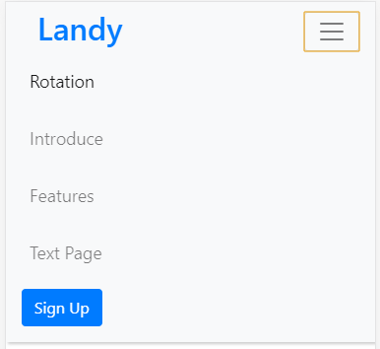

2. 轮播图

2.1 pc端轮播图区块中的图片为大背景图，如图所示

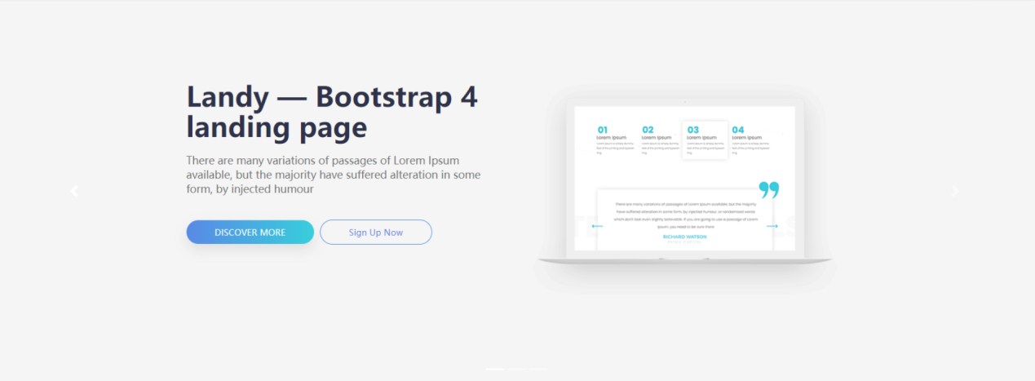

2.2 移动端轮播图则显示为其他图片

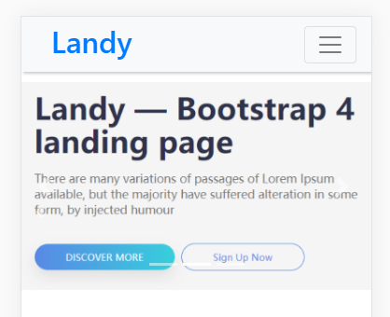

3.图片选项卡

3.1 pc端选项卡区域，点击底部文字区块切换中间图片的显示

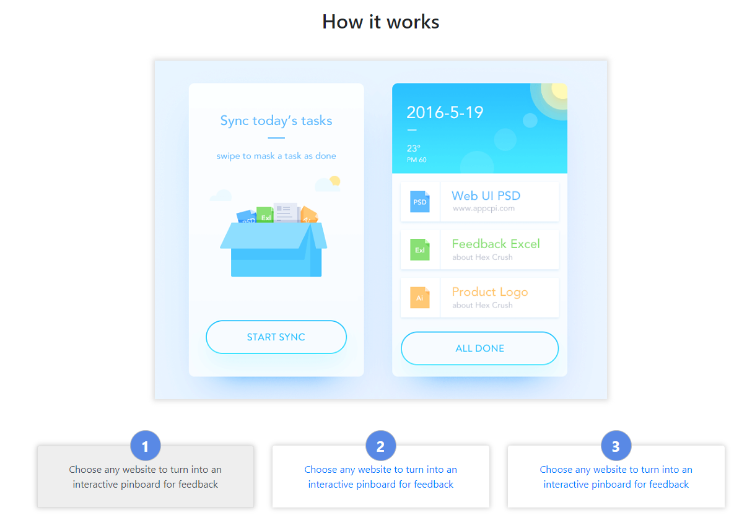

3.2 移动端选项卡区域，为竖向排列

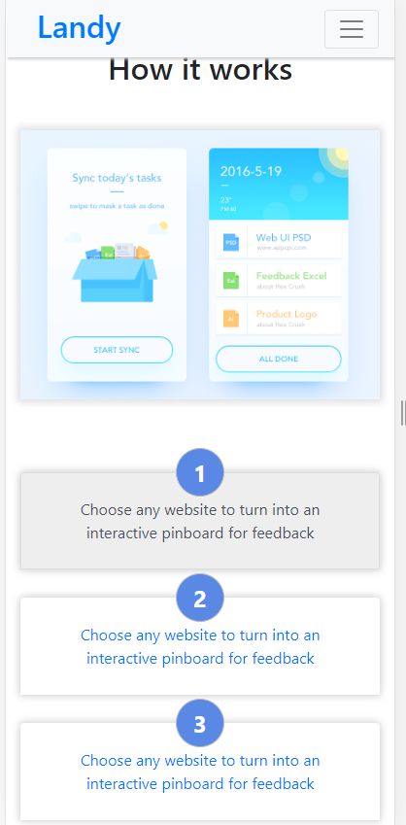

4.信息展示区块

4.1 pc端信息展示区块如下图所示

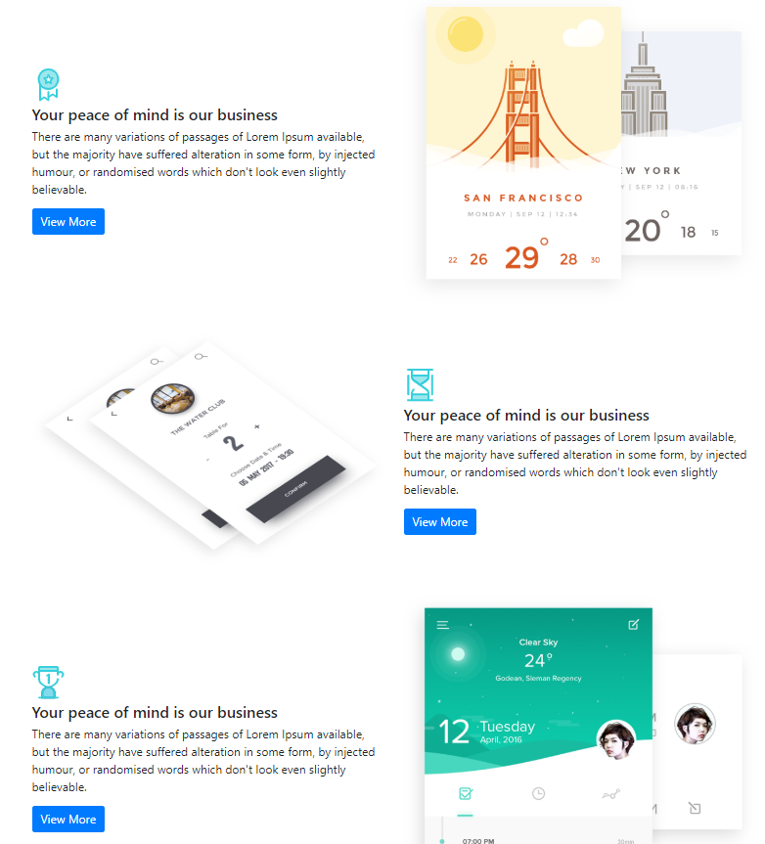

4.2 移动端信息展示区块

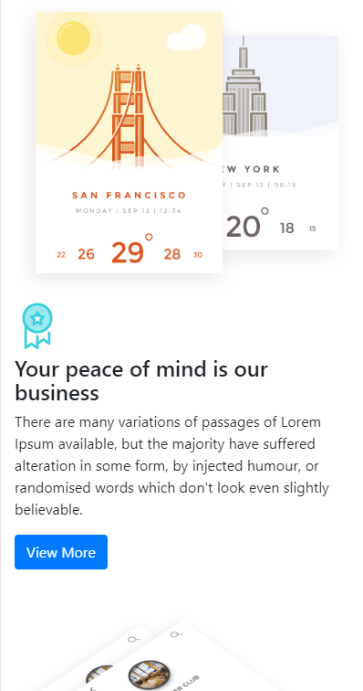

5.更多功能区块

5.1 pc端更多功能区块如图所示

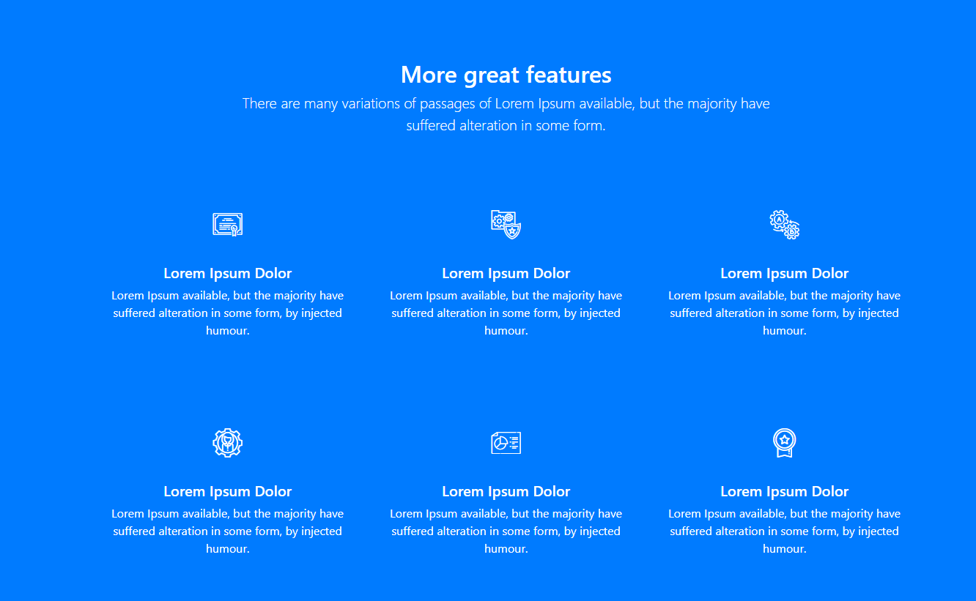

5.2 移动端更多功能区块有两种显示情况，如图所示

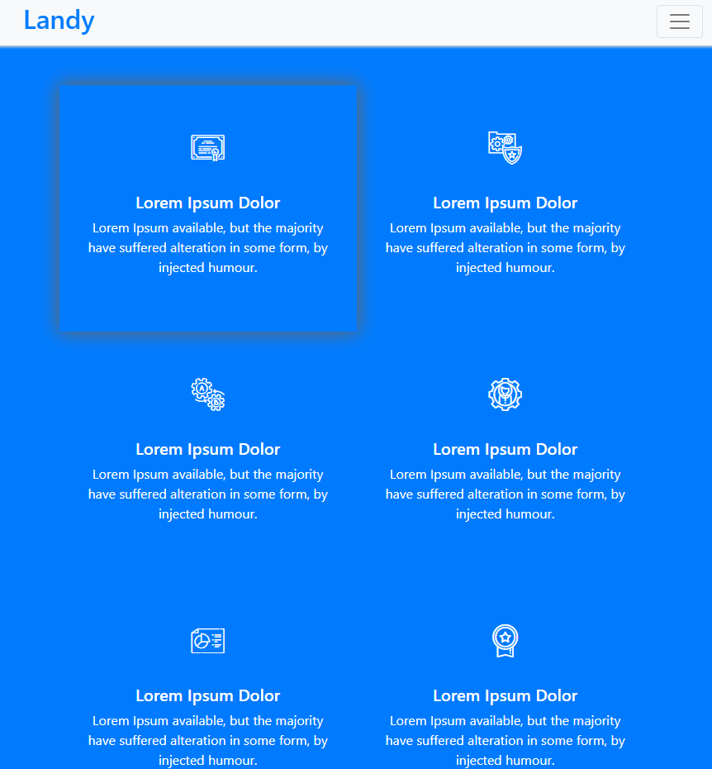

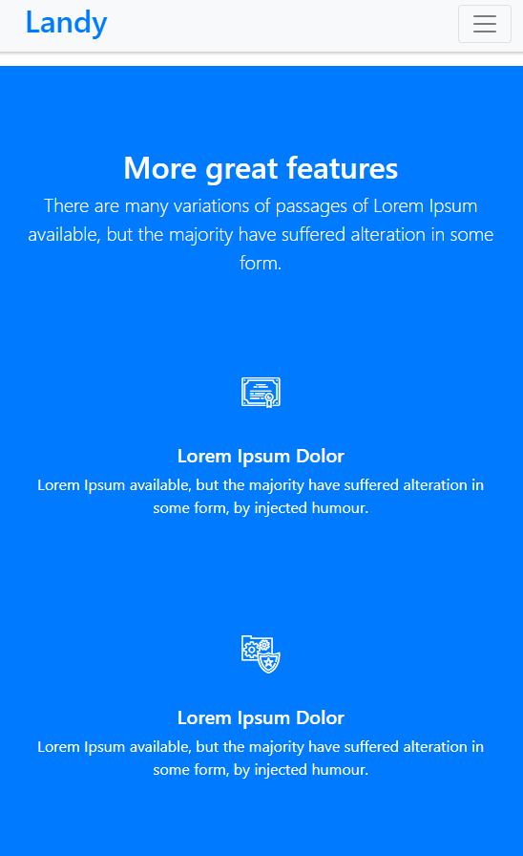

6.底部版权区块

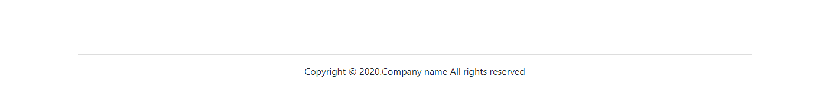

## 任务1.2 项目准备

#### 任务描述

创建项目所需文件

下载和引入jQuery和Bootstrap4

#### 任务实施

1.根据图示目录创建项目文件夹

1.1 css文件夹存放该项目的.css样式文件

fonts 文件夹存放该项目的字体文件

images文件夹存放该项目所需的图片文件

js文件夹存放该项目所需的.js文件

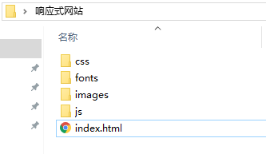

2.项目所需的jQuery文件和Bootstrap文件可以使用网络地址的形式引入项目；下面将讲解下载文件并以本地路径的形式引入项目中

2.1到[jQuery官网](https://jquery.com/download/)下载任意版本的jquery.js文件，官网下载页面如下图所示

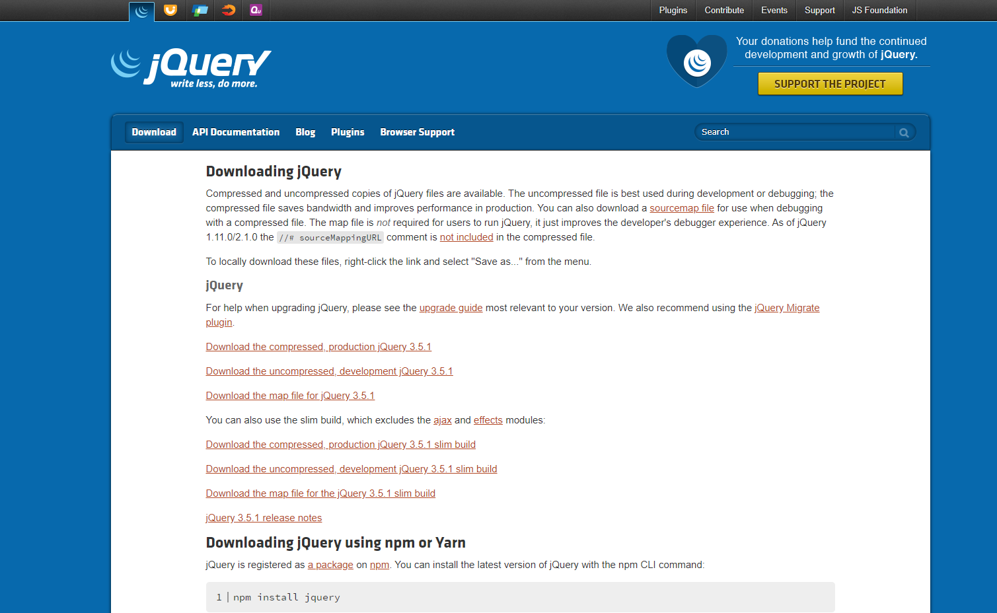

2.2 点击第一个文件，会调转至js文件内容，键盘Ctrl+S组合键保存.min.js至本地即可



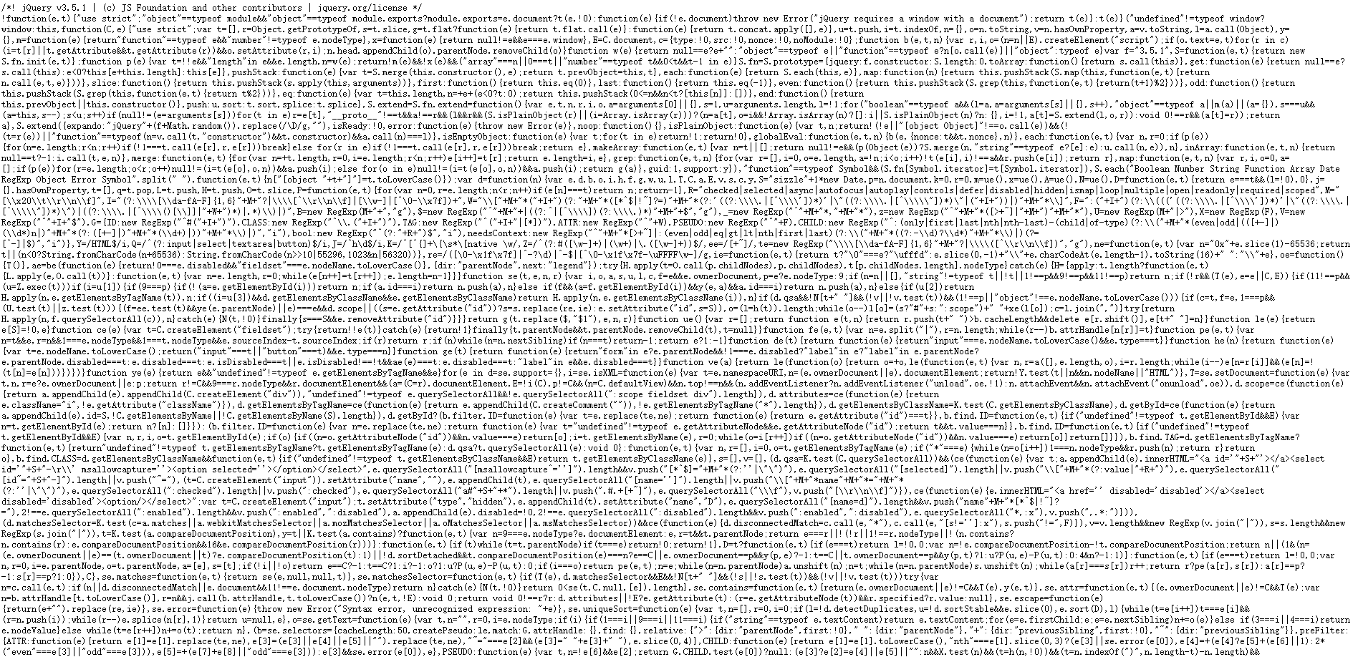

2.3到[Bootstrap4官网](https://getbootstrap.net/docs/getting-started/download/)下载Bootstrap相关文件

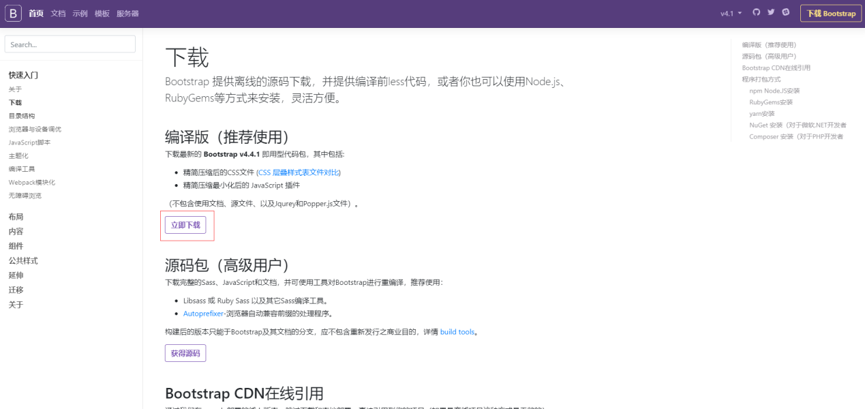

3.将项目所需的文件放至对应文件夹下

3.1 bootstrap.min.css 为压缩过的bootstrap样式文件

default.css 为该项目需要手动编写的样式文件（需手动创建）

landy-iconfont.css 为该项目的字体及字体图标文件

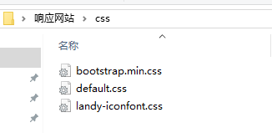

3.2 图示四个文件为字体文件

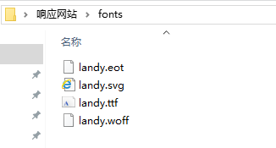

3.3 将图片放至images文件夹下

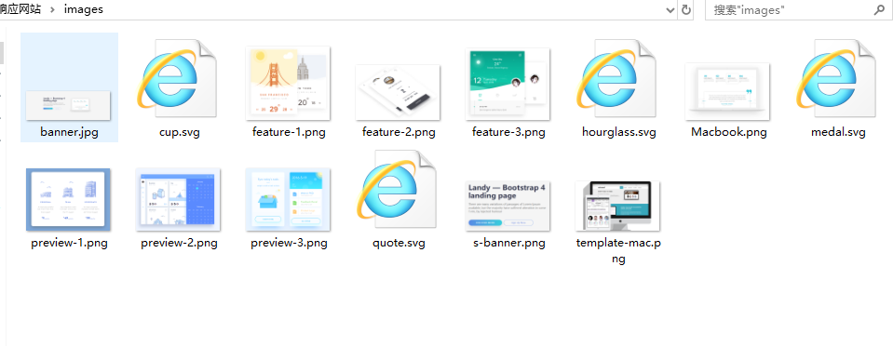

3.4 将两个压缩后的.min.js文件放至js文件夹下

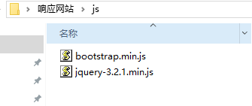

4.在编辑器中打开该项目文件夹，在index.html中引入所需文件

4.1 在编辑器中打开index.html，写入以下代码，jquery.min.js必须放在其他js文件最前面

<!DOCTYPE html>

<html lang="zh-CN">

<head>

<meta charset="utf-8">

<meta name="viewport" content="width=device-width, initial-scale=1, shrink-to-fit=no">

<!-- Bootstrap CSS -->

<link rel="stylesheet" type="text/css" href="css/bootstrap.min.css">

<link rel="stylesheet" type="text/css" href="css/landy-iconfont.css">

<link rel="stylesheet" type="text/css" href="css/default.css">

<title>响应式网站</title>

</head>

<body>

</body>

<script src="js/jquery-3.2.1.min.js"></script>

<script src="https://cdnjs.cloudflare.com/ajax/libs/popper.js/1.14.7/umd/popper.min.js" integrity="sha384-UO2eT0CpHqdSJQ6hJty5KVphtPhzWj9WO1clHTMGa3JDZwrnQq4sF86dIHNDz0W1" crossorigin="anonymous"></script>

<script src="js/bootstrap.min.js"></script>

</html>

# 单元二 导航栏

### 学习目标

本单元主要学习目标：

了解bootstrap中的导航栏组件提供的样式

掌握灵活使用bootstrap组件的方式

## 任务2.1 导航栏区块

#### 任务描述

利用bootstrap提供的组件完成页面顶部的导航栏

#### 任务实施

1.根据bootstrap文档中[导航栏组件](https://getbootstrap.net/docs/components/navbar/)制作一个导航栏固定于页面顶部，导航栏左边为“品牌”，右边为导航项和一个注册按钮

1.1 pc端的导航栏是响应式的，其样式效果会根据设备宽度自动变化

1.2 导航栏在设备宽度小于992px时，变为一个可折叠的导航栏

接下来开始编写页面代码，在index.html中的body标签写入以下代码

<header class="header">

<nav class="navbar navbar-expand-lg navbar-light bg-light p-2.5 fixed-top text-primary shadow-nav" id="navbar-example2">

<a class="h2 pl-3" href="#">Landy</a>

<button class="navbar-toggler navbar-toggler-right" type="button" data-toggle="collapse" data-target="#navbarNav" aria-controls="navbarNav" aria-expanded="false" aria-label="Toggle navigation">

<span class="navbar-toggler-icon"></span>

</button>

<div class="collapse navbar-collapse" id="navbarNav" style="font-size: 1.1rem">

<ul class="navbar-nav ml-auto">

<li class="nav-item m-2">

<a class="nav-link active" href="#">Rotation</a>

</li>

<li class="nav-item m-2">

<a class="nav-link" href="#">Introduce</a>

</li>

<li class="nav-item m-2">

<a class="nav-link" href="#">Features</a>

</li>

<li class="nav-item m-2">

<a class="nav-link" href="#">Text Page</a>

</li>

</ul>

<div class="navbar-text mr-4">

//按钮代码

</div>

</div>

</nav>

</header>

2.点击sign up按钮会弹出一个注册表单模态框。在//按钮代码处写入以下代码

<a href="#" data-toggle="modal" data-target="#exampleModal" class="btn btn-primary navbar-btn btn-shadow btn-gradient">Sign Up</a>

3.sign up弹出的模态框需要使用bootstrap提供的[模态框](https://getbootstrap.net/docs/components/modal/)组件来制作，根据文档中的模态框组件案例，在</header>后另起一行写入以下代码

<div id="exampleModal" tabindex="-1" role="dialog" aria-labelledby="exampleModalLabel" aria-hidden="true" class="modal fade">

<div role="document" class="modal-dialog">

<div class="modal-content">

<div class="modal-header">

<h5 id="exampleModalLabel" class="modal-title">Sign Up Modal</h5>

<button type="button" data-dismiss="modal" aria-label="Close" class="close"><span aria-hidden="true">×</span></button>

</div>

<div class="modal-body">

<form>

<div class="form-group">

<label for="exampleInputEmail1">Email address</label>

<input type="email" class="form-control" id="exampleInputEmail1" aria-describedby="emailHelp" placeholder="Enter email">

<small id="emailHelp" class="form-text text-muted">We'll never share your email with anyone else.</small>

</div>

<div class="form-group">

<label for="InputFullname1">Fullname</label>

<input type="text" class="form-control" id="InputFullname1" placeholder="Fullname">

</div>

<div class="form-group">

<label for="InputPassword1">Password</label>

<input type="password" class="form-control" id="InputPassword1" placeholder="Password">

</div>

<button type="submit" class="btn btn-primary">Submit</button>

</form>

</div>

</div>

</div>

</div>

4.导航栏页面结构完成，在default.css文件中写入以下样式

body{

padding-top: 70px;

position: relative;

}

.shadow-nav{

box-shadow: 2px 2px 3px #ccc;

}

# 单元三 轮播图

### 学习目标

本单元主要学习目标：

了解bootstrap中的轮播效果组件提供的样式

掌握灵活使用bootstrap轮播组件的方式

## 任务3.1 轮播图区块

#### 任务描述

掌握bootstrap轮播图组件的使用

掌握bootstrap响应式网页中常用轮播图结构

#### 任务实施

1.参照bootstrap文档中的[轮播效果](https://getbootstrap.net/docs/components/carousel/)的实例，制作该项目的轮播图

1.1 轮播图需要带有控制器，姿态指示器以及自动轮播效果

1.2 在大屏幕(lg)和超大屏幕(xl)的情况下图片应为背景图，在其他屏幕宽度情况下，图片则使用<img>来显示。编辑器中在模态框区块后另一起行写入以下代码

<div id="carouselExampleIndicators" class="carousel slide" data-ride="carousel">

<ol class="carousel-indicators">

<li data-target="#carouselExampleIndicators" data-slide-to="0" class="active"></li>

<li data-target="#carouselExampleIndicators" data-slide-to="1"></li>

<li data-target="#carouselExampleIndicators" data-slide-to="2"></li>

</ol>

<div class="carousel-inner">

<div class="carousel-item active">

<a href="#" class="pc-imgbox d-none d-lg-block" style="background-image: url(images/banner.jpg)"></a>

<a href="#" class="m-imgbox d-block d-lg-none"><img class="d-block w-100" src="images/s-banner.png" alt=""></a>

</div>

<div class="carousel-item">

<a href="#" class="pc-imgbox d-none d-lg-block" style="background-image: url(images/banner.jpg)"></a>

<a href="#" class="m-imgbox d-block d-lg-none"><img class="d-block w-100" src="images/s-banner.png" alt=""></a>

</div>

<div class="carousel-item">

<a href="#" class="pc-imgbox d-none d-lg-block" style="background-image: url(images/banner.jpg)"></a>

<a href="#" class="m-imgbox d-block d-lg-none"><img class="d-block w-100" src="images/s-banner.png" alt=""></a>

</div>

</div>

<a class="carousel-control-prev" href="#carouselExampleIndicators" role="button" data-slide="prev">

<span class="carousel-control-prev-icon" aria-hidden="true"></span>

<span class="sr-only">Previous</span>

</a>

<a class="carousel-control-next" href="#carouselExampleIndicators" role="button" data-slide="next">

<span class="carousel-control-next-icon" aria-hidden="true"></span>

<span class="sr-only">Next</span>

</a>

</div>

2.页面结构代码写好之后，在default.css文件加入以下样式代码

.carousel-inner .pc-imgbox{

display: block;

width: 100%;

height: 650px;

background-size: cover;

background-position: center;

background-repeat: no-repeat;

}

.carousel-inner .m-imgbox{

display: block;

width: 100%;

}

# 单元四 选项卡

### 学习目标

本单元主要学习目标：

了解bootstrap中的选项卡组件提供的样式

掌握灵活使用bootstrap选项卡组件的方式

## 任务4.1 选项卡区块

#### 任务描述

掌握bootstrap中选项卡组件的使用

#### 任务实施

1.参照bootstrap文档提供的[选项卡](https://getbootstrap.net/docs/components/navs/#tabs)组件，制作该项目的选项卡功能，点击下方文字切换中间图片的显示

1.1 使用section标签包裹这一区块，该区块代码如下

<section id="browser" class="browser">

<div class="container">

<div class="row d-flex justify-content-center">

<div class="col-lg-8 text-center">

<h2 class="h2 mb-5">How it works</h2>

<div class="browser-mockup">

<div id="nav-tabContent" class="tab-content">

<div id="nav-first" role="tabpanel" aria-labelledby="nav-first-tab" class="tab-pane fade show active">

<img src="images/preview-3.png" class="img-fluid">

</div>

<div id="nav-second" role="tabpanel" aria-labelledby="nav-second-tab" class="tab-pane fade">

<img src="images/preview-2.png" class="img-fluid">

</div>

<div id="nav-third" role="tabpanel" aria-labelledby="nav-third-tab" class="tab-pane fade">

<img src="images/preview-1.png" class="img-fluid">

</div>

</div>

</div>

</div>

</div>

<div id="myTab" role="tablist" class="nav nav-tabs">

<div class="row">

<div class="col-md-4 tabBox">

<a id="nav-first-tab" data-toggle="tab" href="#nav-first" role="tab" aria-controls="nav-first" aria-expanded="true" class="nav-item nav-link active">

<span class="number">1</span>

Choose any website to turn into an interactive pinboard for feedback

</a>

</div>

<div class="col-md-4 tabBox">

<a id="nav-second-tab" data-toggle="tab" href="#nav-second" role="tab" aria-controls="nav-second" class="nav-item nav-link">

<span class="number">2</span>Choose any website to turn into an interactive pinboard for feedback

</a>

</div>

<div class="col-md-4 tabBox">

<a id="nav-third-tab" data-toggle="tab" href="#nav-third" role="tab" aria-controls="nav-third" class="nav-item nav-link">

<span class="number">3</span>

Choose any website to turn into an interactive pinboard for feedback

</a>

</div>

</div>

</div>

</div>

</section>

2.选项卡页面结构写好之后，在default.css中加入以下样式代码

.browser-mockup{

box-shadow: 0px 0px 8px 3px #ddd;

}

.browser .nav-tabs{

border:none;

}

#myTab{

margin-top: 60px;

}

#myTab .tabBox{

position: relative;

margin: 15px 0px;

}

#myTab .tabBox .number{

position: absolute;

top: -25px;

left: 50%;

margin-left: -25px;

border: 1px solid #bbb;

border-radius: 50%;

background-color: #5989e5;

display: block;

width: 50px;

height: 50px;

color: #fff;

font-size: 24px;

font-weight: 700;

text-align: center;

line-height: 48px;

}

#myTab .tabBox a{

padding: 25px;

text-align: center;

box-shadow: 0px 0px 8px 1px #ccc;

}

#myTab .tabBox a.active{

border:1px solid #ddd;

background-color: #eee;

}

# 单元五 信息展示区块

### 学习目标

本单元主要学习目标：

了解bootstrap中的栅格系统

掌握及灵活应用栅格系统

## 任务5.1 信息展示区块

#### 任务描述

灵活应用bootstrap栅格系统的类完成信息区块

#### 任务实施

1.参照bootstrap文档中的栅格系统，制作该项目的信息展示区块

1.1 页面宽度在大于992px（lg）时，分为两列，文字和图片横向排列，页面宽度小于992px时，竖向排位一列，图片在前文字在后。在编辑器中创建新的<section>标签写入以下代码

<section id="features" class="features">

<div class="container">

<div class="row d-flex align-items-center mb-5">

<div class="text col-lg-6 order-2 order-lg-1">

<div class="icon"><img src="images/medal.svg" alt="图标" class="img-fluid"></div>

<h4>Your peace of mind is our business</h4>

<p>There are many variations of passages of Lorem Ipsum available, but the majority have suffered alteration in some form, by injected humour, or randomised words which don't look even slightly believable. </p><a href="#" class="btn btn-primary btn-shadow btn-gradient">View More</a>

</div>

<div class="image col-lg-6 order-1 order-lg-2"><img src="images/feature-1.png" alt="..." class="img-fluid"></div>

</div>

<div class="row d-flex align-items-center mb-5">

<div class="image col-lg-6"><img src="images/feature-2.png" alt="图标" class="img-fluid"></div>

<div class="text col-lg-6">

<div class="icon"><img src="images/hourglass.svg" alt="..." class="img-fluid"></div>

<h4>Your peace of mind is our business</h4>

<p>There are many variations of passages of Lorem Ipsum available, but the majority have suffered alteration in some form, by injected humour, or randomised words which don't look even slightly believable. </p><a href="#" class="btn btn-primary btn-shadow btn-gradient">View More</a>

</div>

</div>

<div class="row d-flex align-items-center mb-5">

<div class="text col-lg-6 order-2 order-lg-1">

<div class="icon"><img src="images/cup.svg" alt="图标" class="img-fluid"></div>

<h4>Your peace of mind is our business</h4>

<p>There are many variations of passages of Lorem Ipsum available, but the majority have suffered alteration in some form, by injected humour, or randomised words which don't look even slightly believable. </p><a href="#" class="btn btn-primary btn-shadow btn-gradient">View More</a>

</div>

<div class="image col-lg-6 order-1 order-lg-2"><img src="images/feature-3.png" alt="..." class="img-fluid"></div>

</div>

</div>

</section>

2.信息展示区块页面结构写好之后，在default.css中加入以下样式代码

.features .icon{

width: 50px;

height: auto;

}

# 单元六 更多功能

### 学习目标

本单元主要学习目标：

掌握bootstrap中栅格系统的使用

## 任务6.1 更多功能区块

#### 任务目标

灵活使用栅格系统完成更多功能区块和底部版权区块

#### 任务实施

1.参照bootstrap的栅格系统完成更多功能介绍区块

1.1 区块文字居中，功能介绍区分6块，pc端鼠标停留在区块时有阴影效果，页面宽度大于992px(lg)时，分为两行三列，页面宽度在中等屏幕下(md)，分为三行两列，页面宽度小于768px(md)时，排为一列。在编辑器中新建section标签写入以下代码

<section id="extra-features" class="extra-features bg-primary">

<div class="container text-center">

<header>

<h2>More great features</h2>

<div class="row">

<p class="lead col-lg-8 mx-auto">There are many variations of passages of Lorem Ipsum available, but the majority have suffered alteration in some form.</p>

</div>

</header>

<div class="row">

<div class="item col-lg-4 col-md-6">

<div class="icon"><i class="icon-diploma"></i></div>

<h3 class="h5">Lorem Ipsum Dolor</h3>

<p>Lorem Ipsum available, but the majority have suffered alteration in some form, by injected humour.</p>

</div>

<div class="item col-lg-4 col-md-6">

<div class="icon"><i class="icon-folder-1"></i></div>

<h3 class="h5">Lorem Ipsum Dolor</h3>

<p>Lorem Ipsum available, but the majority have suffered alteration in some form, by injected humour.</p>

</div>

<div class="item col-lg-4 col-md-6">

<div class="icon"><i class="icon-gears"></i></div>

<h3 class="h5">Lorem Ipsum Dolor</h3>

<p>Lorem Ipsum available, but the majority have suffered alteration in some form, by injected humour.</p>

</div>

<div class="item col-lg-4 col-md-6">

<div class="icon"><i class="icon-management"></i></div>

<h3 class="h5">Lorem Ipsum Dolor</h3>

<p>Lorem Ipsum available, but the majority have suffered alteration in some form, by injected humour.</p>

</div>

<div class="item col-lg-4 col-md-6">

<div class="icon"><i class="icon-pie-chart"></i></div>

<h3 class="h5">Lorem Ipsum Dolor</h3>

<p>Lorem Ipsum available, but the majority have suffered alteration in some form, by injected humour.</p>

</div>

<div class="item col-lg-4 col-md-6">

<div class="icon"><i class="icon-quality"></i></div>

<h3 class="h5">Lorem Ipsum Dolor</h3>

<p>Lorem Ipsum available, but the majority have suffered alteration in some form, by injected humour.</p>

</div>

</div>

</div>

</section>

2.页面结构完成后，在default.css中加入以下代码

.extra-features{

color: #fff;

}

.extra-features .icon{

font-size: 2.5rem;

margin-bottom: 20px;

}

.extra-features header{

padding: 30px 0px;

}

.extra-features .row .item{

padding: 50px 30px;

}

.extra-features .row .item:hover{

box-shadow: 0px 0px 22px 2px #666;

cursor: pointer;

}

3. 底部版权区域在container容器中居中，在编辑器中新建footer标签写入以下代码

<footer class="copyrights">

<div class="container">

<div class="col-sm-12 text-center">

<p>Copyright &copy; 2020.Company name All rights reserved</p>

</div>

</div>

</footer>

4.版权区域页面结构代码写好之后，在default.css中加入以下样式代码

.copyrights{

margin-top: 35px;

padding: 60px 10px 25px 10px;

}

.copyrights .container{

padding-top: 15px;

border-top: 2px solid #ddd;

}