京东商城首页实操手册

# 单元1：项目准备

## 任务1.1 项目开发工具选用

（1）本项目旨在教授HTML和CSS的基础知识，提升基础技能，使用的工具可以是简单的代码编辑工具，这里使用VSCode（Visual Studio Code）进行项目代码的编辑。

（2）VSCode的下载地址：https://code.visualstudio.com/，根据自己的电脑下载对应的版本，按照默认的安装进程将工具安装好。

## 任务1.2 新建项目

（1）VSCode是代码编辑工具，需要在电脑中新建一个项目文件夹，然后将项目文件夹拖放到VSCode中，就新建了本项目。

## 任务1.3 全局配置

### 将所用到的图片资源插入项目的images文件夹中，京东图标导入项目中。

（2）将所用到的外部样式文件normalize.css放入项目的css文件夹中。

（3）将所需要导入的字体文件font文件导入项目中。

导入后的项目如图：

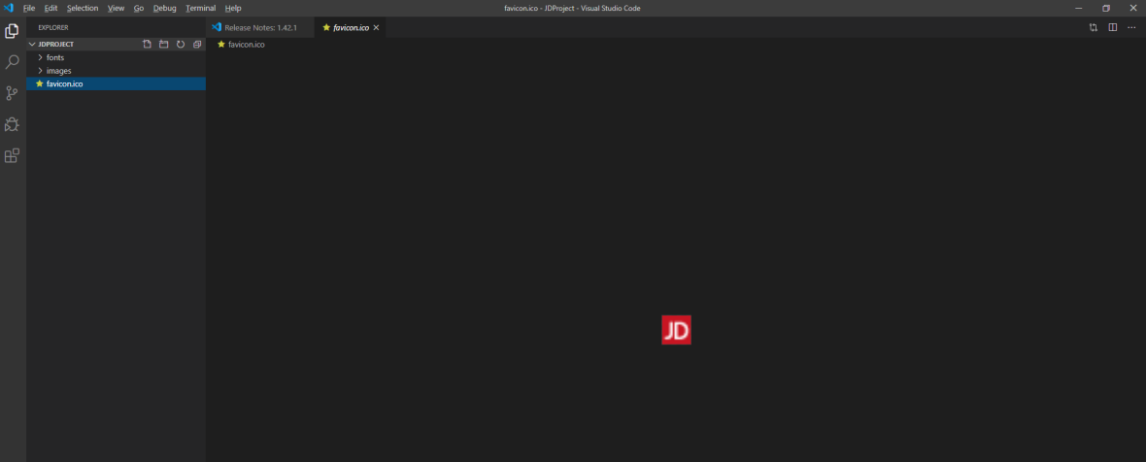

# 单元2：项目整体编写

## 任务2.1 页面标题及描述

1. 在项目主目录中新建index.html，在其中添加如下代码：

<!DOCTYPE html>

<html lang="en">

<head>

    <meta charset="UTF-8">

    <title>京东(JD.COM)-正品低价、品质保障、配送及时、轻松购物！</title>

    <meta name="description" content="京东JD.COM-专业的综合网上购物商城,销售家电、数码通讯、电脑、家居百货、服装服饰、母婴、图书、食品等数万个品牌优质商品.便捷、诚信的服务，为您提供愉悦的网上购物体验!" />

    <meta name="Keywords" content="网上购物,网上商城,手机,笔记本,电脑,MP3,CD,VCD,DV,相机,数码,配件,手表,存储卡,京东" />

</head>

<body>

</body>

注：<meta/>标签中charset指定了编码格式，descroption是页面内容描述，Keywords是搜索引擎搜索页面的关键字，<title/>标签是页面标题。

## 任务2.2顶部开始模块

1. 在index.html的head标签中添加css样式文件导入

<link rel="stylesheet" href="css/normalize.css" />

<link rel="stylesheet" href="css/base.css" />

<link rel="stylesheet" href="css/index.css">

，在<body></body>标签中添加代码如下：

<div class="J_event">

<a href="#" class="w">

<i></i>

</a>

</div>

1. 在项目文件中新建base.css文件，在base.css文件中添加开始模块样式，代码如下：

@font-face {

    font-family: 'icomoon';

    src:  url('../fonts/icomoon.eot?axvffw');

    src:  url('../fonts/icomoon.eot?axvffw#iefix') format('embedded-opentype'),

      url('../fonts/icomoon.ttf?axvffw') format('truetype'),

      url('../fonts/icomoon.woff?axvffw') format('woff'),

      url('../fonts/icomoon.svg?axvffw#icomoon') format('svg');

    font-weight: normal;

    font-style: normal;

  }

/* 京东 顶部 start */

body {

    background-color: #F6F6F6;

}

* {

    margin: 0;

    padding: 0;

}

.w {

    width: 1190px;

    margin: auto;

}

.J_event {

    background-color: #000;

}

.J_event a {

    display: block;

    height: 80px;

    background: url(../images/top.jpg) no-repeat;

    position: relative;

}

.J_event a i {

    width: 20px;

    height: 20px;

    position: absolute;

    right: 0;

    top: 5px;

    font-family: "icomoon";

    font-style: normal;

    text-align: center;

    line-height: 20px;

    color: #fff;

    background: rgba(0,0,0,0.4);

}

实现的效果如下图：

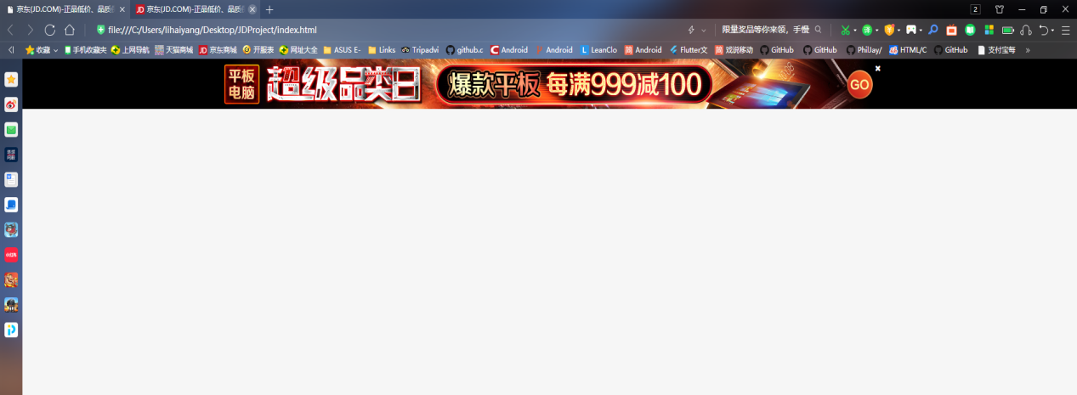

注：normalize.css文件是针对浏览器的css初始化，base.css文件只写公共样式，是针对页面的头部和底部样式，index.css文件是针对index.html的样式文件，<link> 标签定义文档与外部资源的关系，最常见的用途是链接样式表，@font-face是用于字体导入。

## 任务2.3导航模块

1. 在index.html文件的<body>标签中添加如下代码：

<div class="shortcut">

        <div class="w">

            <ul class="fl">

                <li>

                    <i class="pos"></i>

                    北京

                 </li>

            </ul>

            <ul class="fr">

                <li>

                    <a href="#">

                         你好，请登录&nbsp;&nbsp;

                    </a>

                    <a href="#" class="style-red">

                         免费注册

                    </a>

                </li>

                <li class="spacer"></li>

                <li>

                    <a href="#">

                        我的订单

                    </a>

                </li>

                <li class="spacer"></li>

                <li class="dropdown">

                    <a href="#">

                        我的京东

                    </a>

                    <i></i>

                </li>

                <li class="spacer"></li>

                <li>

                    <a href="#">

                        京东会员

                    </a>

                </li>

                <li class="spacer"></li>

                <li>

                    <a href="#">

                        企业采购

                    </a>

                </li>

                <li class="spacer"></li>

                <li class="dropdown">

                    <a href="#">

                        客户服务

                    </a>

                    <i></i>

                </li>

                <li class="spacer"></li>

                <li class="dropdown">

                    <a href="#">

                        网站导航

                    </a>

                    <i></i>

                </li>

                <li class="spacer"></li>

                <li style="position: relative; z-index: 1;">

                    <a href="#">

                        手机京东

                    </a>

                    <div class="erweima">

                        <img src="images/erweima.png" alt="">

                    </div>

                </li>

            </ul>

        </div>

    </div>

1. 在base.css文件中添加导航模块的样式，代码如下：

.fr {

    float: right;

}

.fl {

    float: left;

}

.style-red {

    color: #f10215!important;

}

li {

    list-style: none;

}

ul {

    margin: 0;

    padding: 0;

}

.shortcut {

    height: 30px;

    line-height: 30px;

    background-color: #E3E4E5;

    border-bottom: 1px solid #DDDDDD;

    color: #9D9D9D;

    font-size: 12px;

}

.shortcut a {

    color: #9D9D9D;

    font-size: 12px;

    text-decoration: none;

}

.shortcut a:hover {

    color: #c81623;

}

.pos {

    font-family: "icomoon";

    font-style: normal;

    font-size: 14px;

    color: #f10215;

}

.shortcut .fl li {

    margin-left: 200px;

    height: 30px;

    overflow: hidden;

}

.shortcut .fr li {

    float: left;

}

.spacer {

    width: 1px;

    height: 10px;

    background-color: #ccc;

    margin: 10px 10px 0;

}

.dropdown {

    padding-right: 15px;

    position: relative;

}

.dropdown i {

    font-family: "icomoon";

    font-style: normal;

    font-size: 16px;

    position: absolute;

    right: -2px;

    top: -2px;

}

.erweima {

    width: 60px;

    height: 60px;

    border: 1px solid #ccc;

    padding: 3px;

    position: absolute;

    left: -8px;

    top: 35px;

}

实现的效果如下图：

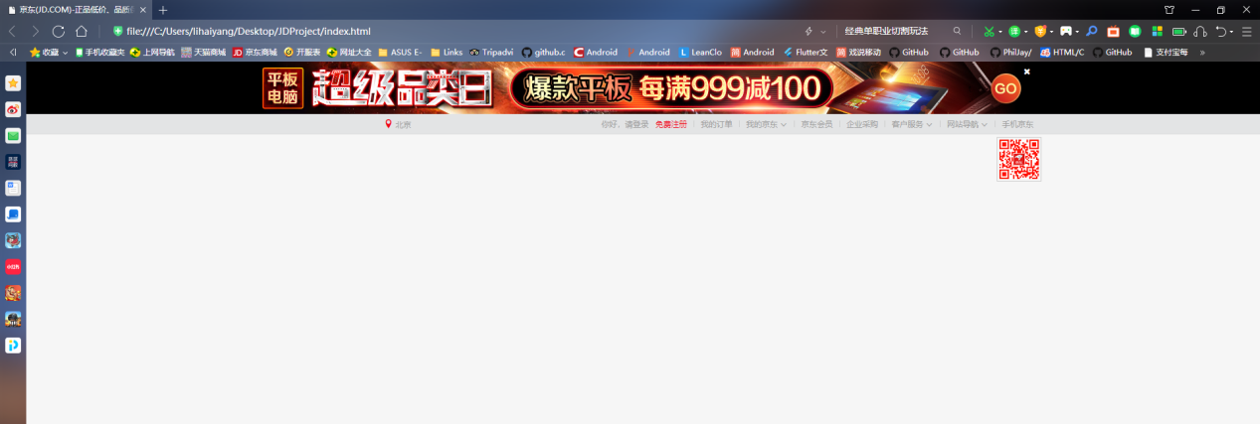

注：<ul>标签是用于定义无序列表，一般与<li>标签一起使用，<a>标签用于定义超链接，从一个页面链接到另一个页面，href属性指定的是链接的目标，#代表是锚点链接到当前页面，<i>标签中不是空格，是引入的字体文件的图标，需要将中间的内容复制进来。

## 任务2.4 header头部模块

1. 在index.html文件的<body>标签中添加如下代码：

<div class="header">

        <div class="w inner">

             <!-- logo 部分 -->

             <div class="logo">

                <h1>

                    <a href="#" title="京东网">京东</a>

                </h1>

             </div>

             <!-- 搜索部分 -->

             <div class="search">

                <input type="text" value="单反相机">

                <button>

                    <i></i>

                </button>

                <em></em>

             </div>

             <!-- 热词部分 -->

             <div class="hotwords">

                <a href="#" class="style-red">学生专享</a>

                <a href="#">300减160</a>

                <a href="#">七折返场</a>

                <a href="#">骑行运动</a>

                <a href="#">家电榜单</a>

                <a href="#">无损播放器</a>

                <a href="#">汽车脚垫</a>

                <a href="#">巧克力</a>

                <a href="#">铝合金门窗</a>

             </div>

                <!-- 购物车 -->

             <div class="myCar">

                <i></i>

                <a href="#">我的购物车</a>

                <s>0</s>

             </div>

            <!-- 电脑 -->

            <div class="computer">

                <a href="#">

                    <img src="images/computer.jpg" height="40" width="190" alt="">

                </a>

            </div>

            <!-- 导航栏信息 -->

            <div class="navitems">

                <ul>

                    <li><a href="#">秒杀</a></li>

                    <li><a href="#">优惠券</a></li>

                    <li><a href="#">闪购</a></li>

                    <li><a href="#">拍卖</a></li>

                </ul>

                <div class="spacer"></div>

                <ul>

                    <li><a href="#">京东服饰</a></li>

                    <li><a href="#">京东超市</a></li>

                    <li><a href="#">生鲜</a></li>

                    <li><a href="#">全球购</a></li>

                </ul>

                <div class="spacer"></div>

                <ul>

                    <li><a href="#">京东金融</a></li>

                </ul>

            </div>

        </div>

    </div>

（2）在base.css文件中添加导航模块的样式，代码如下：

input, button {

    padding: 0;

    border: 0;

}

a {

    text-decoration: none;

}

img {

    vertical-align: top;  /* 去除 图片低测缝隙  图片和文字的基线对齐 */

}

.header {

    height: 140px;

}

.inner {

    height: 140px;

    position: relative;

}

/* logo模块 */

.logo {

    width: 190px;

    height: 170px;

    position: absolute;

    top: -30px;

    left: 0;

    background-color: purple;

    box-shadow: 0 -12px 10px rgba(0,0,0,.2);

}

.logo h1 {

    margin: 0;

}

.logo a {

    display: block;

    width: 190px;

    height: 170px;

    background: url(../images/logo.jpg) no-repeat;

    text-indent: -99999px;

    overflow: hidden;

}

/* 搜索模块 */

.search {

    width: 550px;

    height: 35px;

    position: absolute;

    top: 25px;

    left: 320px;

}

.search input {

    width: 493px;

    height: 33px;

    border: 1px solid #F10215;

    padding-left: 5px;

    outline: none; /* 取消蓝色边框 */

    color: #989898;

    float: left;

}

.search button {

    width: 50px;

    height: 35px;

    background-color: #F10215;

    float: left;

    cursor: pointer; /* 鼠标变成小手 */

    outline: none;

}

.search i {

    font-family: "icomoon";

    color: #fff;

    font-style: normal;

    font-size: 16px;

}

.search em {

    position: absolute;

    top: 10px;

    right: 65px;

    width: 19px;

    height: 15px;

    cursor: pointer;

    background: url(../images/sprite-search.png) no-repeat;

}

.search em:hover {

    background-position: -30px 0;

}

/* 热点模块 */

.hotwords {

    position: absolute;

    top: 70px;

    left: 320px;

}

.hotwords a {

    color: #9E9B99;

    font-size: 12px;

}

.hotwords a:hover {

    color: #f10215;

}

/* 购物车模块 */

.myCar {

    width: 188px;

    height: 33px;

    border: 1px solid #ccc;

    position: absolute;

    top: 25px;

    right: 100px;

    text-align: center;

    line-height: 33px;

}

.myCar a {

    font-size: 12px;

    color: #f10215;

}

.myCar i {

    font-family: "icomoon";

    font-style: normal;

    color: #f10215;

    margin-right: 3px;

}

.myCar s {

    position: absolute;

    top: 5px;

    left: 140px;

    text-decoration: none;

    background-color: #f10215;

    height: 16px;

    line-height: 16px;

    font-size: 12px;

    padding: 0 3px;

    border-radius: 7px;

    color: #fff;

}

/* 电脑模块 */

.computer {

    position: absolute;

    right: 0;

    bottom: 10px;

}

/* 导航栏信息模块 */

.navitems {

    position: absolute;

    left: 200px;

    bottom: 0;

}

.navitems ul {

    float: left;

}

.navitems ul li{

    float: left;

    margin-left: 30px;

}

.navitems li a {

    font-size: 16px;

    color: #555A5F;

    font-weight: 700;

    height: 40px;

    line-height: 40px;

    display: block;

}

.navitems li a:hover {

    color: #f10215;

}

.navitems .spacer {

    float: left;

    margin-top: 15px;

    margin-left: 20px;

    margin-right: -10px;

}

实现的效果如下图：

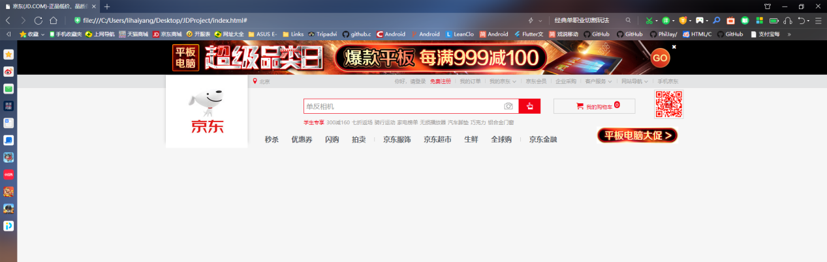

注：<h1>标签是标题标签，添加title属性后会在鼠标移动到标签后显示title中的内容，<input>标签是输入框，value属性是输入框中的默认内容，<em> 标签告诉浏览器把其中的内容表示为强调的内容。

## 任务2.5商品分类列表以及热门商品

（1）在index.html文件的<body>标签中添加如下代码：

<div class="jd">

        <div class="w jd-inner">

            <div class="jd-clo1">

                <ul>

                    <li><a href="#">家用电器</a></li>

                    <li>

                        <a href="#">手机</a>

                        <span>/</span>

                        <a href="#">运营商</a>

                        <span>/</span>

                        <a href="#">数码</a>

                    </li>

                    <li>

                        <a href="#">电脑</a>

                        <span>/</span>

                        <a href="#">运营商</a>

                        <span>/</span>

                        <a href="#">数码</a>

                    </li>

                    <li>

                        <a href="#">手机</a>

                        <span>/</span>

                        <a href="#">运营商</a>

                        <span>/</span>

                        <a href="#">数码</a>

                    </li>

                    <li>

                        <a href="#">手机</a>

                        <span>/</span>

                        <a href="#">运营商</a>

                        <span>/</span>

                        <a href="#">数码</a>

                    </li>

                    <li>

                        <a href="#">手机</a>

                        <span>/</span>

                        <a href="#">运营商</a>

                        <span>/</span>

                        <a href="#">数码</a>

                    </li>

                    <li>

                        <a href="#">手机</a>

                        <span>/</span>

                        <a href="#">运营商</a>

                        <span>/</span>

                        <a href="#">数码</a>

                    </li>

                    <li>

                        <a href="#">手机</a>

                        <span>/</span>

                        <a href="#">运营商</a>

                        <span>/</span>

                        <a href="#">数码</a>

                    </li>

                    <li>

                        <a href="#">手机</a>

                        <span>/</span>

                        <a href="#">运营商</a>

                        <span>/</span>

                        <a href="#">数码</a>

                    </li>

                    <li>

                        <a href="#">手机</a>

                        <span>/</span>

                        <a href="#">运营商</a>

                        <span>/</span>

                        <a href="#">数码</a>

                    </li>

                    <li>

                        <a href="#">手机</a>

                        <span>/</span>

                        <a href="#">运营商</a>

                        <span>/</span>

                        <a href="#">数码</a>

                    </li>

                    <li>

                        <a href="#">手机</a>

                        <span>/</span>

                        <a href="#">运营商</a>

                        <span>/</span>

                        <a href="#">数码</a>

                    </li>

                    <li>

                        <a href="#">手机</a>

                        <span>/</span>

                        <a href="#">运营商</a>

                        <span>/</span>

                        <a href="#">数码</a>

                    </li>

                    <li>

                        <a href="#">手机</a>

                        <span>/</span>

                        <a href="#">运营商</a>

                        <span>/</span>

                        <a href="#">数码</a>

                    </li>

                    <li>

                        <a href="#">手机</a>

                        <span>/</span>

                        <a href="#">运营商</a>

                        <span>/</span>

                        <a href="#">数码</a>

                    </li>

                    <li>

                        <a href="#">手机</a>

                        <span>/</span>

                        <a href="#">运营商</a>

                        <span>/</span>

                        <a href="#">数码</a>

                    </li>

                </ul>

            </div>

            <div class="jd-clo2">

                <div class="jd-clo2-hd">

                    <a href="#" class="arr-l"></a>

                    <a href="#" class="arr-r"></a>

                    <ol>

                        <li class="current"></li>

                        <li></li>

                        <li></li>

                        <li></li>

                        <li></li>

                        <li></li>

                        <li></li>

                        <li></li>

                    </ol>

                    <ul>

                        <li><a href="#"><img src="images/banner.jpg"></a></li>

                    </ul>

                </div>

                <div class="jd-clo2-bd">

                    <div class="firstPic">

                        <img src="images/pic1.jpg" >

                    </div>

                    <div>

                        <img src="images/pic2.jpg" >

                    </div>

                </div>

            </div>

            <div class="jd-clo3">

                <div class="user">

                    <div class="user-info">

                        Hi, 欢迎来到京东!  <br />

                        <a href="#">登录</a>

                        <a href="#">注册</a>

                        <a href="#" class="info-img">

                            <img src="images/no_login.jpg">

                        </a>

                    </div>

                    <div class="user-profit">

                        <a href="#">新人福利</a>

                        <a href="#">PLUS会员</a>

                    </div>

                </div>

                <div class="news">

                    <div class="tab-hd">

                        <a href="javascript:;" class="cuxiao">促销</a>

                        <a href="javascript:;">公告</a>

                        <a href="#" class="more1">更多</a>

                        <div class="line"></div>

                    </div>

                    <div class="tab-bd">

                        <ul>

                            <li><a href="#">蓄电池专场下单立减100元</a></li>

                            <li><a href="#">蓄电池专场下单立减100元</a></li>

                            <li><a href="#">蓄电池专场下单立减100元</a></li>

                            <li><a href="#">蓄电池专场下单立减100元</a></li>

                        </ul>

                    </div>

                </div>

                <div class="jd-service">

                    <ul>

                        <li>

                            <a href="#">

                                <i></i>

                                <p>机票</p>

                            </a>

                        </li>

                        <li>

                            <a href="#">

                                <i></i>

                                <p>机票</p>

                            </a>

                        </li>

                        <li>

                            <a href="#">

                                <i></i>

                                <p>机票</p>

                            </a>

                        </li>

                        <li>

                            <a href="#">

                                <i></i>

                                <p>机票</p>

                            </a>

                        </li>

                        <li>

                            <a href="#">

                                <i></i>

                                <p>机票</p>

                            </a>

                        </li>

                        <li>

                            <a href="#">

                                <i></i>

                                <p>机票</p>

                            </a>

                        </li>

                        <li>

                            <a href="#">

                                <i></i>

                                <p>机票</p>

                            </a>

                        </li>

                        <li>

                            <a href="#">

                                <i></i>

                                <p>机票</p>

                            </a>

                        </li>

                        <li>

                            <a href="#">

                                <i></i>

                                <p>机票</p>

                            </a>

                        </li>

                        <li>

                            <a href="#">

                                <i></i>

                                <p>机票</p>

                            </a>

                        </li>

                        <li>

                            <a href="#">

                                <i></i>

                                <p>机票</p>

                            </a>

                        </li>

                        <li>

                            <a href="#">

                                <i></i>

                                <p>机票</p>

                            </a>

                        </li>

                    </ul>

                </div>

            </div>

        </div>

        <!-- 广告结束 -->

        <div class="ad">

            <a href="#"></a>

        </div>

    </div>

（2）在html.css文件中添加分类列表和热门商品模块的样式，代码如下：

.jd {

    /* height: 480px; */

    /* background-color: pink; */

    position: relative;

}

.jd-inner {

    height: 480px;

    /* background-color: skyblue; */

    z-index: 999;  /* 只有定位的盒子才有 z-index */

    position: relative;

}

.ad {

    height: 480px;

    background: url(../images/bg.png) no-repeat top center;

    position: absolute;  /* 行内块转换 */

    top: 0;

    left: 0;

    width: 100%;  /* 强制显示宽度 */

}

.ad a {

    display: block;

    height: 100%;

}

.jd-clo1 {

    width: 190px;

    height: 465px;

    background-color: #6E6568;

    float: left;

    padding-top: 15px;

}

.jd-clo1 li {

    padding-left: 10px;

    height: 28px;

    line-height: 28px;

}

.jd-clo1 li:hover {

    background-color: #999395;

}

.jd-clo1 li a {

    color: #fff;

    font-size: 14px;

}

.jd-clo1 li span {

    color: #fff;

    font-size: 12px;

}

.jd-clo2 {

    width: 790px;

    height: 480px;

    float: left;

    margin-left: 10px;

}

.jd-clo2-hd {

    height: 340px;

    margin-bottom: 10px;

    position: relative;

}

.jd-clo2-bd div {

    width: 390px;

    height: 130px;

    float: left;

}

.jd-clo2-bd div img {

    width: 100%;

}

.firstPic {

    margin-right: 10px;

}

.arr-l, .arr-r {

    position: absolute;

    top: 50%;

    margin-top: -30px;

    width: 30px;

    height: 60px;

    background: rgba(0, 0, 0, 0.3);

    font-family: "icomoon";

    color: #fff;

    text-align: center;

    line-height: 60px;

    font-size: 25px;

}

.arr-l {

    left: 0;

}

.arr-r {

    right: 0;

}

.jd-clo2-hd ol {

    position: absolute;

    bottom: 20px;

    left: 50%;

    margin-left: -90px;

    width: 180px;

    height: 20px;

    background: rgba(255, 255,255, 0.3);

    border-radius: 10px;

}

.jd-clo2-hd ol  li {

    width: 12px;

    height: 12px;

    background-color: #fff;

    border-radius: 50%;

    float: left;

    margin: 4px 5px;

    cursor: pointer;

}

.jd-clo2-hd .current {

    background-color: #f10215;

}

.jd-clo3 {

    width: 190px;

    height: 480px;

    float: right;

}

.jd-clo3 a {

    font-size: 12px;

    color: #747474;

}

.user {

    height: 95px;

    background-color: pink;

    padding: 20px 15px 0;

}

.user-info {

    height: 40px;

    padding-left: 54px;

    font-size: 12px;

    color: #747474;

    line-height: 22px;

    position: relative;

}

.user-info a  {

    font-size: 12px;

    color: #747474;

}

.user-info a:hover  {

    color: #f10215;

}

.info-img {

    width: 40px;

    height: 40px;

    position: absolute;

    top: 0;

    left: 0;

    border-radius: 50%;

    overflow: hidden;

}

.info-img  img {

    width: 100%;

    height: auto; /* 自动 跟随者宽度 一起缩放 */

}

.user-profit {

    margin-top: 14px;

}

.user-profit a {

   width: 70px;

   height: 20px;

   border: 2px solid #f10215;

   display: inline-block;

   font-size: 12px;

   color: #f10215;

   text-align: center;

   line-height: 20px;

   margin-right: 4px;

}

.user-profit a:hover {

    background-color: #f10215;

    color: #fff;

}

.news {

    height: 149px;

    border-top: 1px solid #ccc;

    border-bottom: 1px solid #ccc;

    padding: 5px 15px 0;

}

.tab-hd {

    border-bottom: 1px solid #ccc;

    padding: 3px 0;

    position: relative;

}

.tab-hd a {

    margin: 0 4px;

}

.cuxiao {

    border-right: 1px solid #ccc;

    padding-right: 10px;

}

.news .more1 {

    position: absolute;

    top: 6px;

    right: 0;

}

.line {

    width: 28px;

    height: 2px;

    background-color: #f10215;

    position: absolute;

    bottom: -1px;

    left: 0;

}

.tab-bd {

    margin-top: 10px;

}

.tab-bd li {

    height: 23px;

    line-height: 23px;

}

.jd-service  {

    height: 209px;

    /* background-color: skyblue; */

    width: 190px;

    overflow: hidden;

}

.jd-service  ul {

    width: 195px;

}

.jd-service li {

    width: 47px;

    height: 69px;

    /* background-color: purple; */

    float: left;

    border-right: 1px solid #ccc;

    border-bottom: 1px solid #ccc;

}

.jd-service li a {

    width: 100%;

    height: 100%;  /* 根据父亲 */

    /* height: auto; 针对于自己的高度和宽度 */

    display: block;

}

.jd-service  i {

    display: block;

    width: 24px;

    height: 24px;

    margin: 15px auto 8px;

    background: url(../images/sprite_fs@1x.png) no-repeat;

}

.jd-service  p {

    text-align: center;

}

实现的效果如下图：

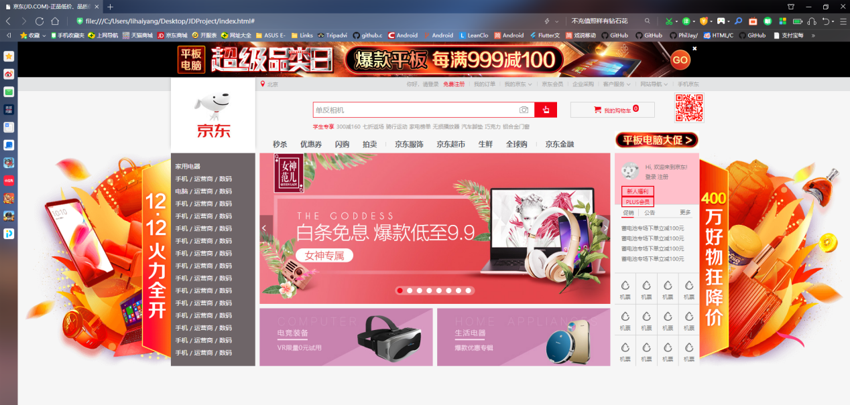

注：<p>标签定义了一个段落。

## 任务2.6 footer底部模块

1. 在index.html文件的<body>标签中添加如下代码：

<div class="footer">

        <!-- 多快好省 -->

          <div class="footer-service">

               <div class="w footer-service-inner">

                   <ul class="clearfix">

                       <li>

                           <div class="service_unit">

                               <h5>多</h5>

                               <p>品类齐全，轻松购物</p>

                           </div>

                       </li>

                       <li>

                           <div class="service_unit">

                               <h5 class="kuai">快</h5>

                               <p>多仓直发，极速配送</p>

                           </div>

                       </li>

                       <li>

                           <div class="service_unit">

                               <h5 class="hao">好</h5>

                               <p>正品行货，精致服务</p>

                           </div>

                       </li>

                       <li>

                           <div class="service_unit">

                               <h5 class="sheng">省</h5>

                               <p>天天低价，畅选无忧</p>

                           </div>

                       </li>

                   </ul>

               </div>

          </div>

          <!-- 帮助模块 -->

          <div class="w help">

                   <dl>

                       <dt>购物指南</dt>

                       <dd><a href="#">购物流程</a></dd>

                       <dd><a href="#">会员介绍</a></dd>

                       <dd><a href="#">生活旅行</a></dd>

                       <dd><a href="#">常见问题</a></dd>

                       <dd><a href="#">大家电</a></dd>

                       <dd><a href="#">联系客服</a></dd>

                   </dl>

                   <dl>

                       <dt>购物指南</dt>

                       <dd><a href="#">购物流程</a></dd>

                       <dd><a href="#">会员介绍</a></dd>

                       <dd><a href="#">生活旅行</a></dd>

                       <dd><a href="#">常见问题</a></dd>

                       <dd><a href="#">大家电</a></dd>

                       <dd><a href="#">联系客服</a></dd>

                   </dl>

                   <dl>

                       <dt>购物指南</dt>

                       <dd><a href="#">购物流程</a></dd>

                       <dd><a href="#">会员介绍</a></dd>

                       <dd><a href="#">生活旅行</a></dd>

                       <dd><a href="#">常见问题</a></dd>

                       <dd><a href="#">大家电</a></dd>

                       <dd><a href="#">联系客服</a></dd>

                   </dl>

                   <dl>

                       <dt>购物指南</dt>

                       <dd><a href="#">购物流程</a></dd>

                       <dd><a href="#">会员介绍</a></dd>

                       <dd><a href="#">生活旅行</a></dd>

                       <dd><a href="#">常见问题</a></dd>

                       <dd><a href="#">大家电</a></dd>

                       <dd><a href="#">联系客服</a></dd>

                   </dl>

                   <dl>

                       <dt>购物指南</dt>

                       <dd><a href="#">购物流程</a></dd>

                       <dd><a href="#">会员介绍</a></dd>

                       <dd><a href="#">生活旅行</a></dd>

                       <dd><a href="#">常见问题</a></dd>

                       <dd><a href="#">大家电</a></dd>

                       <dd><a href="#">联系客服</a></dd>

                   </dl>

                   <dl class="cover">

                       <dt>京东自营覆盖区县</dt>

                       <dd class="info">京东已向全国2661个区县提供自营配送服务，支持货到付款、POS机刷卡和售后上门服务。

                       </dd>

                       <dd class="more"><a href="#">查看详情 > </a></dd>

                   </dl>

          </div>

       <!-- 版权模块 -->

       <div class="w copyright">

               <div class="links">

                   <a href="#">关于我们</a>

                   <span>|</span>

                   <a href="#">关于我们</a>

                   <span>|</span>

                   <a href="#">关于我们</a>

                   <span>|</span>

                   <a href="#">关于我们</a>

                   <span>|</span>

                   <a href="#">关于我们</a>

                   <span>|</span>

                   <a href="#">关于我们</a>

                   <span>|</span>

                   <a href="#">关于我们</a>

                   <span>|</span>

                   <a href="#">关于我们</a>

                   <span>|</span>

                   <a href="#">关于我们</a>

                   <span>|</span>

                   <a href="#">关于我们</a>

                   <span>|</span>

                   <a href="#">关于我们</a>

                   <span>|</span>

                   <a href="#">English</a>

                   <span>|</span>

                   <a href="#">Site</a>

                   <span>|</span>

                   <a href="#">Media & IR</a>

                   <span>|</span>

               </div>

               <div class="c-info">

                   <p>京公网安备 11000002000088号|京ICP证070359号|互联网药品信息服务资格证编号(京)-经营性-2014-0008|新出发京零 字第大120007号</p>

                   <p>互联网出版许可证编号新出网证(京)字150号|出版物经营许可证|网络文化经营许可证京网文[2014]2148-348号|违法和不良信息举报电话：4006561155</p>

                   <p>Copyright © 2004 - 2017  京东JD.com 版权所有|消费者维权热线：4006067733经营证照</p>

                   <p>京东旗下网站：京东支付|京东云</p>

               </div>

               <div class="tupian">

                   <a href="#"></a>

                   <a href="#" class="kexin"></a>

                   <a href="#"></a>

                   <a href="#"></a>

                   <a href="#"></a>

                   <a href="#"></a>

               </div>

       </div>

    </div>

（2）在base.css文件中添加底部footer模块的样式，代码如下：

.clearfix:before,.clearfix:after {

    content:"";

    display: table;  /* 这句话可以出发BFC BFC可以清除浮动,BFC我们后面讲 */

  }

  .clearfix:after {

   clear:both;

  }

  .clearfix {

    *zoom:1;

  }

.footer {

    height: 560px;

    background-color: #EAEAEA;

}

.footer-service {

    border-bottom: 1px solid #DEDEDE;

}

.footer-service-inner {

    padding: 30px 0;

}

.footer-service-inner li {

    float: left;

    width: 297px;

    height: 42px;

}

.service_unit {

    width: 225px;

    height: 42px;

    margin: 0 auto;

    position: relative;

}

.service_unit h5 {

    width: 36px;

    height: 42px;

    position: absolute;

    top: 0;

    left: 0;

    background: url(../images/ico_service.png) no-repeat;

    text-indent: -999px;

    overflow: hidden;

}

.service_unit p {

    line-height: 42px;

    margin-left: 45px;

    font-size: 18px;

    font-weight: 700;

}

.service_unit .kuai {

    background-position: 0 -44px;

}

.service_unit .hao {

    background-position: 0 -86px;

}

.service_unit .sheng {

    background-position: 0 -128px;

}

.help {

    height: 180px;

    /* background-color: pink; */

    padding-top: 20px;

}

.help dl {

    float: left;

    width: 195px;

}

.help dt {

    font-size: 14px;

    font-weight: 700;

    color: #666;

    height: 30px;

}

.help dd {

    height: 22px;

}

.help dd a{

    color: #727272;

    font-size: 12px;

}

.help dd a:hover {

    color: #f10215;

}

.help .cover {

    float: right;

    width: 207px;

    height: 150px;

    background: url(../images/ico_footer.png) no-repeat;

}

.cover dt {

    text-align: center;

}

.help .info {

    width: 175px;

    height: 50px;

    font-size: 12px;

    margin-top: 5px;

    margin-left: 10px;

    line-height: 18px;

    color: #727272;

}

.more {

    text-align: right;

    padding-right: 10px;

}

/* 版权模块 */

.copyright {

    border-top: 1px solid #ccc;

    padding-top: 15px;

}

.links {

    text-align: center;

}

.links a {

    color: #727272;

    font-size: 12px;

}

.links span {

    font-size: 12px;

    color: #D4CDCD;

    margin: 0 6px;

}

.c-info {

    font-size: 12px;

    color: #9E9E9B;

    text-align: center;

    line-height: 20px;

    margin-top: 10px;

}

.tupian {

    text-align: center;

    margin-top: 10px;

}

.tupian a{

    width: 103px;

    height: 32px;

    display: inline-block;

    background: url(../images/ico_footer.png) no-repeat 0 -151px;

}

.tupian .kexin {

    background-position: -104px -151px;

}

实现的效果如下图：

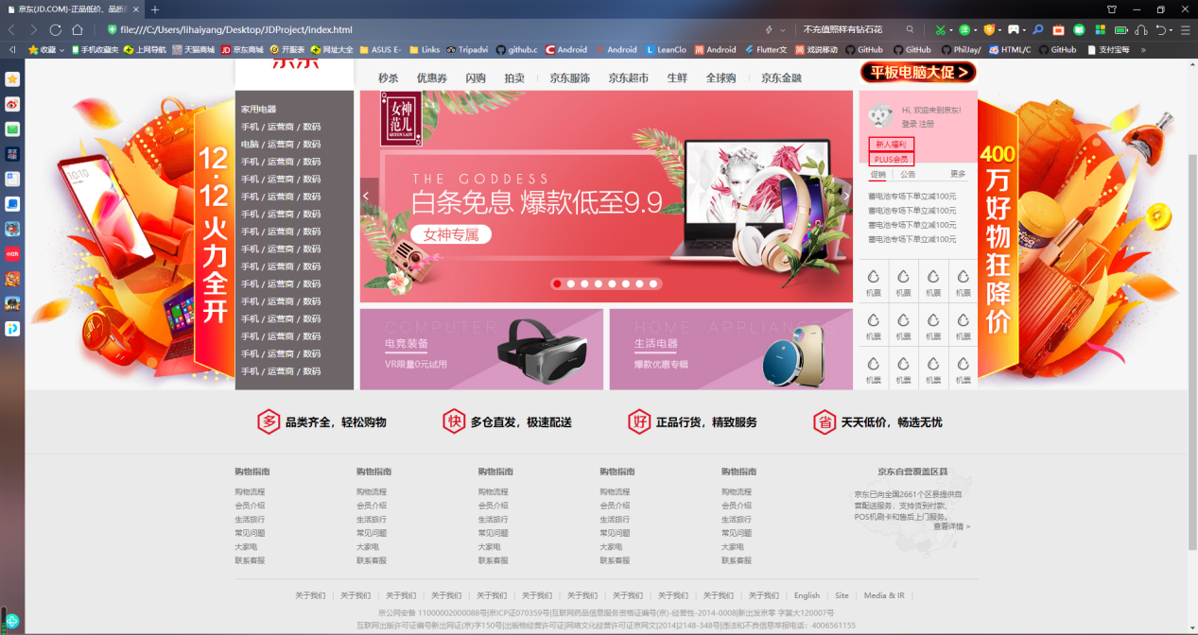

注：<dl>标签用于定义一个定义列表，结合<dt>标签和<dd>标签使用，<dt>标签用于定义列表中的项目，<dd>标签用于描述列表中的项目。