**INDIAN INSTITUTE OF TECHNOLOGY (INDIAN SCHOOL OF MINES ), DHANBAD**



**PROJECT ON REMOVAL OF SPECKLE NOISE FROM SAR IMAGES USING DS ALGORIHM**

**SUBMITTED BY,**

**N NAGA SAI KRISHNA (ADM NO. 14JE000157)**

**SAMANWAY DEY(ADM NO. 14JE000237)**

**ABHINAV SRIHARI R(ADM NO 14JE000373)**

**DATE: 11/04/2017**

**PROJECT MENTOR**

**DR. SUSHANTA MUKHOPADHYAY**

**ASSOCIATE PROFESSOR,**

**IIT(ISM) DHANBAD**

Certificate

This is to certify that this report is submitted by N Naga Sai Krishna (Admission No 14JE000157), Samanway Dey (Admission No 14JE000237),Abhinav Srihari.R (Admission No 14JE000373) students of Computer Science and Engineering, Indian Institute of Technology ( Indian School of Mines ), Dhanbad and they have successfully completed a project on Smoothing of SAR images using Directional Smoothing Algorithm in 6th Semester of Academic year 2015-2016.

Dr. Sushanta Mukhopadhyay

…………………………

Associate Professor

Department of CSE

IIT(ISM) Dhanbad

Acknowledgement

We express our deep sense of gratitude and respect towards our project mentor, Dr. Sushanta Mukhopadhyay, Associate Professor, Department of Computer Science and Engineering, Indian Institute of Technology (Indian School of Mines), Dhanbad. We are very grateful for the generosity, expertise and guidance We have received from him while working on the project. Expressing our sincere thanks to our mentor, we would like to convey our sincere regards and gratitude for encouraging us to undertake this project and to work on it at time and again, it would not have been possible without him. We have all but enjoyed working on this project under his wings and We shall keep so for the times to come.

**What is Synthetic Aperture Radar (SAR)**

Synthetic aperture radar (SAR) is a form of radar that is used to create two- or 3-dimensional images of objects, such as landscapes. SAR uses the motion of the radar antenna over a target region to provide finer spatial resolution than conventional beam-scanning radars. SAR is typically mounted on a moving platform such as an aircraft or spacecraft, and has its origins in an advanced form of side-looking airborne radar (SLAR). The distance the SAR device travels over a target in the time taken for the radar pulses to return to the antenna creates the large "synthetic" antenna aperture (the "size" of the antenna). As a rule of thumb, the larger the aperture, the higher the image resolution will be, regardless of whether the aperture is physical (a large antenna) or 'synthetic' (a moving antenna) – this allows SAR to create high resolution images with comparatively small physical antennas.

The properties of SAR can be described as having high resolution capability which is independent of flight altitude, not being dependent on the weather as SAR can select proper frequency range.

**Noise in SAR imagery**

There are some problems with SAR imagery, Specially there is noise in images from Synthetic Aperture Radar. Like some of the noise is phase noise or Speckle noise. Speckle is the dominant noise in SAR imagery. It is due to multiple coherent reflections from the ambience around the target. Multi looking or adaptive edge preserving filtering can be used to remove the noise.

**Speckle Noise**

Speckle is a granular 'noise' that inherently exists in and degrades the quality of the active radar, synthetic aperture radar (SAR), medical ultrasound and optical coherence tomography images. The vast majority of surfaces, synthetic or natural, are extremely rough on the scale of the wavelength. Images obtained from these surfaces by coherent imaging systems such as laser, SAR, and ultrasound suffer from a common phenomenon called speckle. Speckle, in both cases, is primarily due to the interference of the returning wave at the transducer aperture. The origin of this noise is seen if we model our reflectivity function as an array of scatterers . Because of the finite resolution, at any time we are receiving from a distribution of scatterers within the resolution cell. These scattered signals add coherently; that is, they add constructively and destructively depending on the relative phases of each scattered waveform. Speckle noise results from these patterns of constructive and destructive interference shown as bright and dark dots in the image

Speckle noise in SAR images is usually modeled as a purely multiplicative noise process of the form given in Eq.(1) below. The true radiometric values of the image are represented by u, and the values measured by the radar instrument are represented by v. The speckle noise is represented by s.

v(r,c) = u(r,c) s(r,c) …………………(1)

For single-look SAR images, s is Rayleigh distributed (for amplitude images) or negative exponentially distributed (for intensity images) with a mean of 1. For multi-look SAR images with independent looks, has a gamma distribution with a mean of 1.

**Theory of Enhanced Directional Smoothing**

To protect the edges from blurring while smoothing, a directional averaging filter can be useful. Spatial averages û(r, c: Θ) are calculated in several directions as



which excludes to v(r, c) - and a direction Θ* is found such that | v(r, c) - û(r, c:Θ*) | is minimum. Then

û(r,c) = û(r,c:Θ*)

gives the desired result for the suitably chosen window W and a NΘ number of directions, and where k and l depends on the size of such windows (kernel). The EDS filter has a speckle reduction approach that performs spatial filtering in a square-moving window know as kernel. The EDS filtering is based on the statistical relationship between the central pixel and its surround-ding pixels as shown in Figure 1.

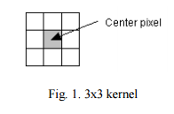

The typical size of the filter window can range from 3-by-3 to 33-by-33, the size of the window must be odd. A larger filter window means that a larger area of the image can be used for calculation and possibly requires more computation time depending on the complexity of the filter’s algorithm. If the size of filter window is too large, the important details will be lost due to over smoothing. On the other hand, if the size of the filter window is too small, speckle reduction may not be very effective. In practice, a 3-by-3 or a 7-by-7 filter window usually yields the best results.

EDS performs the filtering based on either local statistical data given in the filter window to determine the noise variance within the filter window, or estimating the local noise variance using the effective equivalent number of looks (ENL) of a SAR image. The estimated noise variance is then used to determine the amount of smoothing needed for each speckle image. The noise variance determined from the local filter window is more applicable if the intensity of an area is constant or flat whilst ENL is suitable if there are difficulties determining if an area of the image is flat.

The assessment parameters that are used to evaluate the performance of speckle reduction are Noise Variance, Mean Square Difference, Equivalent Number of Looks(ENL).

**Noise Variance (NV)**

NV determines the contents of the speckle in the image. A lower variance gives a “smoother” image as more speckle is reduced, although, it not necessarily depends on the intensity. The formula for calculating the variance is given in Equation below



**Mean Square Difference (MSD)**

MSD indicates average difference of the pixels throughout the image where uj is the denoised image, and vj is the original image. A higher MSD indicates a greater difference between the original and denoised image. This means that there is a significant speckle reduction. Nevertheless, it is necessary to be very careful with the edges. The formula for the MSD calculation is given in Equation below



**Equivalent Numbers of Looks (ENL)**

Another good approach of estimating the speckle noise level in a SAR image is to measure the ENL over a uniform image region. A larger the value of ENL usually corresponds to a better quantitative performance. The value of ENL also depends on the size of the tested region, theoretically a larger region will produces a higher ENL value than over a smaller region but it also trade off the accuracy of the readings. Due to the difficulty in identifying uniform areas in the image, we proposed to divide the image into smaller areas of 25 x 25 pixels, obtain the ENL for each of these smaller areas and finally take the average of these ENL values. The formula for the ENL calculation is given in Equation below



where µ is the mean of the uniform region and σ is the standard deviation of an uniform region The significance of obtaining both MSD and ENL measurements in this work is to analyze the performance of the filter on the overall region as well as in smaller uniform regions.

**Code**

The code for main function is added below.

function [v] = homo(V)

v = V;

v = double(v);

[ROW, COL] = size(v);

v = v + ones(ROW,COL);

v = log(v);

v = eds(v,ROW,COL);

v = exp(v);

v = round(v);

v = v - ones(ROW,COL);

v = uint8(v);

%imshow(v);

cv1 = variance(V);

cv2 = variance(v);

n = msd(v,V);

enl1=enl(V);

enl2=enl(v);

end

And the implementation of EDS function is like –

function v = eds(v,ROW , COL)

for r = 2:ROW-1

for c = 2:COL-1

d(1) =(v(r,c-1) + v(r,c+1))/2;

d(2) =(v(r-1,c) + v(r+1,c))/2;

d(3) =(v(r-1,c-1) + v(r+1,c+1))/2;

d(4) =(v(r+1,c-1) + v(r-1,c+1))/2;

for n = 1:4

D(n) = abs(d(n) - v(r,c));

end

[Dmin,aDmin] = min(D);

v(r,c) = d(aDmin);

end

end

The code for determining the variance of the images is –

function [cr]=variance(i)

v1=i;

[m n]=size(v1);

vr=(sum(v1));

vr=(sum(vr));

v1=double(v1);

v1=power(v1,2);

Vr=sum(v1);

Vr=sum(Vr);

n=n*m;

cr=((Vr/n)-(vr/n)*(vr/n));

sdr=sqrt(cr);

end

Code for finding Mean Square difference of an image is given below.

function [ d ] = msd( v,V )

[m n] = size(v);

x = v - V;

x = double(x);

x = power(x,2);

x = sum(x);

x = sum(x);

n = m*n;

d = x/n;

end

Code for finding Equivalent Number of Looks (ENL) is given below.

function [ d ] = enl( v )

w=variance(v);

[n m]=size(v);

n=n*m;

v=sum(v);

v=sum(v);

d=double(v);

d=d/n;

d=d/w;

d=d*d;

end

**INPUT:**

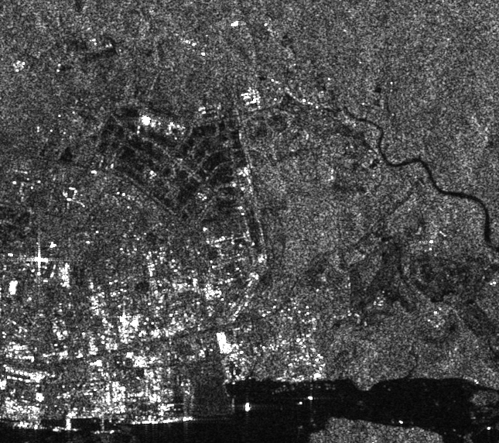

**OUTPUT:**

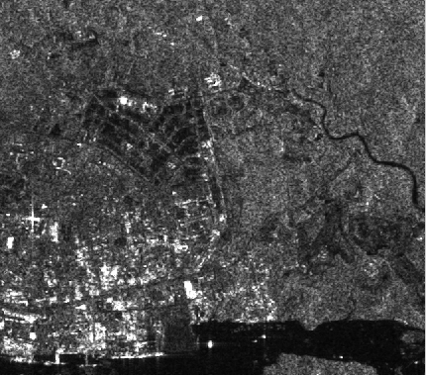

>> i=imread('sar.gif');

>> v=homo(i);

>> variance (i)

ans =

1.9883e+003

>> variance (v)

ans =

1.5342e+003

>> enl(i)

ans =

0.0014

>> enl(v)

ans =

0.0023

>> msd(i,v)

ans =

103.9297

**INPUT:**

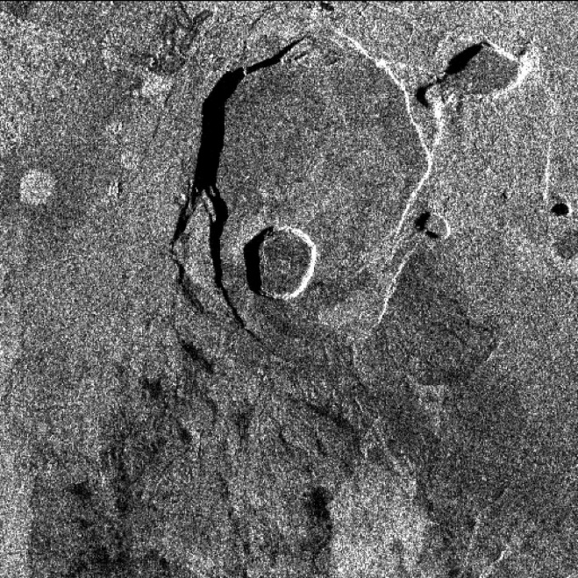

**OUTPUT:**

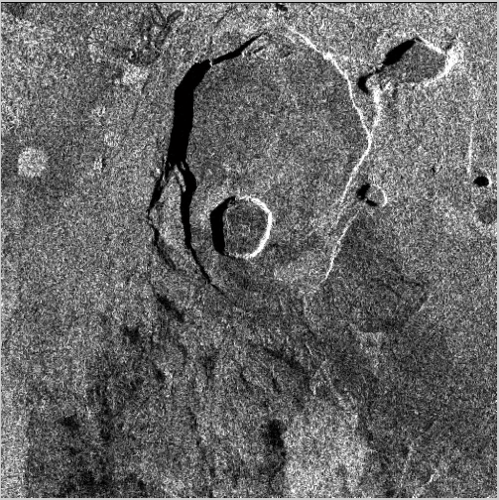

>> i=imread('p2.jpg');

>> v=homo(i);

>> variance(i)

ans =

2.6513e+003

>> variance(v)

ans =

2.1086e+003

>> enl(i)

ans =

0.0015

>> enl(v)

ans =

0.0023

>> msd(i,v)

ans =

136.2009

**REFERENCE:**

1. Research paper on Enhanced Directional Smoothing Algorithm for Edge-Preserving Smoothing of Synthetic-Aperture Radar Images by Mario Mastriani and Alberto E. Giraldez
2. www.wikipedia.org