Biodiversity
Multiple-choice practice
Name: ________________________ Class: ____________
There are 69 questions compiled from Longman HKCEE and/or YKTo papers. Choose the one best answer.
Part A — HKDSE-style (YKTo)
1. 1The Binomial system used in biology was proposed by
A. Newton. B. Darwin. C. Pasteur. D. Linnaeus.
2. 2The binomial system is used to describe
A. a kind of asexual reproduction such as binary fission.
B. the bisexual flowers that bear both the male and female reproductive systems.
C. the scientific naming of living organisms.
D. the mode of life by which the organism can live both in water and on land.
3. 3The scientific name of a species must (1) be written in Latin or Greek. (2) be underlined when it is written by hand. (3) be italicized when it is in print. (4) consist of a genus name and a species name.
A. (1) only
B. (1) and (2) only
C. (1) and (3) only
D. (2), (3) and (4) only
4. The scientific name of tiger is Panthera tigris. Which of the following combinations of the taxonomic groups that the tiger belonged to is CORRECT?
 | Panthera | tigris
A. | Family | Genus
B. | Genus | Family
C. | Species | Genus
D. | Genus | Species

5. 5Which of the following taxonomic groups do both Bauhinia variegata (宮粉洋蹄甲) and Bauhinia purpurea (紅花洋蹄甲) belong to ? (1) Species (2) Genus (3) Family
A. (1) only
B. (1) and (2) only
C. (2) and (3) only
D. (1), (2) and (3)
6. What are Bauhinia variegata and Bauhinia purpurea?
A. Two subspecies of the same species.
B. The same species in two different genera.
C. Two different species of two different genera.
D. Two different species of the same genus.
7. Which of the following is the CORRECT descending order of hierarchy in the classification of organisms?
A. Species, family, genus, order, class, phylum
B. Genus, family, class, order, phylum, species
C. Phylum, class, order, family, genus, species
D. Species, genus, class, family, order, phylum
8. Which of the following series of taxonomic groups has organisms with increasing diversity?
A. Genus Family Order Class
B. Domain Kingdom Class Order
C. Order Family Genus Species
D. Phylum Order Family Species
B. Classification systems
9. Which of the following is/are the reason(s) that the systems for classifying organisms keep on changing? (1)New evidences from the discovery of new species. (2) New technology gives more accurate information for studying the organisms (3) The development of the concept of the phylogenetic relationships between organisms.
A. (1) only
B. (2) only
C. (1) and (2) only
D. (1), (2) and (3)
10. Which of the following is regarded by some scientists as non-living thing?
A. Virus B. Bacteria C. Yeast D. Diatom
11. Which of the following is/are features of the modern classification system? (1) Organisms are put into the same taxonomic groups entirely according to their morphological similarities. (2) Information from the DNA base sequence of different organisms is used to develop the phylogenetic relationship between them. (3) All organisms arose from a common ancestor
A. (1) only
B. (2) only
C. (1) and (2) only
D. (2) and (3) only
12. Which of the following is the three domain system proposed by Carl Woese in 1977?
A. Virus, Bacteria, Eukaryotes B. Bacteria, Plantae, Amimalia
C. Archaea, Bacteria, Eukarya D. Prokaryotes, Eukaryotes, Protista
13. Which of the following are names of the Six Kingdoms of living organisms? (1) Virus (2) Plantae (3) Eubacteria (4) Prokaryotae (5) Fungi (6) Ferns(7) Protista (8) Animalia (9) Moss (10) Archaebacteria
A. (1), (2), (3), (6), (8) and (10) only
B. (1), (4), (5), (7), (9) and (10) only
C. (2), (4), (5), (7), (8) and (9) only
D. (2), (3), (5), (7), (8) and (10) only
14. Which of the following about Prokaryotae are INCORRECT? (1) It has no genetic material. (2) It has no membrance-bound organelle. (3) It has no photosynthetic pigments. (4) It has no cell wall.
A. (1) and (2) only
B. (1) and (3) only
C. (2) and (4) only
D. (1), (3) and (4) only
15. Which of the following should be included in the kingdom Prokaryotae?
(1) Amoeba (2) Bacteria (3) Algae (4) Mushrooms
A. (1) only B. (2) only C . (1) and (3) onlyD . (2) and (4) only
16. Which of the following related with bacteria are FALSE?
(1) They have no cell wall. (2) None of them can synthesize food.
(3) All of them are harmful. (4) None of them can move about.
(5) They have no sexual reproduction.
la | With true nucleus | 2
lb | Without true nucleus | 3
2a | Has peptidoglycan component in cell wall | P
2b | No peptidoglycan component in cell wall | Q
3a | Has chlorophyll | R
3b | No chlorophyll | S

A. (1) and (2) only B. (2) and (3) only C. (1), (2) and (4) only D. (1), (2), (3), (4) and (5) Directions: Questions 23.17 and 23.18 refer to the simple dichotomous key below, which lists some features of four organisms P, Q, R and S.
17. Which of the following combinations of the grouping of the organisms is CORRECT?
 | P | Q | R | S
A | Eubacteria | Archaebacteria | Plantae | Animalia
B | Archaebacteria | Eubacteria | Fungi | Animalia
C | Prokaryotes | Eukaryotes | Plantae | Fungi
D | Archaebacteria | Eubacteria | Fungi | Animalia

18. Which of the following kingdom(s) has/ have members that are prokaryotes? (1) Archaebacteria (2) Eubacteria (3) Protista
A. (1) only
B. (2) only
C. (3) only
D. (1) and (2) only
19. Which of the following should be included in the kingdom Protista?
(1) Bacteria (2) Paramecium (3) Bread mould (4) Diatom
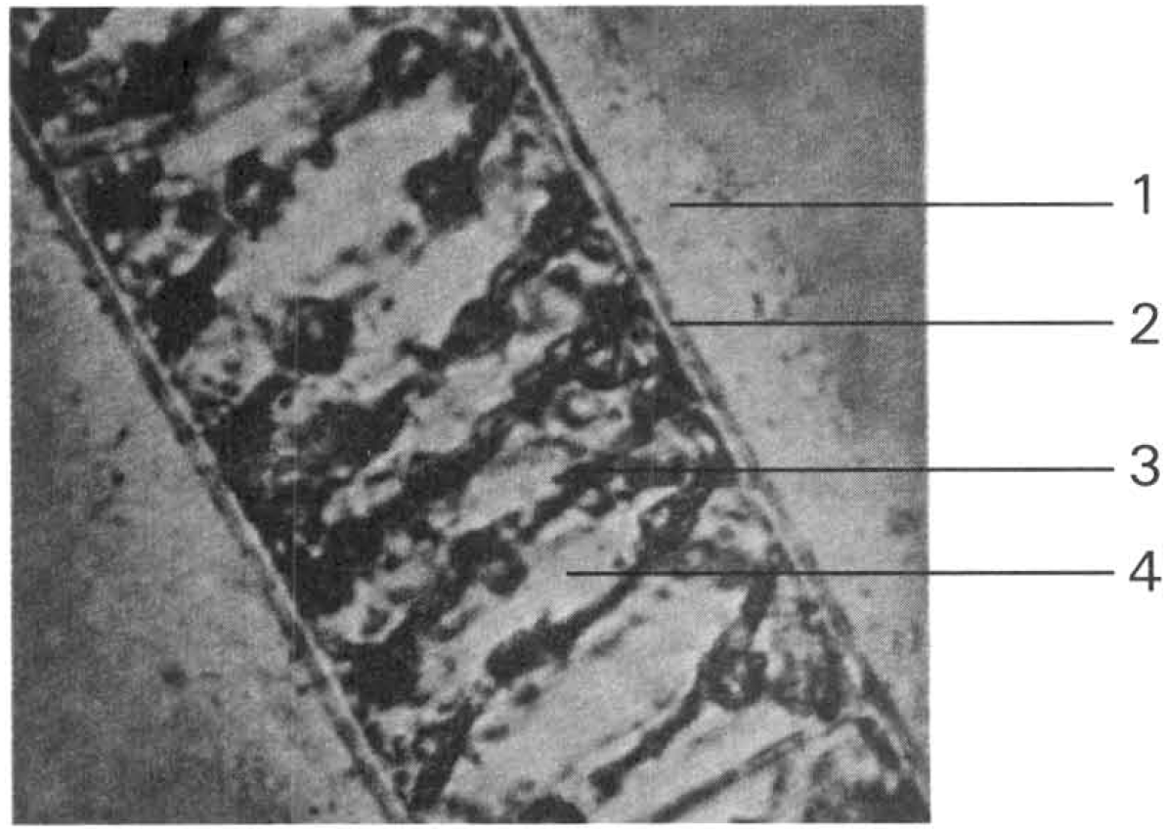
A. (1) and (2) only B. (2) and (3) only C. (2) and (4) only D. (3) and (4) only Directions: Questions 23.20 and 23.21 refer to the photomicrograph below, which shows the structure of an aquatic plant. Structure 1 is mucus in nature and structure 3 has green pigment
20. Which structure enables it to carry out autotrophic nutrition?
A. (1) only
B. (2) only
C. (3) only
D. (4) only
21. Which of the following related with the above organism is CORRECT?
A. The part labelled (2) is semipermeable.
B. It is a decomposer in the ecosystem.
C. It is an alga.
D. The part labelled (1) protects it against adverse temperature change.
22. Lichen consists of
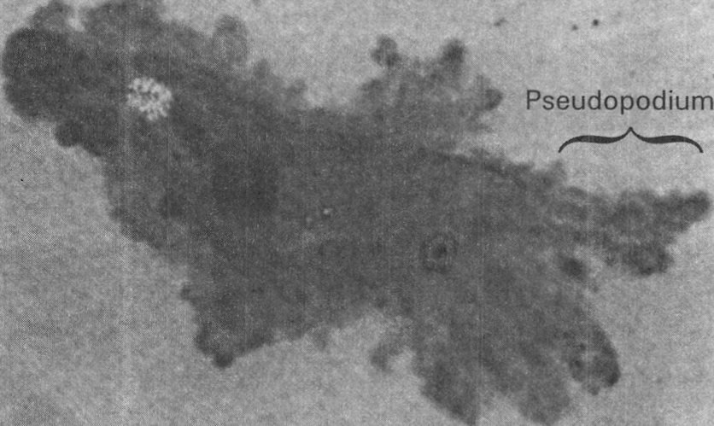
A. a moss and a fern. B. an alga and a fungus.
C. a fungus and a pine tree. D. an alga and an angiosperm. Directions: Question 23.23 refers to the photomicrograph below, which shows the structure of an animal. Its structure and activities resemble a white blood cell.
23. Which of the following related with the animal illustrated above is INCORRECT?
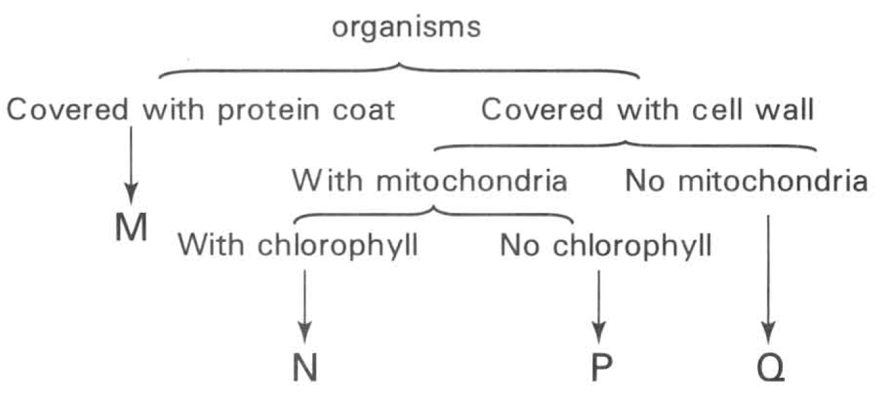
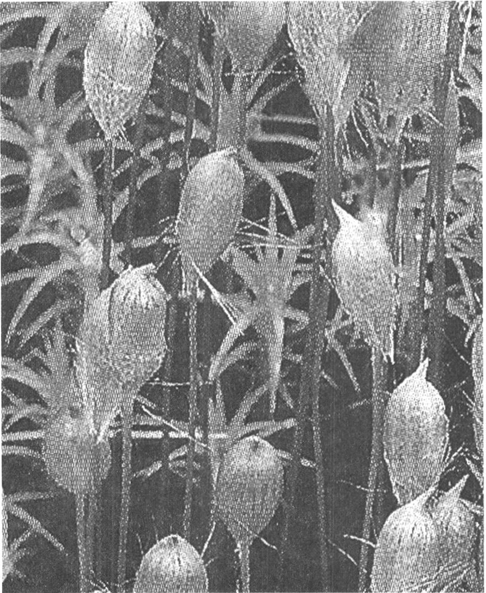
A. It is unicellular. B. It is uninucleated.
C. It is a prokaryote. D. It moves about by forming pseudopodia (false feet). Directions: Questions 23.24 to 23.27 refer to the simple dichotomous key below, which lists some features of four organisms M, N, P and
24. What is organism M?
A. Virus B. Bacteria C. Fungi D. Algae
25. Which of the following structures may be possessed by organisms in group N? (1) Vascular tissues (2) Spores (3) Seeds (4) Fruits
A. (1) and (2) only
B. (2) and (3) only
C. (3) and (4) only
D. (1), (2), (3) and (4)
26. Which of the following taxonomic groups CORRECTLY sort P?
(1) Archea (2) Eukarya (3) Protista (4) Fungi
 | Domain | Kingdom
A. | (1) | (3)
B. | (2) | (3)
C. | (2) | (4)
D. | (3) | (4)

27. Which of the following taxonomic groups CORRECTLY sort Q?
(1) Archaebacteria (2) Eubacteria (3) Archea (4) Bacteria
 | Domain | Kingdom
A. | (1) | (4)
B. | (3) | (2)
C. | (2) | (4)
D. | (4) | (2)

la | With chlorophyll | 2
lb | Without chlorophyll | W
2a | With leaves | 3
2b | Without leaves | X
3a | With seeds | Y
3b | Without seeds | Z

C. Kingdoms — Fungi and Plantae Directions: Questions 23.28 and 23.29 refer to the simple dichotomous key below ,which lists some features of four organisms W, X, Y and Z.
28. Which of the following identification is CORRECT?
 | W | X | Y | Z
A. | Fern | Maize | Fungi | Moss
B. | Moss | Fern | Maize | Fungi
C. | Fungi | Moss | Maize | Fern
D. | Moss | Fern | Fungi | Maize

29. Which of the following plants can also be grouped as Y? (1) Grass (2) Pine (3) Onion (4) Potato
A. (1) only
B. (2) only
C. (3) and (4) only
D. (1), (2), (3) and (4)
30. The organism shown in the photograph below is found on the forest floor. Which of the following statements about this organism is CORRECT?
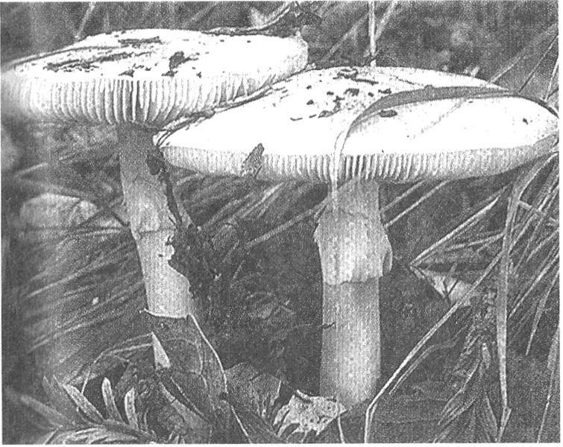
A. It is the producer in the food web of the woodland ecosystem.
B. It enriches the nutrients content of soil by absorbing the nitrogen gas from air.
C. It is important for the recycling of inorganic nutrients in nature.
D. It has extensive fibrous root system to absorb mineral salts in soil.
31. Which of the following characteristics are associated with most green plants?
(1) Cell wall (2) Chloroplast (3) Heterotrophic nutrition (4) Must live in soil
A. (1) and (2) only B. (1) and (4) only C. (1), (2) and (3) only D. (1), (2) and (4) only Directions: Question 23.32 refers to the photograph below, which shows a group of very small green plants with the capsules producing spores.
32. Which of the following is/are CORRECT descriptions of the plant shown in the photograph? (1) Its seeds are dispersed by wind. (2) It can only live in damp and shady area. (3)It depends on wind for pollination. (4) It has no true roots and cuticle.
A. (1) and (2) only
B. (1) and (3) only
C. (2) and (4) only
D. (1), (2) and (3) only
33. Directions: Questions 23.33 refers to the photograph below, which shows a green plant. Which of the following descriptions about this plant is/are CORRECT? (1) It is the pioneer plant in a newly established habitat. (2) It has vascular tissues. (3)It produces spores for reproduction.
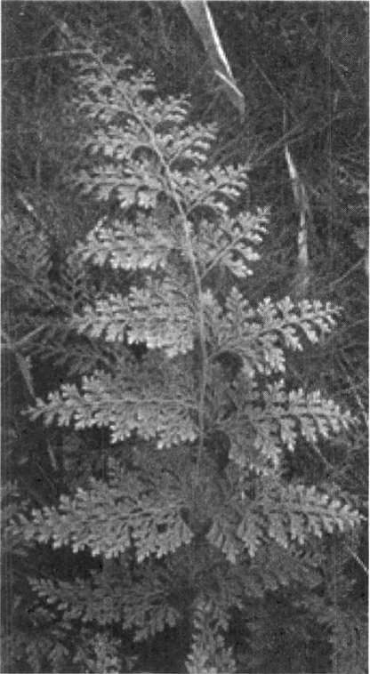
A. (1) only
B. (2) only
C. (1) and (2) only
D. (2) and (3) only
34. Which of the following produce spores as the means of reproduction (1) Penicillium (2) Fern (3) Rose (4) Moss
A. (1) and (2) only
B. (2) and (3) only
C. (3) and (4) only
D. (1), (2) and (4) only
35. Which of the following matching is INCORRECT?
Directions: Questions 23.36 and 23.37 refer to the photographs below, which show four different plants.
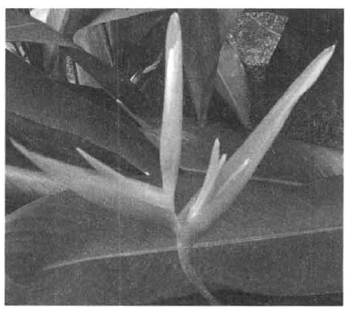
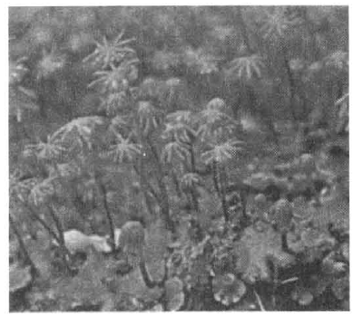
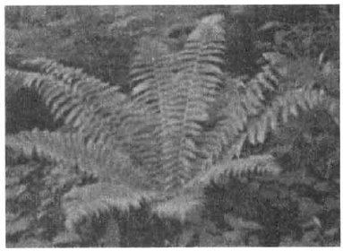
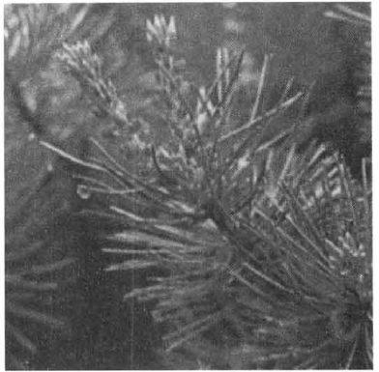
 | Group | Examples
A. | Flowering plants | Grass and Bauhinia
B. | Non-flowering | Pine and pineapple plants
C. | Mammals | Man and bat
D. | Invertebrates | Jellyfish and coral

M | N | O | P

36. Which plant is INCORRECTLY classified?
 | Plant | Major group
A. | M | Flowering plant
B. | N | Moss
C. | O | Fern
D. | P | Flowering plant

37. Which of the following statements is INCORRECT?
 |  | Features
 | Chlorophyll | Seeds | Fruits
I | + | + | +
II | - | - | -
III | + | + | -
IV | + | - | -

A. M produces seeds. B. N has chlorophyll.
C. O produces spores. D. P produces fruits Directions: Questions 23.38 and 23.39 refer to the table below, which shows some features of four organisms. Key: + Present - Absent
38. Which of the following organisms is INCORRECTLY classified?
 | Organism | Major group
A. | I | Pineapple
B. | II | Fungi
C. | III | Grass
D. | IV | Algae

39. Which of the following organisms possesses the same features as organism I? (1) Strawberry (2) Pine (3) Bamboo (4) Apple
A. (1) and (2) only
B. (1) and (4) only
C. (2), (3) and (4) only
D. (1), (3) and (4) only
40. The following table shows the characteristics of four different plants:
Key: + Present – Absent
Which of the following combinations of them is CORRECT?
Directions: Questions 41 to 43 refer to the photographs below, which show four types of plants.
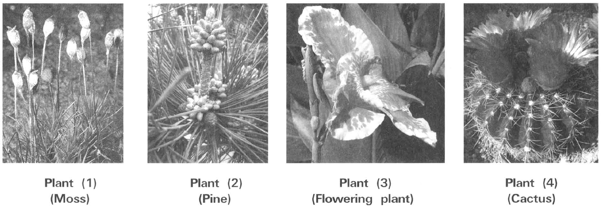
. | Plant V | Plant W | Plant X | Plant Y
Leaves with veins | - | - | + | +
Seeds | - | - | + | +
Fruits | - | - | - | +
Chlorophyll | - | + | + | +

 | Plant V | Plant W | Plant X | Plant Y
A. | Alga | Fungi | Gymnosperms | Flowering plants
B. | Ferns | Moss | Flowering plants | Gymnosperms
C. | Fungi | Moss | Gymnosperms | Flowering plants
D. | Fungi | Ferns | Flowering plants | Gymnosperms

41. Two of these plants live in two extreme environmental conditions. Which of the following combinations of them is CORRECT?
 | Moist and shady places | Hot , dry and sunny places
A. | Plant (1) | Plant (2)
B. | Plant (3) | Plant (4)
C. | Plant (1) | Plant (4)
D. | Plant (3) | Plant (2)

42. Which plants depend on external agents to spread the pollen grains?
A. (1) only
B. (2) only
C. (3) and (4) only
D. (2), (3) and (4)
43. Which plants produce fruits to disperse the seeds?
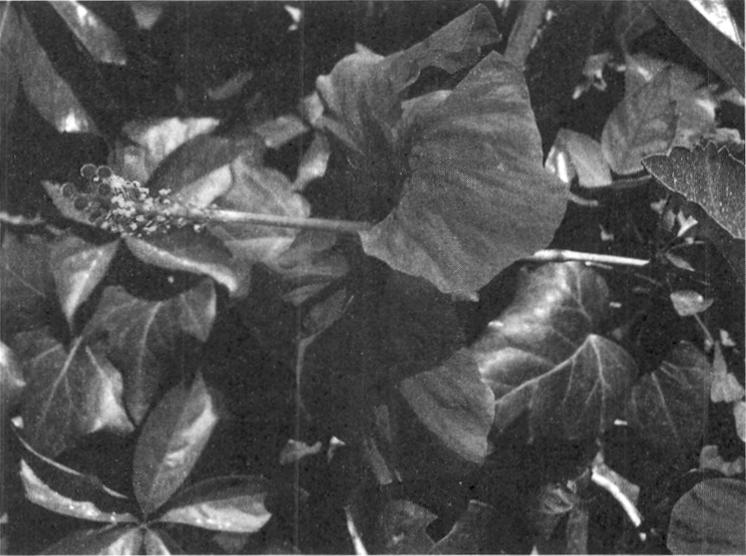
A. (3) only
B. (4) only
C. (2) and (3) only
D. (3) and (4) only
44. The photograph below shows a plant. Which of the following about the plant shown in the photograph above is CORRECT? (1) It can produce seeds. (2) It has leaves with parallel venation. (3) It can produce fruits to aid dispersal of the species.
A. (1) and (2) only
B. (2) and (3) only
C. (1) and (3) only
D. (1), (2) and (3)
45. Which of the following comparisons between pine and pineapple is CORRECT?
 | Pine | Pineapple
A. | X develops from ovary. | Y develops from flower.
B. | The seeds inside X have one cotyledon. | The seeds inside Y have two cotyledons.
C. | It has needle-shaped leaves. | It has leaves with parallel venation.
D. | It does not produce pollen grains. | It produces pollen grains.

46. The photograph below shows the storage organ of sweet potato with a leafy structure growing out of it. Which of the following statements CANNOT be deduced from the information obtained from the photograph? (1) The storage organ shown carries out sexual reproduction because of the production of a leafy offspring from it. (2) It is a flowering plant because the storage organ is a fruit that germinates to produce a seedling. (3) It is not a flowering plant because it does not bear flowers. A. Kingdom animalia Directions: Questions 47 and 48 refer to the four diagrams below, which show four different animals.
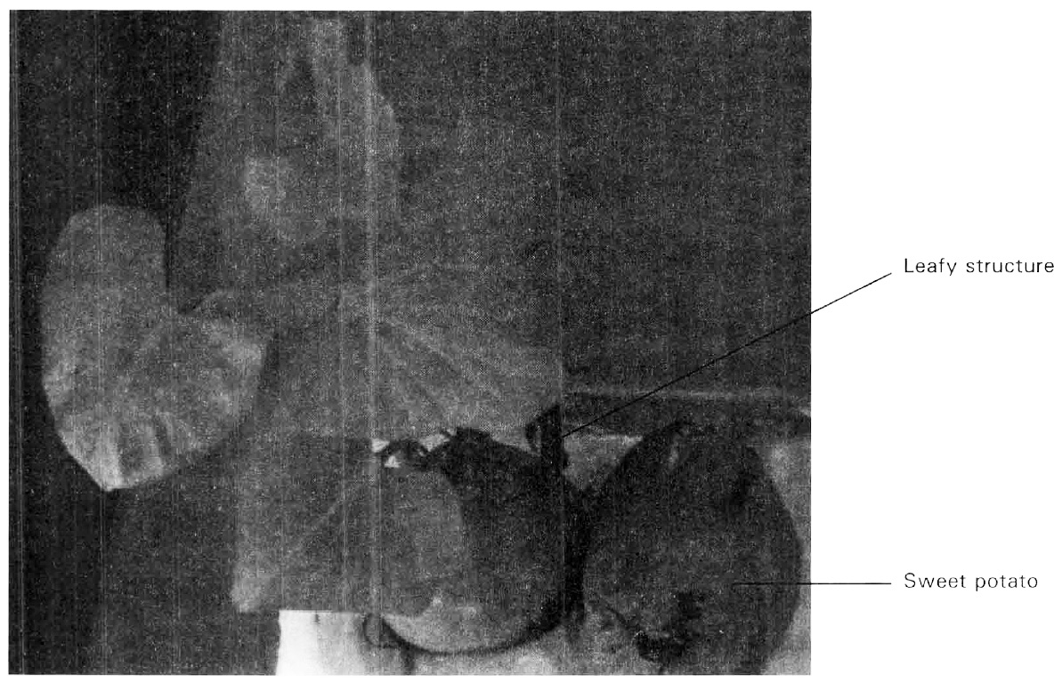
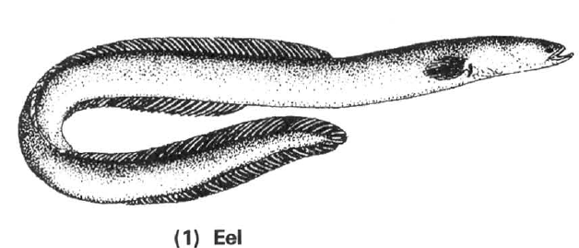
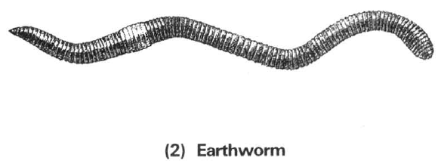
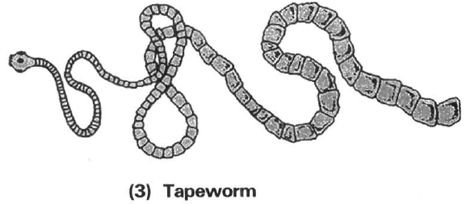
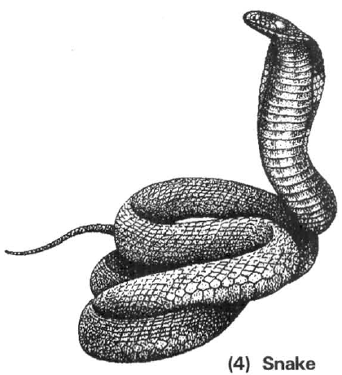
A. (1) only
B. (2) only
C. (3) only
D. (1), (2) and (3)
47. Which of the following combinations of animals under the two major groups are CORRECT?
 | Vertebrates | Invertebrates
A. | (1) and (2) | (3) and (4)
B. | (1) and (4) | (2) and (3)
C. | (1) only | (2), (3) and (4)
D. | Nil | (1), (2), (3) and (4)

48. Which of these animals have scales covering their body surface?
A. (1) and (2) only
B. (2) and (3) only
C. (3) and (4) only
D. (1) and (4) only
49. Use the simple key below to identify the following animals: shark, mosquito, bat, pigeon and frog. Key:
The animals are identified as:
Directions: Questions 50 and 51 refer to the following photographs of animals.
(1) Sea anemone (2) Sea urchin (3) Sea cucumber
(4) Sea horse (5) Sea hare (6) Sea lion
1a | possesses wings | 2
1b | does not possess wings | 3
2a | possesses vertebral column | 4
2b | does not possess vertebral column | M
3a | possess scales | N
3b | does not possess scales | P
4a | possesses mammary glands | Q
4b | does not possess mammary glands | R

 | M | P | Q | R | N
A. | Pigeon | Frog | Mosquito | Bat | Crocodile
B. | Mosquito | Bat | Pigeon | Frog | Shark
C. | Bat | Shark | Mosquito | Pigeon | Crocodile
D. | Mosquito | Frog | Bat | Pigeon | Shark

50. A student sorted the above animals into two groups: Which characteristic is used to sort these animals into the above two groups?
Group M | Group N
(1) | (4)
(2) | (6)
(3)
(5)

A. Radial symmetry
B. Living in sea
C. Moving ability
D. Vertebral column
51. Another student sorted the above animals into another two groups. Which characteristic is used to sort these animals?
Group M | Group N
(1)(2)(3) | (4)(5)(6)

A. Radial symmetry
B. Living in sea
C. Vertebral column
D. Moving ability
52. The animal shown in the photograph at the bottom of the left column is identified to be an invertebrate. Which of the following reasons supports this identification? (1) It is very small with the body length about 1 cm only. (2) It has an external shell covering the body. (3) It has no jointed legs.
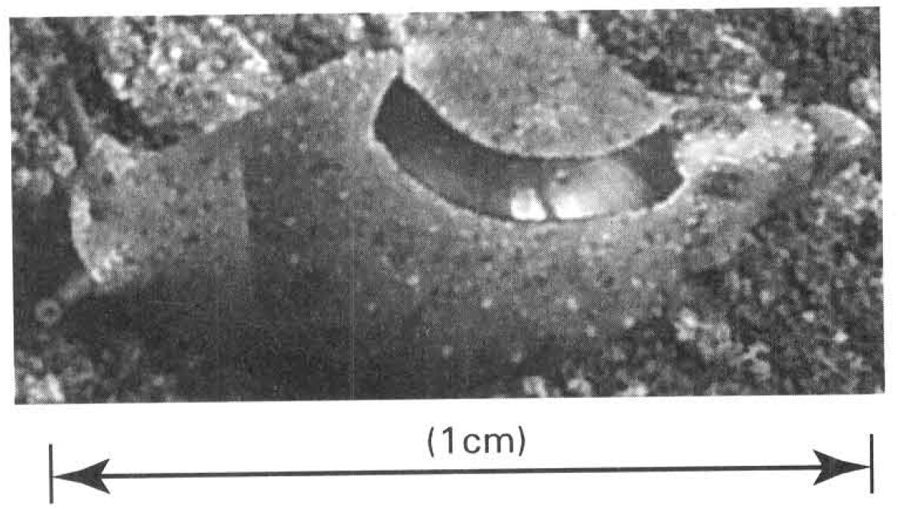
A. (1) only
B. (2) only
C. (3) only
D. None of the above is valid
53. The table below shows the features of four animals.
Key: + Present - Absent
Which of the following combinations CORRECTLY match the animals?
 | Animal W | Animal X | Animal Y | Animal Z
Feathers | + | - | - | -
Scales | + | - | + | -
Hairs | - | + | - | -
Vertebral column | + | + | + | +

 | Animal W | Animal X | Animal Y | Animal Z
A. | Penguin | Tortoise | Sea lion | Frog
B. | Turtle | Penguin | Newt | Sea lion
C. | Pigeon | Sea lion | Turtle | Newt
D. | Newt | Frog | Tortoise | Pigeon

54. Which of the following animals CANNOT be classified as fishes? (1) Dolphin (2) Sea horse (3) Jelly fish (4) Newt
A. (1) and (2) only
B. (2) and (3) only
C. (3) and (4) only
D. (1), (3) and (4) only
55. A specimen collected from a freshwater pond is identified to be an amphibian, NOT a fish because it
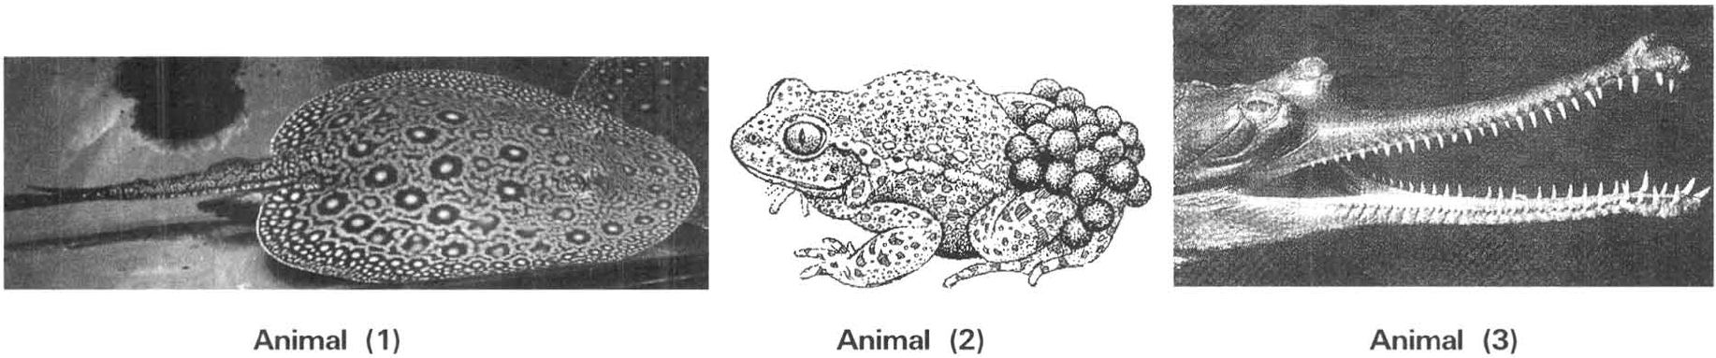
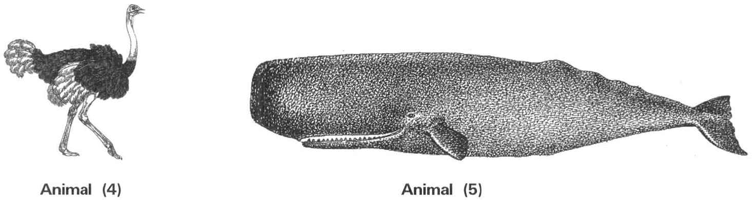
A. cannot breathe in water. B. has slimy and naked skin.
C. can crawl out of water. D. can leave water for a short period of time. Directions: Questions 56 and 57 refer to the following five animals.
56. Which of these animals carry out external fertilisation?
A. (1) and (2) only
B. (1) and (5) only
C. (2) and (3) only
D. (2) and (4) only
57. Which of these animals produce eggs with calcareous shells?
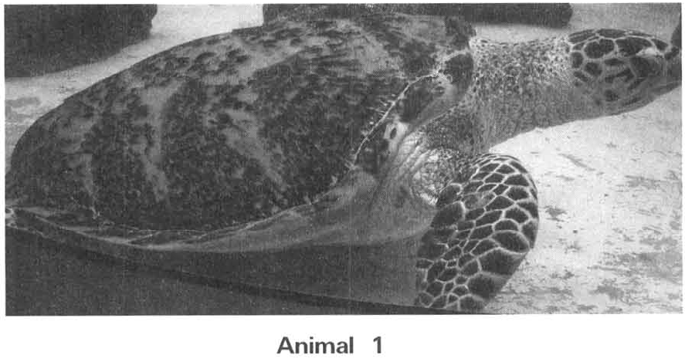
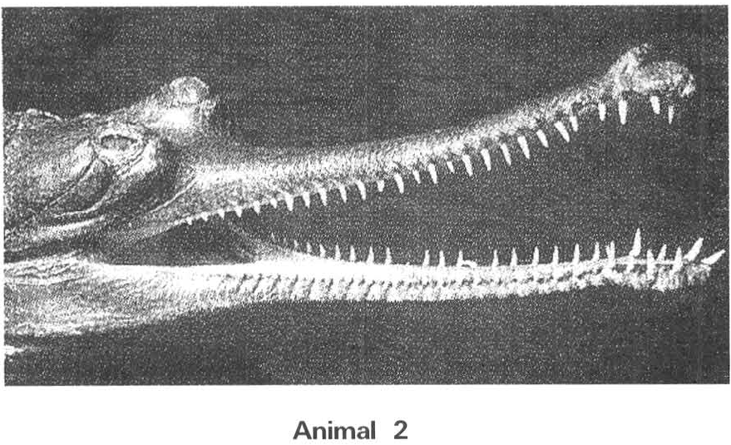
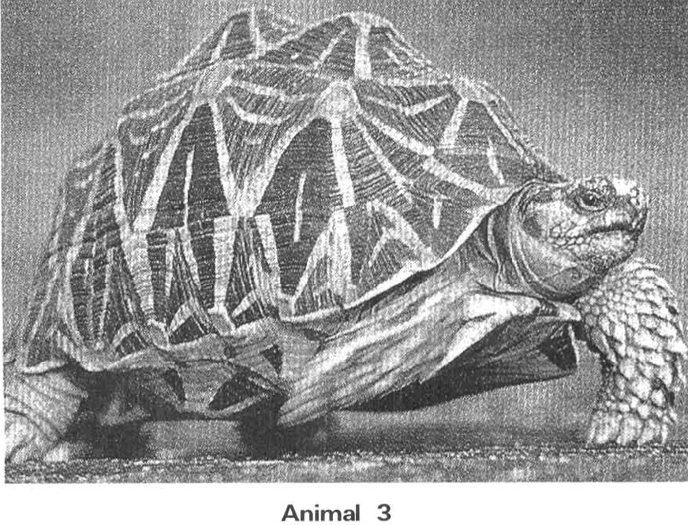
A. (1) and (2) only B. (2) and (3) only C. (3) and (4) only D. (3) and (5) only Directions: Questions 58 and 59 refer to the photographs below, which show three type of animals.
58. Which of the following statements is INCORRECT?
A. They are amphibians because they can live both in water and on land.
B. All of them have scales covering their body.
C. They breathe by lungs.
D. They produce eggs with calcareous shells.
59. Which of the following animals belong to the same group of animals as shown in the photographs?
A. Eel
B. Snake
C. Newt
D. Toad
60. Which of the following features are TRUE for birds?
(1) Possess feathers (2) Possess pinnae (3) With no teeth (4) Possess scales
Animal 1 | Animal 2 | Animal 3 | Animal 4 | Animal 5 | Animal 6
Whale | Owl | seal | Shark | Penguin | Sea horse

A. (1) and (2) only B. (1) and (3) only C. (3) and (4) only D. (1), (3) and (4) only Directions: Questions 61 to 63 refer to the table below, which show six type of animals.
61. Which of the following combinations CORRECTLY match the groups of animals sorted under the three classes?
 | Fish | Birds | Mammals
A. | Animals 3, 4 | Animal 2 only | Animals 1, 3, 5
B. | Animals 4, 6 | Animals 2,5 | Animals 1,3
C. | Animal 4 only | Animals 2, 5 | Animals 1, 3, 6
D. | Animals 4, 5 | Animal 2 only | Animals 1, 3, 6

62. Which of the following structures is/are common to all the animals shown in the diagrams and photographs? (1) Hairs (2) Vertebral column (3) Mammary glands (4) Scales
A. (1) only
B. (2) only
C. (2) and (4) only
D. (1) and (3) only
63. The animals above mainly use two types of organs for breathing. Which of the following combinations CORRECTLY match the animals to the type of breathing organs used?
 | Gills | Lungs
A. | Animal 4 | Animals 1, 2, 3, 5, 6
B. | Animals 3, 4 | Animals 1, 2, 5, 6
C. | Animals 4, 5 | Animals 1, 2, 3, 6
D. | Animals 4,6 | Animals 1, 2, 3, 5

64. The table below lists some features of four animals M,N, P and Q.
Key: + Present - Absent
Directions: Questions 65 to 67 refer to the six photographs below, which show six different animals.
Ostrich (2) Dolphin (3) Sea lion (4) Bat (5) Penguin (6) Whale
 | Vertebral column | Moist skin | Scales | Wings
M | + | + | + | -
N | + | - | + | +
P | - | + | - | -
Q | - | - | - | +

 | M | N | P | Q
A. | Crocodile | Bat | Tapeworm | Bee
B. | Turtle | Eagle | Frog | Mosquito
C. | Shark | Bat | Toad | Mosquito
D. | Goldfish | Eagle | Earthworm | Bee

65. Which animals have their bodies covered with feathers?
A. (1) and (4) only
B. (3) and (5) only
C. (1) and (5) only
D. (2) and (5) only
66. Which animals use gills to breathe?
A. (2) and (5) only
B. (2) and (6) only
C. (3) and (5) only
D. None of them
67. Which of the following statements is CORRECT?
A. (1) and (4) are birds. B. (2) and (6) are fish.
C. (3) and (5) are mammals. D. All of them have vertebral column.
68. A tissue is
A. a group of cells joined together.
B. a group of cells of the same function.
C. a group of different types of cells.
D. a structure composed of different organs to perform a particular function.
69. Which of the following is the CORRECT order of the increasing complexity of an organism?
A. Organ, organism, tissue, system, cell B. Cell, tissue, organ, system, organism
C. Cell, system, organ, organism, tissue D. Tissue, organism, organ, system, cell Biodiversity M.C. Suggested Solutions

Answers
Answers are printed in red.
1. C

2. C. the scientific naming of living organisms.

3. C. (1) and (3) only

4. D

5. C. (2) and (3) only

6. D. Two different species of the same genus.

7. C. Phylum, class, order, family, genus, species

8. B. Classification systems

9. D. (1), (2) and (3)

10. A. Virus B. Bacteria C. Yeast D. Diatom

11. D. (2) and (3) only

12. C. Archaea, Bacteria, Eukarya D. Prokaryotes, Eukaryotes, Protista

13. D. (2), (3), (5), (7), (8) and (10) only

14. D. (1), (3) and (4) only

15. B

16. D

17. A

18. D. (1) and (2) only

19. C

20. C. (3) only

21. C. It is an alga.

22. B

23. C. It is a prokaryote. D. It moves about by forming pseudopodia (false feet). Directions: Questions 23.24 to 23.27 refer to the simple dichotomous key below, which lists some features of four organisms M, N, P and

24. A. Virus B. Bacteria C. Fungi D. Algae

25. D. (1), (2), (3) and (4)

26. C

27. D

28. C

29. D. (1), (2), (3) and (4)

30. C. It is important for the recycling of inorganic nutrients in nature.

31. A. (1) and (2) only B. (1) and (4) only C. (1), (2) and (3) only D. (1), (2) and (4) only Directions: Question 23.32 refers to the photograph below, which shows a group of very small green plants with the capsules producing spores.

32. C. (2) and (4) only

33. D. (2) and (3) only

34. D. (1), (2) and (4) only

35. B

36. A

37. D

38. C

39. D. (1), (3) and (4) only

40. C

41. C

42. D. (2), (3) and (4)

43. D. (3) and (4) only

44. C. (1) and (3) only

45. C

46. D. (1), (2) and (3)

47. B

48. D. (1) and (4) only

49. D

50. D. Vertebral column

51. A. Radial symmetry

52. D. None of the above is valid

53. C

54. D. (1), (3) and (4) only

55. B

56. A. (1) and (2) only

57. C

58. A. They are amphibians because they can live both in water and on land.

59. B. Snake

60. D

61. B

62. B. (2) only

63. D

64. D

65. C. (1) and (5) only

66. D. None of them

67. D

68. B. a group of cells of the same function.

69. B

