Biodiversity · items under 80% correct
Multiple-choice practice
Name: ________________________ Class: ____________
No classroom item analysis matched this topic reliably. Items below are those predicted to be answered correctly by fewer than 80% of students. Choose the one best answer.
Part A — HKDSE-style (YKTo)
1. Which of the following should be included in the kingdom Protista?
(1) Bacteria (2) Paramecium (3) Bread mould (4) Diatom
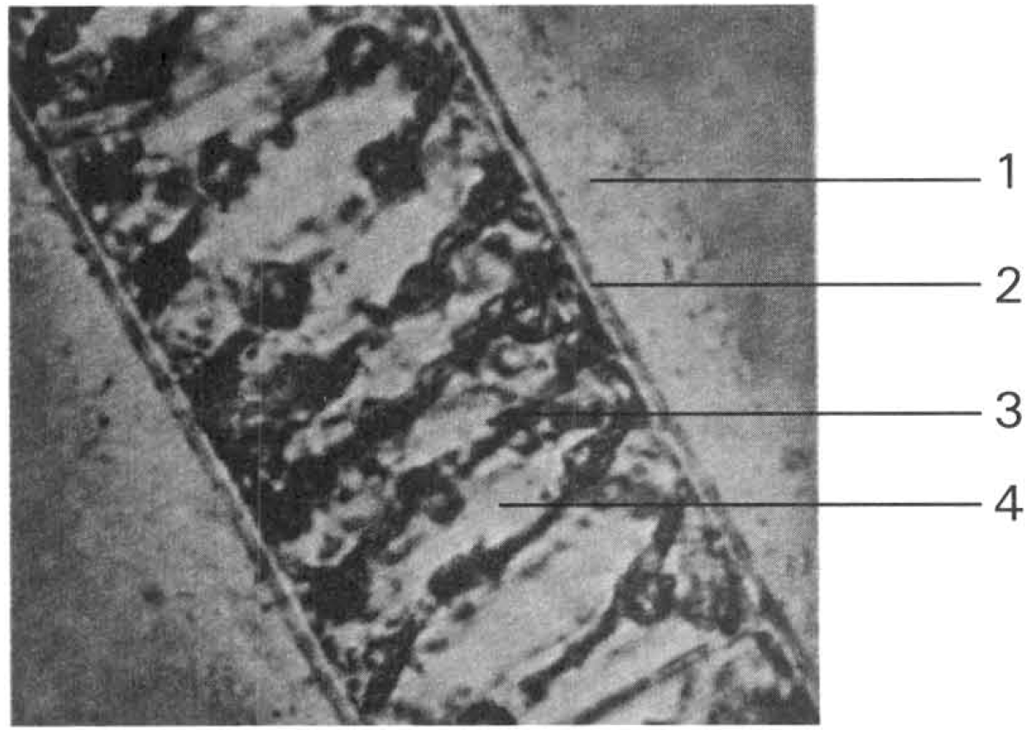
A. (1) and (2) only B. (2) and (3) only C. (2) and (4) only D. (3) and (4) only Directions: Questions 23.20 and 23.21 refer to the photomicrograph below, which shows the structure of an aquatic plant. Structure 1 is mucus in nature and structure 3 has green pigment
2. Which of the following characteristics are associated with most green plants?
(1) Cell wall (2) Chloroplast (3) Heterotrophic nutrition (4) Must live in soil
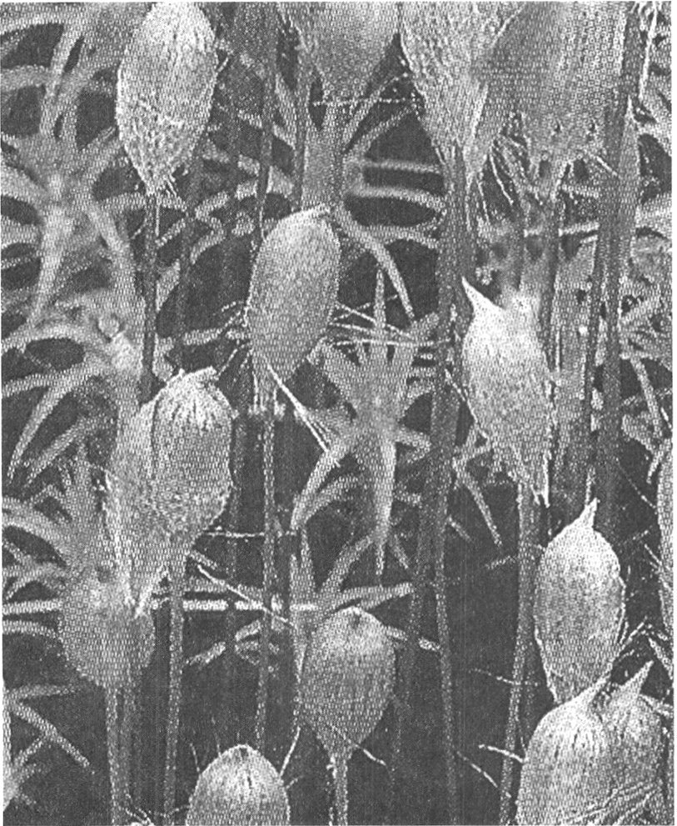
A. (1) and (2) only B. (1) and (4) only C. (1), (2) and (3) only D. (1), (2) and (4) only Directions: Question 23.32 refers to the photograph below, which shows a group of very small green plants with the capsules producing spores.
3. Directions: Questions 23.33 refers to the photograph below, which shows a green plant. Which of the following descriptions about this plant is/are CORRECT? (1) It is the pioneer plant in a newly established habitat. (2) It has vascular tissues. (3)It produces spores for reproduction.
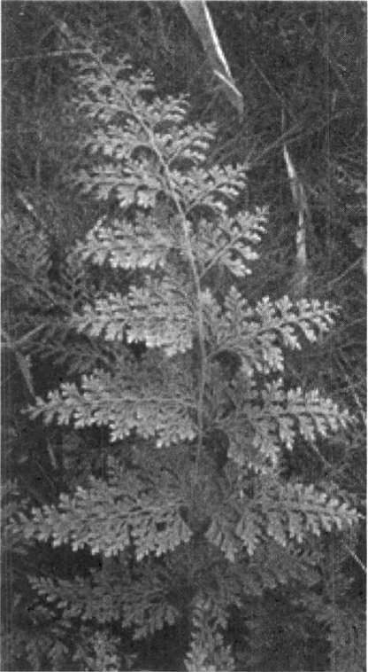
A. (1) only
B. (2) only
C. (1) and (2) only
D. (2) and (3) only
4. The photograph below shows the storage organ of sweet potato with a leafy structure growing out of it. Which of the following statements CANNOT be deduced from the information obtained from the photograph? (1) The storage organ shown carries out sexual reproduction because of the production of a leafy offspring from it. (2) It is a flowering plant because the storage organ is a fruit that germinates to produce a seedling. (3) It is not a flowering plant because it does not bear flowers. A. Kingdom animalia Directions: Questions 47 and 48 refer to the four diagrams below, which show four different animals.
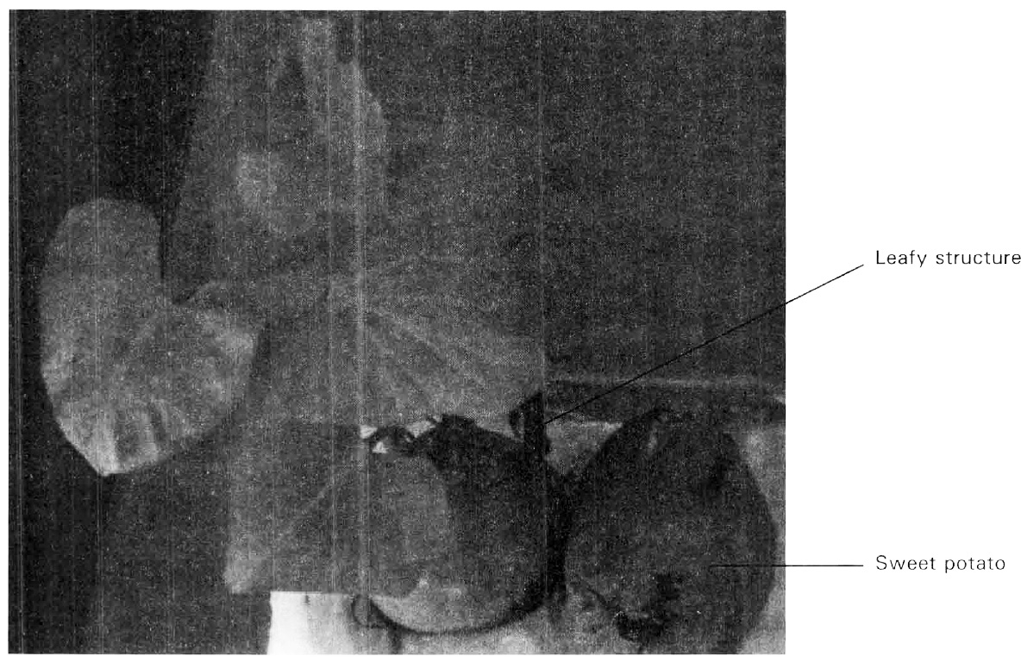
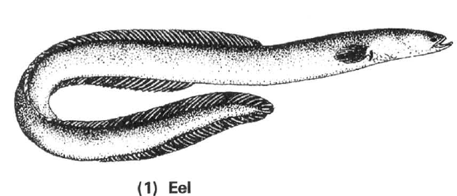
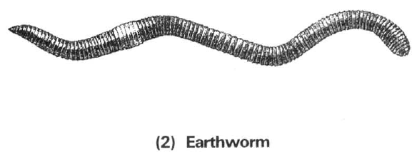
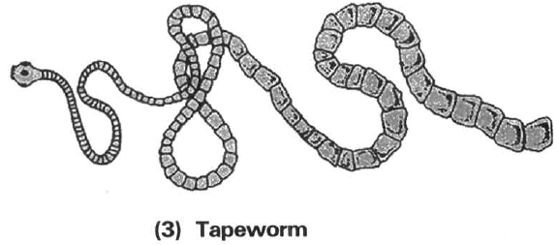
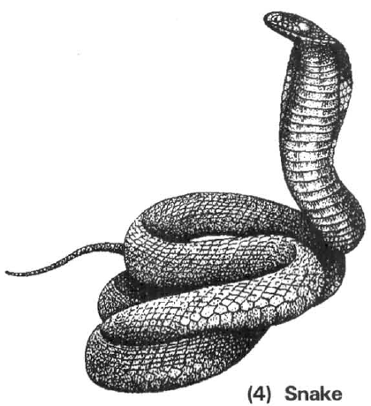
A. (1) only
B. (2) only
C. (3) only
D. (1), (2) and (3)
5. Use the simple key below to identify the following animals: shark, mosquito, bat, pigeon and frog. Key:
The animals are identified as:
Directions: Questions 50 and 51 refer to the following photographs of animals.
(1) Sea anemone (2) Sea urchin (3) Sea cucumber
(4) Sea horse (5) Sea hare (6) Sea lion
1a | possesses wings | 2
1b | does not possess wings | 3
2a | possesses vertebral column | 4
2b | does not possess vertebral column | M
3a | possess scales | N
3b | does not possess scales | P
4a | possesses mammary glands | Q
4b | does not possess mammary glands | R

 | M | P | Q | R | N
A. | Pigeon | Frog | Mosquito | Bat | Crocodile
B. | Mosquito | Bat | Pigeon | Frog | Shark
C. | Bat | Shark | Mosquito | Pigeon | Crocodile
D. | Mosquito | Frog | Bat | Pigeon | Shark

6. The animal shown in the photograph at the bottom of the left column is identified to be an invertebrate. Which of the following reasons supports this identification? (1) It is very small with the body length about 1 cm only. (2) It has an external shell covering the body. (3) It has no jointed legs.
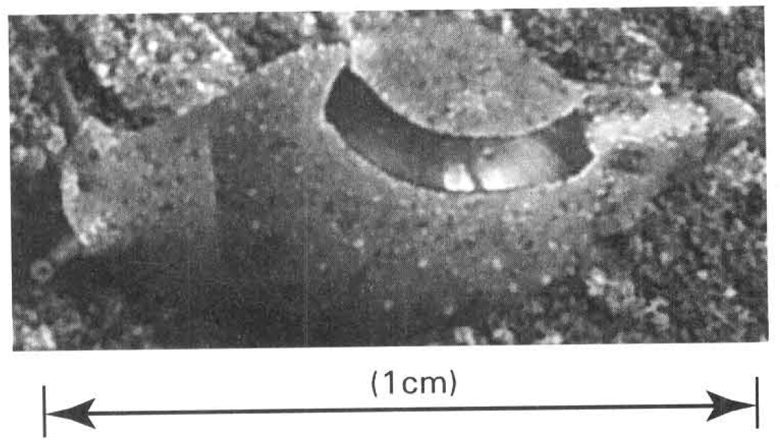
A. (1) only
B. (2) only
C. (3) only
D. None of the above is valid
7. Which of these animals produce eggs with calcareous shells?
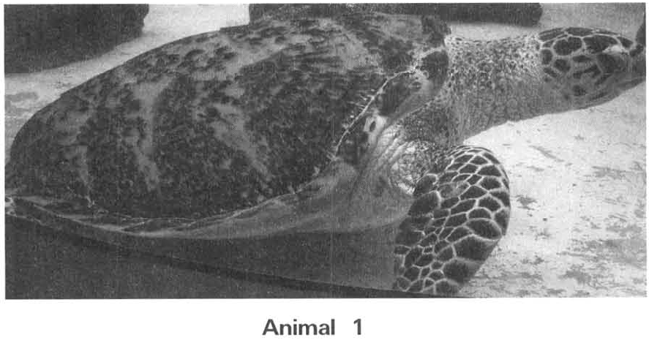
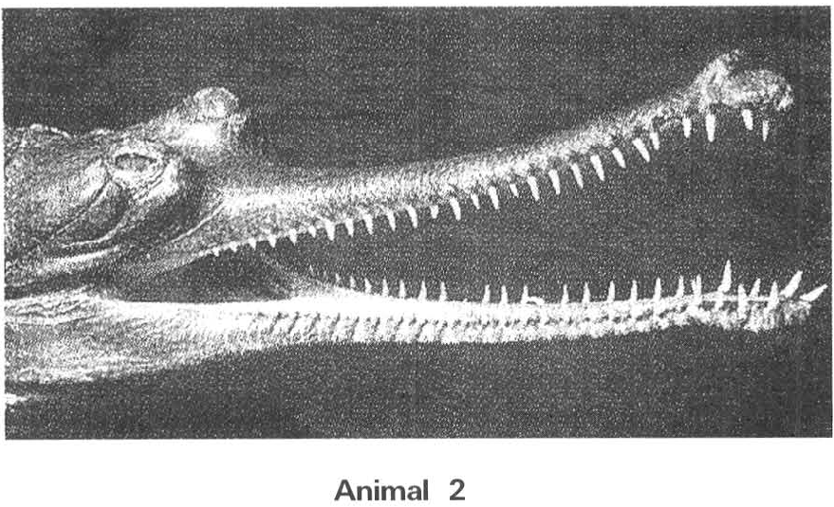
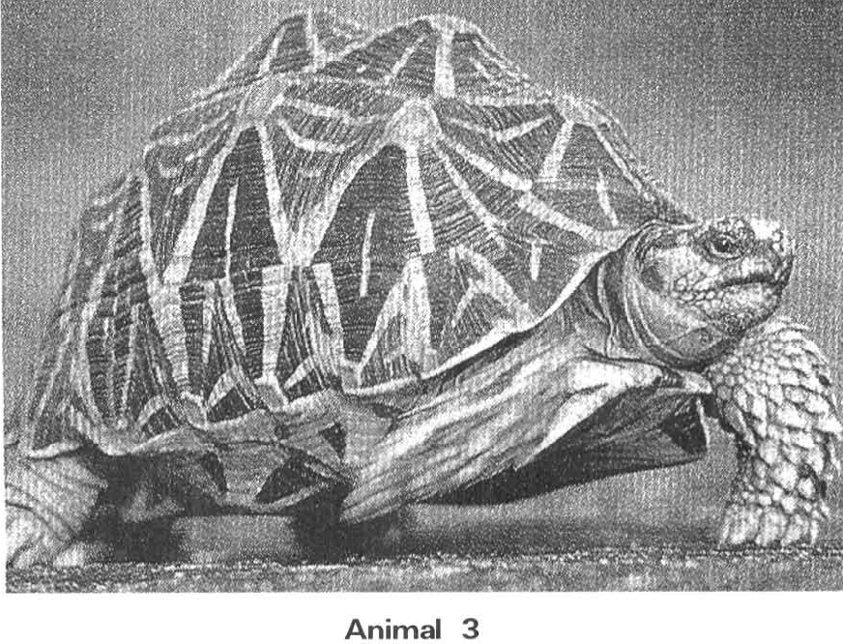
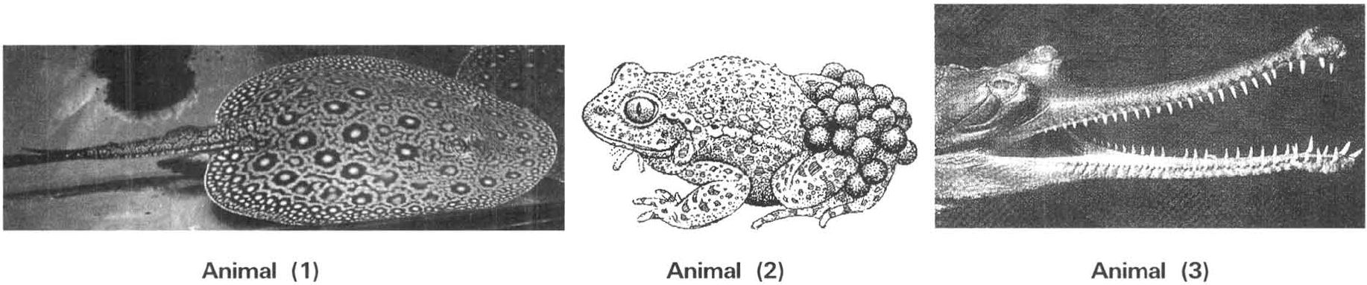
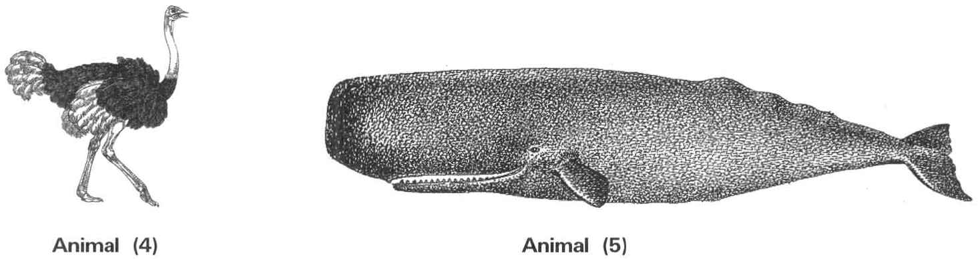
A. (1) and (2) only B. (2) and (3) only C. (3) and (4) only D. (3) and (5) only Directions: Questions 58 and 59 refer to the photographs below, which show three type of animals.
8. Which of the following matching is INCORRECT?
Directions: Questions 23.36 and 23.37 refer to the photographs below, which show four different plants.
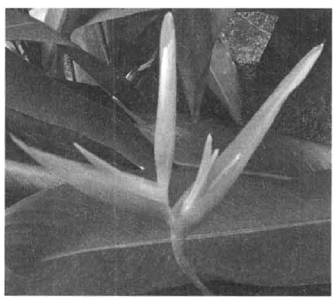
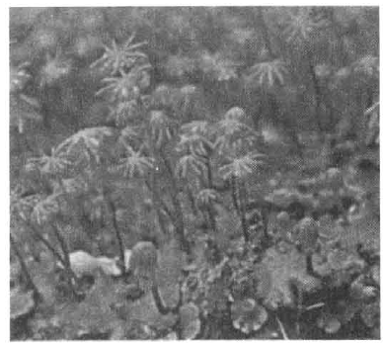
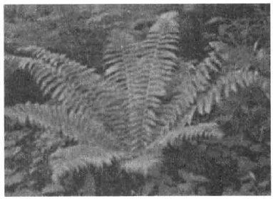
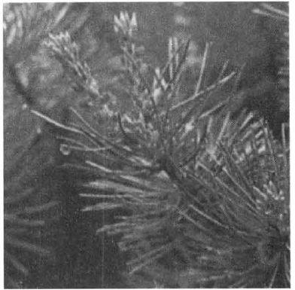
 | Group | Examples
A. | Flowering plants | Grass and Bauhinia
B. | Non-flowering | Pine and pineapple plants
C. | Mammals | Man and bat
D. | Invertebrates | Jellyfish and coral

M | N | O | P

9. Which of the following about Prokaryotae are INCORRECT? (1) It has no genetic material. (2) It has no membrance-bound organelle. (3) It has no photosynthetic pigments. (4) It has no cell wall.
A. (1) and (2) only
B. (1) and (3) only
C. (2) and (4) only
D. (1), (3) and (4) only
10. Which of the following is/are CORRECT descriptions of the plant shown in the photograph? (1) Its seeds are dispersed by wind. (2) It can only live in damp and shady area. (3)It depends on wind for pollination. (4) It has no true roots and cuticle.
A. (1) and (2) only
B. (1) and (3) only
C. (2) and (4) only
D. (1), (2) and (3) only
11. The photograph below shows a plant. Which of the following about the plant shown in the photograph above is CORRECT? (1) It can produce seeds. (2) It has leaves with parallel venation. (3) It can produce fruits to aid dispersal of the species.
A. (1) and (2) only
B. (2) and (3) only
C. (1) and (3) only
D. (1), (2) and (3)
12. Which of the following structures is/are common to all the animals shown in the diagrams and photographs? (1) Hairs (2) Vertebral column (3) Mammary glands (4) Scales
A. (1) only
B. (2) only
C. (2) and (4) only
D. (1) and (3) only
13. Which of the following related with bacteria are FALSE?
(1) They have no cell wall. (2) None of them can synthesize food.
(3) All of them are harmful. (4) None of them can move about.
(5) They have no sexual reproduction.
la | With true nucleus | 2
lb | Without true nucleus | 3
2a | Has peptidoglycan component in cell wall | P
2b | No peptidoglycan component in cell wall | Q
3a | Has chlorophyll | R
3b | No chlorophyll | S

A. (1) and (2) only B. (2) and (3) only C. (1), (2) and (4) only D. (1), (2), (3), (4) and (5) Directions: Questions 23.17 and 23.18 refer to the simple dichotomous key below, which lists some features of four organisms P, Q, R and S.
14. Which of the following taxonomic groups CORRECTLY sort P?
(1) Archea (2) Eukarya (3) Protista (4) Fungi
 | Domain | Kingdom
A. | (1) | (3)
B. | (2) | (3)
C. | (2) | (4)
D. | (3) | (4)

15. Which of the following taxonomic groups CORRECTLY sort Q?
(1) Archaebacteria (2) Eubacteria (3) Archea (4) Bacteria
 | Domain | Kingdom
A. | (1) | (4)
B. | (3) | (2)
C. | (2) | (4)
D. | (4) | (2)

la | With chlorophyll | 2
lb | Without chlorophyll | W
2a | With leaves | 3
2b | Without leaves | X
3a | With seeds | Y
3b | Without seeds | Z

C. Kingdoms — Fungi and Plantae Directions: Questions 23.28 and 23.29 refer to the simple dichotomous key below ,which lists some features of four organisms W, X, Y and Z.
16. Which plants depend on external agents to spread the pollen grains?
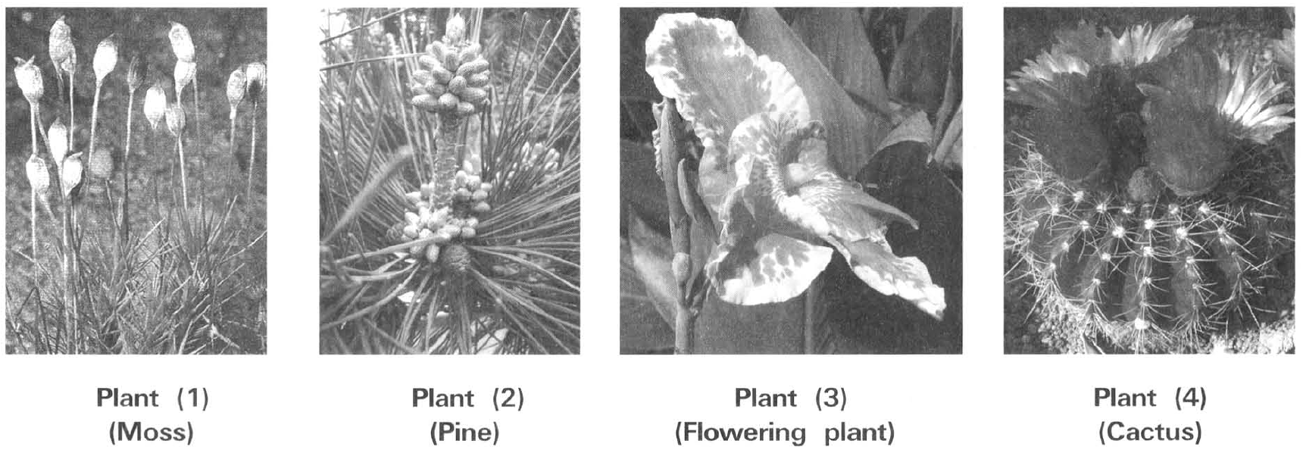
A. (1) only
B. (2) only
C. (3) and (4) only
D. (2), (3) and (4)
17. Which of these animals have scales covering their body surface?
A. (1) and (2) only
B. (2) and (3) only
C. (3) and (4) only
D. (1) and (4) only
18. Which of these animals carry out external fertilisation?
A. (1) and (2) only
B. (1) and (5) only
C. (2) and (3) only
D. (2) and (4) only
19. Which of the following features are TRUE for birds?
(1) Possess feathers (2) Possess pinnae (3) With no teeth (4) Possess scales
Animal 1 | Animal 2 | Animal 3 | Animal 4 | Animal 5 | Animal 6
Whale | Owl | seal | Shark | Penguin | Sea horse

A. (1) and (2) only B. (1) and (3) only C. (3) and (4) only D. (1), (3) and (4) only Directions: Questions 61 to 63 refer to the table below, which show six type of animals.
20. Which of the following related with the animal illustrated above is INCORRECT?
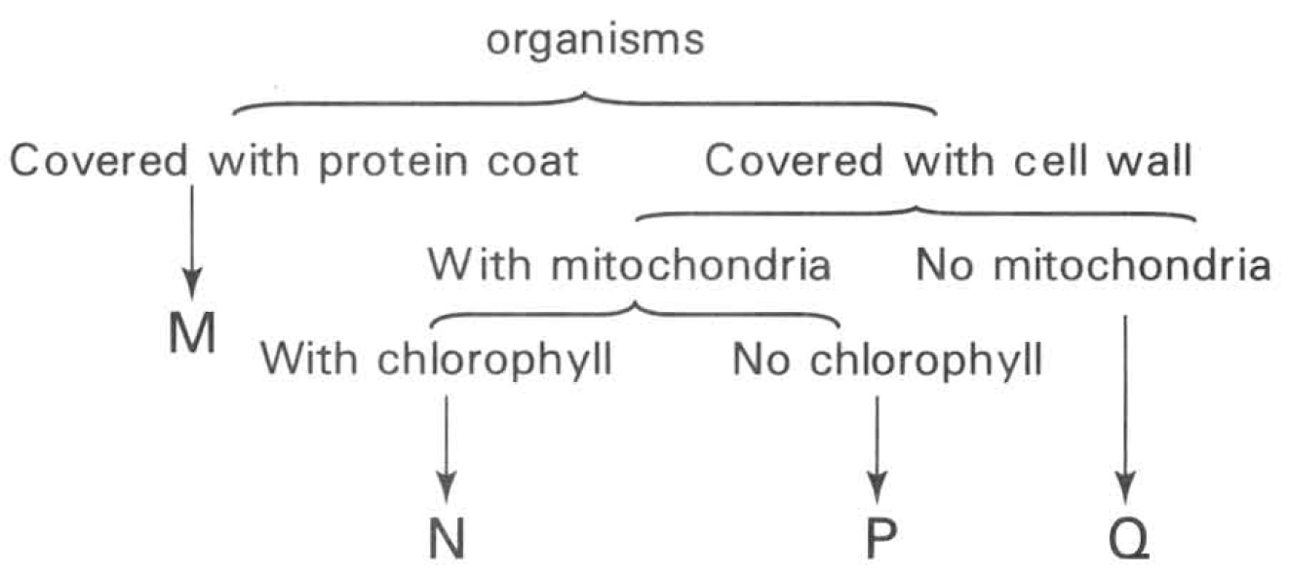
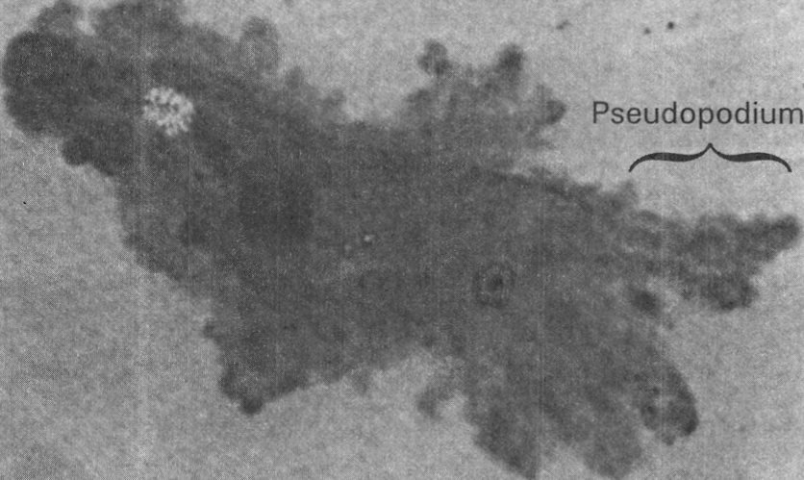
A. It is unicellular. B. It is uninucleated.
C. It is a prokaryote. D. It moves about by forming pseudopodia (false feet). Directions: Questions 23.24 to 23.27 refer to the simple dichotomous key below, which lists some features of four organisms M, N, P and
21. Which plant is INCORRECTLY classified?
 | Plant | Major group
A. | M | Flowering plant
B. | N | Moss
C. | O | Fern
D. | P | Flowering plant

22. Which of the following statements is INCORRECT?
 |  | Features
 | Chlorophyll | Seeds | Fruits
I | + | + | +
II | - | - | -
III | + | + | -
IV | + | - | -

A. M produces seeds. B. N has chlorophyll.
C. O produces spores. D. P produces fruits Directions: Questions 23.38 and 23.39 refer to the table below, which shows some features of four organisms. Key: + Present - Absent
23. Which of the following organisms is INCORRECTLY classified?
 | Organism | Major group
A. | I | Pineapple
B. | II | Fungi
C. | III | Grass
D. | IV | Algae

Answers
Answers are printed in red.
1. C
Predicted class correct ≈ 41% (no classroom match)
2. A. (1) and (2) only B. (1) and (4) only C. (1), (2) and (3) only D. (1), (2) and (4) only Directions: Question 23.32 refers to the photograph below, which shows a group of very small green plants with the capsules producing spores.
Predicted class correct ≈ 41% (no classroom match)
3. D. (2) and (3) only
Predicted class correct ≈ 41% (no classroom match)
4. D. (1), (2) and (3)
Predicted class correct ≈ 41% (no classroom match)
5. D
Predicted class correct ≈ 41% (no classroom match)
6. D. None of the above is valid
Predicted class correct ≈ 41% (no classroom match)
7. C
Predicted class correct ≈ 41% (no classroom match)
8. B
Predicted class correct ≈ 44% (no classroom match)
9. D. (1), (3) and (4) only
Predicted class correct ≈ 45% (no classroom match)
10. C. (2) and (4) only
Predicted class correct ≈ 46% (no classroom match)
11. C. (1) and (3) only
Predicted class correct ≈ 46% (no classroom match)
12. B. (2) only
Predicted class correct ≈ 46% (no classroom match)
13. D
Predicted class correct ≈ 47% (no classroom match)
14. C
Predicted class correct ≈ 47% (no classroom match)
15. D
Predicted class correct ≈ 47% (no classroom match)
16. D. (2), (3) and (4)
Predicted class correct ≈ 47% (no classroom match)
17. D. (1) and (4) only
Predicted class correct ≈ 47% (no classroom match)
18. A. (1) and (2) only
Predicted class correct ≈ 47% (no classroom match)
19. D
Predicted class correct ≈ 47% (no classroom match)
20. C. It is a prokaryote. D. It moves about by forming pseudopodia (false feet). Directions: Questions 23.24 to 23.27 refer to the simple dichotomous key below, which lists some features of four organisms M, N, P and
Predicted class correct ≈ 50% (no classroom match)
21. A
Predicted class correct ≈ 50% (no classroom match)
22. D
Predicted class correct ≈ 50% (no classroom match)
23. C
Predicted class correct ≈ 50% (no classroom match)

Class percentage correct
Matched to this paper by question wording in the source bank and the form answer key, not by a shifted paper number.
Q | Answer | % correct | n | Usual slip
1 | C | 41.0% | pred | —
2 | A | 41.0% | pred | —
3 | D | 41.0% | pred | —
4 | D | 41.0% | pred | —
5 | D | 41.0% | pred | —
6 | D | 41.0% | pred | —
7 | C | 41.0% | pred | —
8 | B | 44.0% | pred | —
9 | D | 45.0% | pred | —
10 | C | 46.0% | pred | —
11 | C | 46.0% | pred | —
12 | B | 46.0% | pred | —
13 | D | 47.0% | pred | —
14 | C | 47.0% | pred | —
15 | D | 47.0% | pred | —
16 | D | 47.0% | pred | —
17 | D | 47.0% | pred | —
18 | A | 47.0% | pred | —
19 | D | 47.0% | pred | —
20 | C | 50.0% | pred | —
21 | A | 50.0% | pred | —
22 | D | 50.0% | pred | —
23 | C | 50.0% | pred | —

