Body defence mechanisms
Multiple-choice practice
Name: ________________________ Class: ____________
There are 81 questions compiled from Longman HKCEE and/or YKTo papers. Choose the one best answer.
Part A — HKCEE level (Longman)
1. Which of the following are aspects of body defence? (1) Prevent entry of microorganisms. (2) Eliminate pathogens by white blood cells. (3) Kill bacteria using antibiotics.
A. (2) only
B. (1) and (2) only
C. (2) and (3) only
D. (1), (2) and (3)
2. Which groups of pathogens cause AIDS, hepatitis B and hand, foot and mouth disease?
 | AIDS | Hepatitis B | Hand, foot and mouth disease
A. | bacterium | virus | bacterium
B. | bacterium | bacterium | virus
C. | virus | bacterium | bacterium
D. | virus | virus | virus

3. Which of the following are possible ways through which people can be infected by germs? (1) Inhalation (2) Sexual intercourse (3) Food contamination
A. (1) and (2) only
B. (1) and (3) only
C. (2) and (3) only
D. (1), (2) and (3)
4. Which of the following are possible measures to prevent the spread of disease? (1) Water should be boiled before drinking. (2) Food should be kept away from flies. (3) Hands should be washed after meals.
A. (1) and (2) only
B. (1) and (3) only
C. (2) and (3) only
D. (1), (2) and (3)
5. Which of the following are possible ways to destroy pathogens? (1) Heating (2) Using radioactivity (3) Using disinfectants
A. (1) and (2) only
B. (1) and (3) only
C. (2) and (3) only
D. (1), (2) and (3)
6. Which of the following are physical barriers to prevent the entry of pathogens? (1) Mucus lining the trachea (2) Gastric juice (3) Conjunctiva
A. (1) only
B. (1) and (3) only
C. (2) and (3) only
D. (1), (2) and (3)
7. Which of the following are chemical barriers to pathogens? (1) Mucus lining the gut (2) Tear (3) Gastric juice
A. (1) and (2) only
B. (1) and (3) only
C. (2) and (3) only
D. (1), (2) and (3)
8. The mammalian skin is involved in body defence because A. it is covered with hair. C. it has a tough outer layer of dead cells.
A. it is covered with hair.
B. it is waterproof.
C. it has a tough outer layer of dead cells.
D. it has a thick fat layer.
9. Cilia can be found in (1) trachea. (2) oesophagus. (3) vagina.
A. (1) only
B. (1) and (2) only
C. (2) and (3) only
D. (1), (2) and (3)
10. Mucus lining the respiratory tract can (1) trap dust particles. (2) kill germs. (3) lubricate the air passage.
A. (1) only
B. (1) and (2) only
C. (2) and (3) only
D. (1), (2) and (3)
11. Which of the following secretions kills bacteria in food most effectively?
A. Saliva B. Gastric juice C. Bile D. Pancreatic juice
12. Blood clotting is a kind of body defence because
A. it kills pathogens at wounds.
B. it prevents excessive blood loss.
C. it stops the entry of pathogens.
D. it prevents loss of white blood cells.
13. White blood cells kill pathogens by (1) engulfing and digesting them.(2) producing antibodies. (3) producing hydrochloric acid.
A. (1) and (2) only
B. (1) and (3) only
C. (2) and (3) only
D. (1), (2) and (3)
14. Arrange the following defence processes at wounds in the correct sequence: (1) Antibody production (2) Blood clotting (3) Inflammation
A. (1), (2), (3)
B. (1), (3), (2)
C. (2), (3), (1)
D. (2), (1), (3).
15. Which of the following are signs of inflammation? (1) Redness (2) Swelling (3) Pain
A. (1) and (2) only
B. (1) and (3) only
C. (2) and (3) only
D. (1), (2) and (3)
16. Which of the following are specific in killing pathogens? (1) Antibody (2) Phagocyte (3) Gastric juice
A. (1) only
B. (1) and (2) only
C. (2) and (3) only
D. (1), (2) and (3)
17. Antibodies are made of
A. carbohydrate.
B. cholesterol.
C. protein.
D. vitamin.
18. Which of the following are possible actions of antibodies? (1) Stick pathogens together (2) Destroy toxins made by pathogens (3) Kill pathogens by phagocytosis
A. (1) and (2) only
B. (1) and (3) only
C. (2) and (3) only
D. (1), (2) and (3)
19. Which of the following correctly describes the features of the antibodies?
A. They act on any kind of pathogen.
B. They are always produced in large amounts.
C. Their production are induced by specific antigens.
D. They are produced by any kind of white blood cells.
20. Which of the following substances may initiate antibody production in mammals?
(1) Pathogens (2) Foreign cells (3) Nicotine
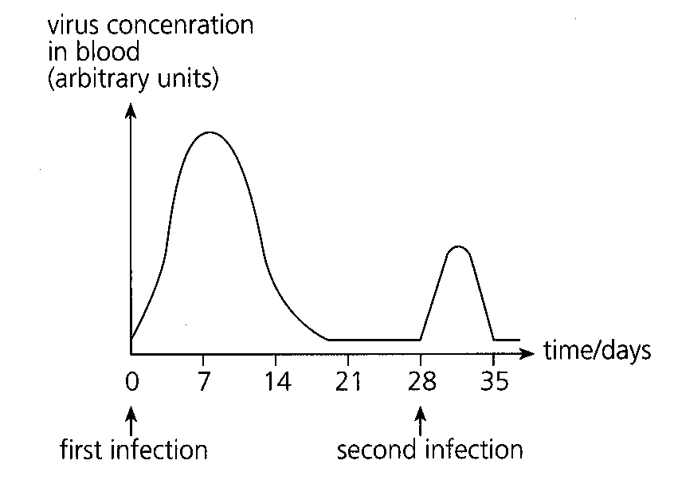
A. (1) only B. (1) and (2) onlyC. (2) and (3) only D. (1), (2) and (3) Directions: Questions 21 and 22 refer to the graph below which shows the concentration of a virus in the blood of a person who was infected by the same virus twice.
21. Which of the following can be concluded from the graph?
A.The person was more resistant to the virus during the first infection.
B.The virus was eliminated less effectively during the second infection.
C.The virus multiplied more rapidly during the first infection.
D.The virus involved in the second infection had a different antigen.
C22.Which of the following graphs best represents the changes in concentration of the specific antibody in the person's blood?
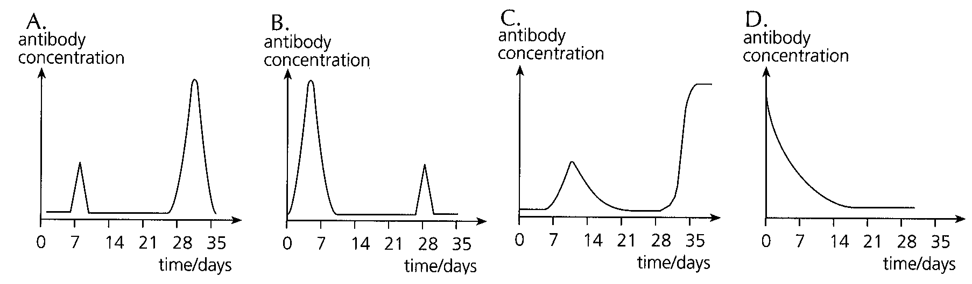
22. If the body is infected by the same pathogen for the second time. Which of the following descriptions of the induced immune response is/are correct? (1) A lot of antibodies are produced. (2) The response is very fast. (3) Antigen of the pathogen is memorised.
A. (1) only
B. (1) and (2) only
C. (2) and (3) only
D. (1), (2) and (3)
23. The graph below shows the concentration of antibody specific to a particular pathogen. The antibody concentration increased rapidly on day 28 because
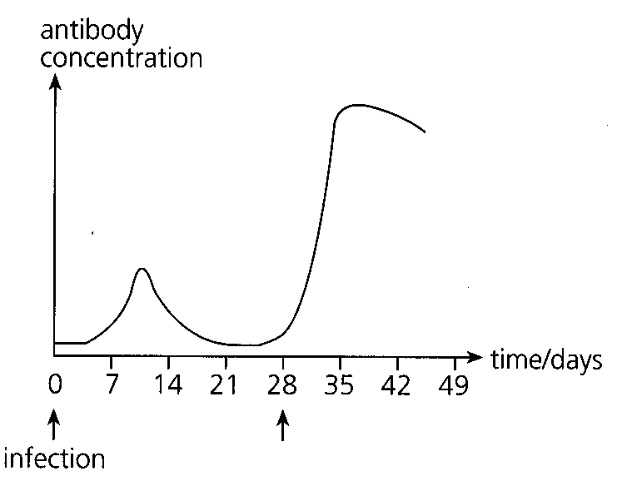
A. more phagocytes were produced.
B. more antibiotics were taken.
C. specific antibodies were injected.
D. the pathogen recurred.
24. The graph below shows two methods by which the level of antibodies in a person's blood may be raised.
Based on the graph, the types of substances that have been injected to the body to bring about the increase in antibody level are:
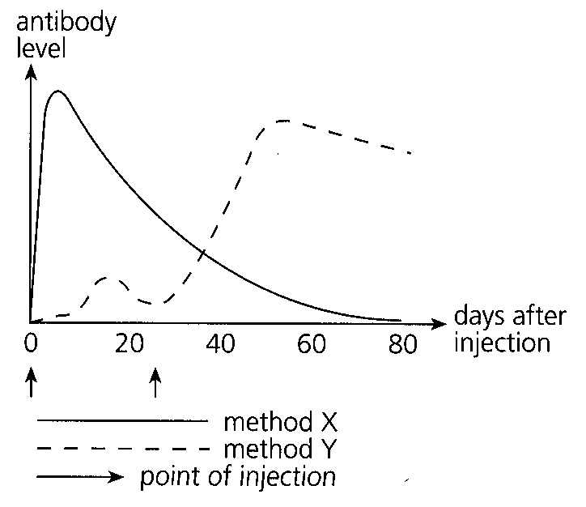
 | Method X | Method Y
A. | antibiotics | antibodies
B. | antigens | antibodies
C. | antibodies | killed pathogens
D. | living pathogens | killed pathogens

25. Vaccines can be prepared from (1) attenuated pathogens. (2) killed pathogens. (3) genetically engineered antigens.
A. (1) and (2) only
B. (1) and (3) only
C. (2) and (3) only
D. (1), (2) and (3)
26. A vaccine protects the human body by
A. reacting with the pathogen.
B. inducing the production of a memory of the pathogen.
C. stimulating the bone marrow to produce more white blood cells.
D. sticking the pathogens together to facilitate phagocytosis.
27. A man was inoculated with killed cowpox virus which resembled the smallpox virus closely. Which of the following is correct?
A. He was immuned to cowpox only.
B. He was immuned to smallpox only.
C. He was immuned to both cowpox and smallpox.
D. He was immuned to any infectious disease.
28. Which of the following diseases may be prevented by vaccination nowadays? (1) Hepatitis B (2) Smallpox (3) AIDS
A. (1) and (2) only
B. (1) and (3) only
C. (2) and (3) only
D. (1), (2) and (3)
29. AIDS is caused by
A. antigens.
B. viruses.
C. bacteria.
D. antibodies.
30. Which of the following body fluids is most likely to be responsible for the transmission of HIV (AIDS virus)?
A. Tear
B. Vaginal fluid
C. Saliva
D. Nasal secretion
31. If antibodies against HIV (AIDS virus) were detected in a person's blood sample, which of the following is a possible deduction?
A. This person is a homosexual. B. This person is immuned to AIDS.
C. This person has received vaccines for AIDS. D. This person has been infected by HIV. Distractors:
Part B — HKDSE-style (YKTo)
32. Directions: Questions 1 to 4 refer to the diagrams below, which show the structures or tissues at four parts of the human body related to defence against infection. Which of the following act as chemical barriers to prevent the invasion of germs into the body? (1) Gastric juice secreted from the stomach lining. (2) Sweat from the sweat glands. (3) Blood clot plugs the wounds at the body surface. (4) Acidic secretion from the vagina.
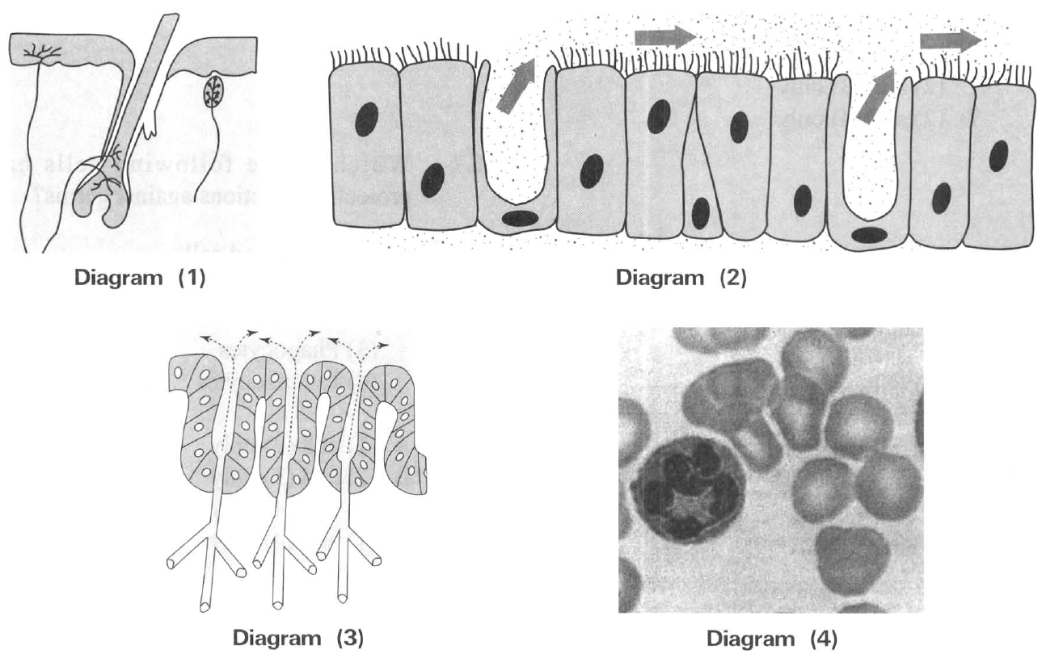
 | Diagram (1) | Diagram (2) | Diagram (3) | Diagram (4)
A. | Integumentary system | Digestive system | Respiratory system | Vascular system
B. | Skeletal system | Respiratory system | Digestive system | Lymphatic system
C. | Integumentary system | Respiratory system | Digestive system | Vascular system
D. | Muscular system | Digestive system | Respiratory system | Lymphatic system

A. (1) and (2) only
B. (2) and (3) only
C. (3) and (4) only
D. (4) and (1) only
33. What is the function of the mucus secreted by the cells lining the respiratory tract?
 | Phagocytosis | Antibody production
A. | B Lymphocytes | Erythrocytes
B. | Thrombocytes | B Lymphocytes
C. | Phagocytes | B Lymphocytes
D. | B Lymphocytes | Erythrocytes

A. They have antiseptic function to kill the germs.
B. They dissolve oxygen to promote gas exchange.
C. They trap germs which can be expelled out by the cilia of the respiratory tract.
D. They inhibit the replication of the germs. 7Which of the following cells have protective functions against germs? (1) Red blood cells (2) Epithelial cells of the small intestine (3) Phagocytes (4) Lymphocytes
A. (1) and (2) only B. (2) and (3) only C. (3) and (4) only D. (1) and (4) only 8Which of the following cells provide the right function against infection?
34. Which of the following are significance of blood clotting? (1) Stops further blood loss (2) Reduces the risk of invasion by germs (3) Triggers the mechanism of antibody production
A. (1) and (2) only
B. (2) and (3) only
C. (1) and (3) only
D. (1), (2) and (3)
35. Inflammation of a wound at the leg is due to the
A. rapid growth of bacteria in the wound.
B. production of antibodies at the wound.
C. local response of the body to bacterial infection.
D. degeneration of tissues at the wound.
36. A man's hand was badly injured in an accident. Without proper treatment of the wound a swollen hard lump appeared at his armpit. It is due to
A. the rapid production of red blood cells in the armpit.
B. the production of large amount of antibodies in the lymph nodes of the armpit.
C. the swelling of the lymph nodes in the armpit.
D. the accumulation of clotted blood in the armpit.
37. Which of the following events account for the inflammatory response of a wound at the skin? (1) Increased permeability of the blood vessels beneath the skin. (2) Passage of large number of phagocytes out of the capillaries. (3) Vasoconstriction of the blood vessel beneath the skin.
A. (1) only
B. (1) and (2) only
C. (2) and (3) only
D. (3) and (1) only
38. Which of the following is the CORRECT sequence of events occurring during phagocytosis? (1) The pathogen is engulfed into the cytoplasm of the macrophage. (2) Cell membrane of the macrophage grows around the pathogen. (3) Lysosomes of the macrophage secrete enzymes to digest the pathogen. (4) Macrophage recognizes the pathogen and attaches to it.
A. (2), (4), (1), (3)
B. (4), (2), (1), (3)
C. (3), (4), (1), (2)
D. (2), (3), (4), (1)
39. Once bacteria successfully enter the bloodstream of a body, which of the following is the immediate effective defence action taken by the body?
A. Increase the beating of the cilia lining the respiratory tract to drive the bacteria out.
B. Increase the secretion of gastric juice to kill the bacteria.
C. Phagocytes engulf the bacteria.
D. Lymphocytes recognise the bacteria.
B. Specific defence mechanisms
40. Which of the following combinations about the two main types of defence mechanisms in the human body is both CORRECT?
 | Specific defence mechanisms | Non-specific defence mechanisms
A. | Inflammation | The epithelium of skin
B. | Phagocytosis | Gastric juice secreted in the stomach
C. | Cell-mediated immune response | Humoral immune response
D. | Humoral immune response | The mucous, ciliated epithelium of the respiratory tract

41. Which of the following comparisons between specific and non-specific defence mechanisms is CORRECT?
 | Specific defence mechanisms | Non-specc defence mechanisms
(1) | Involve T lymphocytes | Involve B lymphocytes
(2) | Take time to develop the immune response | Immediate action
(3) | Develop memory cells against particular pathogens | No memory cells are developed against pathogens
(4) | Must produce antibodies against the pathogens | No antibodies are produced.

A. (1) and (2) only
B. (2) and (3) only
C. (3) and (4) only
D. (4) and (1) only
42. Which of the following provide specific body defence mechanism?
A. Swelling of lymph nodes. B. Production of antibodies by lymphocytes.
C. Phagocytosis of germs by macrophage. D. Blood clotting at the wound.
43. Which of the following statements about antigen is CORRECT?
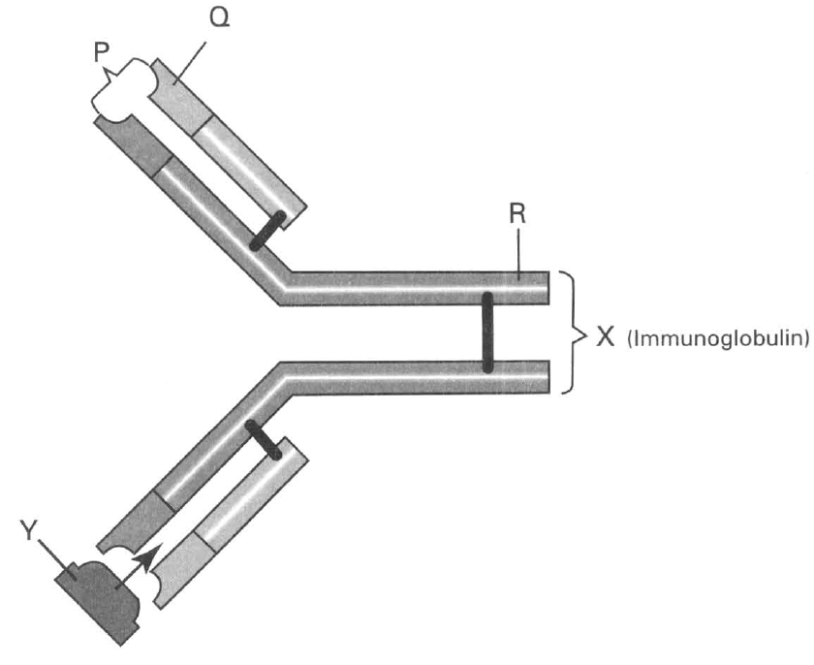
A. It must be a virus. B. It must be a bacterium.
C. It must be a pathogen.
D. It can be cell or tissue or macromolecule that once introduced into the human body will trigger the immune response. Directions: Questions 19 and 20 refer to the diagram below, which shows an immunoglobulin X binding to a substance Y.
44. Which of the following combinations of the labelled parts of the immunoglobulin molecule X is CORRECT?
 | P | Q | R
A. | Site to bind with the antigen | Region with variable amino acid sequence | Region with constant amino acid sequence
B. | Site to bind with the antigen | Region with constant amino acid sequence | Region with variable amino acid sequence
C. | Site to bind with the lymphocyte | Region with variable amino acid sequence | Site to bind with the antigen
D. | Site to bind with the macrophage | Region with constant amino acid sequence | Site to bind with the antigen

45. Which of the following can be substance Y attaching to site P? (1) Antigens on transplanted tissue. (2) Red blood cells in unmatched blood transfusion. (3) Virus invading the body. (4) Macromolecule on the cell wall of bacterium .
A. (1) and (2) only
B. (2) and (3) only
C. (3) and (4) only
D. (1), (2), (3) and (4)
46. Which of the following statements about antibodies is CORRECT?
A. The action of an antibody against pathogens is highly specific.
B. Antibodies are made of phospholipids.
C. Antibodies can only act against pathogens.
D. Like enzymes antibodies can be used many times against the toxins produced by pathogens.
47. Which of the following statements about antibodies are CORRECT? (1) They are made of proteins. (2)They are produced by macrophages. (3) They act against specific bacteria. (4) They divide rapidly on the next exposure to the same antigen.
A. (1) and (2) only
B. (2) and (4) only
C. (1) and (3) only
D. (3) and (4) only
48. Which of the following statements about antibodies are INCORRECT? (1)They are produced by microorganisms. (2) They can only act against bacteria. (3) They can only act on specific antigens. (4) They are produced by plasma cells derived from B lymphocytes.
A. (1) and (2) only
B. (3) and (4) only
C. (1) and (3) only
D. (2) and (4) only
49. Which of the following are ways that an antibody can act against pathogens? (1) It causes the breakdown of the pathogens. (2) It causes the pathogens clumping together. (3) It neutralizes the toxins produced by pathogens. (4) It attaches to the pathogens to enhance phagocytosis.
A. (1) and (2) only
B. (2) and (3) only
C. (3) and (4) only
D. (1), (2), (3), (4)
50. Which of the following cells directly secrete antibodies?
A. B lymphocytes B. T lymphocyte
C. Memory cells D. Plasma cells
51. Which of the following is NOT concerned with the specific immune response of the body?
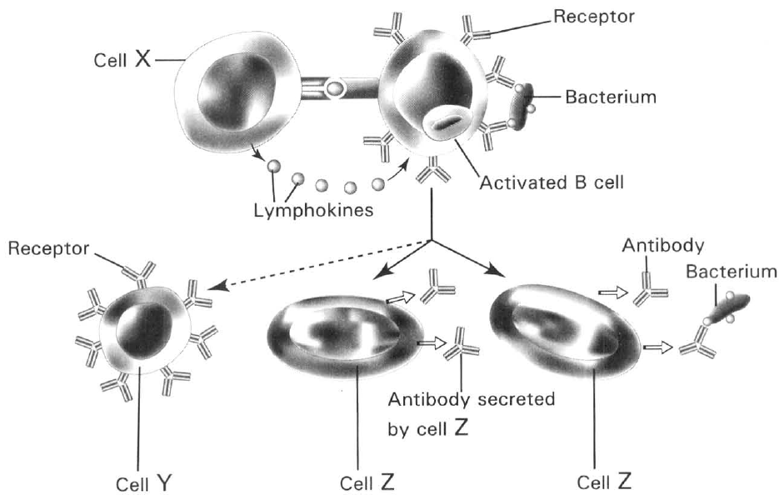
A. B lymphocytes B. T killer cells
C. Memory cells D. Phagocytes Directions: Question 27 refers to the diagram below, which shows a process involved in Humoral Immune Response.
52. Which of the following matching of the cells is CORRECT?
 | Cell X | Cell Y | Cell Z
A. | Memory B cell | Helper T cell | Plasma cell
B. | Helper T cell | Plasma cell | Memory B cell
C. | Helper T cell | Memory B cell | Plasma cell
D. | Plasma cell | Helper T cell | Memory B cell

53. Which of the following concerning the humoral immune response (HIR) is CORRECT?
A. Inflammation.
B. Phagocytosis of antigens.
C. Production of antibodies.
D. Production of T cells.
54. Which of the following combinations about T lymphocytes is CORRECT?
 | Site of production | Site of maturation | Site of storage
A. | Thymus | Bone marrow | Lymph node
B. | Lymph node | Bone marrow | Thymus
C. | Bone marrow | Thymus | Lymph node
D. | Thymus | Lymph node | Bone marrow

55. Which of the following statements about cell-mediated immune response (CMIR) is INCORRECT?
A. It is effective to act against intracellular pathogens.
B. Three types of T cells are produced in this response.
C. No memory cells are produced.
D. It enhances the activities of B lymphocytes.
56. Which of the following is NOT the function of helper T cells?
A. Kill the pathogens directly.
B. Stimulate the B-lymphocytes to divide into plasma cells.
C. Activate the macrophages to engulf the pathogens
D. Regulate the killer T cells to kill the pathogens.
57. Tissue rejection may occur in some organ transplants. In tissue rejection the transplanted organ is destroyed by the
A. killler T cells. B. helper T cells. C. memory T cells D. B cells.
58. Which of the following will occur when the memory cells encounter the antigens that have invaded the body before?
A. Divide rapidly to form many plasma cells or differentiated T cells.
B. Destroy the antigens directly.
C. Inhibit the multiplication of the antigens.
D. Aggregate the antigens into a big mass to enhance phagocytosis to occur.
59. Which of the following statements concerning both B lymphocytes and T lymphocytes are CORRECT?
(1) Both can be stimulated by antigens to produce antibodies.
(2) Both can produce memory cells once activated by related antigens.
(3) Both can specifically destroy cancer cells.
 | Lymphocytes | Name of immune response | Antibodies involved | Production of memory cells
A. | B cells | Cell-mediated response | No | Yes
B. | T cells | Humoral immune response | Yes | No
C. | B cells | Humoral immune response | Yes | Yes
D. | T cells | Cell-mediated response | Yes | No

A. (1) only B. (3) only C. (1) and (2) only D. (2) and (3) only 35Which of the following combinations is CORRECT?
60. Which of the following concerning thelymph nodes is/are CORRECT?
(1) Some lymph nodes swell during bacterial infection.
(2) Lymph nodes are places where the T lymphocytes mature.
(3) Lymph nodes are places where all the lymphocytes are produced.
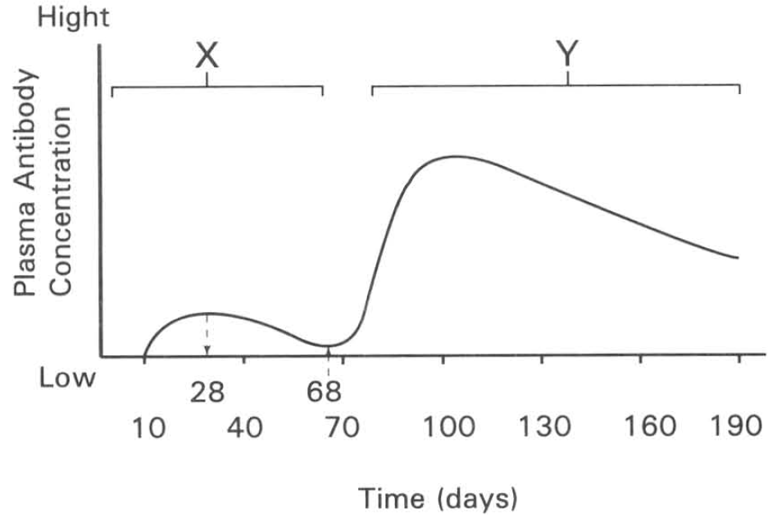
A. (1) only B. (2) only
C. (3) only D. (2) and (3) only Directions: Questions 37 to 41 refer to the diagram below , which shows the change in the antibody level in the blood of a person over a period of time.
61. Which of the following is the probable reason for the rise of the antibody level in blood from day 10 to day 28?
A. The increase in the number of phagocytes in a wound on the skin surface.
B. There was a bacterial infection in the body.
C. There was an injection of antibiotics into the body.
D. There was an injection of antibodies into the body.
62. Which of the following is/are the probable explanation for the change in the antibody level in blood from day 28 to day 68? (1) The immune system stops to produce antibodies. (2) Antibodies are used up in acting against the pathogens. (3) Antibodies degenerate with time.
A. (1) only
B. (2) only
C. (1) and (2) only
D. (1), (2) and (3)
63. Which of the following explanation about the change in the antibody level in blood between day 70 to day 100 is CORRECT?
A. The innate response of the body against the pathogen that enters the body for the first time.
B. The body has been attacked by this pathogen before.
C. The person is doing aerobic exercise during this period.
D. The man has eaten a meal rich in proteins.
64. Which of the following combinations CORRECTLY name the processes labelled X and Y?
 | Response X | Response Y
A. | Active immunity | Passive immunity
B. | Natural Immunity | Artificial immunity
C. | Primary response | Secondary response
D. | Primary succession | Secondary succession

65. Which of the following graphs CORRECTLY shows the amount of pathogens present in the body during the above period?
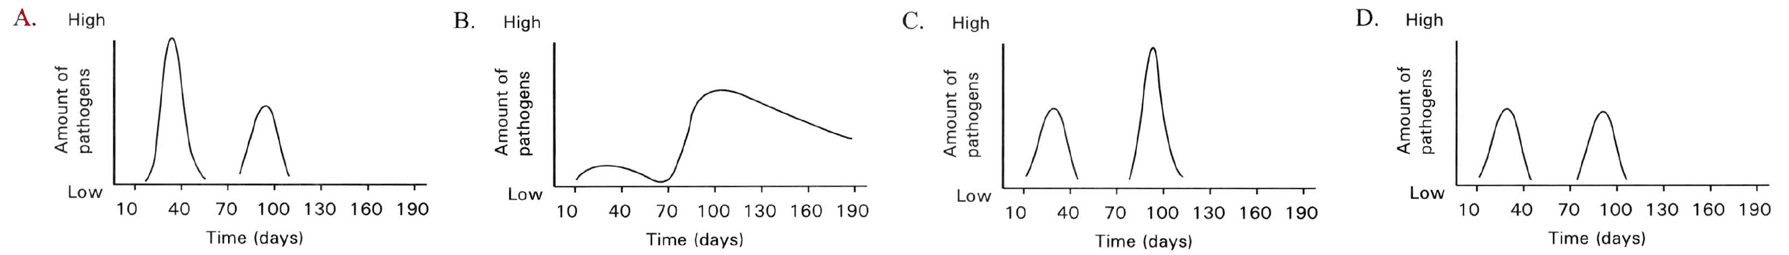
66. Which of the following comparisons between primary response and secondary response is INCORRECT?
Directions: Questions 43 and 44 refer to the graph on the right, which shows the response in the blood of elderly and young children who are given different injections during an outbreak of influenza.
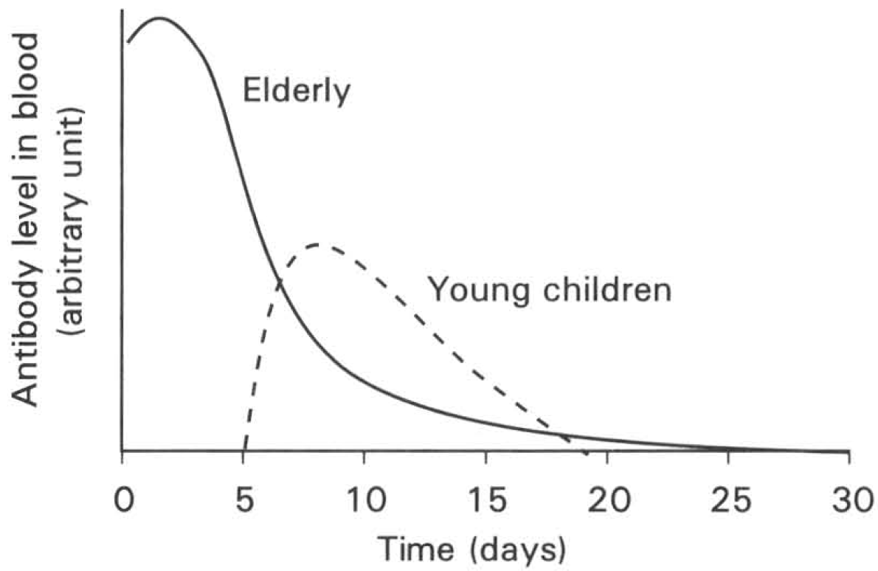
 | Primary response | Secondary response
A. | Higher peak of antibody level is achieved. | Lower peak of antibody level achieved.
B. | Longer latent period | Shorter latent period
C. | Symptoms of disease appear | No symptoms of disease
D. | Antibody level rapidly declines from the peak | Antibody level remains high for a long period of time.

67. Which of the following CORRECTLY matches the 'substances' injected into the elderly and the young children?
 | Elderly | Young children
A. | Antibiotic | Antibodies against the virus
B. | Attenuated viruses | Dead viruses
C. | Antibodies against the viruses | Attenuated viruses
D. | Dead viruses | Antibiotic

68. What is the advantage of injecting the elderly with the substance used for them?
A. This gives immediate protection against the viruses.
B. This gives longer immunity.
C. The body can be protected against a wide range of viruses.
D. This activates the immune system to produce more antibodies against the viruses. 45 Secondary response is due to the production of 'memory' in the primary response during the infection of the body by pathogens. Which of the following concerning this 'memory' is CORRECT?
A. 'Memory' is stored in the brain of the patient.
B. 'Memory' is stored in the antigen of the pathogen.
C. 'Memory' is stored in the antibodies produced in the first infection.
D. 'Memory' is stored in some lymphocytes of the immune system in the first infection.
69. A person was infected by two different pathogens at the same time. He had been infected by one of these two pathogens three months ago. The graph below shows the antibody level in his blood samples over a period of time after the new infection.
Which of the following combinations CORRECTLY represents the immune responses shown by curves P and Q respectively?
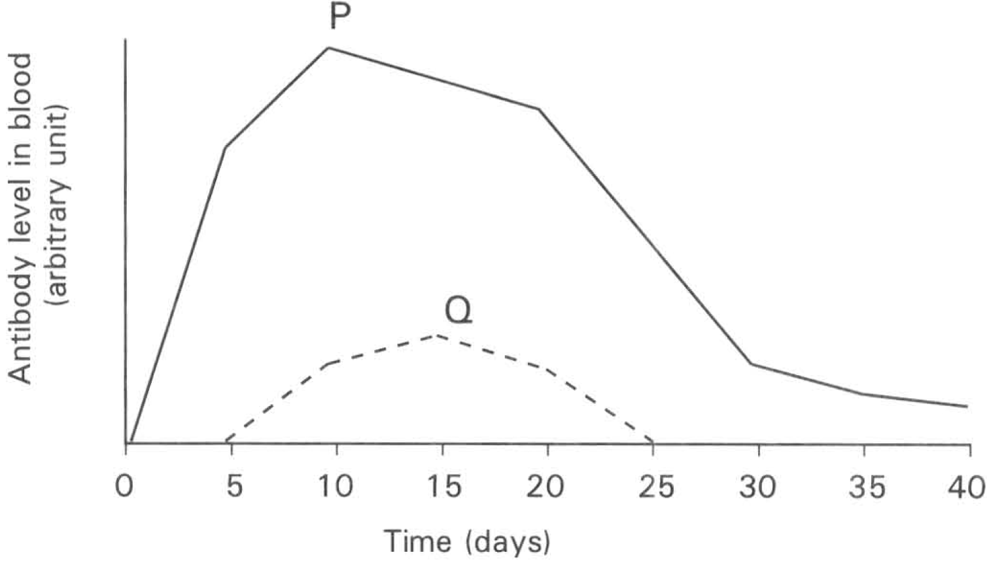
 | Curve P | Curve Q
A. | Primary response due to the first infection by a pathogen | Secondary response due to the second infection by the other pathogen.
B. | Secondary response due to the second infection by a pathogen. | Primary response due to the first infection by the other pathogen
C. | Secondary response due to the first infection by a pathogen. | Primary response due to the second infection by the other pathogen
D. | Primary response due to the second infection by a pathogen | Secondary response due to the first infection by the other pathogen.

70. Vaccine can be prepared from (1) dead pathogens (2) attenuated viruses (3) antigenic components of a pathogen
A. (1) only
B. (2) only
C. (1) and (2) only
D. (1), (2), (3)
71. In the vaccination programme of children in Hong Kong, usually a booster is needed after the first inoculation with a vaccine. What is the purpose of including a booster of the same vaccine in this programme?
A. Young children cannot receive too much vaccine at a time so that the dose is divided into two batches.
B. The life span of vaccine is very short so that the vaccine will be destroyed shortly after the first inoculation. Therefore a second batch is needed to compensate for the loss of the first batch.
C. The booster stimulates the secondary response that triggers the memory cells to produce large amount of antibodies to achieve longer period of immunity.
D. The amount of vaccine in the booster is bigger than that in the first inoculation so that it is more effective.
72. Which of the following is an example of active, natural immunity?
A. Inoculation with vaccine.
B. Injection with antibiotic.
C. Infection with measles.
D. Injection with antibodies.
73. Which of the following about active immunity is CORRECT?
A. Immunity by the exchange of substances through the placenta of the mother.
B. Breast-feeding.
C. Inoculation with attenuated viruses.
D. Injection with antibodies.
74. What is a vaccine?
A. It is the antibody which is inoculated into the body.
B. It is the attenuated or killed pathogen that is inoculated into the body.
C. It is the antibiotic that is injected into the body.
D. It is the transfer of blood to a recipient.
75. Passive immunity is achieved by (1) inoculation of vaccine into the body. (2) inoculation of antibodies into the body. (3) inoculation of antibiotic into the body. (4) passage of antibodies from the maternal blood through the placenta into the foetal blood.
A. (1) only
B. (2) only
C. (2) and (4) only
D. (3) and (4) only
76. Immunity against smallpox is done by injecting attenuated cowpox viruses into a person. (1) Cowpox virus stimulates the lymphocytes to produce memory cells against the cowpox and smallpox viruses. (2) Cowpox virus acts as antibodies against the future invasion by smallpox viruses. (3) Both cowpox viruses and smallpox viruses are of the same size.
A. (1) only
B. (2) only
C. (1) and (2) only
D. (1), (2) and (3)
77. Which of the following is/are ways the foetus inside the womb of the mother acquires passive natural immunity? (1) Preformed antibodies pass across the embryonic membrane. (2) Baby suckles milk from the mammary glands of the mother. (3) Mother injected with antibiotics.
A. (1) only
B. (2) only
C. (3) only
D. (1) and (2) only
78. Which of the following about passive immunity is CORRECT?
Substances in blood | Father | Mother | Daughter | Son
Hepatitis B antigens | + | - | - | -
Antibodies against hepatitis B | - | + | + | -

A. Injecting antibiotics into the body.
B. Achieving through a viral infection.
C. Drinking milk prepared from milk powder.
D. Injecting preformed antibodies into the body. Directions: Questions 56 to 58 refer to the table below which shows the results of blood test of the four members of a family.
79. Which person(s) has /have contracted hepatitis B?
A. Father only
B. Mother only
C. Father and mother only
D. Father, mother and daughter only
80. Which person(s) has successfully produced antibodies against the hepatitis B viruses attacking him/her?
A. Father only B. Mother only C. Daughter and mother only D. Son only
81. Which person can take inoculation of the hepatitis B vaccine to prevent further contraction of this disease?
A. Father only B. Mother only C. Daughter only D. Son only

Answers
Answers are printed in red.
1. B. (1) and (2) only
Class: 72.3% correct (n=112) usual slip B
2. D
Class: 63.4% correct (n=112) usual slip A
3. D. (1), (2) and (3)
Class: 83.0% correct (n=112) usual slip C
4. A. (1) and (2) only
Class: 84.8% correct (n=112) usual slip B
5. D. (1), (2) and (3)

6. B. (1) and (3) only

7. C. (2) and (3) only
Class: 76.8% correct (n=112) usual slip A
8. C. it has a tough outer layer of dead cells.
Class: 66.1% correct (n=112) usual slip A
9. A. (1) only

10. ?

11. B

12. C. it stops the entry of pathogens.
Class: 95.2% correct (n=21) usual slip D
13. A. (1) and (2) only
Class: 69.0% correct (n=42) usual slip B
14. C. (2), (3), (1)

15. D. (1), (2) and (3)

16. ?

17. C. protein.
Class: 74.4% correct (n=43) usual slip D
18. A. (1) and (2) only
Class: 36.4% correct (n=22) usual slip D
19. C. Their production are induced by specific antigens.
Class: 80.5% correct (n=41) usual slip D
20. B
Class: 95.0% correct (n=20) usual slip A
21. C
Class: 86.4% correct (n=22) usual slip D
22. B. (1) and (2) only

23. D. the pathogen recurred.

24. C

25. D. (1), (2) and (3)

26. B. inducing the production of a memory of the pathogen.

27. C. He was immuned to both cowpox and smallpox.

28. A. (1) and (2) only

29. B. viruses.

30. ?

31. D

32. D. (4) and (1) only
Class: 70.0% correct (n=20) usual slip B
33. C. They trap germs which can be expelled out by the cilia of the respiratory tract.
Class: 72.9% correct (n=70) usual slip B
34. A. (1) and (2) only
Class: 86.4% correct (n=22) usual slip B
35. C. local response of the body to bacterial infection.
Class: 85.7% correct (n=21) usual slip A
36. C. the swelling of the lymph nodes in the armpit.
Class: 85.0% correct (n=20) usual slip B
37. B. (1) and (2) only
Class: 86.0% correct (n=43) usual slip A
38. B. (4), (2), (1), (3)

39. C. Phagocytes engulf the bacteria.
Class: 90.9% correct (n=22) usual slip A
40. D
Class: 76.7% correct (n=43) usual slip B
41. B. (2) and (3) only

42. B

43. D. It can be cell or tissue or macromolecule that once introduced into the human body will trigger the immune response. Directions: Questions 19 and 20 refer to the diagram below, which shows an immunoglobulin X binding to a substance Y.

44. A

45. D. (1), (2), (3) and (4)
Class: 63.6% correct (n=22) usual slip A
46. A. The action of an antibody against pathogens is highly specific.

47. C. (1) and (3) only
Class: 81.8% correct (n=22) usual slip A
48. A. (1) and (2) only
Class: 45.5% correct (n=22) usual slip B
49. D. (1), (2), (3), (4)

50. D

51. D

52. C

53. C. Production of antibodies.

54. C

55. C. No memory cells are produced.

56. A. Kill the pathogens directly.

57. A. killler T cells. B. helper T cells. C. memory T cells D. B cells.

58. A. Divide rapidly to form many plasma cells or differentiated T cells.

59. D

60. A. (1) only B. (2) only

61. B. There was a bacterial infection in the body.

62. D. (1), (2) and (3)

63. B. The body has been attacked by this pathogen before.

64. C

65. A

66. A

67. C

68. A. 'Memory' is stored in the brain of the patient.

69. B

70. D. (1), (2), (3)

71. C. The booster stimulates the secondary response that triggers the memory cells to produce large amount of antibodies to achieve longer period of immunity.

72. C. Infection with measles.

73. C. Inoculation with attenuated viruses.

74. B. It is the attenuated or killed pathogen that is inoculated into the body.

75. C. (2) and (4) only

76. A. (1) only

77. A. (1) only

78. D. Injecting preformed antibodies into the body. Directions: Questions 56 to 58 refer to the table below which shows the results of blood test of the four members of a family.

79. D. Father, mother and daughter only

80. C

81. D

