Body defence mechanisms · items under 80% correct
Multiple-choice practice
Name: ________________________ Class: ____________
These items were answered correctly by fewer than 80% of students in class Google Forms, matched by the wording in the source bank and the form answer key. Choose the one best answer.
Part A — HKCEE level (Longman)
1. Which of the following are aspects of body defence? (1) Prevent entry of microorganisms. (2) Eliminate pathogens by white blood cells. (3) Kill bacteria using antibiotics.
A. (2) only
B. (1) and (2) only
C. (2) and (3) only
D. (1), (2) and (3)
2. Which groups of pathogens cause AIDS, hepatitis B and hand, foot and mouth disease?
 | AIDS | Hepatitis B | Hand, foot and mouth disease
A. | bacterium | virus | bacterium
B. | bacterium | bacterium | virus
C. | virus | bacterium | bacterium
D. | virus | virus | virus

3. Which of the following are chemical barriers to pathogens? (1) Mucus lining the gut (2) Tear (3) Gastric juice
A. (1) and (2) only
B. (1) and (3) only
C. (2) and (3) only
D. (1), (2) and (3)
4. The mammalian skin is involved in body defence because A. it is covered with hair. C. it has a tough outer layer of dead cells.
A. it is covered with hair.
B. it is waterproof.
C. it has a tough outer layer of dead cells.
D. it has a thick fat layer.
5. White blood cells kill pathogens by (1) engulfing and digesting them.(2) producing antibodies. (3) producing hydrochloric acid.
A. (1) and (2) only
B. (1) and (3) only
C. (2) and (3) only
D. (1), (2) and (3)
6. Antibodies are made of
A. carbohydrate.
B. cholesterol.
C. protein.
D. vitamin.
7. Which of the following are possible actions of antibodies? (1) Stick pathogens together (2) Destroy toxins made by pathogens (3) Kill pathogens by phagocytosis
A. (1) and (2) only
B. (1) and (3) only
C. (2) and (3) only
D. (1), (2) and (3)
8. Which of the following correctly describes the features of the antibodies?
A. They act on any kind of pathogen.
B. They are always produced in large amounts.
C. Their production are induced by specific antigens.
D. They are produced by any kind of white blood cells.
Part B — HKDSE-style (YKTo)
9. Directions: Questions 1 to 4 refer to the diagrams below, which show the structures or tissues at four parts of the human body related to defence against infection. Which of the following act as chemical barriers to prevent the invasion of germs into the body? (1) Gastric juice secreted from the stomach lining. (2) Sweat from the sweat glands. (3) Blood clot plugs the wounds at the body surface. (4) Acidic secretion from the vagina.
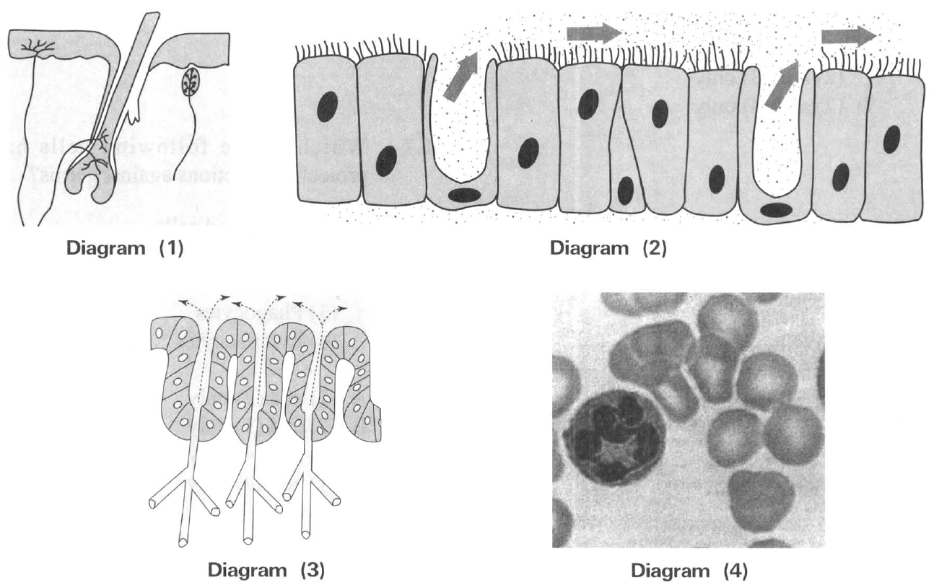
 | Diagram (1) | Diagram (2) | Diagram (3) | Diagram (4)
A. | Integumentary system | Digestive system | Respiratory system | Vascular system
B. | Skeletal system | Respiratory system | Digestive system | Lymphatic system
C. | Integumentary system | Respiratory system | Digestive system | Vascular system
D. | Muscular system | Digestive system | Respiratory system | Lymphatic system

A. (1) and (2) only
B. (2) and (3) only
C. (3) and (4) only
D. (4) and (1) only
10. What is the function of the mucus secreted by the cells lining the respiratory tract?
 | Phagocytosis | Antibody production
A. | B Lymphocytes | Erythrocytes
B. | Thrombocytes | B Lymphocytes
C. | Phagocytes | B Lymphocytes
D. | B Lymphocytes | Erythrocytes

A. They have antiseptic function to kill the germs.
B. They dissolve oxygen to promote gas exchange.
C. They trap germs which can be expelled out by the cilia of the respiratory tract.
D. They inhibit the replication of the germs. 7Which of the following cells have protective functions against germs? (1) Red blood cells (2) Epithelial cells of the small intestine (3) Phagocytes (4) Lymphocytes
A. (1) and (2) only B. (2) and (3) only C. (3) and (4) only D. (1) and (4) only 8Which of the following cells provide the right function against infection?
11. Which of the following combinations about the two main types of defence mechanisms in the human body is both CORRECT?
 | Specific defence mechanisms | Non-specific defence mechanisms
A. | Inflammation | The epithelium of skin
B. | Phagocytosis | Gastric juice secreted in the stomach
C. | Cell-mediated immune response | Humoral immune response
D. | Humoral immune response | The mucous, ciliated epithelium of the respiratory tract

12. Which of the following can be substance Y attaching to site P? (1) Antigens on transplanted tissue. (2) Red blood cells in unmatched blood transfusion. (3) Virus invading the body. (4) Macromolecule on the cell wall of bacterium .
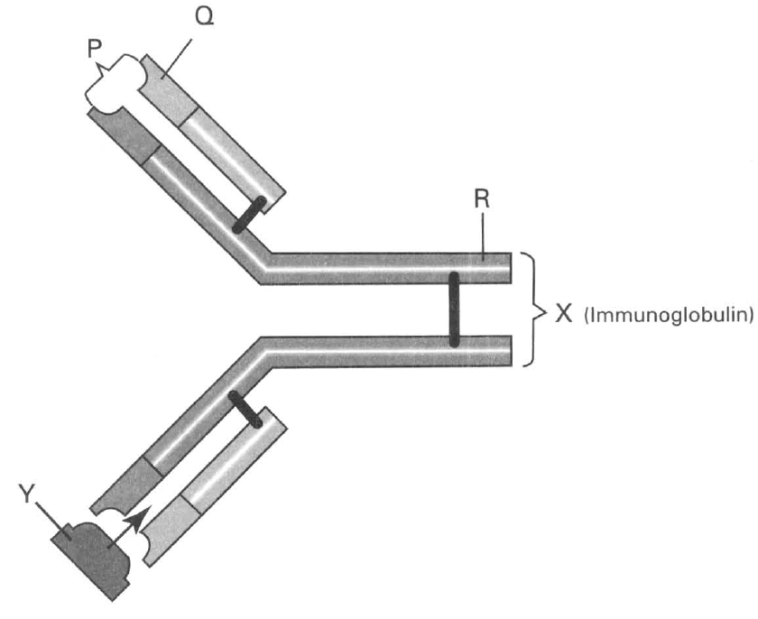
A. (1) and (2) only
B. (2) and (3) only
C. (3) and (4) only
D. (1), (2), (3) and (4)
13. Which of the following statements about antibodies are INCORRECT? (1)They are produced by microorganisms. (2) They can only act against bacteria. (3) They can only act on specific antigens. (4) They are produced by plasma cells derived from B lymphocytes.
A. (1) and (2) only
B. (3) and (4) only
C. (1) and (3) only
D. (2) and (4) only

Answers
Answers are printed in red.
1. B. (1) and (2) only
Class: 72.3% correct (n=112) usual slip B
2. D
Class: 63.4% correct (n=112) usual slip A
3. C. (2) and (3) only
Class: 76.8% correct (n=112) usual slip A
4. C. it has a tough outer layer of dead cells.
Class: 66.1% correct (n=112) usual slip A
5. A. (1) and (2) only
Class: 69.0% correct (n=42) usual slip B
6. C. protein.
Class: 74.4% correct (n=43) usual slip D
7. A. (1) and (2) only
Class: 36.4% correct (n=22) usual slip D
8. C. Their production are induced by specific antigens.
Class: 80.5% correct (n=41) usual slip D
9. D. (4) and (1) only
Class: 70.0% correct (n=20) usual slip B
10. C. They trap germs which can be expelled out by the cilia of the respiratory tract.
Class: 72.9% correct (n=70) usual slip B
11. D
Class: 76.7% correct (n=43) usual slip B
12. D. (1), (2), (3) and (4)
Class: 63.6% correct (n=22) usual slip A
13. A. (1) and (2) only
Class: 45.5% correct (n=22) usual slip B

Class percentage correct
Matched to this paper by question wording in the source bank and the form answer key, not by a shifted paper number.
Q | Answer | % correct | n | Usual slip
1 | B | 72.3% | 112 | B
2 | D | 63.4% | 112 | A
3 | C | 76.8% | 112 | A
4 | C | 66.1% | 112 | A
5 | A | 69.0% | 42 | B
6 | C | 74.4% | 43 | D
7 | A | 36.4% | 22 | D
8 | C | 80.5% | 41 | D
9 | D | 70.0% | 20 | B
10 | C | 72.9% | 70 | B
11 | D | 76.7% | 43 | B
12 | D | 63.6% | 22 | A
13 | A | 45.5% | 22 | B

