Cell cycle and division
Multiple-choice compilation (student-checked)
Name: ________________________ Class: ____________
Answer all questions. Each item has four choices; choose the one best answer. Diagrams are the originals. Follow-up items in a group use the diagram already printed — it is not repeated.
Part A — HKCEE level (Longman)
1. Which of the following statements about mitosis in flowering plants are correct? (1) It occurs throughout the life. (2) It occurs at the root tips and shoot tips only. (3) It may be used for reproduction.
A. (1) and (2) only
B. (1) and (3) only
C. (2) and (3) only
D. (1), (2) and (3)
[Longman cell Q37]
2. Which of the animal cells below are capable of undergoing mitosis? (1) Cheek cells (2) Cells in the Malpighian layer of the skin (3) Neurones (4) Bone marrow cells
A. (1) and (4) only
B. (2) and (3) only
C. (2) and (4) only
D. (3) and (4) only
[Longman cell Q38]
Directions: The following items refer to the diagram below, which shows four of the stages in mitosis.
3. The sequence of mitosis is best represented by
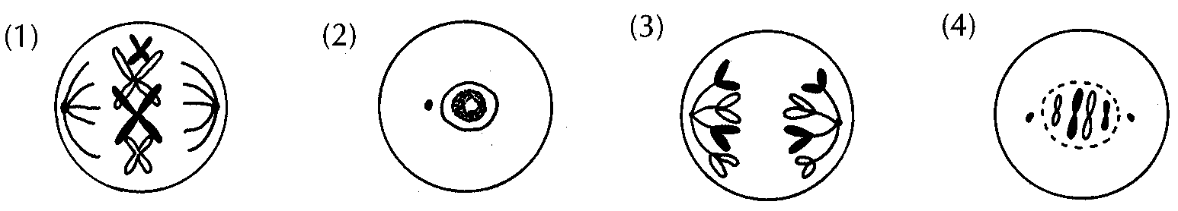
A. (1) → (2) → (3) → (4)
B. (2) → (1) → (3) → (4)
C. (2) → (4) → (1) → (3)
D. (4) → (1) → (3) → (2)
[Longman cell Q39]
4. The probable site of occurrence of this cell division is
A. spongy mesophyll.
B. root tip.
C. testis.
D. Malpighian layer of skin.
[Longman cell Q40]
5. Four of the stages in mitosis are outlined below: (1) DNA molecules are replicated. (2) Chromosomes arrange in single file at the equator. (3) Chromosomes are separated by spindle fibres. (4) Chromosomes become visible. The correct sequence of mitosis is
A. (1) → (4) → (2) → (3)
B. (1) → (4) → (3) → (2)
C. (4) → (1) → (2) → (3)
D. (4) → (3) → (2) → (1)
[Longman cell Q41]
Directions: The following items refer to the diagram below, obtained by sectioning a plant organ.
6. The plant organ is probably the
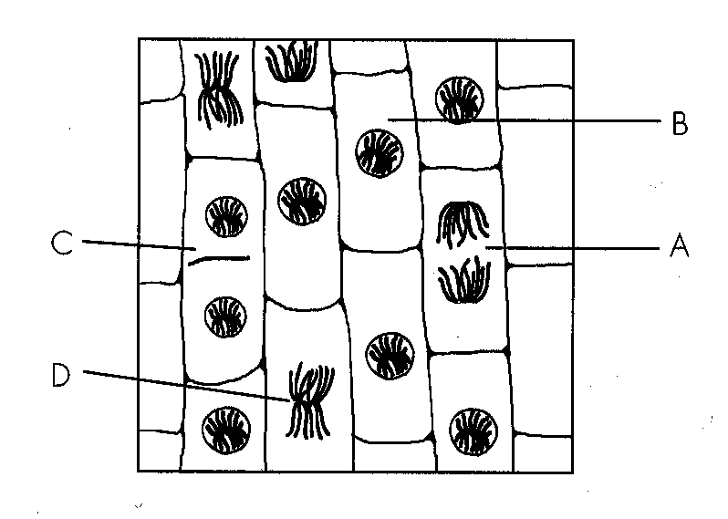
A. transverse section of stem.
B. transverse section of leaf.
C. longitudinal section of root.
D. longitudinal section of petal.
[Longman cell Q42]
7. Which cell represents the stage of mitosis during which chromosomes are being replicated?
A. A
B. B
C. C
D. D
[Longman cell Q43]
8. What is the correct sequence of mitosis?
A. D → B → C → A
B. C → B → A → D
C. B → A → D → C
D. B → D →A → C
[Longman cell Q44]
9. Which of the following lists the level of organization in ascending order of complexity?
A. cell tissue organ organ system organism
B. organism organ system organ - tissue cell
C. cell organ organ system tissue organism
D. organism organ organ system tissue cell
[Longman cell Q45]
Directions: The following items refer to the diagram below, which shows a certain stage of cell division.
10. At this stage of cell division, the DNA content of the cell is equivalent to that of
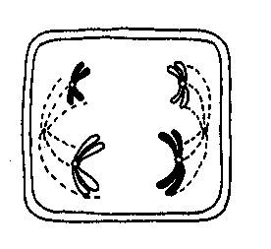
A. 2 chromosomes.
B. 4 chromosomes.
C. 8 chromosomes.
D. 16 chromosomes.
[Longman cell Q46]
11. Which of the following correctly describes the parent cell and the daughter cells resulted from this division? Chromosome number in parent cell | Chromosome number in daughter cell | Number of daughter cells |
A. | 2 | 2 | 2 |
B. | 4 | 4 | 2 |
C. | 4 | 2 | 4 |
D. | 8 | 4 | 4
[Longman cell Q47]
12. Which of the following correctly describes the process of sperm production in human? Division involved | Number of sperms formed in each division | Chromosome number in each sperm |
A. | mitosis | 2 | 46 |
B. | mitosis | 4 | 46 |
C. | meiosis | 2 | 23 |
D. | meiosis | 4 | 23
[Longman cell Q48]
Directions: The following items refer to the diagram below, which shows three stages of a cell division.
13. If the chromosome number of an angiosperm is 8, which of the following has 4 chromosomes?
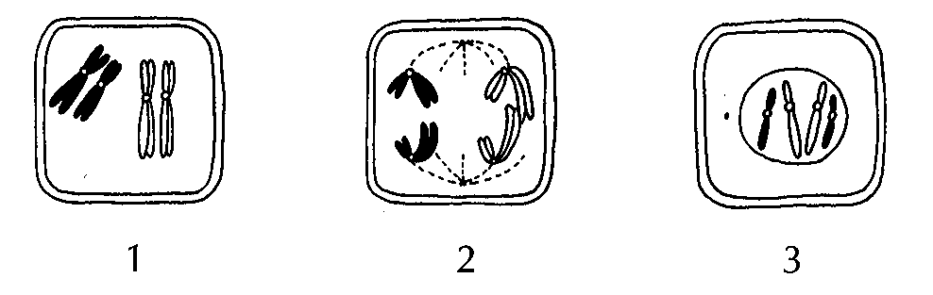
A. Ovary
B. Ovule
C. Stigma
D. Embryo sac
[Longman cell Q49]
14. This type of cell division may occur in the (1) anther. (2) testis. (3) palisade mesophyll. (4) cornea.
A. (1) only
B. (1) and (2) only
C. (2) and (3) only
D. (3) and (4) only
[Longman cell Q50]
15. Which of the following is the possible daughter cell resulting from this division?
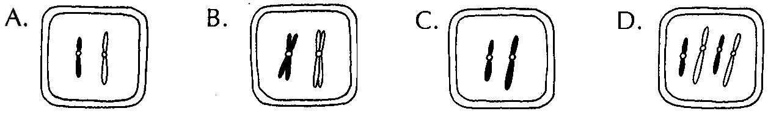
[Longman cell Q51]
16. Four of the stages in the first meiotic division are outlined as follows: (1) Random pairing of chromosomes at the equator (2) Replication of DNA molecules (3) Division of cytoplasm (4) Pulling apart of chromosomes by spindle fibres The correct sequence of the first meiotic division is
A. (1) → (2) → (4) → (3)
B. (2) → (3) → (1) → (4)
C. (2) → (1) → (4) → (3)
D. (2) → (4) → (1) → (3)
[Longman cell Q52]
17. Which of the following comparisons between mitosis and meiosis is correct? Mitosis | Meiosis |
A. | for asexual reproduction only | for sexual reproduction only |
B. | no random assortment of chromosomes | random assortment of chromosomes |
C. | daughter cells always possess 46 chromosomes | daughter cells always possess 23 chromosomes |
D. | daughter cells are always identical among themselves | daughter cells are always different among themselves
[Longman cell Q53]
18. In which part of a flowering plant and a human body does meiosis take place? Flowering plant | Human body |
A. | ovary | sperm duct |
B. | anther | ovary |
C. | stigma | testis |
D. | anther | oviduct
[Longman cell Q54]
The diagram below shows a parent cell with 3 pairs of chromosomes.
19. The diagram below shows a parent cell with 3 pairs of chromosomes.
Which of the following represents the daughter cell resulting from mitosis?
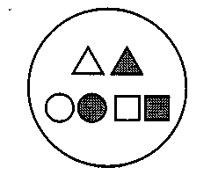
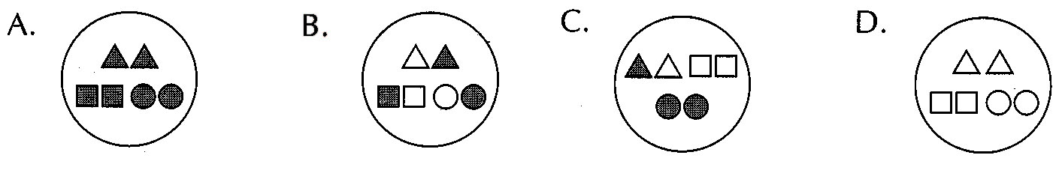
[Longman cell Q55]
Directions: The following items refer to the parent cell below, which has 2 pairs of chromosomes.
20. Which of the following represent the possible daughter cells at the end of meiotic division I?
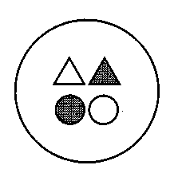
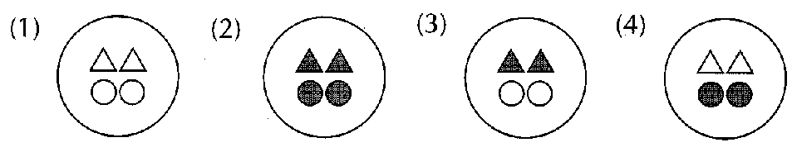
A. (1) and (2) only
B. (2) and (3) only
C. (3) and (4) only
D. (1), (2), (3) and (4)
[Longman cell Q56]
21. Which of the following represent the possible daughter cells at the end of meiotic division II?
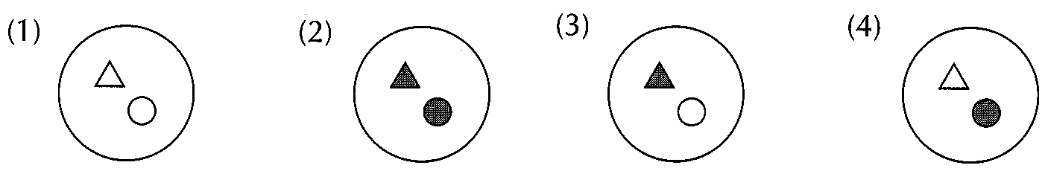
A. (1) and (2) only
B. (2) and (3) only
C. (3) and (4) only
D. (1), (2), (3) and (4)
[Longman cell Q57]
Part B — HKDSE-style (YKTo)
22. The following graph shows the relative DNA content of a cell in the cell cycle. Which matching of processes at X and Y is correct?
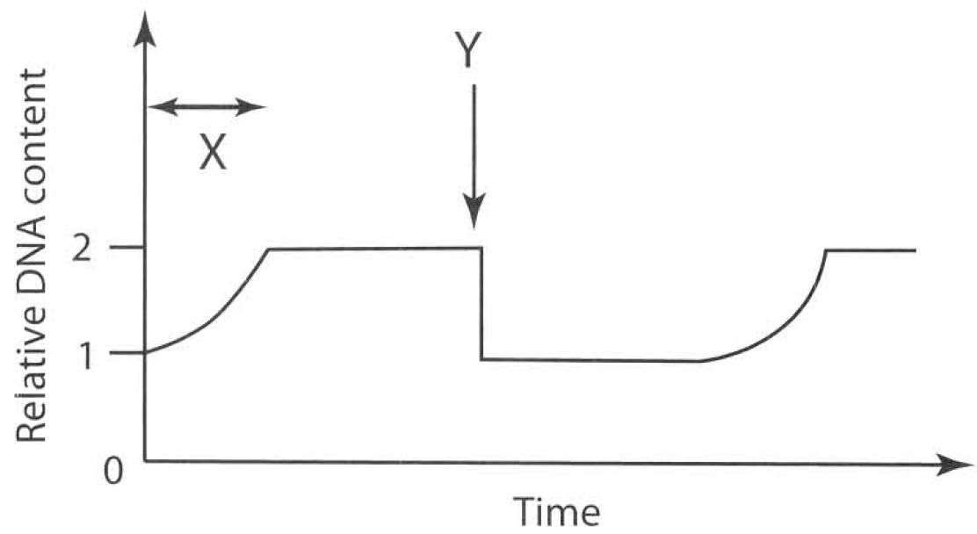
A. X: replication of DNA; Y: mitosis
B. X: replication of DNA; Y: meiosis
C. X: fertilization of male and female gametes; Y: mitosis
D. X: fertilization of male and female gametes; Y: meiosis
[YKTo Q1]
Directions: The following items refer to the graph below, which shows the relative DNA content of a cell in the cell cycle.
23. Which of the following cells has N units of DNA content in period W of a flowering plant?
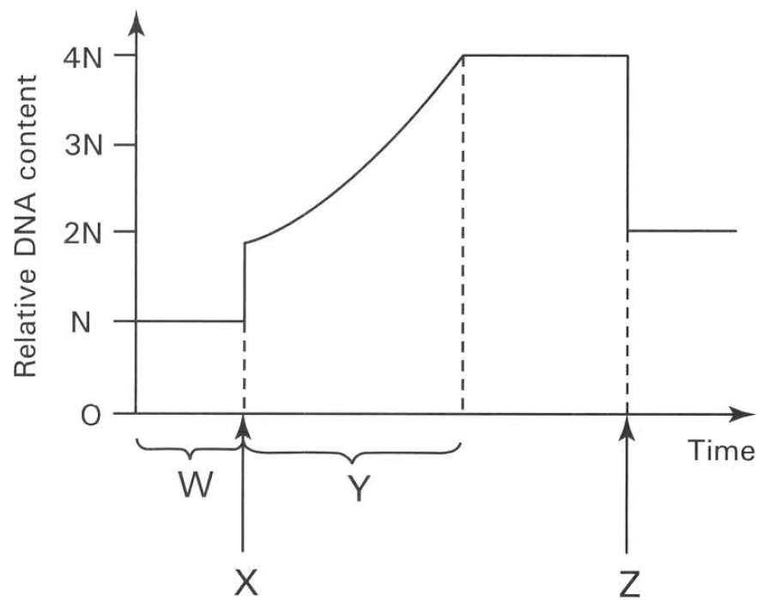
A. Integument of ovule
B. Ovary wall
C. Ovum
D. Wall of pollen sac
[YKTo Q2]
24. Which of the following processes take place at X and Z respectively?
A. X: pollination; Z: fertilization
B. X: fertilization; Z: pollination
C. X: karyokinesis; Z: dispersal
D. X: fertilization; Z: cytokinesis
[YKTo Q3]
25. Which of the following events takes place in period Y?
A. Assortment of chromosomes into gametes.
B. Crossing over between the original and replicated chromosomes.
C. Replication of chromosomes.
D. Pairing of chromosomes in prophase.
[YKTo Q4]
26. Which of the following statements about interphase is CORRECT? (1) The cell is metabolically inactive. (2) The chromosomes usually exist in a non-distinct form which is known as chromatin. (3) The chromosomes are not in an actively dividing stage. (4) Interphase is a characteristic stage in mitosis, not in meiosis.
A. (1) and (3) only
B. (1) and (4) only
C. (2) and (3) only
D. (3) and (4) only
[YKTo Q5]
27. The chromosome number of humans is 46. Under normal conditions which of the following statements is INCORRECT? (1) All the matured red blood cells contain 46 chromosomes. (2) All the egg cells produced contain 23 chromosomes. (3) All the sperms produced contain 23 chromosomes. (4) The white blood cell at the second stage (metaphase) of cell division with the chromosomes arranged at the equator has 46 chromatids.
A. (1) and (2) only
B. (2) and (3) only
C. (3) and (4) only
D. (4) and (1) only
[YKTo Q6]
28. The body cells of humans have 23 pairs of homologous chromosomes. Which of the following statements is CORRECT?
A. The number of DNA molecules in the interphase just before cell division is 46.
B. The number of chromatids in the cell at the first stage of cell division (prophase) is 46.
C. The number of chromosomes in the tubular cell of the sperm duct (vas deferens) is 23.
D. The number of chromosomes in the zygote in the oviduct is 46.
[YKTo Q7]
29. Which of the following is responsible for producing the same kind and same number of chromosomes in the daughter cells in mitosis?
A. Sister chromatids bound by the same centromere arranged individually at the equator and then separate and move into opposite poles.
B. Chromosomes exist as homologous chromosomes in the prophase.
C. Cytoplasm separates into two equal parts.
D. Nuclear membrane reforms around the two daughter nuclei.
[YKTo Q8]
30. Which of the following regions will mitosis occur actively in a man of thirty years old? (1) Inner lining of the alimentary canal (2) Cerebral cortex of the brain (3) Epidermis of the skin (4) Red bone marrow
A. (1) and (2) only
B. (2) and (3) only
C. (3) and (4) only
D. (1), (3) and (4) only
[YKTo Q9]
31. In which of the following processes does mitosis occur? (1) The division of meristematic cells in the root tip of flowering plants. (2) The production of white blood cells in the lymph nodes of mammals. (3) The production of eggs in the ovary of mammals. (4) The vegetative propagation of a ginger.
A. (1) and (2) only
B. (2) and (3) only
C. (2) and (4) only
D. (1), (2) and (4) only
[YKTo Q10]
32. Which of the following statements about mitosis is INCORRECT?
A. All somatic cells are produced by mitosis.
B. Mitosis is responsible for the growth of a zygote to an embryo.
C. A single cell will divide into four daughter cells by mitosis.
D. The daughter cells retain the same chromosome number that their mother cell has.
[YKTo Q11]
Directions: The following items refer to the diagrams below, which represent chromosomes in cells of the salivary gland of the fruit fly, Drosophila melanogaster. (1) (2) (3) (4)
33. Which diagram represents the product of cell division in the gut cells of the fruit fly?
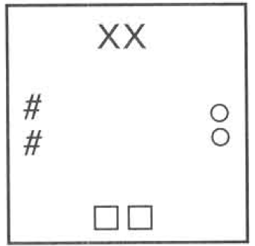
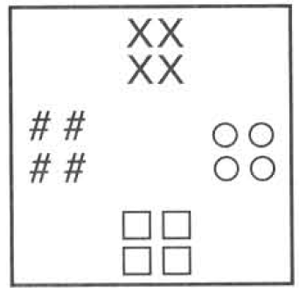
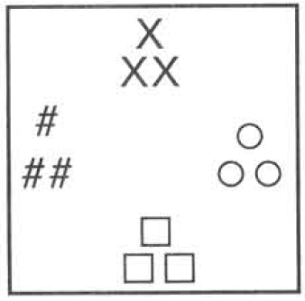
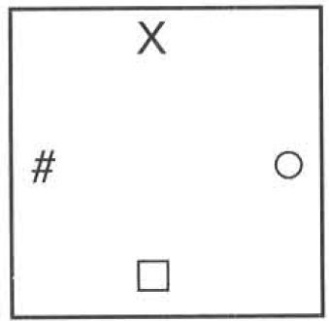
A. (1)
B. (2)
C. (3)
D. (4)
[YKTo Q12]
34. Which diagram represents the cell coming out of the testes of the fruit fly and passing down the sperm ducts?
A. (1)
B. (2)
C. (3)
D. (4)
[YKTo Q13]
35. Which diagram represents the zygote formed by the fusion of the gametes of the fruit fly?
A. (1)
B. (2)
C. (3)
D. (4)
[YKTo Q14]
Directions: The following items refer to the diagrams below, which show four different stages of a nuclear division.
36. Which of the following is the CORRECT sequence of the above process?
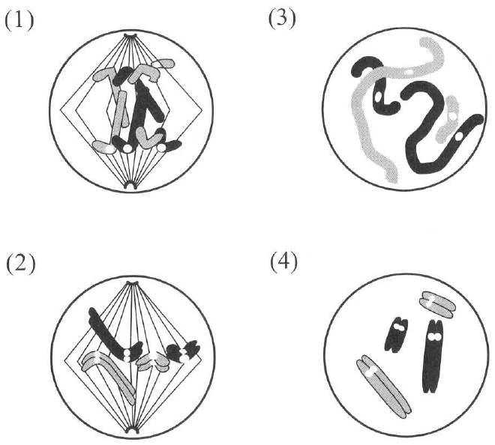
A. (1), (2), (3), (4)
B. (3), (2), (4), (1)
C. (4), (2), (1), (3)
D. (2), (1), (3), (4)
[YKTo Q15]
37. Where will the above type of cell division occur?
A. In the sperm-producing tubules
B. In the bone marrow
C. In the root cap
D. In the matured cells of the petal
[YKTo Q16]
Directions: The following items refer to the diagram below, which shows one stage of nuclear division.
38. How many chromosomes will be present in each daughter cell?
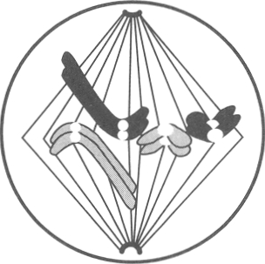
A. 2
B. 4
C. 6
D. 8
[YKTo Q17]
39. Which stage of nuclear division is illustrated above ?
A. Interphase (resting stage)
B. Prophase (first stage)
C. Metaphase (second stage)
D. Telophase (fourth stage)
[YKTo Q18]
40. Which of the following events may take place in the above-mentioned nuclear division? (1) Nuclear membrane reforms around the daughter nuclei. (2) Random assortment of chromosomes in the daughter cells. (3) Crossing over occurs between members of the homologous chromosomes.
A. (1) only
B. (2) only
C. (1) and (2) only
D. (2) and (3) only
[YKTo Q19]
41. Which matching of the events in cell division is CORRECT? (Interphase = resting stage; prophase = 1st; metaphase = 2nd; anaphase = 3rd; telophase = 4th)
A. Replication of chromosomes: interphase; nuclear membrane reforms: metaphase; chromosomes at equator: anaphase; chromatids separate: telophase
B. Replication of chromosomes: interphase; nuclear membrane reforms: telophase; chromosomes at equator: metaphase; chromatids separate: anaphase
C. Replication of chromosomes: telophase; nuclear membrane reforms: interphase; chromosomes at equator: anaphase; chromatids separate: metaphase
D. Replication of chromosomes: prophase; nuclear membrane reforms: interphase; chromosomes at equator: telophase; chromatids separate: anaphase
[YKTo Q20]
Directions: The following items refer to the photomicrograph, which shows several cells obtained from the root tip of onion.
42. Which activity is demonstrated by the cell labelled (X)?
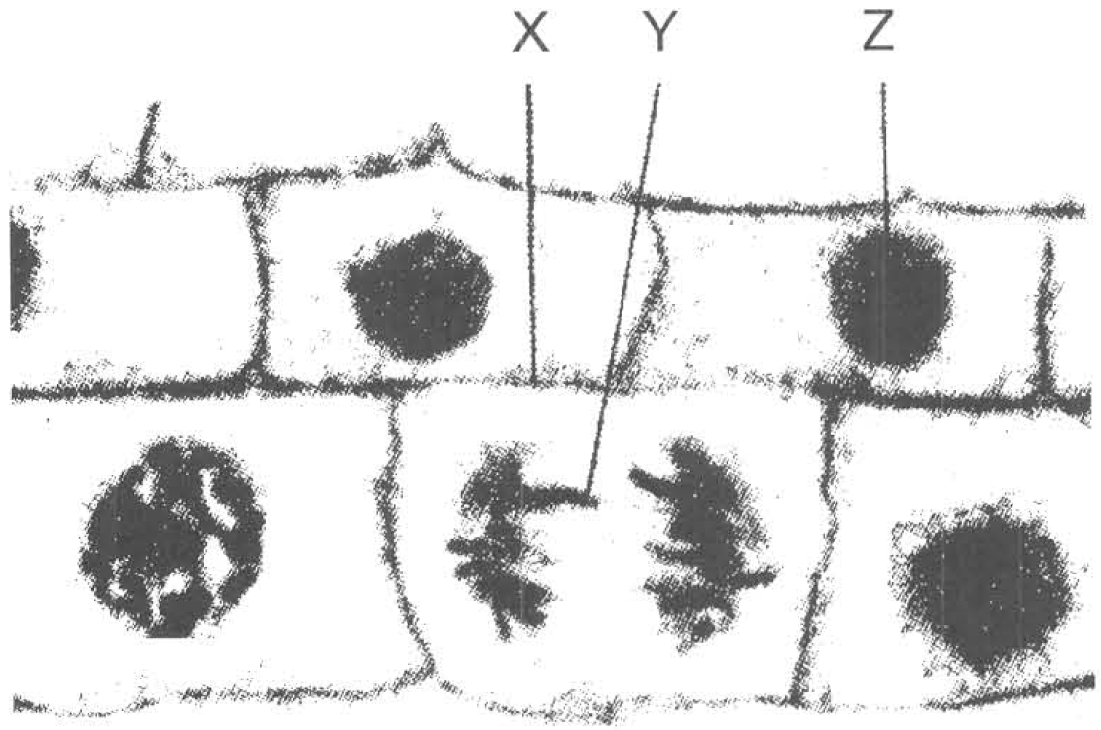
A. Cell enlargement
B. Cell differentiation
C. Mitosis
D. Meiosis
[YKTo Q21]
43. The structure labelled (Y) is
A. chromatin.
B. chromosome.
C. nucleus.
D. chloroplast.
[YKTo Q22]
44. Which of the following is used to build up the structure labelled (X)?
A. Cellulose
B. Glycogen
C. Starch
D. Nucleic acid
[YKTo Q23]
45. Which of the following related with the cell labelled (Z) is CORRECT?
A. Meiosis is processing inside the cell.
B. The cell is undergoing active cell division.
C. The darkly stained spot inside the cell consists of starch grains.
D. The cell is at interphase.
[YKTo Q24]
46. The following events show the different stages of mitosis. (1) Splitting of centromeres (2) Separation of sister chromatids as daughter chromosomes which move towards opposite poles (3) Shortening and thickening of chromosomes (4) Replication of chromosomes Which of the following is the CORRECT sequence of the different stages in mitosis?
A. (1), (2), (4), (3)
B. (4), (2), (3), (1)
C. (4), (3), (1), (2)
D. (1), (2), (3), (4)
[YKTo Q25]
47. A cell plate is formed in a cell in the root tip. Which of the following concerning the condition or activity of this cell is CORRECT?
A. Cytokinesis takes place after the occurrence of meiosis.
B. Cytokinesis takes place after the occurrence of mitosis.
C. In the interphase before the cell elongates.
D. Replication of chromosomes is taking place.
[YKTo Q26]
48. At which stage will the cell or the daughter nucleus possess the least amount of DNA?
A. Stage-S of the interphase
B. Prophase (first stage)
C. Metaphase (second stage)
D. Telophase (fourth stage)
[YKTo Q27]
49. The graph below shows the behaviour of the chromosomes during a mitotic cell division. Which matching of the following CORRECTLY represents the changes shown by curves 1 and 2, and the conditions of the chromosomes in time period X and Y respectively? Distance between the centromeres of the chromosomes and the poles of the cell Distance between centromeres of sister chromatids Sister chromatids are held together by the centromere Sister chromatids become daughter chromosomes
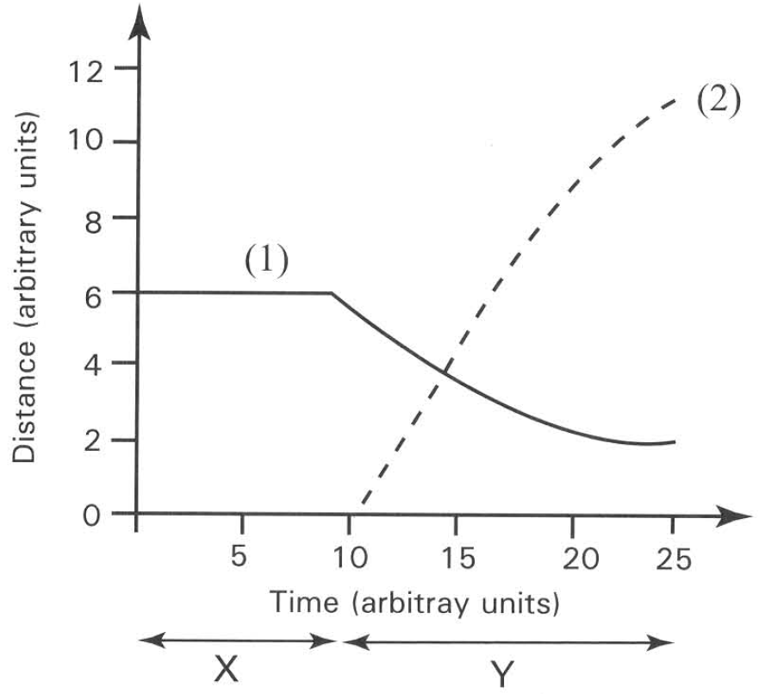
A. (1) (2) X Y
B. (2) (1) X Y
C. (1) (2) Y X
D. (2) (1) Y X
[YKTo Q28]
50. Which of the following events occurs in mitosis?
A. Separation of chromatids
B. Pairing of homologous chromosomes
C. Crossing-over between non-sister chromatids
D. Production of genetic variations
[YKTo Q29]
51. The following events are involved in mitotic cell division. Arrange them in the proper order. (1) Separation of the daughter chromosomes (2) Replication of chromosomes (3) Formation of nuclear membrane around daughter nuclei (4) Separation of the centromere (5) The sister chromatids arrange at the equator
A. (1) →(3) →(5) →(4) →(2)
B. (4) → (3) → (5) → (1) → (2)
C. (2) → (5) → (4) → (1) → (3)
D. (3) → (5) → (4) → (2) → (1)
[YKTo Q30]
52. Which of the following concerned with mitosis is CORRECT? (1) Repair of worn out tissues (2) Asexual reproduction (3) Production of genetic variations (4) Fusion of gametes
A. (1) and (2) only
B. (2) and (3) only
C. (3) and (4) only
D. (1), (2) and (3)
[YKTo Q31]
53. An onion bulb is supported as shown in the diagram below. After two days small white processes grow out of the bottom of the onion bulb. What are these white processes?
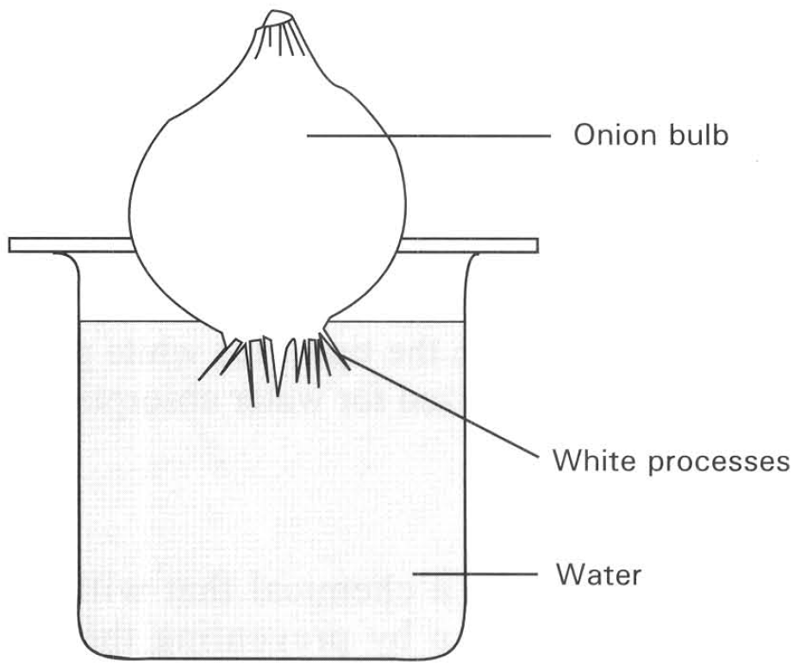
A. Lateral roots
B. Radicle
C. Root hairs
D. Adventitious roots
[YKTo Q32]
Directions: The following items refer to an experiment in which the tip of one white process is removed, stained with acetocarmine, and squashed on a slide as shown.
54. If the slide is examined under a microscope, what special feature can be seen inside the tip?
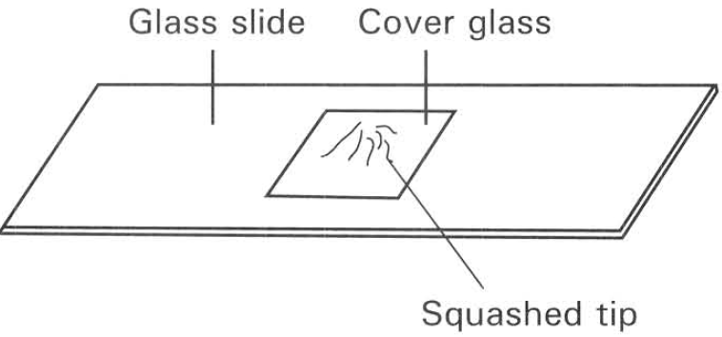
A. Formation of germ cells
B. Formation of chloroplasts
C. Separation of chromosomes
D. Formation of pollen grains
[YKTo Q33]
55. Which of the following is the proper conclusion of the above experiment?
A. Meiosis occurs in the tip of the white process.
B. The cells in the tip of the process are haploid in nature.
C. The cells in the tip of the white process are undergoing cell division.
D. The cells in the tip of the white process are specialized for water absorption.
[YKTo Q34]
56. Colchicine is a chemical that will bring about mutation by preventing the sister chromatids separate from each other. At which stage of nuclear division will colchicine produce the mutagenic effect?
A. Prophase (first stage)
B. Metaphase (second stage)
C. Anaphase (third stage)
D. Telophase (fourth stage)
[YKTo Q35]
57. Which of the following are haploid cells? (1) Muscle cells (2) Ova (3) Nerve cells (4) Sperms
A. (1) and (2) only
B. (2) and (4) only
C. (1) and (3) only
D. (3) and (4) only
[YKTo Q36]
Directions: The following items refer to the diagram below, which shows one stage of a cell division.
58. The above type of cell is taking place in the
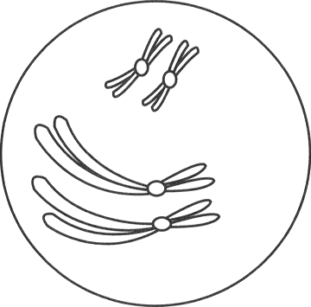
A. style.
B. filament.
C. ovary wall.
D. anther lobe.
[YKTo Q37]
59. In case of mammal the above type of cell division is taking place in
A. ovary.
B. oviduct.
C. uterus.
D. bone marrow.
[YKTo Q38]
60. The number of daughter cells formed at the end of the above division is
A. 1.
B. 2.
C. 4.
D. 6.
[YKTo Q39]
61. Which of the following is the daughter cell formed at the end of the above division?
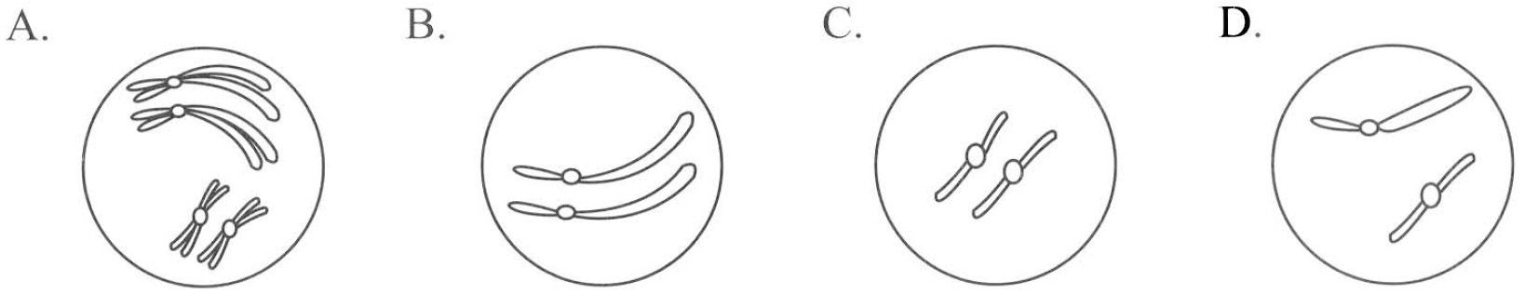
[YKTo Q40]
Directions: The following items refer to the diagrams below, which show important stages of a nuclear division.
62. Which of the following is the CORRECT order of the nuclear division illustrated above?
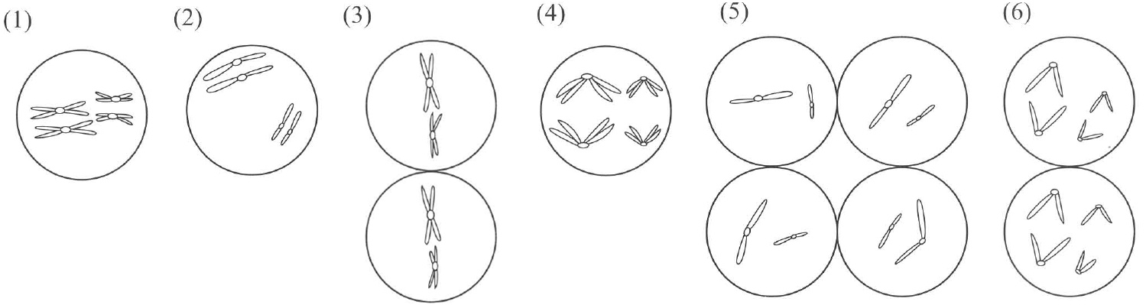
A. (1),(2),(3),(4), (6),(5)
B. (2),(1),(4),(3),(6),(5)
C. (1),(6),(5),(4), (3),(2)
D. (3),(1),(6),(5),(4),(2)
[YKTo Q41]
63. The type of nuclear division illustrated above is
A. mitosis taking place in skin.
B. meiosis taking place in testis.
C. mitosis taking place in root tip.
D. mitosis taking place in flower bud.
[YKTo Q42]
64. Which of the following is the importance of meiosis?
A. Increases the number of chromosomes in the daughter cells.
B. Produces haploid gametes to restore the diploid condition in fertilization.
C. Produces more somatic cells.
D. Essential to complete the process of asexual reproduction.
[YKTo Q43]
65. In which of the following processes does meiosis occur? (1) The production of red blood cells in the bone marrow. (2) The production of pollen grains in the anther lobes. (3) The production of new cells in the liver of mammals. (4) The production of egg cells in the ovule of flowering plants. (5) The division of meristematic cells in the stem apex of flowering plants.
A. (1) and (3) only
B. (2) and (4) only
C. (1), (2) and (4) only
D. (2), (3) and (5) only
[YKTo Q44]
Directions: The following items refer to the diagrams below.
66. Which of the following comparisons of diagrams X and Y is INCORRECT?
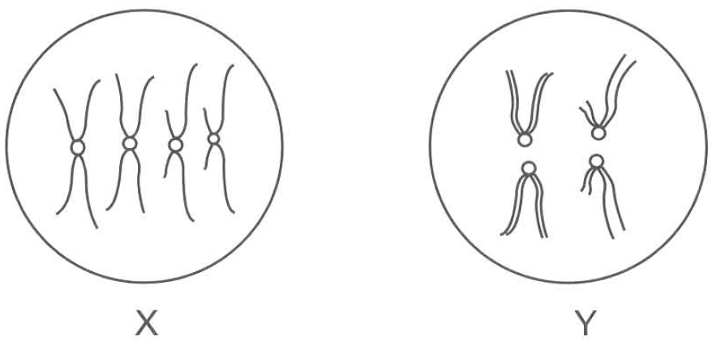
A. X: chromosomes replicate once; Y: chromosomes replicate two times
B. X: cytoplasm divides once; Y: cytoplasm divides twice
C. X: chromosome number of daughter cells stays the same; Y: chromosome number is halved
D. X: genetic makeup of daughter cells same as parent; Y: genetic makeup of daughter cells may differ from parent
[YKTo Q45]
67. The haploid number of chromosomes for the cell illustrated in diagram X is
A. 2.
B. 4.
C. 8.
D. 16.
[YKTo Q46]
68. Which of the following statements about the process of cell division illustrated in diagram Y are INCORRECT? (1) It increases the variability of the offspring. (2) It produces a hybrid vigor. (3) It gives rise to offspring which are genetically identical with the parent cells. (4) It produces two daughter cells. (5) Each of the daughter cells has exactly the same chromosome number the parent cell has.
A. (1) and (4) only
B. (2) and (5) only
C. (1), (3) and (4) only
D. (3), (4) and (5) only 1 2 3 4 5 6 7 8 9 10 A C D C C D D A D D 11 12 13 14 15 16 17 18 19 20 C C D C C B B C A B 21 22 23 24 25 26 27 28 29 30 C B A D C B D A A C 31 32 33 34 35 36 37 38 39 40 A D C C C B D A C D 41 42 43 44 45 46 47 B B B B A A D
[YKTo Q47]
69. Which comparison between mitosis and meiosis is INCORRECT?
A. Mitosis: chromosome replication occurs once; Meiosis: chromosome replication occurs twice
B. Mitosis: daughter cells have the same chromosome number as the parent; Meiosis: daughter cells have half the chromosome number
C. Mitosis: homologous chromosomes do not pair; Meiosis: homologous chromosomes pair
D. Mitosis: no exchange of genetic segments between homologues; Meiosis: genetic segments may be exchanged
[YKTo Q48]
Part C — HKDSE Paper 1A and topic mocks
70. The graph below shows the change in the amount of DNA in a cell which is undergoing cell division. Which statement correctly describes the event in the respective time period?
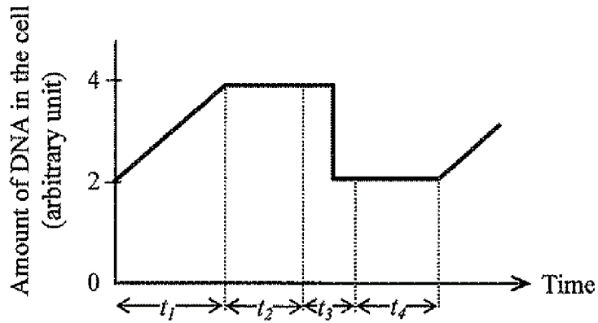
A. During t1, the nuclear membrane disappears.
B. During t2, the homologous chromosomes pair up.
C. During t3, the homologous chromosomes separate.
D. During t4, the synthesis of cell organelles takes place.
[HKDSE 2013]
71. The diagram below shows a dividing cell which is forming an animal's egg cell. What conclusion about the cell division can be drawn from the diagram?
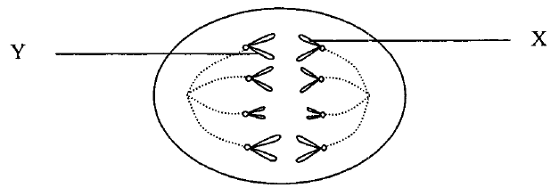
A. The diagram shows a mitotic cell division.
B. The diagram shows the first meiotic cell division.
C. X and Y are homologous chromosomes.
D. Each daughter cell will have four chromosomes.
[HKDSE 2016]
Directions: The following items refer to the graph below, which shows the change in the DNA content of a cell undergoing a certain division. (1) There are two divisions. (2) There is one DNA duplication. (3) DNA content is halved at the end of the whole process.
72. Which of the following can be deduced from the graph?
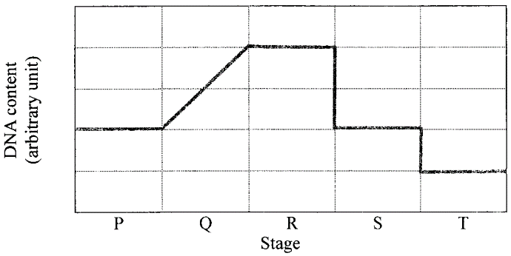
A. (1) and (2) only
B. (1) and (3) only
C. (2) and (3) only
D. (1), (2) and (3)
[HKDSE 2017]
73. Which of the following stages best represent(s) interphase?
A. P only
B. Q only
C. P and Q only
D. P, Q and R only
[HKDSE 2017]
74. Sister chromatids separate from one another during the transition from
A. P to Q.
B. Q to R.
C. R to S.
D. S to T.
[HKDSE 2017]
75. The photomicrographs (same magnification) show some early stages of embryo development. How many cell cycles has the cell in stage I gone through to reach stage III?
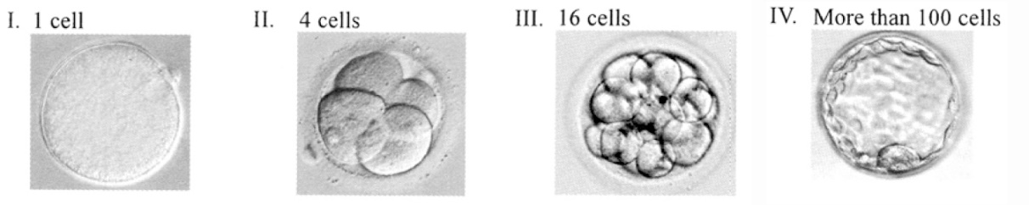
A. 2 cycles
B. 3 cycles
C. 4 cycles
D. 5 cycles
[HKDSE 2020]
76. The amount of DNA in cell P immediately before mitosis is x. After division, there are 4 chromosomes in each daughter cell. Which description is correct?
A. The amount of DNA in the daughter cell is 0.5 x.
B. The amount of DNA in each chromosome is 0.25 x.
C. There are 8 chromosomes in the diploid state of cell P.
D. There are 8 chromosomes in cell P immediately before division.
[HKDSE 2020]
Directions: The following items refer to the diagram below, which shows the appearance of chromosomes in a cell at an early stage of meiotic cell division.
77. What is the chromosome number in the somatic cells of this organism?
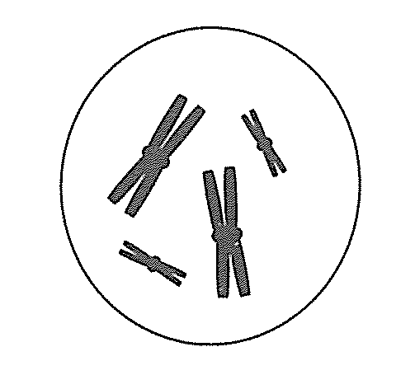
A. 2
B. 4
C. 8
D. 16
[HKDSE 2022]
78. Which diagram correctly shows the arrangement of chromosomes at a later stage of this cell division? Choose A, B, C or D as labelled on the drawing.
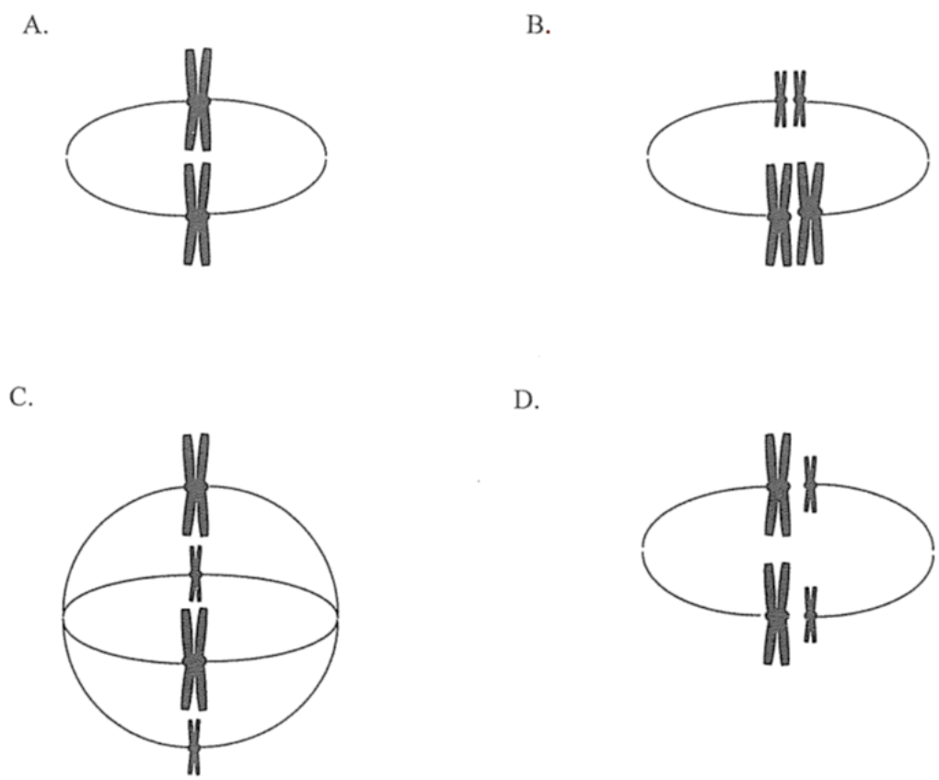
[HKDSE 2022]
Directions: The first diagram shows three stages of a cell cycle. Use it with the four DNA-content graphs.
79. Which graph correctly matches the changes in DNA content in the cell with stages I, II and III? Choose A, B, C or D as labelled on the drawing.
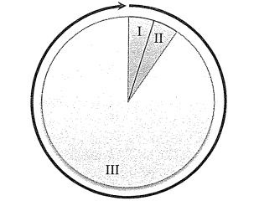
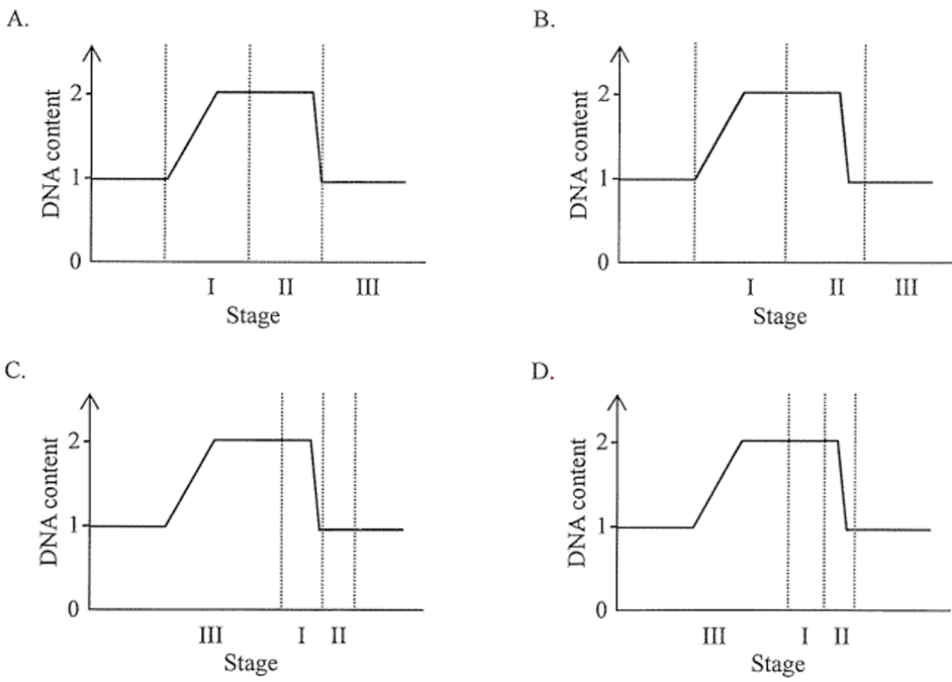
[HKDSE 2023]
Directions: This question and the next refer to the diagram below, which shows the appearance of chromosomes in a cell at an early stage of meiotic cell division.
80. If the amount of DNA in this cell is p, what is the amount of DNA in a non-dividing somatic cell of this organism?
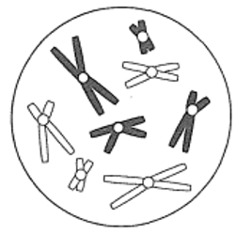
A. ¼ p
B. ½ p
C. p
D. 2 p
[HKDSE 2024]
81. Which of the following diagrams show the possible combinations of the chromosomes in the daughter cells?
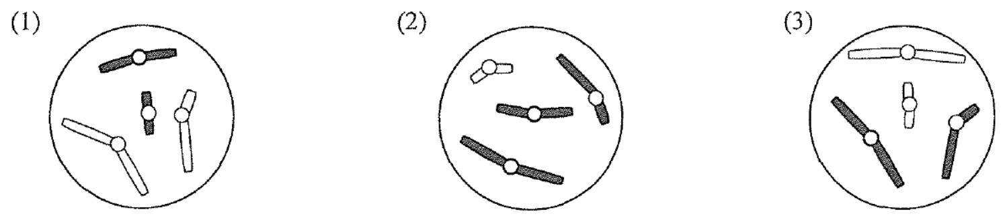
A. (1) and (2) only
B. (1) and (3) only
C. (2) and (3) only
D. (1), (2) and (3)
[HKDSE 2024]
Directions: This question and the next refer to the graph below (amount of DNA in a root-tip cell) and the photomicrographs of stages X, Y and Z.
82. The photomicrographs below show a cell undergoing cell division in three stages, X, Y and Z. Which matching of the stages with the time periods on the graph is correct?
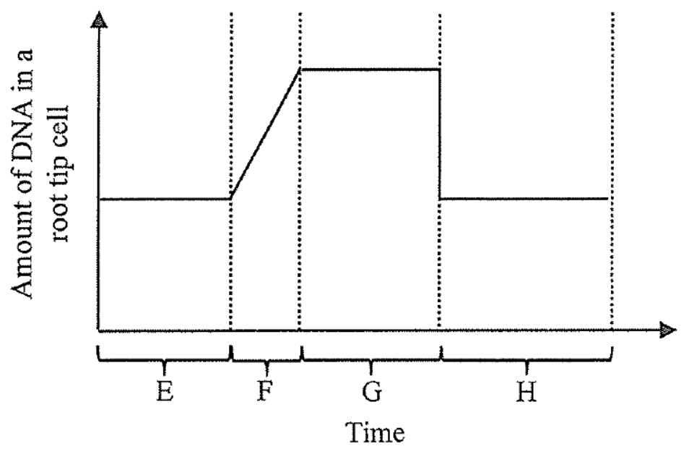
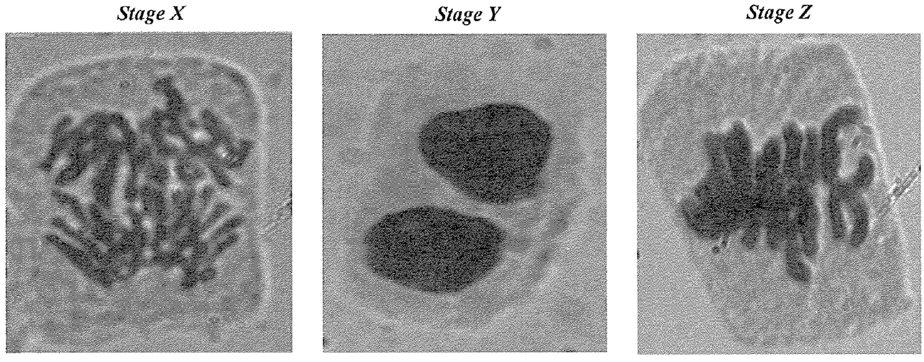
A. X: E; Y: H; Z: F
B. X: F; Y: G; Z: G
C. X: G; Y: G; Z: G
D. X: G; Y: H; Z: G
[HKDSE 2025]
83. Which of the following are functions of this type of cell division in plants?
(1) formation of an embryo from a zygote
(2) multiplication of thin-walled cells
(3) replacement of cells in the root cap
A. (1) and (2) only
B. (1) and (3) only
C. (2) and (3) only
D. (1), (2) and (3)
[HKDSE 2025]
84. A horse (chromosome number = 64) can cross with a donkey (chromosome number = 62) to produce a sterile mule (chromosome number = 63). Which are correct explanations for the sterility of the mule?
(1) A mule's chromosomes cannot all pair up during meiosis.
(2) Mules cannot carry out nuclear division.
(3) Mules have an odd number of chromosomes.
A. (1) and (2) only
B. (1) and (3) only
C. (2) and (3) only
D. (1), (2) and (3)
[HKDSE 2026 Q21]
85. Drug X is designed to kill cancer cells by inhibiting nucleotide synthesis. Which processes of the cancer cells would be inhibited?
(1) DNA replication
(2) transcription
(3) translation
A. (1) and (2) only
B. (1) and (3) only
C. (2) and (3) only
D. (1), (2) and (3)
[HKDSE 2026 Q22]
Directions: The following items refer to an investigation of fin length in fish from two equal-sized populations of the same species over 40 generations.
86. In each generation, fins of different lengths are always observed among the fish in aquarium X. Which of the following contribute to this phenomenon?
(1) crossing over
(2) independent assortment
(3) random fertilisation
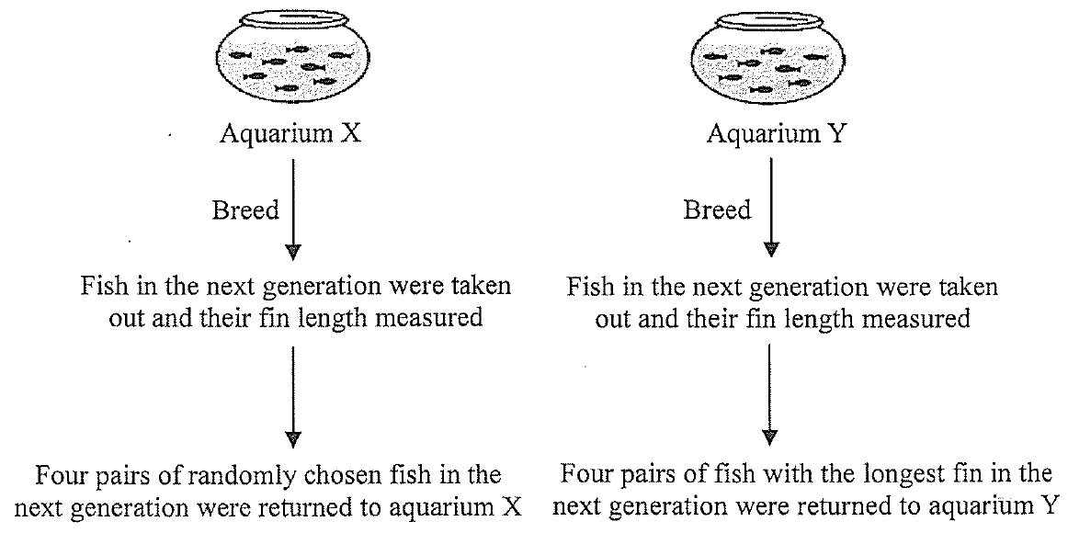
A. (1) and (2) only
B. (1) and (3) only
C. (2) and (3) only
D. (1), (2) and (3)
[HKDSE 2026 Q35]
87. The fish in aquarium Y show a significant increase in fin length over 40 generations. It is most reasonable to conclude that this change is due to
A. artificial selection.
B. mutation.
C. natural selection.
D. speciation.
[HKDSE 2026 Q36]
88. The table below shows the chromosome number of three types of human cells. P = 0, Q = 23, R = 46. Which identification is correct?
A. P nerve cell; Q red blood cell; R sperm
B. P nerve cell; Q sperm; R red blood cell
C. P red blood cell; Q nerve cell; R sperm
D. P red blood cell; Q sperm; R nerve cell
[Aristo mock]
89. The graph below shows the changes in the relative amount of DNA in an egg cell. What processes were taking place at time X and time Y respectively?
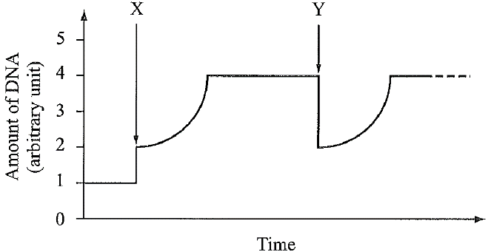
A. X: DNA replication; Y: mitosis
B. X: DNA replication; Y: meiosis
C. X: fertilization; Y: mitosis
D. X: fertilization; Y: meiosis
[Aristo mock]
Directions: The following items refer to the photomicrograph below, which shows onion root-tip cells in different stages of cell division.
90. Which of the following shows the correct sequence of stages in cell division?
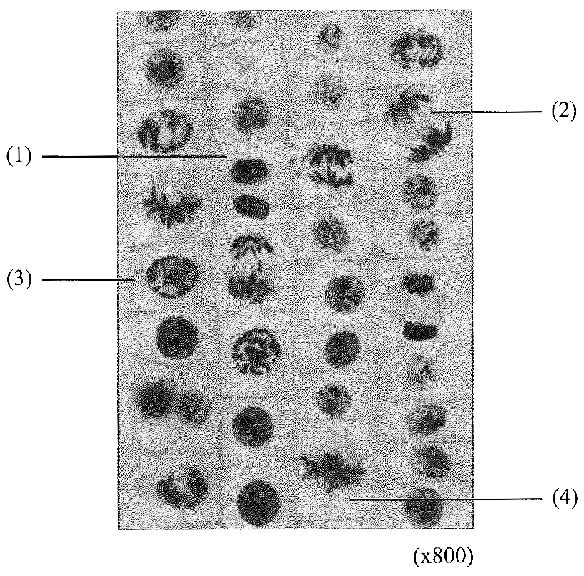
A. (3) (4) (2) (1)
B. (3) (4) (1) (2)
C. (1) (3) (2) (4)
D. (4) (2) (3) (1)
[Aristo mock]
91. Which of the following about the labelled cells is correct?
A. Cell (1) is haploid.
B. Sister chromatids are separating in cell (2).
C. The amount of DNA in cell (2) is two times that in cell (3).
D. Crossing over may have taken place in cell (4).
[Aristo mock]
Directions: The following items refer to the graph below, which shows the changes in the amount of DNA in a cell during a series of cell divisions.
92. Which of the following times contains a cell with a haploid nucleus?
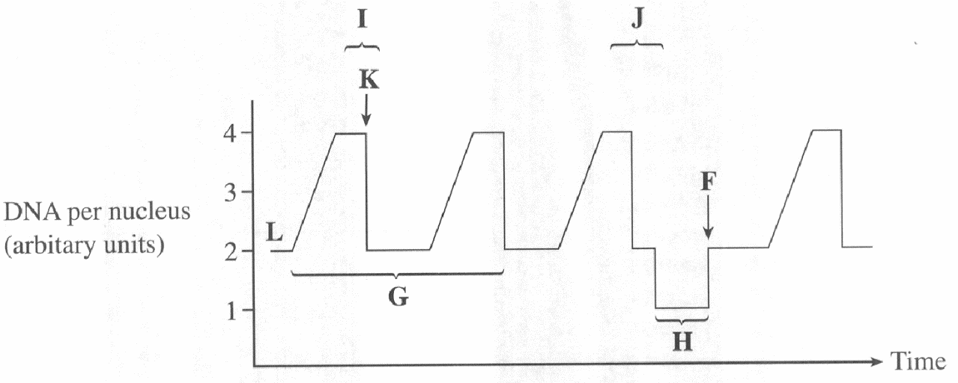
A. time G
B. time H
C. time I
D. time J
[HKEPC]
93. Which statement(s) correctly describe the event in the respective stage?
(1) At stage F, mitotic cell division takes place.
(2) At stage K, members of each homologous pair separate.
(3) At stage L, the amount of DNA is doubled.
A. (3) only
B. (1) and (2) only
C. (2) and (3) only
D. (1), (2) and (3)
[HKEPC]
94. The photomicrograph below shows a cell undergoing cell division in the root of a plant. Which names the type of cell division and describes the movement of structure A?
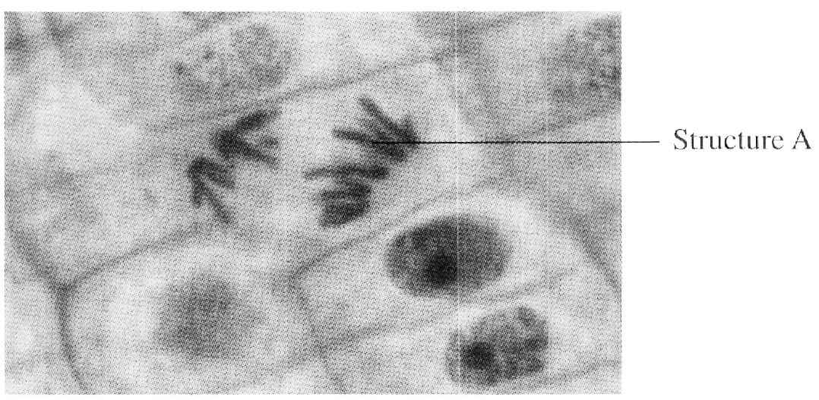
A. meiotic cell division; chromatids separate
B. meiotic cell division; members of a homologous pair separate
C. mitotic cell division; chromatids separate
D. mitotic cell division; members of a homologous pair separate
[HKEPC]
95. The graph below shows the changes in distance between two pairs of centromeres during one mitotic cycle in a plant cell. Which matching of curve and location of the two centromeres is correct?
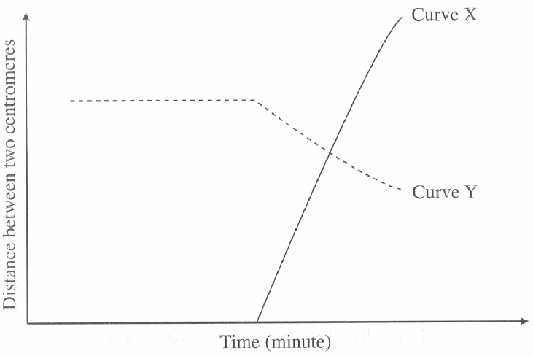
A. Curve X; centromeres on two members of a homologous pair during pairing
B. Curve X; centromeres on two sister chromatids
C. Curve Y; centromeres on two sister chromatids
D. Curve Y; centromeres on two members of a homologous pair during pairing
[HKEPC]
96. The graph below shows the changes in the amount of DNA in a cell during cell division. Which statement correctly describes the event in the respective time period?
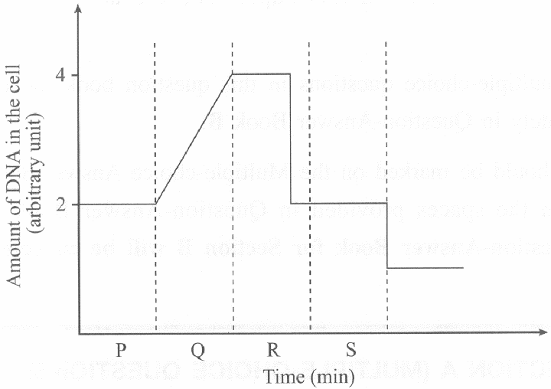
A. In period P, pairs of homologous chromosomes separate.
B. In period Q, DNA replication is carried out.
C. In period R, mitochondria are formed.
D. In period S, the parent cell is becoming diploid.
[Aristo mock]

Answers
YKTo keys are from the original student paper. Longman keys marked “—” still need a check against the source paper. HKDSE 2026: Q21 = B (73%), Q22 = D (44%), Q35 = D (67%). Do not print this page for students.
Part A
1. B (Longman cell Q37) 2. C (Longman cell Q38) 3. B (Longman cell Q39) 4. D (Longman cell Q40) 5. A (Longman cell Q41)
6. — (Longman cell Q42) 7. — (Longman cell Q43) 8. — (Longman cell Q44) 9. — (Longman cell Q45) 10. — (Longman cell Q46)
11. — (Longman cell Q47) 12. A (Longman cell Q48) 13. D (Longman cell Q49) 14. — (Longman cell Q50) 15. A (Longman cell Q51)
16. D (Longman cell Q52) 17. — (Longman cell Q53) 18. — (Longman cell Q54) 19. B (Longman cell Q55) 20. B (Longman cell Q56)
21. B (Longman cell Q57)
Part B
22. A (YKTo Q1) 23. C (YKTo Q2) 24. D (YKTo Q3) 25. C (YKTo Q4) 26. C (YKTo Q5)
27. D (YKTo Q6) 28. D (YKTo Q7) 29. A (YKTo Q8) 30. D (YKTo Q9) 31. D (YKTo Q10)
32. C (YKTo Q11) 33. C (YKTo Q12) 34. D (YKTo Q13) 35. C (YKTo Q14) 36. C (YKTo Q15)
37. B (YKTo Q16) 38. B (YKTo Q17) 39. C (YKTo Q18) 40. A (YKTo Q19) 41. B (YKTo Q20)
42. C (YKTo Q21) 43. B (YKTo Q22) 44. A (YKTo Q23) 45. D (YKTo Q24) 46. C (YKTo Q25)
47. B (YKTo Q26) 48. D (YKTo Q27) 49. A (YKTo Q28) 50. A (YKTo Q29) 51. C (YKTo Q30)
52. A (YKTo Q31) 53. D (YKTo Q32) 54. C (YKTo Q33) 55. C (YKTo Q34) 56. C (YKTo Q35)
57. B (YKTo Q36) 58. D (YKTo Q37) 59. A (YKTo Q38) 60. C (YKTo Q39) 61. D (YKTo Q40)
62. B (YKTo Q41) 63. B (YKTo Q42) 64. B (YKTo Q43) 65. B (YKTo Q44) 66. A (YKTo Q45)
67. A (YKTo Q46) 68. D (YKTo Q47) 69. A (YKTo Q48)
Part C
70. — (HKDSE 2013) 71. — (HKDSE 2016) 72. — (HKDSE 2017) 73. — (HKDSE 2017) 74. — (HKDSE 2017)
75. — (HKDSE 2020) 76. — (HKDSE 2020) 77. — (HKDSE 2022) 78. — (HKDSE 2022) 79. — (HKDSE 2023)
80. — (HKDSE 2024) 81. — (HKDSE 2024) 82. — (HKDSE 2025) 83. — (HKDSE 2025) 84. B (HKDSE 2026 Q21; 73% correct)
85. D (HKDSE 2026 Q22; 44% correct) 86. D (HKDSE 2026 Q35; 67% correct) 87. — (HKDSE 2026 Q36) 88. — (Aristo mock) 89. — (Aristo mock)
90. — (Aristo mock) 91. — (Aristo mock) 92. — (HKEPC) 93. — (HKEPC) 94. — (HKEPC)
95. — (HKEPC) 96. — (Aristo mock)

