Cell cycle and division · items under 80% correct
Multiple-choice practice
Name: ________________________ Class: ____________
These items were answered correctly by fewer than 80% of students in class Google Forms, matched by the wording in the source bank and the form answer key. Choose the one best answer.
Part B — HKDSE-style (YKTo)
1. Directions: Questions 2 to 4 refer to the graph below, which shows the relative DNA content of a cell in the cell cycle. Which of the following cells has N units of DNA content in period W of a flowering plant?
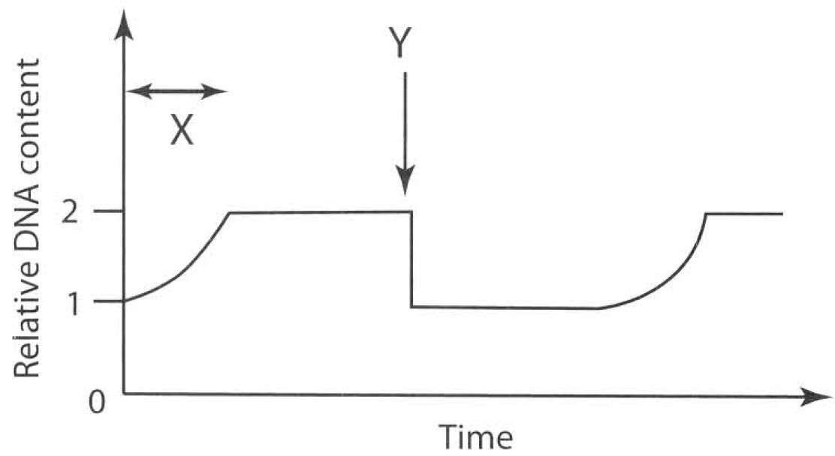
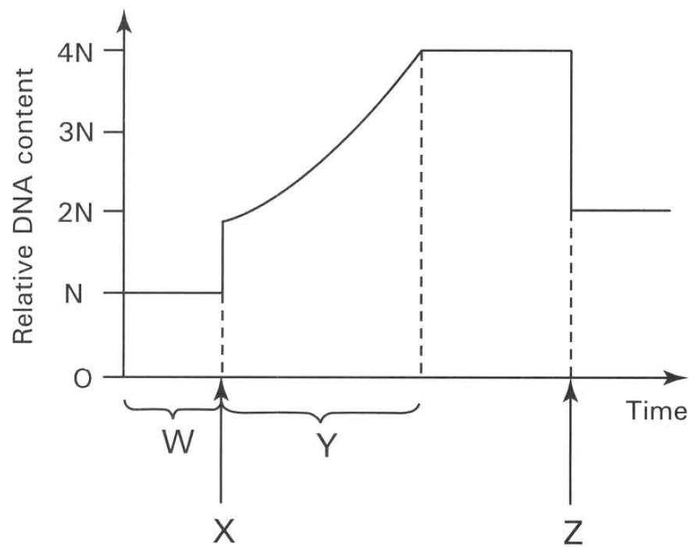
 | X | Y
A. | Replication of DNA | Mitosis
B. | Replication of DNA | Meiosis
C. | fertilisation of male | Mitosis and female gametes
D. | fertilisation of male | Meiosis and female gametes

A. Integument of ovule
B. Ovary wall
C. Ovum
D. Wall of pollen sac
2. Which of the following processes take place at X and Z respectively?
 | X | Y
A. | Pollination | fertilisation
B. | fertilisation | Pollination
C. | Karyokinesis | Dispersal
D. | fertilisation | Cytokinesis

3. Which of the following events takes place in period Y?
A. Assortment of chromosomes into gametes.
B. Crossing over between the original and replicated chromosomes.
C. Replication of chromosomes. D. Pairing of chromosomes in prophase.
4. The chromosome number of humans is 46. Under normal conditions which of the following statements is INCORRECT? (1) All the matured red blood cells contain 46 chromosomes. (2) All the egg cells produced contain 23 chromosomes. (3) All the sperms produced contain 23 chromosomes. (4) The white blood cell at the second stage (metaphase) of cell division with the chromosomes arranged at the equator has 46 chromatids.
A. (1) and (2) only
B. (2) and (3) only
C. (3) and (4) only
D. (4) and (1) only
5. Which of the following regions will mitosis occur actively in a man of thirty years old? (1) Inner lining of the alimentary canal (2) Cerebral cortex of the brain (3) Epidermis of the skin (4) Red bone marrow
A. (1) and (2) only
B. (2) and (3) only
C. (3) and (4) only
D. (1), (3) and (4) only
6. In which of the following processes does mitosis occur? (1) The division of meristematic cells in the root tip of flowering plants. (2) The production of white blood cells in the lymph nodes of mammals. (3) The production of eggs in the ovary of mammals. (4) The vegetative propagation of a ginger.
A. (1) and (2) only
B. (2) and (3) only
C. (2) and (4) only
D. (1), (2) and (4) only
7. Which of the following statements about mitosis is INCORRECT?
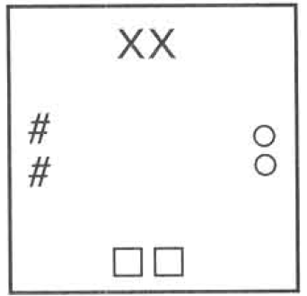
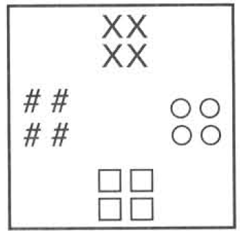
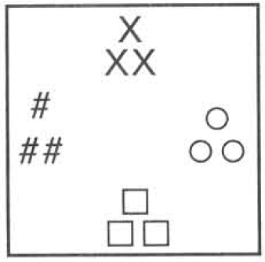
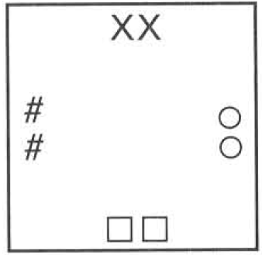
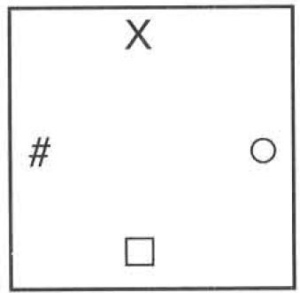
(1) | (2) | (3) | (4)

A. All somatic cells are produced by mitosis.
B. Mitosis is responsible for the growth of a zygote to an embryo.
C. A single cell will divide into four daughter cells by mitosis.
D. The daughter cells retain the same chromosome number that their mother cell has. Directions: Questions 12 to 14 refer to the diagram below, which is a representation of the chromosomes present in the cells of the salivary gland of the fruit fly, Drosophila melanogaster. With reference to the above diagram, answer the following three questions:
8. Which diagram represents the product of cell division in the gut cells of the fruit fly?
A. (1)
B. (2)
C. (3)
D. (4)
9. Which diagram represents the cell coming out of the testes of the fruit fly and passing down the sperm ducts?
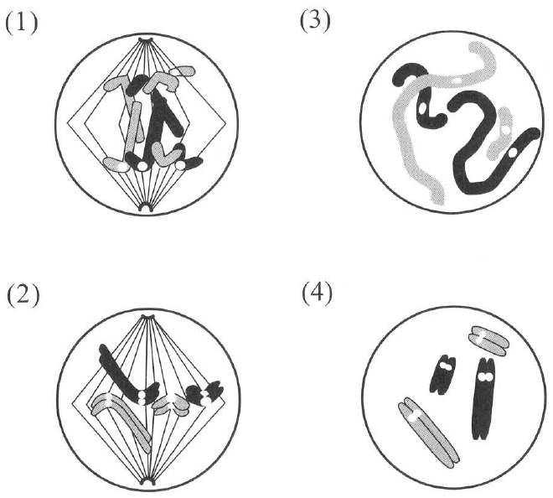
A. (1)
B. (2)
C. (3)
D. (4)
10. Which diagram represents the zygote formed by the fusion of the gametes of the fruit fly?
A. (1) B. (2) C. (3) D. (4) Directions: Questions 15 and 16 refer to the diagrams below, which show four different stages of a nuclear division.
11. Which of the following is the CORRECT sequence of the above process?
A. (1), (2), (3), (4)
B. (3), (2), (4),(1)
C. (4),(2),(1),(3)
D. (2),(1),(3),(4)
12. Where will the above type of cell division occur?
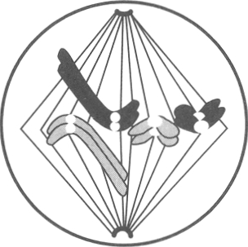
A. In the sperm-producing tubules B. In the bone marrow
C. In the root cap D. In the matured cells of the petal Directions: Questions 17 to 19 refer to the diagram below, which shows one stage of nuclear division.
13. How many chromosomes will be present in each daughter cell? A.2 B.4
A. 2
B. 4
C. 6
D. 8
14. Which stage of nuclear division is illustrated above ?
A. Interphase (resting stage)B . Prophase (first stage)
C. Metaphase (second stage)D . Telophase (fourth stage)
15. Which of the following matching of the different events in a cell division is CORRECT? Hint: Interphase (Resting stage); Prophase (1st stage); Metaphase (2nd stage); Anaphase (3rd stage); Telophase (4th stage)
Directions: Questions 21 to 24 refer to the photomicrograph, which shows several cells obtained from the root tip of onion.
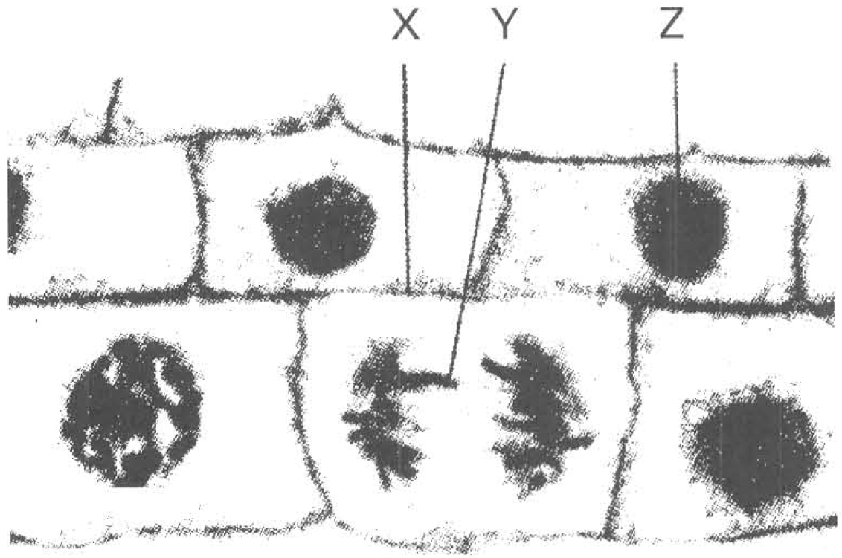
 | Replication of chromosomes | Nuclear membrane forms around the daughter nuclei | Arrangement of the chromosomes at the equator of the cell | Separation of chromatids as daughter chromosomes towards opposite poles
A. | Interphase | Metaphase | Anaphase | Telophase
B. | Interphase | Telophase | Metaphase | Anaphase
C. | Telophase | Interphase | Anaphase | Metaphase
D. | Prophase | Interphase | Telophase | Anaphase

16. Which activity is demonstrated by the cell labelled (X)?
A. Cell enlargement B. Cell differentiation
C. Mitosis D. Meiosis
17. The structure labelled (Y) is
A. chromatin.
B. chromosome.
C. nucleus.
D. chloroplast.
18. Which of the following is used to build up the structure labelled (X)?
A. Cellulose B. Glycogen C. Starch D. Nucleic acid
19. A cell plate is formed in a cell in the root tip. Which of the following concerning the condition or activity of this cell is CORRECT?
A. Cytokinesis takes place after the occurrence of meiosis.
B. Cytokinesis takes place after the occurrence of mitosis.
C. In the interphase before the cell elongates. D. Replication of chromosomes is taking place.

Answers
Answers are printed in red.
1. C. Ovum
Class: 63.3% correct (n=128) usual slip A
2. D
Class: 64.8% correct (n=128) usual slip B
3. C. Replication of chromosomes. D. Pairing of chromosomes in prophase.
Class: 62.5% correct (n=128) usual slip B
4. D. (4) and (1) only
Class: 79.7% correct (n=128) usual slip B
5. D. (1), (3) and (4) only
Class: 71.1% correct (n=128) usual slip C
6. D. (1), (2) and (4) only
Class: 55.5% correct (n=128) usual slip B
7. C. A single cell will divide into four daughter cells by mitosis.
Class: 72.7% correct (n=128) usual slip D
8. C. (3)
Class: 67.2% correct (n=128) usual slip C
9. D. (4)
Class: 53.9% correct (n=128) usual slip B
10. C
Class: 49.2% correct (n=128) usual slip B
11. C. (4),(2),(1),(3)
Class: 73.4% correct (n=128) usual slip D
12. B
Class: 68.8% correct (n=128) usual slip D
13. B. 4
Class: 39.5% correct (n=43) usual slip D
14. C. Metaphase (second stage)D . Telophase (fourth stage)
Class: 76.7% correct (n=43) usual slip C
15. B
Class: 72.1% correct (n=43) usual slip C
16. C. Mitosis D. Meiosis
Class: 76.7% correct (n=43) usual slip C
17. B. chromosome.
Class: 74.4% correct (n=43) usual slip B
18. A. Cellulose B. Glycogen C. Starch D. Nucleic acid
Class: 76.7% correct (n=43) usual slip C
19. B. Cytokinesis takes place after the occurrence of mitosis.
Class: 76.7% correct (n=43) usual slip B

Class percentage correct
Matched to this paper by question wording in the source bank and the form answer key, not by a shifted paper number.
Q | Answer | % correct | n | Usual slip
1 | C | 63.3% | 128 | A
2 | D | 64.8% | 128 | B
3 | C | 62.5% | 128 | B
4 | D | 79.7% | 128 | B
5 | D | 71.1% | 128 | C
6 | D | 55.5% | 128 | B
7 | C | 72.7% | 128 | D
8 | C | 67.2% | 128 | C
9 | D | 53.9% | 128 | B
10 | C | 49.2% | 128 | B
11 | C | 73.4% | 128 | D
12 | B | 68.8% | 128 | D
13 | B | 39.5% | 43 | D
14 | C | 76.7% | 43 | C
15 | B | 72.1% | 43 | C
16 | C | 76.7% | 43 | C
17 | B | 74.4% | 43 | B
18 | A | 76.7% | 43 | C
19 | B | 76.7% | 43 | B

