Cellular organisation
Multiple-choice practice
Name: ________________________ Class: ____________
There are 128 questions compiled from Longman HKCEE and/or YKTo papers. Choose the one best answer.
Part A — HKCEE level (Longman)
1. Iodine solution is a common stain used in microscopy. The purpose of staining living tissues with iodine solution is
A. to turn those structures with starch dark blue.
B. to kill the cells by using up the starch reserve.
C. to provide a brown background for better contrast.
D. to highlight the nucleus.
2. When the word 'bud' is viewed under microscope, the vision will become
A. dub
B. pnq
C. qnp
D. qup
3. When compared with the object, the image seen under a microscope is (1) upside down. (2) laterally inverted. (3) diminished.
A. (1) and (2) only
B. (1) and (3) only
C. (2) and (3) only
D. (1), (2) and (3)
4. Which of the following are incorrect when using microscope? (1)Start focusing with the longest objective first. (2)Use the fine adjustment knob only for focusing under low power magnification.- (3)Use the coarse adjustment knob when focusing down under high power magnification.-
A. (1) and (2) only
B. (1) and (3) only
C. (2) and (3) only
D. (1), (2) and (3)
5. Which of the following is more accurate in measuring the diameter of field of view of a microscope?
Microscope | Eye piece | Objective
I | 10X | 4X
II | 10X | 10X
III | 15X | 10X
IV | 15X | 40X

A. Observe a transparent ruler with graduation marks in cm under lowpower magnification.-
B. Observe a transparent ruler with graduation marks in cm under highpower magnification.-
C. Observe a transparent ruler with graduation marks in mm under lower magnification.
D. Observe a transparent ruler with graduation marks in mm under high power magnification. Directions: Questions 6 to 8 refer to the four microscopes below.
6. The total magnifications in microscopes I and IV are respectively
 | I | IV
A. | 4X | 15X
B | 10X | 40X
C. | 14X | 55X
D. | 40X | 600X

7. How many times would the area of an object seen under microscope II be magnified?
A. 10 times
B. 100 times
C. 1000 times
D. 10000 times
8. Which microscope is least likely to be aided with a table lamp for clear image?
Microscope | Average number of red blood cells counted in one view
P | 374
Q | 1586
R | 9625
S | 386

A. IB. II C. III D. IV Directions: Questions 9 to 11 refer to the four microscopes below which are used to observe the same slide of human blood smear.
9. Which microscope has the lowest magnification?
A. P
B. Q
C. R
D. S
10. Which of the following represents the likely magnifications of eyepiece and objective in microscopes P and S respectively?
 | Microscope P | Microscope S
 | Eye piece | Objective | Eye piece | Objective
A. | 15X | 40X | 10X | 40X
B. | 15X | 40X | 10X | 60X
C. | 10X | 40X | 15X | 40X
D. | 15X | 60X | 15X | 40X

11. Compared with that in microscope R, the image in microscope Q is
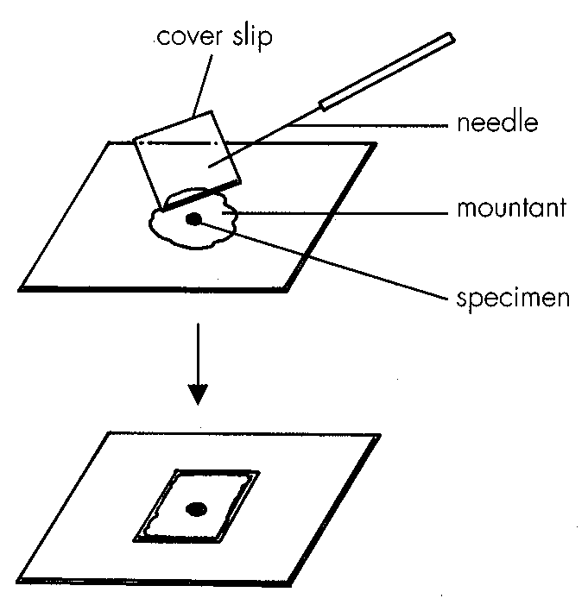
A. dimmer and larger.B. dimmer and smaller.
C. brighter and larger.D. brighter and smaller. Directions: Questions 12 and 13 refer to the following diagram which shows the last step in setting up a slide for microscopic observation.
12. The best mountant used is
A. antiseptic.
B. dilute hydrochloric acid.
C. dilute sodium hydroxide solution.
D. dilute glycerol solution.
13. Which of the following is the reason for using a cover slip?
A. To keep the specimen in position.
B. To preserve the specimen.
C. To flatten the specimen.
D. To protect the eyepiece.
14. Which of the following state the functions of cover slip in microscope? (1) It slows down the evaporation of water from the specimen. (2) It protects the objective lens against getting wet. (3)It prevents the slide from crushing by the objective lens.
A. (1) and (2) only
B. (1) and (3) only
C. (2) and (3) only
D. (1), (2) and (3)
15. Which of the following is/are the function(s) of cell membrane? (1) It allows the entry of glucose into the cell. (2) It stops the movement of starch out of the cell. (3) It keeps water inside the cell.
A. (1) and (2) only
B. (1) and (3) only
C. (2) and (3) only
D. (1), (2) and (3)
16. Which of the following is not the function of nucleus? It contains DN
A.
B. It provides energy for the cell.
C. It carries the genetic information.
D. It controls the activities of the cell.
17. Which of the following are the functions of cell wall? (1) It forms the framework of the cell. (2) It supports the cell. (3) It controls the movement of substances in and out of the cell.
A. (1) and (2) only
B. (1) and (3) only
C. (2) and (3) only
D. (1), (2) and (3)
18. Which of the following statements about chloroplast are correct? (1) It produces oxygen. (2) It contains chlorophyll. (3) It absorbs light.
A. (1) and (2) only
B. (1) and (3) only
C. (2) and (3) only
D. (1), (2) and (3)
19. Which of the following statements about the vacuole in a plant cell is incorrect?
A. It is a reservoir of water for the cell.
B. It contains glucose.
C. It stores up oil.
D. It has reserve of mineral salts.
20. The diagrams below show four types of animal cells.
Which of the following correctly matches the four types of cells?
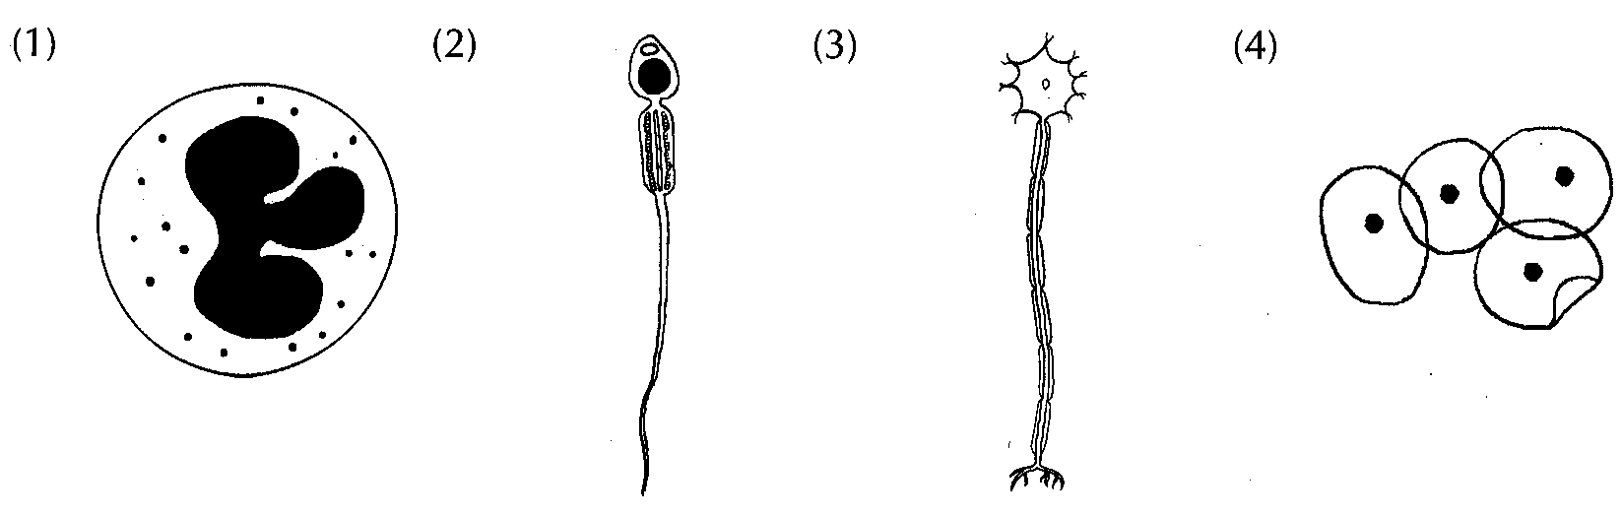
 | Cheek cell | White blood cell | Neurone | Sperm
A. | 1 | 3 | 4 | 2
B. | 4 | 2 | 1 | 3
C. | 3 | 4 | 2 | 1
D. | 4 | 1 | 3 | 2

21. Which of the following is/are the correct description(s) of a plant cell? (1) The cell wall can prevent large molecules from leaving the cytoplasm. (2) The cell membrane is not affected by heating. (3) The nucleus contains DNA. (3) only D. (1), (2) and (3) Directions: Questions 22 and 23 refer to the following four examples of human cells. (1) a mature ovum (2) red blood cell (3) neurone (4) mucus secreting cell-
A.
A. (3) only
B. (1) and (2) only
C. (2) and (3) only
22. Assuming that they have the same cell size, which cell has the largest amount of cytoplasm?
A. (1)
B. (2)
C. (3)
D. (4)
23. Which two examples of cells have the same number of chromosomes?
A. (1) and (2)
B. (1) and (3)
C. (2) and (4)
D. (3) and (4)
24. Which of the following plant cells contains the greatest amount of DNA?
A. Pollen grain
B. Egg cell
C. Xylem cell
D. Mesophyll cell
25. Which of the following is/are present in all types of plant and animal cells?
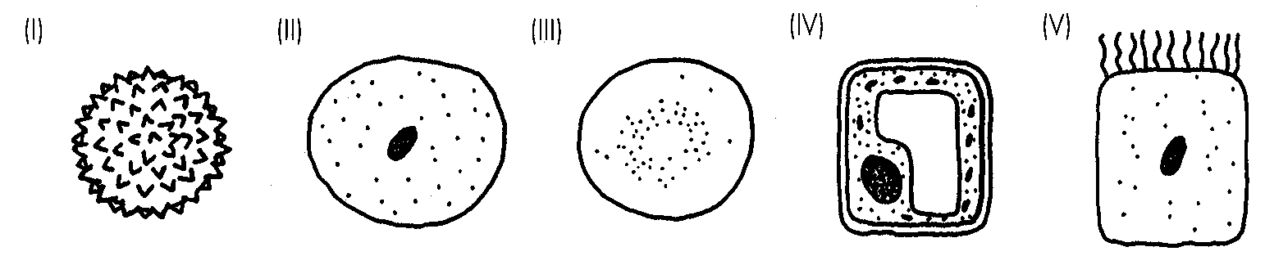
A. Nucleus B. Cell membrane
C. Nucleus and cell membraneD. Nucleus, cell membrane and vacuole Directions: Questions 26 to 28 refer to the drawings below which represent five different types of plant and animal cells.
26. Which of the cells above are animal cells?
A. (I) and (II) only
B. (II) and (III) only
C. (IV) and (V) only
D. (II), (III) and (V) only
27. Cell type (IV) is different from cell type (I) in that cell type (IV) possesses (1) cell wall. (2) chloroplasts. (3) a large vacuole.
A. (1) and (2) only
B. (1) and (3) only
C. (2) and (3) only
D. (1), (2) and (3)
28. Cell types (I), (IV) and (V) are probably
 | (I) | (IV) | (V)
A. | pollen grain | ciliated epithelial cell | palisade mesophyll cell
B. | pollen grain | palisade mesophyll cell | ciliated epithelial cell
C. | ciliated epithelial cell | pollen grain | palisade mesophyll cell
D. | palisade mesophyll cell | pollen grain | ciliated epithelial cell

29. Chloroplasts are present in
A. guard cell and epidermal cell.
B. mesophyll cell and epidermal cell.
C. guard cell and mesophyll cell.
D. guard cell, mesophyll cell and epidermal cell.
30. Which of the following produce(s) carbon dioxide?
(1) Epidermal cell (2) Root hair cell (3) Xylem vessel
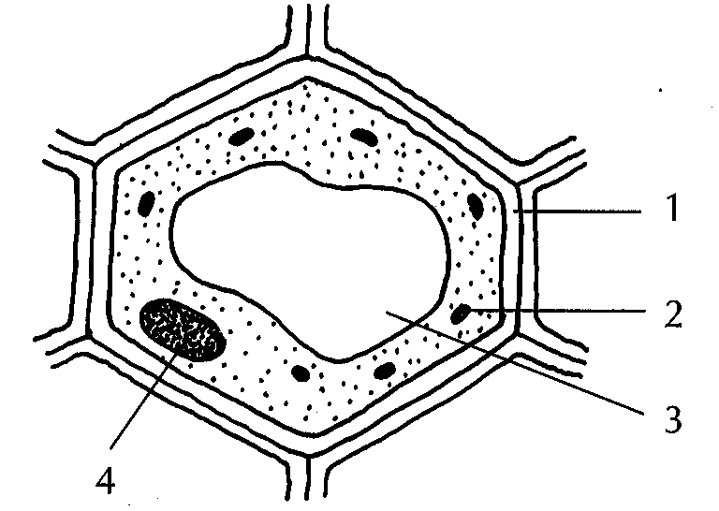
A. (1) only B. (2) only C. (1) and (2) onlyD. (2) and (3) only Directions: Questions 31 to 33 refer to the drawing of a plant cell below.
31. Which structure is present in all types of plant cells? D. 4 32. Structures 2 and 4 contain respectively
A. 1
B. 2
C. 3
D. 4 32. Structures 2 and 4 contain respectively
32. | 4 | A. | starch | DNA | B. | starch | chromosome | C. | chloroplast | chromosome | D. | chlorophyll | DNA
33. Which of the following are normally found in 3?
A. Water and starch
B. Protein and salts
C. Water, glucose and salts
D. Glucose, starch and oil
34. Which of the following structures is absent in a root hair cell?
A. ChloroplastsB. Chromosomes C. Vacuoles D. Cell membrane
35. Which of the following is/are common in a red blood cell and a neurone? (1) DNA (2) Cell membrane (3) Vacuole (4) Nucleus
A. (2) only
B. (1) and (2) only
C. (2) and (3) only
D. (3) and (4) only
36. Both root hair cell and human red blood cell have (1) cell membrane. (2) chromosomes. (3) no chloroplasts. (4) no cell wall.
A. (1) and (2) only
B. (1) and (3) only
C. (1) and (4) only
D. (2) and (3) only
Part B — HKDSE-style (YKTo)
37. Directions: Questions 2.1 to 2.3 refer to an experiment in which five microscopes were used to observe the same slide of blood smear.
Which of the above microscopes enable the student to see the smallest number and the greatest number of red blood cells (RBC) respectively?
Microscope | Eye Piece | Objective
(1) | 5X | 10X
(2) | 10X | 10X
(3) | 5X | 40X
(4) | 15X | 20X
(5) | 10X | 20X

 | Smallest number of RBC seen | Greatest number of RBC seen
A. | (1) | (4)
B. | (2) | (3)
C. | (3) | (2)
D. | (4) | (1)

38. Which microscope gives the brightest image?
A. (1)
B. (2)
C. (3)
D. (4)
39. Which two microscopes enable the student to see the red blood cells of roughly the same size?
A. (1) and (2)
B. (2) and (3)
C. (1) and (3)
D. (3) and (5)
40. If the letters "b" and `p' are observed through a compound microscope, which of the following combinations of the images obtained are CORRECT?
 | Letter 'b' | Letter 'p,'
A. | b | p
B. | d | b
C. | p | q
D. | q | d

41. A student studies the locomotion of water flea under a compound microscope. If the water flea moves to the left and eventually goes out of the field of view, what whould the student do to bring the water flea to the centre of the field of view again?
A. Slowly rotate the fine adjustment knob.
B. Quickly rotate the coarse adjustment knob.
C. Turn the nosepiece until an objective of higher power is in position for observation.
D. Move the microscope slide slightly to the right.
42. Which of the following is/are the INCORRECT2.8 step(s) for using microscope?
(1) Tilt the microscope to an inclined position to enhance observing the specimen on a temporary mount slide.
(2) Use a plane mirror to reflect light to the specimen when the light source is weak.
(3) Move the body tube downward while looking through the eyepiece.
(4) Close one eye when observing the specimen under high power.
A. (1) only B. (2) and (3) only C. (3) and (4) only D. ALL
43. The photomicrograph below shows blood cells that have been magnified by 1 400 times under a light microscope.
What step can be used to observe more blood cells from the same slide of blood smear under the light microscope?
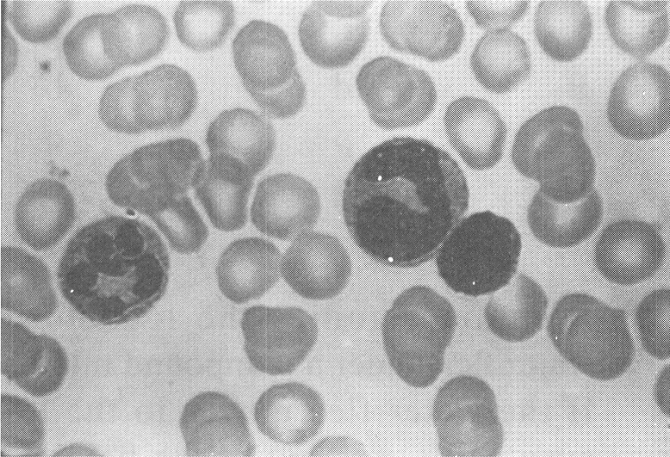
A. Use objective of higher power.
B. Use objective of lower power.
C. Provide light source of stronger illumination.
D. Add more stain before mounting the blood smear.
44. Structures of cells are very small and do not have sharp colours .Even nuclei are relatively big structures in the cells, they cannot be seen easily under the light microscope. Which of the following procedures can make the nuclei more conspicuous under the light microscope?
A. Use thinner cover glass to reduce the distance for light passing through to the specimen.
B. Increase the intensity of the light source to produce a greater contrast effect.
C. Lower the objective to a distance closer to the slide to give a bigger magnification effect.
D. Add stain to the tissues that gives colour to the structures of the cells.
45. If a strip of the onion epidermal peel is stained with iodine solution, which of the following structures of a cell would be deeply stained?
A. Cell wall B. Nucleus C. Cytoplasm D. Vacuole
46. If the root tip squash is stained with acetocarmine, which of the following structures of a cell would be stained deep red?
A. Cell wall B. Cell membrane C. Chromosomes D. Chloroplast
47. Which of the following are reasons for putting a cover slip over a stained specimen for microscopic observation? (1) To permit more light to pass through the specimen so that the specimen is more transparent. (2)To keep the specimen flat for observation. (3) To prevent the specimen from being contaminated by bacteria in air. (4) To prevent the specimen from drying up. (5) To prevent the objective from getting wet by the stain.
A. (1), (2) and (3) only
B. (2), (3) and (4) only
C. (2), (4) and (5) only
D. (1), (3) and (5) only
48. Photomicrograph I is the image of the root section seen under a light microscope. Photomicrograph II is the image of the same section seen under another magnification of the microscope. Arrange the following steps in the right sequence to obtain the magnification needed to produce image II. Photomicrograph I Photomicrograph II (1) Use the fine adjustment knob to focus the specimen under high power. (2) Turn the nose piece to position the high-powered objective to be above the slide. (3) Use the coarse adjustment knob to focus the specimen under lower power. (4) Position the specimen to the centre of the field of view. (5) Lower the body tube until it is about 2 mm above the slide.
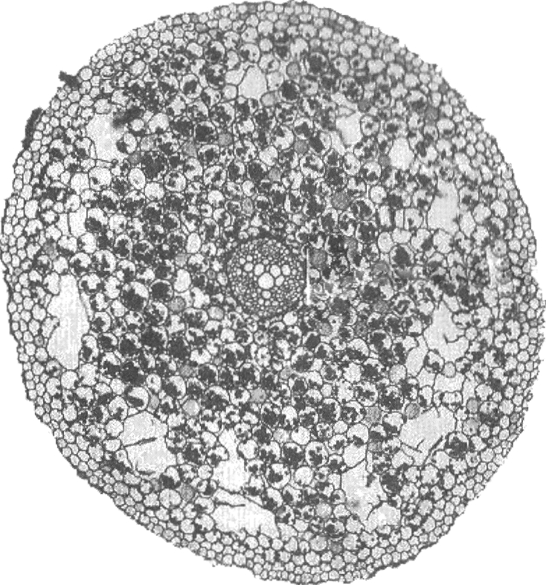
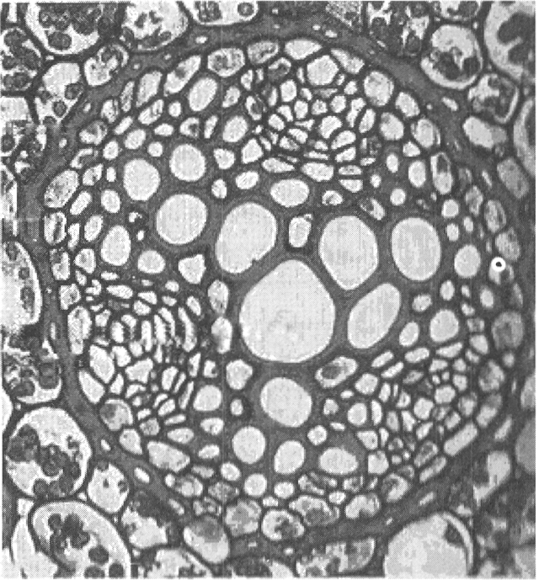
A. (4), (3), (2), (5), (1)
B. (3), (4), (2), (5), (1)
C. (5), (3), (2), (1), (4)
D. (2), (4), (1), (3), (5)
49. Light microscope cannot produce a magnification greater than 1 500 times. Which of the following is the reason to explain this limitation?
A. No optical lens is thick enough to refract light to produce such high magnification.
B. The light intensity of the normal light source provided by the table lamp is not bright enough to produce image of very high magnification.
C. The maximum resolution of a light microscope is limited by the shortest wavelength of light.
D. None of the above reasons is correct.
50. Which of the following combinations about the resolution of light microscope and electron microscope is BOTH CORRECT?
 | Light microscope | Electron microscope
A. | 0.02m | 1.0nm
B. | 0.02m | 10.0nm
C. | 0.20m | 1.0nm
D. | 0.20m | 10.0nm

51. Which of the following is the reason that the resolution of an electron microscope is higher than that of a light microscope?
A. The wavelength of electron beam is much shorter than that of light wave.
B. The magnifying power of the electromagnetic lens of electron microscope is higher than that of the optical lens.
C. The velocity of electron beam is faster than that of light.
D. The energy of the electrons is stronger than that of light.
52. Which of the following are the advantages of observing cells with the use of an electron microscope? (1) High resolution (2) High magnifying power (3) Simple procedures to prepare the specimen for observation (4)Easy operation without much training
A. (1) and (2) only
B. (2) and (3) only
C. (3) and (4) only
D. (1), (2) and (3) only
53. Which of the following structures of a cell can be seen under a light microscope?
A. Ribosomes inside the rough endoplasmic reticulum B. Envelope of the mitochondrion
C. Chloroplast D. Lysosome
54. Which of the following structures of a cell can only be observed under an electron microscope, NOT a light microscope?
A. Chloroplast B. Endoplasmic reticulum C. Mitochondrion D. Nucleus
55. The following photomicrographs (1) to (3) are images of the same type of cells obtained by using three different microscopes.
Which of the following combinations TRULY represents the types of microscopes used to produce the related photomicrographs?
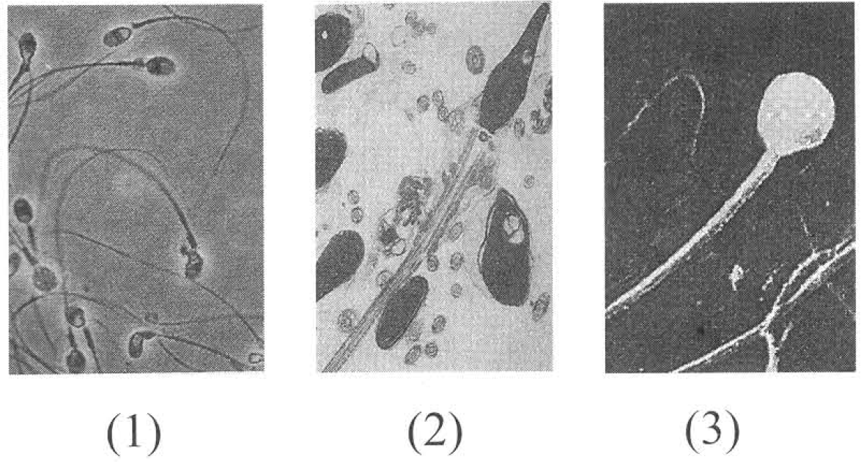
 | Light microscope | Transmission electron microscope | Scanning electron microscope
A. | (1) | (3) | (2)
B. | (3) | (1) | (2)
C. | (1) | (2) | (3)
D. | (2) | (3) | (1)

56. Which of the following part(s) of the microscope can affect the brightness of the image? (1) Minor (2) Iris diaphragm (3) High powered lens B. General structures of cells
A. (1) only
B. (2) only
C. (1) and (2) only
D. (1), (2) and (3)
57. Which of the following statements about cells are INCORRECT?
(1) Cells can arise from non-living matter.
(2) Cells cannot exist in non-living form inside organisms.
(3) The outermost boundary of living cell must be cell wall.
(4) Cells must have nuclei to enable them to carry out their functions.
A. (1) and (3) only B. (2) and (4) only C. (1), (2) and (3) only D. ALL
58. Which of the following structures is the controlling centre of the cell?
A. Nucleus B. Cytoplasm C. Cell wall D. Chloroplast
59. Which of the following living human calls do NOT possess nucleus? (1) Bone cells (2) Matured red blood cells (3) Liver cell
A. (1) only
B. (2) only
C. (1) and (2) only
D. (2) and (3) only
60. Which of the following structures is essential for the producers to carry out their functional role in the ecosystem?
A. Cell membrane B. Cytoplasm C. Cell wall D. Chloroplast
61. Which of the following statements related with the cell wall is INCORRECT? (1) Cell wall is present in all plant cells. (2) Cell wall does not permit sucrose to pass through. (3) Cell wall is composed of cellulose and pectin. (4) Cell wall as part of the living cell can carry out metabolic activities.
A. (1) and (2) only
B. (2) and (4) only
C. (3) and (4) only
D. (1), (3) and (4) only
62. Which of the following comparison between cell wall and cell membrane is INCORRECT?
Directions: Questions 2.27 to 2.30 refer to the diagrams in the right column, which show several types of cells. (The cells are not drawn to the same scale.)
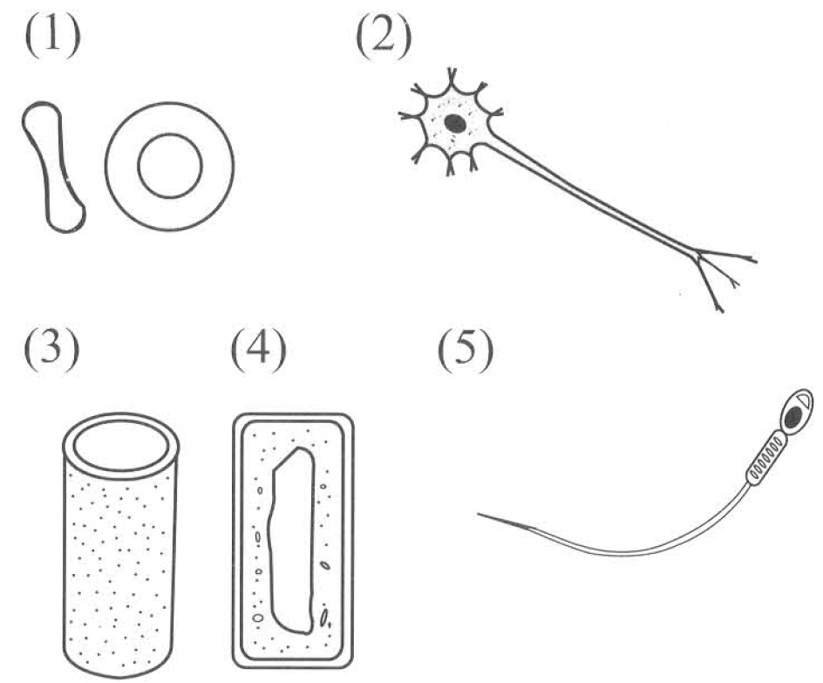
 | Cell wall | Cell membrane
A. | Fully permeable | Selectively permeable
B. | Present in plant cell only | Present in animal cells only
C. | Mainly composed of carbohydrates | Mainly composed of phospholipid and protein
D. | Cell with it as the outermost boundary will not burst in hypotonic solution. | Cell with it as the outermost boundary will burst in hypotonic solution.

63. The shape of cell (1) is maintained by the presence of
A. a rigid cell wall.
B. a cell membrane with specific elasticity.
C. a nucleus.
D. iron atoms inside the cytoplasm.
64. Which of the following matching of cells is CORRECT?
 | (1) | (2) | (3) | (4) | (5)
A. | White blood cell | Muscle cell | Xylem cell | Epidermal cell | Sperm
B. | Red blood cell | Nerve cell | Phloem cell | Epidermal cell | Muscle cell
C. | Red blood cell | Nerve cell | Xylem cell | Palisade mesophyll cell | Sperm
D. | White blood cell | Muscle cell | Xylem cell | Spongy mesophyll cell | Sperm

65. Which of the following matching of the functions of the cells is CORRECT?
. | Transmits nerve impulse | Manufactures sugar | Transmits genetic information to offspring | Conducts water and mineral salts | Transports oxygen
A. | 5 | 3 | 2 | 4 | 1
B. | 2 | 3 | 5 | 1 | 4
C. | 3 | 4 | 2 | 5 | 1
D. | 2 | 4 | 5 | 3 | 1

66. Which cells have all the following structures? Cell membrane, cytoplasm and nucleus.
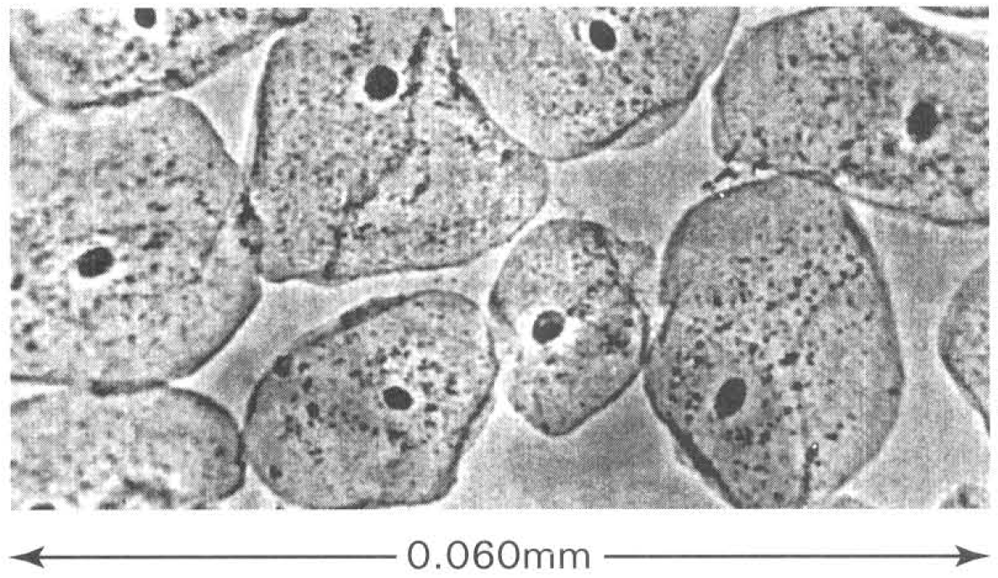
A. (3) and (4) only B. (2) and (5) only C. (1), (2) and (5) only D. (2), (4) and (5) only Directions: Questions 2.31 to 2.34 refer to the photomicrograph below which shows the cheek cells under the high power of a compound microscope.
67. What is the average diameter of a cheek cell in micrometres? (1 micrometre =106 m)
A. 1.5
B. 4.5
C. 15
D. 45
68. If the cheek cell drawn by a student on a report book is of 9 mm in diameter, the magnification of this drawing is
A. 20
B. 60
C. 200
D. 600
69. Using the same microscope to observe a slide of blood smear, how many red blood cells can be seen to line up in one single row across the field of view? (The diameter of the field of view is 0.045 mm. The average diameter of each red blood cell is about 0.0075 mm.)
A. 6
B. 12
C. 60
D. 120
70. Which of the following statements related with the cheek cells are INCORRECT?
(1) They have no cell wall. (2) They are germ cells.
(3) They can move about like Amoeba. (4) They are diploid in nature.
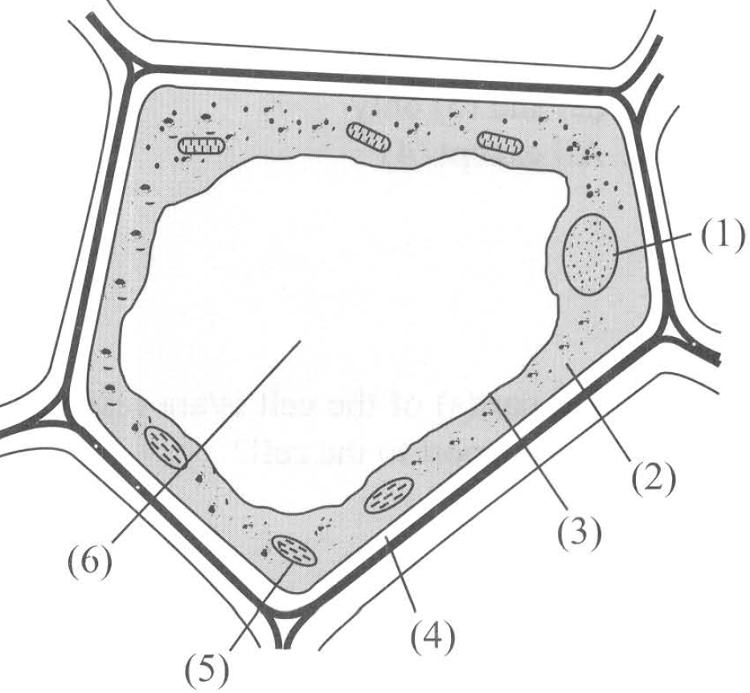
A. (1) only B. (3) only C. (1) and (4) only D. (2) and (3) only Directions: Questions 2.35 to 2.39 refer to the diagram below which shows a plant cell.
71. Which of the following sets of labels is CORRECT?
 | (1) | (2) | (3) | (4) | (5)
A. | Nucleus | Vacuole | Cell wall | Cell membrane | Chloroplast
B. | Chloroplast | Cytoplasm | Cell wall | Cell membrane | Vacuole
C. | Nucleus | Cytoplasm | Cell membrane | Cell wall | Chloroplast
D. | Nucleus | Cytoplasm | Cell wall | Cell membrane | Vacuole

72. The part labelled 4 is (1) semi-permeable. (2) made of cellulose. (3) non-living part. (4) absent in animal cell.
A. (1) and (3) only
B. (1), (2) and (3) only
C. (2), (3) and (4) only
D. (1), (2) and (4) only
73. Which of the following parts is/are absent in the matured xylem cell?
A. (1) only B. (1) and (2) only C. (2) and (5) only D. All except (4)
74. Which part(s) of the cell is/are responsible to give support to the cell?
A. (1) only
B. (2) and (6) only
C. (4) only
D. (4) and (6) only
75. Which of the following substances are normally present in 6?
A. Water, minerals and sucrose B. Proteins and lipids
C. Starch and cellulose D. Chlorophyll and proteins
C. Animal and plant cells
76. Which of the following structures are present in BOTH plant and animal cells? (1) Cell wall (2) Cell membrane (3) Cytoplasm (4) Chloroplasts (5) Nucleus (6) Mitochondria
A. (1),(2),(3) and (4) only
B. (2),(3),(4) and (5) only
C. (2),(3),(5) and (6) only
D. (1),(3),(4) and (6) only
77. Which of the following comparison between animal cell and green plant cell is INCORRECT?
 | Animal cell | Green plant cell
A. | No chloroplast | Has chloroplast
B. | No cell wall | Has cell wall
C. | Has glycogen | No glycogen
D. | Has mitochondria | No mitochondria

78. Which of the following differences between a spongy mesophyll cell and a root hair cell is INCORRECT?
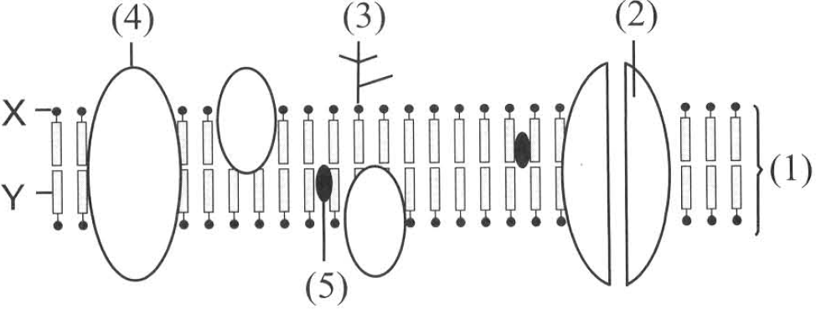
 | Spongy mesophyll cell | Root hair cell
A. | Gas exchange takes place over its surface. | Gas exchange cannot take place at its surface.
B. | It has chloroplasts. | It has no chloroplast.
C. | It has irregular shape. | It has regular shape with a finger-like projection.
D. | It manufactures food. | It cannot manufacture food.

D. Sub-cellular organelles Directions: Questions 2.43 to 22.50 refer to the diagram below, which represents a model of the cell membrane.
79. Which of the following are CORRECT labels of the structures shown in the diagram? (1) Phospholipids (2) Channel protein (3) Glycogen (4) Cholesterol
A. (1) and (2) only
B. (2) and (3) only
C. (1), (2) and (3) only
D. (2), (3) and (4) only
80. Which of the following statements about structure (1) are CORRECT? (1) X is a phosphate which is hydrophilic. (2) X is a phosphate which is hydrophobic. (3) Y is a hydrocarbon which is hydrophilic. (4) Y is a hydrocarbon which is hydrophobic.
A. (1) and (4) only
B. (2) and (3) only
C. (2) and (4) only
D. (1) and (3) only
81. Which structure permits lipids to pass through?
A. (1) only
B. (2) only
C. (3) only
D. (4) only
82. Which structure permits polar molecules to pass down a concentration gradient into the cell ?
A. (1) only
B. (2) only
C. (3) only
D. (4) only
83. Which structure enables certain molecules to pass through the cell membrane with the expenditure of energy?
A. (1)
B. (3)
C. (4)
D. (5)
84. What is the function of the part labelled 3 ?
A. It permits phagocytosis to take place.
B. It enables active transport to take place.
C. It enhances the passage of water across the cell membrane by osmosis.
D. It is a receptor site or recognition site to specific chemicals.
85. The part labelled 5 has properties of lipid. What is its function?
A. It catalyses the transport of electron across the membrane in the light reaction of a green plant cell.
B. It stabilizes the fluid nature of the cell membrane.
C. It assists the transport of substances against the concentration gradient out of the cell.
D. It enhances the generation of ATP to support active transport.
86. Which part will dissolve in organic solvent?
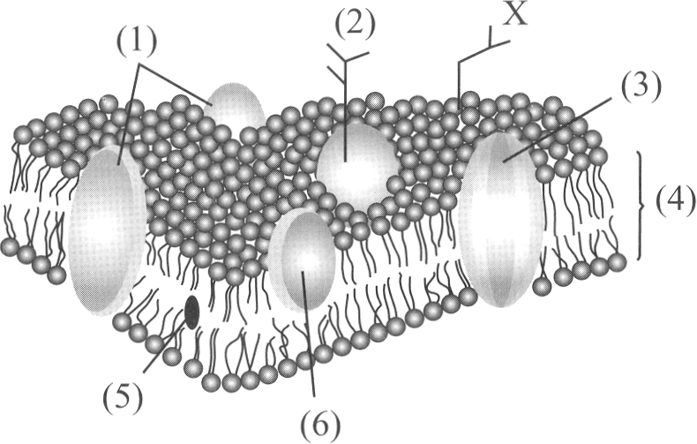
A. (1) B. (2) C. (3) D. (4) Directions: Questions 2.51 to 2.57 refer to the diagram below, which represents the fluid mosaic model of the cell membrane.
87. Which of the following combinations CORRECTLY represents the 'fluid' part and the 'mosaic' part of the cell membrane ?
 | 'Fluid' part | 'Mosaic' part
A. | (1) | (4)
B. | (2) | (5)
C. | (4) | (6)
D. | (2) | (6)

88. Which parts permit vitamin C and vitamin D to pass respectively?
 | Vitamin C | Vitamin D
A. | (1) | (3)
B. | (3) | (4)
C. | (4) | (3)
D. | (3) | (1)

89. What is the significance of the fluid nature of the cell membrane?
(1) Enhances phagocytosis (2) Enhances cell division
(3) Enhance secretion (4) Enhance amoeboid movement
A. (1) and (2) only B. (2) and (3) only C. (3) and (4) only D. ALL
90. What is the significance of the mosaic nature of the cell membrane?
(1) Proteins traverse the lipid layer to permit polar molecules to pass through the cell membrane.
(2) It provides receptor sites on the surface of cell to recognise specific chemicals.
(3) It provides the basic support to the cell membrane.
(4) It prevents virus to invade the cell.
A. (1) and (3) only B. (2) and (3) only C. (1), (2) and (3) only D. ALL
91. If the actual length of layer (4) is 7.5 nm, what is the magnification of the layer in the diagram?
A. 1.33 x107
B. 1.33 x 106
C. 1.33 x 105
D. 1.33 x 104
92. What type of biomolecule is X ?
A. Carbohydrate B. Lipids C. Amino acids D. Nucleic acid
93. Which is the function of the part labelled (3)?
A. It is the only passage along which oxygen molecule can pass into the cell.
B. It allows all water-soluble substances passing into the cell.
C. It allows vitamin A to pass into the cell.
D. It allows small polar molecules to pass into the cell.
94. Which of the following is the property/ function of cell membrane?
A. It is fully permeable.
B. It is selectively permeable.
C. It forms a physical barrier to prevent the entry of virus into the cell.
D. It only permits lipid-soluble substances to enter the cell.
95. Which of the following features about cell membrane is INCORRECT?
(1) It is fully permeable to all substances.
(2) All white blood cells can engulf germs through their cell membrane.
(3) Both the outer surface of the phospholipid bilayer are completely covered by continuous layer of protein molecules with no gap between them.
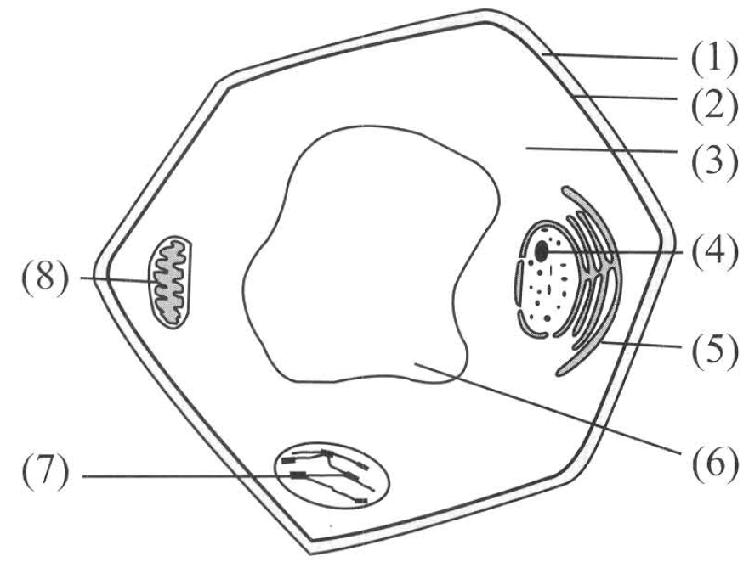
A. (1) only B. (2) only C. (1) and (2) only D. (1), (2) and (3) Directions: Questions 2.60 to 2.62 refer to the diagram below, which represents a plant cell.
96. Which labelled parts are unique to plant cells?
A. (1), (3) and (6) only
B. (2), (5) and (8) only
C. (1), (6) and (7) only
D. (1), (6), (7) and (8) only
97. Where are starch and proteins produced respectively?
 | Site where starch produced | Site where proteins produced
A. | (4) | (7)
B. | (5) | (8)
C. | (7) | (5)
D. | (8) | (4)

98. Where will sugar be oxidised anaerobically?
A. (3)
B. (5)
C. (6)
D. (7)
99. Arrange the following organelles in ascending order according to their size.
A. Nucleus, mitochondrion, chloroplast, ribosome
B. Nucleus, chloroplast, mitochondrion, ribosome
C. Ribosome, mitochondrion, chloroplast, nucleus
D. Chloroplast, mitochondrion, nucleus, ribosome
100. The key below is used to identify the following organelles of a cell.
(1) (a) | Bounded by a double unit membrane | 2
(b) | Not bounded by a double unit membrane | 4
(2) (a) | Membrane bears pores of size with diameter of 80-200nm | M
(b) | Membrane without pores of size with diameter of 80-200 nm | 3
(3) (a) | Inner membrane extends inwards and bears stalked particles | N
(b) | Inner membrane extends inwards and folds to form many flattened sacs | O
(4) (a) | Filled with fluid | P
(b) | Composed of concrete structures in form of one big and one small subunits | Q

 | M | N | O | P | Q
A. | Mitochondria | Chloroplast | Nucleus | Ribosome | Lysosome
B. | Chloroplast | Mitochondria | Ribosome | Nucleus | Lysosome
C. | Nucleus | Chloroplast | Mitochondria | Lysosome | Ribosome
D. | Nucleus | Mitochondria | Chloroplast | Lysosome | Ribosome

101. Which of the following combinations of the organelle and its function is INCORRECT?
Directions: Questions 2.66 to 2.69 refer to the diagrams below, which represent two organelles X and Y.
Organelle X Organelle Y
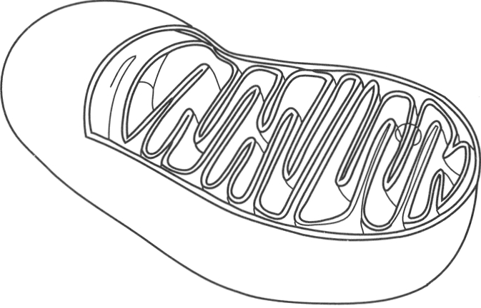
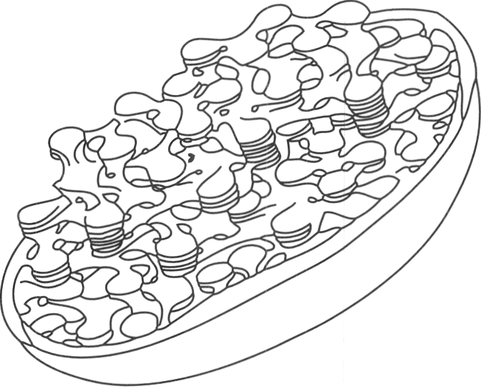
 | Organelle | Function
A. | Chloroplast | Synthesis of organic food
B. | Mitochondrion | Oxidation of respiratory fuels
C. | Rough endoplasmic reticulum | Digestion of particles engulfed into the cell by phagocytosis
D. | Nucleolus | Production of ribosomes

102. Which of the following identity of organelles X and Y are CORRECT?
 | Organelle X | Organelle Y
A. | Chloroplast | Mitochondrion
B. | Mitochondrion | Chloroplast
C. | Endoplasmic reticulum | Nucleus
D. | Nucleus | Endoplasmic reticulum

103. Which of the following differences between organelles X and Y are CORRECT?
 | Organelle X | Organelle Y
(1) | It carries out catabolic activities. | It carries out anabolic activities.
(2) | It produces NADPH. | It produces NADH.
(3) | The inner membrane of the envelope extends into ridges to facilitate the release of energy. | The inner membrane of the envelope extends into sheet-like structures to maximise the absorption of light.
(4) | It is present in animal cells only. | It is present in all plant cells.

A. (1) and (2) only
B. (2) and (4) only
C. (3) and (4) only
D. (1) and (3) only
104. Which of the following about organelles X and Y are INCORRECT?
(1) All the reactions inside organelle X can only take place in darkness while those in organelle Y can only take place in light.
(2) Conversion of energy occurs in both organelles.
(3) ATP is produced by both organelles.
(4) Both organelles can be found in all the cells in a leaf
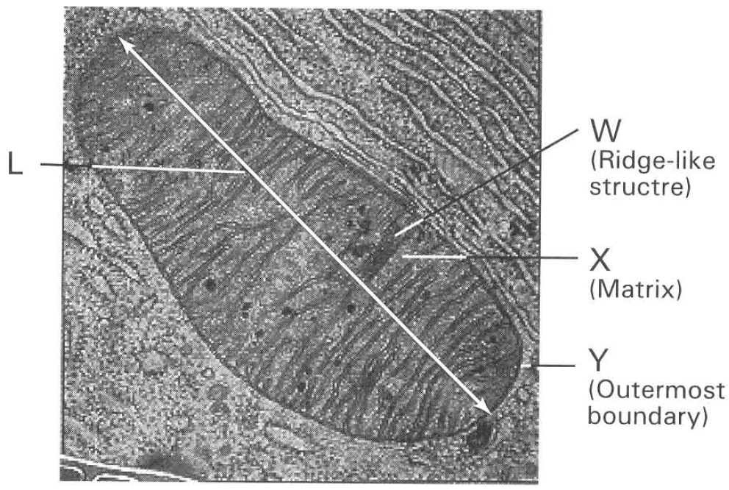
A. (1) only B. (2) and (3) only C. (1) and (4) only D. (2) and (4) only Directions: Questions 2.70 and 2.71 refer to the photomicrograph of an organelle below.
105. Which of the following compounds are BOTH possessed by these two organelles? (1) Simple sugars (2) Enzymes (3) DNA
A. (1) only
B. (1) and (2) only
C. (2) and (3) only
D. (1), (2) and (3)
106. The power of magnification of this photomicrograph is x 50 000. What is the actual length (L) of the organelle shown in the photomicrograph?
A. 1.14 m
B. 0.80 m
C. 0.80 m
D. 1.14 m
107. Which of the following combinations of the functions performed by the parts related are CORRECT?
Directions: Questions 2.72 and 2.73 refer to the photomicrograph of an organelle below.
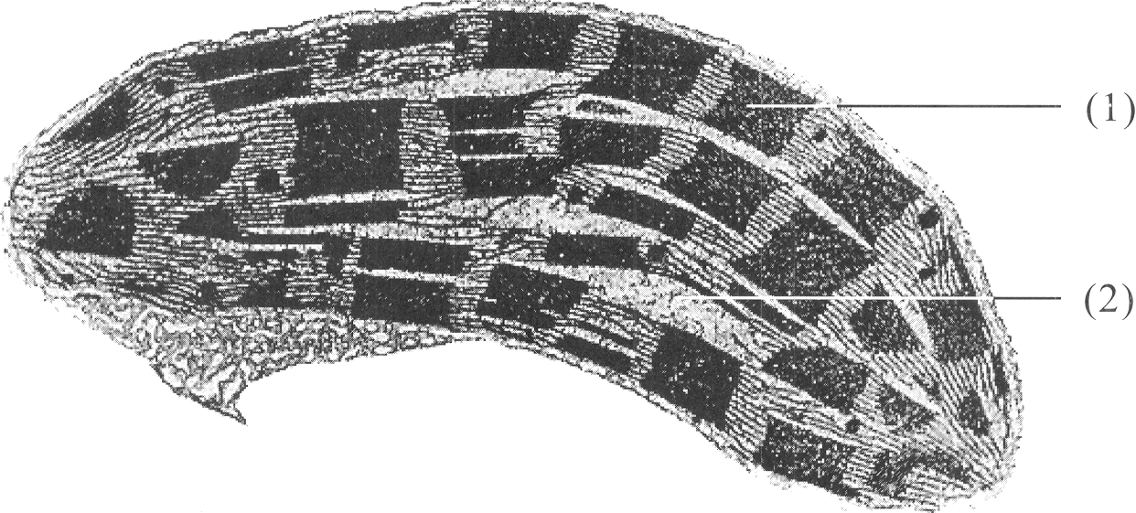
 | W | X | Y
A. | Production of proteins | Krebs cycle occurs | Oxidative phosphorylation
B. | Krebs cycle occurs | Oxidative phosphorylation | Production of proteins
C. | Oxidative phosphorylation | Production of proteins | Krebs cycle occurs
D. | Oxidative phosphorylation | Krebs cycle occurs | Control passage of substancesinto and out of the organelle

108. If the actual length of the organelle shown is 5 um, what is the power of magnification of the photomicrograph?
A. 50 000
B. 5 000
C. 20 000
D. 2 000
109. Which of the following combinations about the structures and / or functions of parts (1) and (2) are CORRECT?
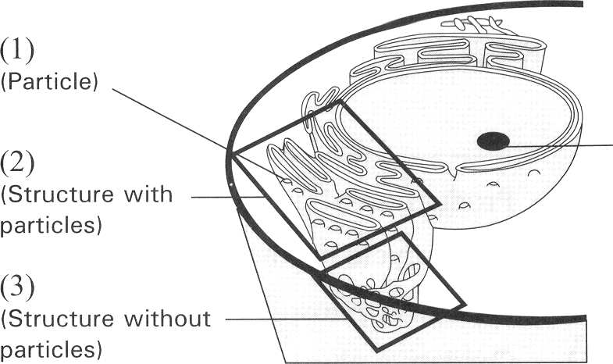
 | Part (1) | Part (2)
(1) | Absorption of light energy | Production of sugars
(2) | Photolysis occurs. | Oxygen is released by reactions taking place there.
(3) | Carbon fixation occurs | Photophosphorylation occurs
(4) | Calvin cycle occurs | Krebs cycle occurs

A. (1) and (2) only B. (2) and (3) onlyC. (1), (2) and (3) only D. (2) and (4) only Directions: Questions 2.74 and 2.75 refer to the diagram at right, which shows some of the organelles in the cell.
110. Which of the following combination of parts are all CORRECTLY labelled?
 | (1) | (2) | (3) | (4)
A. | Ribosome | Smooth endoplasmic reticulum | Rough endoplasmic reticulum | Nucleus
B. | Ribosome | Rough endoplasmic reticulum | Smooth endoplasmic reticulum | Nucleolus
C. | Nucleolus | Nuclear membrane | Chromatin | Nucleus
D. | Nucleolus | Chromatin | Nuclear membrane | Nucleus

111. Which of the following combinations CORRECTLY state the functions of the parts concerned?
Directions: Questions 2.76 and 2.77 refer to the photomicrographs of two membranous organelles in the cell.
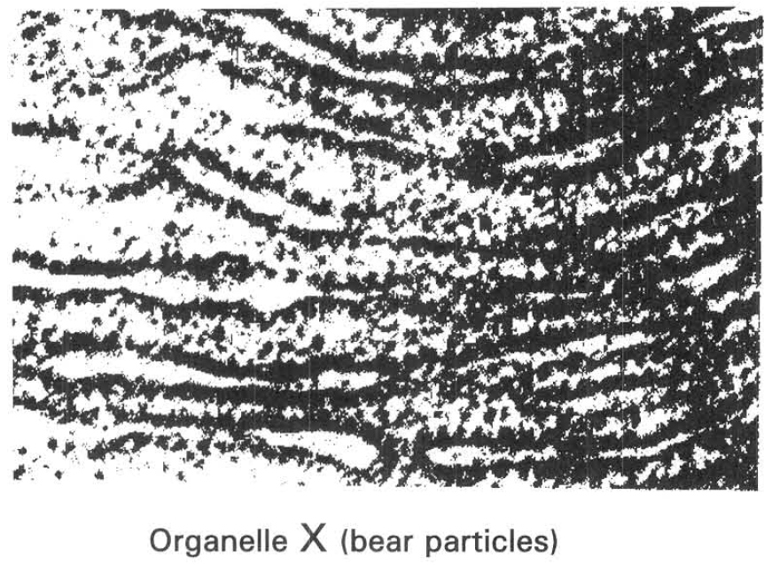
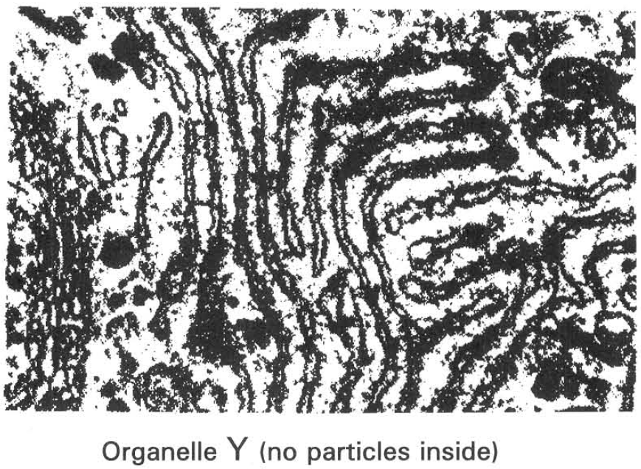
 | (2) | (3)
A. | Synthesis of proteins | Synthesis of lipids
B. | Synthesis of lipids | Synthesis of proteins
C. | Production of ribosomes | Production of mRNA
D. | Production of ATP | Production of NA D

112. Which about of the following combinations these two organelles are CORRECT?
 | Organelle X(bear particles) | Organelle Y (no particles inside)
A. | Produces chromatin | Produces mRNA
B. | Produces glycogen | Produces glucagon
C. | Produces antibiotic | Produces antigens
D. | Produces insulin | Produces sex hormones

113. Which of the following combinations TRULY represents the types of cells having the related organelle in great abundance?
 | Organelle X (bear particles) | Organelle Y (no particles inside)
A. | Cells in the pancreas | Cells in the oily glands in skin
B. | Cells in the alveolar wall | Epithelial cells of the skin
C. | Red blood cells | White blood cells
D. | Bone cells | Muscle cells

114. Which of the following is the pathway by which protein is synthesized and then secreted out of the cell ?
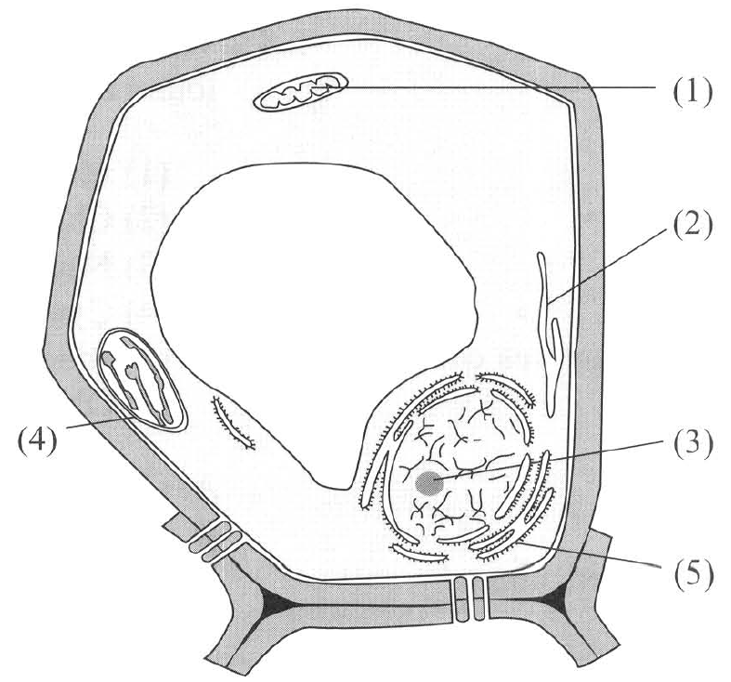
A. Rough endoplasmic reticulum Smooth endoplasmic reticulum Cell surface membrane
B. Smooth endoplasmic reticulum Rough endoplasmic reticulum Cell surface membrane
C. Cell surface membrane Rough endoplasmic reticulum Smooth endoplasmic reticulum
D. Rough endoplasmic reticulum Cell surface membrane Smooth endoplasmic reticulum Directions: Question 2.79 and 2.80 refer to the diagram below which shows the ultra-structure of a plant cell.
115. Where will Krebs cycle and Calvin cycle occur respectively?
 | Krebs cycle | Calvin cycle
A. | 4 | 1
B. | 1 | 4
C. | 2 | 3
D. | 3 | 2

116. Which of the following statements about the role played by part (3) or (5) in the process of protein synthesis is CORRECET ?
A. Part (3) produces ribosomes.
B. Replication of mRNA occurs inside part (5).
C. Amino acids join together into polysaccharide inside (3).
D. Ribosomes are formed inside part (5).
117. Which of the following structures contain DNA? (1) Nucleus (2) Chloroplast (3) Mitochondria (4) Rough endoplasmic reticulum
A. (1) only
B. (1) and (2) only
C. (1), (2) and (3) only
D. (1), (2), (3) and (4)
118. Which of the following structures contain RNA?
(1) Nucleus (2) Ribosome (3) Rough endoplasmic reticulum (4) Nucleolus
A. (1) and (2) onlyB . (2) and (3) onlyC . (1), (2) and (3) only D. (1), (2), (3) and (4)
119. Which of the following structures has the highest concentration of RNA?
A. Smooth endoplasmic reticulum B. Mitochondria
C. Chromosome D. Nucleolus
120. On which of the following structures can phagocytosis take place?
A. Mitochondrion B. Chloroplast
C. Endoplasmic reticulum D. Cell surface membrane E. Prokaryotes and eukaryotes
121. Which of the following structures are found in prokaryotic cells? (1) Mitochondria (2) Chloroplast (3) Nuclear membrane (4) Cytoplasm (5) Ribosome (6) DNA
A. (1), (2) and (3) only
B. (4), (5) and (6) only
C. (1), (3) and (5) only
D. (2), (4) and (6) only
122. Which of the followings are prokaryotes? (1) Fungi (2) Bacteria (3) Moss (4) Blue green algae
A. (1) and (2) only
B. (2) and (3) only
C. (2) and (4) only
D. (1) and (4) only
123. The following is the diagram of an eukaryotic cell. Which of the following labelled parts are absent in prokaryotic cells?
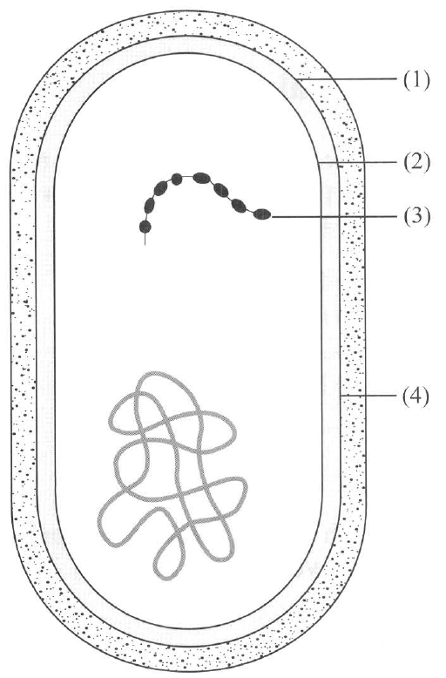
A. (1) and (2) only
B. (2), (3) and (6) only
C. (3), (4) and (5) only
D. (1), (2), (3) and (5) only
124. The following is the diagram of a prokaryotic cell. Which of the following labelled parts are present in certain eukaryotic cells?
A. (1) and (2) only
B. (2) and (4) only
C. (1), (2) and (3) only
D. (1), (2), (3) and (4)
125. 12 B 2.13 C
The maximum resolution of a light microscope is 200 nm (0.2 pm) which is about one half of the shortest wavelength of light (400 nm of violet light).
116
126. 14 C2.20
The wavelength of the beam of electrons used in an electron microscope is approximately 0.005 nm. The limit due to the wavelength of the electron beam is slightly greater than 0.0025 nm.
2.15 A
The wavelength of an electron beam is about 0.005 nm while that of light is 400 nm.
D
(1) The concave side of the mirror can produce greater illuminating effect than the flat side of the mirror.
(2) Iris diaphragm can control the amount of light passing through the central hole of the stage to the slide.
(3) High powered lens reduces the penetration of light.
2.16 A
(3) and (4) are incorrect.
(3) The procedures to prepare the specimen for observation under the electron microscope are very complicated.
(4) Training is needed to acquire the high level of skills for operating the electron microscope.
2.17 C
Chloroplast is big enough to be observed under a light microscope. The other organdies are very small that can only be observed under an electron microscope.
2.18 B
Endoplasmic reticulum is composed of very thin membranes which can only be observed under an electron microscope.
2.19 C
•Photomicrograph (1) shows many sperms of very small size. It has the biggest field of vision showing the greatest number of sperms so that it is produced by light microscope.
•Photomicrographs (2) and (3) just show one sperm with greater details. They are produced by electron microscopes.
•Photomicrograph (3) shows the surface features of sperm so that it is produced by the scanning electron microscope. Thus photomicrograph (2) is produced by the transmission electron microscope.
2.21 D
(1) Cells must arise from pre-existing cells.
(2) Viruses can exist as particles inside living organisms.
(3) Only plant cells have cell wall as the outermost boundary. Animal cells have cell membrane as the outermost boundary.
(4) Red blood cells have no nuclei to increase the space to accommodate more haemoglobin to carry oxygen.
2.22 A
Nucleus contains chromosomes which have the genetic information to control all the metabolic activities of the cell.
2.23 B
Matured red blood cells without nucleus can increase the space to accommodate more haemoglobin to carry oxygen.
2.24 D
Chloroplast can carry out photosynthesis to produce organic food which supports the life ofproducers and consumers in the ecosystems. Moreover photosynthesis can remove the harmful carbon dioxide released by the respiration of organisms and can replace the oxygen consumed by them.
2.25 B
(2) Cell wall is fully permeable that permits sucrose to pass through.
(4) Cell wall is composed of non-living materials so that it cannot carry out metabolic activities.
117
2.26 B
Cell membrane is present in both the plant cells and animal cells.
2.27 B
Red blood cell is an animal cell which has no cell wall (A).
2.28 C
(1) Red blood cell has a biconcave disc shape.
(2) Nerve cell has long cytoplasmic processes that act as the nerve fibres.
(3) Xylem cell has big lumen and thick cell wall to enhance the transport of water and mineral salts.
(4) Palisade mesophyll cell is cylindrical shape with chloroplasts to carry out photosynthesis.
(5) Sperm has long tail to enhance the swimming action to find the egg cell.
2.29 D
(1) Red blood cell has haemoglobin to transport oxygen.
(2) The nerve cell has nerve fibres to transmit nerve impulse.
(3) Xylem cell has long hollow lumen without cross end walls to enhance the transport of water and mineral salts.
(4) Palisade mesophyll cell has chloroplasts carry out photosynthesis to manufacture sugar.
(5) Sperm carries chromosomes in its head to transmit the generic information to offspring.
2.30 D
Matured red blood cells (1) and xylem vessel cell (3) have no nucleus.
2.31 C
The average diameter of a cheek cell is 15 um
( 0.060 mm
= 0.015 mm). 4
2.32 D
( 9 mm
= 600 0.015 mm
2.33 A
( 0.045 mm
= 6 0.0075 mm
2.34 D
(2) They are somatic cells.
(3) They cannot move about.
2.35 C
2.36 C
The cell wall is fully permeable, NOT semipermeable (1).
2.37 D
Matured xylem cell is a dead cell which does not possess any living protoplast.
2.38 D
The rigid cell wall (4) provides mechanical
support and the central vacuole (6) filled
with cell sap provides turgid support.
2.39 A
The cell sap is filled with water, minerals and sucrose.
2.40 C
Cell wall (1) and chloroplast (4) are unique to plant cells.
2.41 D
Green plant cell also has mitochondria to carry out respiration to release energy from food.
2.42 A
Gas exchange takes place at the moist surface of both cells.
2.43 A
(3) is glycoprotein and (4) is carrier-protein.
118
2.44 A
Phospholipid (1) has the phosphate head (X) which is hydrophilic and a hydrocarbon tail (Y) which is hydrophobic.
2.45 A
Phospholipid (1) permits lipids to pass2.53 D
The fluid nature of the cell membrane enables it to break and reform again that is important for phagocytosis, cell division, secretion and amoeboid movement to take place.
through.2.54 C
Virus (4) can penetrate through the fluid part 2.46 Bof the cell membrane.
2.47 C
The carrier-protein (4) enables certain molecules to pass through against the concentration gradient with the expenditure of energy.
2.48 D
The glycoprotein (3) with specific shape acts as receptor site or recognition site to specific chemicals.
2.49 B
Cholesterol (5) stabilizes the fluid nature of the cell membrane.
2.50 A
Phospholipid (1) will dissolve in organic solvent.
2.51 C
The phospholipid (4) forms the fluid part in the middle of the cell membrane. Proteins (6) scattered on the phospholipids or traversed across them form the mosaic part.
2.52 B
Vitamin C is water soluble that can pass through the channel-proteins (3). Vitamin D is lipid soluble so that it can pass through the phospholipid (4).
The channel-protein (2) enables polar molecules to pass down the concentration gradient. | 2.55 B10 mm | 10 x 10-3 m

127. nm7.5 x 10-9 m = 1.33 x 106
2.56 A
X is a sugar attaching to the protein molecule of the cell membrane.
2.57 D
[A] Oxygen can pass through the phospholipid layer (4).
[B] Very big water soluble substances cannot pass through (3).
[C] Vitamin A is lipid soluble that can only pass through the phospholipid layer (4).
[D] The channel-protein has pore that permits small polar molecules to pass through.
2.58 B
Cell membrane is selectively permeable because it allows certain substances to pass through but prevents others to do so.
2.60 C
Cell wall (1), big central vacuole (6) and chloroplast (7) are unique features of plant cells.
2.61 C
Starch is produced by photosynthesis taking place in the chloroplast (7) and proteins are produced by the ribosomes inside the rough endoplasmic reticulum (5).
2.62 A
Glycolysis is an anaerobic process taking place inside the cytoplasm (3).
2.63 C
2.64 D
2.65 C
Rough endoplasmic reticulum contains ribosomes where protein synthesis takes place. Particles engulfed into the cell by phagocytosis are digested intracellularly by lysosomes.
2.66 B
X is mitochondrion (1) where the cristae extended into the organelle.
Y is the chloroplast with many sheet-like thylakoids stacked together.
2.67 D
(1) and (3) are correct.
(1) X carries out respiration which is a catalytic activity that breaks down sugars to release energy.
Y carries out photosynthesis which is an anabolic activity that builds up complex organic compounds from simple inorganic substances.
(3) The cristae of X bear many stalked particles that carry out the oxidative phosphorylation to release energy.
The thylakoids of Y provide large surface area to absorb light.
(2) and (4) are incorrect.
(2) X produces NADH, not NADPH in respiration.
Y produces NADPH, not NADH in photosynthesis.
(4) X is present in both plant and animal cells.
(1) and (4) are incorrect.
(1) Respiration takes place in X in both light and darkness.
The photochemical reactions of photosynthesis can only take place in light in the thylakoids while the carbon fixation can take place in both light and darkness.
(4) Mitochondrion (X) can be found in ALL cells of a leaf.
But chloroplast (Y) can only be found in cells with chlorophyll.
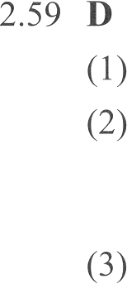
Cell membrane is selectively permeable.Some white blood cells produce antibodies to kill germs so that they are not phagocytic.Proteins scatter in mosaic form on both surfaces of the phospholipid layer.

128. pm5 x 10-6 m
= 20 x 103 = 20 000
2.73 A
Thylakoids (part 1) provide large surface area to absorb light (1) and carry out the photolysis of water (2).
Stroma (part 2) is the place where carbon fixation (Calvin cycle) takes place to produce sugars (1) and oxygen (2).
2.74 B
Ribosomes (1) are particles sticking on the rough endoplasmic reticulum (2) which is a membranous structure connected to the nucleus.
Smooth endoplasmic reticulum (3) has no particles on them.
Nucleolus (4) is a darkly stained body inside the nucleus.
2.75 A
The ribosomes (1) on the rough endoplasmicreticulum (2) carry out protein synthesis while the smooth endoplasmic reticulum (3) carry out the synthesis of lipids.
2.76 D
X is the rough endoplasmic reticulum that produces proteins by the ribosomes attaching on it. Insulin is a protein.
Y is the smooth endoplasmic reticulum that produces lipids. Many sex hormones are steroids.
2.77 A
X – Pancreas produces pancreatic juice which contains many enzymes. Enzymes are proteins.
Y – Oily glands in skin secrete oils which are lipids produced by the smooth endoplasmic reticulum.
2.78 A
The proteins produced by the rough endoplasmic reticulum are transported to the smooth endoplasmic reticulum where the proteins are secreted out through the cell membrane.
2.79 B
Krebs cycle takes place inside the matrix of the mitochondrion (1).
Calvin cycle takes place inside the stroma of the chloroplast (4).
2.80 A
Nucleolus (3) produces ribosomes. Ribosomes attaching on the rough endoplasmic reticulum (5) carry out protein synthesis.
2.81 C
Nucleus (1) contains DNA which controls all the metabolic activities of the cell. Chloroplast (2) and mitochondrion (3) also contain DNA that directs the replication of these organelles during cell division.
2.82 D
Nucleus (1) produces m-RNA which directs the synthesis of proteins on the ribosomes (2) attached on the rough endoplasmic reticulum (3). Nucleolus (4) produces r-RNA which is an important component of the ribosome formed by the nucleolus.
2.83 D
r-RNA as an important component of ribosome is produced by the nucleolus.
2.84 D
Phagocytosis occurs at the cell membrane where particles are engulfed into the cell.
2.85 B
Prokaryotes DO NOT have membranous organelles such as mitochondria (1), chloroplast (2) and nuclear membrane (3).
2.86 C
Bacteria (2) and blue green algae (4) are prokaryotes which have no nuclei.
2.87 D
Prokaryotes have no membranous organelles such as endoplasmic reticulum (1), nuclear membrane (3) and mitochondria (5). The DNA of their chromosomes (2) are NOT bound to proteins.
2.88 C
Eukaryotes have cell wall (1), cell membrane (2) and polysome (3). They have no capsule (4).

Answers
Answers are printed in red.
1. D. to highlight the nucleus.

2. B. pnq

3. A. (1) and (2) only
Class: 75.7% correct (n=70) usual slip D
4. D. (1), (2) and (3)

5. C. Observe a transparent ruler with graduation marks in mm under lower magnification.
Class: 82.9% correct (n=140) usual slip D
6. D

7. D. 10000 times

8. A. IB. II C. III D. IV Directions: Questions 9 to 11 refer to the four microscopes below which are used to observe the same slide of human blood smear.
Class: 61.4% correct (n=70) usual slip B
9. ?

10. B

11. A. dimmer and larger.B. dimmer and smaller.
Class: 75.7% correct (n=70) usual slip C
12. D. dilute glycerol solution.

13. ?

14. ?

15. ?

16. B. It provides energy for the cell.

17. A. (1) and (2) only
Class: 78.6% correct (n=70) usual slip C
18. D. (1), (2) and (3)

19. ?

20. D

21. ?

22. B. (2)

23. D. (3) and (4)

24. D. Mesophyll cell

25. B

26. D. (II), (III) and (V) only

27. C. (2) and (3) only

28. B

29. C. guard cell and mesophyll cell.

30. C

31. A. 1

32. D

33. ?

34. A. ChloroplastsB. Chromosomes C. Vacuoles D. Cell membrane

35. ?

36. B. (1) and (3) only

37. D
Class: 86.6% correct (n=134) usual slip B
38. ?

39. D. (3) and (5)
Class: 90.6% correct (n=64) usual slip A
40. D
Class: 89.6% correct (n=134) usual slip B
41. D. Move the microscope slide slightly to the right.
Class: 84.4% correct (n=64) usual slip B
42. D
Class: 57.8% correct (n=64) usual slip C
43. B. Use objective of lower power.
Class: 85.8% correct (n=134) usual slip D
44. D. Add stain to the tissues that gives colour to the structures of the cells.
Class: 95.3% correct (n=64) usual slip B
45. B
Class: 29.7% correct (n=64) usual slip A
46. C
Class: 57.8% correct (n=64) usual slip A
47. ?

48. B. (3), (4), (2), (5), (1)
Class: 50.7% correct (n=134) usual slip C
49. C. The maximum resolution of a light microscope is limited by the shortest wavelength of light.
Class: 57.8% correct (n=64) usual slip A
50. ?

51. A. The wavelength of electron beam is much shorter than that of light wave.
Class: 54.5% correct (n=134) usual slip B
52. ?

53. C. Chloroplast D. Lysosome
Class: 84.4% correct (n=64) usual slip A
54. B
Class: 62.7% correct (n=134) usual slip D
55. C
Class: 53.1% correct (n=64) usual slip A
56. D. (1), (2) and (3)
Class: 48.4% correct (n=64) usual slip C
57. D
Class: 82.8% correct (n=64) usual slip A
58. A. Nucleus B. Cytoplasm C. Cell wall D. Chloroplast
Class: 98.4% correct (n=64) usual slip B
59. B. (2) only
Class: 98.4% correct (n=64) usual slip A
60. D
Class: 100.0% correct (n=64) usual slip A
61. B. (2) and (4) only
Class: 62.5% correct (n=64) usual slip A
62. B
Class: 89.1% correct (n=64) usual slip C
63. B. a cell membrane with specific elasticity.
Class: 82.8% correct (n=64) usual slip D
64. C
Class: 98.4% correct (n=64) usual slip A
65. D
Class: 96.9% correct (n=64) usual slip A
66. D
Class: 85.9% correct (n=64) usual slip B
67. ?

68. D. 600
Class: 70.3% correct (n=64) usual slip B
69. A. 6
Class: 81.2% correct (n=64) usual slip B
70. D
Class: 81.2% correct (n=64) usual slip B
71. C
Class: 89.1% correct (n=64) usual slip D
72. ?

73. D
Class: 78.1% correct (n=64) usual slip C
74. D. (4) and (6) only
Class: 79.7% correct (n=64) usual slip C
75. A. Water, minerals and sucrose B. Proteins and lipids
Class: 93.8% correct (n=64) usual slip B
76. C. (2),(3),(5) and (6) only
Class: 100.0% correct (n=64) usual slip A
77. D
Class: 96.9% correct (n=64) usual slip C
78. A
Class: 67.2% correct (n=64) usual slip C
79. ?

80. A. (1) and (4) only

81. A. (1) only

82. B. (2) only

83. ?

84. D. It is a receptor site or recognition site to specific chemicals.

85. ?

86. A. (1) B. (2) C. (3) D. (4) Directions: Questions 2.51 to 2.57 refer to the diagram below, which represents the fluid mosaic model of the cell membrane.

87. C

88. B

89. D

90. C

91. B. 1.33 x 106

92. A. Carbohydrate B. Lipids C. Amino acids D. Nucleic acid

93. D. It allows small polar molecules to pass into the cell.

94. B. It is selectively permeable.

95. D

96. C. (1), (6) and (7) only
Class: 91.2% correct (n=57) usual slip A
97. C
Class: 93.0% correct (n=57) usual slip D
98. A. (3)
Class: 75.4% correct (n=57) usual slip D
99. C. Ribosome, mitochondrion, chloroplast, nucleus
Class: 80.7% correct (n=57) usual slip B
100. D
Class: 36.8% correct (n=57) usual slip C
101. C
Class: 87.7% correct (n=57) usual slip D
102. B
Class: 100.0% correct (n=57) usual slip A
103. D. (1) and (3) only
Class: 77.2% correct (n=57) usual slip A
104. C
Class: 40.4% correct (n=57) usual slip B
105. D. (1), (2) and (3)
Class: 42.1% correct (n=57) usual slip B
106. A. 1.14 m
Class: 40.4% correct (n=57) usual slip B
107. D
Class: 73.7% correct (n=57) usual slip A
108. C. 20 000
Class: 78.9% correct (n=57) usual slip D
109. A. (1) and (2) only B. (2) and (3) onlyC. (1), (2) and (3) only D. (2) and (4) only Directions: Questions 2.74 and 2.75 refer to the diagram at right, which shows some of the organelles in the cell.
Class: 78.9% correct (n=57) usual slip C
110. B
Class: 96.5% correct (n=57) usual slip A
111. A
Class: 94.7% correct (n=57) usual slip C
112. D
Class: 86.0% correct (n=57) usual slip B
113. A
Class: 87.7% correct (n=57) usual slip B
114. A. Rough endoplasmic reticulum Smooth endoplasmic reticulum Cell surface membrane
Class: 86.0% correct (n=57) usual slip D
115. B
Class: 82.5% correct (n=57) usual slip A
116. A. Part (3) produces ribosomes.
Class: 91.2% correct (n=57) usual slip C
117. C. (1), (2) and (3) only

118. D

119. D

120. D

121. B. (4), (5) and (6) only

122. C. (2) and (4) only

123. D. (1), (2), (3) and (5) only

124. ?

125. ?

126. ?

127. ?
Class: 84.4% correct (n=64) usual slip B
128. ?
Class: 84.4% correct (n=64) usual slip B

