Cellular organisation · items under 80% correct
Multiple-choice practice
Name: ________________________ Class: ____________
These items were answered correctly by fewer than 80% of students in class Google Forms, matched by the wording in the source bank and the form answer key. Choose the one best answer.
Part A — HKCEE level (Longman)
1. When compared with the object, the image seen under a microscope is (1) upside down. (2) laterally inverted. (3) diminished.
A. (1) and (2) only
B. (1) and (3) only
C. (2) and (3) only
D. (1), (2) and (3)
2. Which microscope is least likely to be aided with a table lamp for clear image?
Microscope | Average number of red blood cells counted in one view
P | 374
Q | 1586
R | 9625
S | 386

A. IB. II C. III D. IV Directions: Questions 9 to 11 refer to the four microscopes below which are used to observe the same slide of human blood smear.
3. Compared with that in microscope R, the image in microscope Q is
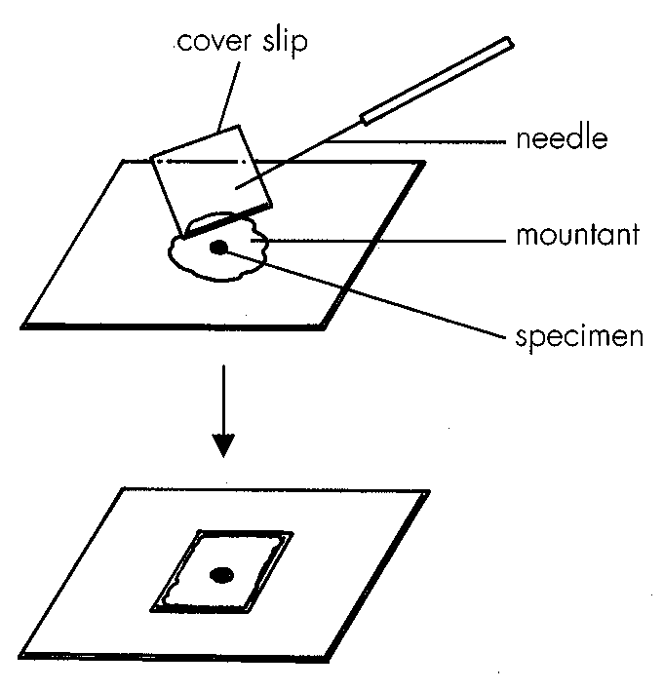
A. dimmer and larger.B. dimmer and smaller.
C. brighter and larger.D. brighter and smaller. Directions: Questions 12 and 13 refer to the following diagram which shows the last step in setting up a slide for microscopic observation.
4. Which of the following are the functions of cell wall? (1) It forms the framework of the cell. (2) It supports the cell. (3) It controls the movement of substances in and out of the cell.
A. (1) and (2) only
B. (1) and (3) only
C. (2) and (3) only
D. (1), (2) and (3)
Part B — HKDSE-style (YKTo)
5. Which of the following is/are the INCORRECT2.8 step(s) for using microscope?
(1) Tilt the microscope to an inclined position to enhance observing the specimen on a temporary mount slide.
(2) Use a plane mirror to reflect light to the specimen when the light source is weak.
(3) Move the body tube downward while looking through the eyepiece.
(4) Close one eye when observing the specimen under high power.
A. (1) only B. (2) and (3) only C. (3) and (4) only D. ALL
6. If a strip of the onion epidermal peel is stained with iodine solution, which of the following structures of a cell would be deeply stained?
A. Cell wall B. Nucleus C. Cytoplasm D. Vacuole
7. If the root tip squash is stained with acetocarmine, which of the following structures of a cell would be stained deep red?
A. Cell wall B. Cell membrane C. Chromosomes D. Chloroplast
8. Photomicrograph I is the image of the root section seen under a light microscope. Photomicrograph II is the image of the same section seen under another magnification of the microscope. Arrange the following steps in the right sequence to obtain the magnification needed to produce image II. Photomicrograph I Photomicrograph II (1) Use the fine adjustment knob to focus the specimen under high power. (2) Turn the nose piece to position the high-powered objective to be above the slide. (3) Use the coarse adjustment knob to focus the specimen under lower power. (4) Position the specimen to the centre of the field of view. (5) Lower the body tube until it is about 2 mm above the slide.
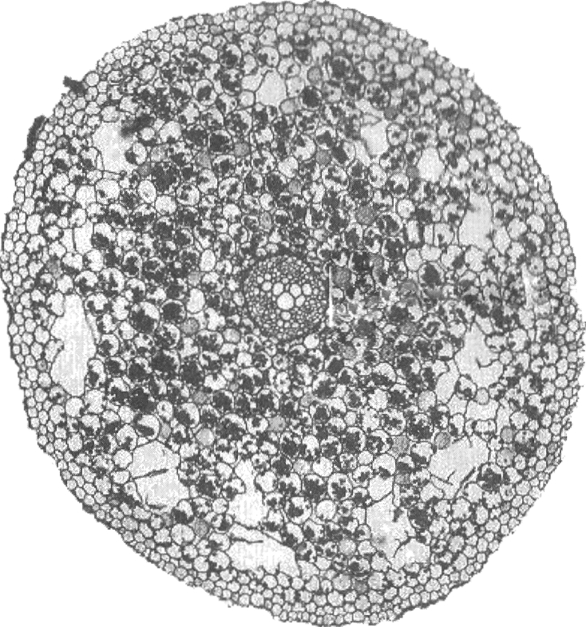
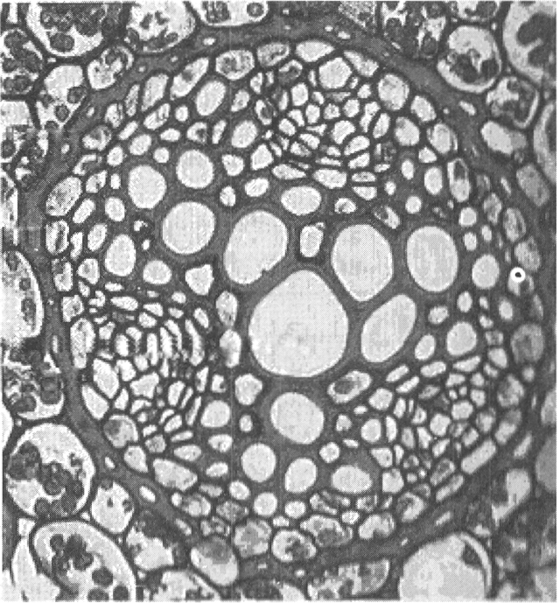
A. (4), (3), (2), (5), (1)
B. (3), (4), (2), (5), (1)
C. (5), (3), (2), (1), (4)
D. (2), (4), (1), (3), (5)
9. Light microscope cannot produce a magnification greater than 1 500 times. Which of the following is the reason to explain this limitation?
A. No optical lens is thick enough to refract light to produce such high magnification.
B. The light intensity of the normal light source provided by the table lamp is not bright enough to produce image of very high magnification.
C. The maximum resolution of a light microscope is limited by the shortest wavelength of light.
D. None of the above reasons is correct.
10. Which of the following is the reason that the resolution of an electron microscope is higher than that of a light microscope?
A. The wavelength of electron beam is much shorter than that of light wave.
B. The magnifying power of the electromagnetic lens of electron microscope is higher than that of the optical lens.
C. The velocity of electron beam is faster than that of light.
D. The energy of the electrons is stronger than that of light.
11. Which of the following structures of a cell can only be observed under an electron microscope, NOT a light microscope?
A. Chloroplast B. Endoplasmic reticulum C. Mitochondrion D. Nucleus
12. The following photomicrographs (1) to (3) are images of the same type of cells obtained by using three different microscopes.
Which of the following combinations TRULY represents the types of microscopes used to produce the related photomicrographs?
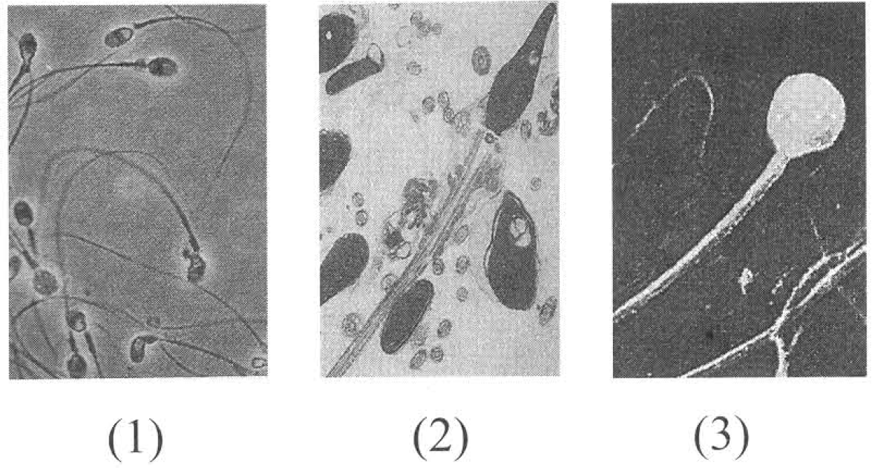
 | Light microscope | Transmission electron microscope | Scanning electron microscope
A. | (1) | (3) | (2)
B. | (3) | (1) | (2)
C. | (1) | (2) | (3)
D. | (2) | (3) | (1)

13. Which of the following part(s) of the microscope can affect the brightness of the image? (1) Minor (2) Iris diaphragm (3) High powered lens B. General structures of cells
A. (1) only
B. (2) only
C. (1) and (2) only
D. (1), (2) and (3)
14. Which of the following statements related with the cell wall is INCORRECT? (1) Cell wall is present in all plant cells. (2) Cell wall does not permit sucrose to pass through. (3) Cell wall is composed of cellulose and pectin. (4) Cell wall as part of the living cell can carry out metabolic activities.
A. (1) and (2) only
B. (2) and (4) only
C. (3) and (4) only
D. (1), (3) and (4) only
15. If the cheek cell drawn by a student on a report book is of 9 mm in diameter, the magnification of this drawing is
A. 20
B. 60
C. 200
D. 600
16. Which of the following parts is/are absent in the matured xylem cell?
A. (1) only B. (1) and (2) only C. (2) and (5) only D. All except (4)
17. Which part(s) of the cell is/are responsible to give support to the cell?
A. (1) only
B. (2) and (6) only
C. (4) only
D. (4) and (6) only
18. Which of the following differences between a spongy mesophyll cell and a root hair cell is INCORRECT?
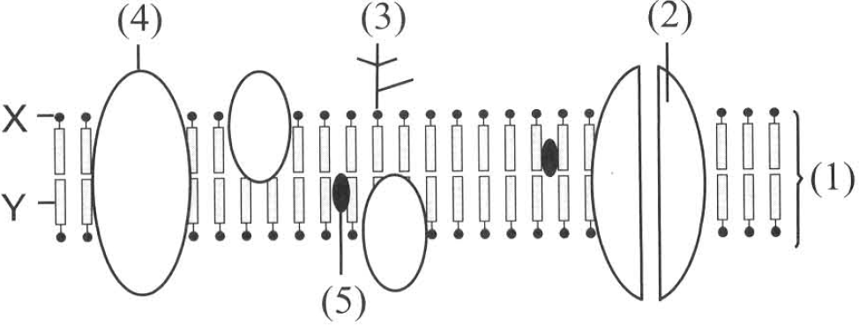
 | Spongy mesophyll cell | Root hair cell
A. | Gas exchange takes place over its surface. | Gas exchange cannot take place at its surface.
B. | It has chloroplasts. | It has no chloroplast.
C. | It has irregular shape. | It has regular shape with a finger-like projection.
D. | It manufactures food. | It cannot manufacture food.

D. Sub-cellular organelles Directions: Questions 2.43 to 22.50 refer to the diagram below, which represents a model of the cell membrane.
19. Where will sugar be oxidised anaerobically?
A. (3)
B. (5)
C. (6)
D. (7)
20. The key below is used to identify the following organelles of a cell.
(1) (a) | Bounded by a double unit membrane | 2
(b) | Not bounded by a double unit membrane | 4
(2) (a) | Membrane bears pores of size with diameter of 80-200nm | M
(b) | Membrane without pores of size with diameter of 80-200 nm | 3
(3) (a) | Inner membrane extends inwards and bears stalked particles | N
(b) | Inner membrane extends inwards and folds to form many flattened sacs | O
(4) (a) | Filled with fluid | P
(b) | Composed of concrete structures in form of one big and one small subunits | Q

 | M | N | O | P | Q
A. | Mitochondria | Chloroplast | Nucleus | Ribosome | Lysosome
B. | Chloroplast | Mitochondria | Ribosome | Nucleus | Lysosome
C. | Nucleus | Chloroplast | Mitochondria | Lysosome | Ribosome
D. | Nucleus | Mitochondria | Chloroplast | Lysosome | Ribosome

21. Which of the following differences between organelles X and Y are CORRECT?
 | Organelle X | Organelle Y
(1) | It carries out catabolic activities. | It carries out anabolic activities.
(2) | It produces NADPH. | It produces NADH.
(3) | The inner membrane of the envelope extends into ridges to facilitate the release of energy. | The inner membrane of the envelope extends into sheet-like structures to maximise the absorption of light.
(4) | It is present in animal cells only. | It is present in all plant cells.

A. (1) and (2) only
B. (2) and (4) only
C. (3) and (4) only
D. (1) and (3) only
22. Which of the following about organelles X and Y are INCORRECT?
(1) All the reactions inside organelle X can only take place in darkness while those in organelle Y can only take place in light.
(2) Conversion of energy occurs in both organelles.
(3) ATP is produced by both organelles.
(4) Both organelles can be found in all the cells in a leaf
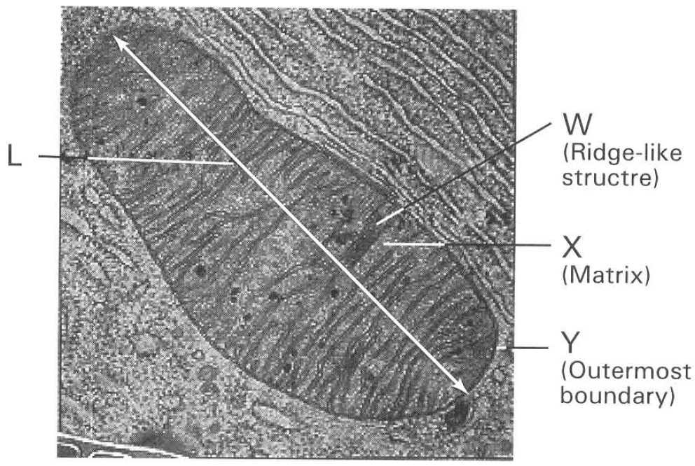
A. (1) only B. (2) and (3) only C. (1) and (4) only D. (2) and (4) only Directions: Questions 2.70 and 2.71 refer to the photomicrograph of an organelle below.
23. Which of the following compounds are BOTH possessed by these two organelles? (1) Simple sugars (2) Enzymes (3) DNA
A. (1) only
B. (1) and (2) only
C. (2) and (3) only
D. (1), (2) and (3)
24. The power of magnification of this photomicrograph is x 50 000. What is the actual length (L) of the organelle shown in the photomicrograph?
A. 1.14 m
B. 0.80 m
C. 0.80 m
D. 1.14 m
25. Which of the following combinations of the functions performed by the parts related are CORRECT?
Directions: Questions 2.72 and 2.73 refer to the photomicrograph of an organelle below.
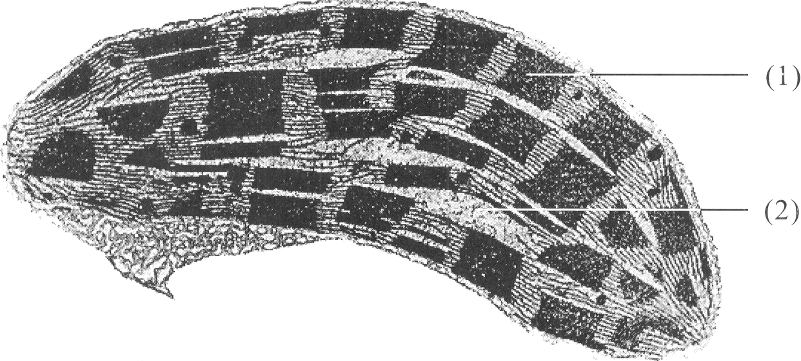
 | W | X | Y
A. | Production of proteins | Krebs cycle occurs | Oxidative phosphorylation
B. | Krebs cycle occurs | Oxidative phosphorylation | Production of proteins
C. | Oxidative phosphorylation | Production of proteins | Krebs cycle occurs
D. | Oxidative phosphorylation | Krebs cycle occurs | Control passage of substancesinto and out of the organelle

26. If the actual length of the organelle shown is 5 um, what is the power of magnification of the photomicrograph?
A. 50 000
B. 5 000
C. 20 000
D. 2 000
27. Which of the following combinations about the structures and / or functions of parts (1) and (2) are CORRECT?
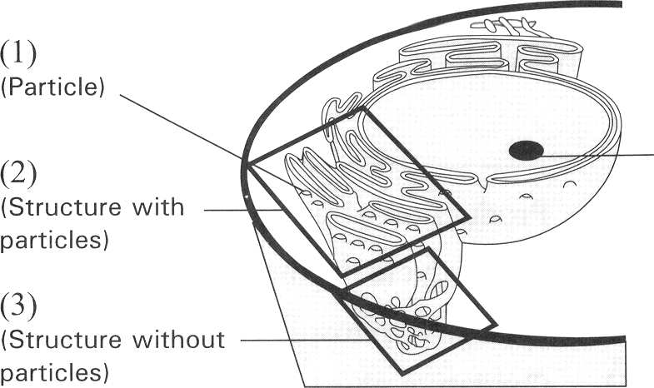
 | Part (1) | Part (2)
(1) | Absorption of light energy | Production of sugars
(2) | Photolysis occurs. | Oxygen is released by reactions taking place there.
(3) | Carbon fixation occurs | Photophosphorylation occurs
(4) | Calvin cycle occurs | Krebs cycle occurs

A. (1) and (2) only B. (2) and (3) onlyC. (1), (2) and (3) only D. (2) and (4) only Directions: Questions 2.74 and 2.75 refer to the diagram at right, which shows some of the organelles in the cell.

Answers
Answers are printed in red.
1. A. (1) and (2) only
Class: 75.7% correct (n=70) usual slip D
2. A. IB. II C. III D. IV Directions: Questions 9 to 11 refer to the four microscopes below which are used to observe the same slide of human blood smear.
Class: 61.4% correct (n=70) usual slip B
3. A. dimmer and larger.B. dimmer and smaller.
Class: 75.7% correct (n=70) usual slip C
4. A. (1) and (2) only
Class: 78.6% correct (n=70) usual slip C
5. D
Class: 57.8% correct (n=64) usual slip C
6. B
Class: 29.7% correct (n=64) usual slip A
7. C
Class: 57.8% correct (n=64) usual slip A
8. B. (3), (4), (2), (5), (1)
Class: 50.7% correct (n=134) usual slip C
9. C. The maximum resolution of a light microscope is limited by the shortest wavelength of light.
Class: 57.8% correct (n=64) usual slip A
10. A. The wavelength of electron beam is much shorter than that of light wave.
Class: 54.5% correct (n=134) usual slip B
11. B
Class: 62.7% correct (n=134) usual slip D
12. C
Class: 53.1% correct (n=64) usual slip A
13. D. (1), (2) and (3)
Class: 48.4% correct (n=64) usual slip C
14. B. (2) and (4) only
Class: 62.5% correct (n=64) usual slip A
15. D. 600
Class: 70.3% correct (n=64) usual slip B
16. D
Class: 78.1% correct (n=64) usual slip C
17. D. (4) and (6) only
Class: 79.7% correct (n=64) usual slip C
18. A
Class: 67.2% correct (n=64) usual slip C
19. A. (3)
Class: 75.4% correct (n=57) usual slip D
20. D
Class: 36.8% correct (n=57) usual slip C
21. D. (1) and (3) only
Class: 77.2% correct (n=57) usual slip A
22. C
Class: 40.4% correct (n=57) usual slip B
23. D. (1), (2) and (3)
Class: 42.1% correct (n=57) usual slip B
24. A. 1.14 m
Class: 40.4% correct (n=57) usual slip B
25. D
Class: 73.7% correct (n=57) usual slip A
26. C. 20 000
Class: 78.9% correct (n=57) usual slip D
27. A. (1) and (2) only B. (2) and (3) onlyC. (1), (2) and (3) only D. (2) and (4) only Directions: Questions 2.74 and 2.75 refer to the diagram at right, which shows some of the organelles in the cell.
Class: 78.9% correct (n=57) usual slip C

Class percentage correct
Matched to this paper by question wording in the source bank and the form answer key, not by a shifted paper number.
Q | Answer | % correct | n | Usual slip
1 | A | 75.7% | 70 | D
2 | A | 61.4% | 70 | B
3 | A | 75.7% | 70 | C
4 | A | 78.6% | 70 | C
5 | D | 57.8% | 64 | C
6 | B | 29.7% | 64 | A
7 | C | 57.8% | 64 | A
8 | B | 50.7% | 134 | C
9 | C | 57.8% | 64 | A
10 | A | 54.5% | 134 | B
11 | B | 62.7% | 134 | D
12 | C | 53.1% | 64 | A
13 | D | 48.4% | 64 | C
14 | B | 62.5% | 64 | A
15 | D | 70.3% | 64 | B
16 | D | 78.1% | 64 | C
17 | D | 79.7% | 64 | C
18 | A | 67.2% | 64 | C
19 | A | 75.4% | 57 | D
20 | D | 36.8% | 57 | C
21 | D | 77.2% | 57 | A
22 | C | 40.4% | 57 | B
23 | D | 42.1% | 57 | B
24 | A | 40.4% | 57 | B
25 | D | 73.7% | 57 | A
26 | C | 78.9% | 57 | D
27 | A | 78.9% | 57 | C

