Classification
Multiple-choice practice
Name: ________________________ Class: ____________
There are 38 questions compiled from Longman HKCEE and/or YKTo papers. Choose the one best answer.
Part A — HKCEE level (Longman)
1. Which of the following arranges the taxonomic groups in ascending group size?
A. Species, genus, family, order, class, phylum, kingdom
B. Genus, species, phylum, family, order, class, kingdom
C. Species, genus, class, order, family, phylum, kingdom
D. Genus, species, order, class, family, kingdom, phylum
2. Animals are classified as invertebrates if
A. they have no legs.
B. they have no backbones.
C. they are coldblooded.-
D. they have exoskeletons.
3. All birds belong to the same (1) kingdom. (2) phylum. (3) species.
A. (1) and (2) only
B. (1) and (3) only
C. (2) and (3) only
D. (1), (2) and (3)
4. Which of the following vertebrate groups are warm blooded?- (1) Birds (2) Reptiles (3) Mammals (4) Amphibians
A. (1) and (2) only
B. (1) and (3) only
C. (3) and (4) only
D. (2), (3) and (4) only
5. Which of the following vertebrate groups carry out internal fertilisation? (1) Birds (2) Reptiles (3) Mammals (4) Amphibians
A. (1) and (2) only
B. (2) and (3) only
C. (3) and (4) only
D. (1), (2) and (3) only
6. Which of the following vertebrate groups lay shelled eggs? (1) Birds (2) Fish (3) Reptiles (4) Amphibians D. (1), (3) and (4) only 7.Snakes, sharks and pigeons are all classified as vertebrates because (1) they have backbones. (2) they are cold blooded.- (3) they have scales. A. (1) Only B. (1) and (2) only C. (2) and (3) only D. (1), (2) and (3) only
A. (1) and (2) only
B. (1) and (3) only
C. (2) and (4) only
D. (1), (3) and (4) only 7.Snakes, sharks and pigeons are all classified as vertebrates because (1) they have backbones. (2) they are cold blooded.- (3) they have scales.
7. Which of the following features can be used to distinguish birds from other vertebrates?
A. Birds have wings. B. Birds have scales on their feet.
C. Birds lay shelled eggs. D. Birds have feathers.
8. Which of the following matches the vertebrate groups correctly with their external covering?
 | Feathers | Scales | Hair
A. | Reptiles | Birds | Fish
B. | Mammals | Fish | Birds
C. | Birds | Reptiles | Mammals
D. | Birds | Fish | Reptiles

9. Vertebrates which can breathe through moist skin are
A. mammals.
B. amphibians.
C. birds.
D. fish.
10. Which of the following diagrams represents the correct relationships among the given groups of living organisms?
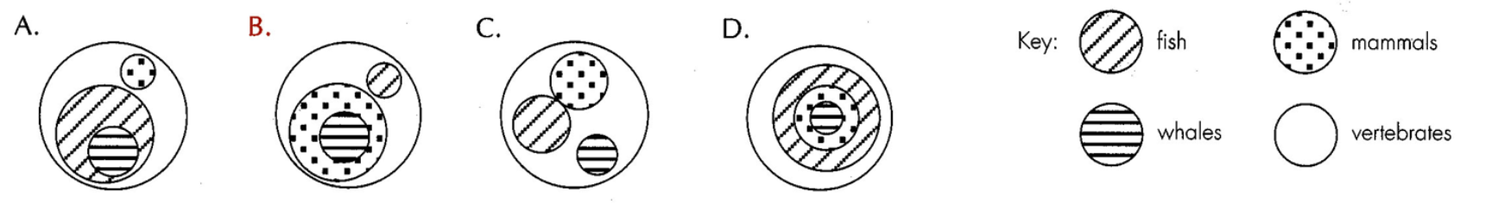
11. The table below lists some features of four different animals. Which of the above animals is a mammal?
Animal 1 | Animal 2 | Animal 3 | Animal 4
backbone | beak | four limbs | wet skin
scales | feathers | mammary glands | four limbs
tail | wings | wings | webbed feet

A. 1
B. 2
C. 3
D. 4
12. The chart on the right lists some features of four animals W, X, Y and Z.
These four animals could be
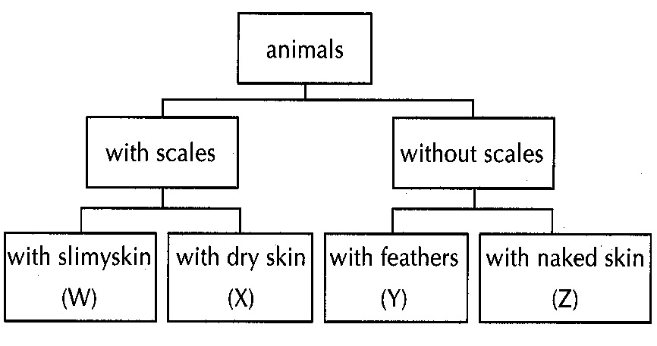
 | W | X | Y | Z
A. | toad | sparrow | snake | eel
B. | eel | snake | sparrow | toad
C. | snake | toad | sparrow | eel
D. | eel | sparrow | snake | toad

13. possesses wet scales …………………….. O
possesses dry scales ……………………… P
Which of the following matching is correct?
Directions: Questions 15 to 18 refer to the diagrams below which show a range of marine animals.
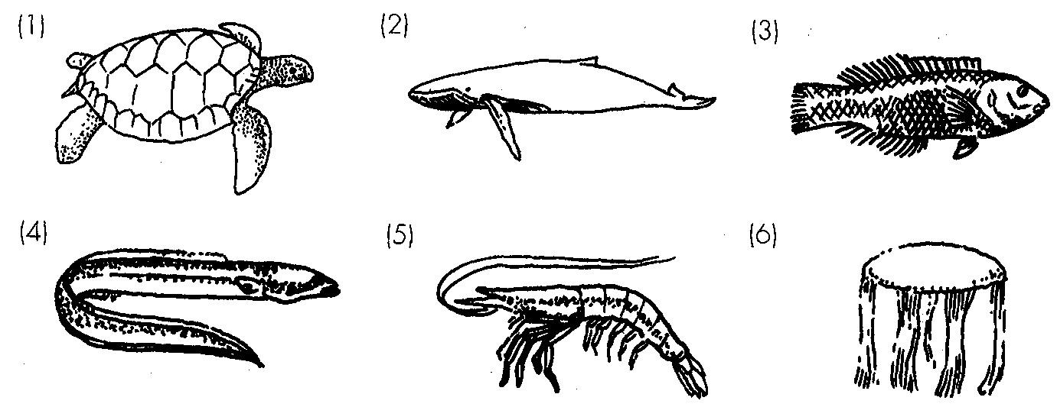
 | M | N | O | P
A. | goldfish | snake | frog | cockroach
B. | frog | cockroach | goldfish | snake
C. | snake | cockroach | frog | goldfish
D. | frog | goldfish | cockroach | snake

14. Which of the following animals should be put in the same group as snakes?
A. (1) only
B. (1) and (3) only
C. (3) and (4) only
D. (1), (3) and (4) only
15. The animals can be classified as either vertebrates or invertebrates. Which of the following is a correct matching?
 | Vertebrates | Invertebrates
A. | (1), (2), (3) and (4) | (5) and (6)
B. | (1) and (2) | (3), (4), (5) and (6)
C. | (2), (3) and (4) | (1), (5) and (6)
D. | (5) and (6) | (1), (2), (3) and (4)

16. Which of the following comparisons between the structural features of (2) and (3) is incorrect?
 | (2) | (3)
A. | possesses lungs | possesses gills
B. | body covered with wet hair | body covered with wet scales
C. | possesses milk glands | does not possess milk glands
D. | possesses diaphragm | does not possess diaphragm

17. The population of (1) in Nature has decreased continuously in recent years. Which of the following is/are the possible causes) for this?
(1) Commercial exploitation of the animal by human
(2) Habitat destruction as a result of pollution or modified land use
(3) Outcompeted by other species
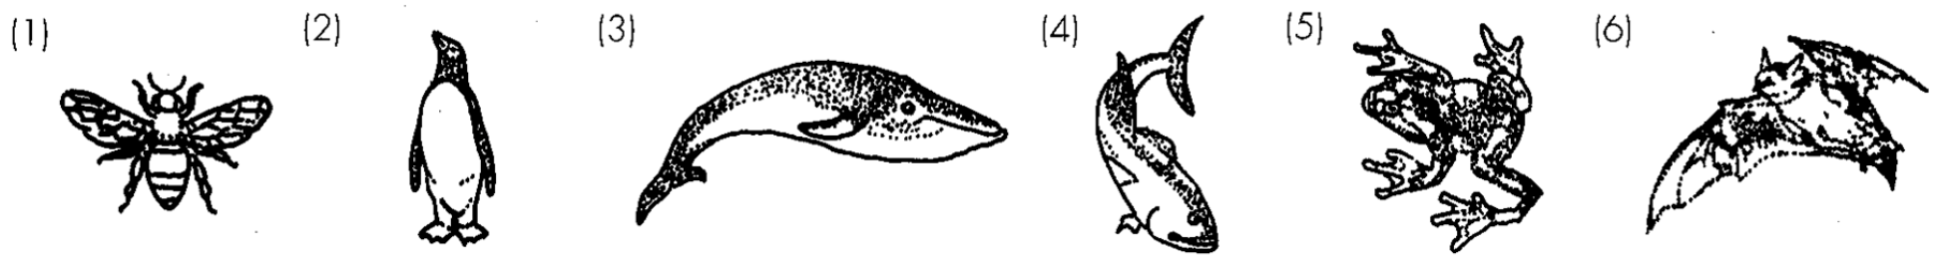
A. (1) only B. (2) only . C. (1) and (2) only D. (1), (2) and (3) Directions: Questions 19 to 21 refer to the diagrams below which show a variety of animals.
18. All the animals shown except (1) can be classified into one group. Which of the following shows the correct match between the group and the feature on which this classification is based?
 | Group | Feature
A. | vertebrates | limbs
B. | vertebrates | backbone
C. | invertebrates | limbs
D. | invertebrates | backbone

19. Two of the above animals belong to the same group as dolphin. Which of the following describes this group and the two animals correctly?
 | Group | Animals
A. | fish | (3) and (4)
B. | bird | (2) and (6)
C. | mammal | (2) and (3)
D. | mammal | (3) and (6)

20. The respiratory structures unique to animals (4) and (5) are respectively
Directions: Questions 22 to 24 refer to the diagrams below which show some living organisms found in a gei wai at Mai Po.
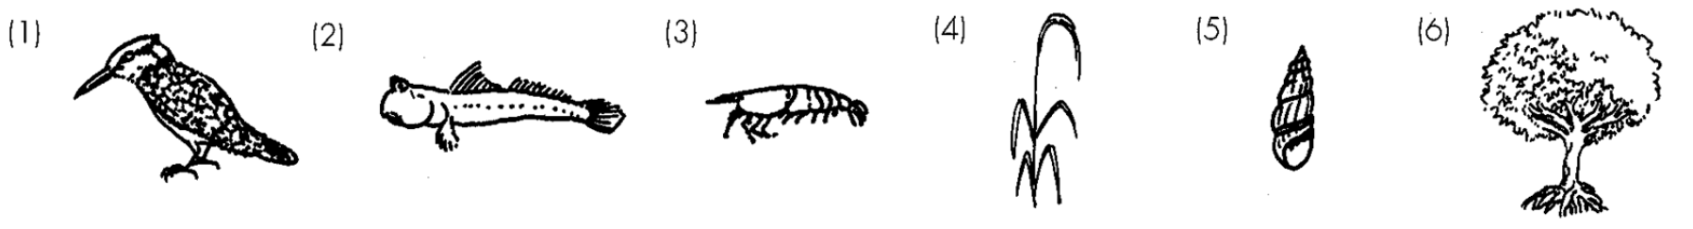
 | (4) | (5 )
A. | lungs | gills
B. | skin | gills
C. | gills | skin
D. | skin | lungs

21. Two of the organisms are invertebrates. They are
A. (1) and (2).
B. (2) and (3).
C. (3) and (5).
D. (4) and (6).
22. Which of the following statements is/are incorrect? (1) (4) is a non flowering plant.- (2) (2) is an amphibian. (3) (6) is a flowering plant.
A. (1) only
B. (2) only
C. (1) and (2) only
D. (2) and (3) only.
23. A dichotomous key to identify some of the above organisms is shown below.
a. With hard outer covering ……… go to b
Without hard outer covering …… go to c
b With legs ………………………. Gei waishrimp
Without legs …………………… Snail
c With feathers ………………….. Kingfisher
Without feathers ………………. Mudskipper
What are organisms (1) and (3)?
 | (1) | (3)
A. | Mudskipper | Snail
B. | Kingfisher | Gei wai shrimp
C. | Mudskipper | Gei wai shrimp
D. | Kingfisher | Snail

24. Which of the following features is common to all plants?
A. Flowers B. Cells with cell walls C. Chlorophyll D. Leaves
25. Which of the following plant groups have no vascular tissues? (1) Ferns (2) Fungi (3) Algae
A. (1) and (2) only
B. (1) and (3) only
C. (2) and (3) only
D. (1), (2) and (3)
26. Which of the following groups of plants possesses veined leaves but cannot produce seeds?
A. Gymnosperms
B. Fungi
C. Mosses
D. Ferns
27. Which of the following structures is present in gymnosperms but not in ferns?
A. Flowers
B. Seeds
C. Vascular tissues
D. Spores
28. Which of the following describe correctly the features of the plant shown in the diagram below?
(1) It produces spores.(2) It has leaves and roots. (3) It develops cones.
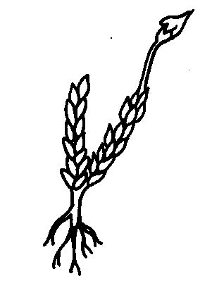
Plant | Features
 | Flowers | Seeds | Chlorophyll
(1) | + | + | -
(2) | - | - | -
(3) | - | + | +
(4) | + | + | +

A. (1) only B. (1) and (2) only C. (2) and (3) only D. (1), (2) and (3) Directions: Questions 30 to 32 refer to the table below which shows some features of four plants. Key: + present absent-
29. Two of the four plants can be put into the same major group. Which of the following is a correct matching?
 | The two plants are | The major group is
A. | (1) and (2) | fungi
B. | (3) and (4) | gymnosperms
C. | (2) and (3) | mosses
D. | (1) and (4) | flowering plants

30. Which of the following plants possesses the same features as plant (2)?
A. Pine
B. Mushroom
C. Grass
D. Spirogyra
31. What is the most likely mode of nutrition of plant (1)?
A. Autotrophic B. Saprophytic C. ParasiticD. Holozoic
32. The chart below describes some features of four plants P, Q, R and S.
These four plants could be
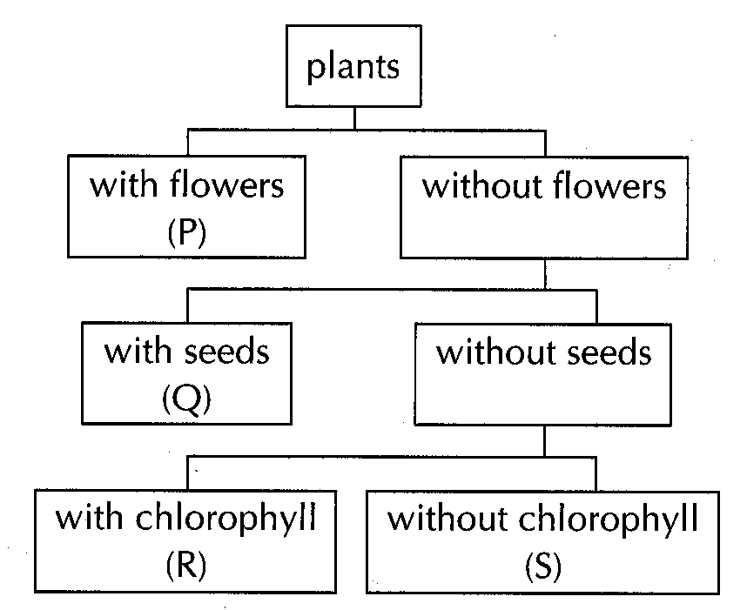
 | P | Q | R | S
A. | flowering plant | gymnosperm | fern | fungus
B. | flowering plant | fern | alga | moss
C. | gymnosperm | flowering plant | moss | fungus
D. | alga | gymnosperm | fern | moss

33. a with chlorophyll ………………. 2 1 b without chlorophyll ……………. W 2 a with flowers …………………… X 2b without flowers ………………… 3 3a with seeds ………………………. Y 3b without seeds ……………………Z
Which of the following key sequences correctly describes the identification of the plant shown below?
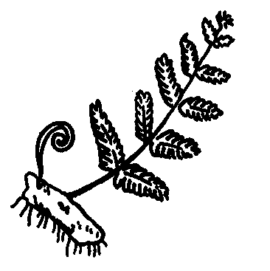
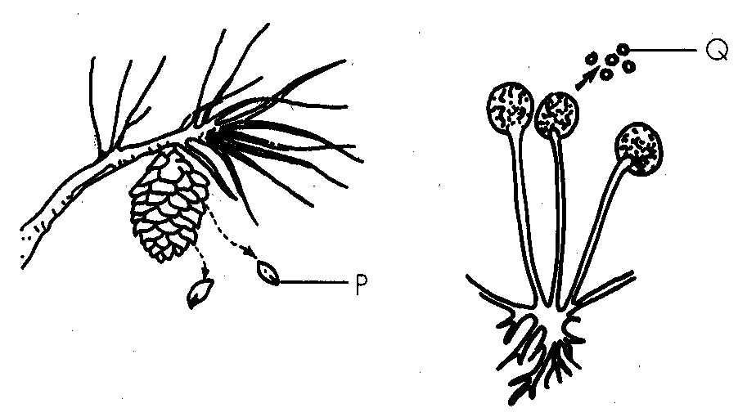
A. 1 b W B. 1 a 2a X
C. 1 a 2b 3a Y D. 1 a 2b 3b Z Directions: Questions 35 and 36 refer to the diagrams on the right which show two kinds of plants.
34. Which of the following features can be used to distinguish these two kinds of plants?
(1) Flower (2) Seed (3) Chlorophyll
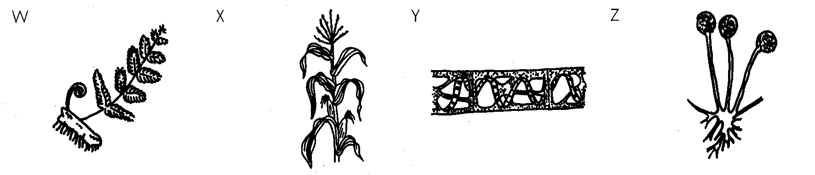
 | P | Q
A | cone | sporangium
B | seed | sporangium
C | cone | spore
D | seed | spore

A. (3) only B. (1) and (2) only C. (1) and (3) only D. (2) and (3) only 36.Structures P and Q are Directions: Questions 37 and 38 refer to the diagrams below which show a variety of plants.
35. Which plant is correctly classified?
 | Plant | Major group
A. | W | mosses
B. | X | flowering plants
C. | Y | fungi
D. | Z | algae

36. Which of the following descriptions is incorrect?
 |  | Features
Organism | Habitat | Root | Stem | Leaf | Chlorophyll | Other features
(1) | land | + | + | + | + | possesses seeds
(2) | water | - | - | - | + | filamentous
(3) | land | - | - | - | - | hairs present
(4) | land | - | - | - | - | hyphae present
(5) | water | - | - | - | - | scales present

A. W produces spores. B. X has leaves with netted veins.
C. Y has chlorophyll. D. Z has hyphae. Directions: Questions 39 & 40 refer to the table below which summarises some of the features in organisms (1) to (5). Keys: + presence absence-
37. What is/are the possible major plant group(s) to which organism (1) belongs?
A. Flowering plants
B. Gymnosperms
C. Ferns or flowering plants
D. Gymnosperms or flowering plants
38. Which organism(s) is/are animal(s)?
A. (3) only
B. (2) and (3) only
C. (3) and (5) only
D. (4) and (5) only

Answers
Answers are printed in red.
1. A. Species, genus, family, order, class, phylum, kingdom

2. B. they have no backbones.

3. A. (1) and (2) only

4. B. (1) and (3) only

5. D. (1), (2) and (3) only

6. ?

7. D

8. C

9. B. amphibians.

10. ?

11. C. 3

12. B

13. B

14. ?

15. A

16. B

17. D

18. B

19. D

20. C

21. C. (3) and (5).

22. C. (1) and (2) only

23. ?

24. ?

25. C. (2) and (3) only

26. D. Ferns

27. ?

28. A. (1) only B. (1) and (2) only C. (2) and (3) only D. (1), (2) and (3) Directions: Questions 30 to 32 refer to the table below which shows some features of four plants. Key: + present absent-

29. D

30. B. Mushroom

31. C

32. A

33. ?

34. D

35. B

36. B

37. D. Gymnosperms or flowering plants

38. C. (3) and (5) only

