Classification · items under 80% correct
Multiple-choice practice
Name: ________________________ Class: ____________
No classroom item analysis matched this topic reliably. Items below are those predicted to be answered correctly by fewer than 80% of students. Choose the one best answer.
Part A — HKCEE level (Longman)
1. Which of the following statements is/are incorrect? (1) (4) is a non flowering plant.- (2) (2) is an amphibian. (3) (6) is a flowering plant.
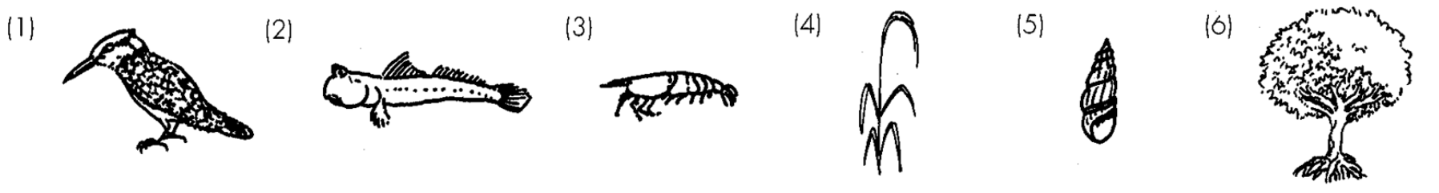
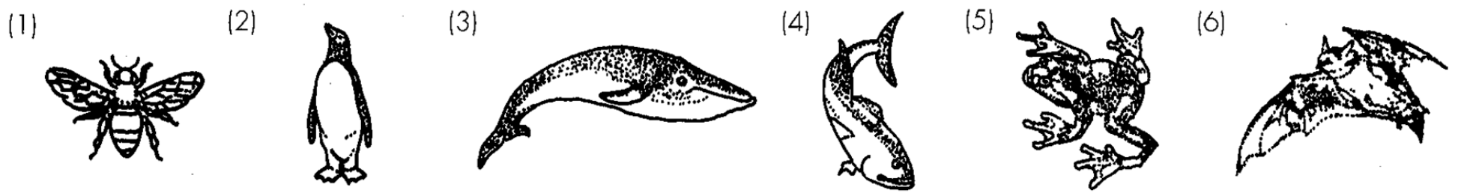
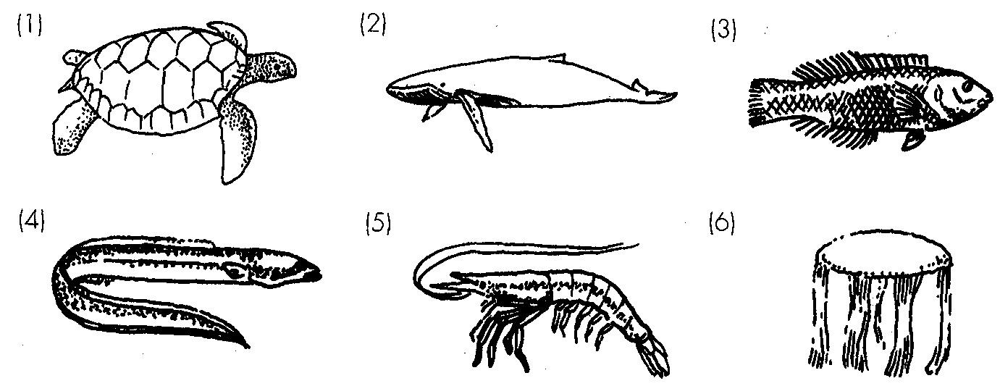
A. (1) only
B. (2) only
C. (1) and (2) only
D. (2) and (3) only.
2. The population of (1) in Nature has decreased continuously in recent years. Which of the following is/are the possible causes) for this?
(1) Commercial exploitation of the animal by human
(2) Habitat destruction as a result of pollution or modified land use
(3) Outcompeted by other species
A. (1) only B. (2) only . C. (1) and (2) only D. (1), (2) and (3) Directions: Questions 19 to 21 refer to the diagrams below which show a variety of animals.
3. Two of the organisms are invertebrates. They are
A. (1) and (2).
B. (2) and (3).
C. (3) and (5).
D. (4) and (6).
4. Which of the following describe correctly the features of the plant shown in the diagram below?
(1) It produces spores.(2) It has leaves and roots. (3) It develops cones.
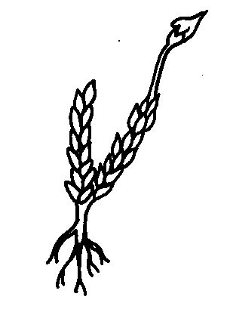
Plant | Features
 | Flowers | Seeds | Chlorophyll
(1) | + | + | -
(2) | - | - | -
(3) | - | + | +
(4) | + | + | +

A. (1) only B. (1) and (2) only C. (2) and (3) only D. (1), (2) and (3) Directions: Questions 30 to 32 refer to the table below which shows some features of four plants. Key: + present absent-
5. Which of the following features can be used to distinguish these two kinds of plants?
(1) Flower (2) Seed (3) Chlorophyll
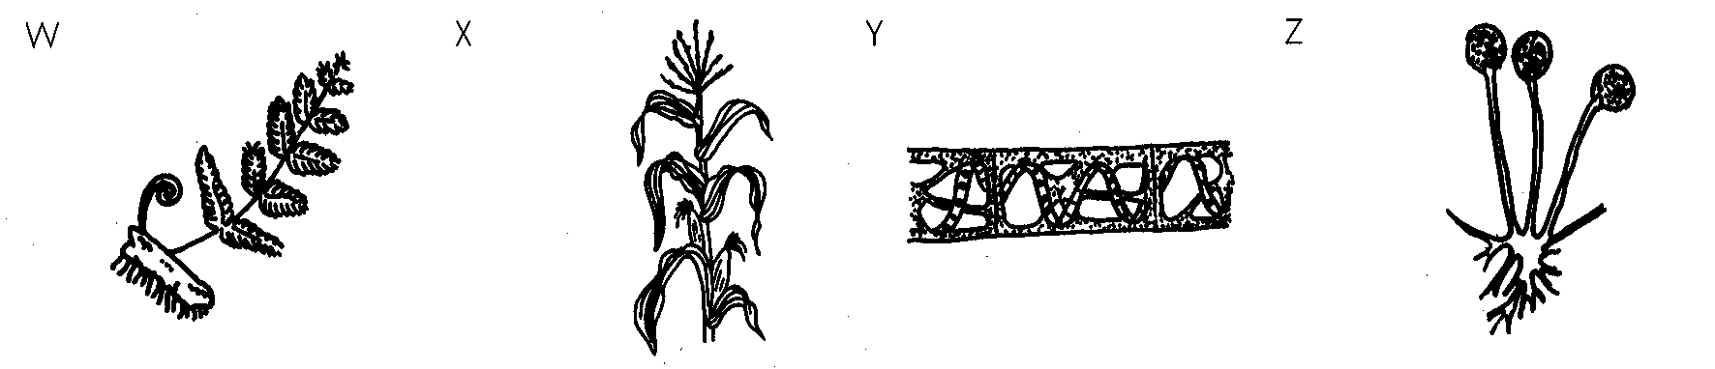
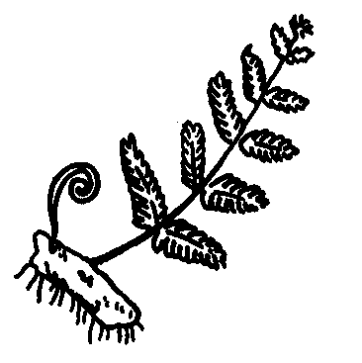
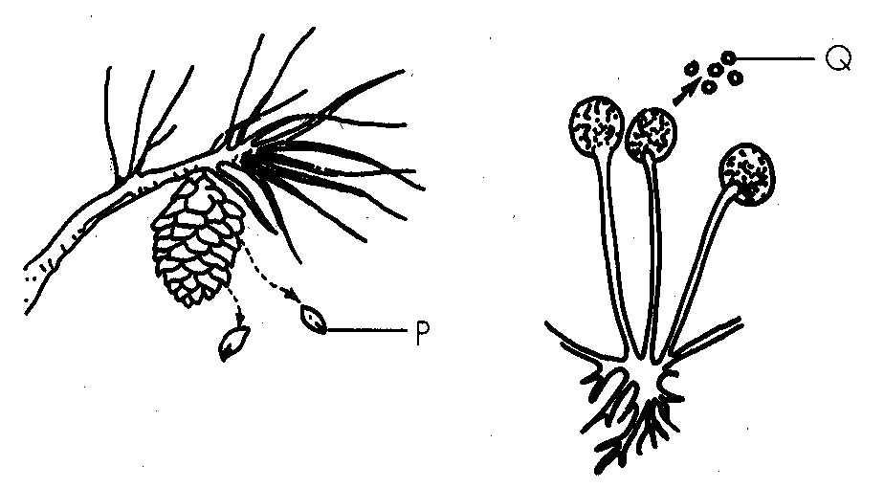
 | P | Q
A | cone | sporangium
B | seed | sporangium
C | cone | spore
D | seed | spore

A. (3) only B. (1) and (2) only C. (1) and (3) only D. (2) and (3) only 36.Structures P and Q are Directions: Questions 37 and 38 refer to the diagrams below which show a variety of plants.
6. Which of the following comparisons between the structural features of (2) and (3) is incorrect?
 | (2) | (3)
A. | possesses lungs | possesses gills
B. | body covered with wet hair | body covered with wet scales
C. | possesses milk glands | does not possess milk glands
D. | possesses diaphragm | does not possess diaphragm

7. All the animals shown except (1) can be classified into one group. Which of the following shows the correct match between the group and the feature on which this classification is based?
 | Group | Feature
A. | vertebrates | limbs
B. | vertebrates | backbone
C. | invertebrates | limbs
D. | invertebrates | backbone

8. Which of the following descriptions is incorrect?
 |  | Features
Organism | Habitat | Root | Stem | Leaf | Chlorophyll | Other features
(1) | land | + | + | + | + | possesses seeds
(2) | water | - | - | - | + | filamentous
(3) | land | - | - | - | - | hairs present
(4) | land | - | - | - | - | hyphae present
(5) | water | - | - | - | - | scales present

A. W produces spores. B. X has leaves with netted veins.
C. Y has chlorophyll. D. Z has hyphae. Directions: Questions 39 & 40 refer to the table below which summarises some of the features in organisms (1) to (5). Keys: + presence absence-
9. All birds belong to the same (1) kingdom. (2) phylum. (3) species.
A. (1) and (2) only
B. (1) and (3) only
C. (2) and (3) only
D. (1), (2) and (3)
10. Which of the following vertebrate groups are warm blooded?- (1) Birds (2) Reptiles (3) Mammals (4) Amphibians
A. (1) and (2) only
B. (1) and (3) only
C. (3) and (4) only
D. (2), (3) and (4) only
11. Which of the following vertebrate groups carry out internal fertilisation? (1) Birds (2) Reptiles (3) Mammals (4) Amphibians
A. (1) and (2) only
B. (2) and (3) only
C. (3) and (4) only
D. (1), (2) and (3) only
12. Which of the following vertebrate groups lay shelled eggs? (1) Birds (2) Fish (3) Reptiles (4) Amphibians D. (1), (3) and (4) only 7.Snakes, sharks and pigeons are all classified as vertebrates because (1) they have backbones. (2) they are cold blooded.- (3) they have scales. A. (1) Only B. (1) and (2) only C. (2) and (3) only D. (1), (2) and (3) only
A. (1) and (2) only
B. (1) and (3) only
C. (2) and (4) only
D. (1), (3) and (4) only 7.Snakes, sharks and pigeons are all classified as vertebrates because (1) they have backbones. (2) they are cold blooded.- (3) they have scales.

Answers
Answers are printed in red.
1. C. (1) and (2) only
Predicted class correct ≈ 50% (no classroom match)
2. D
Predicted class correct ≈ 57% (no classroom match)
3. C. (3) and (5).
Predicted class correct ≈ 57% (no classroom match)
4. A. (1) only B. (1) and (2) only C. (2) and (3) only D. (1), (2) and (3) Directions: Questions 30 to 32 refer to the table below which shows some features of four plants. Key: + present absent-
Predicted class correct ≈ 57% (no classroom match)
5. D
Predicted class correct ≈ 57% (no classroom match)
6. B
Predicted class correct ≈ 60% (no classroom match)
7. B
Predicted class correct ≈ 60% (no classroom match)
8. B
Predicted class correct ≈ 60% (no classroom match)
9. A. (1) and (2) only
Predicted class correct ≈ 62% (no classroom match)
10. B. (1) and (3) only
Predicted class correct ≈ 62% (no classroom match)
11. D. (1), (2) and (3) only
Predicted class correct ≈ 62% (no classroom match)
12. ?
Predicted class correct ≈ 62% (no classroom match)

Class percentage correct
Matched to this paper by question wording in the source bank and the form answer key, not by a shifted paper number.
Q | Answer | % correct | n | Usual slip
1 | C | 50.0% | pred | —
2 | D | 57.0% | pred | —
3 | C | 57.0% | pred | —
4 | A | 57.0% | pred | —
5 | D | 57.0% | pred | —
6 | B | 60.0% | pred | —
7 | B | 60.0% | pred | —
8 | B | 60.0% | pred | —
9 | A | 62.0% | pred | —
10 | B | 62.0% | pred | —
11 | D | 62.0% | pred | —
12 | ? | 62.0% | pred | —

