Nervous and hormonal coordination
Multiple-choice practice
Name: ________________________ Class: ____________
There are 55 questions compiled from Longman HKCEE and/or YKTo papers. Choose the one best answer.
Part A — HKDSE-style (YKTo)
1. Which of the following matching is CORRECT?
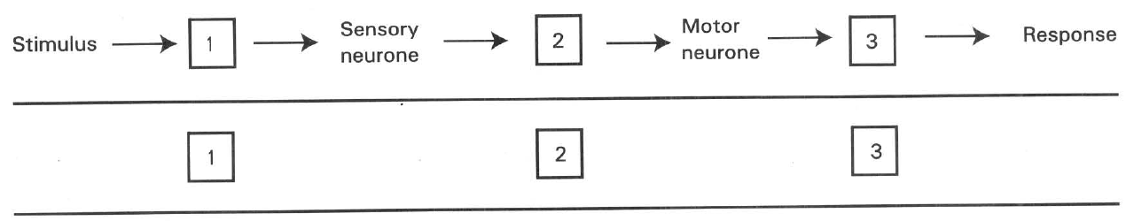
A. | Stretch receptor below the knee cap | Spinal cord | Extensor
B. | Pain receptors on skin of arm | Medulla of the brain | Triceps
C. | Cones in the retina | Cerebellum | Circular muscles in iris
D. | Hair cells in the cochlea | Cerebellum | Salivary gland

2. Which of the following pairings is INCORRECT?
Directions: Questions 3 to 5 refer to the diagram below, which shows a reflex arc in the nervous system.
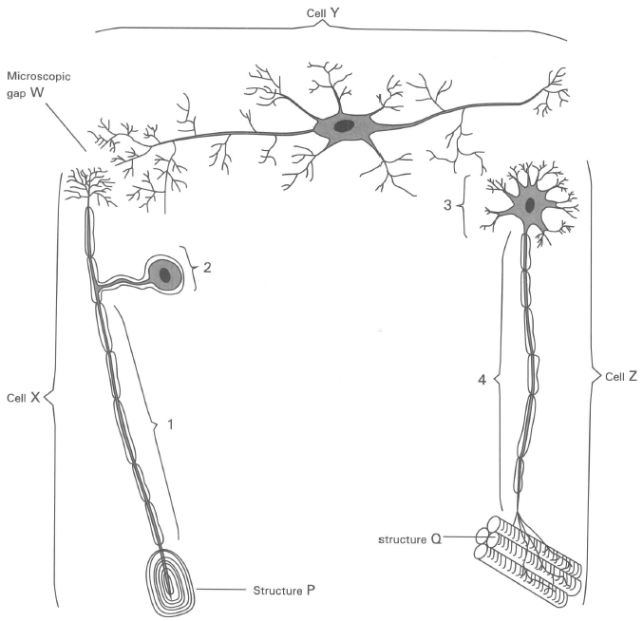
 | Structure | Function
A. | Effector | In form of a gland or muscle to give a response.
B. | Sensory neurones | Cells that pass nerve impulses towards the central nervous system.
C. | Receptors | Cells that produce nerve impulses once they are activated by the stimuli.
D. | Motor neurones | Cells that pass nerve impulses from the motor organs to the central nervous system.

3. Which of the following combinations of names to the labelled parts is CORRECT?
4Which of the following combinations of names to the location of the parts labelled 1, 2, 3 and 4 in the spinal cord is CORRCT?
 | Cell X | Cell Y | Cell Z | Structure P | Structure Q
A. | Motor neurone | Sensory neurone | Interneurone | Effector | Receptor
B. | Sensory neurone | Interneurone | Motor neurone | Receptor | Effector
C. | Interneurone | Motor neurone | Sensory neurone | Effector | Receptor
D. | Sensory neurone | Motor neurone | Interneurone | Receptor | Effector

4. | 2 | 3 | 4 | A. | White matter | Ganglion | Grey matter | Dorsal root | B. | Dorsal root | Ganglion | Grey matter | Ventral root | C. | Dorsal root | Grey matter | White matter | Ventral root | D. | White matter | Grey matter | Ganglion | Dorsal root
5. Nerve impulse is always transmitted in the direction from cell X to cell Y and then to cell Z, never in the reverse direction. Which of the following is responsible for this one-way transmission of nerve impulse? (1) The nerve endings of the part labelled 3 secrete neurotransmitters. (2) Both ends of cell X contain vesicles filled with neurotransmitters. (3) The presence of the microscopic gap W.
A. (1) only
B. (2) only
C. (3) only
D. (1), (2) and (3)
6. Which of the following about the axons of neurones is CORRECT?
A. All axons are myelinated i.e. wrapped with a thick layer of myelin sheath.
B. Axons of all neurones are more or less of the same length.
C. Axons transmit nerve impulses away from the cell bodies of neurones.
D. Axons transmit nerve impulses towards the cell bodies of neurones.
7. The main function of the myelin sheath is to
A. protect the nerve fibre from mechanical injury.
B. prevent the loss of heat energy from the nerve fibre during the nerve impulse transmission.
C. ensure the nerve impulses to travel in one direction ONLY along the nerve fibre.
D. ensure the rapid transmission of nerve impulses along the nerve fibre.
8. Which of the following combinations concerning the comparison of the motor neurone and the sensory neurone is/are CORRECT?
 | Motor neurone | Sensory neurone
(1) | The axon is longer than the dendron | The dendron is longer than the axon.
(2) | The dendron joins the photoreceptors to the brain. | The axon joins the muscle to the spinal cord.
(3) | Passes the nerve impulse towards the central nervous system. | Passes the nerve impulse away from the central nervous system.

A. (1) only
B. (2) only
C. (3) only
D. (1) and (3) only
9. Which of the following about the transmission of nerve impulse in the body is INCORRECT?
(1) It is an electrical process.
(2) No chemical is involved in the transmission of the nerve impulse throughout the body.
(3) No energy is needed. (4) It cannot be transmitted into the muscle fibres.
A. (1) only B, (2) only C. (3) and (4) only D. (2), (3) and (4) only
10. A synapse is
A. the junction between the brain and the spinal cord.
B. the microscopic junction between the nerve endings of two neurones.
C. the boundary between the grey matter and the white matter in the spinal cord.
D. the junction that permits the nerve impulse to be transmitted in either directions between two neurones.
11. Which of the following concerning synapse is CORRECT?
(1) Relays the nerve impulse from the axon of a neurone to the dendron of another neurone.
(2) Relays the nerve impulse from the dendron of a neurone to the axon of another neurone.
(3) Transmits the nerve impulse from the motor nerve ending to the muscle fibre.
(4) Transmits the nerve impulse from an axon to the pacemaker of the heart.
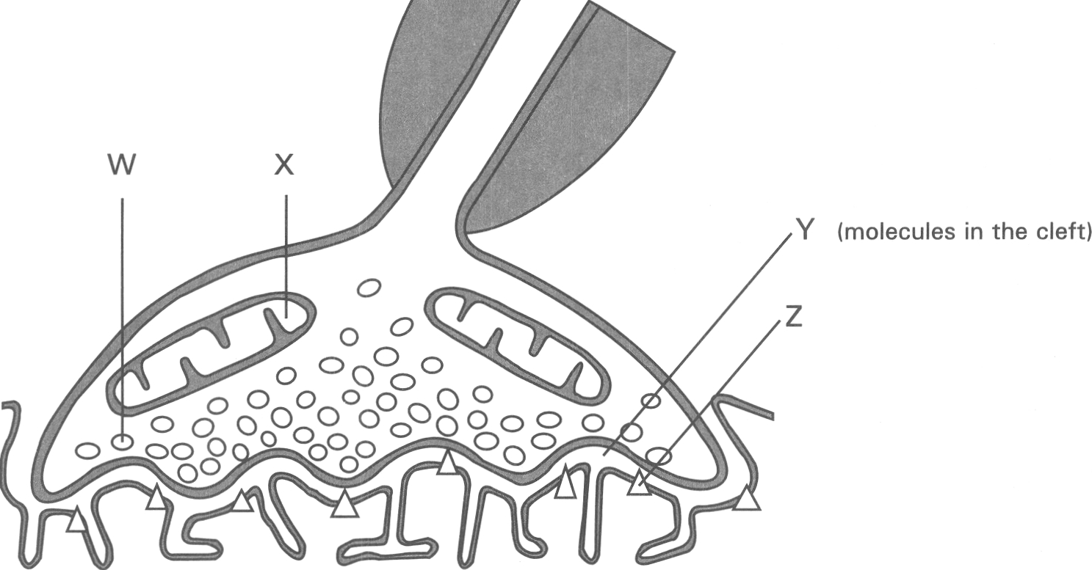
A. (1) only B. (2) only C. (3) and (4) only D. (1), (3) and (4) only Directions: Questions 12 to 15 refer to the diagram below, which shows a structure in the nervous system.
12. What is the function of the organelle labelled X?
A. Replication of mRNA.
B. Translation of genetic information in the synthesis of protein.
C. Production of energy for the synthesis of neurotransmitters.
D. Generation of nerve impulse.
13. Which of the following is/are the name(s) used to describe the structure shown in the diagram? (1) Neuro-muscular junction (2) Synapse (3) Ganglion
A. (1) only
B. (2) only
C. (3) only
D. (1) and (2) only
14. Match the following groups of names to the parts labelled W, X Y and Z.
W | X | Y | Z
A.Nucleus | Vesicle | Hormones | Effector
B.Mitochondrion | Nucleus | Neurotransmitters | Receptor site
C.Mitochondrion | Vesicle | Hormones | Effector
D.Vesicle | Mitochondrion | Neurotransmitters | Receptor site

15. Which of the following parts of the body have the structure shown in the diagram? (1) Cerebrum (2) Medulla oblongata (3) Spinal cord (4) Neuro-muscular junction
A. (1) and (2) only
B. (2) and (3) only
C. (3) and (4) only
D. (1), (2), (3) and (4)
16. The central nervous system consists of
(1) spinal nerves. (2) brain. (3) cranial nerves. (4) spinal cord.
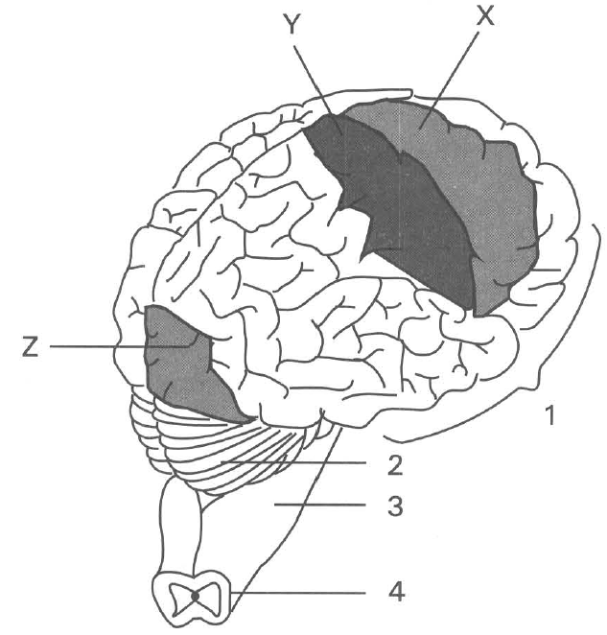
A. (1) and (2) only B. (2) and (3) only
C. (2) and (4) only D. (3) and (4) only Directions: Questions 17 to 20 refer to the diagram below, which shows the human brain and part of the spinal cord. X, Y and Z are the functional areas of the brain.
17. Which of the following sets of names CORRECTLY matches with the labelled regions?
 | Cerebellum | Cerebrum | Spinal cordMedulla oblongata
A. | 2 | 1 | 4 | 3
B. | 1 | 2 | 3 | 4
C. | 4 | 3 | 2 | 1
D. | 2 | 1 | 3 | 4

18. Which of the following region(s) has/have its/their feature(s) CORRECTLY described?
Region | Action initated | Convolution on surface | White matter | Grey matter
1 | Conscious | Greater | Inside | Outside
2 | Unconscious | Lesser | Inside | Outside
4 | Conscious | Medium | Outside | Inside

A. 1 only
B. 2 only
C. 4 only
D. 1 and 2 only
19. Which of the following are the CORRECT functions of the regions labelled 1, 2 and 3?
(I) Coordination of the muscular activities of the body
(II) Control the rate of heart beat
(III) Initiation of the voluntary activities
 | Region 1 | Region 2 | Region 3
A. | (I) | (II) | (III)
B. | (III) | (I) | (II)
C. | (II) | (III) | (I)
D. | (I) | (III) | (II)

20. If the functional areas X, Y and Z are damaged, which of the following sets of results may occur?
 | X damaged | Y damaged | Z damaged
A. | Vision lost | Motor activities stop | Taste sensation lost
B. | Motor activities stop | Sensation lost | Vision lost
C. | Sensation lost | Motor activities stop | Memory lost
D. | Memory lost | Vision lost | Taste sensation lost

21. The highly convoluted surface of the cerebrum is to increase the surface area for
A. absorbing more oxgen to support the complicated processes of reasoning.
B. releasing more heat that is produced by the high metabolic activities of the brain.
C. packing more neurones.
D. absorbing shock during an accidental impact with a hard object.
22. Which of the following are the functions of the medulla oblongata of the human brain? (1) Spontaneous withdrawal of the hand in contact of hot object. (2) Giving a speech. (3) Knee jerk reflex. (4) Regulation of the rate of heart beat. (5) Swallowing action.
A. (1) and (2) only
B. (3) and (4) only
C. (1) and (4) only
D. (4) and (5) only
23. A man was seriously injured in a traffic accident. He could give reflex responses and breathe normally with proper heart beat, but he could not produce any voluntary action. Which of the following parts of his body was damaged?
A. Spinal cord B. Medulla oblongata C. Cerebellum D. Cerebrum
24. When the cerebellum of a man was injured in a traffic accident, he would have the difficulty to
A. see things clearly.
B. hear sound clearly.
C. walk properly.
D. breathe smoothly.
25. The cardiac output of the body is controlled by (1) cerebrum. (2) cerebellum. (3) medulla oblongata.
A. 1 only
B. 2 only
C. 3 only
D. 1 and 2 only
26. Which of the following parts of the nervous system is/are involved when a girl is playing a piano? (1) Cerebrum (2) Cerebellum (3) Spinal cord D. 1, 2 and 3 Directions: Questions 27 to 29 refer to the photomicrograph below, which shows the transverse section of the mammalian spinal cord. 27 Structure X is B. known as white matter. C. composed of dendrons. D. known as grey matter.
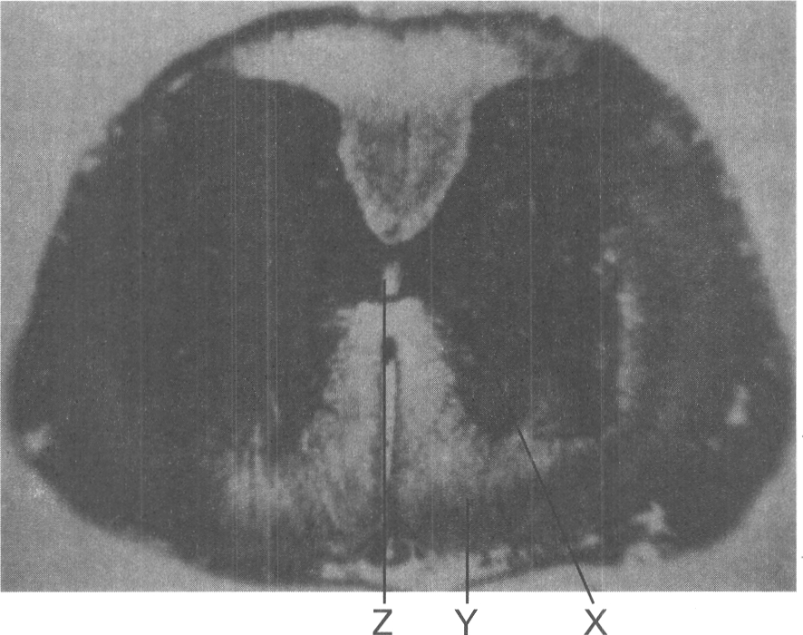
A. 1 only
B. 2 only
C. 3 only
A. composed of axons.
27. Which of the following has the same matter as that in structure X?
A. Inner region of the cerebellum.
B. Cerebral cortex of the cerebrum.
C. Outer region of the kidney.
D. Inner region of the kidney.
28. Which of the following matchings CORRECTLY describes the structures/ substances that are present in the parts labelled X, Y and Z?
 | Part X | Part Y | Part Z
A. | Cell bodies | Nerve fibres | Lymph
B. | Nerve fibres | Cell bodies | Cerebrospinal fluid
C. | Cell bodies | Nerve fibres | Cerebrospinal fluid
D. | White matter | Grey matter | Lymph

29. Which of the following about spinal cord is CORRECT? (1) It is protected inside the vertebral column. (2) It is a cord that bears many spines to increase the area for muscle attachment. (3) It handles ALL the reflex actions of the body. (4) Its cross-section consists of an outer zone of grey matter and inner zone of white matter.
A. (1) only
B. (1) and (2) only
C. (3) and (4) only
D. (1), (3) and (4) only
30. The dorsal ganglion of a spinal nerve contains
A. cerebrospinal fluid.
B. efferent nerve fibres.
C. cell bodies of the motor neurones.
D. cell bodies of the sensory neurones.
31. Which of the following related with the spinal nerve is CORRECT?
A. It is a mixed nerve.
B. It contains sensory nerve fibres only.
C. It contains motor nerve fibres only.
D. The whole nerve is enclosed by the vertebrae.
32. Which of the following statements about reflex action is/are CORRECT?
(1) It is inborn. (2) It is initiated unconsciously.
(3) It is slower than voluntary action.
(4) It must involve the spinal cord.
(5) The same stimulus always produces the same response.
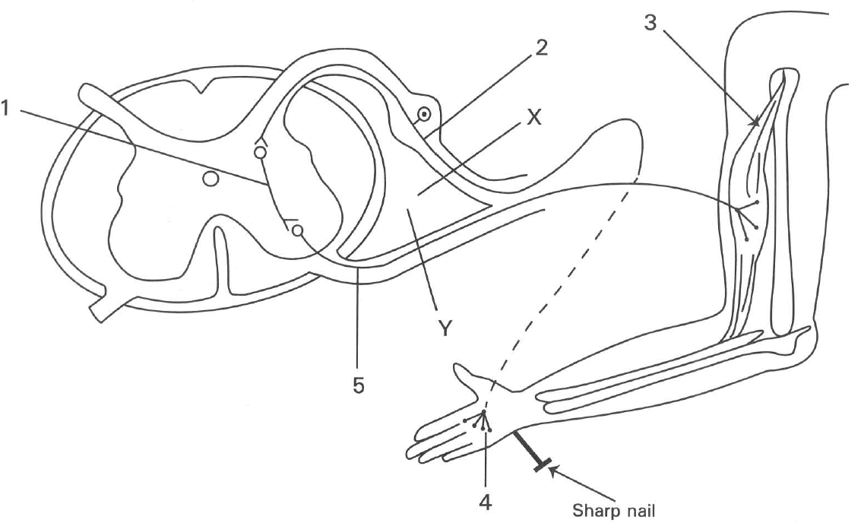
A. (1) and (2) only B. (2), (3) and (5) only
C. (1), (2) and (5) only D. (2), (3) and (4) only Directions: Questions 34 to 38 refer to the diagram below, which shows the nervous pathway connecting the fore-limb to the spinal cord when the hand is pricked by a sharp nail.
33. Which of the following matchings is CORRECT?
 | Receptor | Motor Organ | Connectorneurone | Afferentneurone | Efferentneruone
A. | 3 | 4 | 2 | 5 | 1
B. | 4 | 3 | 5 | 1 | 2
C. | 4 | 3 | 1 | 2 | 5
D. | 3 | 4 | 2 | 1 | 5

34. Which of the following pathways CORRECTLY shows the direction of the transmission of the nerve impulse?
A. 4 3 5 1 2 B . 3 5 1 2 4
C. 4 2 1 5 3 D. 3 4 2 1 5
35. If a cut is made at X, which of the following would happen when the hand is heated?
A. The person could not feel the pain but the hand would be withdrawn once he saw that the flame was heating the hand.
B. The person could not feel any pain and could not voluntarily move his hand.
C. The person could feel the pain and would move his hand spontaneously.
D. The person could feel the pain but could not voluntarily move his hand.
36. If the above experiment is modified by applying an electric current to stimulate the production of nerve impulse at the side of the cut near the dorsal ganglion, which of the conditions described in question 17.36 would occur?
A. The person could not feel the pain but the hand would be withdrawn once he saw that the flame was heating the hand.
B. The person could not feel any pain and could not voluntarily move his hand.
C. The person could feel the pain and would move his hand spontaneously.
D. The person could feel the pain but could not voluntarily move his hand.
37. If a cut is made at Y, which of the conditions described in question 17.36 would occur if the hand is heated?
A. The person could not feel the pain but the hand would be withdrawn once he saw that the flame was heating the hand.
B. The person could not feel any pain and could not voluntarily move his hand.
C. The person could feel the pain and would move his hand spontaneously.
D. The person could feel the pain but could not voluntarily move his hand.
38. Arrange the following structures in the CORRECT sequence when a simple spinal reflex action is triggered by a stimulus. (1) Effector (2) Sensory neurone (3) Receptor (4) Association neurone (5) Motor neurone
A. (1), (2), (3), (4), (5)
B. (1), (5), (4), (2), (3)
C. (3), (5), (4), (2), (1)
D. (3), (2), (4), (5), (1)
39. If the hand is heated, it will be withdrawn immediately. In this operation
A. the spinal cord handles the whole operation without sending any information to the brain.
B. the muscles of the hand handle the whole operation without involving any activities of the central nervous system.
C. the brain receives information directly through the sensory nerve fibres, integrating the information and sending the order out along the motor nerve fibre to effectors for the response to take place.
D. the brain is not involved in the initiation of the response though it is conscious of what has happened.
40. Which of the following is NOT a reflex action?
A. Blinking when solid particles moving quickly in front of the eye.
B. Knee jerk response when the patellar tendon is tapped.
C. Laughing when a funny story is told.
D. Coughing when foreign particles pass down the trachea of the respiratory tract.
41. Which of the following responses does NOT involve the brain in its initiation?
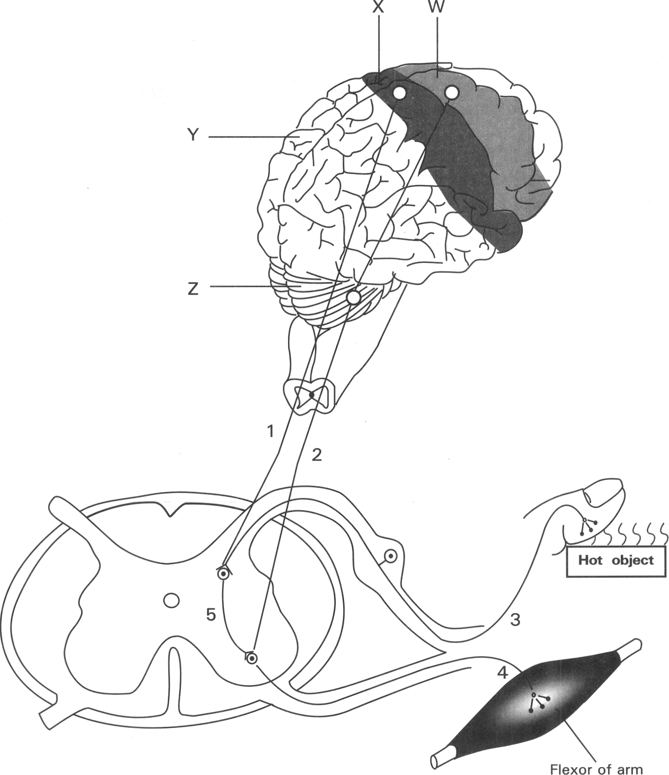
A. Increase in the rate and depth of breathing during exercises.
B. Swallowing saliva when seeing a delicious food.
C. Withdrawing the hand when touching a hot object.
D. Singing a song. Directions: Questions 43 to 46 refer to the diagram below, which shows the nervous pathways in a man when the hand accidentally touches a hot object. He immediately withdraws his hand and then cries out.
42. Why does this man withdraw his hand first before he cries out?
A. The nervous pathway for the withdrawal reflex of the hand is shorter than that for the brain to realize the pain and then to control the mouth to cry out.
B. This man is very sensitive to heat.
C. Though the man has seen the object, he does not know that it is very hot.
D. Speaking involves more muscles than that for withdrawing the hand from the hot object.
43. Which of the following groups of names matches the labelled parts?
 | W | X | Y | Z
A. | Sensory area | Motor area | Cerebellum | Cerebrum
B. | Motor area | Sensory area | Cerebrum | Cerebellum
C. | Sensory area | Motor area | Cerebrum | Cerebellum
D. | Motor area | Sensory area | Cerebellum | Cerebrum

44. If neurone 1 is cut, what would happen to the sensation of pain caused by the hot object, thevoluntary raising of the arm, and the reflex withdrawal of the hand from the hot object?
 | Sensation of pain | Voluntary raising of the arm | Reflex withdrawal of the hand
A. | Yes | Yes | Yes
B. | No | No | No
C. | No | Yes | Yes
D. | No | Yes | No

45. If neurone 2 is cut, what would happen to the sensation of pain caused by the hot object, thevoluntary raising of the arm, and the reflex withdrawal of the hand from the hot object?
 | Sensation of pain | Voluntary raising of the arm | Reflex withdrawal of the hand
A. | Yes | Yes | Yes
B. | No | No | No
C. | No | Yes | Yes
D. | Yes | No | Yes

46. Which of the following comparisons between the spinal cord and the cerebrum is/are INCORRECT?
 | Spinal cord | Cerebrum
(1) | Innervated by both sensory and motor neurones | No sensory neurones.
(2) | Filled with cerebrospinal fluid | No cerebrospinal fluid
(3) | Produce reflex action | Produce voluntary action
(4) | No bony protection | Enclosed by bony structure
(5) | No blood supply | With rich blood supply
(6) | Cannot produce sensation | Produce sensation

A. (3) only
B. (2), (3) and (4) only
C. (1), (3) and (6) only
D. (1), (2), (4) and (5) only
47. Which of the following is a voluntary action?
A. Dilation of the pupil when a person is staying in a dark room.
B. Raising a person's hand to shade the eyes when he/she comes out of a cinema into the open space on a sunny day.
C. Shivering of the body when a girl is staying in an air-conditioned room kept at 19°C.
D. Withdrawing a person's leg when his right bare foot is stepping on a sharp nail.
48. Pupil dilation differs from withdrawing the hand from the hot object in that the former
A. does not involve the spinal cord.
B. is initiated by one's own will (i.e. conscious action).
C. does not need a receptor to perceive the stimulus.
D. is not a reflex action.
49. Which of the following statements about raising the arm to lift a weight is CORRECT? (1) It involves the contraction of the biceps. (2) It is a reflex action. (3) It involves the relaxation of the triceps. (4) Only the spinal cord is involved while the brain is unconscious of this action.
A. (1) and (2) only
B. (2) and (3) only
C. (1) and (3) only
D. (2) and (4) only
50. Which of the following statements concerning voluntary action is/are INCORRECT? (1) It is not inborn. (2) It is stereotype i.e. the same stimulus always gives the same response. (3) It is a conscious response. (4) It cannot be controlled by our own will. B. Hormonal Coordination
A. (1) only
B. (3) only
C. (1) and (2) only
D. (2) and (4) only
51. Which of the following statements about hormone are CORRECT? (1) It is secreted by a ducted gland. (2) It is transported in blood. (3) It produces a long term effect. (4) It usually produces its effect in one specific effector only. B.(2) and (3) only
A. (1) and (2) only
B. (2) and (3) only
C. (3) and (4) only
D. (4) and (1) only
52. Which of the following combinations is CORRECT?
 | Effectors | Response
A. | Liver | Secretes glucagon during vigorous exercise
B. | Sweat glands | Secrete large amount of sweat in a hot and very humid day
C. | Pancreas | Secretes more insulin after eating a starchy meal
D. | Ovary | Secretes more fluids to facilitate the delivery of a baby during birth

53. Which of the following gland(s) is/are capable of secreting hormones? (1) Salivary glands (2) Mammary glands (3) Liver (4) Pancreas (5) Sweat gland
A. (1) only
B. (4) only
C. (2) and (4) only
D. (3) and (5) only
54. Which of the following comparisons between the nervous and hormonal coordination is INCORRECT?
 | Nervous coordination | Hormonal coordination
(1) | Rapid response | Slow response
(2) | Widespread effect | Localized effect
(3) | Long term effect | Short term effect
(4) | Electrical message | Chemical message
(5) | Message passed along nerves | Message carried in blood
(6) | Respond to external stimuli only | Respond to internal stimuli only

A. (1), (2) and (3) only
B. (2), (4) and (6) only
C. (1), (4) and (5) only
D. (2), (3) and (6) only
55. Which of the following comparisons between type I diabetes and type II diabetes is CORRECT?
Suggested Solutions
 | Type I diabetes | Type II diabetes
A. | Due to insulin resistance | Due to the shortage of insulin
B. | Mainly caused by overweight and physical inactivity | Mainly caused by genetic factor
C. | Starts early in life e.g. in childhood or adolescence | Commonly occurs in adults and obese children
D. | Majority of diabetes belongs to this type | Minority of diabetes belong to this type

Answers
Answers are printed in red.
1. A

2. D
Class: 75.0% correct (n=468) usual slip D
3. B
Class: 81.6% correct (n=468) usual slip A
4. A

5. C. (3) only
Class: 74.8% correct (n=468) usual slip A
6. C. Axons transmit nerve impulses away from the cell bodies of neurones.
Class: 63.0% correct (n=468) usual slip B
7. D. ensure the rapid transmission of nerve impulses along the nerve fibre.
Class: 65.8% correct (n=468) usual slip A
8. A. (1) only
Class: 79.2% correct (n=379) usual slip A
9. D
Class: 77.7% correct (n=318) usual slip D
10. B. the microscopic junction between the nerve endings of two neurones.
Class: 62.6% correct (n=318) usual slip D
11. D
Class: 79.9% correct (n=318) usual slip A
12. C. Production of energy for the synthesis of neurotransmitters.
Class: 76.7% correct (n=318) usual slip A
13. D. (1) and (2) only
Class: 73.9% correct (n=318) usual slip C
14. D
Class: 71.4% correct (n=318) usual slip B
15. D. (1), (2), (3) and (4)
Class: 77.0% correct (n=318) usual slip A
16. C. (2) and (4) only D. (3) and (4) only Directions: Questions 17 to 20 refer to the diagram below, which shows the human brain and part of the spinal cord. X, Y and Z are the functional areas of the brain.
Class: 46.9% correct (n=318) usual slip B
17. A
Class: 61.6% correct (n=318) usual slip A
18. D. 1 and 2 only
Class: 71.1% correct (n=318) usual slip D
19. B
Class: 60.2% correct (n=251) usual slip B
20. B
Class: 71.3% correct (n=251) usual slip A
21. C. packing more neurones.
Class: 64.6% correct (n=212) usual slip D
22. D. (4) and (5) only
Class: 84.9% correct (n=212) usual slip C
23. D
Class: 75.5% correct (n=212) usual slip D
24. C. walk properly.
Class: 51.9% correct (n=212) usual slip A
25. C. 3 only
Class: 75.0% correct (n=212) usual slip A
26. D
Class: 73.3% correct (n=191) usual slip A
27. B. Cerebral cortex of the cerebrum.
Class: 82.2% correct (n=191) usual slip A
28. C
Class: 56.0% correct (n=191) usual slip C
29. A. (1) only
Class: 58.0% correct (n=169) usual slip B
30. D. cell bodies of the sensory neurones.
Class: 76.9% correct (n=169) usual slip A
31. A. It is a mixed nerve.
Class: 79.3% correct (n=169) usual slip A
32. C. (1), (2) and (5) only D. (2), (3) and (4) only Directions: Questions 34 to 38 refer to the diagram below, which shows the nervous pathway connecting the fore-limb to the spinal cord when the hand is pricked by a sharp nail.
Class: 69.2% correct (n=169) usual slip A
33. C
Class: 40.8% correct (n=142) usual slip A
34. C. 4 2 1 5 3 D. 3 4 2 1 5
Class: 78.9% correct (n=142) usual slip B
35. A. The person could not feel the pain but the hand would be withdrawn once he saw that the flame was heating the hand.
Class: 59.9% correct (n=142) usual slip A
36. C. The person could feel the pain and would move his hand spontaneously.
Class: 31.0% correct (n=142) usual slip B
37. D. The person could feel the pain but could not voluntarily move his hand.
Class: 65.5% correct (n=142) usual slip C
38. D. (3), (2), (4), (5), (1)
Class: 26.1% correct (n=142) usual slip C
39. D. the brain is not involved in the initiation of the response though it is conscious of what has happened.
Class: 80.0% correct (n=115) usual slip D
40. C. Laughing when a funny story is told.

41. C. Withdrawing the hand when touching a hot object.

42. A. The nervous pathway for the withdrawal reflex of the hand is shorter than that for the brain to realize the pain and then to control the mouth to cry out.

43. B

44. C

45. D

46. D. (1), (2), (4) and (5) only

47. B. Raising a person's hand to shade the eyes when he/she comes out of a cinema into the open space on a sunny day.

48. A. does not involve the spinal cord.

49. C. (1) and (3) only

50. D. (2) and (4) only

51. B. (2) and (3) only

52. C

53. B. (4) only

54. D. (2), (3) and (6) only

55. C

