Ecosystem
Multiple-choice practice
Name: ________________________ Class: ____________
There are 180 questions compiled from Longman HKCEE and/or YKTo papers. Choose the one best answer.
Part A — HKCEE level (Longman)
1. All living organisms found in the same area form
A. an ecosystem.
B. a population.
C. a community.
D. a habitat.
2. An ecosystem includes (1) the sun. (2) the populations of organisms interacting with each other. (3) all physical factors affecting the populations.
A. (1) and (2) only
B. (1) and (3) only
C. (2) and (3) only
D. (1), (2) and (3)
3. Which of the following constitute the environment of an organism? (1) All other organisms living together with it (2) The place where it lives (3) All chemical factors affecting it
A. (1) and (2)
B. (1) and (3)
C. (2) and (3)
D. (1), (2) and (3)
4. Which of the following is a correct description of a habitat?
A. All the plants and animals living together in a particular area B.The place where an organism lives C.All the surroundings of an organism D.The interaction between biotic and abiotic components of an ecosystem
5. The diagram below represents the relationships among an ecosystem, a habitat, a community and the population.
Which of the following is correct?
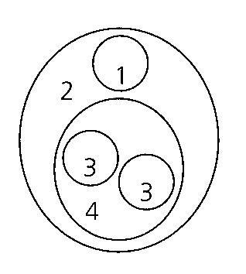
6. | 2 | 3 | 4 | D. | ecosystem | habitat | community | population X7.Which of the following are the forms of energy that enter and leave an ecosystem?
 | Energy output | Energy input
A. | heat | heat
B. | light | heat
C. | light | mechanical energy
D. | mechanical energy | light

A. | population | community | habitat | ecosystem |
B. | community | habitat | population | ecosystem |
C. | habitat | ecosystem | population | community |
D. | ecosystem | habitat | community | population X7.Which of the following are the forms of energy that enter and leave an ecosystem?
7. As energy is transferred along a food chain, which of the following may result in energy loss? (1) Predation (2) Respiration (3) Uneaten parts of organisms
A. (1) and (2) only
B. (1) and (3) only
C. (2) and (3) only
D. (1), (2) and (3)
8. Which of the following are cycled in an ecosystem? (1) Energy (2) Water (3) Phosphorus A.(1) and (2) only B.(1) and (3) only C.(2) and (3) only
A. (1) and (2) only
B. (1) and (3) only
C. (2) and (3) only
D. (1), (2) and (3)
9. Decomposers are essential for a balanced ecosystem because (1) they recycle energy. (2) they break down dead bodies of organisms. (3) they release minerals to the soil for plant absorption. A.(1) and (2) only B.(1) and (3) only C.(2) and (3) only
A. (1) and (2) only
B. (1) and (3) only
C. (2) and (3) only
D. (1), (2) and (3)
10. Which of the following comparisons between the energy flow and the nutrient flow in an ecosystem is correct? X12.The lowest trophic level in a food chain is occupied by D. consumers. Directions: Questions 13 to 15 refer to the food chain below. grasses > grasshoppers → lizards → birds- X13.Which type of organisms in the above food chain is the secondary consumer(s)? B. Grasshoppers C. Lizards D. Birds X14.What is the ecological relationship between grasshoppers and lizards? A. Predation B. Competition C. Commensalism D. Mutualism
 | Energy flow | Nutrient flow
A. | energy trapped in dead bodies cannot be released | nutrients trapped in dead bodies can be released
B. | energy flow is unidirectional | nutrient flow is cyclic
C. | decomposers are not involved | decomposers are involved
D. | energy enters the community in form of light | nutrients enter the community in form of organic food substances

A. producers.
B. herbivores.
C. carnivores.
A. Grasses
11. Which of the following may represent the pyramid of numbers of this food chain? X16.Most food chains are made of three to four species of organisms. Which of the following is the best explanation for this? A.If the number of species is too large, a food web will be formed. B.If the number of species is too large, competition will become very serious. C.The longer the food chain is, the greater the energy loss will be. D.The top consumer of a food chain is usually a very fierce predator which is unlikely to be eaten by a more superior predator. X17.The following is a food chain found in a grassland. grasses > zebras → tsetse flies- Which of the following best represents the numbers of organisms for the above food chain?
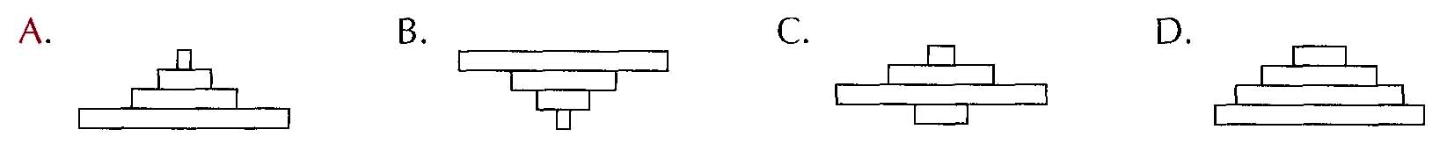
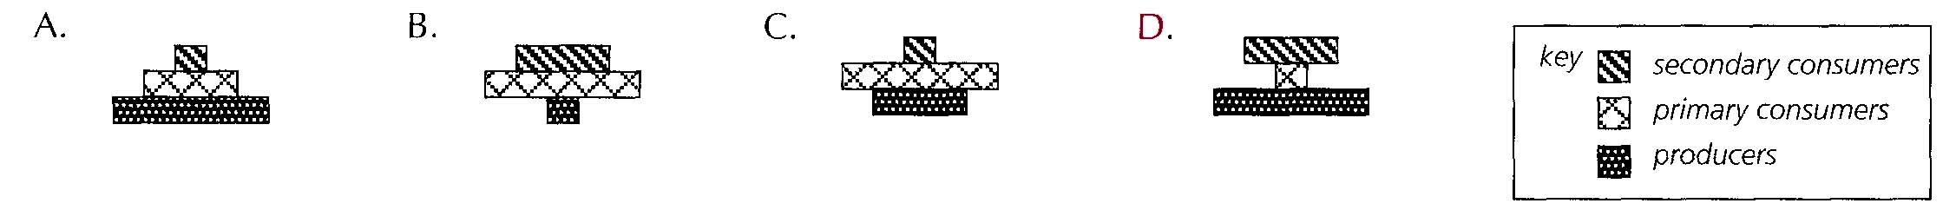
A. If the number of species is too large, a food web will be formed.
B. If the number of species is too large, competition will become very serious.
C. The longer the food chain is, the greater the energy loss will be.
D. The top consumer of a food chain is usually a very fierce predator which is unlikely to be eaten by a more superior predator. X17.The following is a food chain found in a grassland. grasses > zebras → tsetse flies- Which of the following best represents the numbers of organisms for the above food chain?
12. The pyramid of biomass representing the following food chain is: oak trees > insect larvae → birds- DISTRACTOR: B & D X19.The diagrams below show three pyramids of number. They represent the three food chains shown below: Igreen algae > shrimps → fish- IIhibiscus > bees → birds- IIIgrass > sheep → tapeworms- Which of the following is correct? X20.The diagram below shows a pyramid of number. Which of the following food chains can be represented by the above pyramid of number?
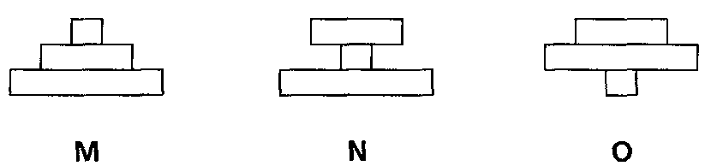
 | I | II | III
A. | M | N | O
B. | N | M | O
C. | M | O | N
D. | O | N | M

A. grasses > grasshoppers → birds -
B. grasses → zebras → lions
C. trees > caterpillars → birds -
D. trees > monkeys → fleas-
13. A woodland community consists of the following organisms in each trophic level:
first trophic level: trees
second trophic level: caterpillars and ants
third trophic level: lizards and toads
fourth trophic level: owls
Which of the following shows the correct pyramid of biomass for this community?
DISTRACTOR: B & D
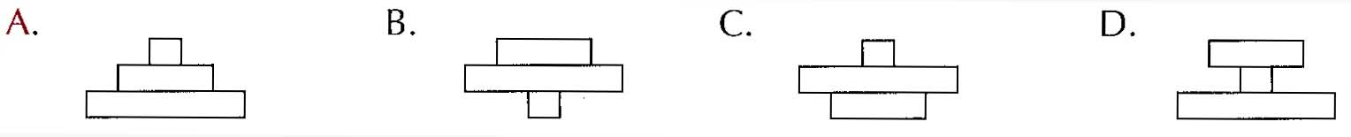
14. A flea sucking blood from a lion can be regarded as a
 | Producer | Secondary consumer
A. | grasses | grasshoppers
B. | hawks | small birds
C. | grasses | small birds
D. | grasshoppers | hawks

A. decomposer. B. primary consumer.
C. secondary consumer. D. tertiary consumer. Directions: Questions 23 and 24 refer to the food chain below. grasses > grasshoppers → small birds → hawks- X23. Which of the following matchings is correct?
15. The total biomass of hawks is less than that of small birds because
A.hawks have a shorter life span.
B.energy is lost when it is transferred from small birds to hawks.
C.hawks are much larger than small birds.
D.hawks are less numerous than small birds.
Directions: Questions 25 to 28 refer to the diagram below which shows a food web in a freshwater stream.
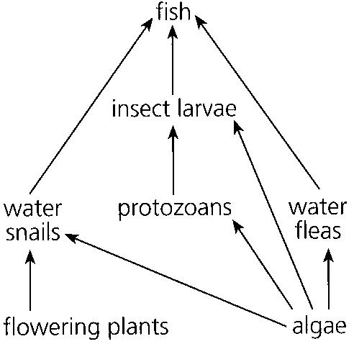
16. All living organisms in the freshwater stream make up a(n)
A. ecosystem.
B. population.
C. community.
D. species.
17. Which population in the food web is omnivorous?
A. Water fleas
B. Insect larvae
C. Water snails
D. Fish
18. If all insect larvae are suddenly removed, which of the following would happen? A.The population of algae would decrease. B.The population of protozoans would decrease. C.The population of water snails would increase. D.The population of fish would increase.
A. The population of algae would decrease.
B. The population of protozoans would decrease.
C. The population of water snails would increase.
D. The population of fish would increase.
19. Which of the following statements about the interrelationships among the organisms are correct?
(1)Water fleas and protozoans are competitors.
(2)Protozoans are the preys of fish.
(3)Insect larvae are the predators and competitors of protozoans.
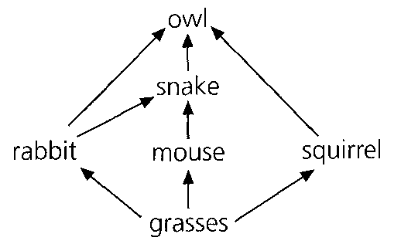
A. (1) and (2) only B. (1) and (3) onlyC. (2) and (3) only D. (1), (2) and (3) only Directions: Questions 29 to 33 refer to the diagram below which shows a food web in a grassland.
20. Which component(s) in the food web is/are (a) secondary consumer(s)?
A. Snake only
B. Snake and owl only
C. Mouse and squirrel only
D. Rabbit, mouse and squirrel only
21. If all mice are removed from the grassland, what will be the most likely effect on the rabbit and snake population? X31.What is/are the relationship(s) between snake and owl? (1) Predation(2) Competition (3) Parasitism
 | Rabbit | Snake
A. | decreases | increases
B. | increases | decreases
C. | does not change | decreases
D. | increases | does not change

A. (1) only
B. (3) only
C. (1) and (2) only
D. (2) and (3) only
22. If all snakes are removed, the owl population will A.increase at first and then decrease to below its original population. B.increase at first and then decrease to its original population. C.decrease at first and the increase to exceed its original population. D.decrease at first and then increase to its original population. X33.Which of the following groups of organisms is/ are not shown in the above food web? (1) Omnivores(2) Producers (3) Decomposers A.(1) only B. (2) only C. (1) and (3) onlyD. (2) and (3) only Directions: Questions 34 to 36 refer to the diagram below which shows the feeding relationships among some organisms found in woodland.
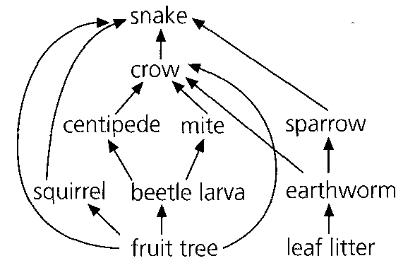
A. increase at first and then decrease to below its original population.
B. increase at first and then decrease to its original population.
C. decrease at first and the increase to exceed its original population.
A. (1) only
23. Which of the following is a carnivore?
A. Snake B. Crow C. Mite D. Earthworm
24. No competition exists between D. the beetle larva and the earthworm. X36.The removal of leaf litter would seriously endanger the existence of A. the snake. B. the crow. C. the sparrow. D. the mite. Directions: Questions 37 to 39 refer to the food chains below which indicate four ways in which man may obtain protein. I beans > man- II grass > cow → man- III rice > mouse → snake → man- IV green algae > protozoans → small fish → large fish → man-
A. the centipede and the mite.
B. the squirrel and the crow.
C. the crow and the snake.
D. the beetle larva and the earthworm. X36.The removal of leaf litter would seriously endanger the existence of
25. For the same amount of energy input, which food chain would produce the greatest amount of protein for man?
A. I
B. II
C. III
D. IV
26. In food chain IV, if the green algae absorb insecticides from the water, which group of organisms in this food chain will accumulate the greatest concentration of insecticides in their bodies?
A.Green algae B. Protozoans C. Man
D.All groups of organisms will have the same concentration of insecticides.
27. What are the trophic levels of beans in food chain I and small fish in food chain IV?
Directions: Questions 40 to 42 refer to the diagram below which shows the annual energy flow through different organisms living on grassland.
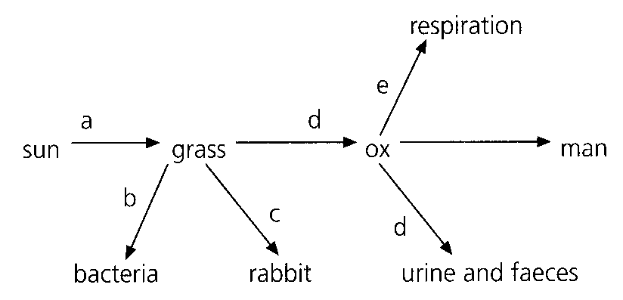
 | Beans | Small fish
A. | cannot be classified | second trophic level
B. | cannot be classified | third trophic level
C. | first trophic level | second trophic level
D. | first trophic level | third trophic level

28. With reference to grass, the difference between the energy input and output is
A. a (-b+c)
B. a (-c+d)
C. a(-b+c+d)
D. ( a+d)(-c+d)
29. Which of the following may account for the difference mentioned in Q. 40?
(1) Respiration (2) Death of grass (3) Dispersal of seeds
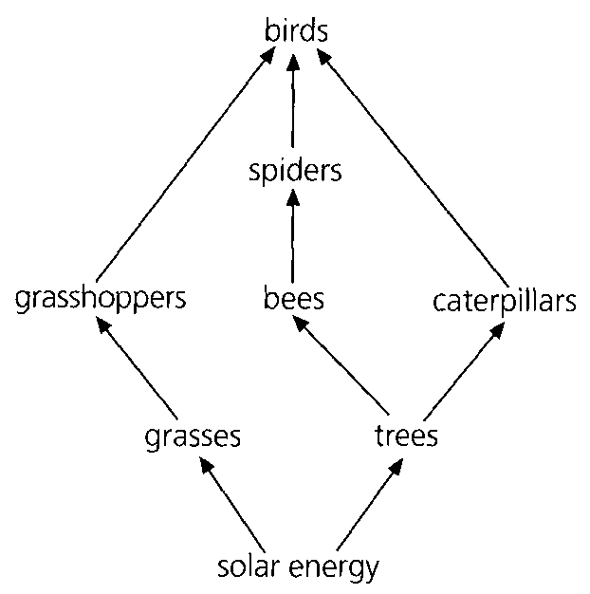
A. (1) only B. (2) only C. (1) and (3) onlyD. (2) and (3) only X42.Which organism in the diagram is a secondary consumer?
A. Bacteria B. Rabbit C. Ox D. Man Directions: Questions 43 to 45 refer to the diagram below which shows the energy flow through some organisms in a woodland. X43.Which of the following food chains cannot be found in the diagram?
A. grasses > grasshoppers → birds-
B. trees > bees → spiders → birds-
C. trees > caterpillars → birds-
D. trees > caterpillars → spiders → birds-
30. To which group of organisms does energy flow from all organisms eventually?
A. Producers B. Top consumers C. Decomposers D. Heterotrophs
31. An increase in the bee population is found to have no effect on the caterpillar population. Which of the following is a possible reason for this?
A.Caterpillars compete better than bees for food.
B.Caterpillars and bees feed on different food sources on the trees.
C.Caterpillars migrate to other habitats.
D.Less caterpillars are eaten by birds.
Directions: Questions 46 to 49 refer to the diagram below which shows a sealed glass sphere containing sea water, green plants and a few shrimps.
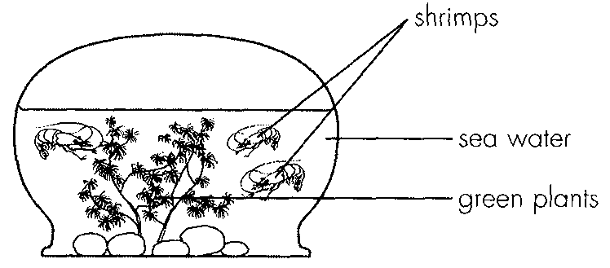
32. The community of this artificial system consists of (1) green plants. (2) shrimps. (3) sea water. D. (1), (2) and (3) X47.The environment of the shrimps includes (1) water. (2) green plants. (3) light. A. (1) only B. (1) and (2) only D. (1), (2) and (3)
A. (1) and (2) only
B. (1) and (3) only
C. (2) and (3) only
D. (1), (2) and (3) X47.The environment of the shrimps includes (1) water. (2) green plants. (3) light.
33. The organisms inside the sphere can survive for many years provided that
A. minerals are added to the water from time to time.
B. oxygen is pumped into the water at regular time intervals.
C. sufficient light is given.
D. extra food is supplied to the shrimps.
34. What ecological principle is best illustrated by this glass sphere?
A. Recycling of energy B. Cycling of materialsC. Symbiosis D. Conservation
35. If the pH of the water in an aquarium containing fish and green plants decreases, which of the following treatments may help to restore the pH?
(1) Introducing more fish
(2) Growing more green plants
(3) Exposing the aquarium to brighter illumination
Jar | Organisms at the beginning | Results
I | X and Y | X disappeared and Y still survived
II | X and Z | X still survived and Z was partly eaten
III | Y and Z | Y died and Z was unchanged

A. (1) and (2) only B. (1) and (3) only C. (2) and (3) only D. (1), (2) and (3) Directions: Questions 51 and 52 refer to an experiment performed to investigate a certain food chain involving three organisms X, Y and Z. The organisms were grouped separately in three glass jars covered with lids. The organisms were placed in each glass jar at the beginning and were observed after a week. The results are recorded in the table below.
36. The possible food chain that can be concluded from the experiment is
A. X Y Z
B. Y Z X
C. Z X Y
D. Z Y X
37. Why is it impossible to draw conclusion from the experiment if all the three organisms are put together in the same jar?
A. There would be insufficient food for the organisms.
B. There would be insufficient space to hold the organisms.
C. It would be more difficult to control the environmental factors.
D. It would be impossible to work out their feeding relationships.
38. What is the least number of trophic levels that the carbon of a carnivore has passed through? D. Four X54.Which of the following processes releases carbon from dead organic matter? A. Photosynthesis B. DecompositionC. Death D. Denitrification Directions: Questions 55 to 57 refer to the simplified carbon cycle below.
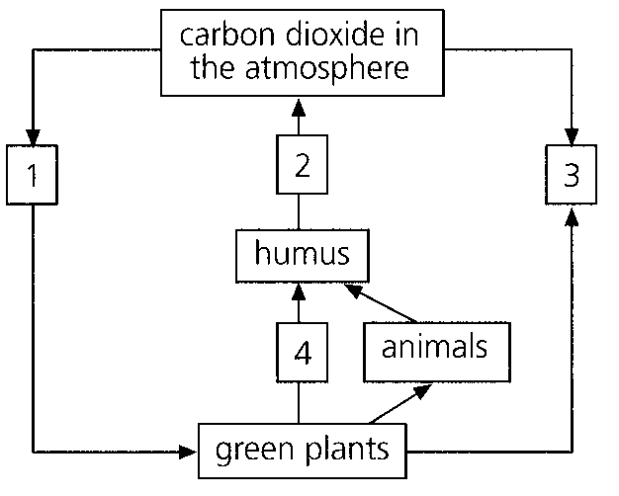
A. One
B. Two
C. Three
D. Four X54.Which of the following processes releases carbon from dead organic matter?
39. Which of the following shows the correct matching of processes labelled 1, 2 and 3?
40. | 2 | 3 | D. | respiration | respiration | photosynthesis X56.The organisms involved in process 2 are A. producers. B. consumers. C. saprophytes. D. parasites.
A. | respiration | respiration | photosynthesis |
B. | photosynthesis | decomposition | respiration |
C. | photosynthesis | respiration | decomposition |
D. | respiration | respiration | photosynthesis X56.The organisms involved in process 2 are
41. Process 4 represents
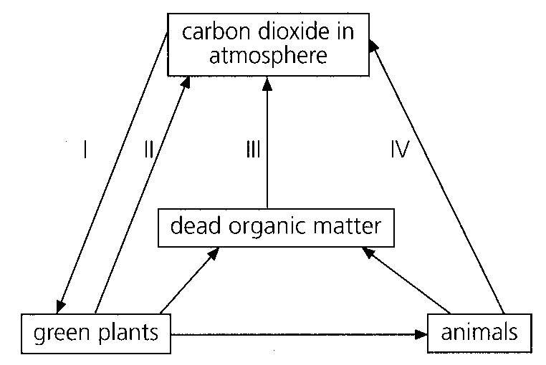
A. death. B. feeding. C. excretion. D. carbon fixation. Directions: Questions 58 and 59 refer to the carbon cycle shown below. X58.Which process(es) involve(s) the action of bacteria?
A. III only B. I and IV only C. II and V only D. II, III and IV only X59.Which process(es) consume(s) oxygen?
A. I only B. IV only C. II, III, IV only D. II, III, IV and V only X60.Which of the following processes releasecarbon dioxide into the atmosphere? (1) Photosynthesis (2) Putrefaction (3) Respiration
A. (1) and (2) only B. (1) and (3) only C. (2) and (3) onlyD. (1), (2) and (3)
42. Decomposers return nitrogen to the physical environment mainly in the form of
A. urea.
B. nitrates.
C. ammonium compounds.
D. nitrogen gas.
43. Which of the following processes is a form of decomposition? A.Conversion of ammonium compounds in soil to nitrates B.Conversion of nitrogenous waste of animals to ammonia C.Conversion of nitrates in soil to nitrogen gas D.Fixation of atmospheric nitrogen 63.Saprophytic bacteria are important in thenitrogen cycle because A.they convert ammonium compounds to nitrates. B.they convert proteins to ammonium compounds. C.they release nitrogen gas into the atmosphere. D.they convert atmospheric nitrogen into nitrates. Directions: Questions 64 to 66 refer to the diagram below which shows a simplified nitrogen cycle. X64.Which of the following processes involve the action of microorganisms? A. (1) and (5) only B. (2) and (7) only C. (1), (3) and (5) only D. (1), (3), (4), (5) and (6) only
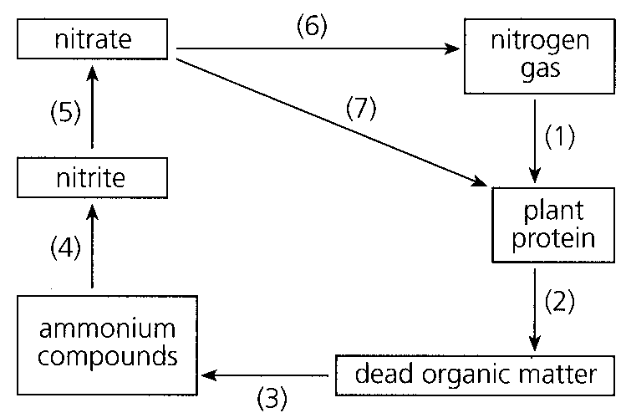
D. Fixation of atmospheric nitrogen 63.Saprophytic bacteria are important in thenitrogen cycle because
A. they convert ammonium compounds to nitrates.
B. they convert proteins to ammonium compounds.
C. they release nitrogen gas into the atmosphere.
44. Process (1) can be brought about by growing A.wheat.
A. wheat.
B. potatoes.
C. grasses.
D. peas.
45. Process (6) occurs more rapidly in A.well aerated soil.- D. cold conditions. X67. Which of the following pairs of processes matches correctly with the groups of microoganisms? X68.Nitrogenous fertilizers are usually in the form of ammonium salts. They are converted to nitrates in soil by A. nitrogen fixation. B. denitrification. C. nitrification.D. putrefaction.
 | Nitrogenfixing bacteria- | Putrefying bacteria and fungi
A. | change ammonia to nitrite | change nitrate to protein
B. | change ammonia to nitrogen gas | change protein to ammonia
C. | change nitrogen gas to nitrate | change nitrate to protein
D. | change nitrogen gas to ammonia | change protein to ammonia

A. well aerated soil.-
B. waterlogged soil.-
C. sunny places.
D. cold conditions. X67. Which of the following pairs of processes matches correctly with the groups of microoganisms? X68.Nitrogenous fertilizers are usually in the form of ammonium salts. They are converted to nitrates in soil by
46. A crop field requires regular addition of nitrogenous fertilizers but a natural grassland does not. Which of the following provides the best explanation for this?
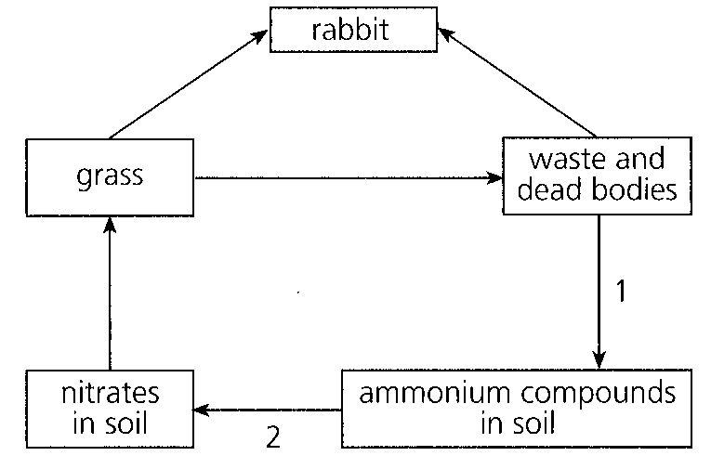
A. Crops are harvested. B.Minerals in the crop field are absorbed by the crops. C.Rate of denitrification is faster in the crop field. D.Grasses are well adapted to soils with low nitrogen content. Directions: Questions 70 to 72 refer to the diagram below which shows some pathways by which nitrogen is cycled in a grassland. X70.The processes represented by 1 and 2 are:
47. | 2 | D. | nitrification | nitrogen fixation X71.Two groups of organisms are involved in process 1. They are A. viruses and bacteria. B. bacteria and fungi.C. fungi and algae. D. algae and protozoa.
A. | decomposition | nitrogen fixation |
B. | putrefaction | nitrification |
C. | nitrogen fixation | putrefaction |
D. | nitrification | nitrogen fixation X71.Two groups of organisms are involved in process 1. They are
48. What major compound is formed in grass from the nitrates in the soil?
A. DNA B. Chlorophyll C. Protein D. Auxin
49. In the nitrogen cycle, certain mutualistic organisms convert
A. nitrogen gas to nitrates in soil.
B. nitrates in soil to nitrogen gas.
C. nitrogen gas to proteins in organisms.
D. ammonia to nitrates in soil.
50. Which of the following processes can increase the nitrate content of soil? (1) Addition of ammonium compounds (2) Growing leguminous plants (3) Lightning
A. (1) and (2) only
B. (1) and (3) only
C. (2) and (3) only
D. (1), (2) and (3)
51. The nitrogenfixing bacteria in the root nodules of leguminous plants benefits the plants by -
A. fixing atmospheric nitrogen into nitrates.
B. adding nitrogen compounds in the soil.
C. providing extra protein.
D. increasing the uptake of nitrates from soil.
52. Continuous hunting of rabbits in the grassland results in a decrease in the nitrogen content of the soil because
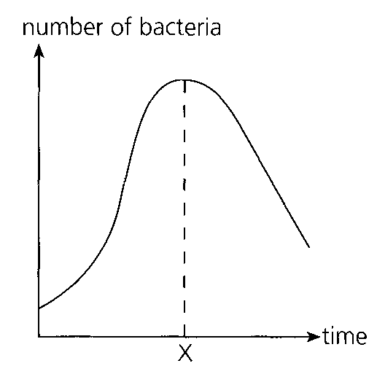
A. the waste and dead bodies of rabbits cannot be decomposed.
B. nitrogen absorbed by the rabbits cannot be returned to the soil.
C. rabbits also feed on denitrifying bacteria in soil.
D. grasses grow more rapidly and absorb more nitrates from the soil. Directions: Questions 77 and 78 refer to the graph below which shows the change in the number of bacteria in a culture medium over a period of time.
53. Which of the following may be a possible reason for the decrease in the number of bacteria after time X?
A. Death due to old age B. Accumulation of toxic waste products
C. Emigration D. Eaten by microscopic animals
54. Which of the following correctly shows the relationship between the pair of organisms?
 | Organisms | Relationship
A. | leguminous plants and nitrifying bacteria | mutualism
B. | algae and fungi in lichen | commensalism
C. | rabies virus and dog | parasitism
D. | tapeworm and man | predation

55. Which of the following pairs of organisms benefit each other in their association?
A. Barnacle and crab B. Lion and zebra
C. Alga and fungus in lichen D. Tapeworm and man
56. The following graph shows the changes in the numbers of two species of animals living in the same habitat over a period of time. The relationship between the two species is most likely D. mutualism. X82.The following graphs show the relative numbers of two species of organisms when they are reared separately and reared together. The relationship between the two species is most likely D. mutualism.
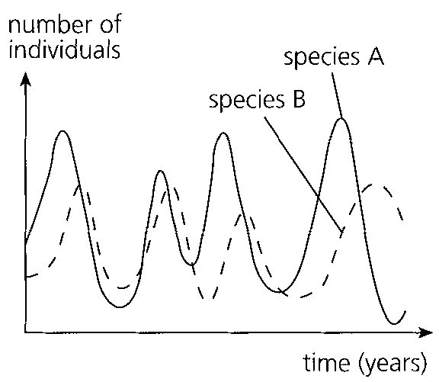
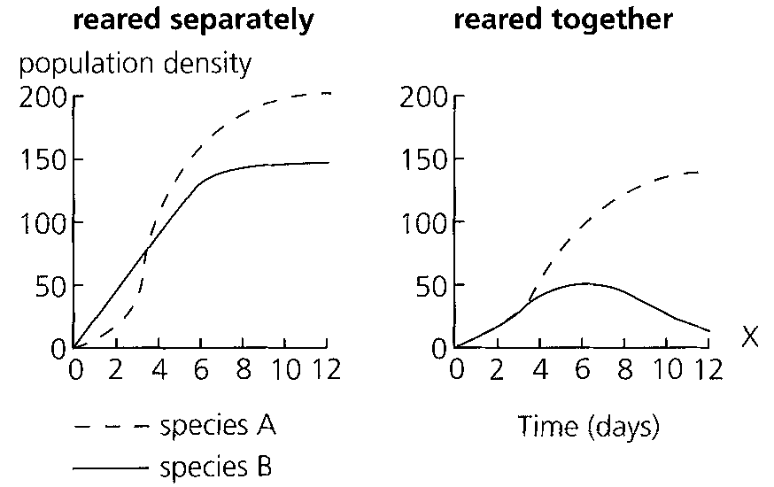
A. competition.
B. parasitism.
C. predation.
D. mutualism. X82.The following graphs show the relative numbers of two species of organisms when they are reared separately and reared together. The relationship between the two species is most likely
57. Which of the following is incorrectly matched?
X84.Which of the following pairs of organisms exhibits a relationship different from the other three pairs?
 | Phenomenon | Example
A. | saprophytism | moulds on bread
B. | mutualism | nitrogenfixing bacteria in root nodules of leguminous plants-
C. | commensalisms | epiphytes on trees
D. | competition | bees and caterpillars on the same tree

A. Algae and fungi in lichens B. Nitrogen fixing bacteria and pea plants-
C. Crops and weeds in the same fieldD. Sea anemones and hermit crabs
58. The photograph below shows the interaction between two plants. The type of interaction shown by the photograph is
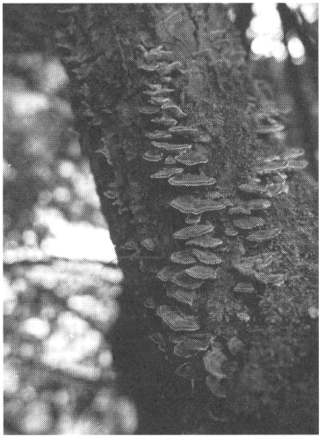
A. parasitism.
B. mutualism.
C. commensalism.
D. competition.
59. Which of the following shows the effects of competition on the two species involved?
('+' = benefited, ' = harmed, '0' = neither benefited nor harmed)-
Name: _________________________________ ( )
Marks: _________________________________
 | Organism 1 | Organism 2
A. | + | -
B. | + | +
C. | - | -
D. | + | 0

Part B — HKDSE-style (YKTo)
60. 1Which of the following definitions of ecological terms is/are CORRECT?
Term | Definition
(1) Habitat | Habits of an organism adapted to the environment
(2) Population | A group of organisms of the same species living together in a given area
(3) Community | The population of animals only that live and interact with each others in a given area
(4) Ecosystem | All the physiological systems of an organism are in equilibrium with each others

A. (1) only
B. (2) only
C. (2) and (3) only
D. (3) and (4) only
61. 2Which of the following is the definition of ecological community?
A. It is a group of men and women living together in a given area. They form a functional society.
B. It is a group of animals living together in a habitat.
C. It is a group of organisms living together and interacting with each other in a habitat.
D. It is a group of microorganisms living in a habitat that enables the recycling of matter to take place.
62. 3Plants and animals living together and interacting with each others form a
A. ecosystem.
B. biosphere.
C. community.
D. population.
63. 4Which of the following are essential features of an ecosystem? (1) Microorganisms must be present. (2) Light energy is available to support the producers. (3) Soil must be present to supply nutrients for the producers. (4) The top consumer must be a carnivore.
A. (1) and (2) only
B. (1) and (3) only
C. (2) and (3) only
D. (3) and (4) only
64. 5Which of the following is classified as a biome?
A. All the organisms living in a freshwater pond.
B. Vegetation eaten by lemmings which in turn are eaten by arctic fox.
C. The collective totality of all living organisms on earth.
D. A major division of the biotic communities of the earth defined mainly by the dominant vegetation.
65. 6Arrange the following in ascending order according to the complexity. (1) ecosphere (2) species (3) population (4) community (5) ecosystem B. Biotic community I — terms
A. (1), (2), (3), (5), (4)
B. (1), (3), (2), (4), (5)
C. (2), (3), (4), (5), (1)
D. (2), (4), (3), (1), (5)
66. Which of the following definition/description of a niche is CORRECT?
A. The ecological address of an organism in an ecosystem.
B. The biological relationships between organisms in an ecosystem.
C. The sum total of the way of life of a species in its environment.
D. The population of all organisms living in the same habitat.
67. The diagram below shows a ladybird eating a piece of leaf. It will be eaten by a small bird nearby. It releases carbon dioxide and excreta to the surrounding. Which of the following terms CORRECTLY describes the overall ecological status of the ladybird?
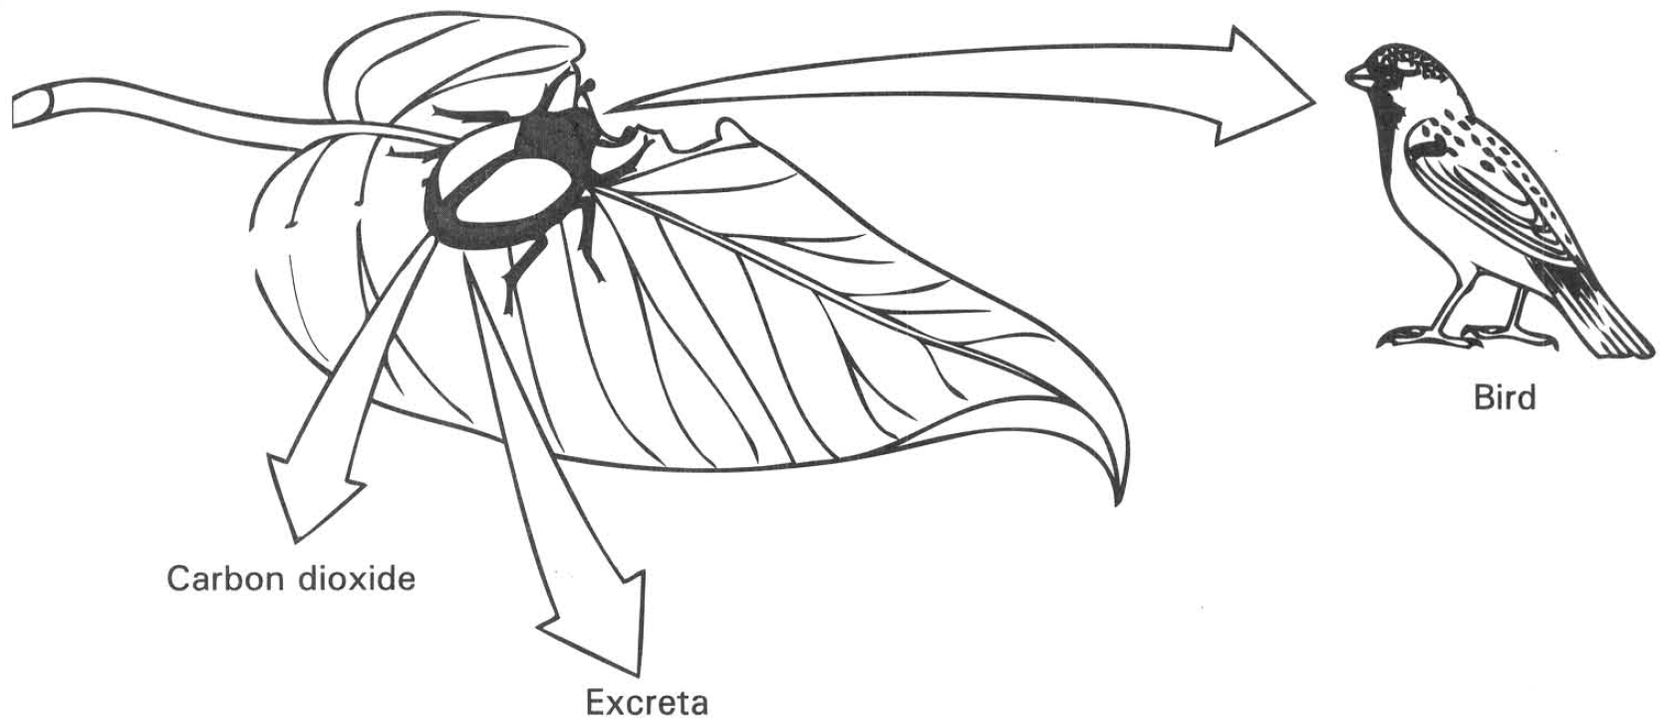
A. Omnivore B. Prey C. Niche D. Community
68. 9Which of the following communities has the highest species diversity?
 | Species1 | Species2 | Species3 | Species4 | Species5 | Species6 | Species7 | Total numberof individuals
Community W | 32 | 24 | 56 | 0 | 17 | 0 | 0 | 129
Community X | 24 | 12 | 0 | 54 | 31 | 12 | 41 | 174
Community Y | 32 | 21 | 28 | 16 | 19 | 21 | 36 | 173
Community Z | 0 | 27 | 69 | 56 | 0 | 13 | 24 | 189

A. Community W B. Community X C. Community Y D. Community Z
C. Biotic community II — Biological relationships between organisms
69. Which of the following matching between the ecological terms and the biological relationships between individuals X and Y is CORRECT? Keys: + Gains benefits - Causes harms 0 No benefits nor harms
 | Ecological terms | Biological relationships between individuals
 |  | X | Y
(1) | Commensalism | + | 0
(2) | Mutualism | + | +
(3) | Predation | - | 0
(4) | Competition | - | +
(5) | Parasitism | + | -

A. (1) and (2) only
B. (1) and (4) only
C. (1), (3) and (4) only
D. (1), (2) and (5) only
70. Which of the following matching of the organisms and their activities are CORRECT?
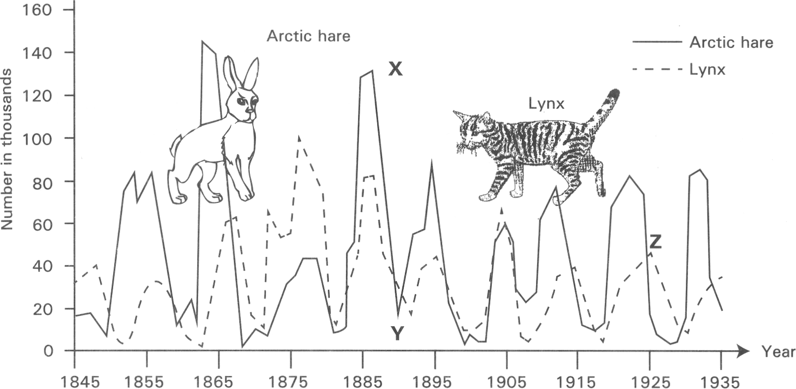
 | Organisms | Activities
(1) | Parasite | It gains benefits from other organism and causes harms to the latter.
(2) | Saprophyte | It lives in the same habitat with another organism and has the same requirements of the natural resources with the latter.
(3) | Predator | It kills and feeds on another organism.
(4) | Competitor | It depends on dead organic matter for nutrients supply.

A. (1) and (2) only B. (1) and (3) only C. (2) and (3) onlyD. (1) and (4) only Directions: Questions 20.12 to 20.15 refer to the graph below, which shows the population changes of the lynx and arctic hares over a period of time.
71. The population changes shown by the curves suggests that the arctic hare
A. has longer life span than the lynx.
B. can tolerate tough environmental conditions than the lynx.
C. is preyed by the lynx.
D. is a herbivore and the lynx is a carnivore.
72. The population change of the lynx always lags behind that of the hare. Which of the following is a possible explanation of this pattern of population change?
A. The hare is smaller in size than the lynx so that it grows faster than the lynx.
B. The lynx is bigger in size so that it can easily be spotted by hunters.
C. The hare as herbivore has more stable food supply while the lynx depends on the hares for food supply.
D. The lynx has more predators than the hare.
73. Which of the following account for the decrease in the number of the hares from X to Y? (1) Spread of disease (2) Increase in the population of the lynx (3) Increase of competition among the hares
A. (1) and (2) only
B. (1) and (3) only
C. (2) and (3) only
D. (1), (2) and (3)
74. Which of the following account for the decrease in the number of the lynx from Z?
(1) Starvation
(2) Lack of shelter from enemies
(3) Spread of diseases
(4) Lack of space due to over crowding
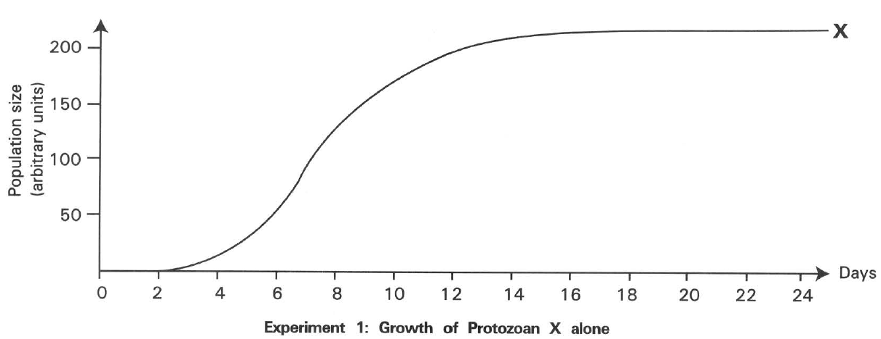
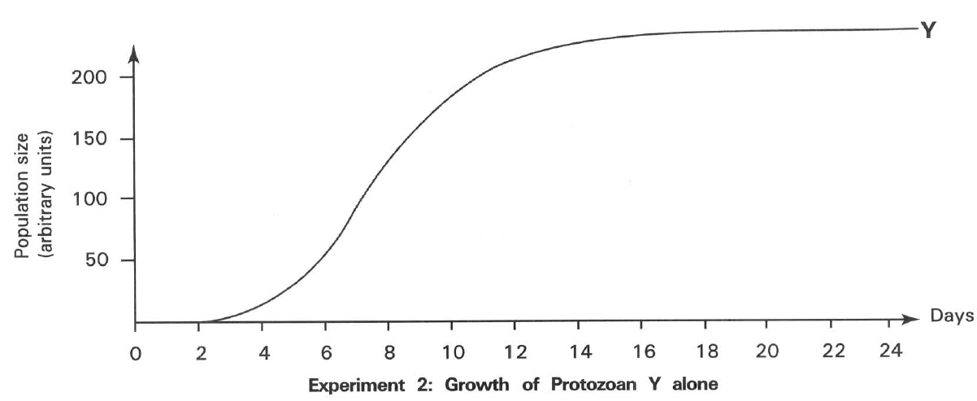
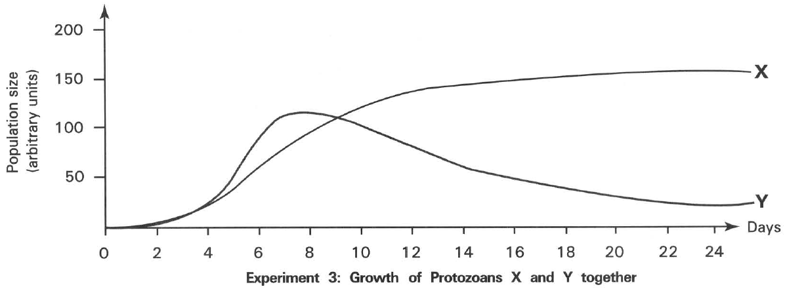
A. (1) and (2) only B. (2) and (3) only
C. (1) and (3) only D. (2) and (4) only Directions: Questions 20.16 and 20.17 refer to the graphs below, which show the change in the population size of two different species of protozoa, X and Y, in three experiments. In experiment 1 and experiment 2 protozoa X and Y are grown separately alone in different culture medium. In experiment 3 they are grow together in the same culture media. There is abundant nutrient supply in the culture media.
75. In experiments 1 and 2, the population size of both protozoa X and Y grew to high level and then remained unchanged. Which of the following is the explanation of these results?
A. Each species of protozoa has limited life span.
B. There is a shortage of food for these protozoa to grow.
C. These protozoa are attacked by pathogens.
D. The rate of reproduction is the same as the rate of death.
76. What biological relationship between protozoa X and Y is shown by the results of experiment 3?
A. Predation B. Commensalism C. Competition D. Parasitism
77. The photograph below shows the Mikania micrantha (FCEM) which is an exotic vine. It climbs up other plants to reach their canopy for better sunlight. However its leaves grow rapidly and eventually cover other plants which may die due to the shortage of sunlight for photosynthesis.
What is the biological relationship between Mikania micrantha and other plants?
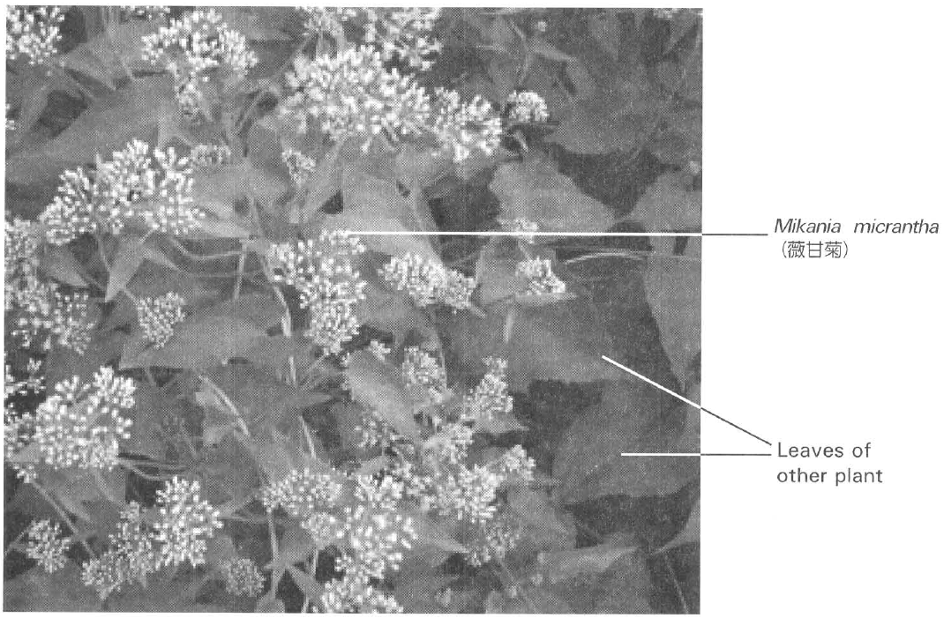
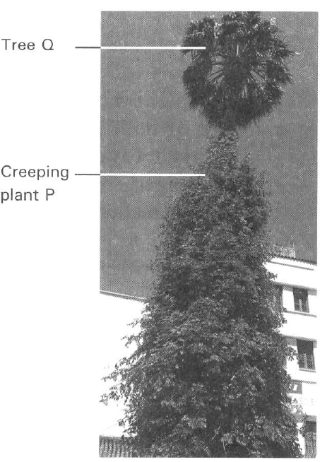
A. Parasitism B. Mutualism
C. Competition D. Commensalism
78. The photograph at right shows that a creeping plant P almost covers the whole trunk of tree Q to gain sunlight for photosynthesis. The tree Q is still in healthy condition. What is the biological relationship between the climbing plant P and tree Q?
A. Parasitism
B. Mutualism
C. Competition
D. Commensalism
79. The photograph below shows a climbing plant R (Dodder, k4 -) with thin stem and very small leaves coiling around another plant (S).1t sends suckers into the vascular tissues of plant S to obtain organic nutrients. What is the biological relationship between plant R and plant S?
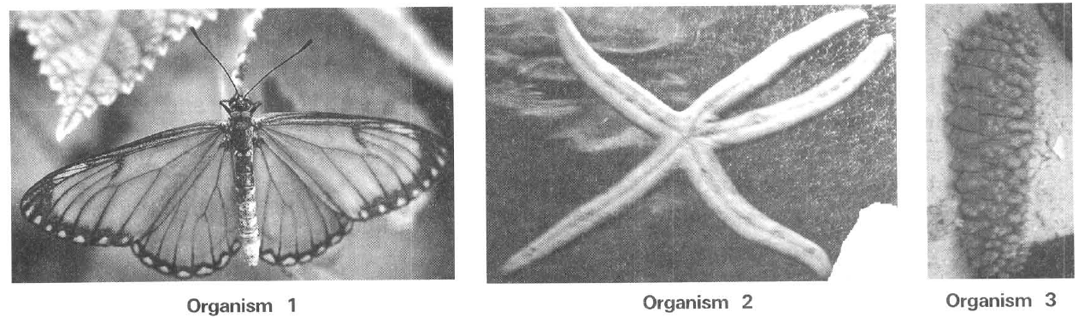
A. ParasitismB. Mutualism C. Competition D. Commensalism
80. The photograph below shows an insect with its mouth parts piercing into the vascular tissues of the thin stem of the plant R (Dodder) to suck organic nutrients from it.
What are the roles played by the insect and the plant R shown in the diagram?
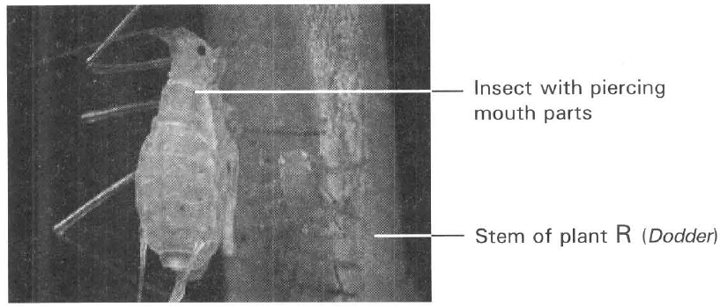
 | Insect | Plant R
A. | Primary consumer | Producer
B. | Carnivore | Herbivore
C. | Secondary consumer | Primary consumer
D. | Secondary consumer | Producer

81. Each of the diagrams below shows the biological association between two organisms.
Which of the following matching between the biological relationships of the organisms is CORRECT
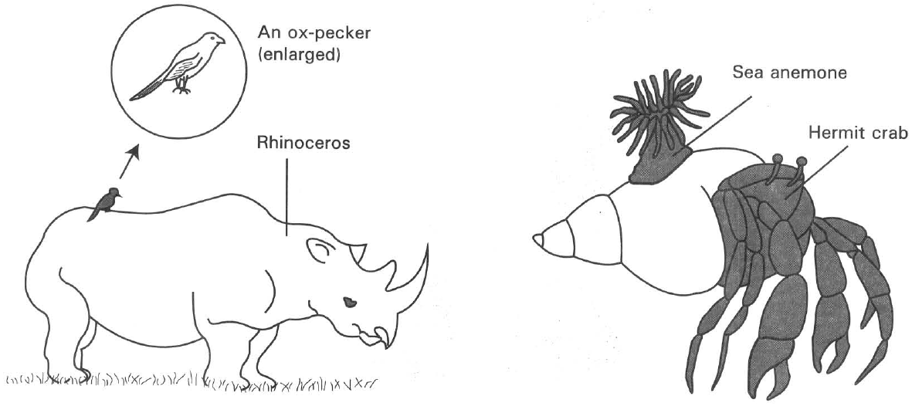
 | Biological relationships between the organisms
 | Ox pecker and rhinoceros | Sea anemone and hermit crab
A. | Parasitism | Predation
B. | Predation | Parasitism
C. | Commensalism | Mutualism
D. | Mutualism | Commensalism

D. Biotic community III — ecological succession
82. Which of the following is an example of primary succession?
A. Leaves of crop plants are eaten by caterpillars which in turn are eaten by shrews. The shrews are eaten by badgers.
B. In the first year a farm field is grown with crop plants with high nutrient demand. In the second year it is succeeded with growth of crop plants with low nutrient demand. In the third year it is followed by growth of legume plants.
C. A barren rocky surface is colonized by lichens. Then it is widely covered with mosses. With time goes by the site is dominated in sequence by herbs community, shrubs community and then trees community.
D. After hill fire, the site is rapidly colonized by a series of different biotic communities such as herbs, shrubs and then trees .
83. The photographs X and Y below show the conditions of an island shortly after a volcanic eruption and 47 years later.
Which of the following CORRECTLY accounts for the change of a barren island in photograph X to become the island full of trees in photograph Y?
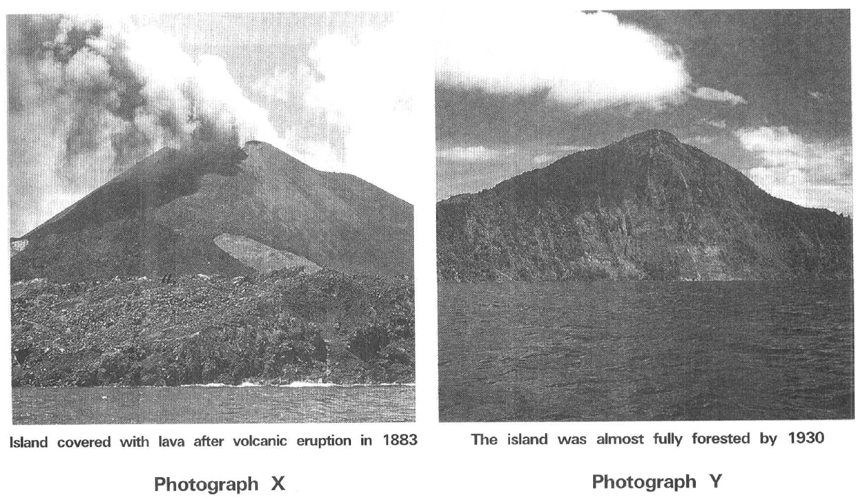
A. The lava contains large amount of nutrients to support the vigorous plant growth.
B. Sunlight is the ultimate source of energy to support the vigorous plant growth.
C. Primary succession leads to the changes of the biotic communities on the island.
D. Recycling of matters is very efficient on the island. E. Functioning of an ecosystem
84. What is the importance of decomposers in an ecosystem?
A. To release mineral salts from dead organic matter to the environment.
B. The recycling of energy in the ecosystem.
C. To promote the release of energy from the organisms.
D. To limit the growth of consumers in the ecosystem.
85. What is the importance of producers in an ecosystem?
(1) To provide inorganic nutrients in the environment.
(2) To provide organic food to the consumers.
(3) To remove carbon dioxide from the ecosystem.
(4) To replenish the oxygen supply to the environment.
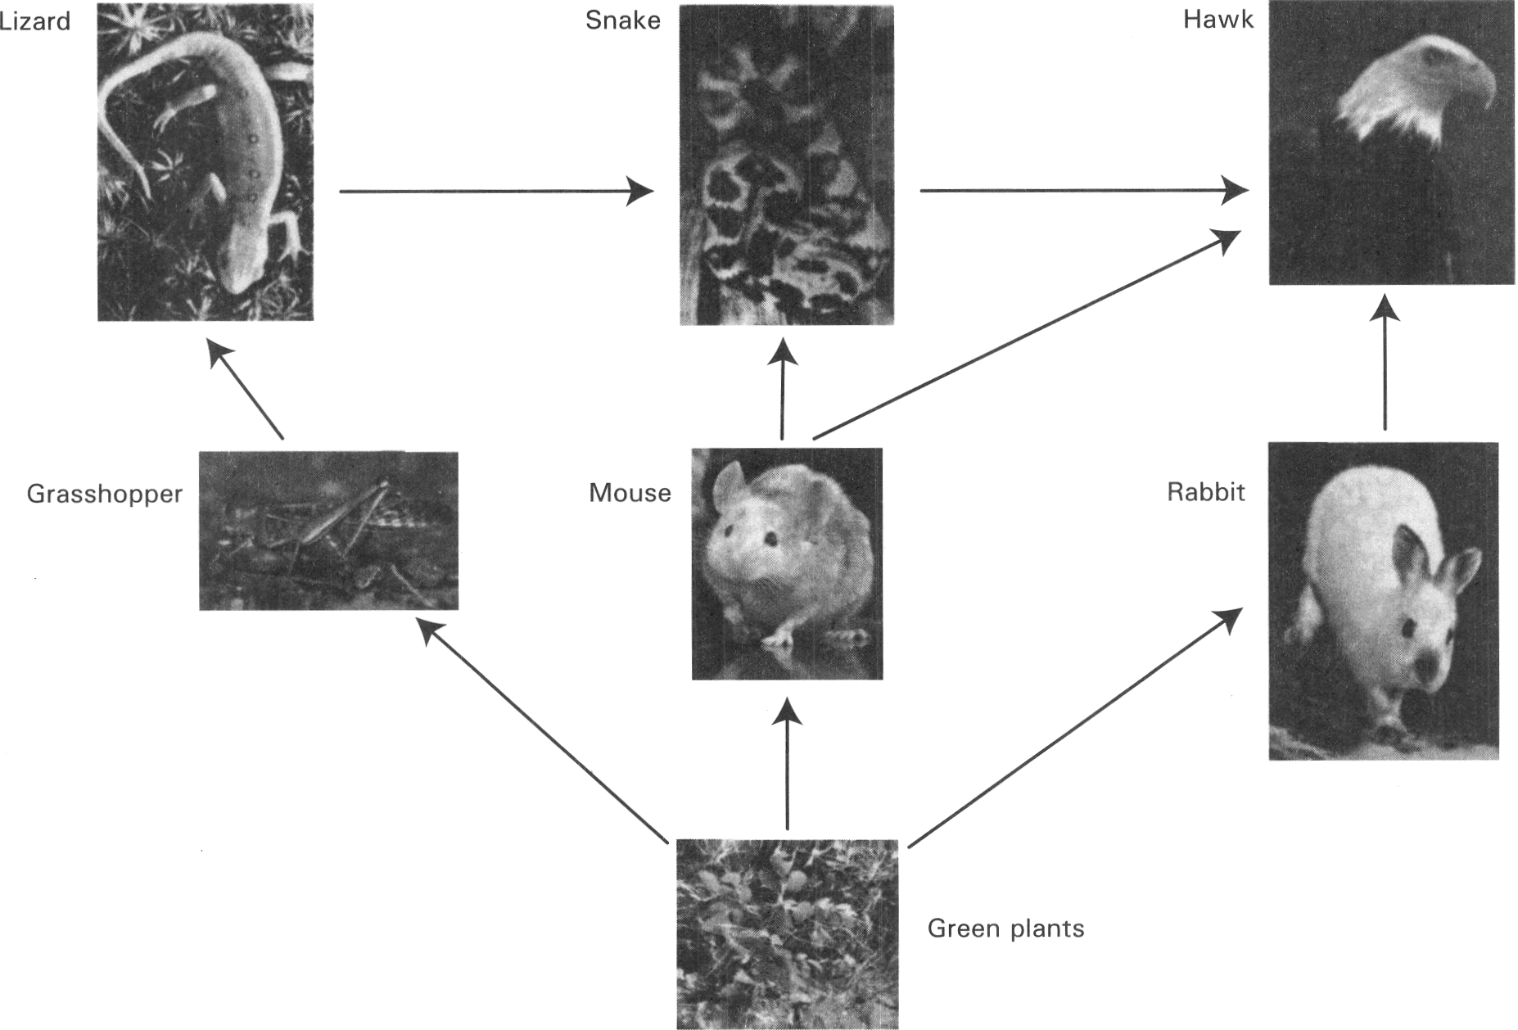
A. (1) and (2) only B. (2) and (3) only C. (3) and (4) only D. (2), (3) and (4) only Directions: Questions 20.27 to 20.33 refer to the photographs below which show the food web of a grassland community
86. What is the highest trophic level in this food web?
A. The 3rd trophic level
B. The 4th trophic level
C. The 5th trophic level
D. The 6th trophic level
87. What is/are the biological relationships between snake and hawk? (1) Commensalism (2) Competition (3) Predation
A. (1) only
B. (1) and (2) only
C. (2) and (3) only
D. (3) and (1) only
88. Which of the following pairs organisms are secondary consumers?
A. Grasshopper and mouse
B. Mouse and rabbit
C. Lizard and snake
D. Grasshopper and rabbit
89. Which of the following statements are CORRECT? (1) Hawk is the secondary and tertiary consumers. (2) Grasshopper and rabbit are competitors. (3) Both lizard and mouse are the preys of snake.
A. (1) and (2) only
B. (1) and (3) only
C. (2) and (3) only
D. (1), (2) and (3)
90. Which of the following has the lowest biomass in the food web illustrated above?
A. Hawk
B. Grasshopper
C. Rabbit
D. Green plants
91. What would most probably happen if the number of rabbits increased o ftremendously?
A. The amount of green plants would increase.
B. The number of mice would increase.
C. The number of grasshoppers would decrease.
D. The number of snakes would increase.
92. This food web does NOT include
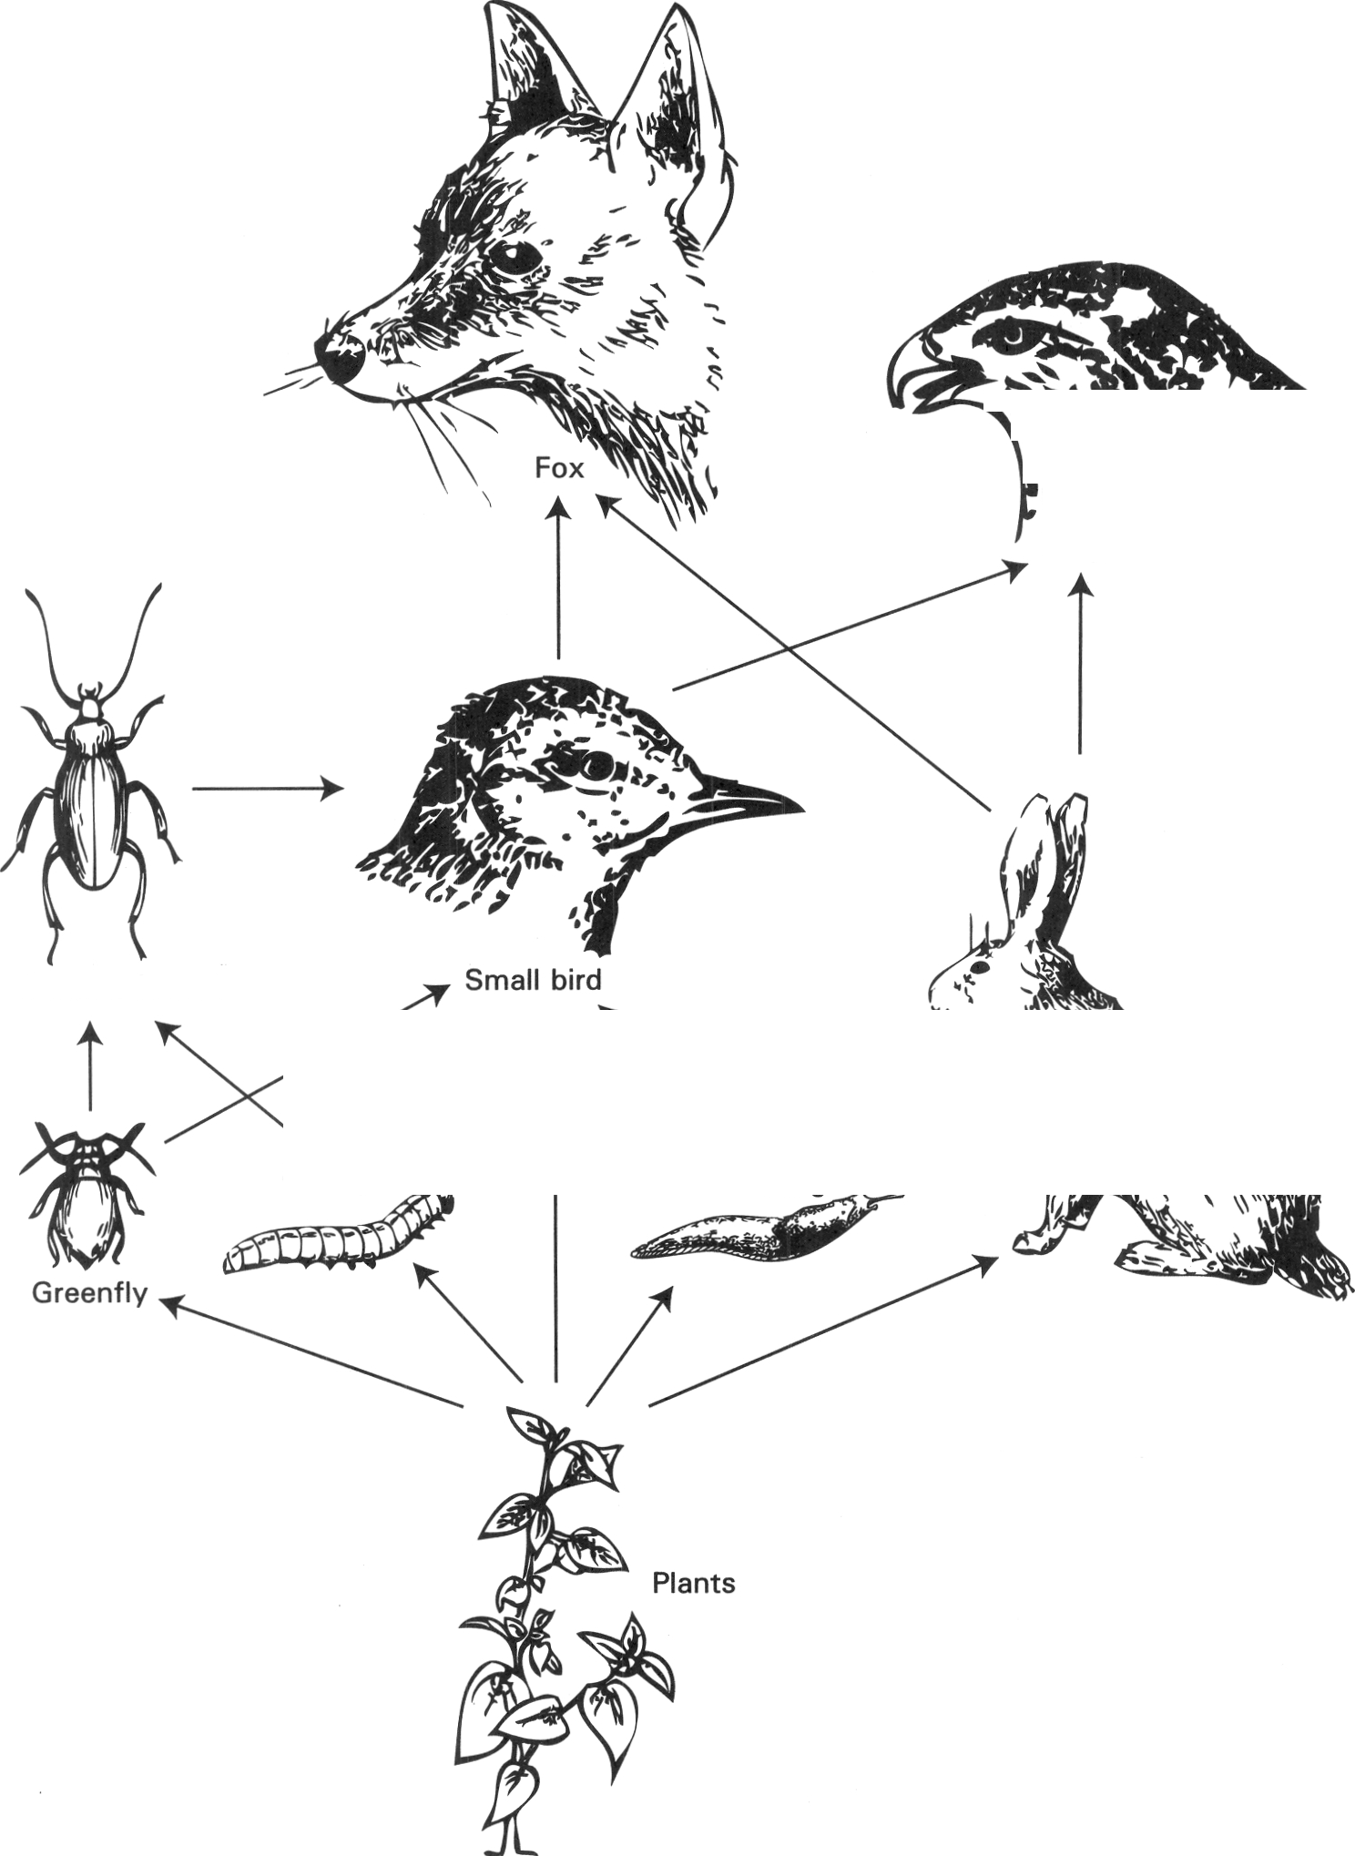
A. decomposers.
B. producers.
C. secondary consumers.
D. tertiary consumers. Directions: Questions 20.34 to 20.39 refer to the food web below.
93. Which of the following in the food web has the lowest biomass?
A. Greenfly B. Caterpillar
C. Slug D. Rabbit
94. Which of the following animals is both the primary consumer, secondary consumer and tertiary consumer?
A. Fox B. Large hawk
C. Small bird D. Carnivorous insect
95. What is/are the biological relationships between small bird and caterpillar? (1) Mutualism (2) Competition (3) Predation
A. (1) only
B. (2) only
C. (1) only
D. (2) and (3) only
96. What would probably happen if the large hawks were removed away? (1) There would be a decrease in the small bird and rabbit. (2) There would be decrease in caterpillar and slug. (3) There would be increase in carnivorous insects
A. (1) only
B. (2) only
C. (3) only
D. (1) and (3) only
97. The biomass of the rabbit is (1) greater than that of the plants. (2) smaller than that of the fox. (3) greater than that of the large hawk.
A. (1) only
B. (2) only
C. (3) only
D. (1) and (3) only
98. Which of the following is the most efficient energy flow in the food web above?
A. Plants Small bird
B. Plants Rabbit Fox
C. Plants Slug Small bird Fox
D. Plants Rabbit Large hawk
99. The trophic levels of a food chain are seldom more than five . Which of the following reasons is CORRECT?
 | Components of the community
Aquarium | At the beginning of the experiment | After a few days
(1) | Animals Z Animals XPlants P | Survived Dead Partly eaten
(2) | Animals Y Animals X Plants P | Vanished Survived Remained the same
(3) | Animals Z Animals Y Plants P | Vanished Survived Slightly eaten
(4) | Animals X Animals Y Animals Z | Dead Vanished Vanished

A. The number of organisms living in a habitat is not big enough to be divided into five categories.
B. The herbivores are usually smaller in size than the carnivores so that they cannot support large number of carnivores.
C. There is tremendous loss of energy between the trophic levels along the food chain.
D. The weather of most places is not sunny all day long that limits the supply of light energy to support long food chains. Directions: Questions 20.41 to 20.43 refer to the experiment described below. Three types of aquatic animals X, Y, Z and a group of plants P are grouped in different combinations in four different aquaria which are covered with lids. The components of the community in each aquarium at the beginning of the experiment and a few days later are recorded as below.
100. Which of the following is/are herbivore(s)?
A. Animals X only B. Animals Y only C. Animals Z only D. Animals X and Y only
101. Which of the following is/are the top consumer(s)?
A. Animals X only B. Animals Y only
C. Animals Z only D. Animals Y and Z only
102. According to the result of the experiment, which of the following TRULY represents the food chain of the organisms in the above community?
A. P X Y Z
B. P Y X Z
C. P Z Y X
D. P Y Z X
103. Which of the following abiotic factors favour the decomposition of the dead remains into inorganic nutrients in soil?
 | Temperature | Humidity
A. | high | low
B. | low | high
C. | high | high
D. | low | low

104. Which of the following statements related with the pyramid of numbers is/ are INCORRECT? (1) It represents the number of living organisms in each trophic level of a food chain. (2) It only represents the number of consumers in an ecosystem. (3) It gives a more accurate information about the energy content of each trophic level than that of the pyramid of mass.
A. (1) only
B. (2) only
C. (3) only
D. (2) and (3) only
105. The diagram below shows the pyramid of number in an ecosystem Which of the following statements related with the food chain is CORRECT? (1) It is a parasitic food chain. (2) The producers are very large in size. (3) The consumers have very high rate of reproduction.
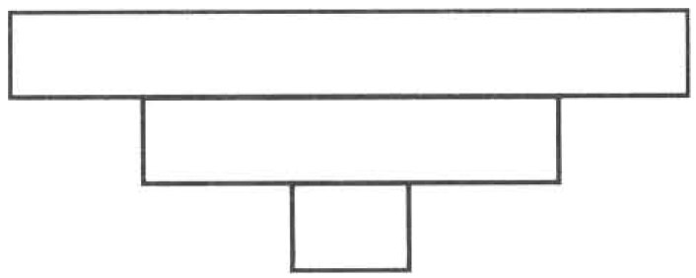
A. (1) only
B. (1) and (2) only
C. (1) and (3) only
D. (1), (2) and (3)
106. The following diagrams represent four types of pyramids of number P, Q, R and S.
The following are four food chains labelled (1), (2), (3) and (4):
Food chain (1) Tree Beetle Endoparasite
Food chain (2) Phytoplanktons Krill (small crustaceans) Whale
Food chain (3) Tree Greenfly Carnivorous insects
Food chain (4) Big crop plants Caterpillar Bird
Which of the following matching between the pyramids of number and the food chains are CORRECT?
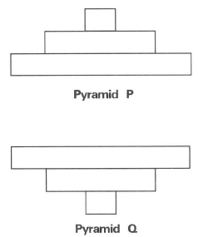
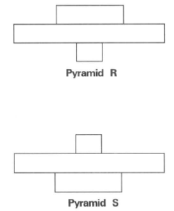
 | Pyramid P | Pyramid Q | Pyramid R | Pyramid S
A. | (1) | (4) | (3) | (2)
B. | (3) | (2) | (4) | (1)
C. | (2) | (1) | (3) | (4)
D. | (1) | (4) | (2) | (3)

107. The following diagrams represent two types of pyramids of biomass X and Y.
The following are three food chains labelled (1), (2) and (3):
Food chain (1) Tree Beetle Endoparasite
Food chain (2) Grasses Grasshopper Mantis
Food chain (3) Phytoplankton in ocean Small zooplankton in ocean Bigger zooplankton in ocean
Which of the following matching between the pyramids of biomass and the food chains are CORRECT?
Directions: Questions 20.49 and 20.50 refer to the diagram below which shows the energy flow along a simplified food chain.
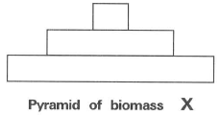
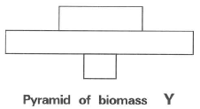
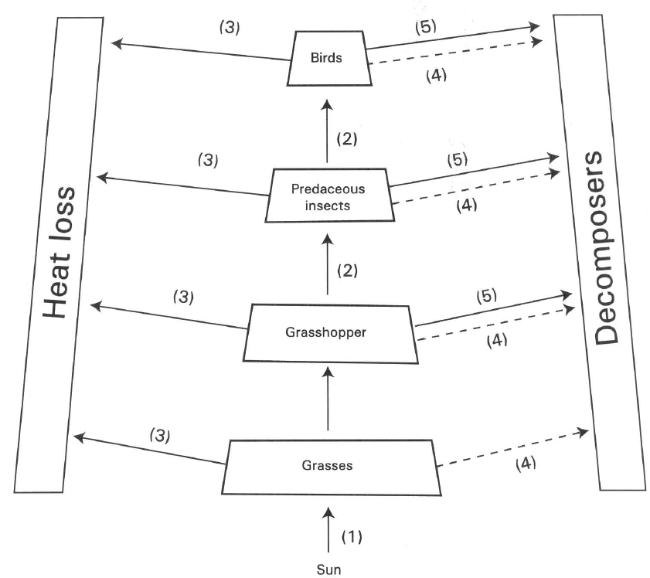
 | Food chain (1) | Food chain (2) | Food chain (3)
A. | Pyramid of biomass X | Pyramid of biomass Y | Pyramid of biomass X
B. | Pyramid of biomass Y | Pyramid of biomass X | Pyramid of biomass X
C. | Pyramid of biomass X | Pyramid of biomass X | Pyramid of biomass Y
D. | Pyramid of biomass Y | Pyramid of biomass Y | Pyramid of biomass X

108. Which of the following statements related to the diagram is NOT TRUE?
A. Energy can be recycled in the ecosystem.
B. The ultimate source of energy in the food chain is the sun.
C. The step-wise energy loss accounts for the decrease in the biomass along the food chain.
D. Producer is the food source for other members in the food chain.
109. Which of the following matching is CORRECT?
 | (1) | (2) | (3) | (4) | (5)
A. | Respiration | Holozoic nutrition | Photosynthesis | Decay | Egestion and excretion
B. | Photosynthesis | Feeding | Respiration | Egestion andexcretion | Decay
C. | Photosynthesis | Predation | Respiration | Decay | Egestion and excretion
D. | Respiration | Holophytic nutrition | Photosynthesis | Egestion and excretion | Decay

110. Which of the following processes account for the decrease in the biomass along the food chain? (1) Increase in size of the organisms in the higher trophic level. (2) Excretion, respiration and metabolism of the organisms in each trophic level consume energy. (3) Decomposition of the dead bodies of the organisms at each trophic level.
A. (1) only
B. (1) and (2) only
C. (1) and (3) only
D. (2) and (3) only
111. Which of the following statements about a functional ecosystem is FALSE?
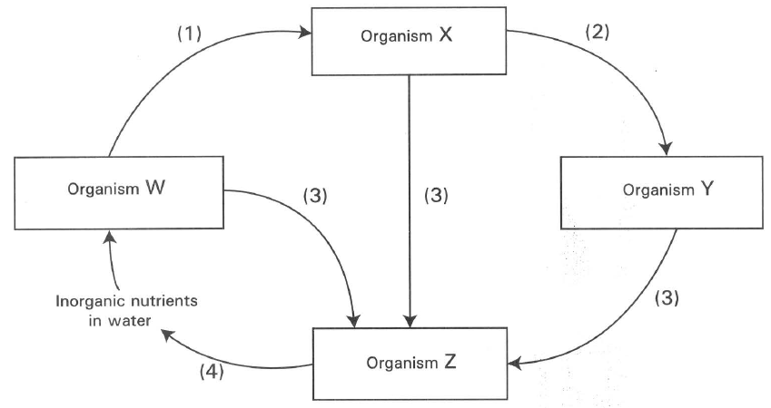
A. The flow of materials in the ecosystem is a cyclic process.
B. Producer is an important component in the ecosystem to trap the energy from the sun.
C. The flow of energy in the ecosystem is a cyclic process.
D. The total biomass of the primary consumers is smaller than that of the producers. F. Cycling of materials in an ecosystem I — nutrient cycle Directions: Questions 2033 and 20.54 refer to the diagram below, which shows the simplified cycling of nutrients in an aquatic ecosystem
112. Which of the following matching of organisms is CORRECT?
 | Organism W | Organism X | Organism Y | Organism Z
A. | Decomposer | Herbivore | Carnivore | Producer
B. | Producer | Carnivore | Herbivore | Decomposer
C. | Herbivore | Carnivore | Decomposer | Producer
D. | Producer | Herbivore | Carnivore | Decomposer

113. Which of the following matching of processes is CORRECT?
Directions: Questions 20.55 to 20.62 refer to the diagram below, which shows a closed glass container with snails, pond weeds and pond mud inside.
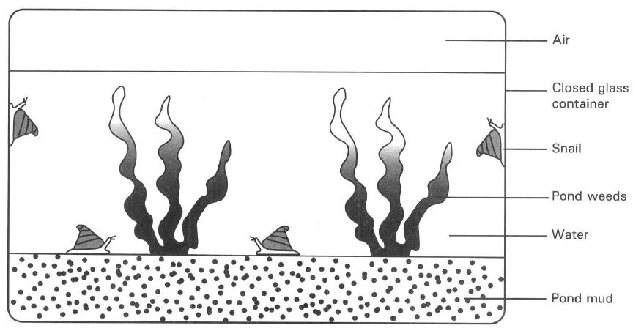
 | Process (1) | Process (2) | Process (3) | Process (4)
A. | Photosynthesis | Predation | Respiration | Decomposition
B. | Feeding | Excretion | Decomposition | Death
C. | Feeding | Predation | Death | Decomposition
D. | Predation | Feeding | Respiration | Photosynthesis

114. Which of the following condition(s) is/are essential to keep the organisms inside the closed glass container to remain alive for months? (1) Continuous illuminating the glass container with light (2) Weekly replacing the water inside the glass container with distilled water. (3) Weekly replacing the pond mud with sterilized mud.
A. (1) only
B. (2) only
C. (1) and (2) only
D. (2) and (3) only
115. If the glass container is completely covered with aluminium foil, after a few days the snails die. It is because (1) the water is overheated. (2) no food is available to the snails. (3) no photosynthesis takes place to replenish for the loss of oxygen.
A. (1) only
B. (2) only
C. (3) only
D. (1) and (3) only
116. The pond weed is very important to the snail because it provides the latter with (1) oxygen (2) shelter (3) food
A. (1) only
B. (2) only
C. (1) and (3) only
D. (2) and (3) only
117. Which of the following microorganisms are essential for the pond weeds to be in healthy conditions inside the aquarium? (1) Nitrogen-fixing bacteria (2) Nitrifying bacteria (3) Denitrifying bacteria (4) Putrefying bacteria
A. (1) and (2) only
B. (2) and (3) only
C. (2) and (4) only
D. (3) and (4) only
118. The ultimate source of energy for the snail to crawl along the glass comes from
A. the glucose inside the body fluid of the snail.
B. the starch inside the pond weeds.
C. the light illuminating the pond weeds.
D. the microorganisms present in soil.
119. The number of snails will remain relatively constant in the glass container. It is because its population size is mainly limited by
A. the amount of oxygen in the glass jar.
B. the availability of pond weeds.
C. the amount of carbon dioxide in water.
D. the space available in the glass container.
120. The acidity of the water in the glass container is highest at/in
A. the morning.
B. mid-night.
C. noon.
D. the afternoon.
121. If the pH of the water in the glass container is a bit low at day time, the condition can be improved by
(1) replacing the pond mud with clay soil (2) putting in more snails.
(3) growing more pond weeds.
Which of the above suggestions would increase the pH of water?
A. (1) only B. (3) only C. (1) and (2) only D. (2) and (3) only G. Cycling of materials in an ecosystem II — carbon cycle
122. What is the functional role of microorganisms in the carbon cycle?-
A. Producers B. Parasites C. Consumers D. Decomposers
123. The total amount of carbon in an ecosystem
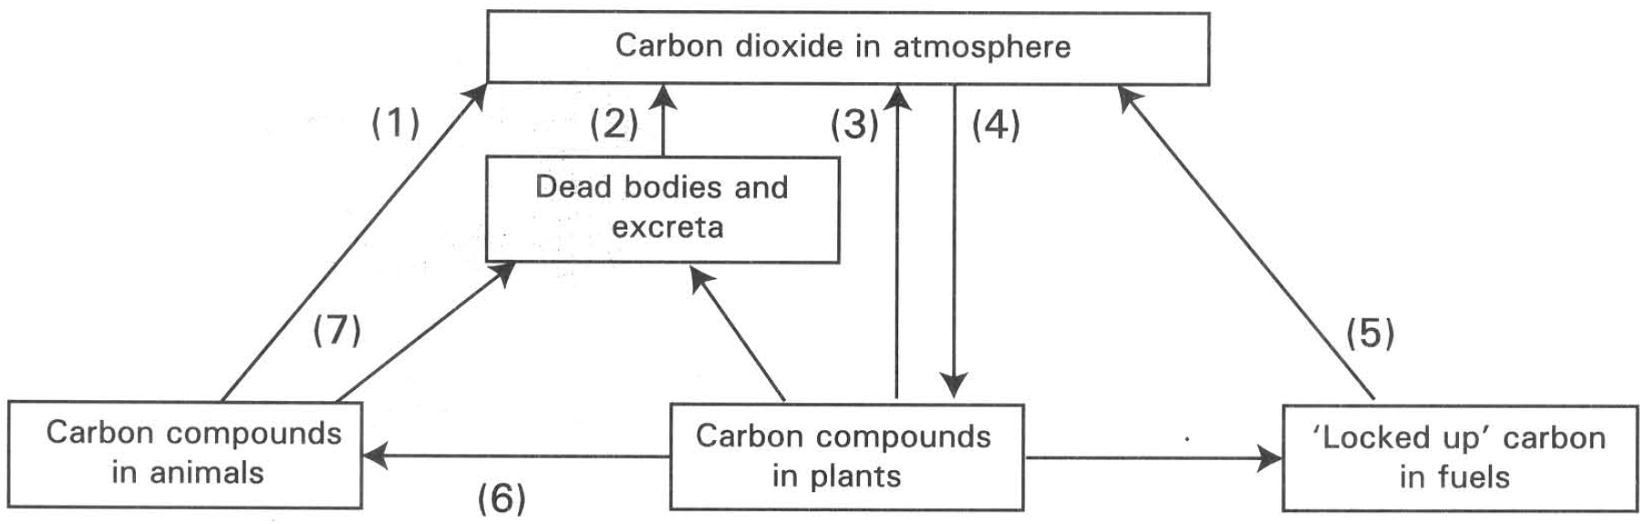
A. is maintained at a constant level. B. is increasing rapidly.
C. is decreasing rapidly. D. is fluctuating vigorously. Directions: Questions 20.65 to 20.73 refer to the diagram below, which shows the carbon cycle.
124. Which process is responsible for building up the biomass of the producers in an ecosystem?
A. (1) only
B. (2) only
C. (3) only
D. (4) only
125. Which process involves microorganisms?
A. (1) only
B. (2) only
C. (3) only
D. (4) only
126. Which of the following TWO processes are exactly the same?
A. (1) and (3)
B. (2) and (5)
C. (1) and (5)
D. (1) and (6)
127. The amount of energy available to the organisms decreases along the food chain .Through which of the following processes is the energy mainly lost?
A. (1), (2) and (3)
B. (4), (5) and (6)
C. (4), (6) and (7)
D. (1), (5) and (6)
128. The carbon compounds in animals are mainly in the form of (1) carbonhydrates (2) proteins (3) water (4) fats
A. (1) only
B. (4) only
C. (3) and (4) only
D. (1), (2) and (4) only
129. The present atmospheric CO2 concentration is 0.033%. It is estimated that in the year 2050 the atmospheric CO2 concentration will be increased to 0.045%. Which of the following processes is mainly responsible for this increase?
A. (1)
B. (2)
C. (3)
D. (5)
130. Which processes will reduce the concentration of oxygen in the atmosphere?
A. (1),(2),(3) and (5) only
B. (1),(4),(5) and (6) only
C. (2),(6),(7) and (1) only
D. (2),(3),(4) and (7) only
131. Which of the following combinations show the CORRECT processes that release energy?
A. (1), (2), (3) and (5)
B. (1), (4), (5) and (6)
C. (2), (6), (7) and (1)
D. (2), (3), (4) and (5)
132. Which of the following matching is CORRECT?
 | (2) | (3) | (4) | (5) | (6) | (7)
A. | Burning | Death | Photosynthesis | Decomposition | Respiration | Feeding
B. | Decomposition | Respiration | Feeding | Burning | Photosynthesis | Death & excretion
C. | Decomposition | Respiration | Photosynthesis | Burning | Feeding | Death & excretion
D. | Burning | Combustion | Feeding | Respiration | Feeding | Photosynthesis

133. The importance of putrefying microorganisms in the carbon cycle is to
A. fix the carbon dioxide from the atmosphere in the carbon cycle.
B. act as producers in trapping more energy in the first trophic level of the ecosystem.
C. break the carbonaceous compounds of the dead remains into simpler molecules.
D. change the carbonaceous compounds in soil to carbon particles.
134. Which of the following will occur in the absence of producers in an ecosystem?
(1) All consumers will die.
(2) Gradual increase in the concentration of the atmospheric carbon dioxide.
(3) Rapid growth of microorganisms occurs.
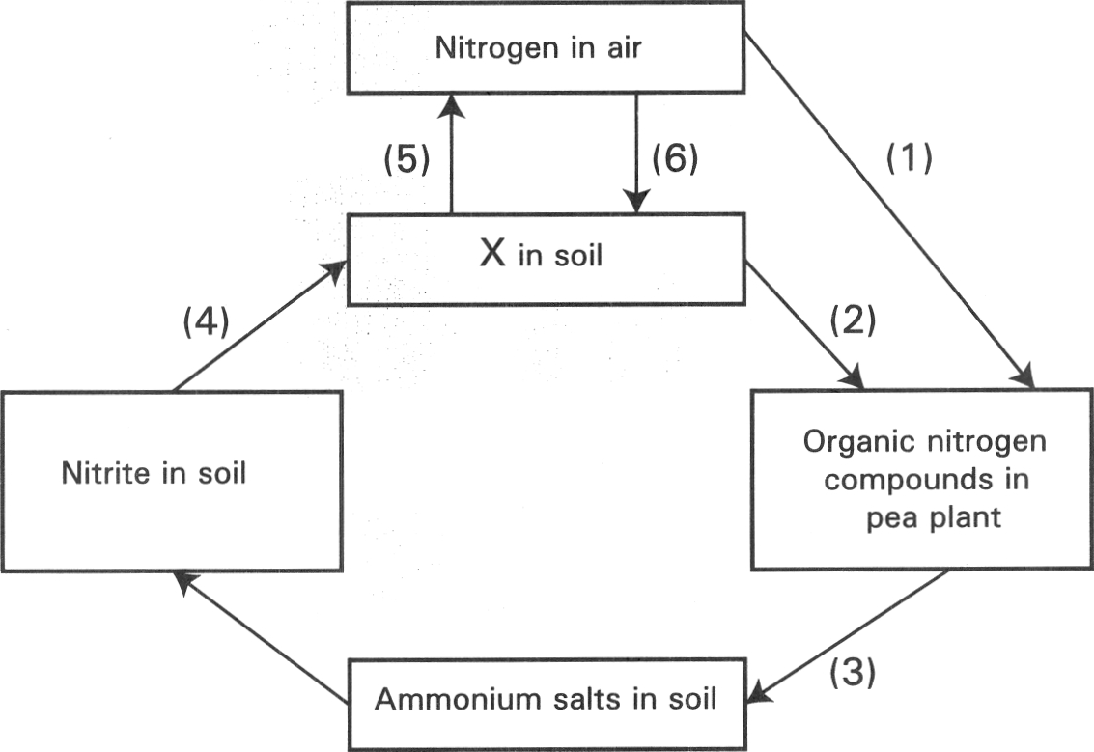
A. (1) only B. (1) and (2) only C. (2) and (3) only D. (1), (2), and (3) H. Cycling of materials in an ecosystem III — nitrogen cycle Directions: Questions 20.76 to 20.82 refer to the diagram below which shows some of the pathways in the nitrogen cycle.
135. What will chemical X become in the tissues of pea plants? (1) Starch (2) Protein (3) Fat
A. (1) only
B. (2) only
C. (1) and (2) only
D. (1) and (3) only
136. Which of the following matching of processes is CORRECT?
 | (1) | (3) | (4) | (5)
A. | Nitrogen-fixation | Putrefaction | Nitrification | Denitrification
B. | Excretion | Nitrogen-fixation | Denitrification | Nitrification
C. | Excretion | Denitrification | Nitrification | Nitrogen-fixation
D. | Nitrogen-fixation | Putrefaction | Ammonification | Nitrification

137. Which of the following matching of processes is CORRECT?
 | (2) | (6)
A. | Photosynthesis | Respiration
B. | Nitrogen fixation | Denitrification
C. | Absorption | Lightning
D. | Putrefaction | Nitrification

138. Which of the following matching of the bacteria and the processes is CORRECT?
. | (1) | (3) | (4) | (5)
A. | Nitrogen-fixing bacteria | Putrefying bacteria | Denitrifying bacteria | Nitrifying bacteria
B. | Denitrifying bacteria | Nitrifying bacteria | Putrefying bacteria | Nitrogen-fixing bacteria
C. | Denitrifying bacteria | Nitrogen-fixing bacteria | Putrefying bacteria | Nitrifying bacteria
D. | Nitrogen-fixing bacteria | Putrefying bacteria | Nitrifying bacteria | Denitrifying bacteria

139. Which of the following has the same symbiotic relationship as the pea plants with their partners living inside their tissues? (1) Soya bean (2) Rice (3) Wheat (4) Ground nut
A. (1) and (2) only
B. (2) and (3) only
C. (3) and (4) only
D. (4) and (1) only
140. Where will the bacteria contributed greatly to the build-up of organic nitrogen compounds inside the pea plant locate?
A. Leaf
B. Stem
C. Fruit
D. Root nodule
141. Which process will reduce the fertility of soil?
A. (1) only B. (3) only C. (4) only D. (5) only Directions: Questions 20.83 to 20.86 refer to the diagram below which shows some of the pathways in the nitrogen cycle.
142. Which of the following combinationsCORRECTLY matches the processes that depend on saprophytic bacteria and the symbiotic bacteria respectively?
 | Saprophytic bacteria | Symbiotic bacteria
A. | (3) | (4)
B. | (4) | (5)
C. | (6) | (3)
D. | (4) | (2)

143. Which labelled processes do not involve bacterial activities?
A. (1) and (2) only
B. (2) and (3) only
C. (3) and (6) only
D. (4) and (5) only
144. Which labelled processes will decrease the fertility of soil?
A. (1), (3) and (6) only
B. (2), (4) and (5) only
C. (1), (4) and (6) only
D. (2), (3) and (6) only
145. Which of the following conditions are favourable to the bacterial activities of the processes labelled (4), (5) and (1) ?
 | (4) | (5) | (1)
A. | High soil temperature | Water-logged soil | Well aerated soil
B. | Low soil temperature | Well aerated soil | Water-logged soil
C. | High soil temperature | Well aerated soil | Water-logged soil
D. | Low soil temperature | Water-logged soil | Well aerated soil

146. The following are components of the nitrogen cycle. Starting with the protein molecules in living organisms, arrange them in the CORRECT sequence. (1) Ammonium salts in soil (2) Nitrates in soil (3) Organically combined nitrogen in organisms (4) Nitrites in soil
A. (2), (4), (3) and (1)
B. (3), (1), (4) and (2)
C. (2), (3), (4) and (1)
D. (3), (4), (1) and (2)
147. The activity of nitrifying bacteria in soil changes
A. ammonium compounds into nitrites and nitrates.
B. atmospheric nitrogen into plant protein.
C. the nitrogenous wastes into ammonium compounds.
D. atmospheric nitrogen into nitrates.
148. The role of saprophytic microorganisms is
A. to fix the atmospheric nitrogen gas to organic nitrogen compounds.
B. to convert the ammonium compounds to nitrites.
C. to oxidise the nitrite to nitrate.
D. to break down the proteins of dead bodies to ammonium compounds.
149. Which of the following plants can grow in a nitrogen-deficient soil? (1) Wheat (2) Maize (3) Pea (4) Pitcher plant
A. (1) and (2) only
B. (2) and (3) only
C. (3) and (4) only
D. (4) and (1) only
150. Which of the following process(es) resemble(s) to the role of the nitrogen-fixing bacteria in the root nodules of the leguminous plants? (1) Lightning and thunderstorm in the atmosphere (2) Activities of the denitrifying bacteria in soil (3) The industrial production of fertilizer
A. (1) only
B. (1) and (2) only
C. (1) and (3) only
D. (2) and (3) only
151. By genetic engineering the nitrogen-fixing genes of the bacteria living inside the root nodules of the leguminous plants can be transferred into the common crop plants, this will (1) increase the resistance of the crop plants to bacterial attack. (2) increase the nitrogen content of the crop plants. (3) decrease the use of fertilizers. (4) increase the use of insecticide.
A. (1) and (2) only
B. (2) and (3) only
C. (1) and (4) only
D. (2) and (4) only
152. Which of the following processes can increase the nitrogen content of soil? (1) Harvest of rice (2) Growing peanut. (3) Burning the shrubs (4) Lightning and thunderstorm
A. (1) and (2) only
B. (2) and (3) only
C. (3) and (4) only
D. (2), (3), and (4) only
153. Which of the following is the reason for adding nitrogenous fertilizer regularly to a crop field but not to a natural grassland?
A. The rhizomes of grasses can fix the atmospheric nitrogen.
B. The rhizomes of grasses provide nutrients for the future growth of the daughter plants.
C. Crops are harvested continuously.
D. Grasses can grow as pioneer plant in the nutrient poor soil.
154. The graph below shows the effect of varying the amount of nitrogen fertilizer added on the field of maize grains. Which of the following conclusions is/ are valid? (1) The increase in the amount of nitrogen fertilizer added is proportional to the yield of the maize grains. (2) Maize grains cannot grow in the absence of nitrogen fertilizer. (3)It is most economical to add nitrogen fertilizer at a concentration of 100kg ha-1.
A. (1) only
B. (2) only
C. (3) only
D. (1) and (3) only
155. Which of the following is/are the importance of the nitrogen cycle? (1) Maintains the fertility of soil. (2) Keeps the nitrogen content in air constant. (3) Reduces the nitrate content of soil so as to increase the water potential of soil. It helps to maintain a constant supply of water to plants. D. (2) and (3) only I. Major types of ecosystem
A. (1) only
B. (1) and (2) only
C. (1) and (3) only
D. (2) and (3) only I. Major types of ecosystem
156. The photographs below show four types of ecosystems.
Which of the following combinations CORRECTLY match the photographs with the ecosystems?
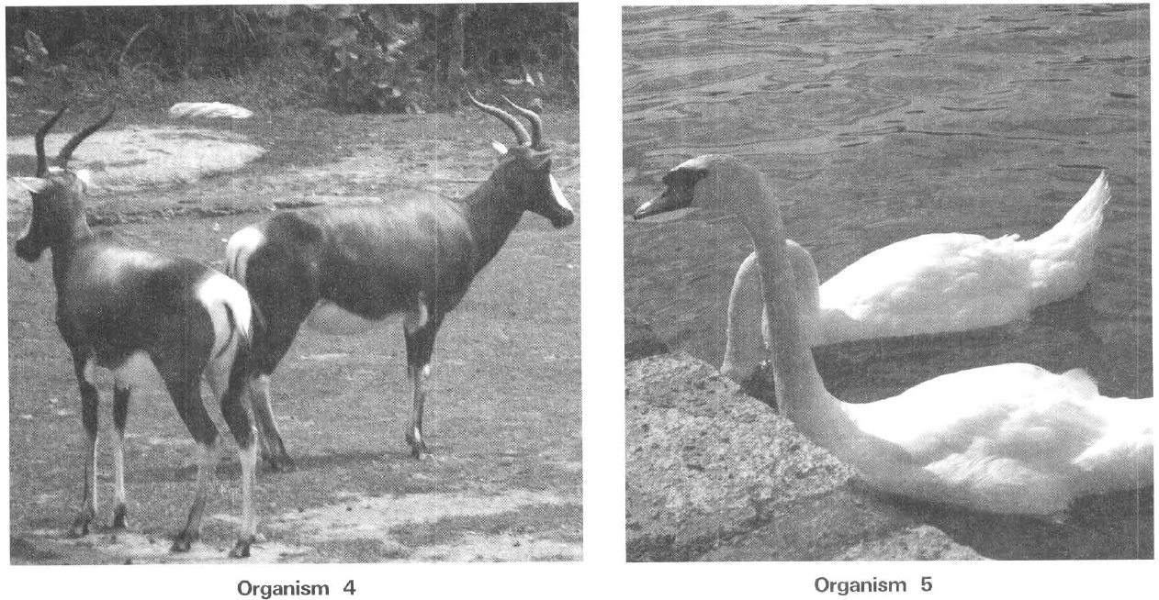
 | Photograph 1 | Photograph 2 | Photograph 3 | Photograph 4
A. | Grassland | Sandy shore | Woodland | Rocky shore
B. | Woodland | Rocky shore | Grassland | Mangrove
C. | Tundra | Muddy shore | Savanna | Rocky shore
D. | Savanna | Rocky shore | Tundra | Sandy shore

157. The following organisms can be found in different ecosystems.
Which of the following combinations CORRECTLY match the organisms 1 to 5 with the ecosystems in which they can be found .
 | Organism 1 | Organism 2 | Organism 3 | Organism 4 | Organism 5
A. | Mudflat | Woodland | Mangrove | Stream | Desert
B. | Woodland | Desert | Mudflat | Pond | Mangrove
C. | Grassland | Woodland | Desert | Stream | Mudflat
D. | Mangrove | Desert | Woodland | Pond | Mudflat

158. The following organisms can be found in different ecosystems.
Which of the following combinations CORRECTLY match the organisms 1 to 5 with the ecosystems in which they can be found.
J. Impacts of human activities to the environment
 | Organism 1 | Organism 2 | Organism 3 | Organism 4 | Organism 5
A. | Woodland | Sandy shore | Rocky shore | Grassland | Stream
B. | Grassland | Pond | Rocky shore | Woodland | Sandy shore
C. | Grassland | Stream | Mud Eat | Savanna | Pond
D. | Woodland | Pond | Stream | Savanna | Ocean

159. Which of the following human activities lead to the destruction of natural habitats? (1) Building the third runway of the Hong Kong International airport. (2) Changing part of the Country Park in Hong Kong for building domestic premises. (3) Afforestation. (4) Expanding the Landfills in Tuen Mun, Tseung Kwan 0 and Ta Kwu Leng.
A. (1) and (2) only
B. (2) and (3) only
C. (3) and (4) only
D. (1), (2) and (4) only
160. Which of the following will lead to the danger of the extinction of species? (1) Overfishing (2) Trading of valuable medicine manufactured from wild life. (3) Keeping animals in zoo. (4) Sale of ornaments made from turtle shell.
A. (1) only
B. (2) only
C. (1) and (2) only
D. (1), (2) and (4) only
161. According to their nature pollutants can be divided into two groups
A. renewable and non-renewable.
B. biodegradable and non-biodegradable.
C. primary and secondary.
D. natural and artificial.
162. Which of the following are more likely to be the sources of air pollutants? (1) Oil refineries (2) Motor cars (3) Gardens and parks (4) Industrial plants
A. (1) and (2) only
B. (1) and (3) only
C. (2) and (3) only
D. (1), (2) and (4) only
163. Which of the following are effects of air pollution? (1) Promoting smog formation. (2) Promoting solar illumination. (3) Lowering air temperature. (4) Deteriorating respiratory diseases.
A. (1) and (2) only
B. (1) and (4) only
C. (2) and (3) only
D. (2), (3) and (4) only
164. Which of the following is/are causes(s) of greenhouse effect? (1) Increased consumption of fossil fuels. (2) Large scale and unlimited destruction of tropical rainforests. (3) Depletion of the ozone layer in the atmosphere.
A. (1) only
B. (2) only
C. (3) only
D. (1) and (2) only
165. Which of the following is the reason for afforestation to be an effective way to reduce global warming?
A. The large canopy of trees can effectively cut off large amount of sunlight reaching the surface of the earth.
B. Transpiration of the trees can effectively cool down the air temperature.
C. The large amount of oxygen released during photosynthesis can increase the thickness of the ozone layer in the atmosphere.
D. The huge forests can effectively remove large amount of carbon dioxide by photosynthesis.
166. Burning fossil fuels to generate electricity is a key factor causing greenhouse effect. Which of the following are the alternate energy sources to generate power? (1) Hydroelectric power (2) Nuclear power (3) Windmill farm (4) Solar energy plates
A. (1) and (2) only
B. (2) and (3) only
C. (3) and (4) only
D. (1), (2) , (3) and (4)
167. Which of the following is/are cause(s) for the formation of acid rain? (1) The release of sulphur dioxide and nitrogen oxides from the combustion of fossil fuels. (2) The tremendous release of heat from the machineries. (3) The large scale deforestation.
A. (1) only
B. (2) only
C. (1) and (2) only
D. (2) and (3) only
168. If untreated sewage of a pig's farm is discharged directly into a river, which of the following changes would occur in the water at a short distance downstream from the farm?
 | Concentration of organic matter | Bacterial population | Level of dissolved oxygen
A. | Increase | Increase | Decrease
B. | Decrease | Increase | Increase
C. | Increase | Increase | Increase
D. | Decrease | Decrease | Decrease

169. Which of the following agricultural practices would cause eutrophication (algal bloom) in the ponds next to a farmland?
A. Extensive growth of one type of crops on the farmland.
B. Adding excessive inorganic fertilizers to the farmlands.
C. Adding large amount of insecticides to the farmland.
D. Frequent harvest of crops from the farmland.
170. Red tides are rather common in summer in Hong Kong. It is caused by
A. a sudden decrease in the penetration of light in water.
B. a sudden increase in the oxygen content of water.
C. a sudden enrichment of nutrients in water.
D. a sudden increase in the population of decomposers in water.
171. Red tide causes harms to aquatic organisms because it (1) uses up large amount of dissolved oxygen. (2) produces toxic substances. (3) clog the respiratory surface of filter feeders in water. (4) compete with aquatic animals for food.
A. (1) and (2) only
B. (2) and (3) only
C. (3) and (4) only
D. (1), (2) and (3) only
172. Which of the following methods of disposing solid or semi-solid wastes will lead to air pollution?
A. Landfill B. Composting C. Incineration
D. Separation of wastes at the sources K. Conservation
173. What are the conditions of a good and well balanced environment? (1) Wastes produced by living organisms can be eliminated by natural processes within a short period of time. (2) The amount of natural resources should be maintained at a reasonable level without the danger of exhaustion. (3) Pollutants are left in the environment.
A. (2) only
B. (1) and (2) only
C. (1) and (3) only
D. (2) and (3) only
174. Which of the following combinations CORRECTLY match the renewable resources and the non-renewable resources?
 | Renewable resources | Non-renewable resources
A. | Timber | Water
B. | Fish | Coal
C. | Aluminum | Oxygen
D. | Glass | Timber

175. Timber is a renewable resource because
A. it can carry out reproduction to replace for the loss.
B. it can be reused.
C. it can be recycled.
D. it is of great abundance on earth.
176. Which of the following is/are consequence(s) of the unlimited use of fossil fuels? (1) Deterioration of air quality (2) Ultimate exhaustion of this natural resource (3)Decrease in the oxygen concentration in the atmosphere
A. (1) only
B. (2) only
C. (1) and (2) only
D. (2) and (3) only
177. From June to July each year the fishermen in Hong Kong are prohibited to fish in the South China Sea. Which of the following is the reason for this practice?
A. Gives time for the fishermen to relax from their hard work.
B. Enables them to have time to repair their fishing gears.
C. Gives time for fish to grow and reproduce to replace for the loss due to frequent fishing in the year.
D. Avoids the typhoon season that will endanger the life of the fishermen.
178. Which of the following are helpful to protect the environment? (1) Set up country parks, marine parks and wetland park. (2) Sep up gardens and swimming pools. (3) Set up theme parks and ocean park.
A. (1) only
B. (2) only
C. (1) and (3) only
D. (2) and (3) only
179. Which of the following is NOT a practice for conservation?
A. Build more sewage treatment plants
B. Set up more landfills.
C. Control the human population.
D. Effective separation of solid wastes at the sources.
180. Which of the following explanation of the 3 R's concept in conservation is CORRECT?
A. To rearrange, reallocate and return the resources.
B. To regenerate energy in three different effective ways.
C. To reduce, reuse and recycle the wastes.
D. To react rapidly to the demand of resources by reforming the system of distributing resources and recollecting the unused resources. Ecosystem M.C.

Answers
Answers are printed in red.
1. C. a community.
Class: 57.2% correct (n=269) usual slip C
2. C. (2) and (3) only
Class: 70.3% correct (n=269) usual slip D
3. D. (1), (2) and (3)
Class: 75.1% correct (n=269) usual slip A
4. B
Class: 76.6% correct (n=269) usual slip C
5. C
Class: 84.0% correct (n=269) usual slip C
6. ?
Class: 71.0% correct (n=93) usual slip C
7. C. (2) and (3) only

8. C. (2) and (3) only
Class: 63.9% correct (n=269) usual slip A
9. C. (2) and (3) only
Class: 73.3% correct (n=30) usual slip D
10. ?

11. C. The longer the food chain is, the greater the energy loss will be.

12. ?

13. ?

14. ?

15. B
Class: 36.7% correct (n=30) usual slip D
16. ?

17. ?

18. C. The population of water snails would increase.

19. B
Class: 83.3% correct (n=30) usual slip C
20. B. Snake and owl only
Class: 86.7% correct (n=30) usual slip A
21. ?

22. C. decrease at first and the increase to exceed its original population.

23. ?

24. ?

25. ?

26. C

27. D
Class: 76.7% correct (n=30) usual slip A
28. ?

29. ?

30. ?

31. B
Class: 83.3% correct (n=30) usual slip A
32. ?

33. C. sufficient light is given.

34. B
Class: 80.0% correct (n=30) usual slip A
35. C
Class: 60.0% correct (n=65) usual slip B
36. ?

37. D. It would be impossible to work out their feeding relationships.
Class: 73.3% correct (n=30) usual slip C
38. ?

39. ?

40. ?
Class: 71.0% correct (n=93) usual slip C
41. ?

42. C. ammonium compounds.

43. ?

44. D. peas.

45. ?

46. A. Crops are harvested. B.Minerals in the crop field are absorbed by the crops. C.Rate of denitrification is faster in the crop field. D.Grasses are well adapted to soils with low nitrogen content. Directions: Questions 70 to 72 refer to the diagram below which shows some pathways by which nitrogen is cycled in a grassland. X70.The processes represented by 1 and 2 are:

47. B. | putrefaction | nitrification |
Class: 71.0% correct (n=93) usual slip C
48. C

49. C. nitrogen gas to proteins in organisms.

50. D. (1), (2) and (3)

51. ?

52. B. nitrogen absorbed by the rabbits cannot be returned to the soil.

53. B

54. C

55. C. Alga and fungus in lichen D. Tapeworm and man

56. D. mutualism. X82.The following graphs show the relative numbers of two species of organisms when they are reared separately and reared together. The relationship between the two species is most likely
Class: 94.3% correct (n=35) usual slip B
57. D
Class: 85.7% correct (n=35) usual slip B
58. C. commensalism.
Class: 85.7% correct (n=35) usual slip C
59. C
Class: 82.9% correct (n=35) usual slip A
60. A. (1) only

61. A. It is a group of men and women living together in a given area. They form a functional society.

62. A. ecosystem.

63. A. (1) and (2) only

64. A. All the organisms living in a freshwater pond.

65. A. (1), (2), (3), (5), (4)

66. C. The sum total of the way of life of a species in its environment.
Class: 66.5% correct (n=269) usual slip B
67. C
Class: 56.8% correct (n=125) usual slip D
68. A. Community W B. Community X C. Community Y D. Community Z

69. D. (1), (2) and (5) only
Class: 100.0% correct (n=34) usual slip A
70. B
Class: 78.1% correct (n=64) usual slip A
71. C. is preyed by the lynx.
Class: 85.0% correct (n=254) usual slip B
72. C. The hare as herbivore has more stable food supply while the lynx depends on the hares for food supply.
Class: 72.4% correct (n=254) usual slip A
73. D. (1), (2) and (3)
Class: 77.2% correct (n=254) usual slip A
74. C. (1) and (3) only D. (2) and (4) only Directions: Questions 20.16 and 20.17 refer to the graphs below, which show the change in the population size of two different species of protozoa, X and Y, in three experiments. In experiment 1 and experiment 2 protozoa X and Y are grown separately alone in different culture medium. In experiment 3 they are grow together in the same culture media. There is abundant nutrient supply in the culture media.
Class: 67.4% correct (n=95) usual slip A
75. D. The rate of reproduction is the same as the rate of death.
Class: 72.4% correct (n=254) usual slip A
76. C
Class: 65.4% correct (n=254) usual slip C
77. C. Competition D. Commensalism
Class: 44.1% correct (n=34) usual slip A
78. D. Commensalism
Class: 83.5% correct (n=254) usual slip B
79. A. ParasitismB. Mutualism C. Competition D. Commensalism

80. A
Class: 74.3% correct (n=144) usual slip C
81. C
Class: 58.7% correct (n=109) usual slip A
82. C. A barren rocky surface is colonized by lichens. Then it is widely covered with mosses. With time goes by the site is dominated in sequence by herbs community, shrubs community and then trees community.
Class: 86.3% correct (n=255) usual slip B
83. C. Primary succession leads to the changes of the biotic communities on the island.
Class: 22.9% correct (n=35) usual slip A
84. A. To release mineral salts from dead organic matter to the environment.
Class: 73.5% correct (n=49) usual slip B
85. D
Class: 66.3% correct (n=190) usual slip A
86. C. The 5th trophic level
Class: 79.4% correct (n=126) usual slip A
87. C. (2) and (3) only
Class: 52.1% correct (n=96) usual slip A
88. C. Lizard and snake
Class: 70.5% correct (n=146) usual slip A
89. D. (1), (2) and (3)
Class: 83.1% correct (n=71) usual slip A
90. A. Hawk
Class: 65.7% correct (n=172) usual slip B
91. C. The number of grasshoppers would decrease.
Class: 74.3% correct (n=136) usual slip A
92. A. decomposers.
Class: 91.9% correct (n=172) usual slip B
93. D
Class: 57.1% correct (n=49) usual slip B
94. C. Small bird D. Carnivorous insect
Class: 80.2% correct (n=106) usual slip D
95. D. (2) and (3) only
Class: 84.9% correct (n=172) usual slip A
96. B. (2) only
Class: 83.1% correct (n=71) usual slip D
97. C. (3) only
Class: 30.8% correct (n=65) usual slip A
98. A. Plants Small bird
Class: 77.2% correct (n=92) usual slip B
99. C. There is tremendous loss of energy between the trophic levels along the food chain.
Class: 86.9% correct (n=122) usual slip B
100. C
Class: 56.9% correct (n=65) usual slip D
101. A. Animals X only B. Animals Y only
Class: 79.7% correct (n=172) usual slip A
102. C. P Z Y X
Class: 79.7% correct (n=172) usual slip B
103. C
Class: 52.3% correct (n=65) usual slip A
104. D. (2) and (3) only
Class: 51.0% correct (n=49) usual slip A
105. B. (1) and (2) only
Class: 42.9% correct (n=35) usual slip D
106. C
Class: 59.0% correct (n=122) usual slip A
107. C
Class: 55.4% correct (n=65) usual slip B
108. A. Energy can be recycled in the ecosystem.
Class: 62.9% correct (n=35) usual slip C
109. B
Class: 22.8% correct (n=57) usual slip A
110. D. (2) and (3) only
Class: 45.7% correct (n=35) usual slip B
111. C. The flow of energy in the ecosystem is a cyclic process.
Class: 85.7% correct (n=35) usual slip B
112. D
Class: 65.7% correct (n=35) usual slip B
113. C
Class: 81.3% correct (n=91) usual slip A
114. A. (1) only
Class: 55.9% correct (n=34) usual slip C
115. C. (3) only
Class: 59.3% correct (n=91) usual slip C
116. C. (1) and (3) only
Class: 63.8% correct (n=69) usual slip A
117. C. (2) and (4) only
Class: 46.2% correct (n=91) usual slip A
118. C. the light illuminating the pond weeds.
Class: 69.6% correct (n=56) usual slip A
119. B. the availability of pond weeds.
Class: 73.2% correct (n=56) usual slip A
120. B. mid-night.
Class: 79.4% correct (n=34) usual slip C
121. B
Class: 79.4% correct (n=34) usual slip C
122. D
Class: 85.3% correct (n=34) usual slip A
123. A. is maintained at a constant level. B. is increasing rapidly.
Class: 79.4% correct (n=34) usual slip D
124. D. (4) only
Class: 82.4% correct (n=34) usual slip C
125. B. (2) only
Class: 82.4% correct (n=34) usual slip A
126. A. (1) and (3)
Class: 85.3% correct (n=34) usual slip B
127. A. (1), (2) and (3)
Class: 58.8% correct (n=34) usual slip C
128. D. (1), (2) and (4) only
Class: 85.3% correct (n=34) usual slip A
129. D. (5)
Class: 76.5% correct (n=34) usual slip A
130. A. (1),(2),(3) and (5) only
Class: 82.4% correct (n=34) usual slip B
131. A. (1), (2), (3) and (5)
Class: 64.7% correct (n=34) usual slip C
132. C
Class: 97.1% correct (n=34) usual slip B
133. C. break the carbonaceous compounds of the dead remains into simpler molecules.
Class: 85.3% correct (n=34) usual slip A
134. D
Class: 11.8% correct (n=34) usual slip B
135. B. (2) only
Class: 97.1% correct (n=35) usual slip A
136. A
Class: 94.3% correct (n=35) usual slip C
137. C
Class: 91.4% correct (n=35) usual slip B
138. D
Class: 94.3% correct (n=35) usual slip C
139. D. (4) and (1) only
Class: 77.1% correct (n=35) usual slip A
140. A. Leaf

141. A. (1) only B. (3) only C. (4) only D. (5) only Directions: Questions 20.83 to 20.86 refer to the diagram below which shows some of the pathways in the nitrogen cycle.

142. A

143. A. (1) and (2) only

144. A. (1), (3) and (6) only

145. A

146. A. (2), (4), (3) and (1)

147. A. ammonium compounds into nitrites and nitrates.

148. A. to fix the atmospheric nitrogen gas to organic nitrogen compounds.

149. A. (1) and (2) only

150. A. (1) only

151. A. (1) and (2) only

152. A. (1) and (2) only

153. A. The rhizomes of grasses can fix the atmospheric nitrogen.

154. A. (1) only

155. A. (1) only

156. A

157. A

158. A

159. A. (1) and (2) only

160. A. (1) only

161. A. renewable and non-renewable.

162. A. (1) and (2) only

163. A. (1) and (2) only

164. A. (1) only

165. A. The large canopy of trees can effectively cut off large amount of sunlight reaching the surface of the earth.

166. A. (1) and (2) only

167. A. (1) only

168. A

169. A. Extensive growth of one type of crops on the farmland.

170. A. a sudden decrease in the penetration of light in water.

171. A. (1) and (2) only

172. A. Landfill B. Composting C. Incineration

173. A. (2) only

174. A

175. A. it can carry out reproduction to replace for the loss.

176. A. (1) only

177. A. Gives time for the fishermen to relax from their hard work.

178. A. (1) only

179. A. Build more sewage treatment plants

180. A. To rearrange, reallocate and return the resources.

