Ecosystem · items under 80% correct
Multiple-choice practice
Name: ________________________ Class: ____________
These items were answered correctly by fewer than 80% of students in class Google Forms, matched by the wording in the source bank and the form answer key. Choose the one best answer.
Part A — HKCEE level (Longman)
1. All living organisms found in the same area form
A. an ecosystem.
B. a population.
C. a community.
D. a habitat.
2. An ecosystem includes (1) the sun. (2) the populations of organisms interacting with each other. (3) all physical factors affecting the populations.
A. (1) and (2) only
B. (1) and (3) only
C. (2) and (3) only
D. (1), (2) and (3)
3. Which of the following constitute the environment of an organism? (1) All other organisms living together with it (2) The place where it lives (3) All chemical factors affecting it
A. (1) and (2)
B. (1) and (3)
C. (2) and (3)
D. (1), (2) and (3)
4. Which of the following is a correct description of a habitat?
A. All the plants and animals living together in a particular area B.The place where an organism lives C.All the surroundings of an organism D.The interaction between biotic and abiotic components of an ecosystem
5. | 2 | 3 | 4 | D. | ecosystem | habitat | community | population X7.Which of the following are the forms of energy that enter and leave an ecosystem?
 | Energy output | Energy input
A. | heat | heat
B. | light | heat
C. | light | mechanical energy
D. | mechanical energy | light

A. | population | community | habitat | ecosystem |
B. | community | habitat | population | ecosystem |
C. | habitat | ecosystem | population | community |
D. | ecosystem | habitat | community | population X7.Which of the following are the forms of energy that enter and leave an ecosystem?
6. Which of the following are cycled in an ecosystem? (1) Energy (2) Water (3) Phosphorus A.(1) and (2) only B.(1) and (3) only C.(2) and (3) only
A. (1) and (2) only
B. (1) and (3) only
C. (2) and (3) only
D. (1), (2) and (3)
7. Decomposers are essential for a balanced ecosystem because (1) they recycle energy. (2) they break down dead bodies of organisms. (3) they release minerals to the soil for plant absorption. A.(1) and (2) only B.(1) and (3) only C.(2) and (3) only
A. (1) and (2) only
B. (1) and (3) only
C. (2) and (3) only
D. (1), (2) and (3)
8. The total biomass of hawks is less than that of small birds because
A.hawks have a shorter life span.
B.energy is lost when it is transferred from small birds to hawks.
C.hawks are much larger than small birds.
D.hawks are less numerous than small birds.
Directions: Questions 25 to 28 refer to the diagram below which shows a food web in a freshwater stream.
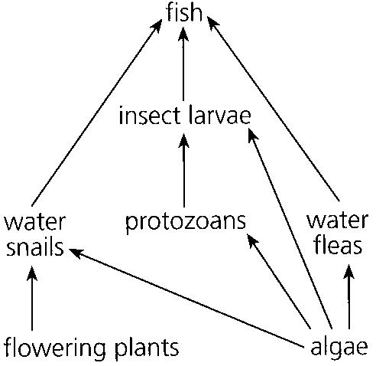
9. What are the trophic levels of beans in food chain I and small fish in food chain IV?
Directions: Questions 40 to 42 refer to the diagram below which shows the annual energy flow through different organisms living on grassland.
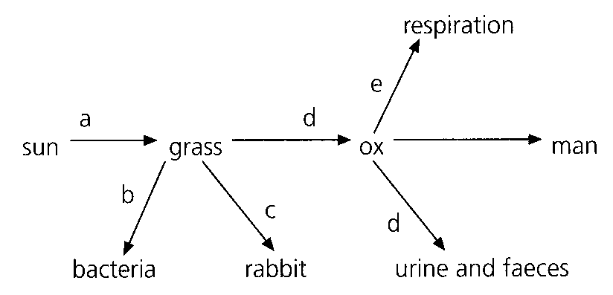
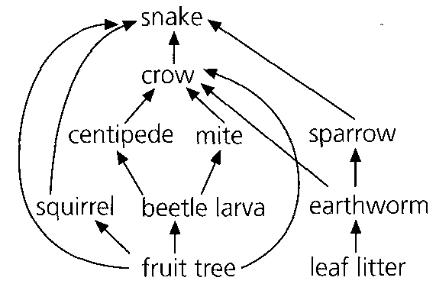
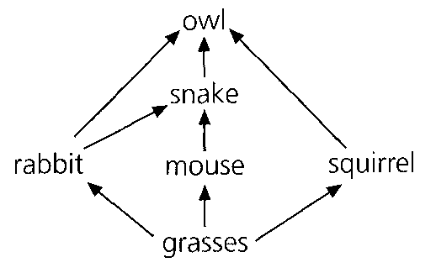
 | Beans | Small fish
A. | cannot be classified | second trophic level
B. | cannot be classified | third trophic level
C. | first trophic level | second trophic level
D. | first trophic level | third trophic level

10. What ecological principle is best illustrated by this glass sphere?
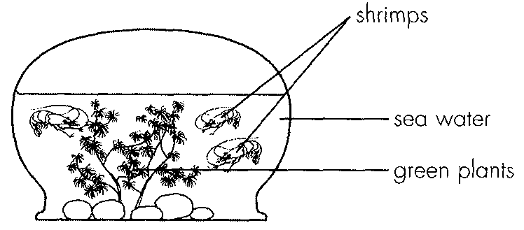
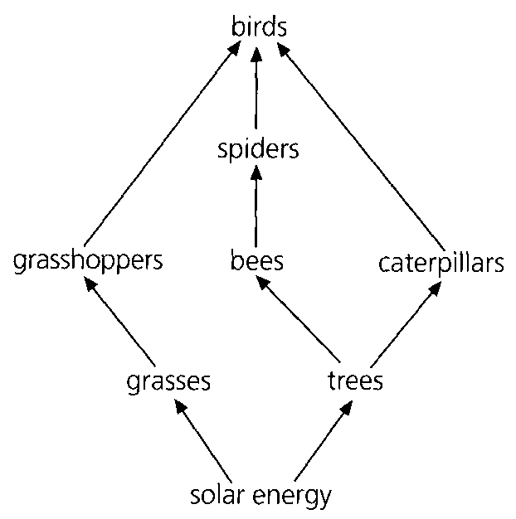
A. Recycling of energy B. Cycling of materialsC. Symbiosis D. Conservation
11. If the pH of the water in an aquarium containing fish and green plants decreases, which of the following treatments may help to restore the pH?
(1) Introducing more fish
(2) Growing more green plants
(3) Exposing the aquarium to brighter illumination
Jar | Organisms at the beginning | Results
I | X and Y | X disappeared and Y still survived
II | X and Z | X still survived and Z was partly eaten
III | Y and Z | Y died and Z was unchanged

A. (1) and (2) only B. (1) and (3) only C. (2) and (3) only D. (1), (2) and (3) Directions: Questions 51 and 52 refer to an experiment performed to investigate a certain food chain involving three organisms X, Y and Z. The organisms were grouped separately in three glass jars covered with lids. The organisms were placed in each glass jar at the beginning and were observed after a week. The results are recorded in the table below.
12. Why is it impossible to draw conclusion from the experiment if all the three organisms are put together in the same jar?
A. There would be insufficient food for the organisms.
B. There would be insufficient space to hold the organisms.
C. It would be more difficult to control the environmental factors.
D. It would be impossible to work out their feeding relationships.
13. | 2 | 3 | D. | respiration | respiration | photosynthesis X56.The organisms involved in process 2 are A. producers. B. consumers. C. saprophytes. D. parasites.
A. | respiration | respiration | photosynthesis |
B. | photosynthesis | decomposition | respiration |
C. | photosynthesis | respiration | decomposition |
D. | respiration | respiration | photosynthesis X56.The organisms involved in process 2 are
14. | 2 | D. | nitrification | nitrogen fixation X71.Two groups of organisms are involved in process 1. They are A. viruses and bacteria. B. bacteria and fungi.C. fungi and algae. D. algae and protozoa.
A. | decomposition | nitrogen fixation |
B. | putrefaction | nitrification |
C. | nitrogen fixation | putrefaction |
D. | nitrification | nitrogen fixation X71.Two groups of organisms are involved in process 1. They are
Part B — HKDSE-style (YKTo)
15. Which of the following definition/description of a niche is CORRECT?
A. The ecological address of an organism in an ecosystem.
B. The biological relationships between organisms in an ecosystem.
C. The sum total of the way of life of a species in its environment.
D. The population of all organisms living in the same habitat.
16. The diagram below shows a ladybird eating a piece of leaf. It will be eaten by a small bird nearby. It releases carbon dioxide and excreta to the surrounding. Which of the following terms CORRECTLY describes the overall ecological status of the ladybird?
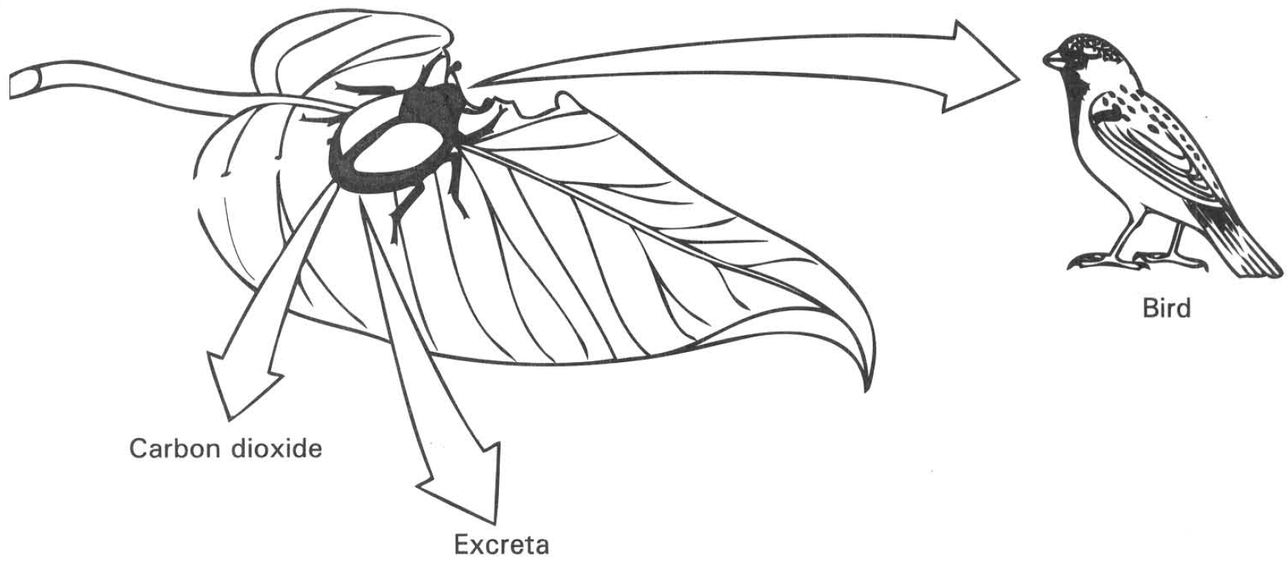
A. Omnivore B. Prey C. Niche D. Community
17. Which of the following matching of the organisms and their activities are CORRECT?
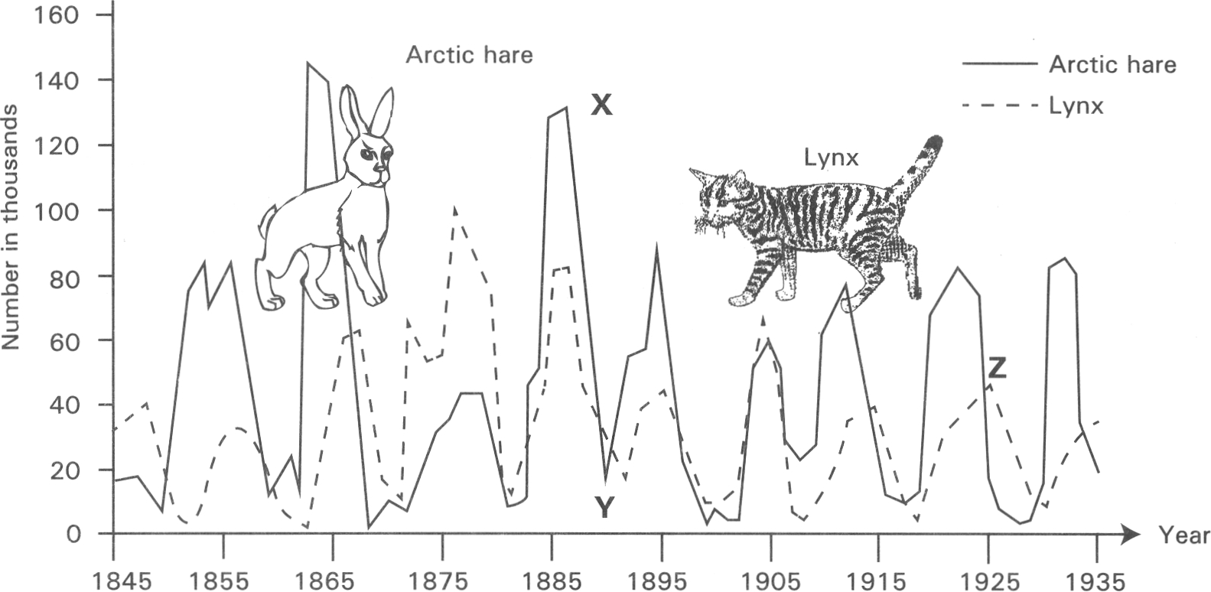
 | Organisms | Activities
(1) | Parasite | It gains benefits from other organism and causes harms to the latter.
(2) | Saprophyte | It lives in the same habitat with another organism and has the same requirements of the natural resources with the latter.
(3) | Predator | It kills and feeds on another organism.
(4) | Competitor | It depends on dead organic matter for nutrients supply.

A. (1) and (2) only B. (1) and (3) only C. (2) and (3) onlyD. (1) and (4) only Directions: Questions 20.12 to 20.15 refer to the graph below, which shows the population changes of the lynx and arctic hares over a period of time.
18. The population change of the lynx always lags behind that of the hare. Which of the following is a possible explanation of this pattern of population change?
A. The hare is smaller in size than the lynx so that it grows faster than the lynx.
B. The lynx is bigger in size so that it can easily be spotted by hunters.
C. The hare as herbivore has more stable food supply while the lynx depends on the hares for food supply.
D. The lynx has more predators than the hare.
19. Which of the following account for the decrease in the number of the hares from X to Y? (1) Spread of disease (2) Increase in the population of the lynx (3) Increase of competition among the hares
A. (1) and (2) only
B. (1) and (3) only
C. (2) and (3) only
D. (1), (2) and (3)
20. Which of the following account for the decrease in the number of the lynx from Z?
(1) Starvation
(2) Lack of shelter from enemies
(3) Spread of diseases
(4) Lack of space due to over crowding
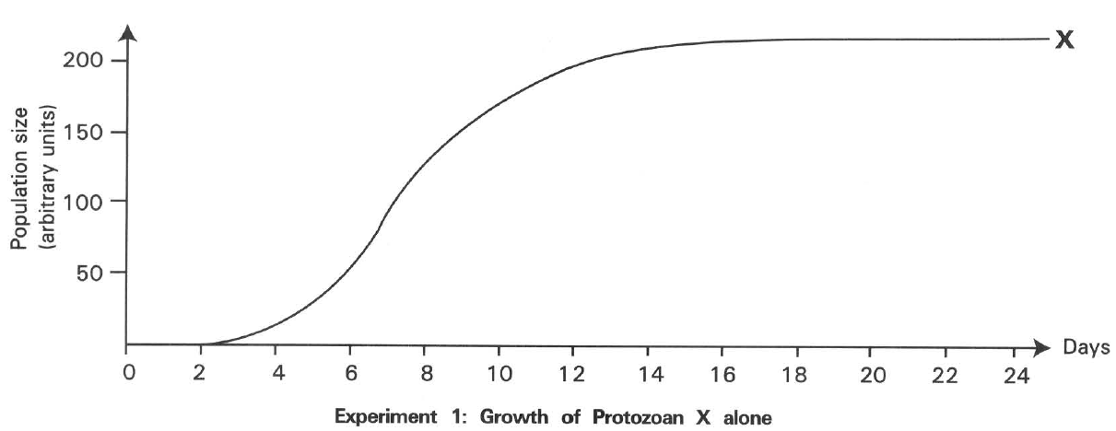
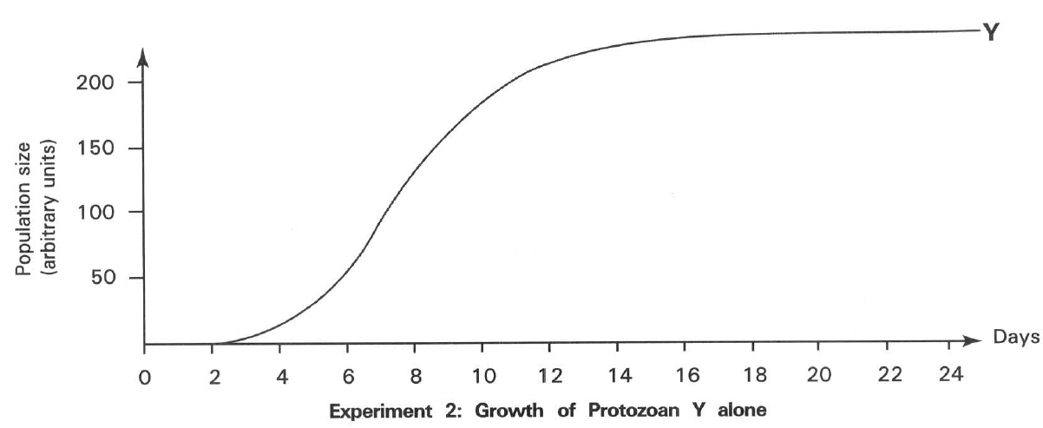
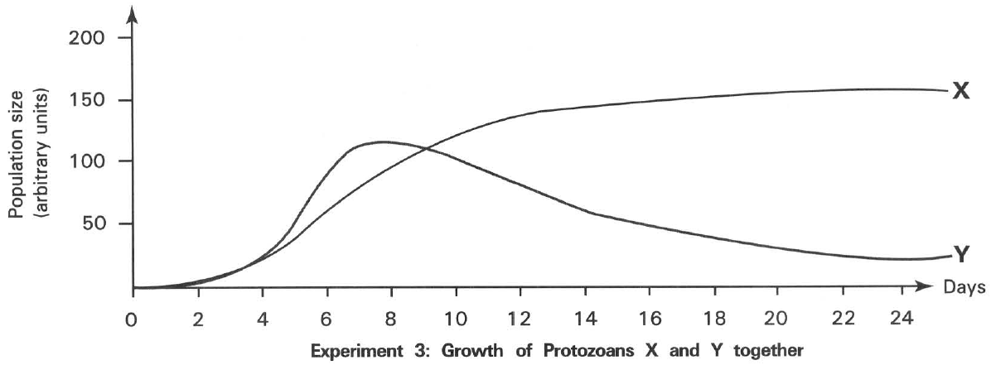
A. (1) and (2) only B. (2) and (3) only
C. (1) and (3) only D. (2) and (4) only Directions: Questions 20.16 and 20.17 refer to the graphs below, which show the change in the population size of two different species of protozoa, X and Y, in three experiments. In experiment 1 and experiment 2 protozoa X and Y are grown separately alone in different culture medium. In experiment 3 they are grow together in the same culture media. There is abundant nutrient supply in the culture media.
21. In experiments 1 and 2, the population size of both protozoa X and Y grew to high level and then remained unchanged. Which of the following is the explanation of these results?
A. Each species of protozoa has limited life span.
B. There is a shortage of food for these protozoa to grow.
C. These protozoa are attacked by pathogens.
D. The rate of reproduction is the same as the rate of death.
22. What biological relationship between protozoa X and Y is shown by the results of experiment 3?
A. Predation B. Commensalism C. Competition D. Parasitism
23. The photograph below shows the Mikania micrantha (FCEM) which is an exotic vine. It climbs up other plants to reach their canopy for better sunlight. However its leaves grow rapidly and eventually cover other plants which may die due to the shortage of sunlight for photosynthesis.
What is the biological relationship between Mikania micrantha and other plants?
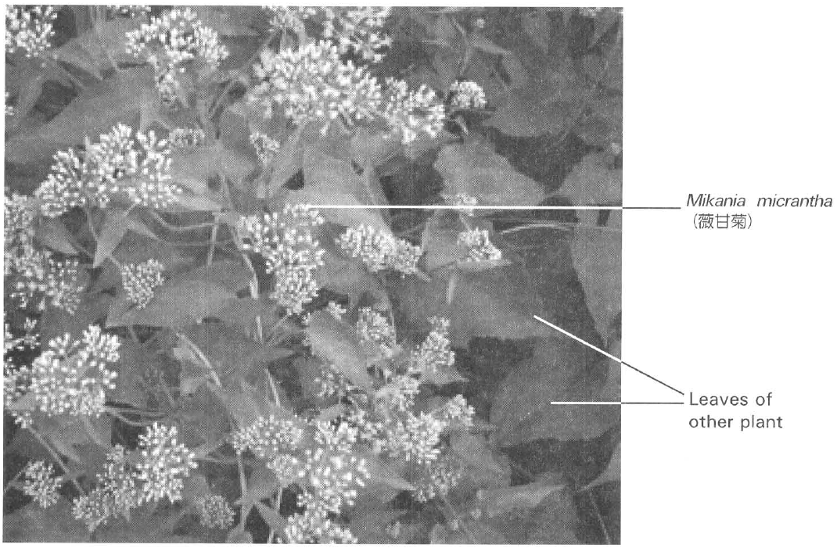
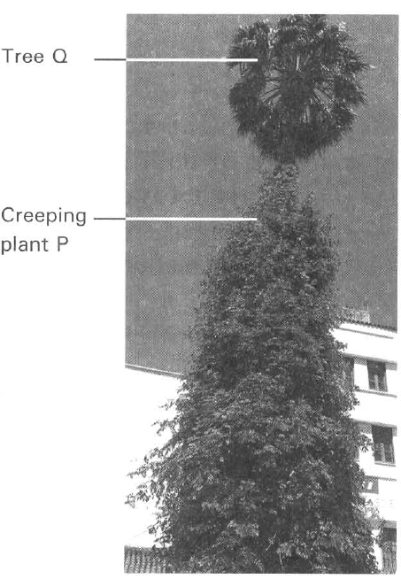
A. Parasitism B. Mutualism
C. Competition D. Commensalism
24. The photograph below shows an insect with its mouth parts piercing into the vascular tissues of the thin stem of the plant R (Dodder) to suck organic nutrients from it.
What are the roles played by the insect and the plant R shown in the diagram?
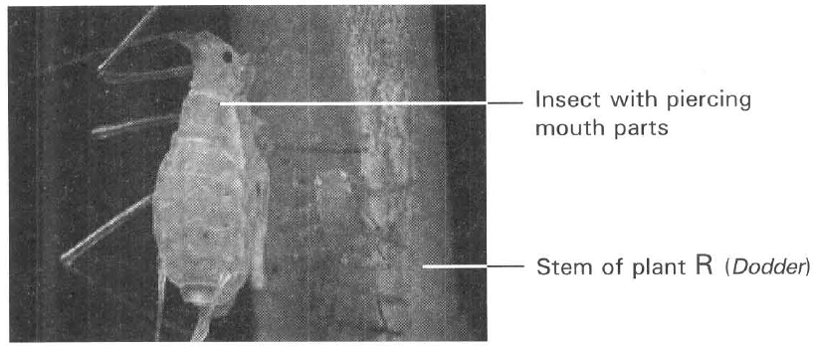
 | Insect | Plant R
A. | Primary consumer | Producer
B. | Carnivore | Herbivore
C. | Secondary consumer | Primary consumer
D. | Secondary consumer | Producer

25. Each of the diagrams below shows the biological association between two organisms.
Which of the following matching between the biological relationships of the organisms is CORRECT
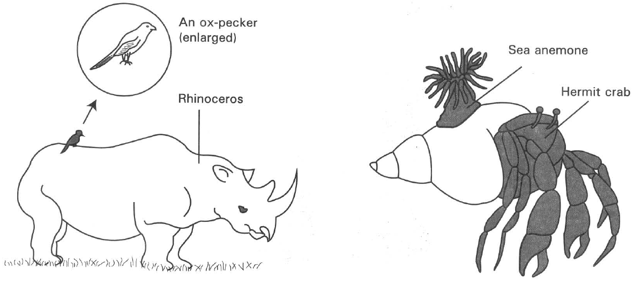
 | Biological relationships between the organisms
 | Ox pecker and rhinoceros | Sea anemone and hermit crab
A. | Parasitism | Predation
B. | Predation | Parasitism
C. | Commensalism | Mutualism
D. | Mutualism | Commensalism

D. Biotic community III — ecological succession
26. The photographs X and Y below show the conditions of an island shortly after a volcanic eruption and 47 years later.
Which of the following CORRECTLY accounts for the change of a barren island in photograph X to become the island full of trees in photograph Y?
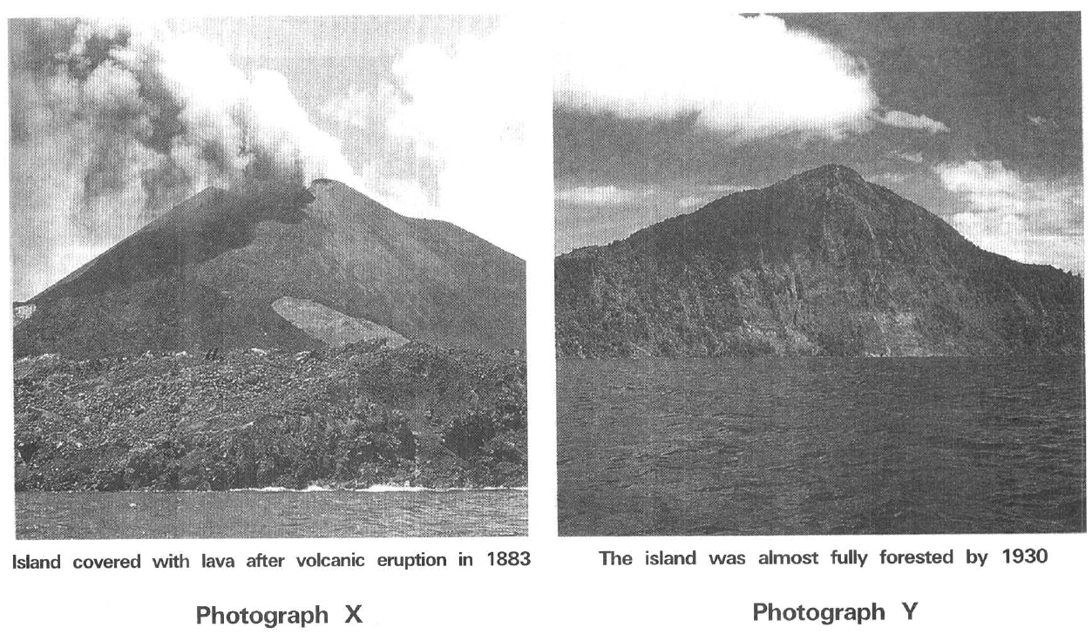
A. The lava contains large amount of nutrients to support the vigorous plant growth.
B. Sunlight is the ultimate source of energy to support the vigorous plant growth.
C. Primary succession leads to the changes of the biotic communities on the island.
D. Recycling of matters is very efficient on the island. E. Functioning of an ecosystem
27. What is the importance of decomposers in an ecosystem?
A. To release mineral salts from dead organic matter to the environment.
B. The recycling of energy in the ecosystem.
C. To promote the release of energy from the organisms.
D. To limit the growth of consumers in the ecosystem.
28. What is the importance of producers in an ecosystem?
(1) To provide inorganic nutrients in the environment.
(2) To provide organic food to the consumers.
(3) To remove carbon dioxide from the ecosystem.
(4) To replenish the oxygen supply to the environment.
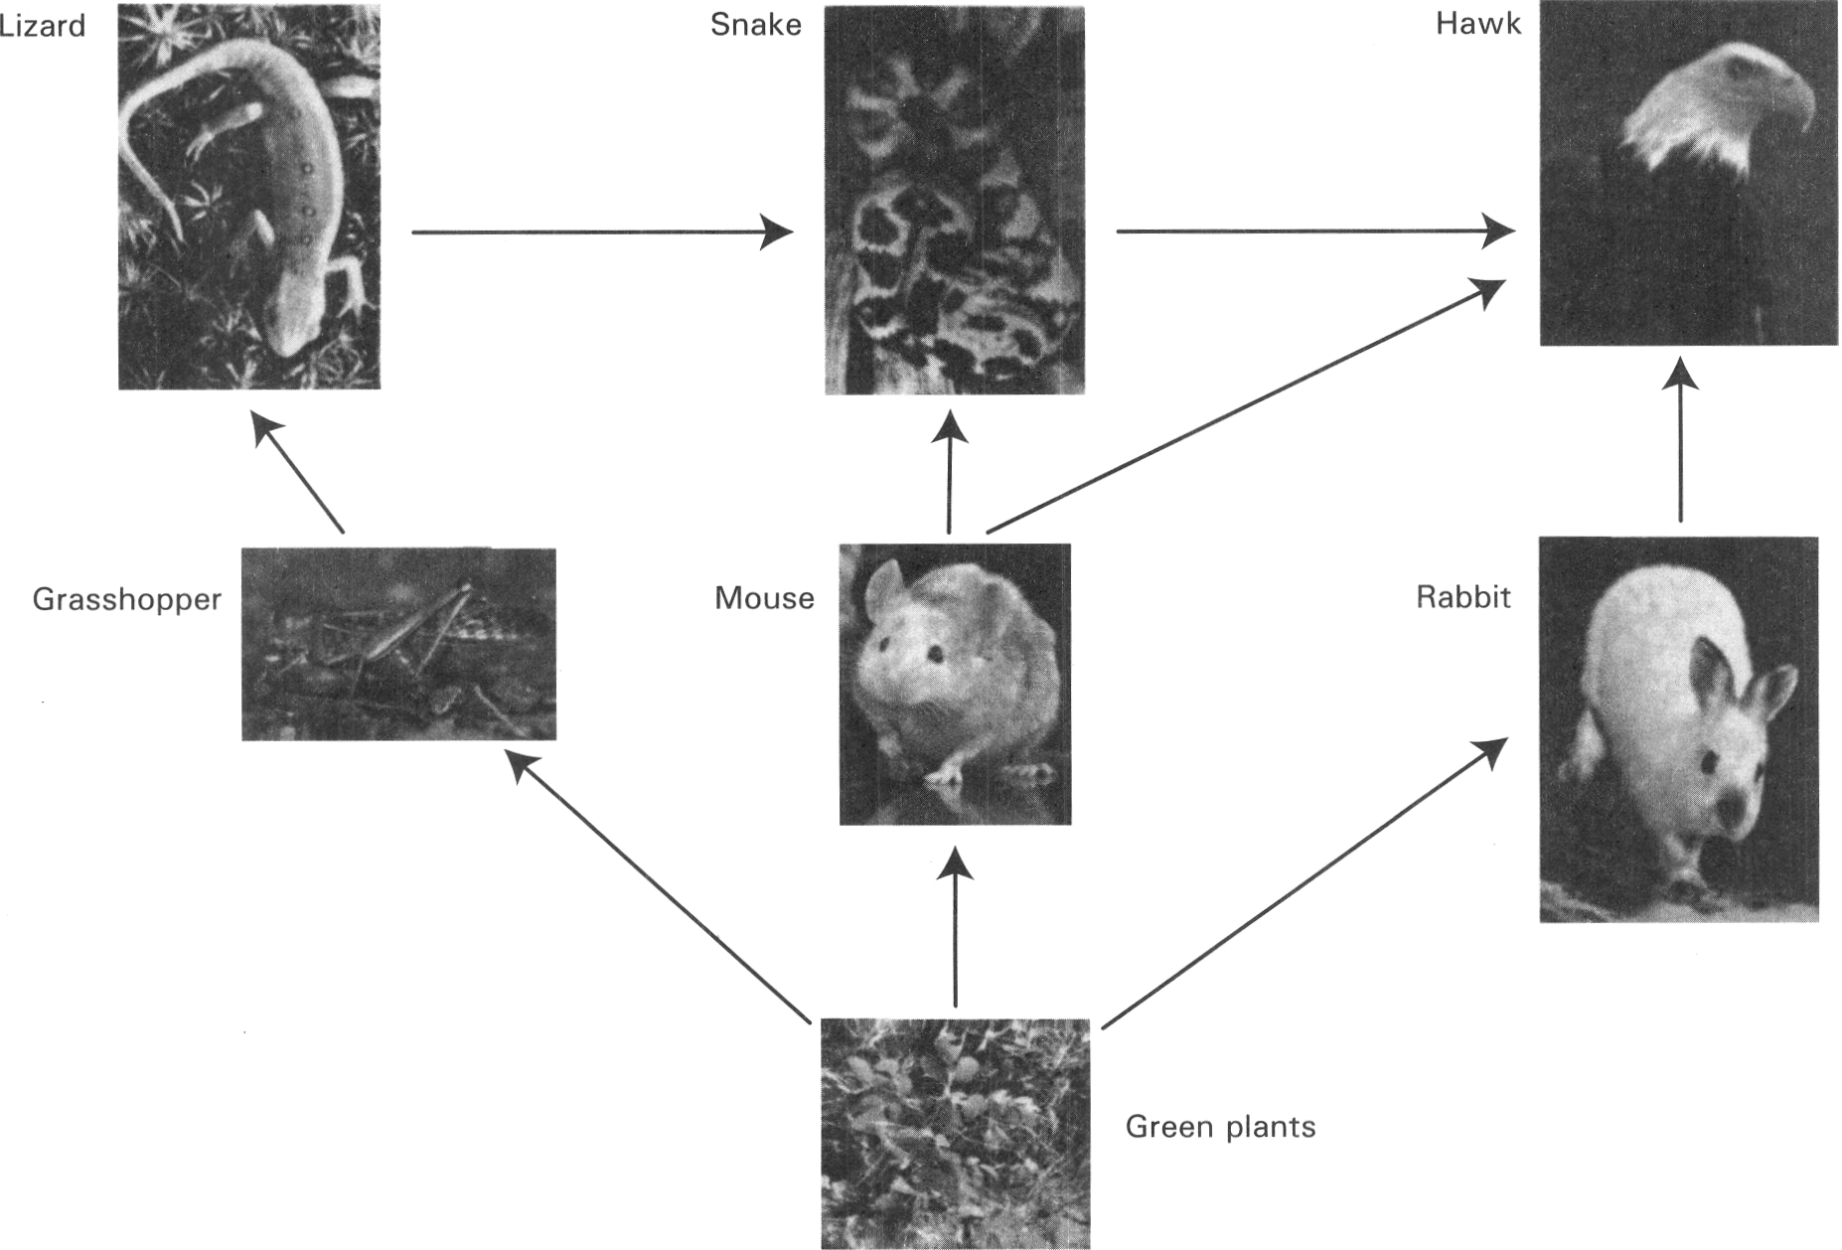
A. (1) and (2) only B. (2) and (3) only C. (3) and (4) only D. (2), (3) and (4) only Directions: Questions 20.27 to 20.33 refer to the photographs below which show the food web of a grassland community
29. What is the highest trophic level in this food web?
A. The 3rd trophic level
B. The 4th trophic level
C. The 5th trophic level
D. The 6th trophic level
30. What is/are the biological relationships between snake and hawk? (1) Commensalism (2) Competition (3) Predation
A. (1) only
B. (1) and (2) only
C. (2) and (3) only
D. (3) and (1) only
31. Which of the following pairs organisms are secondary consumers?
A. Grasshopper and mouse
B. Mouse and rabbit
C. Lizard and snake
D. Grasshopper and rabbit
32. Which of the following has the lowest biomass in the food web illustrated above?
A. Hawk
B. Grasshopper
C. Rabbit
D. Green plants
33. What would most probably happen if the number of rabbits increased o ftremendously?
A. The amount of green plants would increase.
B. The number of mice would increase.
C. The number of grasshoppers would decrease.
D. The number of snakes would increase.
34. Which of the following in the food web has the lowest biomass?
A. Greenfly B. Caterpillar
C. Slug D. Rabbit
35. Which of the following animals is both the primary consumer, secondary consumer and tertiary consumer?
A. Fox B. Large hawk
C. Small bird D. Carnivorous insect
36. The biomass of the rabbit is (1) greater than that of the plants. (2) smaller than that of the fox. (3) greater than that of the large hawk.
A. (1) only
B. (2) only
C. (3) only
D. (1) and (3) only
37. Which of the following is the most efficient energy flow in the food web above?
A. Plants Small bird
B. Plants Rabbit Fox
C. Plants Slug Small bird Fox
D. Plants Rabbit Large hawk
38. Which of the following is/are herbivore(s)?
A. Animals X only B. Animals Y only C. Animals Z only D. Animals X and Y only
39. Which of the following is/are the top consumer(s)?
A. Animals X only B. Animals Y only
C. Animals Z only D. Animals Y and Z only
40. According to the result of the experiment, which of the following TRULY represents the food chain of the organisms in the above community?
A. P X Y Z
B. P Y X Z
C. P Z Y X
D. P Y Z X
41. Which of the following abiotic factors favour the decomposition of the dead remains into inorganic nutrients in soil?
 | Temperature | Humidity
A. | high | low
B. | low | high
C. | high | high
D. | low | low

42. Which of the following statements related with the pyramid of numbers is/ are INCORRECT? (1) It represents the number of living organisms in each trophic level of a food chain. (2) It only represents the number of consumers in an ecosystem. (3) It gives a more accurate information about the energy content of each trophic level than that of the pyramid of mass.
A. (1) only
B. (2) only
C. (3) only
D. (2) and (3) only
43. The diagram below shows the pyramid of number in an ecosystem Which of the following statements related with the food chain is CORRECT? (1) It is a parasitic food chain. (2) The producers are very large in size. (3) The consumers have very high rate of reproduction.
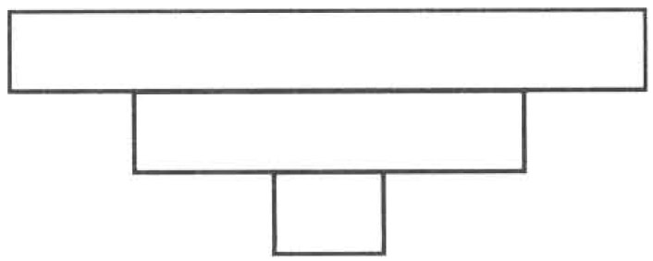
A. (1) only
B. (1) and (2) only
C. (1) and (3) only
D. (1), (2) and (3)
44. The following diagrams represent four types of pyramids of number P, Q, R and S.
The following are four food chains labelled (1), (2), (3) and (4):
Food chain (1) Tree Beetle Endoparasite
Food chain (2) Phytoplanktons Krill (small crustaceans) Whale
Food chain (3) Tree Greenfly Carnivorous insects
Food chain (4) Big crop plants Caterpillar Bird
Which of the following matching between the pyramids of number and the food chains are CORRECT?
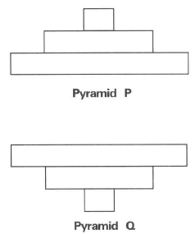
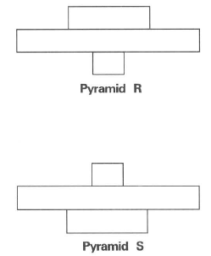
 | Pyramid P | Pyramid Q | Pyramid R | Pyramid S
A. | (1) | (4) | (3) | (2)
B. | (3) | (2) | (4) | (1)
C. | (2) | (1) | (3) | (4)
D. | (1) | (4) | (2) | (3)

45. The following diagrams represent two types of pyramids of biomass X and Y.
The following are three food chains labelled (1), (2) and (3):
Food chain (1) Tree Beetle Endoparasite
Food chain (2) Grasses Grasshopper Mantis
Food chain (3) Phytoplankton in ocean Small zooplankton in ocean Bigger zooplankton in ocean
Which of the following matching between the pyramids of biomass and the food chains are CORRECT?
Directions: Questions 20.49 and 20.50 refer to the diagram below which shows the energy flow along a simplified food chain.
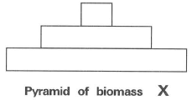
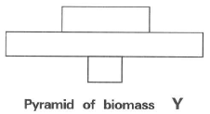
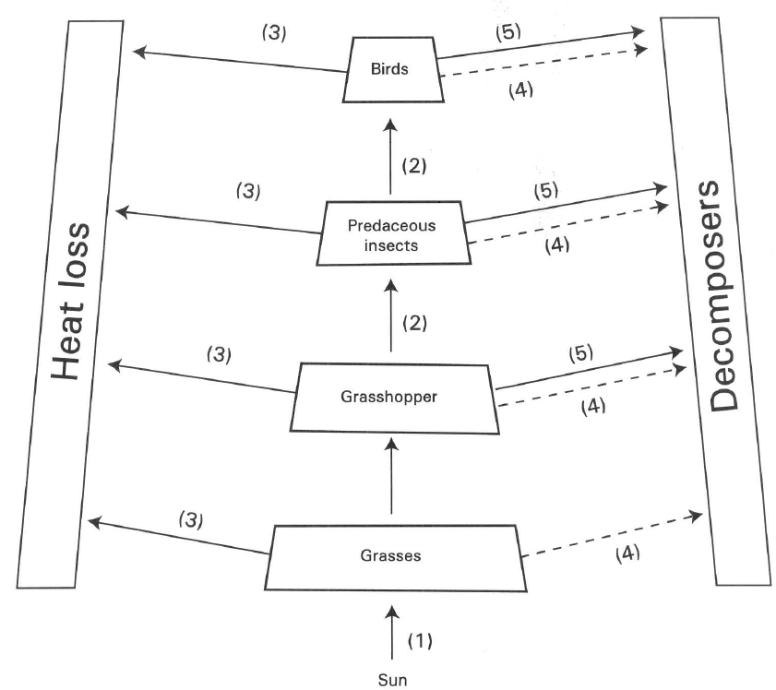
 | Food chain (1) | Food chain (2) | Food chain (3)
A. | Pyramid of biomass X | Pyramid of biomass Y | Pyramid of biomass X
B. | Pyramid of biomass Y | Pyramid of biomass X | Pyramid of biomass X
C. | Pyramid of biomass X | Pyramid of biomass X | Pyramid of biomass Y
D. | Pyramid of biomass Y | Pyramid of biomass Y | Pyramid of biomass X

46. Which of the following statements related to the diagram is NOT TRUE?
A. Energy can be recycled in the ecosystem.
B. The ultimate source of energy in the food chain is the sun.
C. The step-wise energy loss accounts for the decrease in the biomass along the food chain.
D. Producer is the food source for other members in the food chain.
47. Which of the following matching is CORRECT?
 | (1) | (2) | (3) | (4) | (5)
A. | Respiration | Holozoic nutrition | Photosynthesis | Decay | Egestion and excretion
B. | Photosynthesis | Feeding | Respiration | Egestion andexcretion | Decay
C. | Photosynthesis | Predation | Respiration | Decay | Egestion and excretion
D. | Respiration | Holophytic nutrition | Photosynthesis | Egestion and excretion | Decay

48. Which of the following processes account for the decrease in the biomass along the food chain? (1) Increase in size of the organisms in the higher trophic level. (2) Excretion, respiration and metabolism of the organisms in each trophic level consume energy. (3) Decomposition of the dead bodies of the organisms at each trophic level.
A. (1) only
B. (1) and (2) only
C. (1) and (3) only
D. (2) and (3) only
49. Which of the following matching of organisms is CORRECT?
 | Organism W | Organism X | Organism Y | Organism Z
A. | Decomposer | Herbivore | Carnivore | Producer
B. | Producer | Carnivore | Herbivore | Decomposer
C. | Herbivore | Carnivore | Decomposer | Producer
D. | Producer | Herbivore | Carnivore | Decomposer

50. Which of the following condition(s) is/are essential to keep the organisms inside the closed glass container to remain alive for months? (1) Continuous illuminating the glass container with light (2) Weekly replacing the water inside the glass container with distilled water. (3) Weekly replacing the pond mud with sterilized mud.
A. (1) only
B. (2) only
C. (1) and (2) only
D. (2) and (3) only
51. If the glass container is completely covered with aluminium foil, after a few days the snails die. It is because (1) the water is overheated. (2) no food is available to the snails. (3) no photosynthesis takes place to replenish for the loss of oxygen.
A. (1) only
B. (2) only
C. (3) only
D. (1) and (3) only
52. The pond weed is very important to the snail because it provides the latter with (1) oxygen (2) shelter (3) food
A. (1) only
B. (2) only
C. (1) and (3) only
D. (2) and (3) only
53. Which of the following microorganisms are essential for the pond weeds to be in healthy conditions inside the aquarium? (1) Nitrogen-fixing bacteria (2) Nitrifying bacteria (3) Denitrifying bacteria (4) Putrefying bacteria
A. (1) and (2) only
B. (2) and (3) only
C. (2) and (4) only
D. (3) and (4) only
54. The ultimate source of energy for the snail to crawl along the glass comes from
A. the glucose inside the body fluid of the snail.
B. the starch inside the pond weeds.
C. the light illuminating the pond weeds.
D. the microorganisms present in soil.
55. The number of snails will remain relatively constant in the glass container. It is because its population size is mainly limited by
A. the amount of oxygen in the glass jar.
B. the availability of pond weeds.
C. the amount of carbon dioxide in water.
D. the space available in the glass container.
56. The acidity of the water in the glass container is highest at/in
A. the morning.
B. mid-night.
C. noon.
D. the afternoon.
57. If the pH of the water in the glass container is a bit low at day time, the condition can be improved by
(1) replacing the pond mud with clay soil (2) putting in more snails.
(3) growing more pond weeds.
Which of the above suggestions would increase the pH of water?
A. (1) only B. (3) only C. (1) and (2) only D. (2) and (3) only G. Cycling of materials in an ecosystem II — carbon cycle
58. The total amount of carbon in an ecosystem
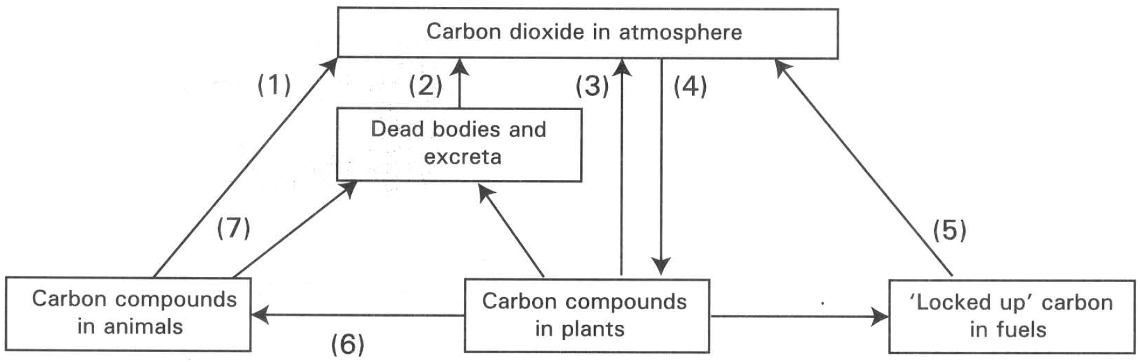
A. is maintained at a constant level. B. is increasing rapidly.
C. is decreasing rapidly. D. is fluctuating vigorously. Directions: Questions 20.65 to 20.73 refer to the diagram below, which shows the carbon cycle.
59. The amount of energy available to the organisms decreases along the food chain .Through which of the following processes is the energy mainly lost?
A. (1), (2) and (3)
B. (4), (5) and (6)
C. (4), (6) and (7)
D. (1), (5) and (6)
60. The present atmospheric CO2 concentration is 0.033%. It is estimated that in the year 2050 the atmospheric CO2 concentration will be increased to 0.045%. Which of the following processes is mainly responsible for this increase?
A. (1)
B. (2)
C. (3)
D. (5)
61. Which of the following combinations show the CORRECT processes that release energy?
A. (1), (2), (3) and (5)
B. (1), (4), (5) and (6)
C. (2), (6), (7) and (1)
D. (2), (3), (4) and (5)
62. Which of the following will occur in the absence of producers in an ecosystem?
(1) All consumers will die.
(2) Gradual increase in the concentration of the atmospheric carbon dioxide.
(3) Rapid growth of microorganisms occurs.
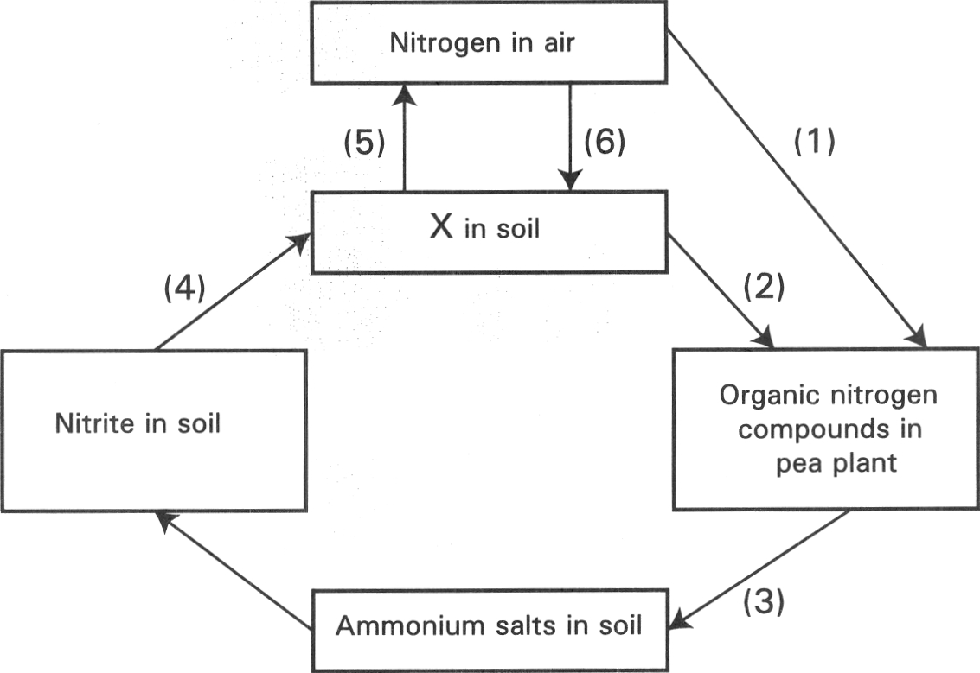
A. (1) only B. (1) and (2) only C. (2) and (3) only D. (1), (2), and (3) H. Cycling of materials in an ecosystem III — nitrogen cycle Directions: Questions 20.76 to 20.82 refer to the diagram below which shows some of the pathways in the nitrogen cycle.
63. Which of the following has the same symbiotic relationship as the pea plants with their partners living inside their tissues? (1) Soya bean (2) Rice (3) Wheat (4) Ground nut
A. (1) and (2) only
B. (2) and (3) only
C. (3) and (4) only
D. (4) and (1) only

Answers
Answers are printed in red.
1. C. a community.
Class: 57.2% correct (n=269) usual slip C
2. C. (2) and (3) only
Class: 70.3% correct (n=269) usual slip D
3. D. (1), (2) and (3)
Class: 75.1% correct (n=269) usual slip A
4. B
Class: 76.6% correct (n=269) usual slip C
5. ?
Class: 71.0% correct (n=93) usual slip C
6. C. (2) and (3) only
Class: 63.9% correct (n=269) usual slip A
7. C. (2) and (3) only
Class: 73.3% correct (n=30) usual slip D
8. B
Class: 36.7% correct (n=30) usual slip D
9. D
Class: 76.7% correct (n=30) usual slip A
10. B
Class: 80.0% correct (n=30) usual slip A
11. C
Class: 60.0% correct (n=65) usual slip B
12. D. It would be impossible to work out their feeding relationships.
Class: 73.3% correct (n=30) usual slip C
13. ?
Class: 71.0% correct (n=93) usual slip C
14. B. | putrefaction | nitrification |
Class: 71.0% correct (n=93) usual slip C
15. C. The sum total of the way of life of a species in its environment.
Class: 66.5% correct (n=269) usual slip B
16. C
Class: 56.8% correct (n=125) usual slip D
17. B
Class: 78.1% correct (n=64) usual slip A
18. C. The hare as herbivore has more stable food supply while the lynx depends on the hares for food supply.
Class: 72.4% correct (n=254) usual slip A
19. D. (1), (2) and (3)
Class: 77.2% correct (n=254) usual slip A
20. C. (1) and (3) only D. (2) and (4) only Directions: Questions 20.16 and 20.17 refer to the graphs below, which show the change in the population size of two different species of protozoa, X and Y, in three experiments. In experiment 1 and experiment 2 protozoa X and Y are grown separately alone in different culture medium. In experiment 3 they are grow together in the same culture media. There is abundant nutrient supply in the culture media.
Class: 67.4% correct (n=95) usual slip A
21. D. The rate of reproduction is the same as the rate of death.
Class: 72.4% correct (n=254) usual slip A
22. C
Class: 65.4% correct (n=254) usual slip C
23. C. Competition D. Commensalism
Class: 44.1% correct (n=34) usual slip A
24. A
Class: 74.3% correct (n=144) usual slip C
25. C
Class: 58.7% correct (n=109) usual slip A
26. C. Primary succession leads to the changes of the biotic communities on the island.
Class: 22.9% correct (n=35) usual slip A
27. A. To release mineral salts from dead organic matter to the environment.
Class: 73.5% correct (n=49) usual slip B
28. D
Class: 66.3% correct (n=190) usual slip A
29. C. The 5th trophic level
Class: 79.4% correct (n=126) usual slip A
30. C. (2) and (3) only
Class: 52.1% correct (n=96) usual slip A
31. C. Lizard and snake
Class: 70.5% correct (n=146) usual slip A
32. A. Hawk
Class: 65.7% correct (n=172) usual slip B
33. C. The number of grasshoppers would decrease.
Class: 74.3% correct (n=136) usual slip A
34. D
Class: 57.1% correct (n=49) usual slip B
35. C. Small bird D. Carnivorous insect
Class: 80.2% correct (n=106) usual slip D
36. C. (3) only
Class: 30.8% correct (n=65) usual slip A
37. A. Plants Small bird
Class: 77.2% correct (n=92) usual slip B
38. C
Class: 56.9% correct (n=65) usual slip D
39. A. Animals X only B. Animals Y only
Class: 79.7% correct (n=172) usual slip A
40. C. P Z Y X
Class: 79.7% correct (n=172) usual slip B
41. C
Class: 52.3% correct (n=65) usual slip A
42. D. (2) and (3) only
Class: 51.0% correct (n=49) usual slip A
43. B. (1) and (2) only
Class: 42.9% correct (n=35) usual slip D
44. C
Class: 59.0% correct (n=122) usual slip A
45. C
Class: 55.4% correct (n=65) usual slip B
46. A. Energy can be recycled in the ecosystem.
Class: 62.9% correct (n=35) usual slip C
47. B
Class: 22.8% correct (n=57) usual slip A
48. D. (2) and (3) only
Class: 45.7% correct (n=35) usual slip B
49. D
Class: 65.7% correct (n=35) usual slip B
50. A. (1) only
Class: 55.9% correct (n=34) usual slip C
51. C. (3) only
Class: 59.3% correct (n=91) usual slip C
52. C. (1) and (3) only
Class: 63.8% correct (n=69) usual slip A
53. C. (2) and (4) only
Class: 46.2% correct (n=91) usual slip A
54. C. the light illuminating the pond weeds.
Class: 69.6% correct (n=56) usual slip A
55. B. the availability of pond weeds.
Class: 73.2% correct (n=56) usual slip A
56. B. mid-night.
Class: 79.4% correct (n=34) usual slip C
57. B
Class: 79.4% correct (n=34) usual slip C
58. A. is maintained at a constant level. B. is increasing rapidly.
Class: 79.4% correct (n=34) usual slip D
59. A. (1), (2) and (3)
Class: 58.8% correct (n=34) usual slip C
60. D. (5)
Class: 76.5% correct (n=34) usual slip A
61. A. (1), (2), (3) and (5)
Class: 64.7% correct (n=34) usual slip C
62. D
Class: 11.8% correct (n=34) usual slip B
63. D. (4) and (1) only
Class: 77.1% correct (n=35) usual slip A

Class percentage correct
Matched to this paper by question wording in the source bank and the form answer key, not by a shifted paper number.
Q | Answer | % correct | n | Usual slip
1 | C | 57.2% | 269 | C
2 | C | 70.3% | 269 | D
3 | D | 75.1% | 269 | A
4 | B | 76.6% | 269 | C
5 | ? | 71.0% | 93 | C
6 | C | 63.9% | 269 | A
7 | C | 73.3% | 30 | D
8 | B | 36.7% | 30 | D
9 | D | 76.7% | 30 | A
10 | B | 80.0% | 30 | A
11 | C | 60.0% | 65 | B
12 | D | 73.3% | 30 | C
13 | ? | 71.0% | 93 | C
14 | B | 71.0% | 93 | C
15 | C | 66.5% | 269 | B
16 | C | 56.8% | 125 | D
17 | B | 78.1% | 64 | A
18 | C | 72.4% | 254 | A
19 | D | 77.2% | 254 | A
20 | C | 67.4% | 95 | A
21 | D | 72.4% | 254 | A
22 | C | 65.4% | 254 | C
23 | C | 44.1% | 34 | A
24 | A | 74.3% | 144 | C
25 | C | 58.7% | 109 | A
26 | C | 22.9% | 35 | A
27 | A | 73.5% | 49 | B
28 | D | 66.3% | 190 | A
29 | C | 79.4% | 126 | A
30 | C | 52.1% | 96 | A
31 | C | 70.5% | 146 | A
32 | A | 65.7% | 172 | B
33 | C | 74.3% | 136 | A
34 | D | 57.1% | 49 | B
35 | C | 80.2% | 106 | D
36 | C | 30.8% | 65 | A
37 | A | 77.2% | 92 | B
38 | C | 56.9% | 65 | D
39 | A | 79.7% | 172 | A
40 | C | 79.7% | 172 | B
41 | C | 52.3% | 65 | A
42 | D | 51.0% | 49 | A
43 | B | 42.9% | 35 | D
44 | C | 59.0% | 122 | A
45 | C | 55.4% | 65 | B
46 | A | 62.9% | 35 | C
47 | B | 22.8% | 57 | A
48 | D | 45.7% | 35 | B
49 | D | 65.7% | 35 | B
50 | A | 55.9% | 34 | C
51 | C | 59.3% | 91 | C
52 | C | 63.8% | 69 | A
53 | C | 46.2% | 91 | A
54 | C | 69.6% | 56 | A
55 | B | 73.2% | 56 | A
56 | B | 79.4% | 34 | C
57 | B | 79.4% | 34 | C
58 | A | 79.4% | 34 | D
59 | A | 58.8% | 34 | C
60 | D | 76.5% | 34 | A
61 | A | 64.7% | 34 | C
62 | D | 11.8% | 34 | B
63 | D | 77.1% | 35 | A

