Enzymes
Multiple-choice practice
Name: ________________________ Class: ____________
There are 52 questions compiled from Longman HKCEE and/or YKTo papers. Choose the one best answer.
Part A — HKDSE-style (YKTo)
1. What is the role of enzyme in an enzymatic reaction?
A. It increases the chance of collisions between reacting molecules.
B. It alters the energy state of the reacting molecules.
C. It provides energy to enhance the reacting molecules to reach the equilibrium.
D. It changes the final reaction to reach equilibrium.
2. An enzyme carries out its catalytic effect by
A. decreasing the activation energy of the reaction.
B. increasing the chance of collision between the substrate molecules and enzyme molecules.
C. bringing the substrate molecules close to the active site of the enzyme.
D. breaking down the macromolecules into smaller ones to enhance the reaction.
3. Which of the following activities are catabolic reactions? (1) Digestion of proteins in the stomach. (2) Glycolysis of sugar in the cytoplasm. (3) Formation of triose phosphate in the Calvin cycle. (4) Formation of muscle molecules from amino acids.
A. (1) and (2) only
B. (2) and (3) only
C. (3) and (4) only
D. (1), (2) and (3) only
4. Which of the following statements about enzymes are TRUE? (1) 37°C is the only temperature at which all enzymes work best. (2) Only digestive glands can secrete enzymes. (3) Hydrolysis of macro-molecules into smaller molecules is catalysed by enzymes. (4) Synthesis of macro-molecules from small molecules is catalysed by enzymes.
A. (1) and (2) only
B. (1) and (3) only
C. (2) and (3) only
D. (3) and (4) only
5. Which of the following statements are TRUE for ALL enzymes? (1) They are denatured at 60°C. (2) They are made of protein molecules. (3) They lower the activation energy of reactions. (4) Their active sites can be occupied by one type of substrate molecules only. (5) They can only catalyse hydrolytic reactions. (6) They work best at pH 7. D. (1), (2), (4), (5) and (6) only
C. (2) They are made of protein molecules. (3) They lower the activation energy of reactions. (4) Their active sites can be occupied by one type of substrate molecules only. (5) They can only catalyse hydrolytic reactions. (6) They work best at pH 7.
A. (1) and (2) only
B. (2) and (3) only
C. (4), (5) and (6) only
6. Which of the following statements about enzymes are INCORRECT? (1) They act as biological catalysts. (2) They are easily denatured by great pH changes. (3) They are very stable to temperature changes. (4) They are required in small amounts for proper functioning. (5) They are only used for breaking down the complex organic compounds into simple and diffusible forms. (6) They carry out their functions best in an alkaline condition.
A. (1), (2) and (4) only
B. (2), (3) and (5) only
C. (2), (4) and (6) only
D. (3), (5) and (6) only
7. Which of the following activities or properties reveals the protein nature of enzymes?
A. Enzymes catalyse the chemical reactions.
B. Enzymes remain unchanged during the reactions.
C. The rate of enzymatic reactions decreases rapidly at high temperatures.
D. Enzymes are inactivated at low temperatures.
8. Which of the following reactions does NOT require enzymes to proceed rapidly inside the human body?
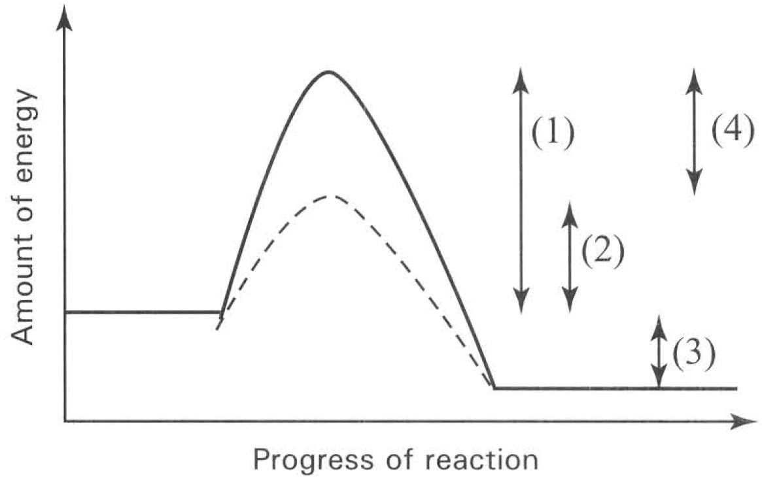
A. Emulsification of fat to oil droplets in the duodenum.
B. Break down of starch to maltose in the mouth cavity.
C. Break down of hydrogen peroxide inside the liver cells.
D. Hydrolysis of fat to fatty acid and glycerol in the ileum.
9. The following graph shows the energy change of a reaction in the presence and absence of enzyme.
Which of the following matching is CORRECT?
Directions: Questions 10 to 15 refer to the diagram below, which shows the reactions between different substances.
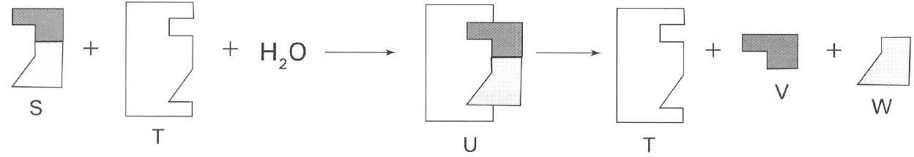
 | Activation energy in the presence of enzyme | Activation energy without enzyme | Energy released with the presence of enzyme from the reaction | Reduction of activation energy in the presence of enzyme
A. | (1) | (2) | (3) | (4)
B. | (2) | (1) | (3) | (4)
C. | (4) | (3) | (1) | (2)
D. | (3) | (4) | (2) | (1)

10. Which molecule can be used again and again?
A. S
B. T
C. U
D. V
11. If substance S is a double sugar (disaccharide), substance T will most likely be a
A. simple sugar.
B. sucrose.
C. sucrase.
D. amylase.
12. If substance T is inactivated,
A. more S will be broken down.
B. more V and W will be formed.
C. less S will be synthesized.
D. less V and W will be formed.
13. The reaction illustrated by the diagram is most likely
A. the digestion of sucrose.
B. the synthesis of organic compounds.
C. the hydrolysis of starch.
D. the photosynthetic process of forming starch.
14. Which of the following statements is WRONG?
A. S is the substrate.
B. Water is required for the reaction to complete.
C. T is one of the products of the reaction.
D. V and W are the products of hydrolysis.
15. If the amount of S is in excess, which of the following statements is TRUE?
A. More V and W combine to form a larger molecule.
B. T is hydrolysed into simpler molecule.
C. The amount and nature of T remains the same at the end of the reaction.
D. The excessive amount of S slows down the rate of reaction.
16. Which of the following chemicals have active sites on their molecules? (1) Trypsin (2) Insulin (3) Maltose (4) Pepsin
A. (1) and (2) only
B. (2) and (3) only
C. (3) and (4) only
D. (1) and (4) only
17. The specificity of enzyme is due to
A. the protein nature of the molecule.
B. the specific shape of a particular site on the surface of the molecule.
C. the presence of many different types of bonds in the molecule.
D. the sensitivity of the molecule to different temperatures.
18. Which of the following features is responsible for the specificity of enzyme?
A. Enzyme is made of polysaccharide which is a complex molecule.
B. Enzyme is a very big molecule which has lots of space for different substrate molecules to attach to.
C. Enzyme has active site with specific shape that can only be fitted in by substrate molecule with the right shape.
D. Enzyme is an organic molecule which works best in the specific reactions taking place inside the organisms.
19. Which of the following enzymes shows the highest specificity to its catalytic role?
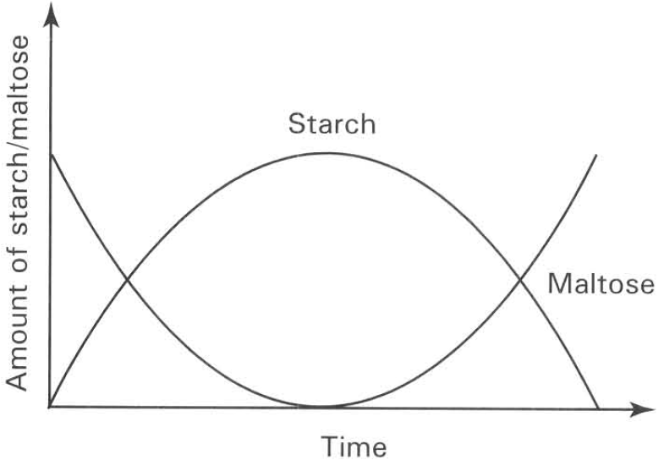
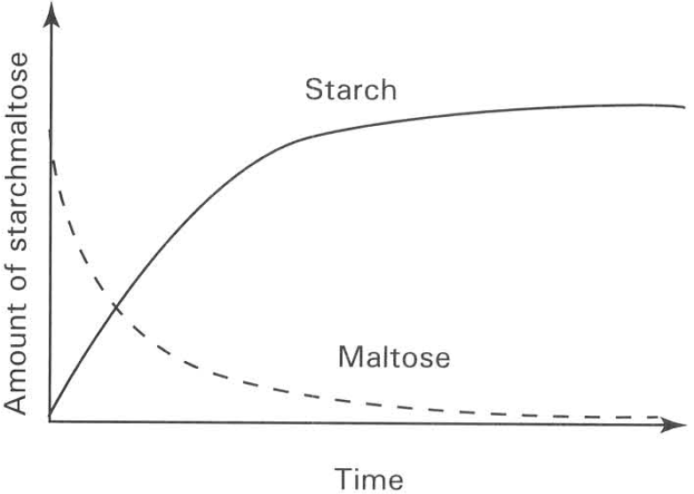
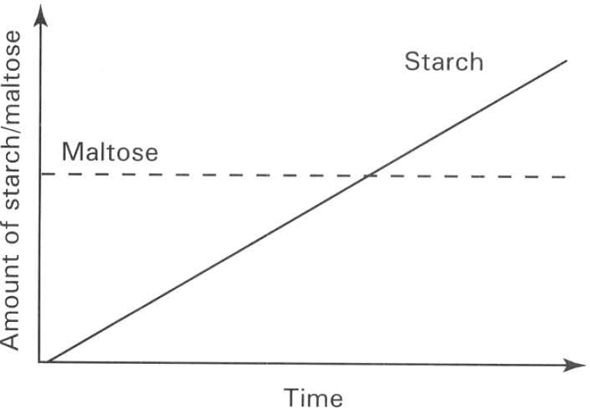
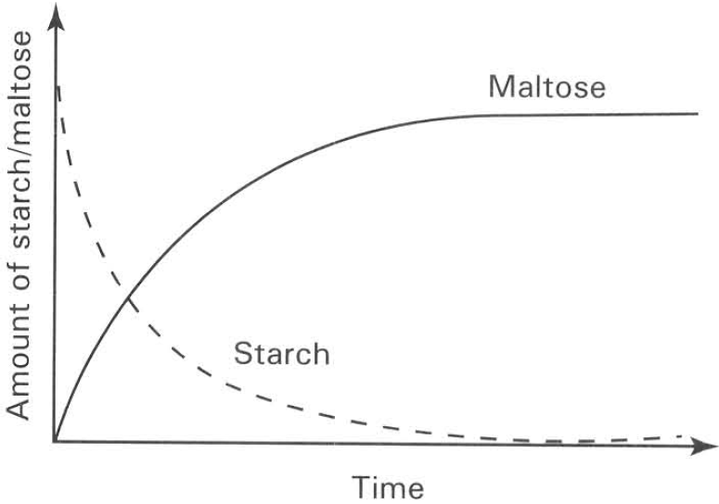
A. | B. | C. | D.

Experi-ment | Substances added to thetest tube | Temperature of water bath | Food tests are carried out 20 minutesafter the start of the experiment
 |  |  | Iodine's Test | Benedict's Test
(1) | 5m1 X+ 3m1 water | 37°C | Blue black colour | Blue colour
(2) | 5m1 X + 2ml Y + 1 ml HCl | 37°C | Blue black colour | Blue colour
(3) | 5m1 X + 2m1 Y + 1 ml water | 37°C | Brown colour | Brick redprecipitate
(4) | 5m1 X + 2m1 Y (boiled) +1 ml water | 37°C | Blue black colour | Blue colour
(5) | 5m1 X + 2m1 Y + 1 ml water | 14°C | Pale blue colour | Green colour with small amount of precipitate

A. Proteases B. Carbohydrases C. Lipases D. Maltase 20 Starch is digested by amylase to maltose. Which of the following graphs TRULY represents the changes of these molecules during the enzymatic reaction? Directions: Questions 21 to 25 refer to the experiments shown in the table below.
20. Which of the following identity of the substances are CORRECT?
 | X | Y | Product of the reaction
A. | Starch | Gastric juice | Reducing sugar
B. | Starch | Pancreatic juice | Reducing sugar
C. | Sugar | Saliva | Non-reducing sugar
D. | Sugar | Saliva | Reducing sugar

21. Which experiment(s) is/are used to show the effect of temperature on the reactions?
A. (1) and (2) only
B. (2) and (3) only
C. (2), (3) and (4) only
D. (3), (4) and (5) only
22. Which experiment shows that extreme pH value destroys the enzymatic reaction?
A. (1)
B. (2)
C. (3)
D. (4)
23. Which of the following is most likely the conclusion drawn from the above experiments?
A. Y is denatured by boiling.
B. X is inactivated at low temperature.
C. High temperature splits X into reducing sugars.
D. High acidity changes X into reducing sugars.
24. The above experiments were repeated without performing the food tests. At regular intervals a sample of the test tube content was removed and the amount of X present was analysed. Which of the following graphs is CORRECT?
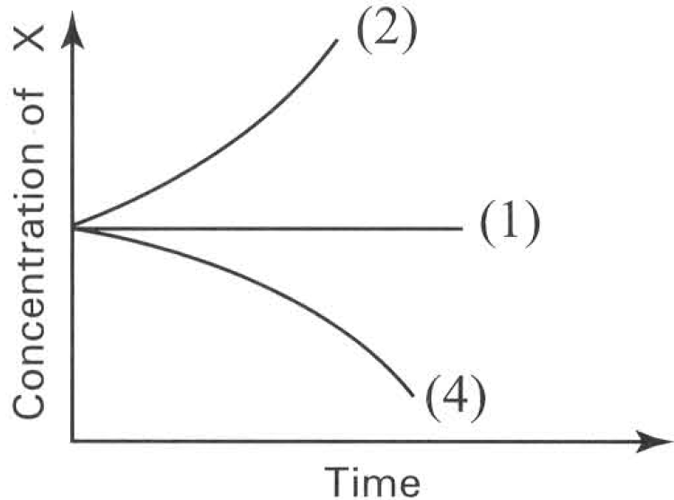
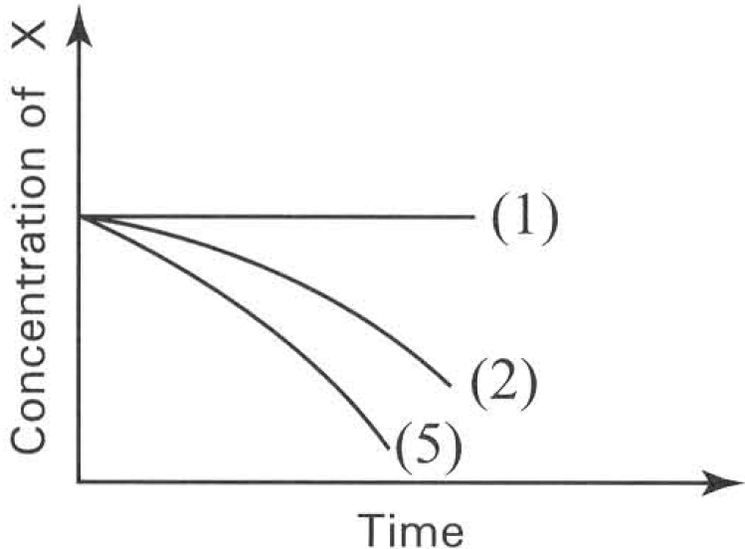
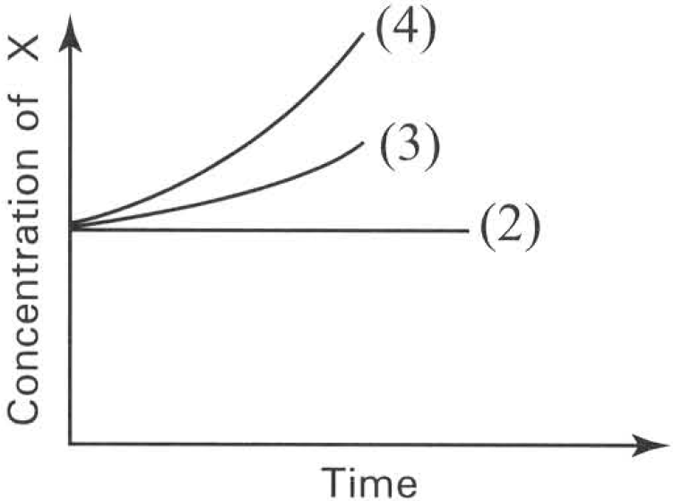
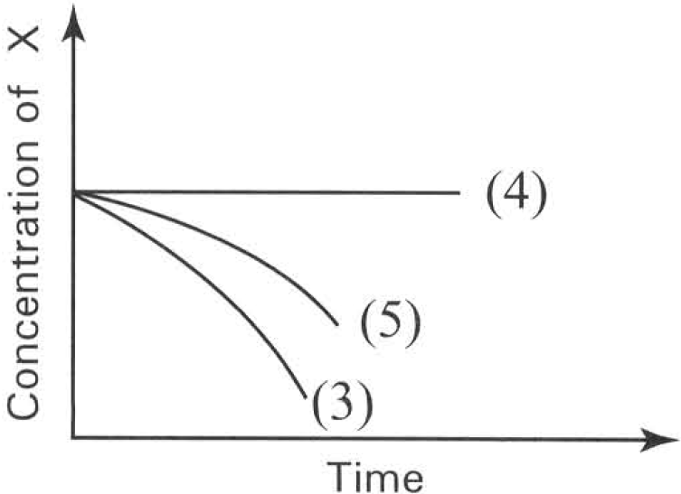
A. | B. | C. | D.

25. Which of the following graphs shows the effect of substrate concentration on the rate of an enzymatic reaction if the substrate is in excess?
Directions: Questions 27 to 31 refer to the experiment described below:
The contents of the two test tubes were mixed together after they have been kept at 20°C for 15 minutes. The volume of gas collected from the mixture was recorded. The experiment was repeated by using 1.5 cm3 of potato extract. The results were plotted in form of a graph as shown below.
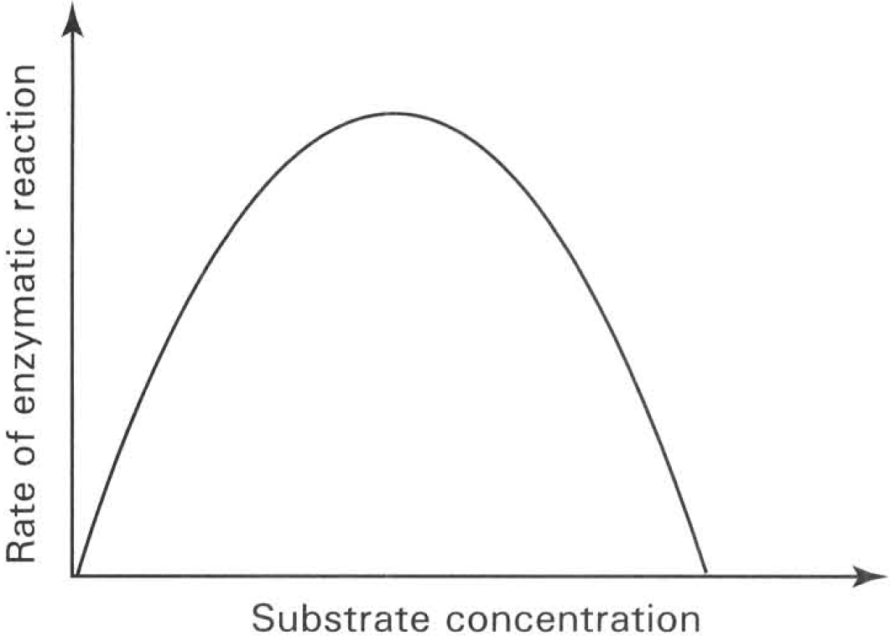
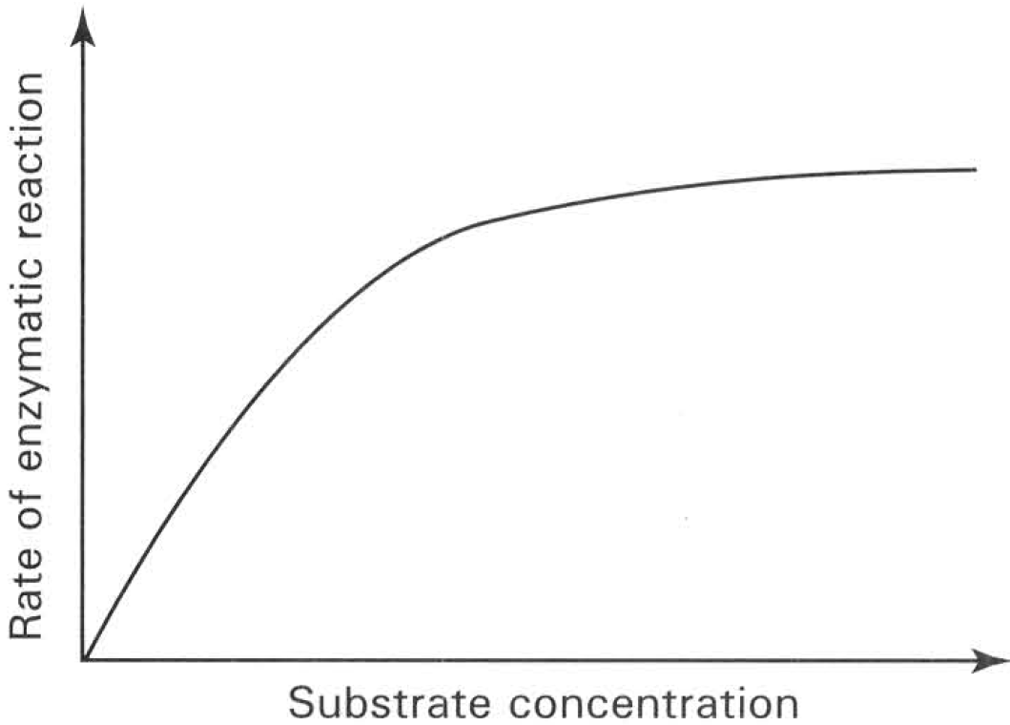
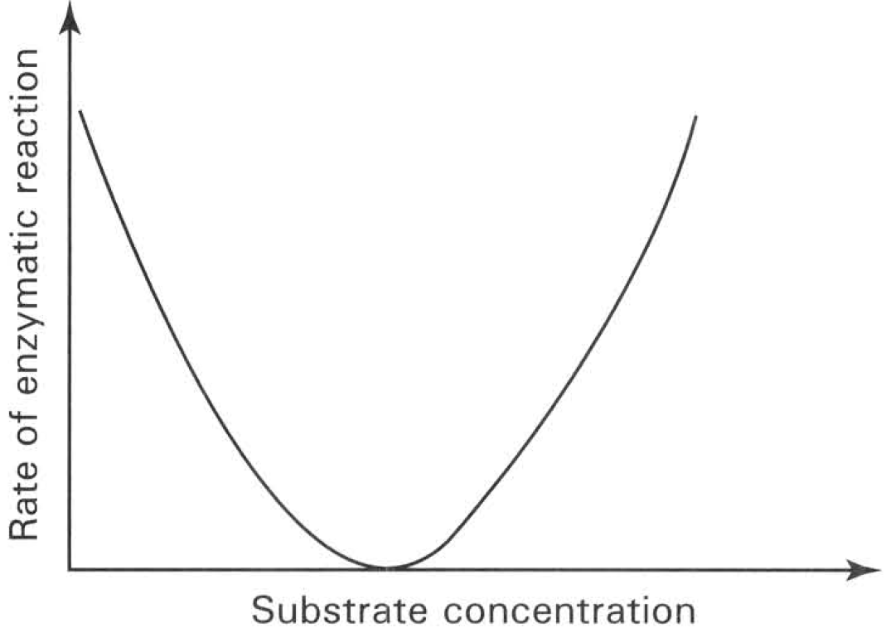
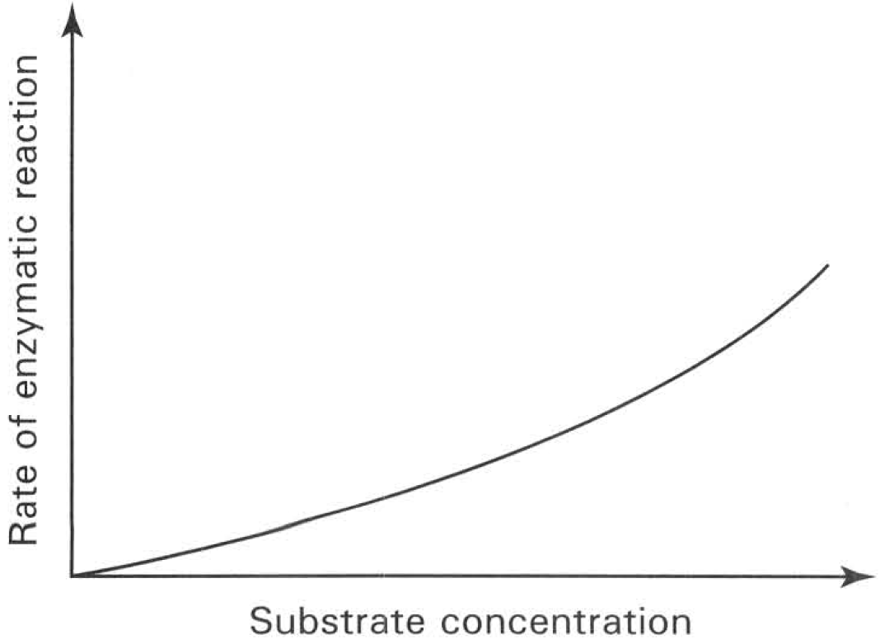
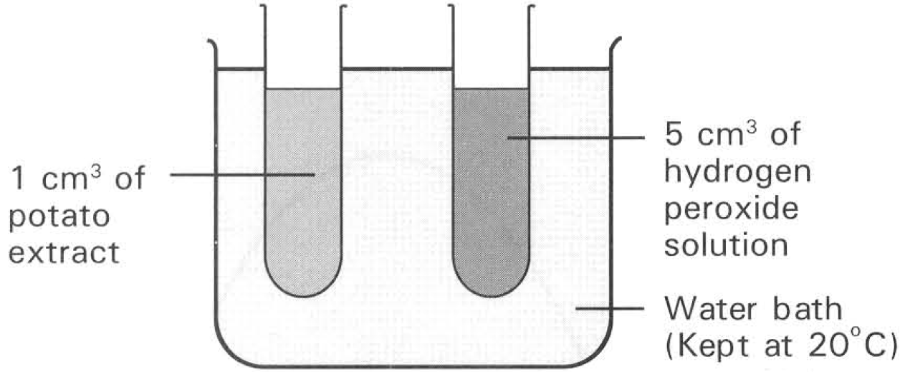
A. | B. | C. | D.

26. The reason for keeping the contents of the two test tubes separately at 20°C before mixing is to ensure that
A. the oxygen dissolved in the potato extract has escaped completely from the extract.
B. the oxygen originally dissolved in the hydrogen peroxide solution has completely escaped from the solution.
C. both contents have reached the given temperature of 20°C.
D. there is enough time for the hydrogen peroxide to decompose completely into gases.
27. What type of gas is collected from the mixture?
A. Oxygen B. Carbon dioxide C. Nitrogen D. Water vapour
28. Which of the following conclusions can be drawn from this experiment?
A. 20°C is the optimum temperature of the reaction.
B. The maximum rate of reaction was reached at the 20th minute.
C. The reaction cannot proceed further because all the hydrogen peroxide has been used up.
D. The reaction cannot proceed further because all the enzymes of the reaction in the potato extract have been used up.
29. The experiment was repeated at 30°C. Which of the following graphs CORRECTLY shows the result of the experiment?
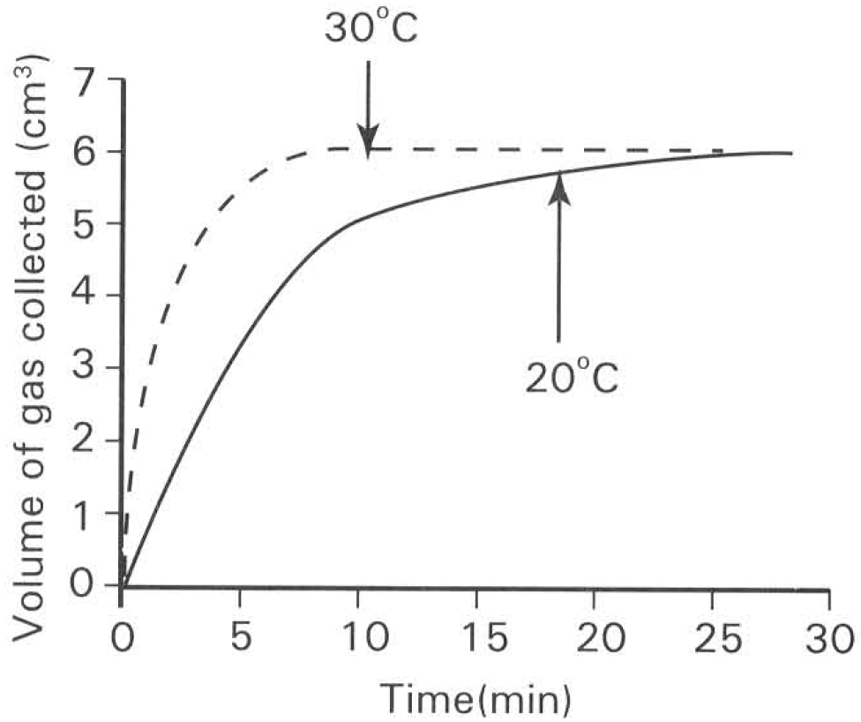
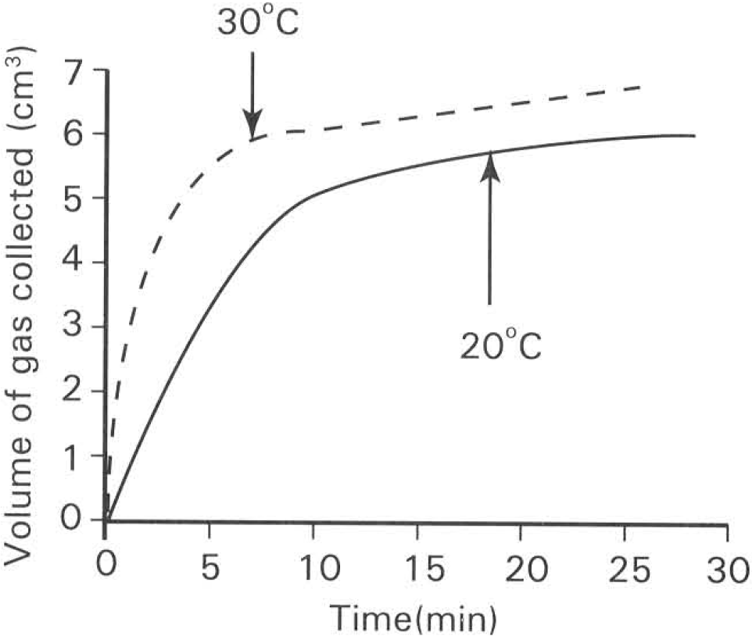
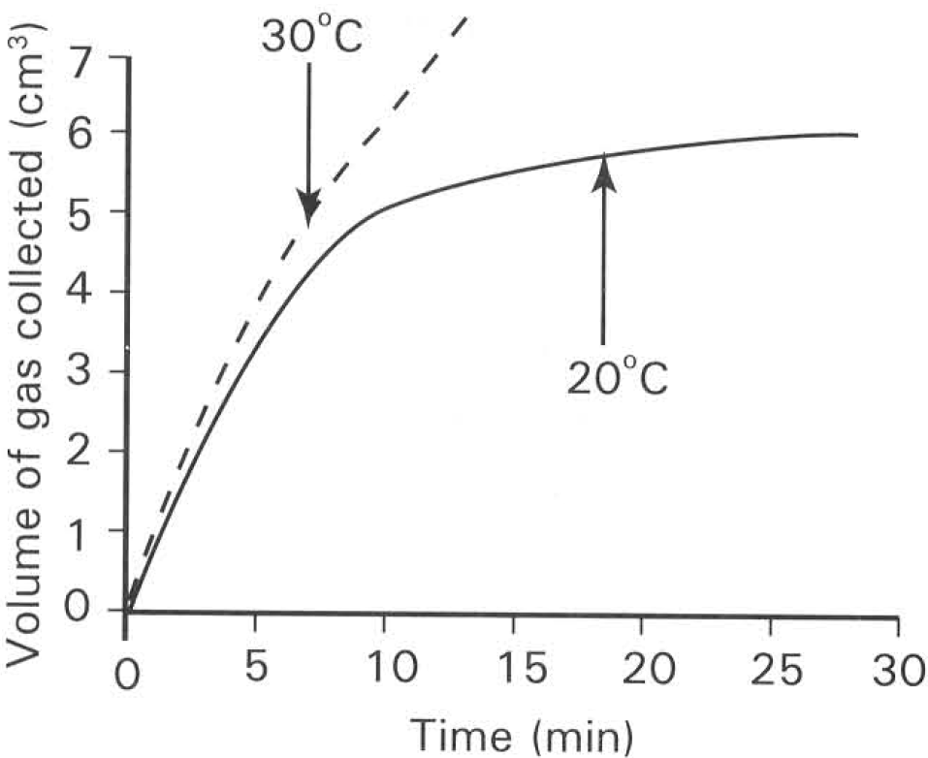
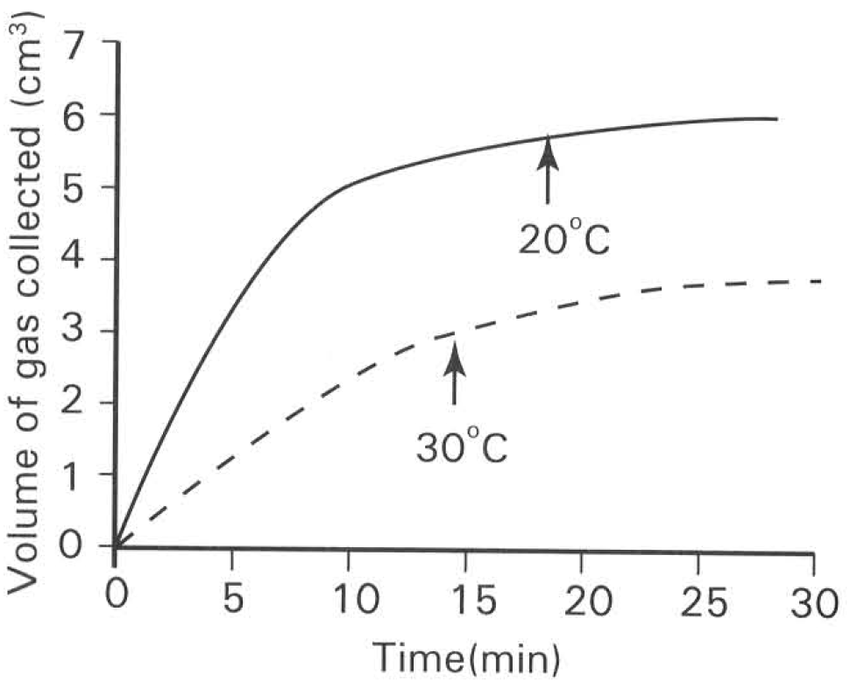
A. | B. | C. | D.

30. Which of the following graphs shows the possible results if a few drops of HCl have been added to the potato extract at the beginning of the experiment?
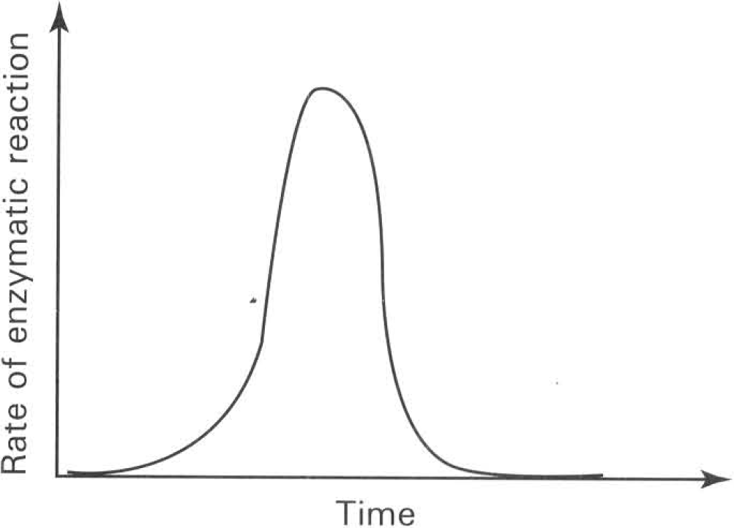
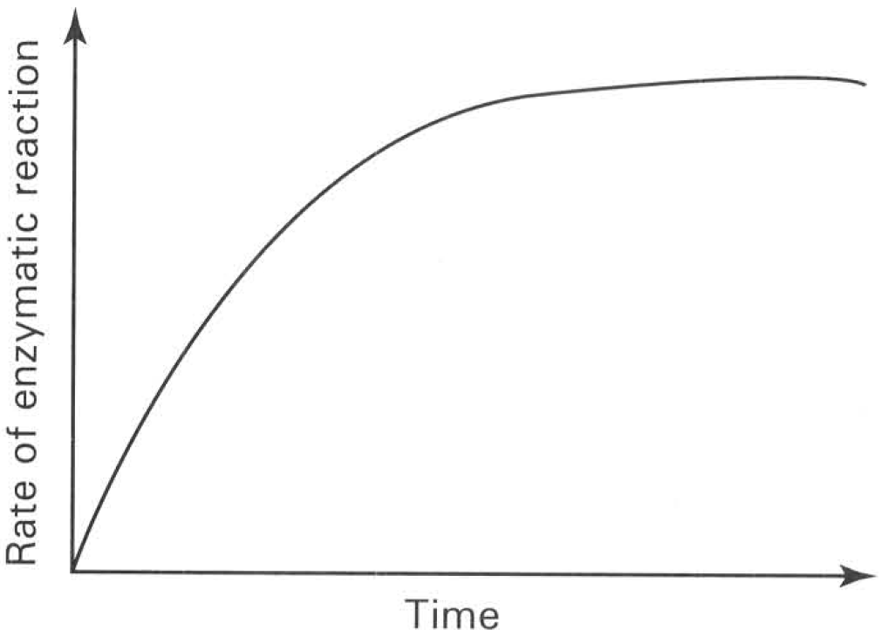
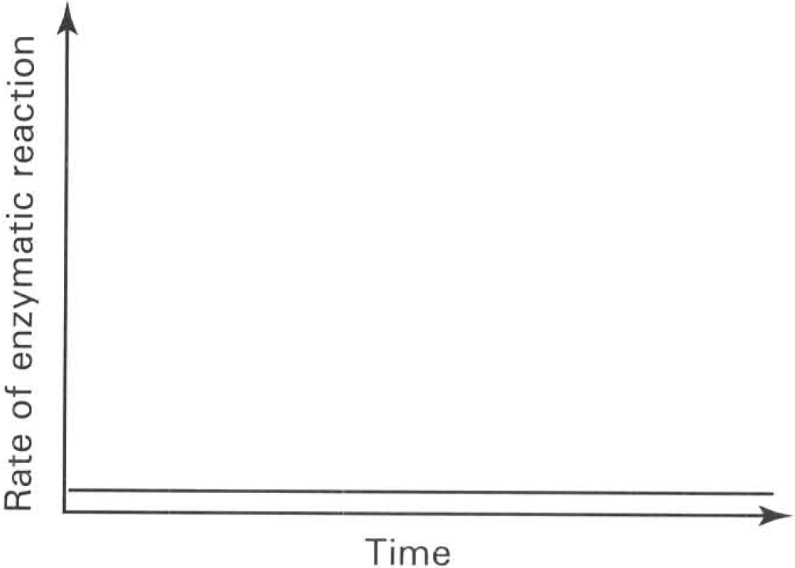
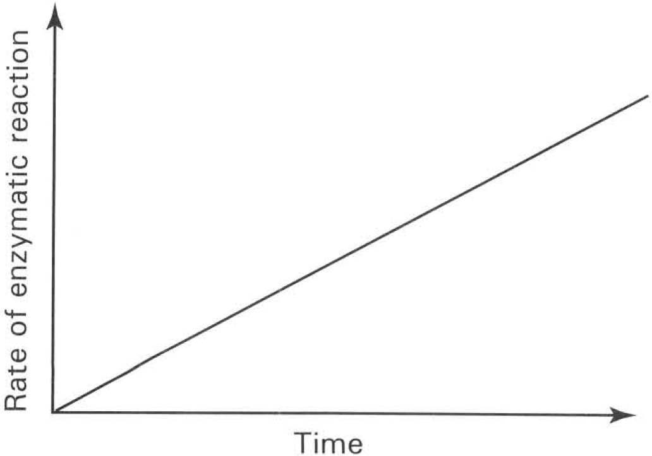
A. | B. | C. | D.

31. Which of the following graphs best shows the effect of temperature on enzymatic reactions'?
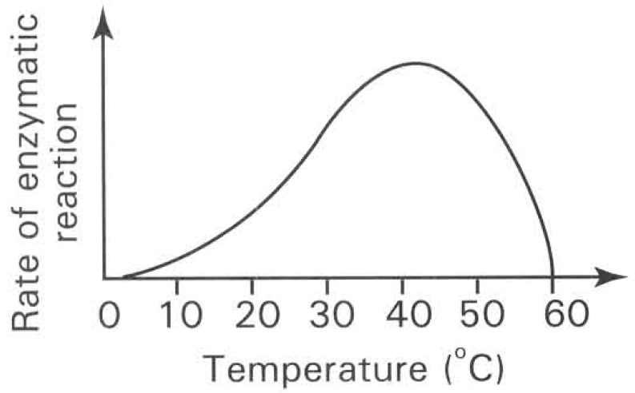
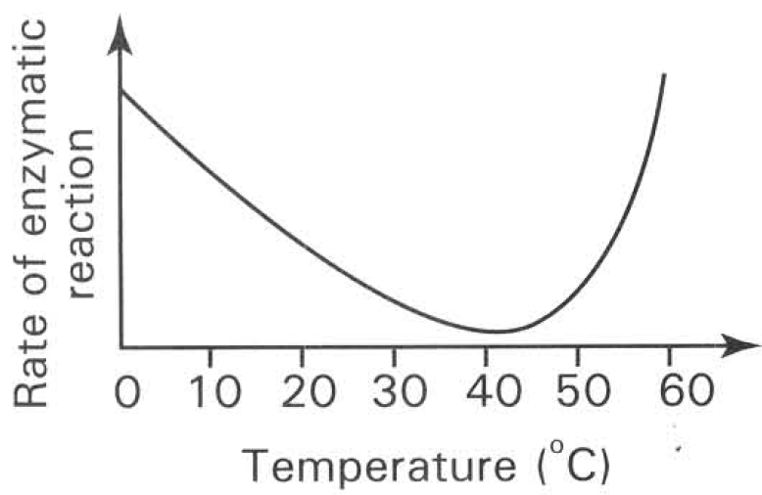
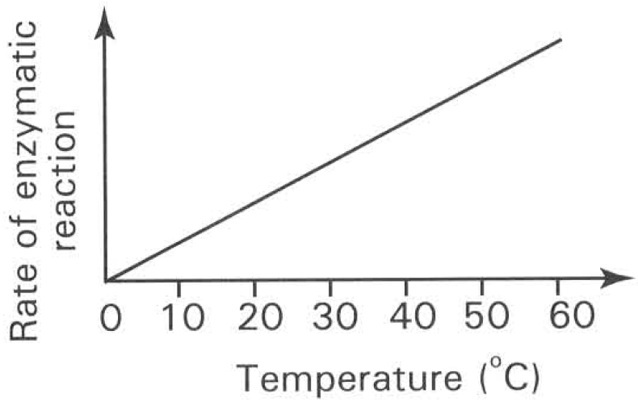
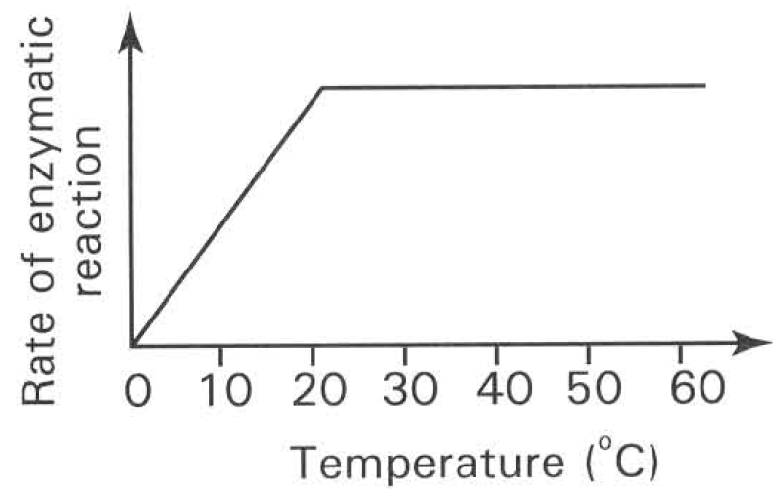
A. | B. | C. | D.

32. 2 ml of amylase solution is added to 5 ml starch solution which is kept in a water bath maintained at 70°C. Then the mixture is cooled down from 70°C to 10°C. Which of the following graphs shows the change in the reaction rate of this mixture?
Directions: Questions 34 to 37 refer to the graph below, which shows the effect of temperature on the activity of amylase on starch.
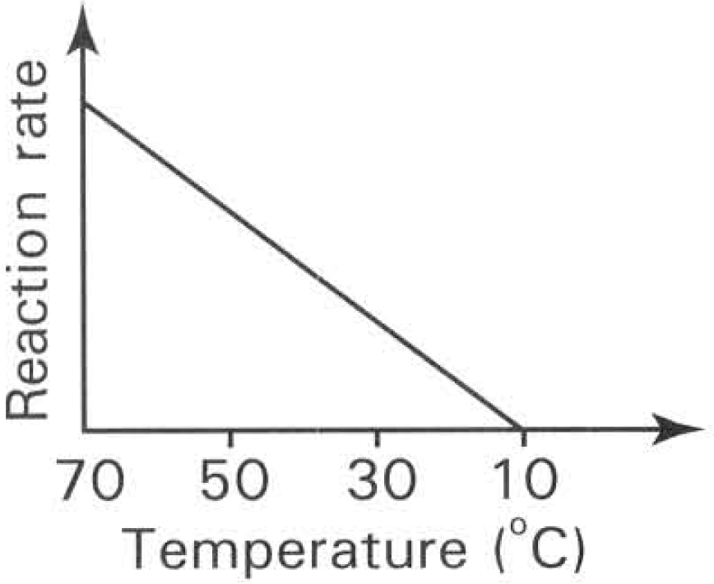
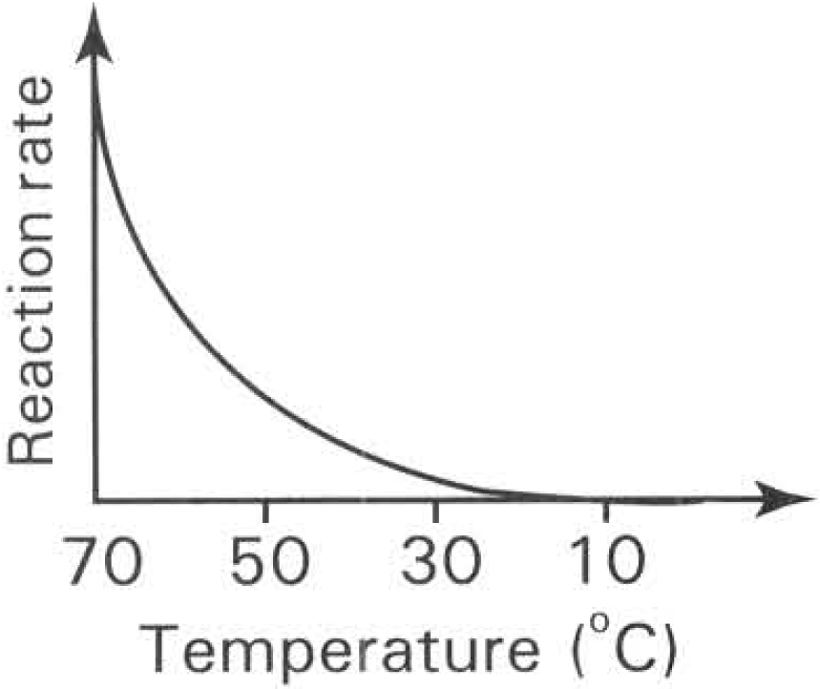
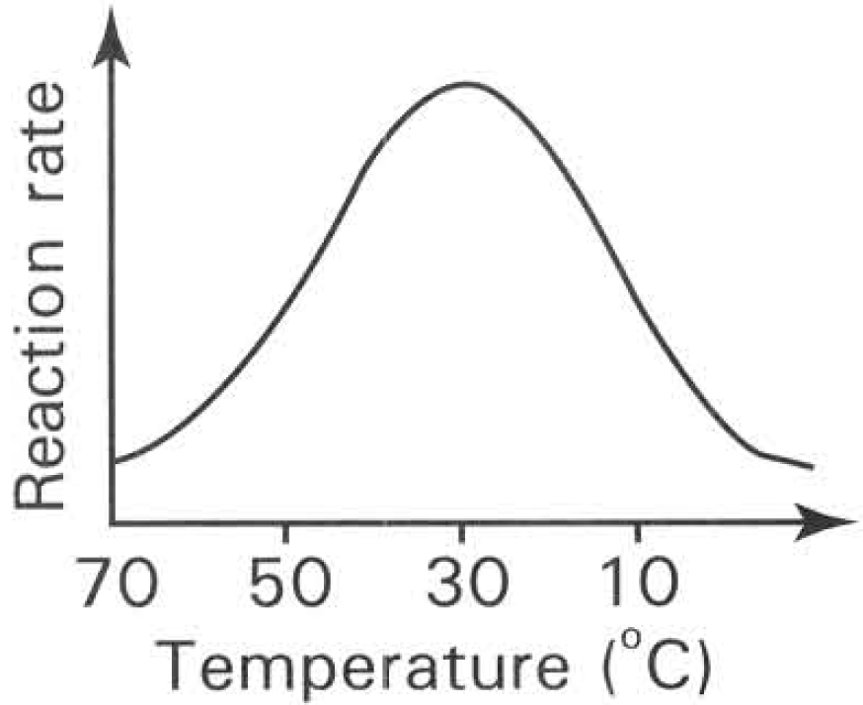
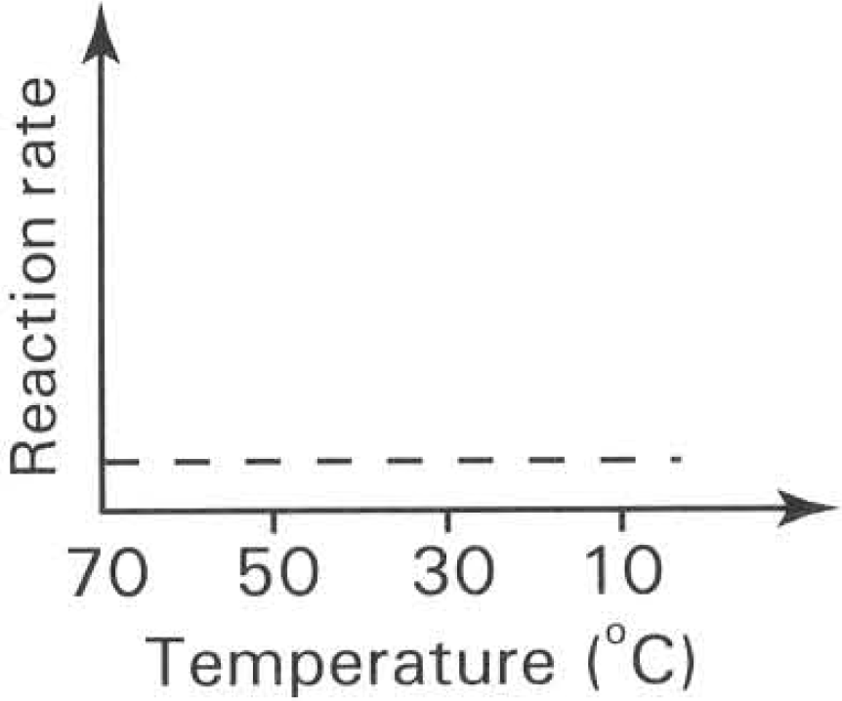
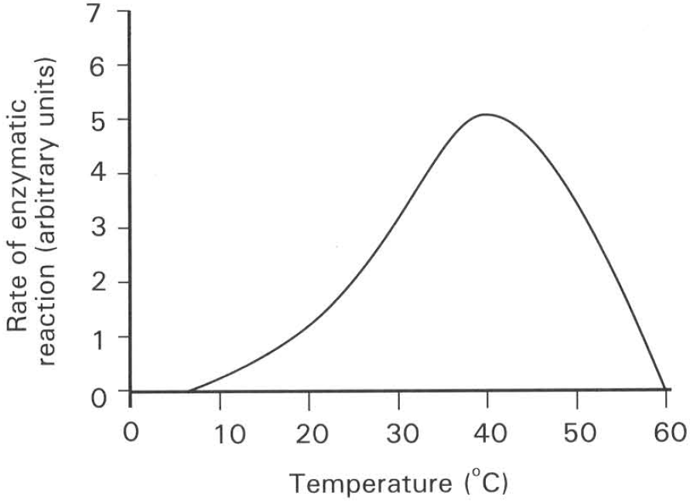
A. | B. | C. | D.

33. Within the same period of time at which temperature will starch be present at the highest concentration?
A. 20°C B. 30°C C. 40°C D. 60°C
34. Within the same period of time at which temperature will maltose be present at the highest concentration?
A. 20°C B. 30°C C. 40°C D. 60°C
35. Which of the following statements about the graph is CORRECT?
A. Increase in temperature increases the rate of reaction.
B. The optimum temperature for this enzymatic reaction is at 60°C.
C. The enzyme is denatured at 60°C.
D. The number of active sites increases from 10oC to 40°C.
36. Which of the following statements about the graph is CORRECT?
A. The kinetic energy of the enzyme and starch molecules is highest at 40°C.
B. The maximum rate of reaction is reached at 40°C .
C. The chemical bonds inside the enzyme are broken down completely at 10°C.
D. The chance of collision between the starch and amylase molecules is highest at 40°C.
37. Four pieces of coagulated egg white of equal length and thickness were treated differently as shown in the following diagrams and the results were observed after one hour.
Which of the following groups of observation of the egg white were completely CORRECT after one hour?
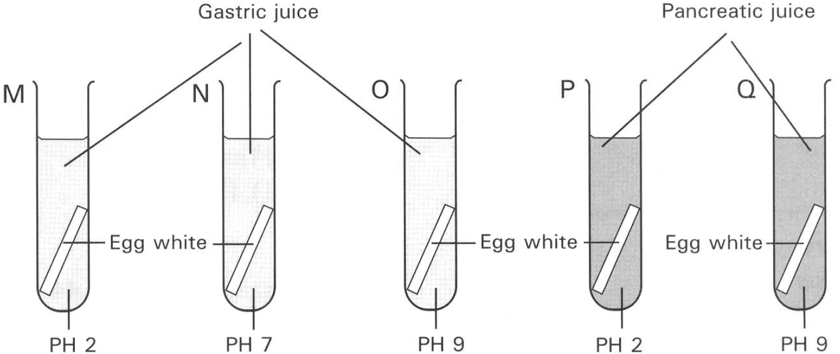
 | Tube M | Tube N | Tube O | Tube P | Tube Q
A. | Digested | Undigested | Undigested | Digested | Undigested
B. | Undigested | Digested | Undigested | Digested | Undigested
C. | Digested | Undigested | Undigested | Undigested | Digested
D. | Undigested | Undigested | Digested | Undigested | Digested

38. What conclusion can be drawn from the previous experiment?
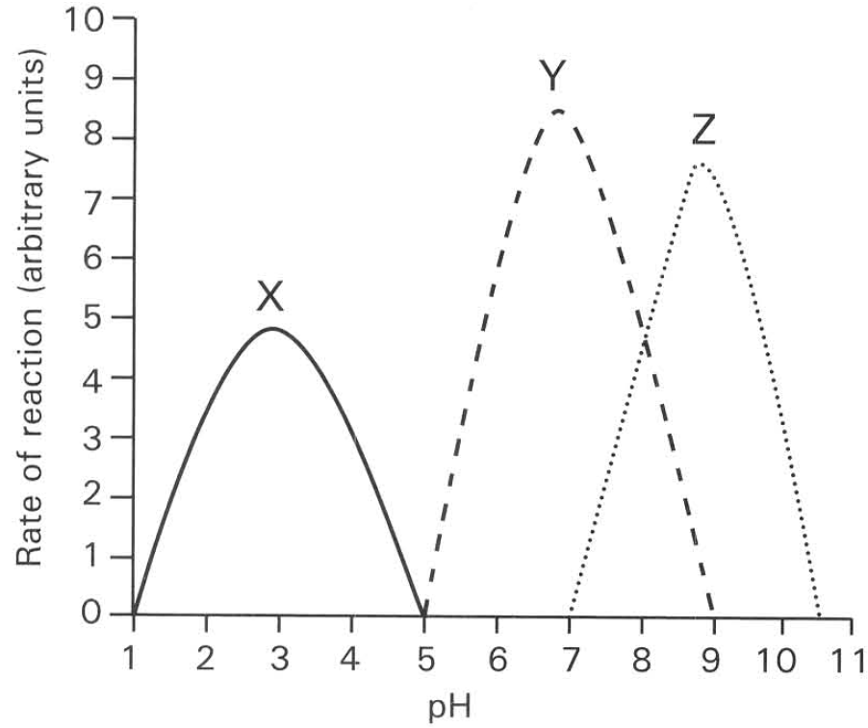
A. Egg white can only be digested at pH 9.
B. Egg white can only be digested at pH 2.
C. Egg white cannot be digested at pH 9.
D. Different digestive enzymes digest egg white at different optimum pH. Directions: Questions 40 to 43 refer to the graph below, which shows the effect of pH on the activities of three enzymes X, Y and Z.
39. Which of the following most likely matches the enzymes X, Y and Z?
41Which of the following is most likely the conclusion that can be drawn from the above graph?
 | X | Y | Z
A. | Salivary amylase | Lipase | Protease in gastric juice
B. | Protease in gastric juice | Lipase | Salivary amylase
C. | Lipase | Protease in gastric juice | Salivary amylase
D. | Protease in gastric juice | Salivary amylase | Lipase

A. All enzymes are denatured at low pH.
B. Increase in pH increases the rate of an enzymatic reaction.
C. pH 7 is the optimum condition for all enzymes to work.
D. Each enzyme has its optimum pH.
40. At which pH will both enzymes Y and Z reach the same rate for the reactions catalysed by them?
A. pH 5.0
B. pH 6.6
C. pH 7.0
D. pH 8.0
41. Which of the following factors should be kept constant in carrying out this experiment?
(1) Concentration of substrate (2) Concentration of enzyme (3) Temperature
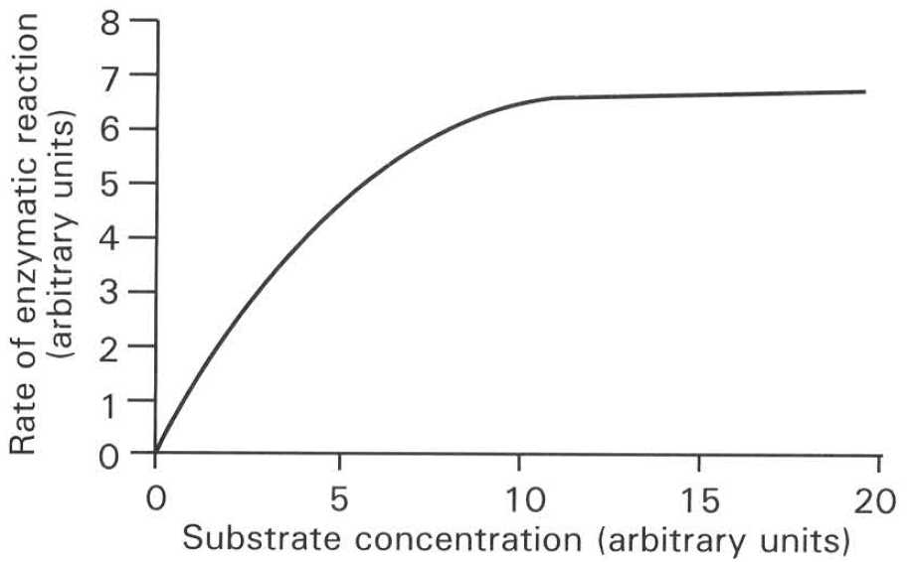
A. (1) only B. (1) and (2) only C. (1) and (3) only D. (1), (2) and (3) Directions: Questions 44 and 45 refer to the graph below.
42. The rate of enzymatic reaction increases when the substrate concentration increases from 0 to 12 units because
A. more active sites are provided by the increase in the substrate concentration.
B. more active sites are provided by the enzyme molecules.
C. the activation energy of the reaction decreases as the substrate molecules increases.
D. the chance of collision between the enzyme molecules and the substrate molecules increases.
43. The rate of enzymatic reaction cannot increase any further when the substrate concentration has reached 12 units. Which of the following explanation is CORRECT?
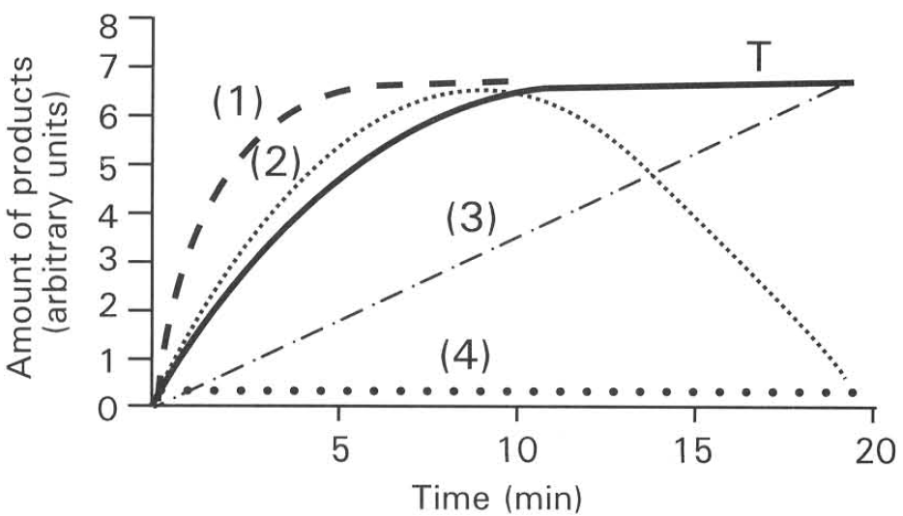
A. No more substrate molecules are available for enzyme molecules to act on.
B. All the enzyme molecules have been used up in the reaction.
C. The substrate concentration is the limiting factor.
D. All the active sites of the enzyme molecules have been occupied by the substrate molecules. Directions: Questions 46 and 47 refer to the graph below. Curve T in the graph shows the amount of products changing with time in an enzymatic reaction kept at 25°C.
44. Which of the following curves shows the possible changes in the amount of products if the experiment is repeated at 10°C?
A. (1)
B. (2)
C. (3)
D. (4)
45. Which of the following curves shows the possible changes in the amount of products if the experiment is repeated at 35°C?
A. (1)
B. (2)
C. (3)
D. (4)
46. An antibiotic used to kill bacteria is an inhibitor that suppresses the enzyme essential for
A. the replication of genetic material.
B. the synthesis of proteins.
C. the formation of cell wall.
D. the occurrence of aerobic respiration.
47. A chemical used to manufacture an insecticide has the feature of
A. inhibiting the enzyme responsible for the formation of cell wall.
B. inhibiting the enzyme responsible for the respiration of insects without harming the plants.
C. inhibiting the enzyme responsible for photophosphorylation.
D. inhibiting the enzymes involved in Calvin cycle. Directions: Questions 50 to 51 refer to the enzymes listed below. (1) Amylase (2) Lipase (3) Protease (4) Cellulase
48. Which of the above enzymes can act as meat tenderizer?
A. (1)
B. (2)
C. (3)
D. (4)
49. Which of the above enzymes can promote the extraction of juice from the fruit tissues and make the juice more clear?
A. (1)
B. (2)
C. (3)
D. (4)
50. Which of the above enzymes is effective in the production of stone-washed jeans?
A. (1)
B. (2)
C. (3)
D. (4)
51. Which of the above enzymes are effective components of washing powder?
A. (1) and (2)
B. (2) and (3)
C. (3) and (4)
D. (4) and (1)
52. Four enzymes (E1 to E4) catalyse the following metabolic pathway. The addition of chemical R causes chemical W to accumulate and nearly all chemicals X, Y and Z disappear. Later the addition of chemical X causes the appearance of chemicals Y and Z again. What is the role of chemical R?
A. It is the inhibitor of enzyme E1.
B. It is the inhibitor of enzyme E2.
C. It is the inhibitor of enzyme E3.
D. It is the inhibitor of enzyme E4.

Answers
Answers are printed in red.
1. B. It alters the energy state of the reacting molecules.
Class: 76.4% correct (n=140) usual slip A
2. A. decreasing the activation energy of the reaction.
Class: 69.3% correct (n=140) usual slip A
3. A. (1) and (2) only
Class: 60.0% correct (n=140) usual slip A
4. D. (3) and (4) only
Class: 90.0% correct (n=140) usual slip B
5. B. (2) and (3) only
Class: 85.0% correct (n=140) usual slip A
6. D. (3), (5) and (6) only
Class: 67.1% correct (n=140) usual slip A
7. C. The rate of enzymatic reactions decreases rapidly at high temperatures.
Class: 81.4% correct (n=140) usual slip A
8. A. Emulsification of fat to oil droplets in the duodenum.
Class: 70.0% correct (n=140) usual slip A
9. B
Class: 82.1% correct (n=140) usual slip C
10. B. T
Class: 74.3% correct (n=140) usual slip B
11. C. sucrase.
Class: 45.7% correct (n=140) usual slip B
12. D. less V and W will be formed.
Class: 88.1% correct (n=101) usual slip B
13. A. the digestion of sucrose.
Class: 93.6% correct (n=78) usual slip C
14. C. T is one of the products of the reaction.
Class: 73.1% correct (n=78) usual slip C
15. C. The amount and nature of T remains the same at the end of the reaction.
Class: 80.8% correct (n=78) usual slip B
16. D. (1) and (4) only
Class: 76.9% correct (n=78) usual slip C
17. B. the specific shape of a particular site on the surface of the molecule.
Class: 47.4% correct (n=78) usual slip B
18. C. Enzyme has active site with specific shape that can only be fitted in by substrate molecule with the right shape.
Class: 73.1% correct (n=78) usual slip A
19. D
Class: 91.0% correct (n=78) usual slip A
20. B
Class: 28.6% correct (n=42) usual slip B
21. D. (3), (4) and (5) only
Class: 45.2% correct (n=42) usual slip B
22. B. (2)
Class: 78.6% correct (n=42) usual slip A
23. A. Y is denatured by boiling.
Class: 76.2% correct (n=42) usual slip D
24. D
Class: 69.0% correct (n=42) usual slip A
25. B
Class: 83.3% correct (n=42) usual slip A
26. C. both contents have reached the given temperature of 20°C.
Class: 83.3% correct (n=42) usual slip C
27. A. Oxygen B. Carbon dioxide C. Nitrogen D. Water vapour
Class: 95.2% correct (n=42) usual slip A
28. C. The reaction cannot proceed further because all the hydrogen peroxide has been used up.
Class: 69.0% correct (n=42) usual slip D
29. A
Class: 54.8% correct (n=42) usual slip A
30. C
Class: 78.6% correct (n=42) usual slip D
31. A
Class: 83.3% correct (n=42) usual slip A
32. D
Class: 52.4% correct (n=42) usual slip A
33. D
Class: 88.1% correct (n=42) usual slip A
34. C
Class: 95.2% correct (n=42) usual slip A
35. C. The enzyme is denatured at 60°C.
Class: 95.2% correct (n=42) usual slip A
36. B. The maximum rate of reaction is reached at 40°C .

37. C

38. D. Different digestive enzymes digest egg white at different optimum pH. Directions: Questions 40 to 43 refer to the graph below, which shows the effect of pH on the activities of three enzymes X, Y and Z.

39. D. Each enzyme has its optimum pH.

40. D. pH 8.0

41. D

42. D. the chance of collision between the enzyme molecules and the substrate molecules increases.

43. D. All the active sites of the enzyme molecules have been occupied by the substrate molecules. Directions: Questions 46 and 47 refer to the graph below. Curve T in the graph shows the amount of products changing with time in an enzymatic reaction kept at 25°C.

44. D. (4)

45. A. (1)

46. C. the formation of cell wall.

47. B. inhibiting the enzyme responsible for the respiration of insects without harming the plants.

48. C. (3)

49. D. (4)

50. D. (4)

51. B. (2) and (3)

52. B. It is the inhibitor of enzyme E2.

