Enzymes · items under 80% correct
Multiple-choice practice
Name: ________________________ Class: ____________
These items were answered correctly by fewer than 80% of students in class Google Forms, matched by the wording in the source bank and the form answer key. Choose the one best answer.
Part A — HKDSE-style (YKTo)
1. What is the role of enzyme in an enzymatic reaction?
A. It increases the chance of collisions between reacting molecules.
B. It alters the energy state of the reacting molecules.
C. It provides energy to enhance the reacting molecules to reach the equilibrium.
D. It changes the final reaction to reach equilibrium.
2. An enzyme carries out its catalytic effect by
A. decreasing the activation energy of the reaction.
B. increasing the chance of collision between the substrate molecules and enzyme molecules.
C. bringing the substrate molecules close to the active site of the enzyme.
D. breaking down the macromolecules into smaller ones to enhance the reaction.
3. Which of the following activities are catabolic reactions? (1) Digestion of proteins in the stomach. (2) Glycolysis of sugar in the cytoplasm. (3) Formation of triose phosphate in the Calvin cycle. (4) Formation of muscle molecules from amino acids.
A. (1) and (2) only
B. (2) and (3) only
C. (3) and (4) only
D. (1), (2) and (3) only
4. Which of the following statements about enzymes are INCORRECT? (1) They act as biological catalysts. (2) They are easily denatured by great pH changes. (3) They are very stable to temperature changes. (4) They are required in small amounts for proper functioning. (5) They are only used for breaking down the complex organic compounds into simple and diffusible forms. (6) They carry out their functions best in an alkaline condition.
A. (1), (2) and (4) only
B. (2), (3) and (5) only
C. (2), (4) and (6) only
D. (3), (5) and (6) only
5. Which of the following reactions does NOT require enzymes to proceed rapidly inside the human body?
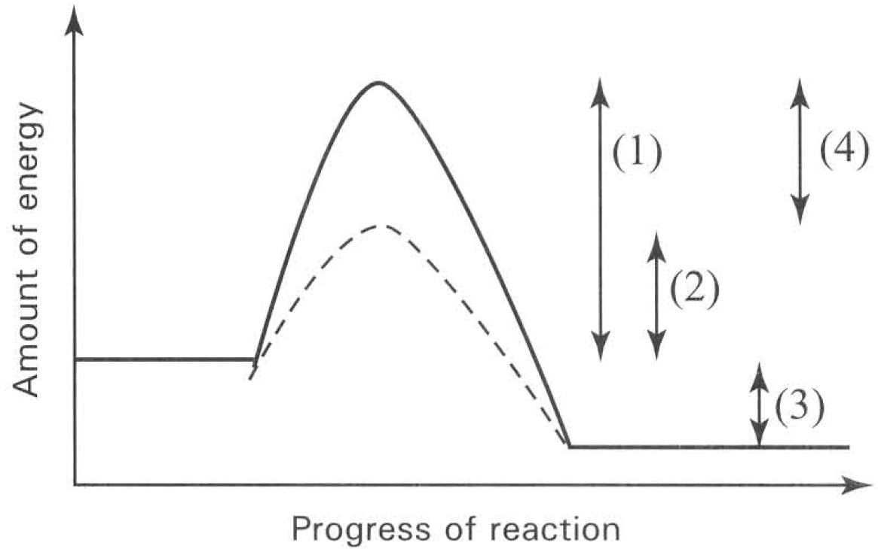
A. Emulsification of fat to oil droplets in the duodenum.
B. Break down of starch to maltose in the mouth cavity.
C. Break down of hydrogen peroxide inside the liver cells.
D. Hydrolysis of fat to fatty acid and glycerol in the ileum.
6. Which molecule can be used again and again?
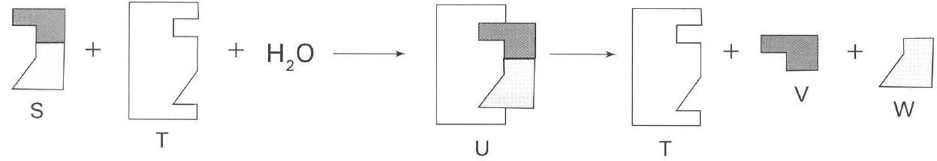
A. S
B. T
C. U
D. V
7. If substance S is a double sugar (disaccharide), substance T will most likely be a
A. simple sugar.
B. sucrose.
C. sucrase.
D. amylase.
8. Which of the following statements is WRONG?
A. S is the substrate.
B. Water is required for the reaction to complete.
C. T is one of the products of the reaction.
D. V and W are the products of hydrolysis.
9. Which of the following chemicals have active sites on their molecules? (1) Trypsin (2) Insulin (3) Maltose (4) Pepsin
A. (1) and (2) only
B. (2) and (3) only
C. (3) and (4) only
D. (1) and (4) only
10. The specificity of enzyme is due to
A. the protein nature of the molecule.
B. the specific shape of a particular site on the surface of the molecule.
C. the presence of many different types of bonds in the molecule.
D. the sensitivity of the molecule to different temperatures.
11. Which of the following features is responsible for the specificity of enzyme?
A. Enzyme is made of polysaccharide which is a complex molecule.
B. Enzyme is a very big molecule which has lots of space for different substrate molecules to attach to.
C. Enzyme has active site with specific shape that can only be fitted in by substrate molecule with the right shape.
D. Enzyme is an organic molecule which works best in the specific reactions taking place inside the organisms.
12. Which of the following identity of the substances are CORRECT?
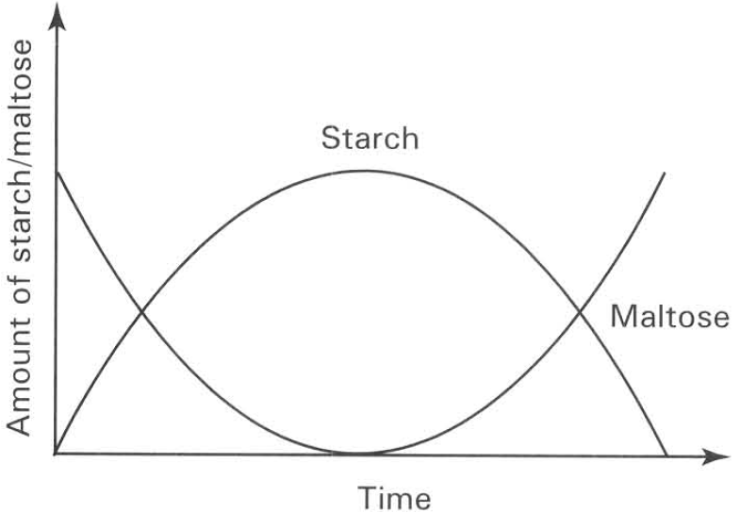
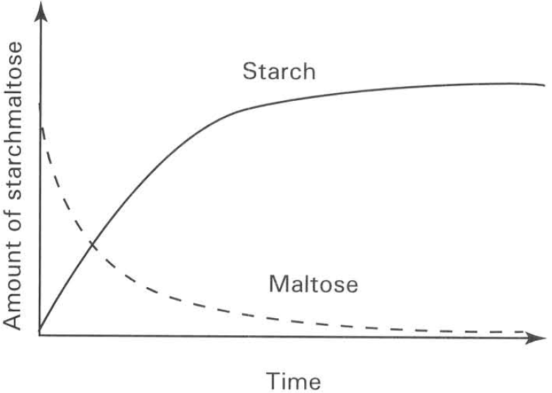
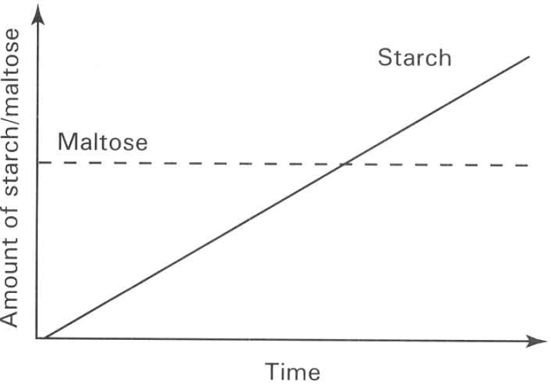
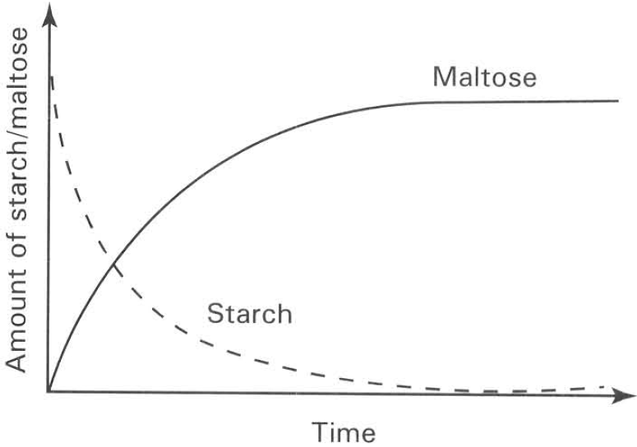
 | X | Y | Product of the reaction
A. | Starch | Gastric juice | Reducing sugar
B. | Starch | Pancreatic juice | Reducing sugar
C. | Sugar | Saliva | Non-reducing sugar
D. | Sugar | Saliva | Reducing sugar

13. Which experiment(s) is/are used to show the effect of temperature on the reactions?
A. (1) and (2) only
B. (2) and (3) only
C. (2), (3) and (4) only
D. (3), (4) and (5) only
14. Which experiment shows that extreme pH value destroys the enzymatic reaction?
A. (1)
B. (2)
C. (3)
D. (4)
15. Which of the following is most likely the conclusion drawn from the above experiments?
A. Y is denatured by boiling.
B. X is inactivated at low temperature.
C. High temperature splits X into reducing sugars.
D. High acidity changes X into reducing sugars.
16. The above experiments were repeated without performing the food tests. At regular intervals a sample of the test tube content was removed and the amount of X present was analysed. Which of the following graphs is CORRECT?
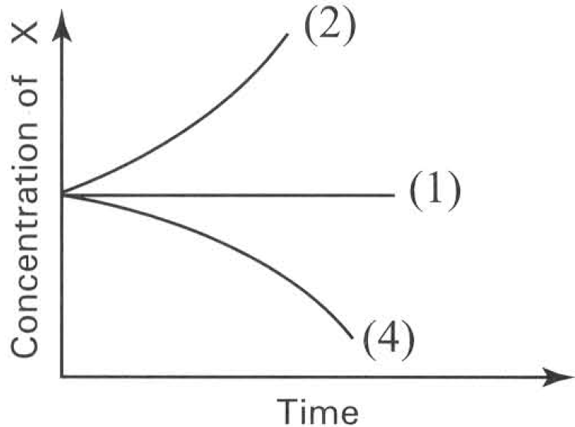
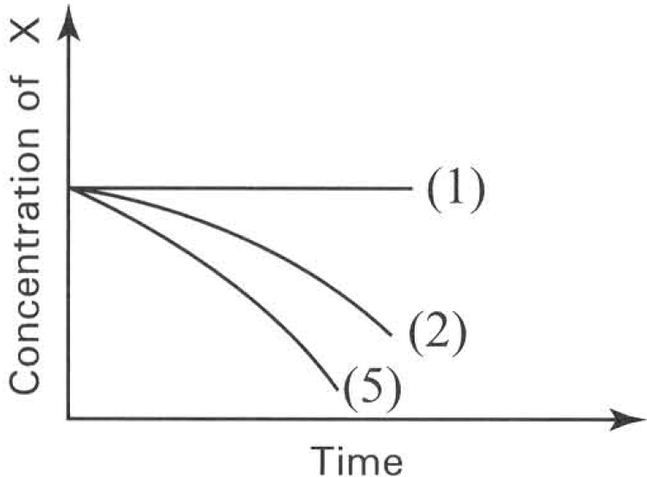
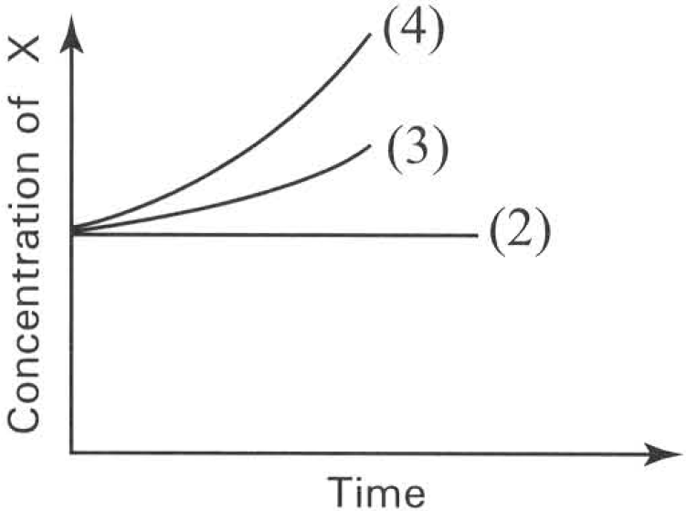
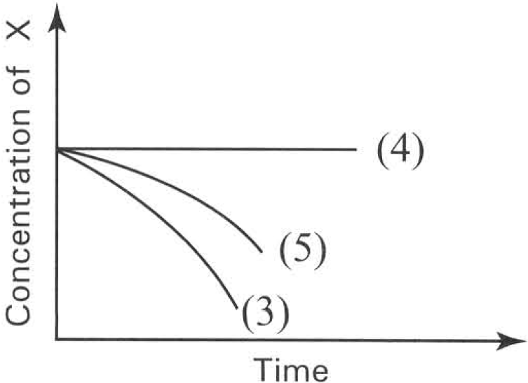
A. | B. | C. | D.

17. Which of the following conclusions can be drawn from this experiment?
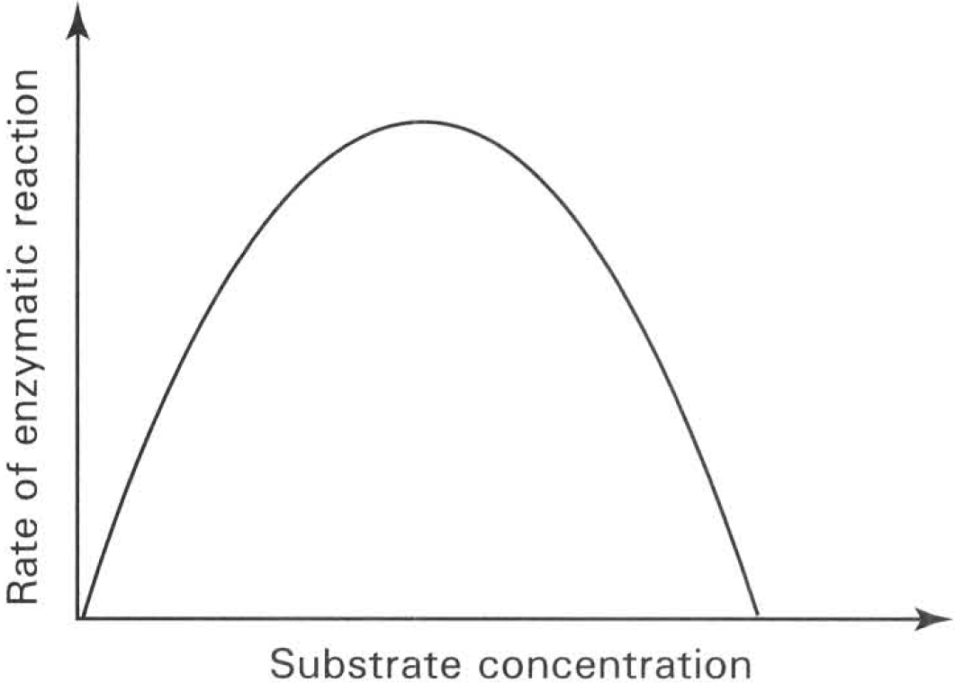
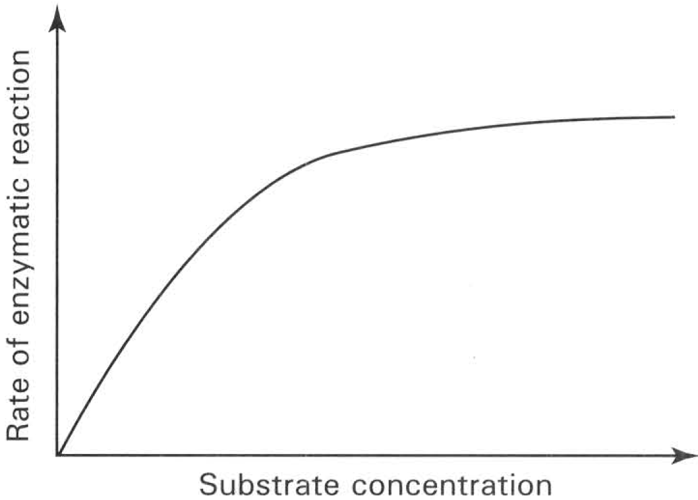
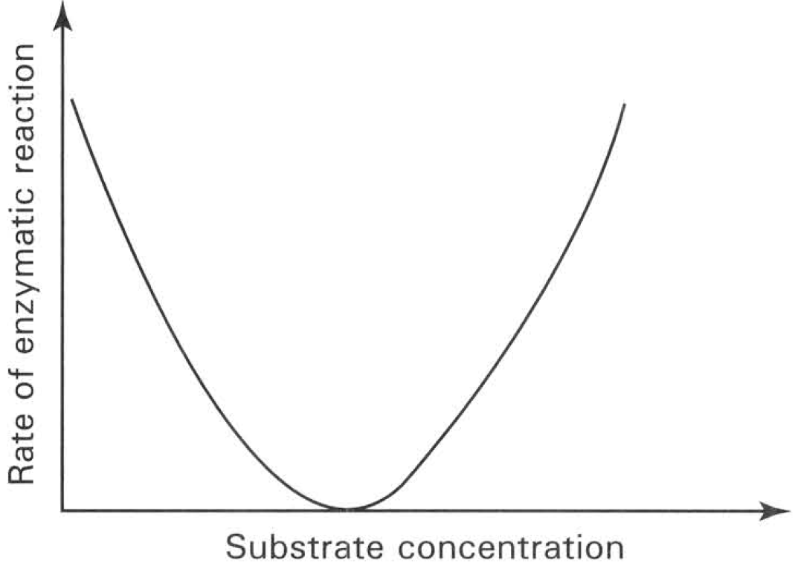
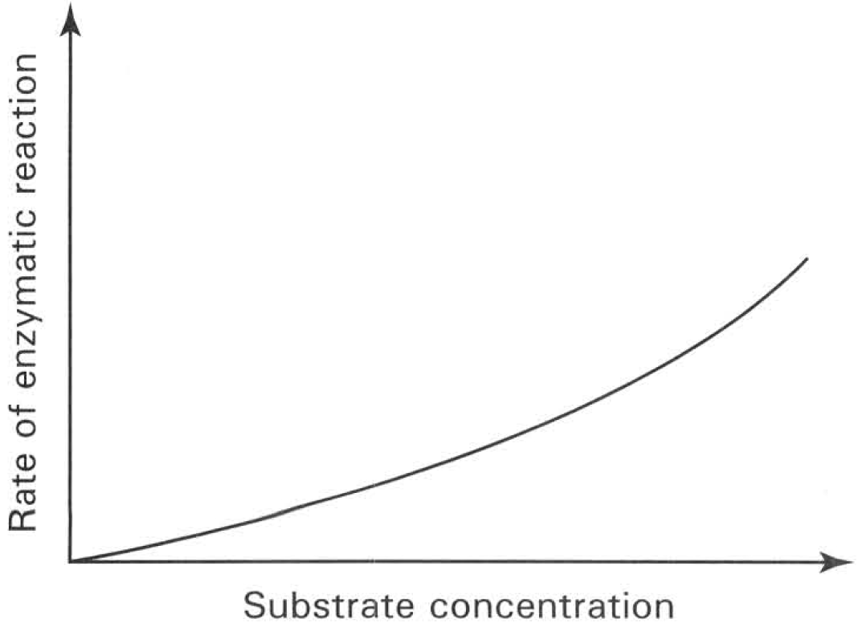
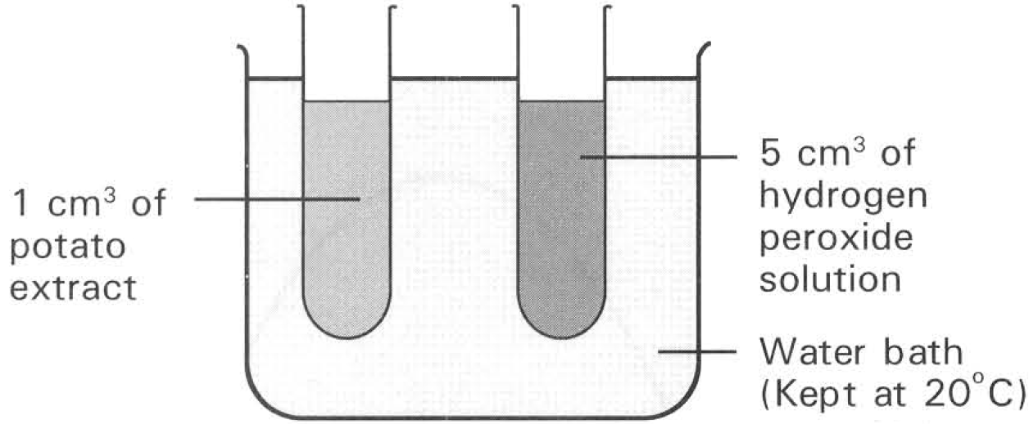
A. 20°C is the optimum temperature of the reaction.
B. The maximum rate of reaction was reached at the 20th minute.
C. The reaction cannot proceed further because all the hydrogen peroxide has been used up.
D. The reaction cannot proceed further because all the enzymes of the reaction in the potato extract have been used up.
18. The experiment was repeated at 30°C. Which of the following graphs CORRECTLY shows the result of the experiment?
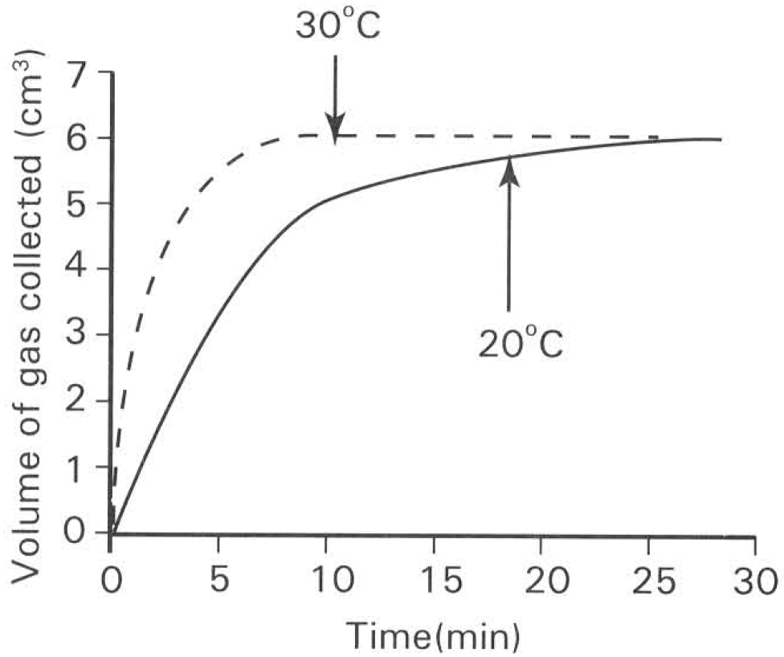
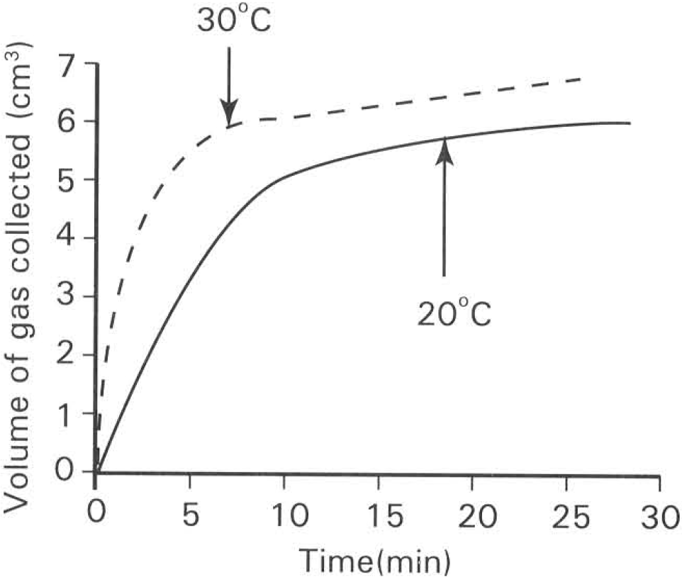
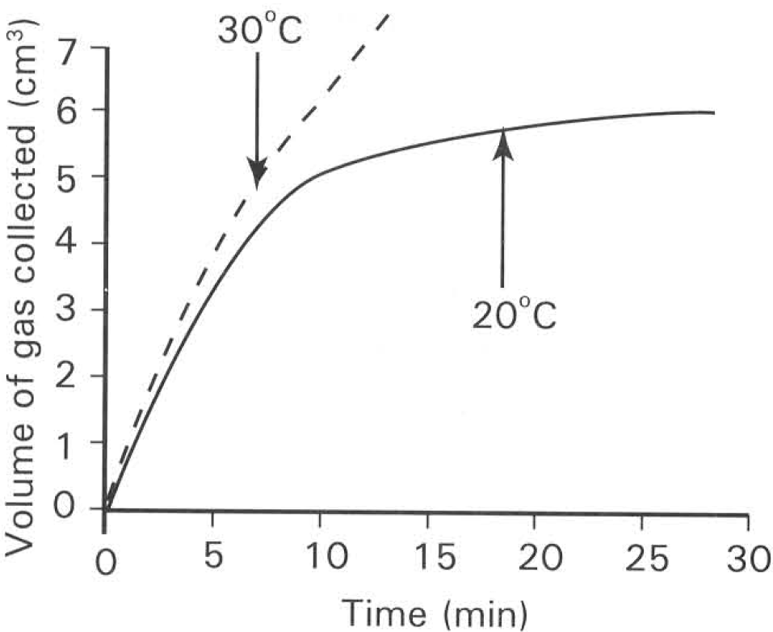
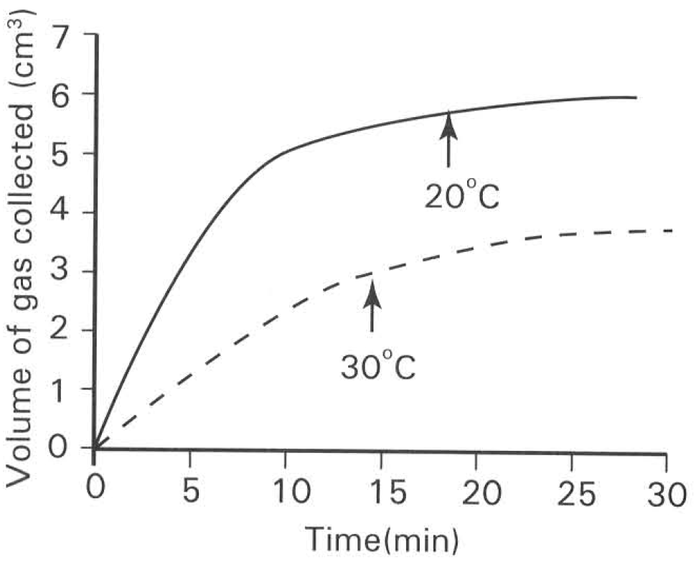
A. | B. | C. | D.

19. Which of the following graphs shows the possible results if a few drops of HCl have been added to the potato extract at the beginning of the experiment?
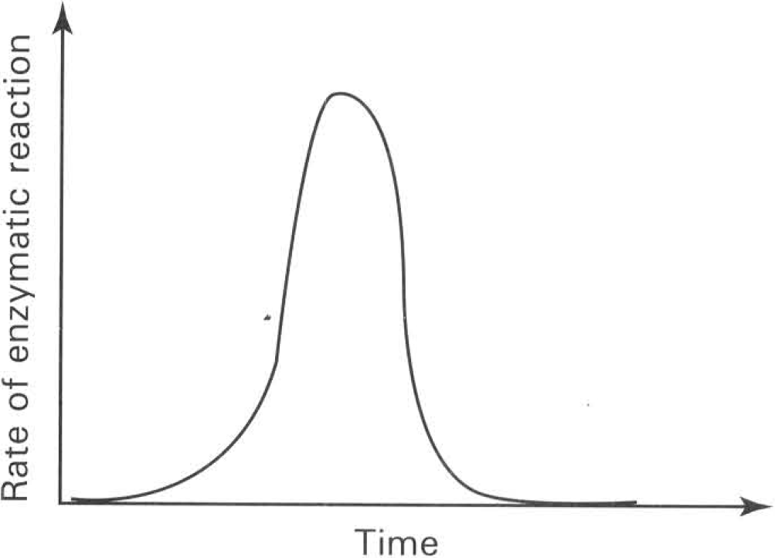
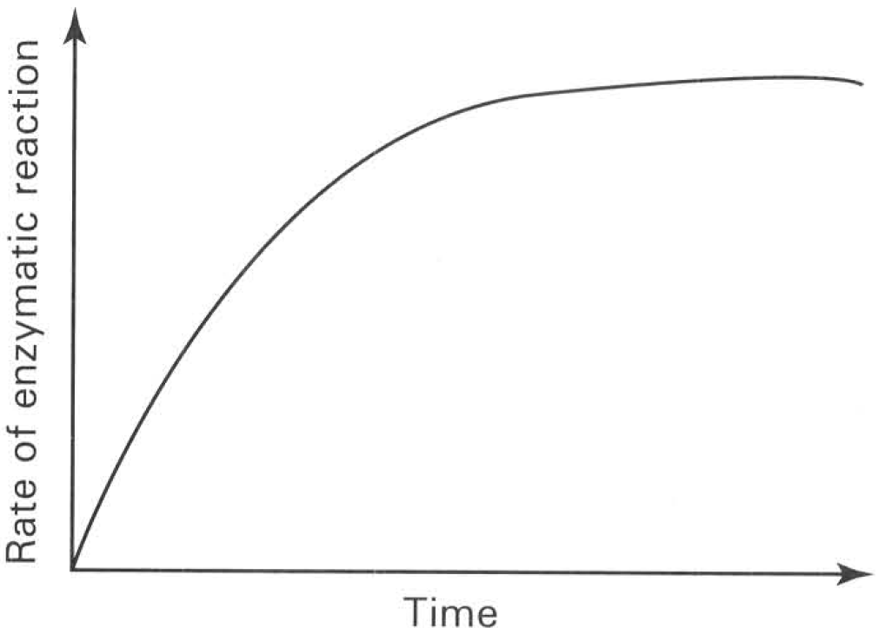
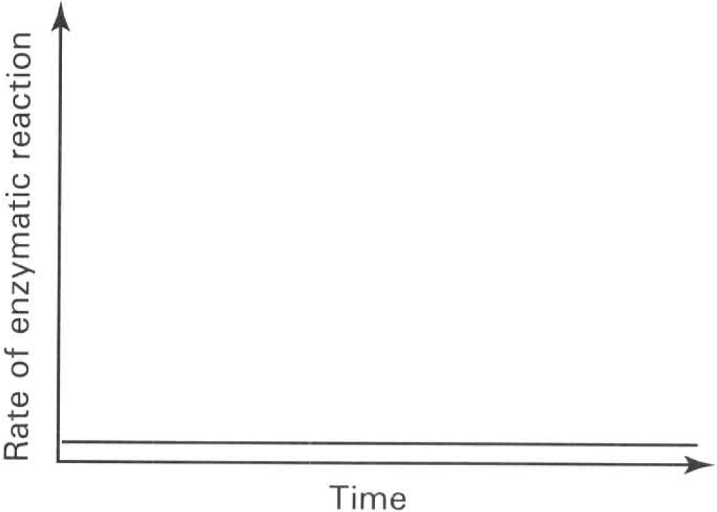
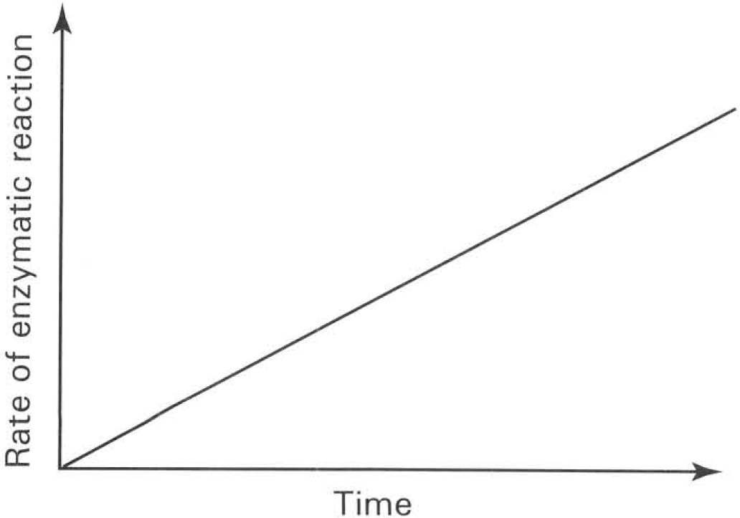
A. | B. | C. | D.

20. 2 ml of amylase solution is added to 5 ml starch solution which is kept in a water bath maintained at 70°C. Then the mixture is cooled down from 70°C to 10°C. Which of the following graphs shows the change in the reaction rate of this mixture?
Directions: Questions 34 to 37 refer to the graph below, which shows the effect of temperature on the activity of amylase on starch.
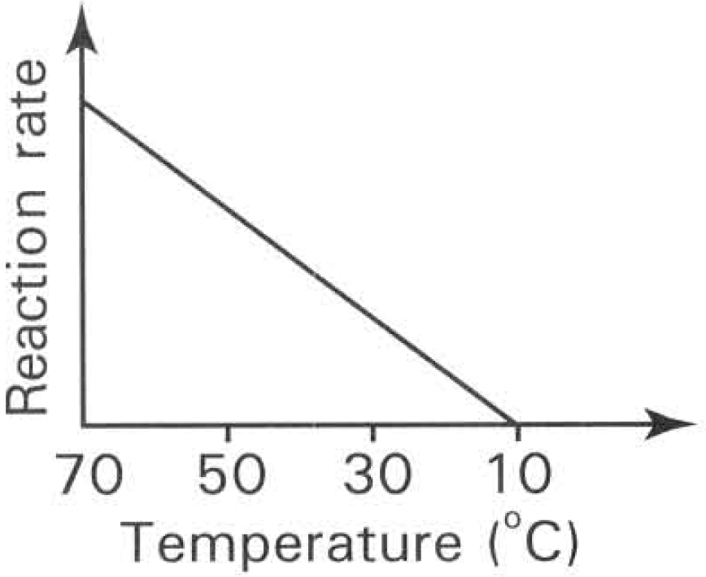
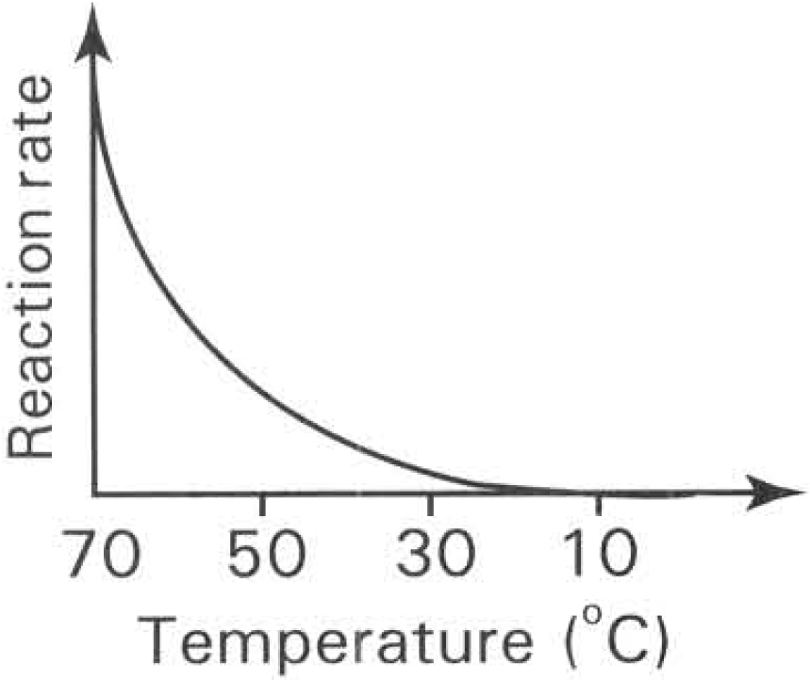
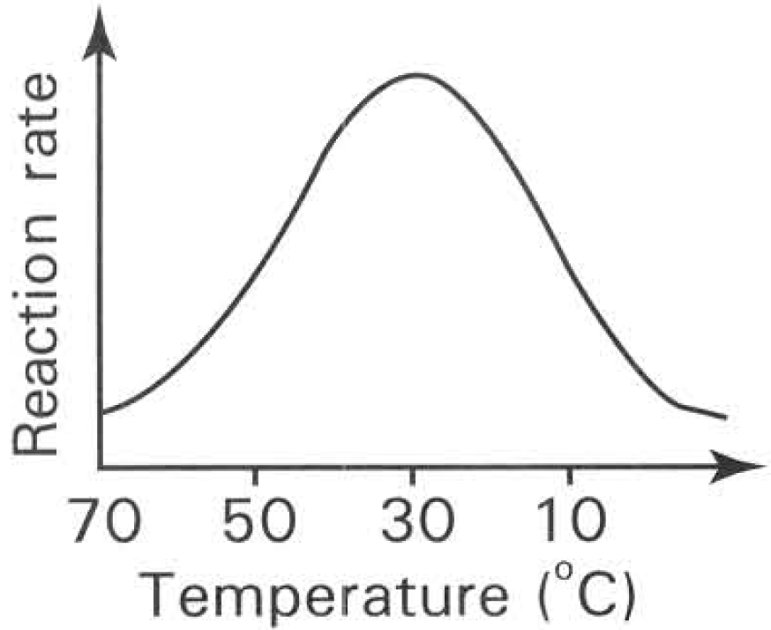
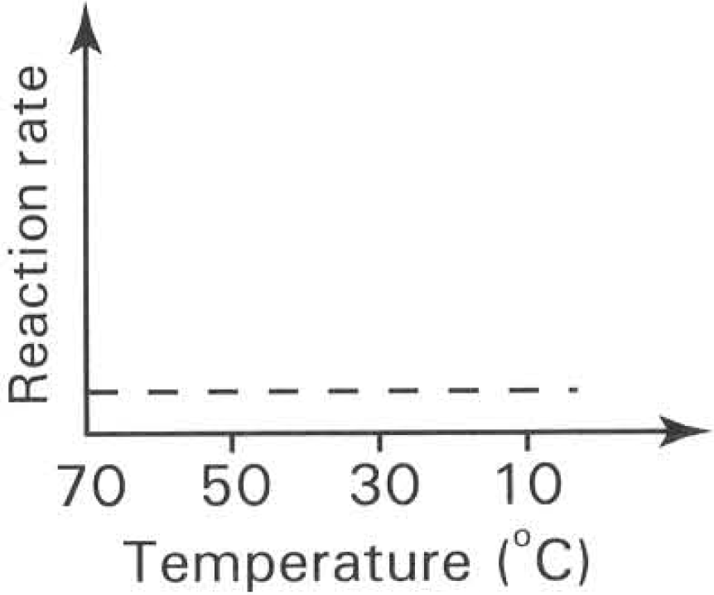
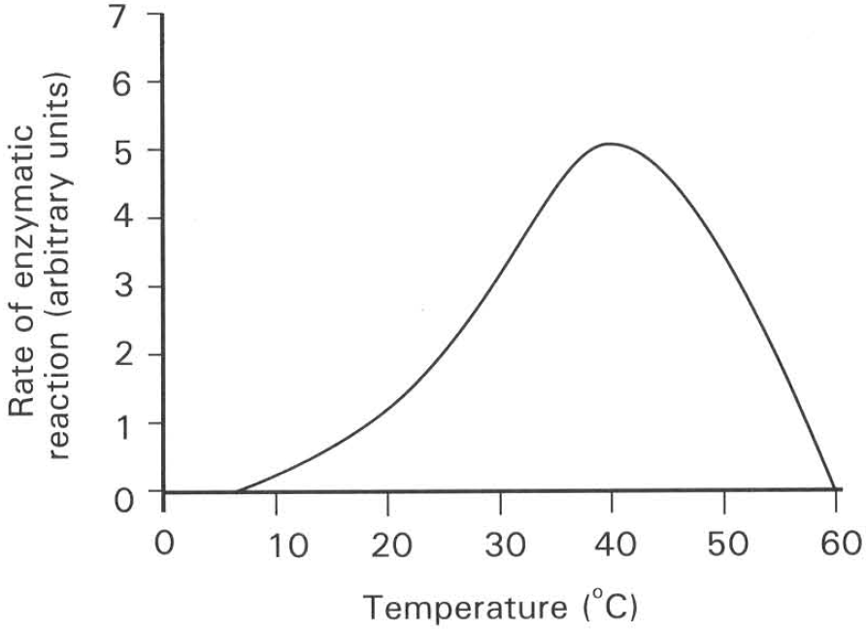
A. | B. | C. | D.

Answers
Answers are printed in red.
1. B. It alters the energy state of the reacting molecules.
Class: 76.4% correct (n=140) usual slip A
2. A. decreasing the activation energy of the reaction.
Class: 69.3% correct (n=140) usual slip A
3. A. (1) and (2) only
Class: 60.0% correct (n=140) usual slip A
4. D. (3), (5) and (6) only
Class: 67.1% correct (n=140) usual slip A
5. A. Emulsification of fat to oil droplets in the duodenum.
Class: 70.0% correct (n=140) usual slip A
6. B. T
Class: 74.3% correct (n=140) usual slip B
7. C. sucrase.
Class: 45.7% correct (n=140) usual slip B
8. C. T is one of the products of the reaction.
Class: 73.1% correct (n=78) usual slip C
9. D. (1) and (4) only
Class: 76.9% correct (n=78) usual slip C
10. B. the specific shape of a particular site on the surface of the molecule.
Class: 47.4% correct (n=78) usual slip B
11. C. Enzyme has active site with specific shape that can only be fitted in by substrate molecule with the right shape.
Class: 73.1% correct (n=78) usual slip A
12. B
Class: 28.6% correct (n=42) usual slip B
13. D. (3), (4) and (5) only
Class: 45.2% correct (n=42) usual slip B
14. B. (2)
Class: 78.6% correct (n=42) usual slip A
15. A. Y is denatured by boiling.
Class: 76.2% correct (n=42) usual slip D
16. D
Class: 69.0% correct (n=42) usual slip A
17. C. The reaction cannot proceed further because all the hydrogen peroxide has been used up.
Class: 69.0% correct (n=42) usual slip D
18. A
Class: 54.8% correct (n=42) usual slip A
19. C
Class: 78.6% correct (n=42) usual slip D
20. D
Class: 52.4% correct (n=42) usual slip A

Class percentage correct
Matched to this paper by question wording in the source bank and the form answer key, not by a shifted paper number.
Q | Answer | % correct | n | Usual slip
1 | B | 76.4% | 140 | A
2 | A | 69.3% | 140 | A
3 | A | 60.0% | 140 | A
4 | D | 67.1% | 140 | A
5 | A | 70.0% | 140 | A
6 | B | 74.3% | 140 | B
7 | C | 45.7% | 140 | B
8 | C | 73.1% | 78 | C
9 | D | 76.9% | 78 | C
10 | B | 47.4% | 78 | B
11 | C | 73.1% | 78 | A
12 | B | 28.6% | 42 | B
13 | D | 45.2% | 42 | B
14 | B | 78.6% | 42 | A
15 | A | 76.2% | 42 | D
16 | D | 69.0% | 42 | A
17 | C | 69.0% | 42 | D
18 | A | 54.8% | 42 | A
19 | C | 78.6% | 42 | D
20 | D | 52.4% | 42 | A

