Food and humans
Multiple-choice practice
Name: ________________________ Class: ____________
There are 55 questions compiled from Longman HKCEE and/or YKTo papers. Choose the one best answer.
Part A — HKCEE level (Longman)
1. Which of the following are the functions of carbohydrates? (1) As respiratory substrates(2) As storage molecules (3) As structural molecules
A. (1) and (2) only
B. (1) and (3) only
C. (2) and (3) only
D. (1), (2) and (3)
2. Which of the following is/are the function(s) of proteins? (1) As functional molecules (2) As structural molecules (3) As respiratory substrates A.(1) only
A. (1) only
B. (1) and (2) only
C. (2) and (3) only
D. (1), (2) and (3)
3. Which of the following are the functions of fat in a human body? (1)It is formed around some internal organs to protect them. (2)It is converted into carbohydrates for cell respiration during starvation. (3) It is used to make some hormones.
A. (1) and (2) only
B. (1) and (3) only
C. (2) and (3) only
D. (1), (2) and (3)
4. Which of the following correctly describes the functions of monosaccharides, dissacharides and polysaccharides in flowering plants?
 | Monosaccharides | Disaccharides | Polysaccharides
A. | releasing energy | making cell wall | storage
B. | transport | releasing energy | making cell wall
C. | transport | storage | making cell wall
D. | releasing energy | transport | storage

5. The importance of vitamin A is to
A. make visual purple.
B. make visual red.
C. make visual blue.
D. make visual green.
6. Calcium can make bones and teeth strong because it can form D. calcium sulphate. 7Which of the following is/are the functions of dietary fibre. (1) To stimulate peristalsis. (2) To add bulk for intestine to act on. (3) To act as a source of energy. A. (1) only B. (1) and (2) onlyC. (2) and (3) only D. (1), (2) and (3)
A. calcium chloride.
B. calcium carbonate.
C. calcium phosphate.
D. calcium sulphate. 7Which of the following is/are the functions of dietary fibre. (1) To stimulate peristalsis. (2) To add bulk for intestine to act on. (3) To act as a source of energy.
7. Excess protein in a human body will be .
A. stored in the muscles.
B. deaminated in the liver.
C. broken down to release energy.
D. excreted in the form of amino acids.
8. Human needs iron to
A. form haemoglobin. B. prevent bleeding gums.
C. make bones and teeth harder. D. maintain night vision. 10.Sailors often have bleeding gums, especially during tooth brushing. Which of the following reasons most likely explains this?-
A. They use sea water for tooth brushing.-B. They lose balance during tooth brushing.-
C. They are short of fresh water supply. D. Their diets lack fresh vegetables.
9. Which of the following matchings is correct?
 | Deficiency disease | Lacking of
A. | scurvy | vitamin C
B. | rickets | iron
C. | anaemia | iodine
D. | beriberi- | vitamin D

10. The deficiency disease of vitamin A is
A. scurvy.
B. rickets.
C. colourblindness.-
D. nightblindness.-
11. Which of the following correctly matches the deficiency diseases and their associated causes?
 | Anaemia | Rickets | Beri-beri
A. | iron | calcium | vitamin D
B. | iodine | vitamin D | vitamin B
C. | iron | phosphorus | vitamin B
D | iodine | calcium | vitamin B

12. The deficiency disease of roughage is
A. anaemia.
B. diarrhoea.
C. indigestion.
D. constipation.
13. Vegetarians are likely to suffer from protein deficiency unless their diets include
A. maize.
B. mushrooms.
C. pods and beans.
D. potatoes and tomatoes.
14. Excess vitamin C in a human body will be D. stored up in the liver. 17. Goitre is the deficiency disease of A. iron. B. phosphorus. C. calcium. D. iodine.
A. egested.
B. excreted.
C. broken down to release energy.
D. stored up in the liver. 17. Goitre is the deficiency disease of
15. Which of the following food would you recommend to a patient who cannot see things clearly at night?
A. Liver B. Seafood C. Cheese D. Tomatoes
16. When compared with meat eaters, plant-eaters are more likely to- (1) have constipation. (2) have protein deficiency. (3) be overweight.
A. (1) only
B. (2) only
C. (1) and (2) only
D. (2) and (3) only
17. If you were a doctor, what diet would you recommend to a patient suffering from goitre?
A. Liver and beef B. Dairy products and beans-C. Fruits and vegetables D. Shrimps and clams
18. Which of the following diseases may not be caused by the deficiency of vitamins in one's diet?
A. Rickets B. Scurvy C. Night blindness-D. Beri -beri
19. Which of the following diseases may not be caused by the deficiency of minerals in one's diet?
A. Rickets B. Anaemia C. Goitre D. Night-blindess
20. Breast feeding is preferable to bottle-feeding because- (1)breast feeding is more economical.- (2)human milk contains all the nutrients needed by babies while cow milk does not. (3)antibodies in human milk can make babies healthy while cow milk cannot.
A. (1) only
B. (2) only
C. (3) only
D. (2) and (3) only
21. On equal mass basis, which of the following food contains most protein?
A. Tomatoes B. Broad beans C. Melon D. Pepper
22. The percentages of carbohydrates, fats and proteins in bean curd are most probably
 | carbohydrates | fats | proteins
A. | 89% | 1% | 0%
B. | 76% | 13% | 4%
C. | 65% | 0% | 21%
D. | 0% | 2% | 92%

23. The composition of milk is analysed as follows.
Substances P and Q are probably
Directions: Questions 27 to 29 refer to the table below which shows the composition of some of the food substances in 100 g of four vegetables.
Composition of milk | Mass (in g) in 250 ml of milk
carbohydrate | 12.5
protein | 9.5
fat | 7.7
vitamins | 0.8
substance P | 1.3
substance Q | 218.2

 | P | Q
A. | water | dietary fibre
B. | dietary fibre | calcium
C. | calcium | water
D. | water | calcium

Vegetable | Carbohydrates (g) | Proteins (g) | Minerals | Vitamins
I | 20 | 2.2 | trace | trace
II | 8 | 15.7 | calcium | trace
III | 3 | 1.9 | iron | A
IV | 4 | 0.7 | trace | C

24. Which of the following combinations is correct?
 | I | II | III | IV
A. | soya bean | potato | spinach | green pepper
B. | potato | soya bean | green pepper | spinach
C. | soya bean | potato | green pepper | spinach
D. | potato | soya bean | spinach | green pepper

25. Which of the vegetables can ease kwashiokor?
A. I
B. II
C. III
D. IV
26. Patients suffering from night blindness should eat more vegetable-
A. I.
B. II.
C. III.
D. IV.
27. Which of the following kinds of food are rich in vitamin A? (1) Cod liver oil (2) Cheese (3) Egg yolk
A. (1) and (2) only
B. (1) and (3) only
C. (2) and (3) only
D. (1), (2) and (3)
28. Which of the following kinds of food is/are not rich in vitamin C? (1) Citrus fruits (2) Cereals (3) Green vegetables
A. (1) only
B. (2) only
C. (1) and (2) only
D. (2) and (3) only
29. Which of the following kinds of food is not rich in vitamin D?
A. Cod liver oil B. Cheese C. Meat D. Milk
30. Calcium may not be obtained in one's diet from
A. milk.
B. butter.
C. fish.
D. cheese.
31. Which of the following kinds of food are rich in iron? (1) Beef (2) Eggs (3) Whole grains
A. (1) and (2) only
B. (1) and (3) only
C. (2) and (3) only
D. (1), (2) and (3)
32. Dietary fibres mainly come from
A. the cell wall of plant cells.
B. the cell membrane of animal cells.
C. the nucleus of both plant and animal cells
D. the cytoplasm of plant cells.
33. Which of the following should be included in a man's diet? (1) Chloride (2) Phosphate (3) Nitrate (4) Sodium D. (1), (2) and (4) only Directions: Questions 37 to 39 refer to the experiment below which compares the concentration of vitamin C in three fruit juices. Each of the juices was added to 1 ml of solution X drop by drop until solution X turned colourless or pink. 37.Solution X for this experiment should be A. DCPIP solution. C. Biuret solution. D. Benedict's solution.
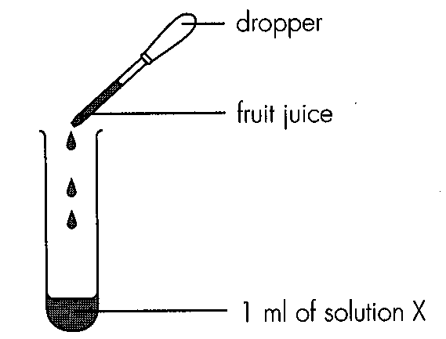
A. (1) and (2) only
B. (2) and (3) only
C. (3) and (4) only
B. hydrogencarbonate indicator solution.
34. The results were tabulated as follows: The concentrations of vitamin C (in descending order) of the three fruit juices are
Fruit juice | Number of drops of fruit juice todecolourize solution X
lemon | 2
orange | 3
grapefruit | 1

A. orange, lemon, grapefruit
B. lemon, orange, grapefruit
C. grapefruit, orange, lemon
D. grapefruit, lemon, orange
35. The accuracy of this experiment can be improved by (1) using 2 ml of solution X. (2) diluting the fruit juices. (3) replacing the dropper with a syringe.
A. (1) only
B. (2) only
C. (1) and (2) only
D. (1), (2) and (3)
36. The best way to preserve vitamin C in vegetables is by
A. high temperature.
B. low temperature.
C. drying.
D. salting.
37. Cooking vegetables in pressure kettle will destroy most of the C. vitamin C.D. vitamin D. Directions: Questions 42 to 44 refer to the experiment below which measured the amount of vitamin C in a lemon. The results were tabulated below.
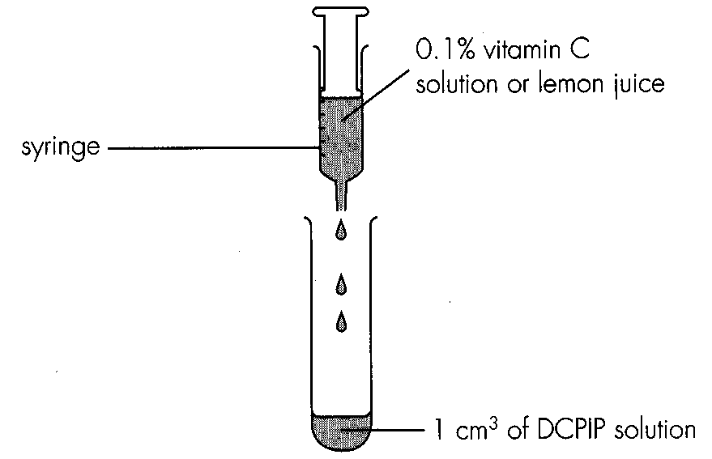
Test solution | Volume (in cm3) needed to decolourize 1 cm3 of DCPIP solution
0.1 % vitamin C solution | 0.6
lemon juice | 0.8

A. vitamin
A.
B. vitamin
B.
38. The concentration of vitamin C in lemon juice is D. 0.133%. 44.Given that 80 g of lemon juice can be squeezed from the lemon, the amount of vitamin C (in mg) in the lemon is B. 40. C. 60. D. 80.
A. 0.025%.
B. 0.05%.
C. 0.075%.
A. 20.
39. Which of the following food tests require(s) heating? (1) Benedict's test (2) Iodine test (3) Emulsion test (4) Biuret test
A. (1) only
B. (3) only
C. (2) and (4) only
D. (1), (3) and (4) only
40. Which of the following correctly describes the positive results in food tests?
 | Benedict's test | Iodine test | Biuret test | Emulsion test
A. | orange | dark blue | purple | clear
B. | brickred- | brown | purple | milky
C. | orange | dark blue | blue | milky
D. | brickred- | blueblack- | purple | milky

41. An unknown food sample was tested for its chemical composition and the results were summarized below. The food sample is most probably
Food test | Result
Benedict's test | blue
Biuret test | purple
Iodine test | blue-black
Emulsion test | clear

A. rice.
B. bread.
C. cheese.
D. milk.
42. The results of food tests on a food sample were summarized below.
The food sample should contain
Food test | Result
Spot test | translucent spot appeared for 15 minutes
DCPIP test | turned pink
Biuret test | turned blue

A. ascorbic acid only. B. vitamin C and protein only.
C. vitamin C and fat only. D. protein and fat only.
43. The table below summarized the results of food tests on a food sample:
The food sample should contain
Food test | Result
Benedict's test | turned green
Biuret test | turned blue
Iodine test | turned dark blue
Spot test | translucent spot appeared for a while

Daily requirements | Woman X | Woman Y
energy (k)) | 7800 | 11000
protein (g) | 60 | 72
vitamin D (mg) | 3.2 | 11.3
calcium (mg) | 650 | 1180
iron (mg) | 14 | 18

A. glucose and oil. B. maltose and starch. C. oil and maltose. D. protein and starch. Directions: Questions 50 and 51 refer to the table below which shows the daily energy and nutrient requirements of two women.
44. Assuming that both women are of similar weight, woman Y is probably
A. a labour worker.
B. pregnant.
C. having rickets.
D. having kwashiokor.
45. What will you suggest for woman Y in order to meet her needs?
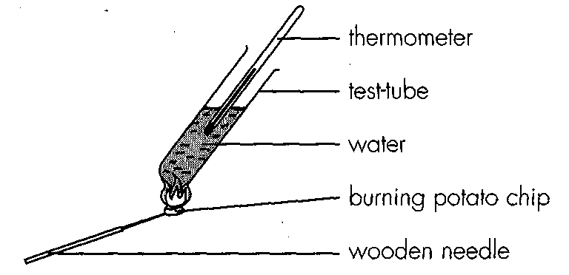
A. Spinach & carrots B. Fish & liver C. Chicken & pepper D. Soya beans & cheese Directions: Questions 52 to 54 refer to the diagram below which shows the experimental setup for measuring the energy value of food.-
46. The experimental set up is called-
A. potometer. B. auxanometer. C. calorimeter. D. Sphagmomanometer. 53. Given: mass of potato chip = M p mass of water = Mw temperature rise = T specific heat capacity of water = C Which of the following formulae correctly calculates the energy value per unit mass of potato chip?
A. (Mp x C xT )/MW B. (Mw x C x T) / MP C. (M p x C x T) /Mw D. (M w x C x T) / Mp
47. Which of the following precautions is most important for this experiment? A.The thermometer used should be a mercury in-glass thermometer.- B.The test tube should be surrounded by a tin can.- C.The potato chip should be burnt completely. D.The water must not be boiling.
A. The thermometer used should be a mercury in-glass thermometer.-
B. The test tube should be surrounded by a tin can.-
C. The potato chip should be burnt completely.
D. The water must not be boiling.
48. The percentages (by mass) of carbohydrates, fats and proteins in four food samples are shown in the table below.
Which of the food samples should be avoided by a person who is on diet?
 | Hamburger | Chicken leg | Pineapple pie | Curry pie
carbohydrates (%) | 30 | 19 | 43 | 28
fats (%) | 26 | 46 | 16 | 25
proteins (%a) | 31 | 42 | 7 | 9

Diet | Carbohydrates (g) | Proteins (g) | Fats (g)
I | 30 | 50 | 40
II | 100 | 10 | 10
III | 100 | 20 | 0
IV | 120 | 0 | 0

A. Hamburger B. Chicken leg C. Pineapple pie D. Curry pie Directions: Questions 56 and 57 refer to the following four diets.
49. Which of the four diets contain approximately the same amount of energy?
A. I and II only
B. II and IV only
C. I, II and IV only
D. II, III and IV only
50. Urine from the person adopting diet I and that from the person adopting diet II is likely to be different in that the former has
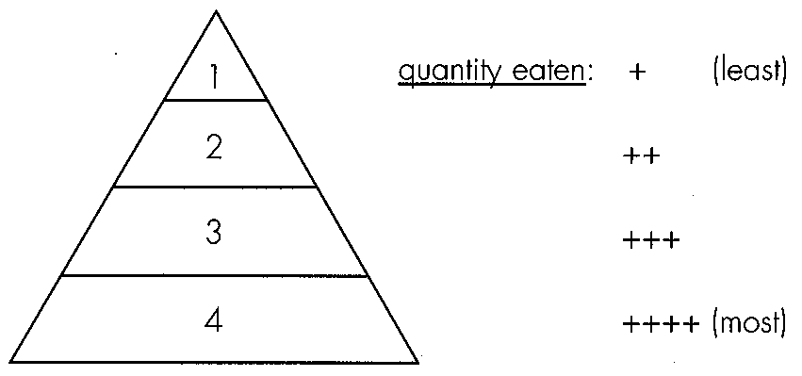
A. less glucose.B. more fatty acid. C. more urea. D. less mineral salts. Directions: Questions 58 and 59 refer to the following food pyramid which explains how balanced diet can be achieved.
51. The main food substances present in the food represented by 2 and 4 are respectively
 | Food substances in 2 | Food substances in 4
A. | proteins | carbohydrates
B. | lipids | carbohydrates
C. | proteins | mineral salts
D. | vitamins | carbohydrates

52. Examples of food represented by 1 and 3 are respectively
Directions: Questions 60 and 61 refer to the pie charts below which show the relative amounts of three categories of food in four diets.
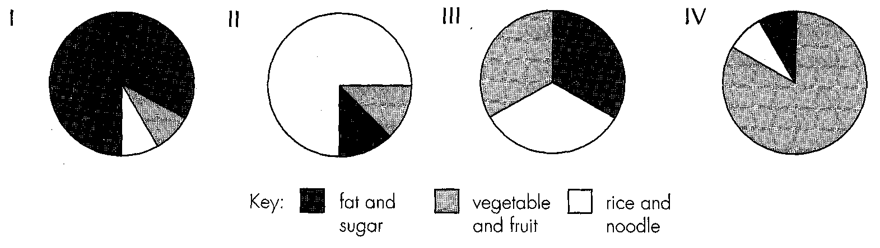
 | Examples of food for 1 | Examples of food for 3
A. | butter | milk
B. | candies | banana
C. | beef | rice
D. | bread | spinach

53. Which diet may result in overweight?
A. I
B. II
C. III
D. IV
54. Which diet is closer to a balanced diet? A.I B. II C. III D. IV
A. I
B. II
C. III
D. IV
55. Which of the following factors may affect dietary requirements? (1) Age (2) Activity (3) Pregnancy (4) Sex D.(1), (2), (3) and (4)
A. (1), (2) and (3) only
B. (1), (2) and (4) only
C. (2), (3) and (4) only
D. (1), (2), (3) and (4)

Answers
Answers are printed in red.
1. D. (1), (2) and (3)
Class: 78.2% correct (n=211) usual slip B
2. B. (1) and (2) only
Class: 61.1% correct (n=211) usual slip B
3. D. (1), (2) and (3)
Class: 47.4% correct (n=211) usual slip D
4. D
Class: 62.6% correct (n=211) usual slip C
5. A. make visual purple.
Class: 79.6% correct (n=211) usual slip A
6. A. calcium chloride.
Class: 73.8% correct (n=210) usual slip B
7. B. deaminated in the liver.
Class: 84.8% correct (n=211) usual slip A
8. A. They use sea water for tooth brushing.-B. They lose balance during tooth brushing.-
Class: 78.7% correct (n=211) usual slip B
9. A
Class: 92.5% correct (n=107) usual slip A
10. D. nightblindness.-
Class: 51.4% correct (n=107) usual slip D
11. C
Class: 77.6% correct (n=107) usual slip B
12. D. constipation.
Class: 78.5% correct (n=107) usual slip B
13. C. pods and beans.
Class: 59.8% correct (n=107) usual slip D
14. D. stored up in the liver. 17. Goitre is the deficiency disease of
Class: 87.9% correct (n=107) usual slip C
15. D
Class: 69.5% correct (n=59) usual slip C
16. B. (2) only
Class: 81.4% correct (n=59) usual slip C
17. D
Class: 78.0% correct (n=59) usual slip B
18. A. Rickets B. Scurvy C. Night blindness-D. Beri -beri
Class: 71.2% correct (n=59) usual slip D
19. C
Class: 55.9% correct (n=59) usual slip D
20. C. (3) only
Class: 76.3% correct (n=59) usual slip C
21. B
Class: 39.0% correct (n=59) usual slip B
22. C
Class: 96.6% correct (n=59) usual slip D
23. C
Class: 96.6% correct (n=59) usual slip D
24. D
Class: 93.2% correct (n=59) usual slip B
25. B. II
Class: 96.6% correct (n=59) usual slip D
26. C. III.
Class: 100.0% correct (n=59) usual slip A
27. D. (1), (2) and (3)
Class: 94.9% correct (n=59) usual slip D
28. B. (2) only

29. ?

30. B. butter.

31. A. (1) and (2) only

32. A. the cell wall of plant cells.

33. ?

34. D. grapefruit, lemon, orange

35. D. (1), (2) and (3)

36. B. low temperature.

37. C

38. C. 0.075%.

39. ?

40. D

41. B. bread.

42. A. ascorbic acid only. B. vitamin C and protein only.

43. B

44. B. pregnant.

45. D

46. ?

47. D. The water must not be boiling.

48. B

49. C. I, II and IV only

50. C

51. A

52. B

53. A. I

54. B. II

55. D. (1), (2), (3) and (4)

