Gas exchange in humans
Multiple-choice practice
Name: ________________________ Class: ____________
There are 112 questions compiled from Longman HKCEE and/or YKTo papers. Choose the one best answer.
Part A — HKCEE level (Longman)
1. Directions: Questions 1 to 3 refer to the human breathing system below.
Food is prevented from entering structure 1 because
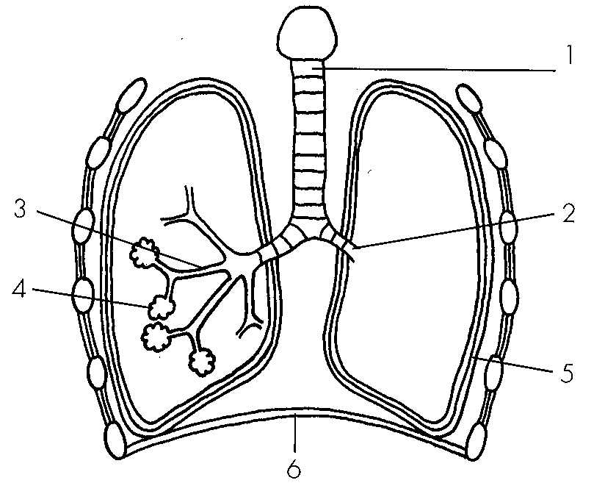
A. structure 1 will constrict during swallowing.
B. oesophagus will dilate during swallowing.
C. glottis will constrict during swallowing.
D. larynx will be raised during swallowing.
2. Which of the numbered structures will recoil due to its elasticity during expiration?
A. 3
B. 4
C. 5
D. 6
3. Which of the following organs are protected by rib cage? (1) Lungs (2) Liver (3) Heart (4) stomach D.(3) and (4) only
A. (1) and (3) only
B. (2) and (3) only
C. (2) and (4) only
D. (3) and (4) only
4. Which of the following shows the possible route for deposition of asbestos in the lungs? A.larynx > pharynx → trachea → bronchus → bronchiole → alveolus- B.pharynx > larynx → trachea → bronchus → bronchiole → alveolus- C.pharynx > larynx → trachea → bronchiole → bronchus → alveolus- D.larynx → pharynx > trachea → bronchiole → bronchus → alveolus-
A. larynx > pharynx → trachea → bronchus → bronchiole → alveolus-
B. pharynx > larynx → trachea → bronchus → bronchiole → alveolus-
C. pharynx > larynx → trachea → bronchiole → bronchus → alveolus-
D. larynx → pharynx > trachea → bronchiole → bronchus → alveolus-
5. Which of the following state the roles of mucus secreting cells in the human breathing system? (1)To secrete mucus which moistens the inspired air. (2)To secrete mucus which warms up the inspired air. (3)To secrete mucus which traps dust and dirt. A.(1) and (2) only
A. (1) and (2) only
B. (1) and (3) only
C. (2) and (3) only
D. (1), (2) and (3)
6. Which of the following describe(s) the role(s) of cilia in the human breathing system? (1)To draw air into the lungs by beating down. (2)To get rid of sputum/phlegm by beating up. (3)To trap dust and dirt from the inspired air.
A. (1) only
B. (2) only
C. (3) only
D. (1), (2) and (3)
7. In the respiratory tract, bacteria in the inhaled air may be
A. trapped by cilia.
B. killed by antibodies.
C. engulfed by phagocytes.
D. trapped by mucus.
8. Breathing through the mouth (due to running nose) during cold or influenza is disadvantageous because
(1)the air reaching the lungs will be colder.
(2)the air reaching the lungs will be drier.
(3)the air reaching the lungs will contain more bacteria.
A.(1) only B. (3) only C. (1) and (2) only D. (2) and (3) only
Directions: Questions 10 and 11 refer to the diagram below which shows the transverse section of the human thorax.
10. Structures 1, 2 and 3 are
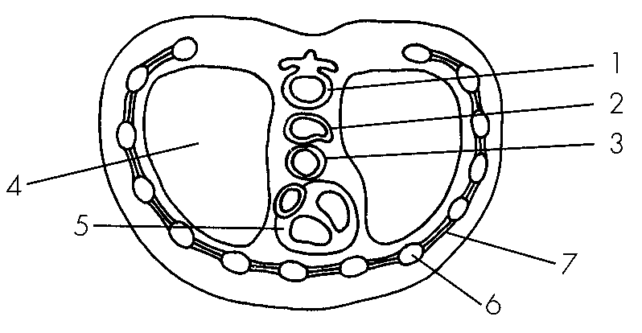
9. | 2 | 3 |
A. | backbone | oesophagus | trachea |
B. | backbone | trachea | oesophagus |
C. | trachea | backbone | oesophagus |
D. | trachea | oesophagus | backbone
10. Which of the following structures will increase in size during inhalation?
A. 4
B. 5
C. 6
D. 7
11. Which of the following is the likely composition of oxygen and carbon dioxide in the expired air?
Directions: Questions 13 and 14 refer to the experiment below which compares the carbon dioxide content in the inhaled and exhaled air.
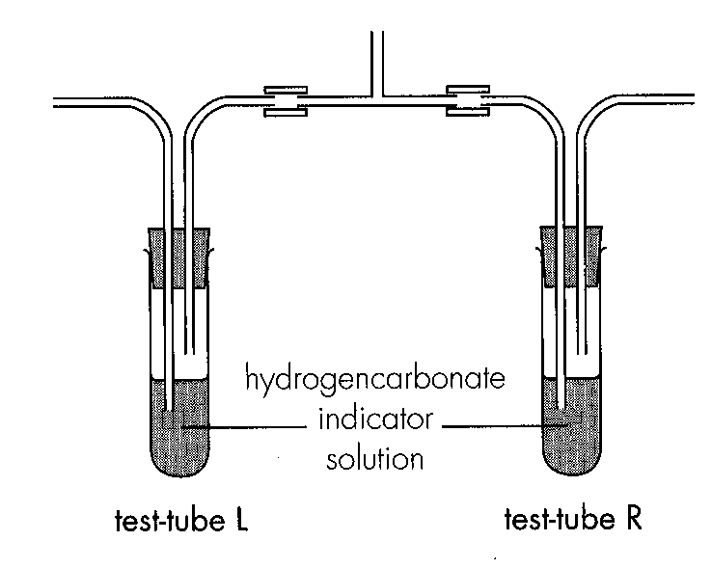
 | oxygen | carbon dioxide
A. | 19.74% | 0.06%
B. | 16.23% | 0.82%
C. | 21.38% | 4.05%
D. | 17.01% | 3.32%

12. Which of the following correctly describes the colour of indicator solution before and after the experiment?
 | Before theexperiment | After theexperiment
 | Test-tubes Land R | Test-tube L | Test-tube R
A. | purple | purple | yellow
B. | purple | yellow | purple
C. | red | yellow | red
D. | red | red | yellow

13. The compositions of inspired and expired air are compared as follows.
Which of the following conclusions can be drawn from the above comparison?
(1)Nitrogen is disposed of during exhalation.
(2)Oxygen is taken up by the body during breathing.
(3)Carbon dioxide is disposed of during breathing.
(4)Water vapour is lost during breathing.
A.(2) and (3) only B. (1), (2) and (3) only
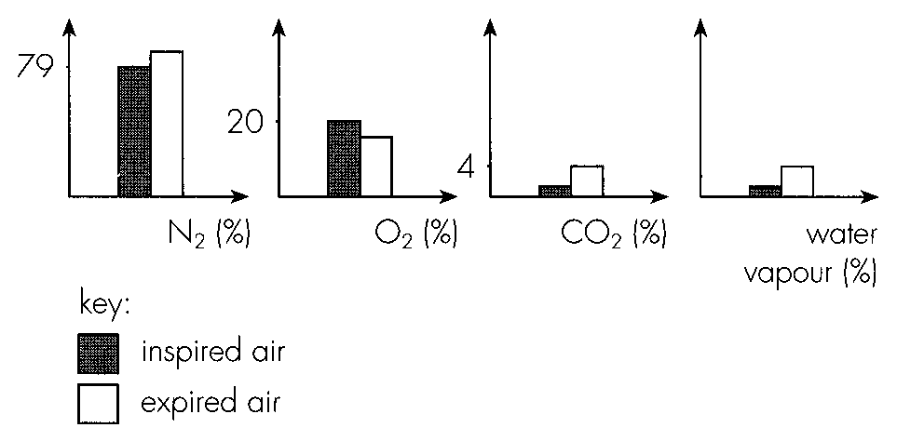
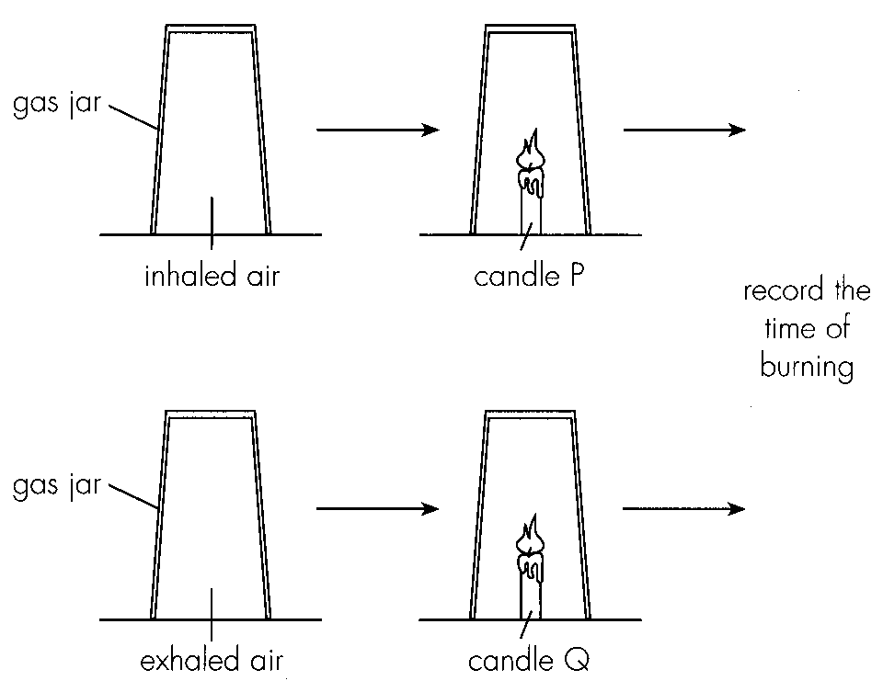
C. (2), (3) and (4) only D. (1), (2), (3) and (4) Directions: Questions 16 to 18 refer to the experiment below which compares the content of inhaled and exhaled air by noting the time of burning of a candle inside a gas jar.
14. Which component of the inhaled and exhaled air is being compared in this experiment?
A. Oxygen B. Carbon dioxide C. Water vapour D. Nitrogen
15. The expected time of burning will be:
 | Time of burning of candle P | Time of burning of candle Q
A. | 10 s | 10s
B. | 10 s | 8s
C. | 10 s | 12s
D. | 8 s | 10s

16. Which of the following is the best way to collect exhaled air from a person?
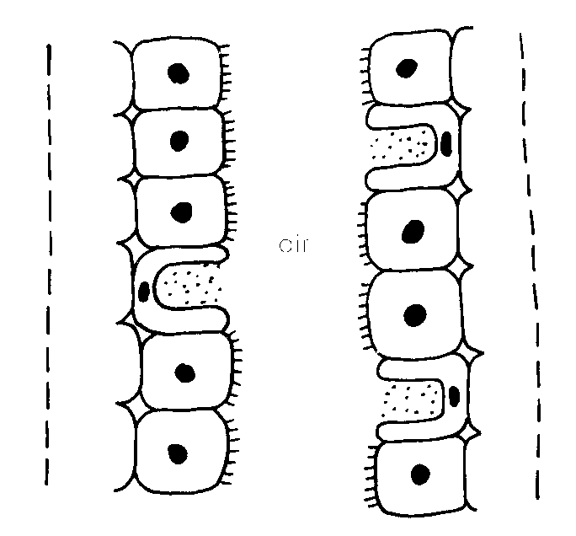
A. By downward displacement of air B. By upward displacement of air
C. By collecting over water D. By blowing air into the gas jar directly Directions: Questions 19 and 20 refer to the drawing below which shows the inner surface at certain part of the breathing system.
17. The part of breathing system shown is most probably
A. trachea.
B. alveolus.
C. pleural membrane.
D. bronchiole.
18. The function(s) of this inner surface include(s):
(1)Warming the inspired air
(2) Moistening the inspired air
(3) Digesting dust particles in the inspired air
(4) Disposal of dust particles from the inspired air
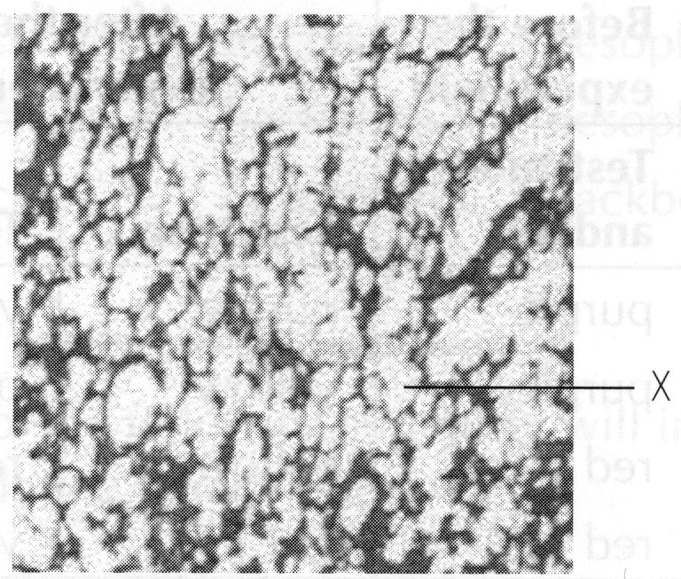
A. (1) and (2) only B. (1), (2) and (3) only
C. (1), (2) and (4) only D. (1), (2), (3) and (4) Directions: Questions 21 to 23 refer to the photomicrograph below which shows the section of an internal organ.
19. The photomicrograph shows the section of A.testis. D. lung. 22. Structure X is numerous so that A.more air is present in the lungs for the supply of oxygen. B.the distance for the diffusion of gases is shorter. C.the surface area for the diffusion of gases is larger. D.more air is present in the lungs for the removal of carbon dioxide. 23. Structure X in heavy cigarette smoker will (1)become less numerous. (2) become smaller. (3)become thicker. (4) lined with more mucus. A. (1) and (4) only B. (2) and (3) only C. (1), (2) and (4) only D. (1), (3) and (4) only
A. testis.
B. kidney.
C. heart.
D. lung. 22. Structure X is numerous so that
20. Which of the following features can facilitate the functions of alveoli? (1) Vascularized (2) Inner wall lined with mucus (3) Wall of one cell thick-
A. (1) and (2) only
B. (1) and (3) only
C. (2) and (3) only
D. (1), (2) and (3)
21. Which of the following graphs best represents the changes in lung pressure when the diaphragm is flattening?
Directions: Questions 26 and 27 refer to the rib cage model at two different states.
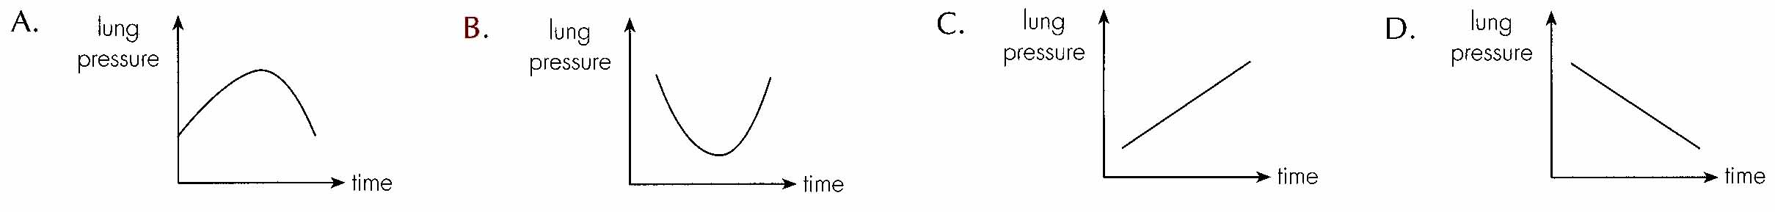
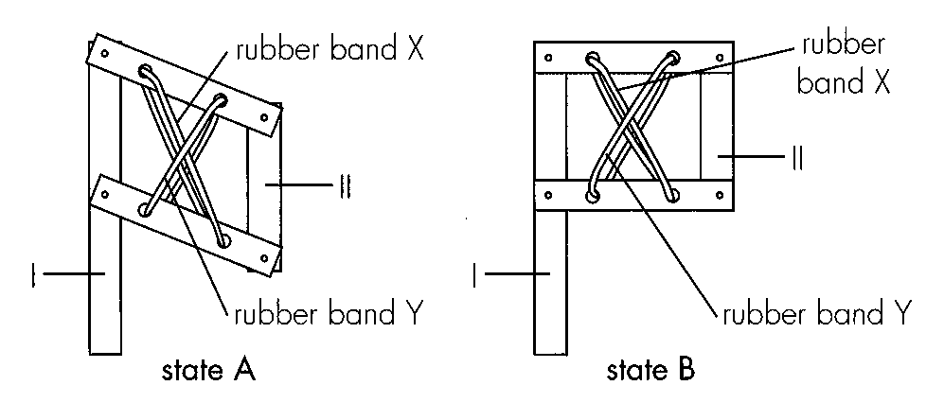
22. What do I, II and X represent respectively?
 | I | II | X
A. | sternum | backbone | internal intercostal muscle
B. | backbone | sternum | internal intercostal muscle
C. | sternum | backbone | external intercostal muscle
D. | backbone | sternum | external intercostal muscle

23. When the rib cage model changes from state B to state A, what are the corresponding changes in the human breathing system?
Directions: Questions 28 to 30 refer to the model below which demonstrates the action of diaphragm during breathing.
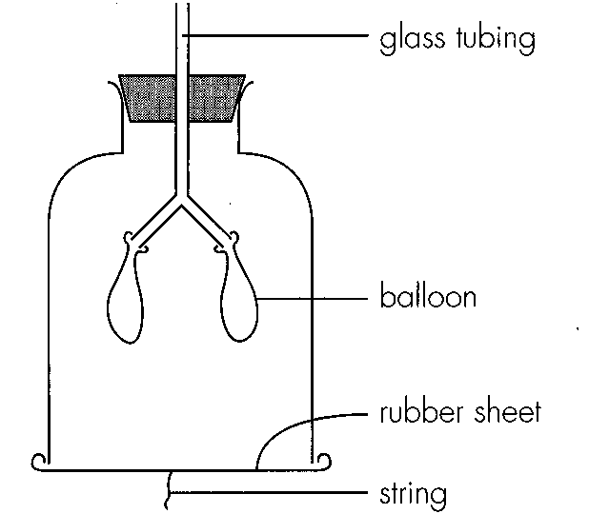
 | diaphragm | rib cage | lungs
A. | domeshaped - | downward | deflated
B. | flattened | inward | deflated
C. | domeshaped - | downward | inflated
D. | flattened | inward | inflated

24. Which part of the model represents the diaphragm in the breathing system?
A. Glass tubing B. Balloon C. Rubber sheetD. String
25. Which of the following describes and explains the change in the model when the string is pulled down?
 | Change | Explanation
A. | balloon will be deflated | sudden increase in volume inside the bell jar
B. | balloon will be deflated | sudden decrease in volume inside the bell jar
C. | balloon will be inflated | sudden increase in pressure inside the bell jar
D. | balloon will be inflated | sudden decrease in pressure inside the bell jar

26. This model cannot truly represent the action of diaphragm because (1) diaphragm is dome shaped but the model is not.- (2) diaphragm can recoil by itself but the model cannot. (3) diaphragm can contract by itself but the model cannot. A. (1) and (2) only
A. (1) and (2) only
B. (1) and (3) only
C. (2) and (3) only
D. (1), (2) and (3)
27. Which of the following is true about the states of intercostal muscles and diaphragm during inspiration?
 | Intercostal muscles | Diaphragm
A. | contracting | domeshaped-
B. | contracting | flattened
C. | relaxing | domeshaped-
D. | relaxing | flattened

28. Which of the following statements concerning diaphragm is/are correct? (1)Only mammals possess diaphragm. (2)Diaphragm separates the lungs from liver. (3) Diaphragm stops its activity while sleeping. A.(1) and (2) only C.(2) and (3) only
A. (1) and (2) only
B. (1) and (3) only
C. (2) and (3) only
D. (1), (2) and (3)
29. Which of the following would happen if the pleura of the lung was punctured? (1) Air would leak into the pleural cavity. (2) The lungs would collapse. (3) The rib cage would not be pulled upwards and outwards.
A. (1) and (2) only
B. (2) and (3) only
C. (3) and (4) only
D. (1), (2) and (3)
30. Which of the following muscle(s) dominate(s) when a person is inhaling during sleeping? (1) Internal intercostal muscle (2) External intercostal muscle (3) Diaphragm
A. (2) only
B. (3) only
C. (1) and (2) only
D. (2) and (3) only
31. Vital capacity is defined as
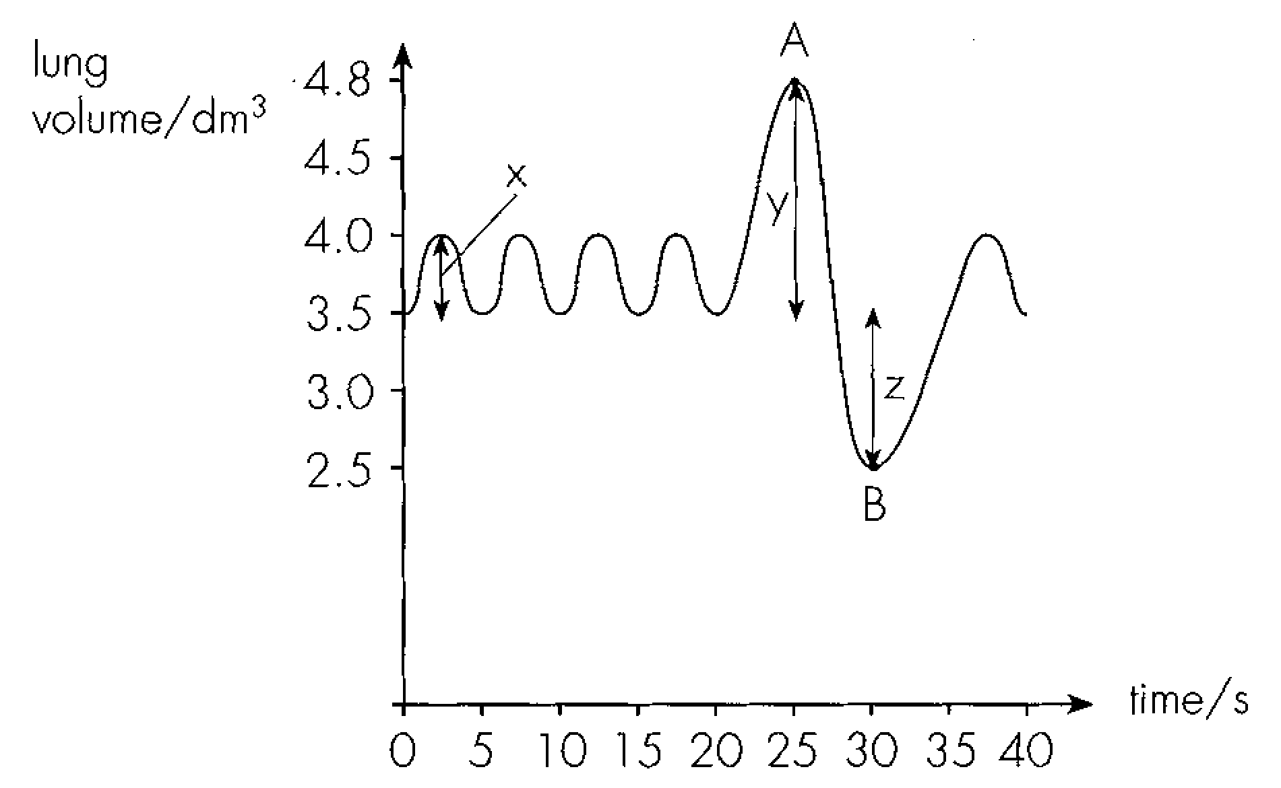
A. the volume of air breathed out after breathing in as much air as possible. B.the volume of air breathed in after breathing out as much air as possible. C.the maximum volume of air breathed out after breathing in as much air as possible.
D. the maximum volume of air breathed in after breathing out as much air as possible. Directions: Questions 36 to 38 refer to the graph below which records the changes in lung volume of a person at rest and during the measurement of vital capacity.
32. The tidal volume and breathing rate at rest are
A. 0.5 dm 3 and 12 times per minute
B. 3.5 dm 3 and 12 times per minute
C. 4.4 dm 3 and 12 times per minute
D. 0.5 dm 3 and 15 times per minute
33. Vital capacity can be calculated by
A. X+Z
B. Y+Z
C. Y X+Z-
D. X+Y+Z
34. What are the states of the rib cage at points A and B respectively?
 | A | B
A. | upward and outward | downward and inward
B. | upward and inward | downward and outward
C. | downward and outward | upward and inward
D. | downward and inward | upward and outward

35. The following spirogram was obtained by measuring the changes in lung volume during two periods of time, P and Q.
Which of the following match with the breathing patterns during periods P and Q?
(1)The person is attending Biology lesson during period P and PE lesson during period Q.
(2)More lactic acid is detected in the urine during period Q.
(3) Rates of oxygen consumption and carbon dioxide production are higher during period Q. A. (1) and (2) only B. (1) and (3) only C. (2) and (3) only D, (1), (2) and (3)
Directions: Questions 40 to 42 refer to the graph below which shows the changes in lung pressure during one complete breathing cycle of a person.
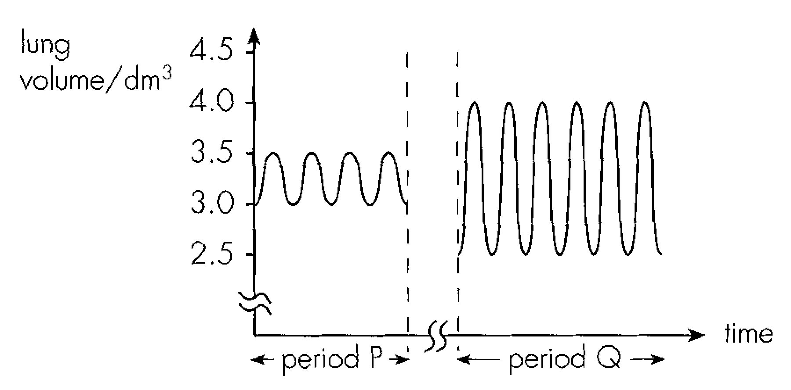
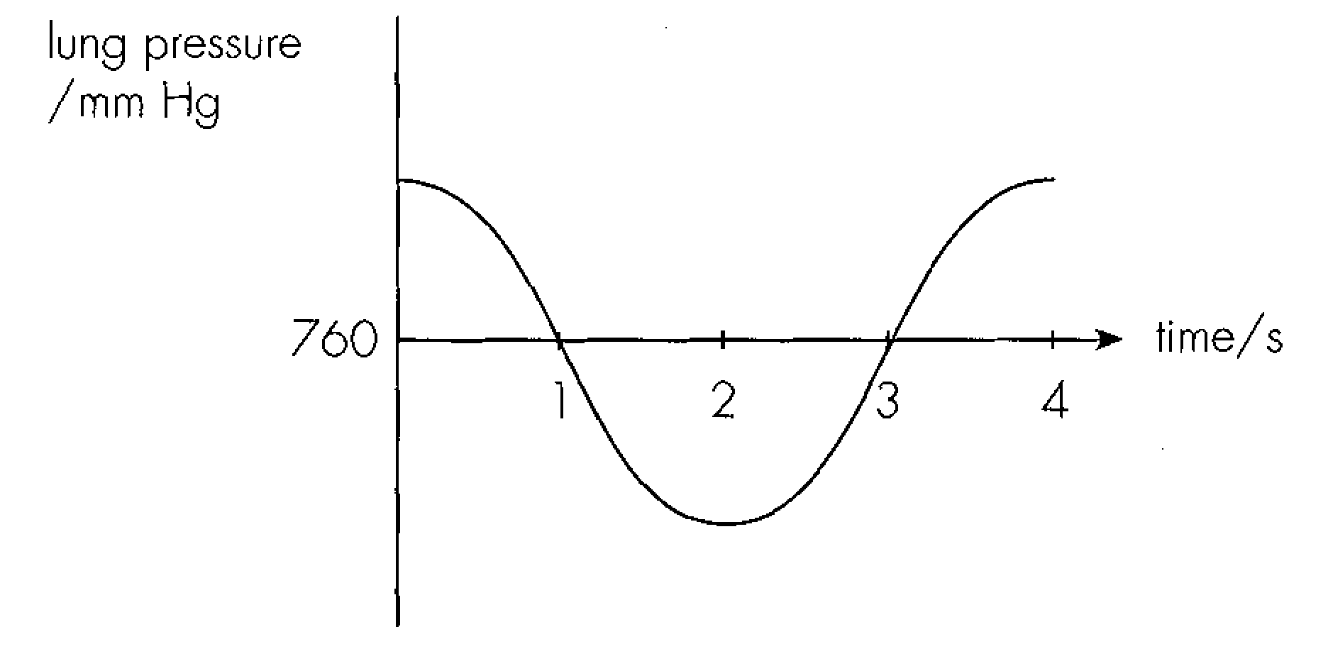
36. During which period of time is the person inhaling?
A. 0-2 s
B. 1 3 s-
C. 2 4 s-
D. 0 1 and 3-4 s-
37. The evidence for inhalation during the period of time in Question 40 was that B.the lung pressure was decreasing.
A. the lung pressure was decreasing first and then increasing.
B. the lung pressure was decreasing.
C. the lung pressure was lower than atmospheric pressure.
D. the lung pressure was increasing.
38. The lung pressure is decreasing during the period 01 s because-
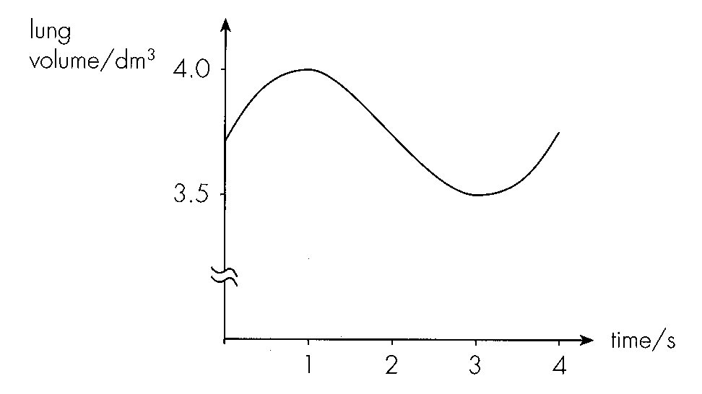
A. the rib cage is moving downward and inward. B.the diaphragm is returning to dome shaped.-
C. the person is exhaling.
D. the air in the lungs is flowing out. Directions: Questions 43 to 45 refer to the graph below which shows the changes in lung volume during one breathing cycle of a person.
39. The tidal volume of this person is
A. 0.25 dm3.
B. 0.5 dm3.
C. 3.5 dm 3.
D. 4.0 dm 3.
40. During which period of time is air flowing out of the person's lungs?
A. 02 s-
B. 2 4 s -
C. 13 s-
D. 0 1 and 3-4 s-
41. The breathing rate of this person is
A. 4 seconds per breath.
B. 1 minute per 15 breaths.
C. 14 breaths per minute.
D. 15 breaths per minute.
42. Breathing rate increases during vigorous exercise because A.blood oxygen concentration increases. B.blood oxygen concentration decreases.
A. blood oxygen concentration increases.
B. blood oxygen concentration decreases.
C. blood carbon dioxide concentration increases.
D. blood carbon dioxide concentration decreases.
43. Which of the following can be increased after prolonged physical training? (1) Tidal volume(2) Volume of blood pumped by heart once (3) Pulse rate (4) Vital capacity A. (1) and (4)
A. (1) and (4)
B. (2) and (3)
C. (2) and (4)
D. (2), (3) and (4)
44. Which of the following will happen while a person is sprinting as rapidly as possible?
 | Tidal volume | Breathing rate | Vital capacity
A. | increasing | increasing | decreasing
B. | same | increasing | increasing
C. | increasing | same | increasing
D. | increasing | increasing | same

45. When a person is breathing in and out with a plastic bag via the mouth (with the nose clipped) continuously for 5 minutes, which of the following graphs best describes the likely changes in breathing rate?
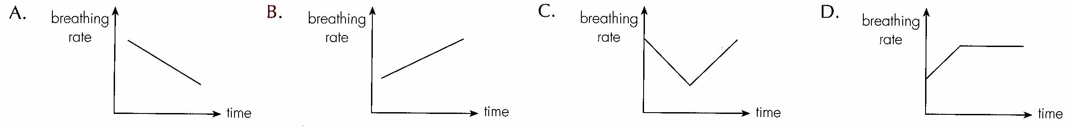
46. After vigorous exercise, oxygen debt can be repaid by
Smoking history | Number of deathsdue to lung cancer
Non-smokers | 16
Smoking for 1 to 5 years | 35
Smoking for 6 to 10 years | 129
Smoking for more than 15 years | 187

A. excreting lactic acid via urination.
B. inhaling extra oxygen.
C. breaking down lactic acid in the liver.
D. consuming glucose. Directions: Questions 52 and 53 refer to a survey of the relationship between smoking and lung cancer. The number of deaths due to lung cancer among women aged over 60 years was analysed and the results were tabulated below.
47. If you were the researcher, what other studies would you carry out in order to make the survey more meaningful?
(1)Similar study on men aged over 60 years.
(2)Similar study on women aged below 60 years.
(3)Similar study on women aged over 60 years who died of heart disease.
A.(1) only B. (1) and (2) onlyC. (1) and (3) only D. (1), (2) and (3)
Directions: Questions 54 to 56 refer to the experiment on the next page which compares the relative amounts of 2 chemical substances present in the smoke from cigarette with filter and without filter.
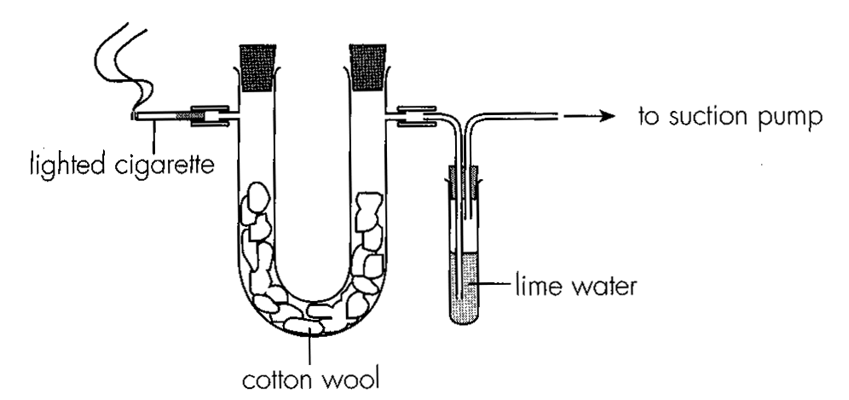
48. Which of the following is correct?
 | Substance tested by cotton wool | Substance tested by lime water
A. | nicotine | carbon monoxide
B. | nicotine | carbon dioxide
C. | tar | carbon monoxide
D. | tar | carbon dioxide

49. The probable results for this experiment would be
Cigarette | Cigarette
without filter | with filter
cotton | lime | cotton | lime
wool | water | wool | water
A. | deeper | more | lighter | less
 | brown | milky | brown | milky
B. | lighter | milky | deeper | milky
 | brown |  | brown
C. | deeper | milky | lighter | milky
 | brown |  | brown
D. | brown | more | brown | less
 |  | milky |  | milky

50. The addictive effect of smoking is caused by
A. tar only.
B. carbon monoxide only.
C. nicotine only.
D. tar and nicotine.
51. Which of the following structures' functioning are affected by tobacco smoke? (1) Trachea (2) Alveolus (3) Intercostal muscle (4) Diaphragm
A. (1) and (2) only
B. (2) and (3) only
C. (3) and (4) only
D. (1) and (4) only
52. Which of the following changes would occur in the body of a habitual smoker?
A. the tidal volume decreases.
B. the heart rate decreases.
C. the blood oxygen content decreases.
D. the blood pressure decreases.
53. Which of the following statements support the slogan 'smoking is hazardous to health'? (1) (1) Smoking can cause lung cancer.
(2) Smoking can cause coronary heart disease.
(3) Smoking can reduce male fertility.
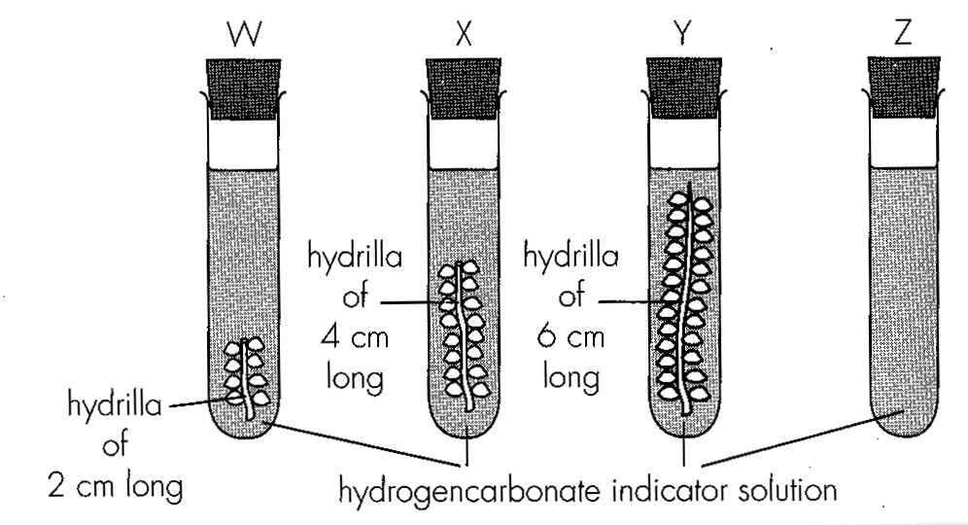
A. (1) and (2) only B. (1) and (3) only C. (2) and (3) only D. (1), (2) and (3) Directions: Questions 60 and 61 refer to the experiment below. The four tubes W to Z contain the same volume of hydrogencarbonate indicator solution.
54. If the experiment was conducted under strong and uniform light, which of the following correctly describe the colour change and the relative rate of colour change in tubes W, X and Y?
 | Colour change | Relative rate of colour change
A. | red to yellow | Y>X>W
B. | red to purple | Y>X>W
C. | red to purple | W>X>Y
D. | red to yellow | W>X>Y

55. If the hydrogencarbonate indicator solution in tube Z changed from red to yellow, which of the following is/are the probable reasons) for this?
(1)Strong light decomposes the indicator solution into carbon dioxide.
(2)Carbon dioxide in the air turns the indicator solution yellow.
(3)Test tube Z had been used to hold acid before this experiment.-
A.(1) only B. (2) only C. (3) onlyD. (1) and (2) only
Directions: Questions 62 to 64 refer to the experiment below which studies the effect of light intensity on carbon dioxide exchange in land plants.
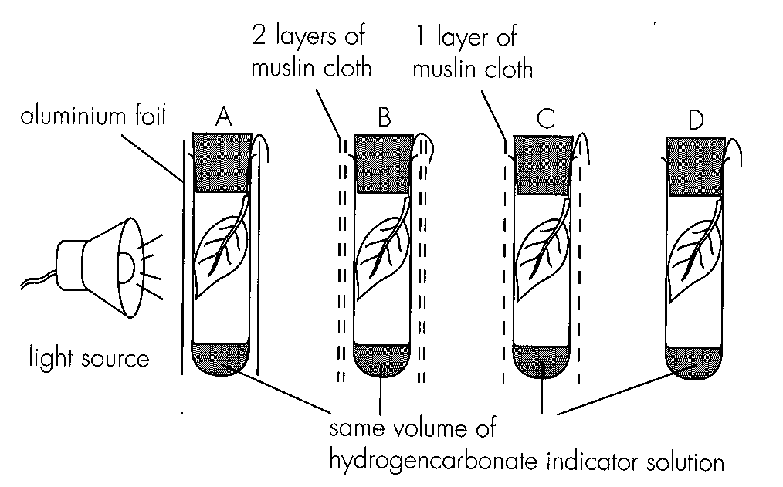
56. What would be the results in tubes A and D respectively?
 | A | D
A. | yellow | purple
B. | yellow | red
C. | red | purple
D. | purple | yellow

57. In a sunny day, the changes in pH of water in a freshwater aquarium with seaweed only are best represented by:
Directions: Questions 66 to 68 refer to the graph below which shows the effect of fight intensity on gaseous exchange of leaves.
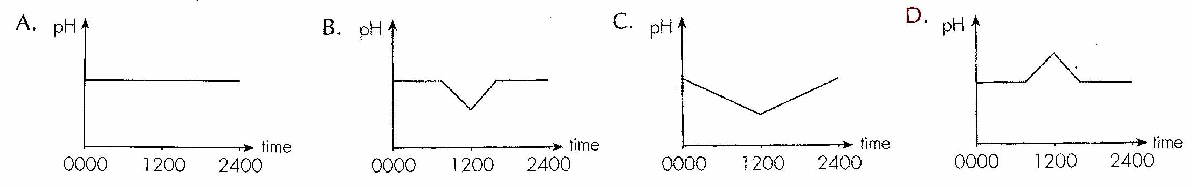
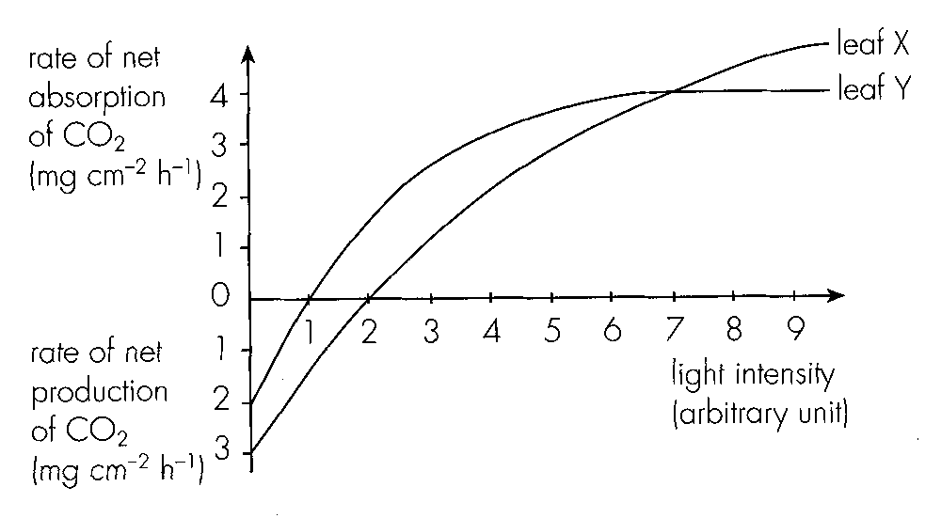
58. Which of the following statements about the graph is/are correct? (1)At zero light intensity, the rate of carbon dioxide production due to respiration was 3 mg cm 2-h1- in leaf X. (2)There was neither carbon dioxide absorption nor carbon dioxide production at alight intensity of 1 unit in leaf Y. (3)At a light intensity of 7 units, the rate of carbon dioxide absorption due to photosynthesis was 4 mg cm 2-h1- in both leaves X and Y.
A. (1) only
B. (1) and (2) only
C. (1) and (3) only
D. (2) and (3) only
59. If the area of leaf X is 16 cm 2, how much carbon dioxide is absorbed during photosynthesis by leaf X at a light intensity of 4 units for 2 hours?
A. 32 mg
B. 64 mg
C. 128 mg
D. 160 mg
60. What is the probable environment in which leaves X and Y are living respectively?
Directions: Questions 69 to 71 refer to the graph below which shows the rates of net uptake and net release of oxygen in a plant over one day.
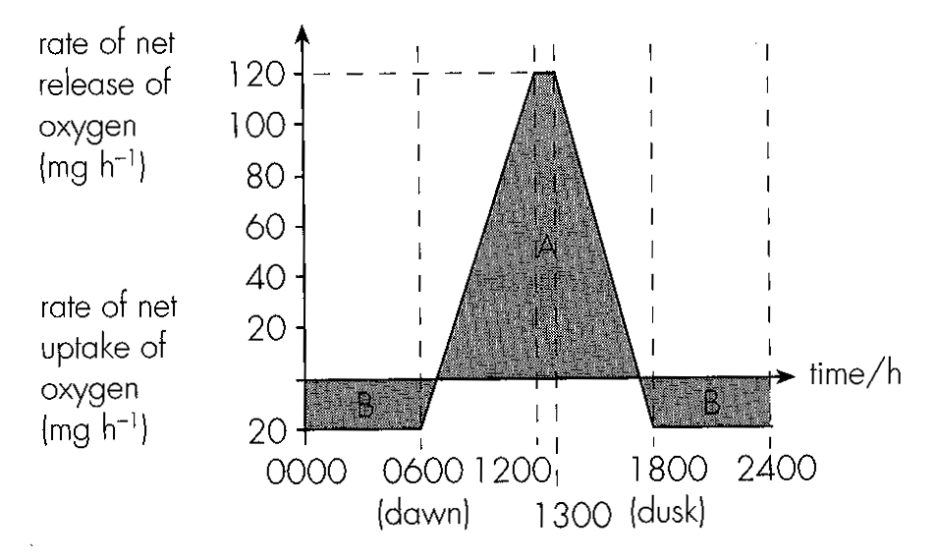
 | leaf X | leaf Y
A. | sunny | sunny
B. | sunny | shaded
C. | shaded | sunny
D. | shaded | shaded

61. Assuming that the rate of respiration remains constant throughout the day, how, much oxygen are absorbed by the plant during respiration in one day?
A. 20 mg
B. 120 mg
C. 240 mg
D. 480 mg
62. How much oxygen are released from the plant during photosynthesis between 1200 and 1300 hour?
A. 100 mg
B. 120 mg
C. 140 mg
D. 160 mg
63. When area A is larger than area B, it indicates that
A. the plant is fully mature.
B. the plant is gaining weight.
C. the plant is ageing.
D. the plant is losing weight.
Part B — HKDSE-style (YKTo)
64. Directions: Questions 1 to 8 refer to the diagram below which shows the respiratory system of humans.
Which will be the conditions of the following labelled structures during expiration?
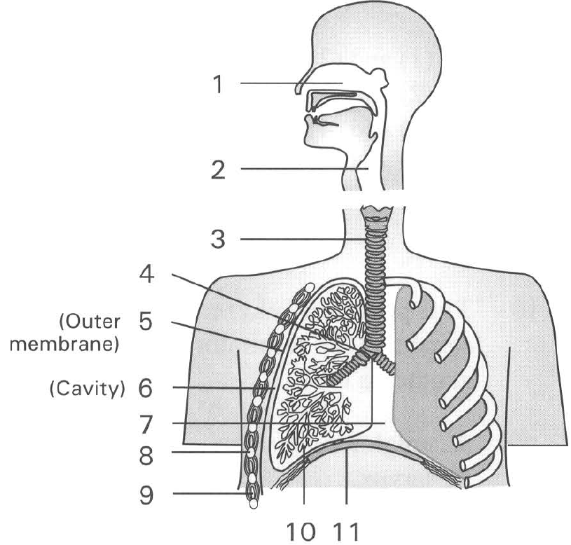
65. | 9 | 11 | A. | Moves upward and forward | Contracted | Contracted | B. | Moves downward and backward | Relaxed | Relaxed | C. | Moves upward and forward | Relaxed | Relaxed | D. | Moves downward and backward | Contracted | Contracted
66. Which of the following statements about the functioning of the respiratory system are INCORRECT? (1) Large number of hairs are guarding inside the nasal cavity to filter the inhaled air. (2) The lungs can change their size during ventilation. (3) The intercostal muscles contract during inhalation/inspiration. (4) Gas exchange only takes place between the air inside the air sacs and the gases inside the blood capillaries during inhalation/ inspiration.
A. (1) and (2) only
B. (2) and (3) only
C. (1) and (4) only
D. (2) and (4) only
67. The position where the alimentary canal and the respiratory tract meet one another is the
A. epiglottis.
B. larynx.
C. glottis.
D. pharynx.
68. Arrange the following structures in descending order according to their diameter. (1) Air sac (2) Trachea (3) Bronchiole (4) Bronchus D. (2), (3), (4) and (1) 12Which of the following structures are strengthened by cartilage.? (1) Air sac/alveolus (2) Trachea (3) Larynx (4) Bronchus B. (2) and (4) only C. (3) and (4) only D. (2), (3) and (4) only
A. (1), (2), (3) and (4)
B. (1), (3), (4) and (2)
C. (2), (4), (3) and (1)
A. (1) and (2) only
69. Which of the following is responsible to warm the inhaled air before it reaches the air sac?
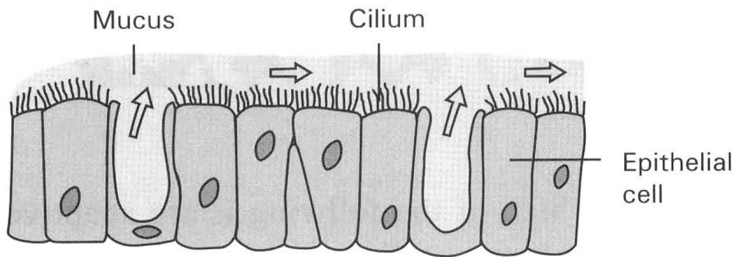
A. Hairs guarding the nostrils.
B. Mucus covering the inner surface of the nasal cavity.
C. Blood capillaries supplying the epithelium of the nasal cavity.
D. Cilia covering the inner surface of the trachea. Directions: Questions 14 to 16 refer to the diagram below which shows the structure of the inner lining of certain organs inside the human body : 14Where will this structure be found in the human body? (1) Larynx (2) Nasal cavity (3) Bronchiole (4) Air sac/alveolus (5) Nostril (6) Trachea
A. (1), (2) and (3) only B. (2), (3) and (6) only
C. (3), (4) and (5) onlyD . (3), (5) and (6) only
70. Which of the following is NOT a function of this structure?
A. Traps the dust particles and germs. B. Permits gas exchange to take place.
C. Sweeps the trapped particles and germs away. D. Moistens the inhaled air. 16What is the function of the close packing of these epithelial cells ?
A. Increases the surface area for gas exchange.
B. Provides a smooth surface to reduce the resistance to air flow.
C. Forms a physical barrier to prevent the invasion of germs into the body tissues.
D. Strengthens the respiratory tract to prevent collapse during ventilation.
71. It is advisable to breathe air through the nasal cavities rather than through the mouth cavity into the lungs. The reason is that
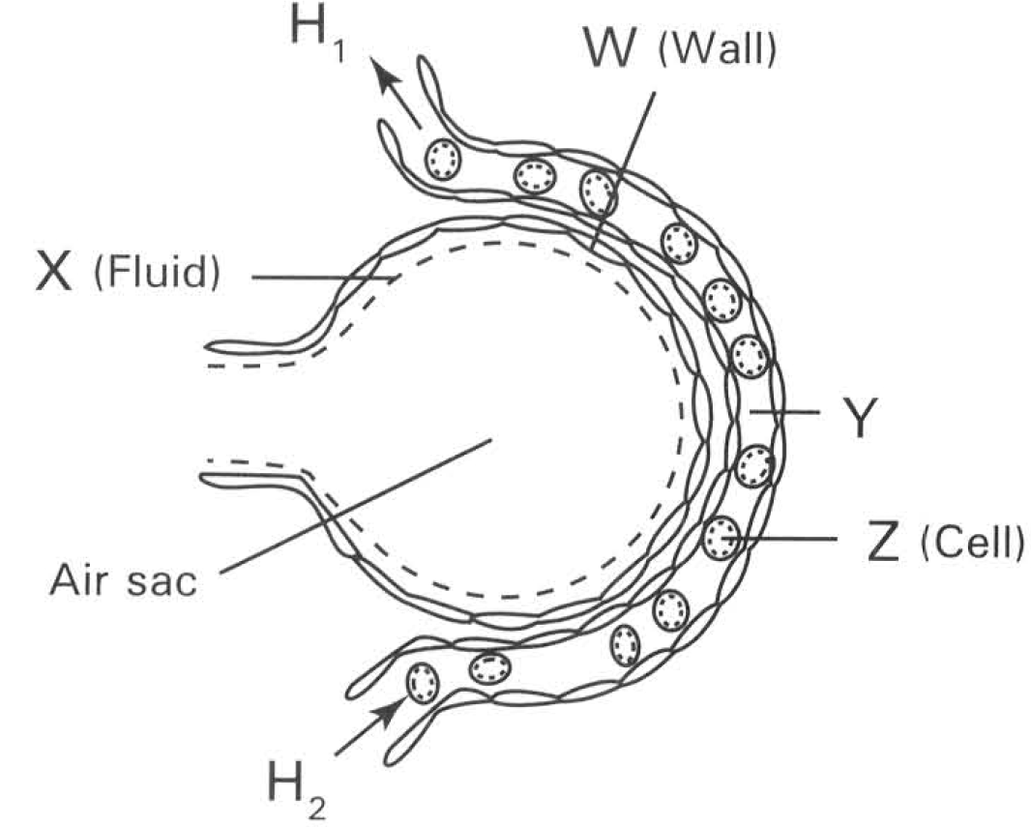
A. the nasal cavities are the proper parts of the respiratory system while the mouth cavity is part of the alimentary canal.
B. the nasal cavities only permit oxygen in while carbon dioxode is trapped by the cilia lining the inner surface of the nasal cavities.
C. the nasal cavities are present nearer to the brain so that they are better coordinated to control the amount of air required to flow into the lungs.
D. the ciliated, mucous epithelium lining the inner surface of the nasal cavities filter the inhaled air by trapping the dust particles and germs in air.
B. Air sacs, gas exchange and transport of gases Directions: Questions 18 and 19 refer to the diagram below which shows an air sac covered with a blood capillary.
72. Which heart chambers are connected by blood vessels to the ends of the capillary labelled Hl and H2?
 | H1 | H2
A. | Left atrium | Right ventricle
B. | Left ventricle | Right atrium
C. | Right atrium | Left ventricle
D. | Right ventricle | Left atrium

73. Which of the following features are essential to the effective removal of carbon dioxide from blood? (1) Structure W is in folded form. (2) Substance X is present at the inner surface of the air sac. (3) Rapid rate of blood flow along structure Y. (4) The presence of haemoglobin in cell Z.
A. (1) and (2) only
B. (2) and (3) only
C. (3) and (4) only
D. (1), (2) and (3) only
74. The air sac is densely covered with blood capillaries to
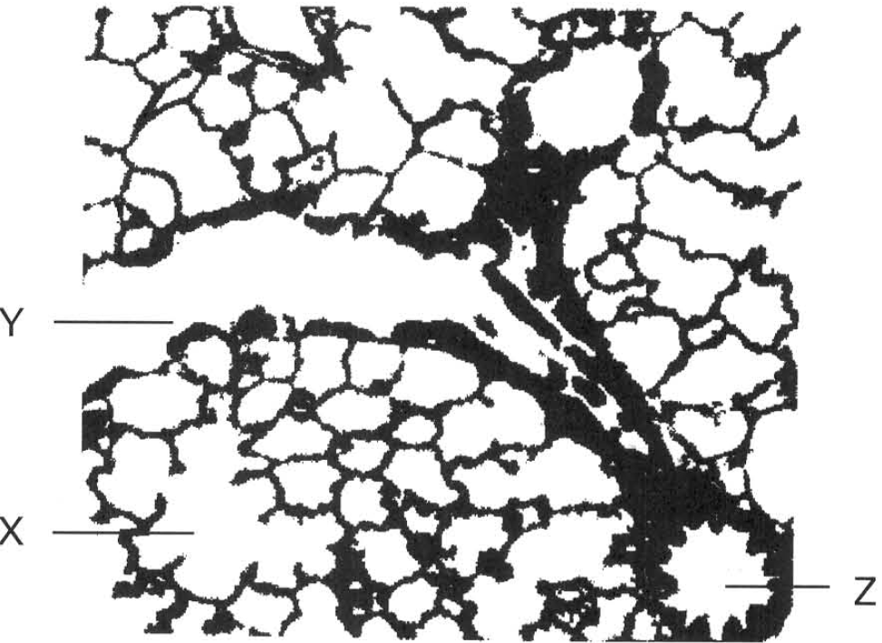
A. increase the spongy nature of the lungs for enhancing ventilation.
B. provide large respiratory surface.
C. to maintain steep concentration gradient of gases between the air sac and blood.
D. supply large amount of nutrients for supporting the vigorous metabolic activities of the cells forming the wall of the air sac. Directions: Questions 21 and 22 refer to the photomicrograph below which shows a section of the lung.
75. Which of the following is/are adaptive features of X to act as an efficient respiratory surface? (1) The wall is one cell thick. (2) The inner surface is covered with water film. (3) It has a folded appearance. (4) It is strengthened by cartilaginous rings.
A. (1) and (2) only
B. (2) and (3) only
C. (3) and (4) only
D. (1), (2) and (3) only
76. Z is a blood vessel with a thicker wall than Y. When Z is compared with Y,which of the following comparisons is CORRECT?
 | Z | Y
A. | Less oxygen | more oxygen
B. | More red blood cells | less red blood cells
C. | Less carbon dioxide | more carbon dioxide
D. | Lower water content | higher water content

77. In humans, how is oxyen carried from the lungs to the tissue cells of the legs? (1) Oxyhaemoglobin dissociates into oxygen and haemoglobin. (2) Oxygen is carried away from the lungs by the pulmonary veins. (3) Oxygen diffuses through the blood capillary wall into the lymph. (4) Oxygen diffuses through the moist alveolar linings into the blood. (5) Oxygen diffuses into the red blood cells and combines with the haemoglobin to form oxyhaemoglobin.
A. (3), (2), (5), (4) and (1)
B. (4), (5), (2), (1) and (3)
C. (2), (4), (5), (3) and (1)
D. (4), (2), (5), (1) and (3)
78. Which of the following substances/cells are involved in the transport of carbon dioxide in humans?
(1) Red blood cells (2) Pleural fluid (3) Plasma (4) Blood platelets
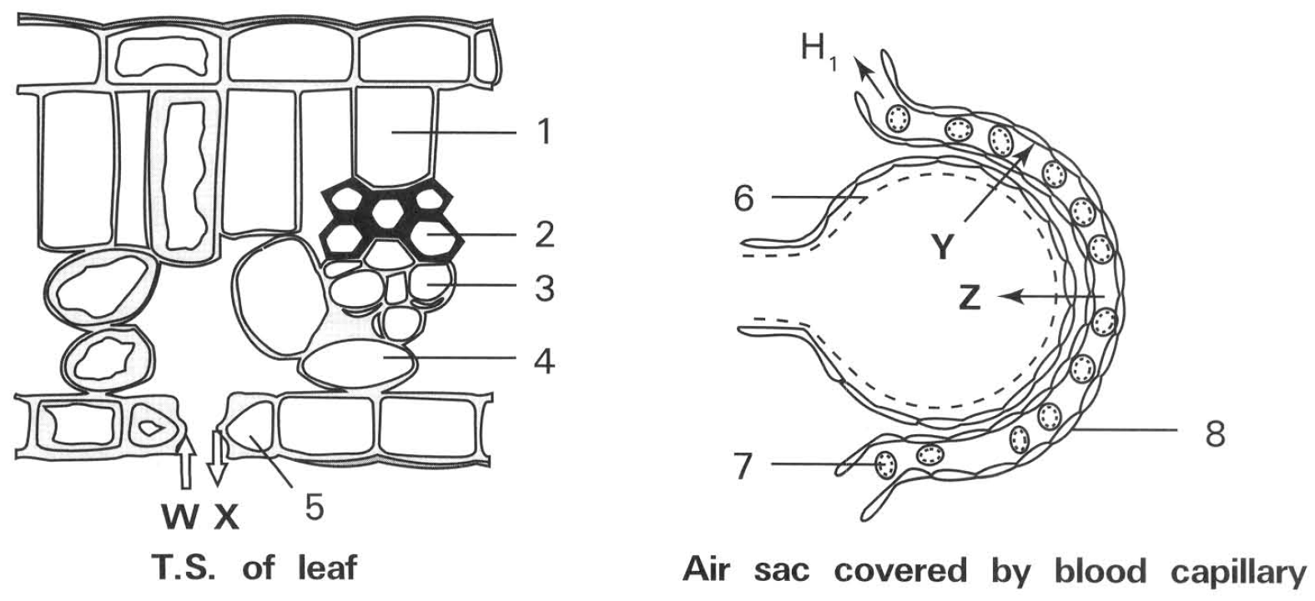
A. (1) and (2) only B. (2) and (3) only C. (3) and (4) only D. (1) and (3) only 25Carbon dioxide is mainly transported in form of
A. hydrogencarbonate ions.
B. carbon dioxide.
C. oxyhaemoglobin.
D. haemoglobin. Directions: Questions 26 to 29 refer to the following diagrams which show the T.S. of a leaf and an air sac covered with a blood capillary. The following diagrams show the tissues of leaf and the air sac.
79. Which of the following TRULY represent the direction of movement of oxygen at day time in both organs?
A. W and Y only
B. W and Z only
C. X and Y only
D. X and Z only
80. Which labelled cell is responsible for the transport of oxygen throughout the organism?
A. 2 only
B. 4 only
C. 5 only
D. 7 only
81. Which of the following statements about the movement of carbon dioxide and oxygen between the cells of the leaf and the air sac with the atmosphere is CORRECT? (1) The movement of gases into and out of the organs depends on simple diffusion. (2) The movement of gases into the leaf is aided by transpiration. (3) The movement of gases into the air sac is aided by specific muscles of the human body.
A. (1) only
B. (2) only
C. (1) and (2) only
D. (1) and (3) only
82. Which of the following differences between the structures labelled 2 and 8 is/are CORRECT?
 | Structure 2 | Structure 8
(1) | Composed of Composed of dead cells | living cells
(2) | Fluid moves under tension | Fluid moves under pressure
(3) | Has one function only | Has multiple functions

A. (1) onlyB . (2) only C. (1) and (2) onlyD . (2) and (3) only
83. Which of the following is responsible for the effective passage of oxygen into the blood capillaries covering the surface of air sacs? (1) Low concentration of oxygen in the blood capillaries covering the air sacs. (2) High concentration of carbon dioxide in the blood capillaries covering the air sacs. (3) Rapid flow of blood away from the blood capillaries covering the air sacs. (4) Presence of haemoglobin inside the red blood cells.
A. (1) and (2) only
B. (2) and (3) only
C. (3) and (4) only
D. (1), (3) and (4) only
84. Which of the following TRULY accounts for the high concentration of oxygen maintained inside the air sac?
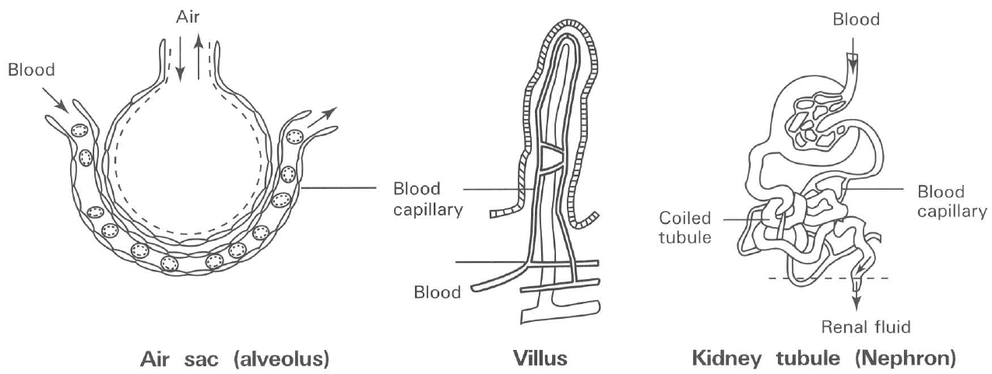
A. The haemoglobin inside the red blood cells can effectively combine with oxygen to form oxyhaemoglobin inside the blood capillaries covering the air sac.
B. Blood inside the blood capillaries covering the air sacs flows rapidly to maintain a steep concentration of oxygen between air and blood.
C. Inhalation continuously brings in fresh air to the air sacs.
D. Carbon dioxide diffuses from the blood capillaries into the air sacs. Directions: Questions 32 to 34 refer to the diagrams below which show three mammalian structures and the blood capillaries supplying them.
85. Which of the following are adaptive features that are commonly possessed by the above structures to perform the function efficiently? (1) All are folded or coiled to increase area. (2) All are covered with mucus to enhance the absorption of substances. (3) All are richly supplied with oxygenated blood. (4) All are composed of thin wall to enhance the passage of substances across them.
A. (1) and (2) only
B. (2) and (3) only
C. (1) and (4) only
D. (1), (3) and (4) only
86. The substances that pass through the wall of the above structures INTO the associated blood capillaries are
 | Air sac/alveolus | Villus | Coiled tubule of nephron
A. | Carbon dioxide | Amino acids | Glucose
B. | Oxygen | Big oil droplets | Water
C. | Carbon dioxide | Urea | Mineral salts
D. | Oxygen | Water | Amino acids

87. The processes responsible for the movement of the substances in question 11.33 are
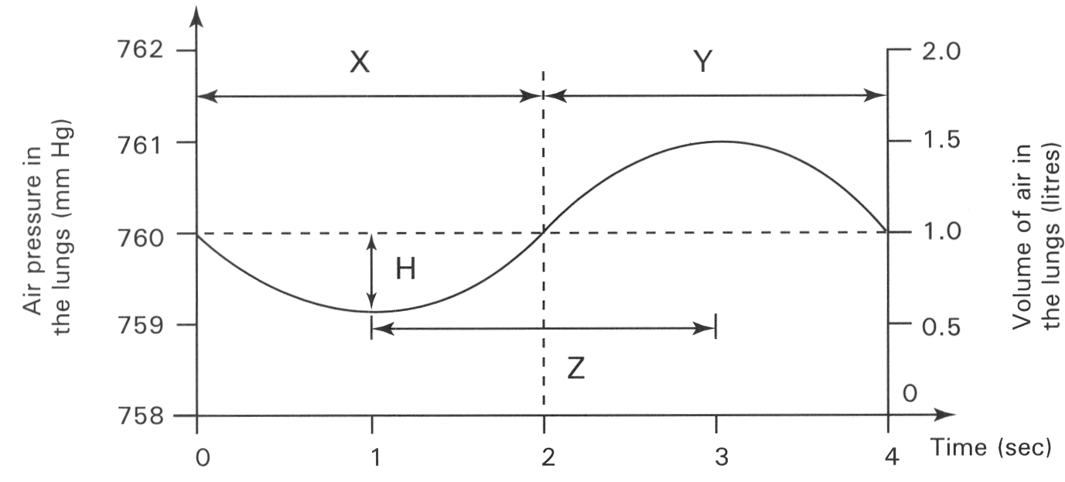
 | Air sac/alveolus | Villus | Coiled tubule of nephron
A. | Diffusion | Osmosis | Active transport
B. | Active transport | Diffusion | Osmosis
C. | Diffusion | Active transport | Diffusion
D. | Active transport | Osmosis | Diffusion

C. Ventilation Directions: Questions 35 to 38 refer to the graph below which shows the changes in the pressure and volume of the lungs of a healthy person during a complete cycle of breathing at rest. (The atmospheric pressure is 760 mm Hg.)
88. During period X which of the following combinations is CORRECT? 36During which period will gas exchange take place? D. X and Y 37Which is the rate and depth of breathing of this man? 38
 | Intercostal muscles | Position of ribs | Muscles of diaphragm | Volume of thorax | Air movement
A. | Relax | Pulled upwards and forwards | Contract | Increased | Out of the lungs
B. | Contract | Remained in position | Relax | Decreased | Out of the lungs
C. | Relax | Lowered downwards and Backwards | Relax | Decreased | Out of the lungs
D. | Contract | Pulled upwards and forwards | Contract | Increased | Into the lungs

 | Rate of breathing | Depth of breathing
A. | 4 times per minute | 1 litre per breath
B. | 8 times per minute | 2 litres per breath
C. | 15 times per minute | 1 litre per breath
D. | 16 times per minute | 1 litre per breath

 | A heavy cigarette smoker | A well-trained athlete
 | Time period X | Change in pressure H | Time period X | Change in pressure H
A. | Increase | Increase | Decrease | Decrease
B. | Increase | Decrease | Decrease | Increase
C. | Decrease | Increase | Increase | Decrease
D. | Decrease | Decrease | Increase | Increase

A. X only
B. Y only
C. Z only
D. X and Y 37Which is the rate and depth of breathing of this man? 38
89. Why is the concentration of carbon dioxide in the air exhaled out of the nasal cavity lower than that in the air sac?
A. Carbon dioxide diffuses continuously from the blood capillaries surrounding the air sac.
B. The epithelial cells forming the wall of the nasal cavity do not respire.
C. The air exhaling out of the air sac is diluted by the air present in the respiratory tract when it reaches the nasal cavity.
D. There is no gas exchange in the trachea.
90. If the outer pleural membrane of the right lung is punctured, which of the following will happen ?
A. The person would die because of the failure to breathe.
B. The right lung would collapse while the left lung would increase the rate of breathing.
C. The right lung would increase the rate of breathing.
D. Air would leak out of the right lung.
91. Which of the following has the same function as the pleural fluid?
(1) Pericardial fluid (2) Synovial fluid (3) Cerebrospinal fluid (4) Tissue fluid
A. (1) and (2) onlyB . (2) and (3) onlyC . (3) and (4) onlyD . (4) and (1) only
92. Which of the following comparisons of the gas composition between exhaled and inhaled air is INCORRECT?
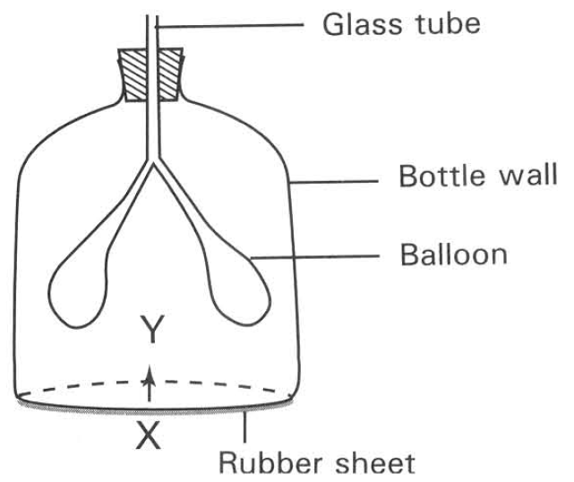
 | Inhaled air | Exhaled air
(1) Oxygen | 20% | 0%
(2) Caron dioxide | 0.03% | 4%
(3) Water vapour | Variable | Fully saturated
(4) Nitrogen | 78% | 0%

A. (1) and (2) only B. (2) and (3) only
C. (1) and (4) only D. (3) and (4) only Directions: Questions 43 and 44 refer to the diagram below which shows a model used to illustrate a biological process.
93. Which of the following structures in humans are CORRECTLY represented by the labelled parts of the model?
Glass tube | Bottle wall | Balloons | Rubber sheet
A.Trachea | Abdominal wall | Lungs | Diaphragm
B.Bronchus | Thoracic wall | Heart | Pericardium
C.Trachea | Thoracic wall | Lungs | Diaphragm
D.Bronchus | Linings of the nasal cavities | Air sac | Pleural membranes

94. Which of the following is TRUE when the rubber sheet is pushed up from position X to position Y?
Directions: Questions 45 and 46 refer to the diagram below which shows a model used to illustrate a biological process.
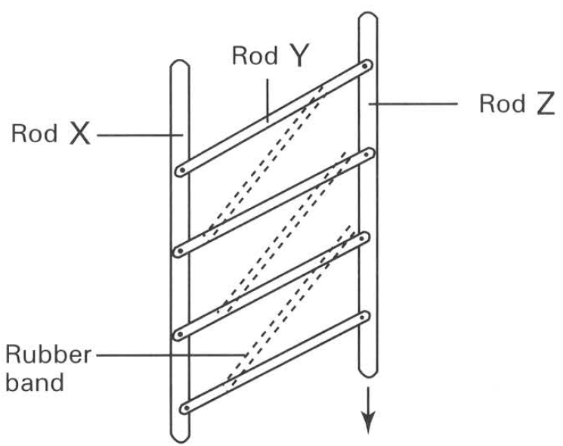
Pressure inside the bottle | Size of balloons | Pressure insideballoons | Air flow alongglass tube
A.Increased | Decreased | Increased | In
B.Decreased | Decreased | Decreased | Out
C.Decreased | Increased | Increased | Out
D.increased | Decreased | Increased | Out

95. Which of the following structures in humans are CORRECTLY represented by the labelled parts of the model?
 | Rod X | Rod Y | Rod Z | Rubber hand
A. | Sternum | Rib | Vertebral column | Tendon
B. | Vertebral column | Sternum | Rib | Ligament
C. | Sternum | Rib | Vertebral column | Intercostal muscles
D. | Vertebral column | Rib | Sternum | Intercostal muscles

96. Which of the following movements of the human body is corresponding to the movement of rod Z indicated in the diagram?
A. Movement of the vertebral column
B. Sliding movement of the pleural membranes
C. Inward movement of the chest wall
D. Movement of air into the lungs
97. Which of the following statements about the ribs is CORRECT?
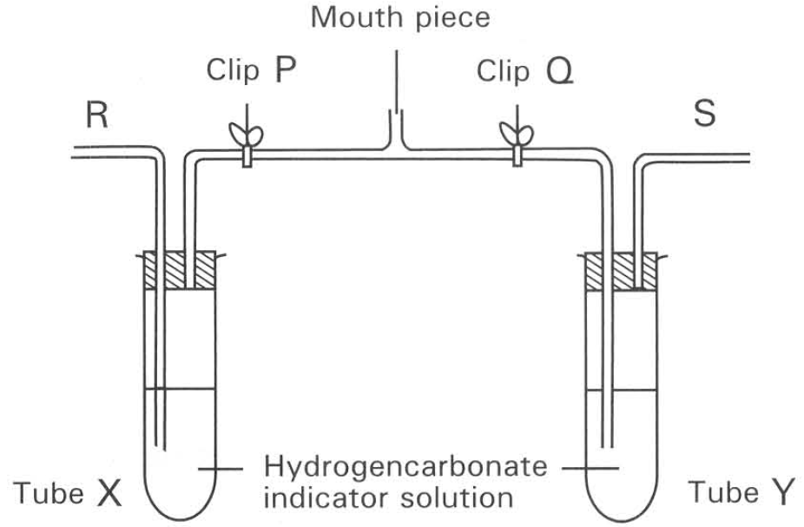
A. All the ribs are made of bones only.
B. All the ribs join the thoracic vertebrae and the sternum together.
C. The ribs in humans play an important part in the movement of the limbs.
D. The ribs chiefly serve to help inspiration and expiration of humans. Directions: Questions 48 and 49 refer to the diagram below which shows an experiment used to compare the amount of a certain gas component in the inhaled and exhaled air.
98. When a boy expires out several times through the mouth piece, which of the following combinations is CORRECT?
 | Air outlet | Clip P | Clip Q | Colour of hydrogencarbonate indicator solution in
 |  |  |  | tube X | tube Y
A. | R | Open | Closed | Yellow | Red
B. | S | Closed | Open | Yellow | Yellow
C. | R | Open | Closed | Yellow | Red
D. | S | Closed | Open | Red | Yellow

99. Which gas component is compared in this experiment?
Original volume of air sample | 10.3 ml
Volume of air sample after addition of concentrated sodium hydroxide solution | 10.l ml
Volume of air sample after further addition of alkaline pyrogallol solution | 8.0 ml

A. Oxygen B. Carbon dioxide C. Water vapour D. Nitrogen Directions: Questions 11.50 to11.52 refer to the experiment described below. A sample of expired air was introduced into a gas burette. The composition of the gas was analysed and results were shown in the table below:
100. The volume percentage of oxygen is
51The volume percentage of carbon dioxide is
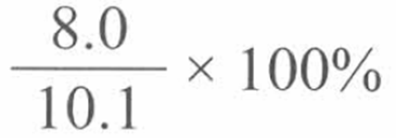
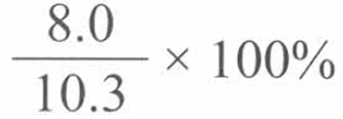
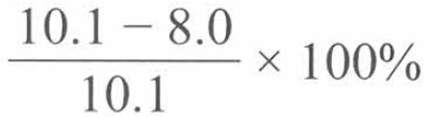
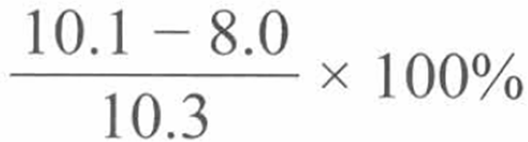
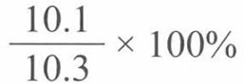
A. | B. | C. | D.

A. | B. | C. | D.

101. Which of the following is an essential precaution for the above experiment?
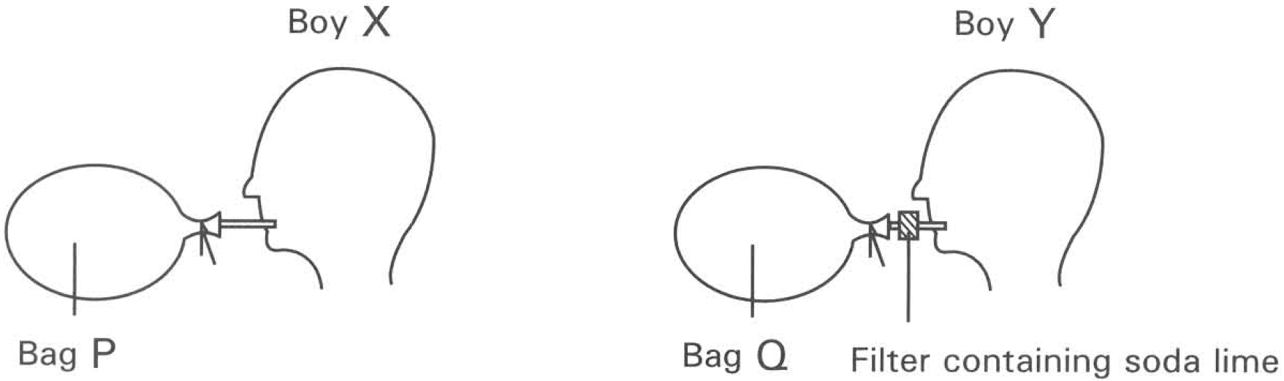
 | Bag P | Bag Q
 | Oxygen content | Carbon dioxide content | Oxygen contentCarbon dioxide content
A.B.C.D. | About 4%About 20%About 16%About 16% | About 4%About 0.03%About 4%About 0.03% | About 20%About 16%About 16%About 20% | About 0.03%About 4%ZeroZero

A. Alkaline pyrogallol solution must be added before concentrated sodium hydroxide solution is added to absorb the gas.
B. The volume of gas inside the burette should only be measured after the water levels inside and outside the burette are adjusted to the same.
C. The volume of gas inside the burette should only be measured at different temperatures.
D. The volume of each gas is measured once to reduce human errors. Directions: Questions 53 to 55 refer to the diagram below. It shows an experiment performed by two boys, X and Y. Both bags P and Q are originally filled with normal air. These boys breathe in and out for 30 seconds. 53After the experiment the composition of the air inside the bags are:
102. Immediately after the experiment, the rate and depth of breathing of these two boys will
 | Boy X | Boy Y
A. | Decrease | Increase
B. | Increase | Decrease
C. | Remain unchanged | Remain unchanged
D. | Decrease | Remain unchanged

103. The factor that stimulates these two boys to have the responses given in the previous question are
 | Boy X | Boy Y
A. | Increase in carbon dioxide concentration in blood | Decrease in carbon dioxide concentration in blood
B. | Decrease in oxygen concentration in blood | Increase in carbon dioxide concentration in blood
C. | Decrease in oxygen concentration in blood | Decrease in carbon dioxide concentration in blood
D. | Decrease in carbon dioxide concentration in blood | Increase in carbon dioxide concentration in blood

104. Respiratory centre that controls the rate of breathing in humans is located in
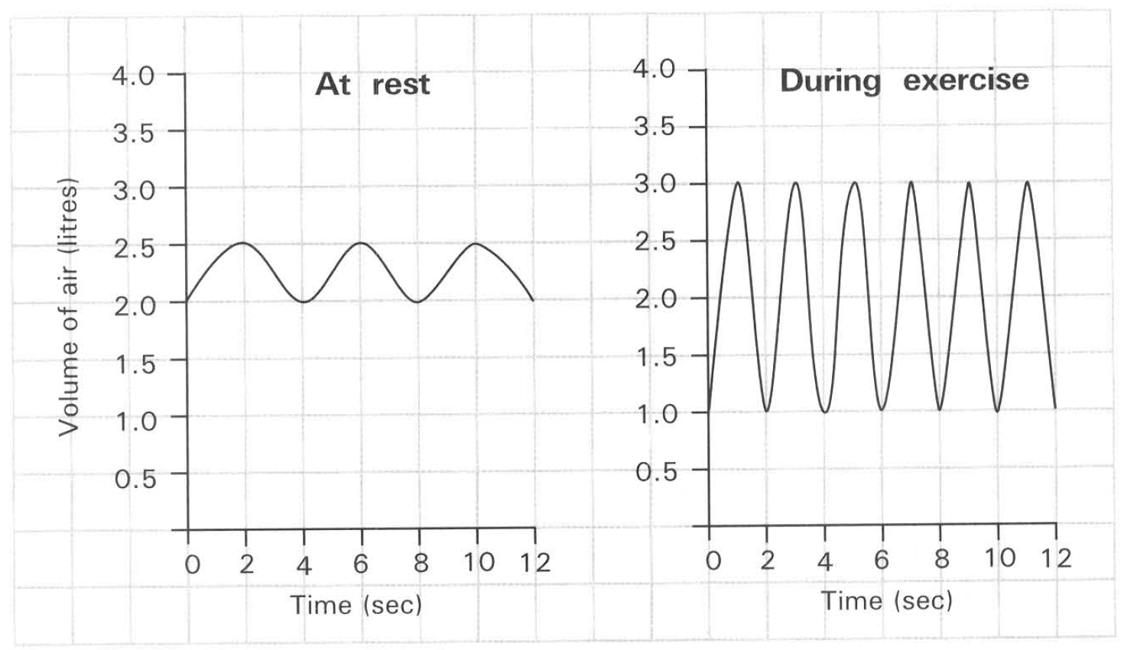
A. the lungs. B. the heart.
C. the hypothalamus of the brain. D. the medulla oblongata of the brain. Directions: Questions 57 to 59 refer to the graphs below which show the rate and depth of breathing at rest and during exercise respectively. 57The rate of breathing at rest is
A. 3 times per minute.
B. 6 times per minute.
C. 9 times per minute.
D. 15 times per minute.
105. What is the volume of air that is moved into the lungs during vigorous exercise?
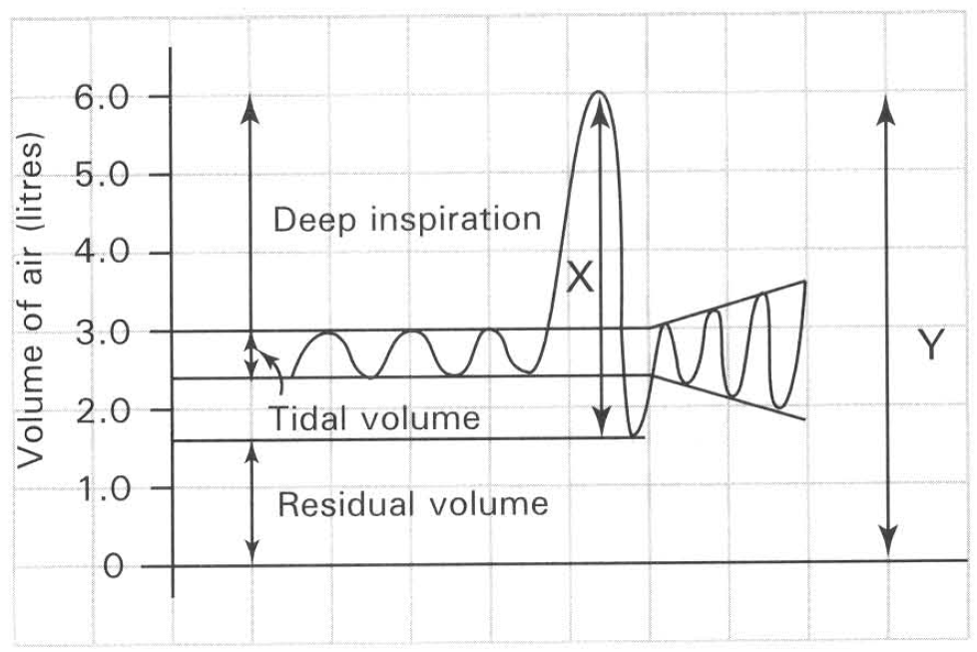
 | Rate of breathing | Depth of breathing | Tidal volume | Vital capacity
A. | Increased | Increased | Increased | Increased
B. | Increased | Remains unchanged | Increased | Remains unchanged
C. | Remains unchanged | Increased | Remains unchanged | Increased
D. | Increased | Increased | Increased | Remains unchanged

A. 2 litres per minute B. 3 litres per minute C. 6 litres per minute D. 60 litres per minute 59During exercise which of the following will happen? (1) Increase the intake of oxygen into the lungs (2) Remove more carbon dioxide from the body (3) More lactic acid is produced (4) Less glycogen is stored in the liver
A. (1) and (2) only B. (1), (2) and (3) only
C. (2), (3) and (4) only D. (1), (2), (3) and (4) Directions: Questions 60 and 61 refer to the graph below which shows the volumes of air moved during breathing. 60 X is known as
A. oxygen-carrying capacity.
B. total lung capacity.
C. vital capacity. D. carrying capacity. 61Which volume increases during vigorous exercises?
A. Residual volume B. Tidal volume
C. X D. Y 62During the vigorous muscular activities of a boy, which of the following aspects of breathing will occur?
D. Respiratory diseases
106. The infection of SARS virus will increase the thickness of the mucus layer covering the inner surface of the air sacs. Which of the following is the undesirable effect of this infection on the patient?
A. The distance between the oxygen in the air inside the air sacs to blood increases.
B. There is decrease in the total surface area of the air sacs for gas exchange.
C. The resistance to the diffusion of oxygen through the mucus layer to blood increases.
D. The rate of diffusion of carbon dioxide from blood through the mucus layer to the air sacs increases.
107. Emphysema is one of the respiratory diseases caused by smoking. The following photomicrographs represent the air sacs of a patient with the disease and that of a healthy person.
Which of the following features is responsible to the difficulty of breathing of the patient?
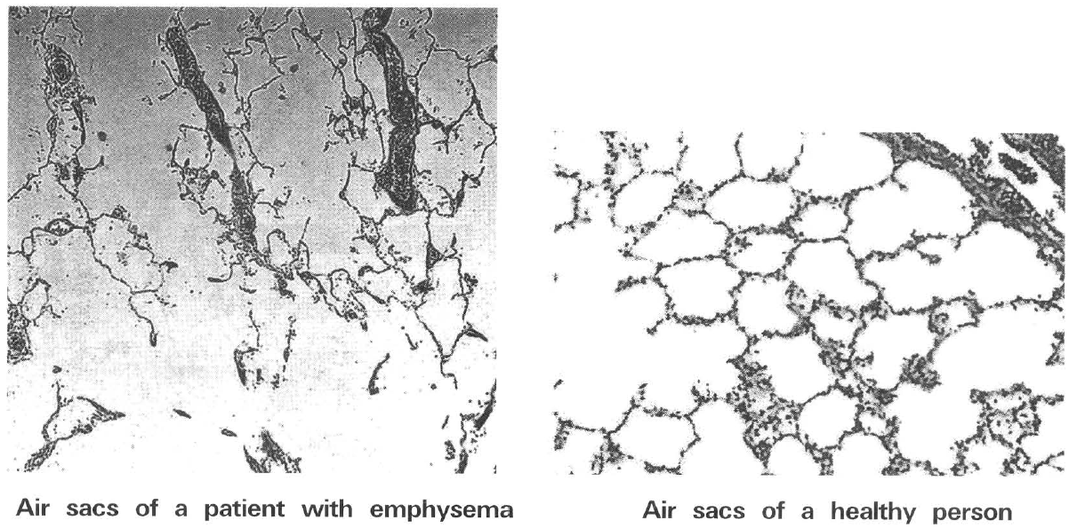
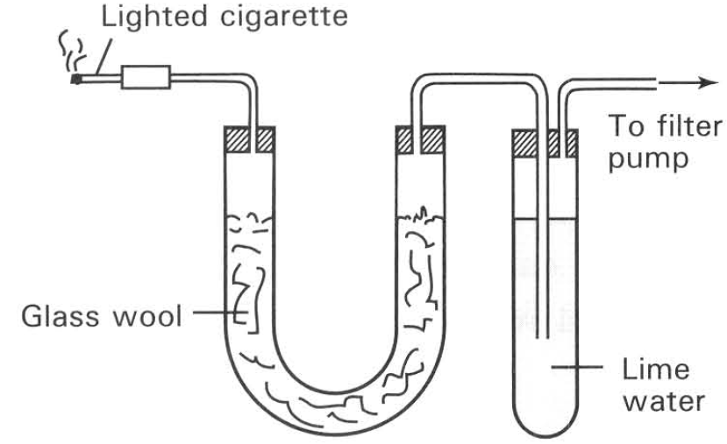
A. The increased diffusion of carbon dioxide from blood into the air sas.
B. Breakdown of the walls of the air sacs greatly reduces the surface area for gas exchange.
C. There is decrease in the number of haemoglobin molecules inside the red blood cells.
D. There is decrease in the number of red blood cells present in blood.
108. The following diagram shows an experiment to find out the components of cigarette smoke. Which of the following components in the cigarette smoke are detected by the above experimental set-up? (1) Tar (2) Carbon dioxide (3) Nicotine
A. (1) only
B. (3) only
C. (1) and (2) only
D. (1), (2), and (3)
109. Cigarette smoking endangers health because (1) the tar in cigarette smoke contains carcinogens. (2) the carbon monoxide and nicotine have physiological effects that may lead to the development of heart diseases. (3) the tar damages the cilia in the trachea that cannot filter the air properly to reduce the risk of bacterial infection.
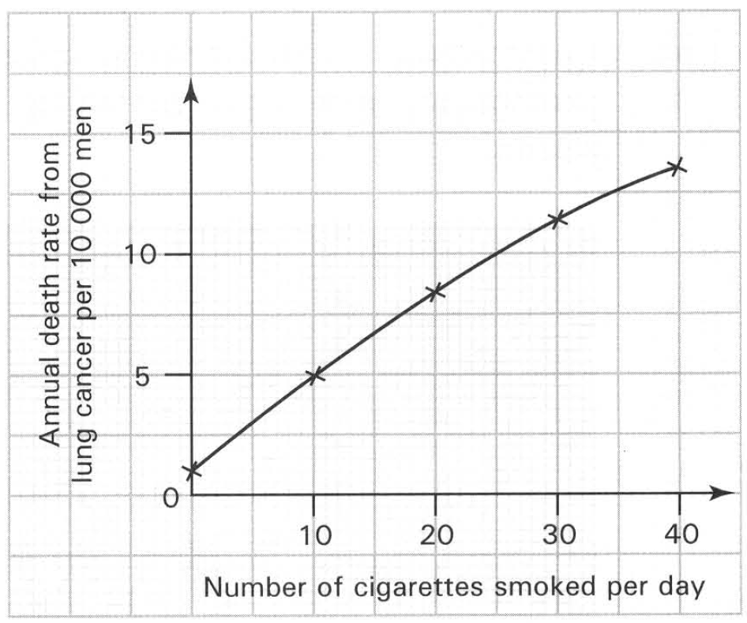
A. (1) only
B. (2) only
C. (2) and (3) only
D. (1), (2) and (3)
110. The graph below shows the relationship between the death rate from lung cancer and the number of cigarettes smoked per day. Which of the following conclusions CANNOT be drawn from the graph? (1) Cigarettes contain poisonous chemicals. (2) Non-smokers have the lowest death rate caused by lung cancer. (3) Cigarette smokers will eventually die due to lung cancer. (4) The death rate of lung cancer among smokers is directly proportional to the number of cigarettes smoked per day. (5) Non-smokers will not die due to lung cancer. (6) The death rate of lung cancer for men smoking 40 cigarettes per day is almost 18 times that of non-smokers.
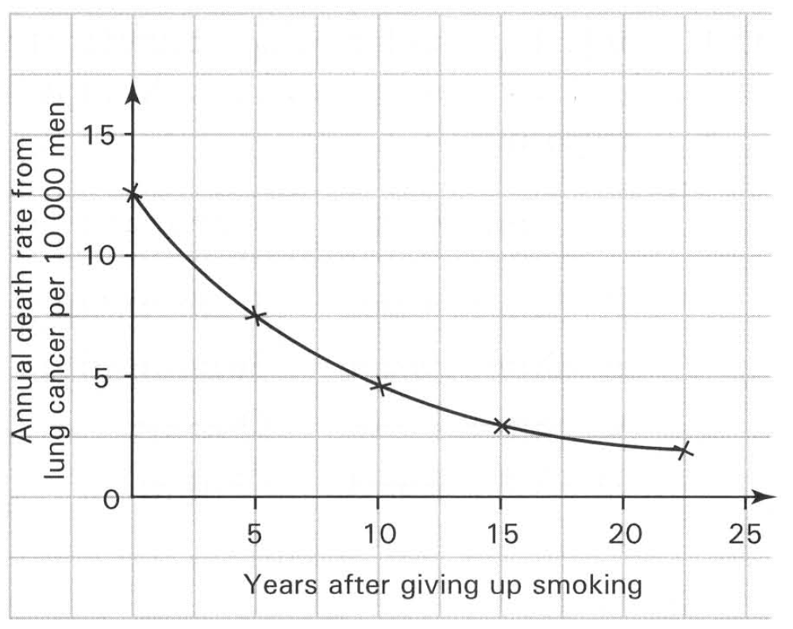
A. (1), (4) and (5) only
B. (2), (4) and (6) only
C. (1), (2) and (6) only
D. (1), (3) and (5) only
111. Which of the following conclusion can be drawn from the graph below?
A. Cigarette smoke contains carcinogenic chemicals.
B. The longer the period of giving up smoking the lower is the risk of death from lung cancer.
C. Smokers will only die due to lung cancer.
D. Cigarette smokers will die of lung cancer at old age only.
112. The histogrm below shows the effect of cigarette smoking on the chances of developing bronchitis.
Which of the following conclusions CANNOT be drawn from the above histogram?
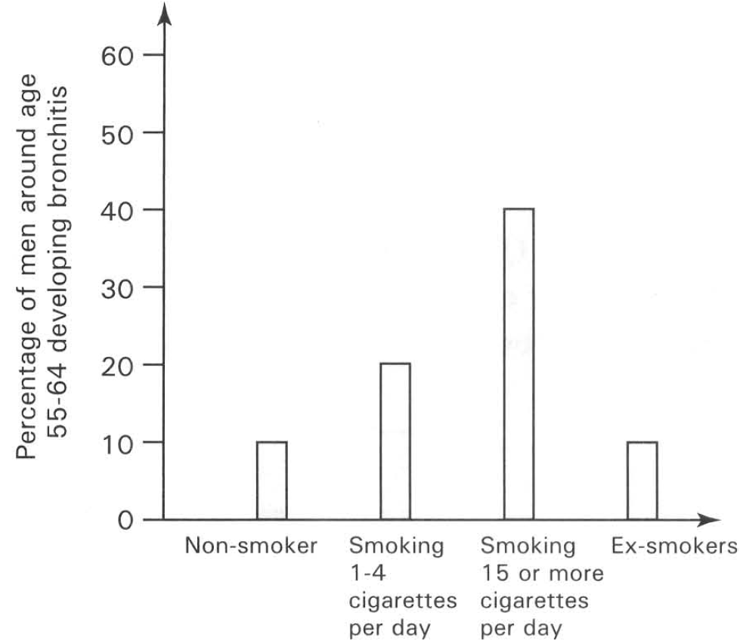
A. Ex-smokers and non-smokers have the same chances of developing bronchitis.
B. The chances of developing bronchitis among smokers increase as the number of cigarettes smoked per day increases.
C. Giving up smoking reduces the chance of developing bronchitis.
D. Bronchitis only occurs in elderly people.

Answers
Answers are printed in red.
1. B. oesophagus will dilate during swallowing.
Class: 75.0% correct (n=148) usual slip B
2. A. 3
Class: 64.2% correct (n=148) usual slip A
3. A. (1) and (3) only
Class: 70.9% correct (n=148) usual slip D
4. D. larynx → pharynx > trachea → bronchiole → bronchus → alveolus-
Class: 76.4% correct (n=148) usual slip B
5. A. (1) and (2) only
Class: 64.9% correct (n=148) usual slip A
6. D. (1), (2) and (3)
Class: 64.2% correct (n=148) usual slip D
7. ?

8. ?

9. B. | backbone | trachea | oesophagus |
Class: 82.4% correct (n=148) usual slip A
10. ?

11. C
Class: 68.9% correct (n=148) usual slip B
12. ?

13. ?

14. D
Class: 73.6% correct (n=148) usual slip B
15. ?

16. ?

17. ?

18. ?

19. ?

20. ?

21. ?

22. ?

23. ?

24. ?

25. ?

26. ?

27. ?

28. ?

29. ?

30. ?

31. ?

32. ?

33. ?

34. ?

35. ?

36. ?

37. ?

38. ?

39. ?

40. ?

41. ?

42. ?

43. ?

44. ?

45. ?

46. ?

47. ?

48. ?

49. ?

50. ?

51. ?

52. ?

53. ?

54. ?

55. ?

56. ?

57. ?

58. ?

59. ?

60. ?

61. ?

62. ?

63. ?

64. B

65. B

66. C. (1) and (4) only

67. D. pharynx.
Class: 62.2% correct (n=148) usual slip B
68. C. (2), (4), (3) and (1)

69. C. (3), (4) and (5) onlyD . (3), (5) and (6) only
Class: 93.9% correct (n=49) usual slip B
70. B. Provides a smooth surface to reduce the resistance to air flow.

71. D. the ciliated, mucous epithelium lining the inner surface of the nasal cavities filter the inhaled air by trapping the dust particles and germs in air.
Class: 14.3% correct (n=49) usual slip B
72. A
Class: 49.0% correct (n=49) usual slip C
73. D. (1), (2) and (3) only

74. C. to maintain steep concentration gradient of gases between the air sac and blood.
Class: 70.0% correct (n=50) usual slip D
75. D. (1), (2) and (3) only

76. A

77. B. (4), (5), (2), (1) and (3)

78. D. haemoglobin. Directions: Questions 26 to 29 refer to the following diagrams which show the T.S. of a leaf and an air sac covered with a blood capillary. The following diagrams show the tissues of leaf and the air sac.

79. C. X and Y only

80. D. 7 only

81. D. (1) and (3) only

82. C

83. D. (1), (3) and (4) only

84. C. Inhalation continuously brings in fresh air to the air sacs.

85. C. (1) and (4) only

86. D

87. A

88. D. X and Y 37Which is the rate and depth of breathing of this man? 38

89. C. The air exhaling out of the air sac is diluted by the air present in the respiratory tract when it reaches the nasal cavity.

90. B. The right lung would collapse while the left lung would increase the rate of breathing.

91. A. (1) and (2) onlyB . (2) and (3) onlyC . (3) and (4) onlyD . (4) and (1) only

92. C. (1) and (4) only D. (3) and (4) only Directions: Questions 43 and 44 refer to the diagram below which shows a model used to illustrate a biological process.

93. C

94. D

95. D

96. C. Inward movement of the chest wall

97. D. The ribs chiefly serve to help inspiration and expiration of humans. Directions: Questions 48 and 49 refer to the diagram below which shows an experiment used to compare the amount of a certain gas component in the inhaled and exhaled air.

98. D

99. B

100. D

101. B. The volume of gas inside the burette should only be measured after the water levels inside and outside the burette are adjusted to the same.

102. B

103. A

104. D. 15 times per minute.

105. D. Respiratory diseases

106. C. The resistance to the diffusion of oxygen through the mucus layer to blood increases.

107. B. Breakdown of the walls of the air sacs greatly reduces the surface area for gas exchange.

108. C. (1) and (2) only

109. D. (1), (2) and (3)

110. D. (1), (3) and (5) only

111. B. The longer the period of giving up smoking the lower is the risk of death from lung cancer.

112. D. Bronchitis only occurs in elderly people.

