Gas exchange in humans · items under 80% correct
Multiple-choice practice
Name: ________________________ Class: ____________
These items were answered correctly by fewer than 80% of students in class Google Forms, matched by the wording in the source bank and the form answer key. Choose the one best answer.
Part A — HKCEE level (Longman)
1. Directions: Questions 1 to 3 refer to the human breathing system below.
Food is prevented from entering structure 1 because
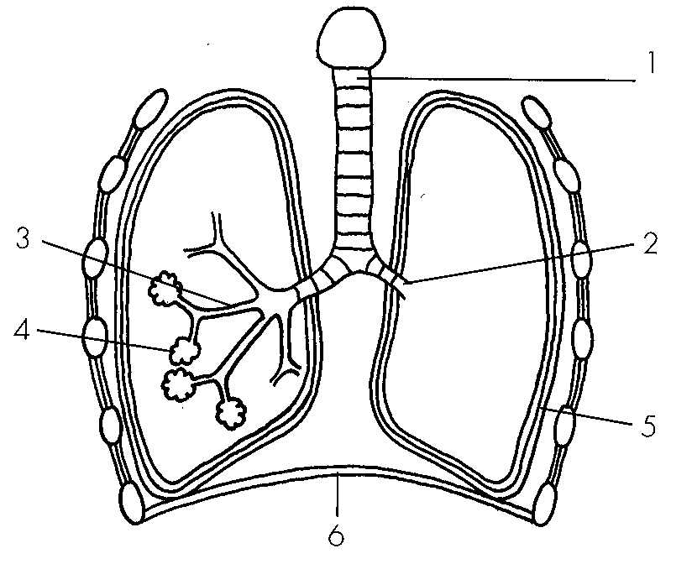
A. structure 1 will constrict during swallowing.
B. oesophagus will dilate during swallowing.
C. glottis will constrict during swallowing.
D. larynx will be raised during swallowing.
2. Which of the numbered structures will recoil due to its elasticity during expiration?
A. 3
B. 4
C. 5
D. 6
3. Which of the following organs are protected by rib cage? (1) Lungs (2) Liver (3) Heart (4) stomach D.(3) and (4) only
A. (1) and (3) only
B. (2) and (3) only
C. (2) and (4) only
D. (3) and (4) only
4. Which of the following shows the possible route for deposition of asbestos in the lungs? A.larynx > pharynx → trachea → bronchus → bronchiole → alveolus- B.pharynx > larynx → trachea → bronchus → bronchiole → alveolus- C.pharynx > larynx → trachea → bronchiole → bronchus → alveolus- D.larynx → pharynx > trachea → bronchiole → bronchus → alveolus-
A. larynx > pharynx → trachea → bronchus → bronchiole → alveolus-
B. pharynx > larynx → trachea → bronchus → bronchiole → alveolus-
C. pharynx > larynx → trachea → bronchiole → bronchus → alveolus-
D. larynx → pharynx > trachea → bronchiole → bronchus → alveolus-
5. Which of the following state the roles of mucus secreting cells in the human breathing system? (1)To secrete mucus which moistens the inspired air. (2)To secrete mucus which warms up the inspired air. (3)To secrete mucus which traps dust and dirt. A.(1) and (2) only
A. (1) and (2) only
B. (1) and (3) only
C. (2) and (3) only
D. (1), (2) and (3)
6. Which of the following describe(s) the role(s) of cilia in the human breathing system? (1)To draw air into the lungs by beating down. (2)To get rid of sputum/phlegm by beating up. (3)To trap dust and dirt from the inspired air.
A. (1) only
B. (2) only
C. (3) only
D. (1), (2) and (3)
7. Which of the following is the likely composition of oxygen and carbon dioxide in the expired air?
Directions: Questions 13 and 14 refer to the experiment below which compares the carbon dioxide content in the inhaled and exhaled air.
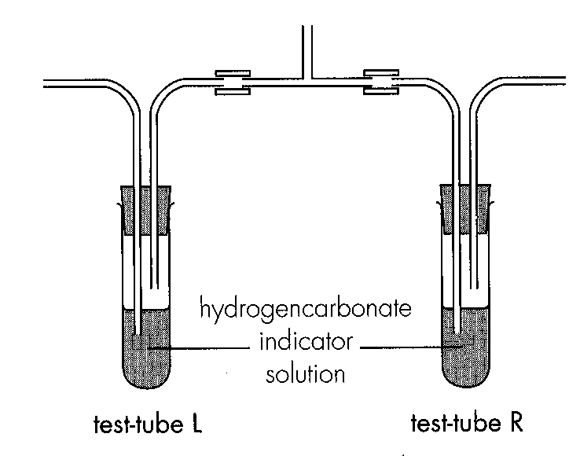
 | oxygen | carbon dioxide
A. | 19.74% | 0.06%
B. | 16.23% | 0.82%
C. | 21.38% | 4.05%
D. | 17.01% | 3.32%

8. Which component of the inhaled and exhaled air is being compared in this experiment?
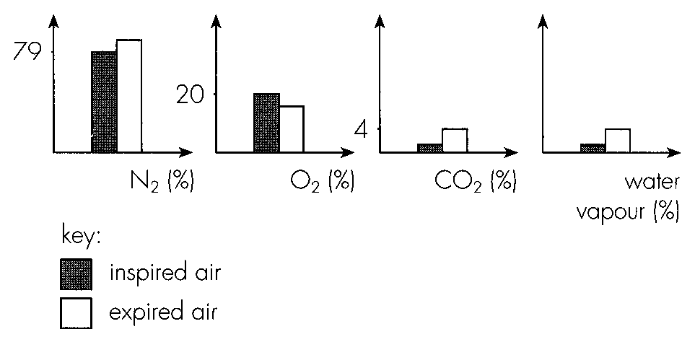
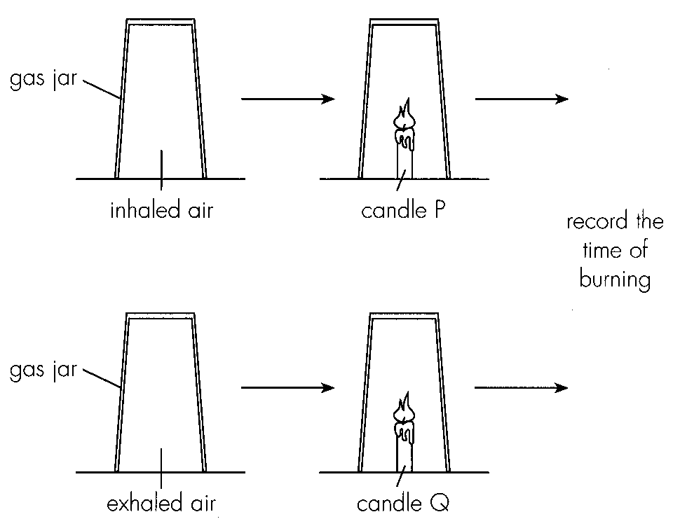
A. Oxygen B. Carbon dioxide C. Water vapour D. Nitrogen
Part B — HKDSE-style (YKTo)
9. The position where the alimentary canal and the respiratory tract meet one another is the
A. epiglottis.
B. larynx.
C. glottis.
D. pharynx.
10. It is advisable to breathe air through the nasal cavities rather than through the mouth cavity into the lungs. The reason is that
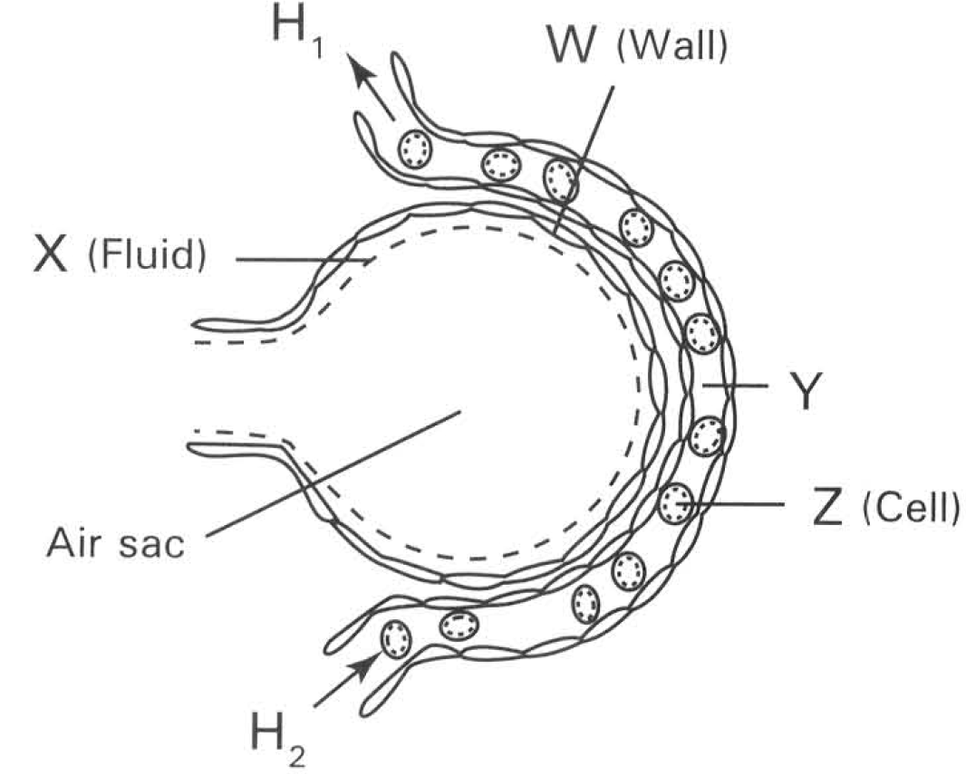
A. the nasal cavities are the proper parts of the respiratory system while the mouth cavity is part of the alimentary canal.
B. the nasal cavities only permit oxygen in while carbon dioxode is trapped by the cilia lining the inner surface of the nasal cavities.
C. the nasal cavities are present nearer to the brain so that they are better coordinated to control the amount of air required to flow into the lungs.
D. the ciliated, mucous epithelium lining the inner surface of the nasal cavities filter the inhaled air by trapping the dust particles and germs in air.
B. Air sacs, gas exchange and transport of gases Directions: Questions 18 and 19 refer to the diagram below which shows an air sac covered with a blood capillary.
11. Which heart chambers are connected by blood vessels to the ends of the capillary labelled Hl and H2?
 | H1 | H2
A. | Left atrium | Right ventricle
B. | Left ventricle | Right atrium
C. | Right atrium | Left ventricle
D. | Right ventricle | Left atrium

12. The air sac is densely covered with blood capillaries to
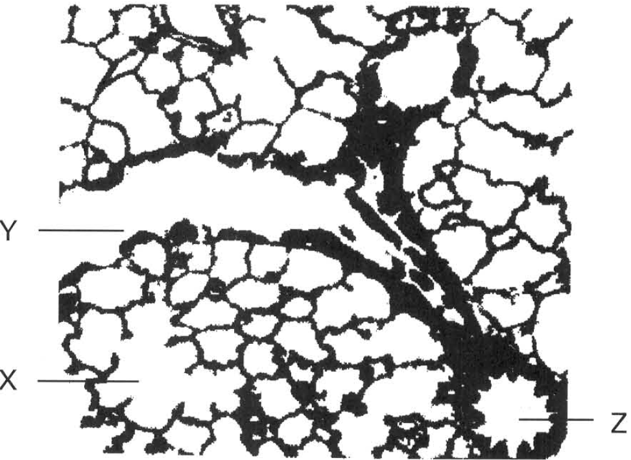
A. increase the spongy nature of the lungs for enhancing ventilation.
B. provide large respiratory surface.
C. to maintain steep concentration gradient of gases between the air sac and blood.
D. supply large amount of nutrients for supporting the vigorous metabolic activities of the cells forming the wall of the air sac. Directions: Questions 21 and 22 refer to the photomicrograph below which shows a section of the lung.

Answers
Answers are printed in red.
1. B. oesophagus will dilate during swallowing.
Class: 75.0% correct (n=148) usual slip B
2. A. 3
Class: 64.2% correct (n=148) usual slip A
3. A. (1) and (3) only
Class: 70.9% correct (n=148) usual slip D
4. D. larynx → pharynx > trachea → bronchiole → bronchus → alveolus-
Class: 76.4% correct (n=148) usual slip B
5. A. (1) and (2) only
Class: 64.9% correct (n=148) usual slip A
6. D. (1), (2) and (3)
Class: 64.2% correct (n=148) usual slip D
7. C
Class: 68.9% correct (n=148) usual slip B
8. D
Class: 73.6% correct (n=148) usual slip B
9. D. pharynx.
Class: 62.2% correct (n=148) usual slip B
10. D. the ciliated, mucous epithelium lining the inner surface of the nasal cavities filter the inhaled air by trapping the dust particles and germs in air.
Class: 14.3% correct (n=49) usual slip B
11. A
Class: 49.0% correct (n=49) usual slip C
12. C. to maintain steep concentration gradient of gases between the air sac and blood.
Class: 70.0% correct (n=50) usual slip D

Class percentage correct
Matched to this paper by question wording in the source bank and the form answer key, not by a shifted paper number.
Q | Answer | % correct | n | Usual slip
1 | B | 75.0% | 148 | B
2 | A | 64.2% | 148 | A
3 | A | 70.9% | 148 | D
4 | D | 76.4% | 148 | B
5 | A | 64.9% | 148 | A
6 | D | 64.2% | 148 | D
7 | C | 68.9% | 148 | B
8 | D | 73.6% | 148 | B
9 | D | 62.2% | 148 | B
10 | D | 14.3% | 49 | B
11 | A | 49.0% | 49 | C
12 | C | 70.0% | 50 | D

