Basic genetics
Multiple-choice practice
Name: ________________________ Class: ____________
There are 146 questions compiled from Longman HKCEE and/or YKTo papers. Choose the one best answer.
Part A — HKCEE level (Longman)
1. Which of the following parts of a flower contains cells with haploid number of chromosomes?
A. Ovary wall B. Style C. Filament D. Anther
2. Which of the following cell types of the same person has genotype different from the other three?
A. Corneal cell B. OvumC. Nerve cell D. Mucus secreting cell-
3. Which of the following correctly states and explains the genotype among different sperms of the same person?
Directions: Questions 4 to 6 refer to the photograph below which shows the chromosomes in a dividing cell of a person as observed during meiosis. The chromosomes are artificially arranged in pairs.
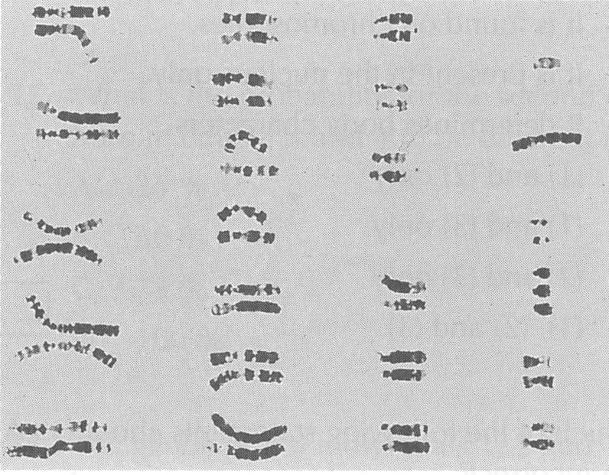
 | Genotype among different sperms | Explanation
A. | same | independent assortment of chromosomes
B. | same | random fertilisation
C. | different | independent assortment of chromosomes
D. | different | random fertilisation

4. How many chromosomes are present in the cheek cell of the same person?
A. 45
B. 46
C. 47
D. 48
5. Which of the following correctly states and explains the sex of this person?
 | Sex | Explanation
A. | male | possession of Y chromosome
B. | male | possession of X chromosome
C. | female | possession of Y chromosome
D. | female | possession of X chromosome

6. What genetic disease is this person suffering from?
A. Sickle cell anaemia- B. Down's syndromeC. Haemophilia D. Colourblindness
7. Which of the following statements about DNA are correct? (1) It is found on chromosomes. (2) It is present in the nucleus only. (3) It determines body characters.
A. (1) and (2) only
B. (1) and (3) only
C. (2) and (3) only
D. (1), (2) and (3)
8. Which of the following statements about DNA are incorrect? (1) One DNA molecule represents one gene. (2) One DNA molecule determines one inherited character. (3) DNA controls the types of protein produced.
A. (1) and (2) only
B. (1) and (3) only
C. (2) and (3) only
D. (1), (2) and (3)
9. Which of the following substances' formation are controlled by DNA? (1) Enzymes (2) Haemoglobin (3) Hormones
A. (1) and (2) only
B. (1) and (3) only
C. (2) and (3) only
D. (1), (2) and (3)
10. Which of the following substances' formation are not controlled by DNA? (1) Insulin (2) Testosterone (3) Fibrinogen
A. (1) only
B. (2) only
C. (3) only
D. (2) and (3) only
11. Which of the following statements about genes are correct? (1) Different forms of an allele are called genes. (2) Genes are short lengths of DNA on chromosomes. (3) Genes are units determining inherited characters.
A. (1) and (2) only
B. (1) and (3) only
C. (2) and (3) only
D. (1), (2) and (3)
12. Which of the following statements about genes are incorrect? (1) One DNA molecule represents one gene. (2) Different forms of a gene are located on different pairs of chromosomes. (3) One chromosome consists of many genes.
A. (1) and (2) only
B. (1) and (3) only
C. (2) and (3) only
D. (1), (2) and (3)
13. Which of the following comparisons between a normal human sperm and a normal human ovum is correct?
 | Human sperm | Human ovum
A. | with one X chromosome | with one X chromosome
B. | with one Y chromosome | with two X chromosomes
C. | with one X or one Y chromosome | with one X chromosome
D. | with one X and one Y chromosome | with two X chromosomes

14. The characteristics of a son are developed A.mostly from his father. C.from his father only.
A. mostly from his father.
B. mostly from his grandfather.
C. from his father only.
D. from both his father and mother.
15. The gender of a person is determined A.immediately after the formation of the zygote. B.immediately after implantation. C.during the development of the embryo. D.during the development of the foetus. Directions: Questions 16 to 18 refer to the pedigree below which shows the inheritance of a certain character with two forms, X and Y. The character is controlled by a single gene (C).
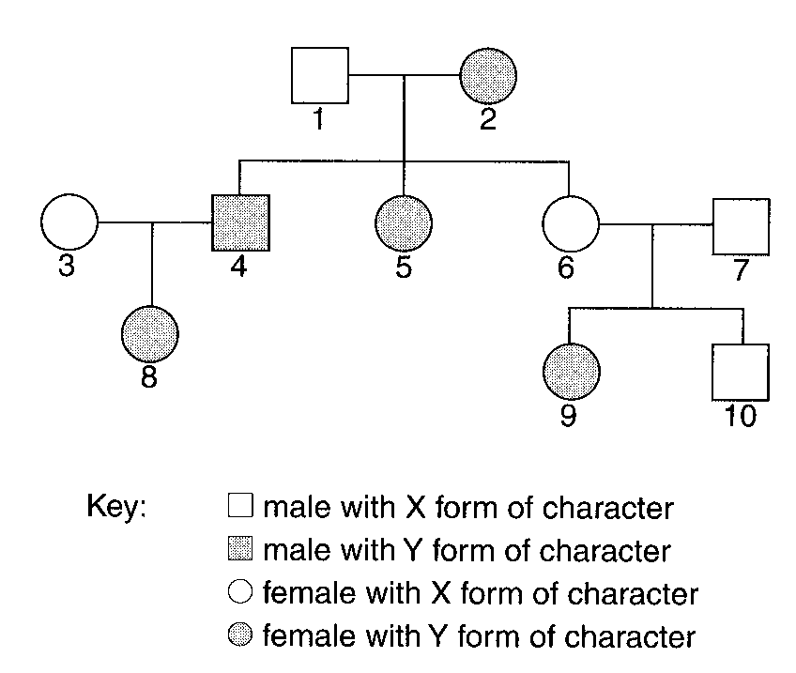
A. immediately after the formation of the zygote.
B. immediately after implantation.
C. during the development of the embryo.
C. .
16. Which of the following can be concluded from the pedigree? A.The Y form of character is dominant to the X form. B.The X form of character is dominant to the Y form. C.Individuals 4 and 5 have different genotypes. D.Individuals 8 and 9 have different genotypes.
A. The Y form of character is dominant to the X form.
B. The X form of character is dominant to the Y form.
C. Individuals 4 and 5 have different genotypes.
D. Individuals 8 and 9 have different genotypes.
17. What is the probability for the second child born to couple 3 and 4 to be different from 8?
A. 25
B. 50
C. 75
D. 100
18. | 2 | 10 | A. | cc | Cc | cc | B. | cc | CC | cc | C. | Cc | cc | CC | D. | CC | cc | Cc
Directions: Questions 19 and 20 refer to the following pedigree which shows the inheritance of body pigmentation in a family. The character is controlled by a single gene (A) which has two forms, the allele for being normal and the allele for being albino.
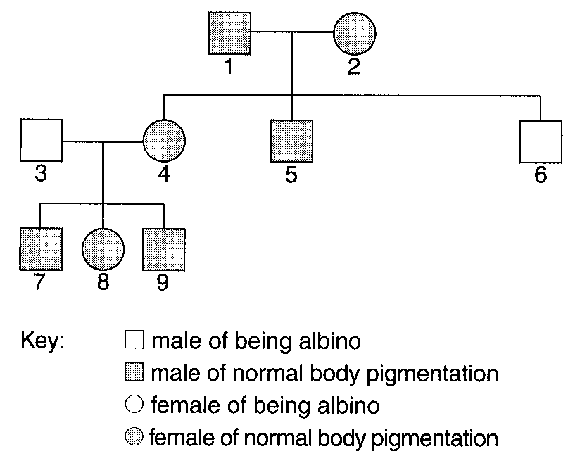
19. Which of the following statements is correct?
A. The allele for being normal is dominant.
B. The allele for being albino is dominant.
C. Individuals 4 and 5 must be heterozygous.
D. Individuals 7, 8 and 9 can be homozygous or heterozygous.
20. If individuals 1 and 2 are going to give birth to their fourth child, what is the chance for their child to be an albino boy?
A. 1/2
B. 1/4
C. 1/8
D. 1 /16
21. In Drosophila, long wing is dominant to short wing. Two heterozygous longwinged -Drosophila crossed and they produced 3 longwinged -Drosophila. No shortwinged -Drosophila was produced because (1) the fourth offspring will be shortwinged.- (2) the sample size is too small. (3) fertilisation is random.
A. (1) and (2) only
B. (1) and (3) only
C. (2) and (3) only
D. (1), (2) and (3)
22. In rats, grey fur is dominant to black fur. In a cross, 2 rats with grey fur were mated and their offspring all had grey fur. Which of the following deductions is correct?
 | Genotypes
Black moth | GG'
Grey moth | GG

A. Both parents must be homozygous for grey fur.
B. One of the parents must be homozygous for grey fur.
C. Both parents must be heterozygous for grey fur.
D. No deduction can be made. Directions: Questions 23 to 25 refer to the effect of industrialization on the evolution of moth in Britain. There are two forms of moth and their genotypes are tabulated below.
23. Which of the following correctly describes the two alleles G and G'?
 | Allele | Phenotype determined | Dominant/ Recessive
A. | G | Black | dominant
B. | G | Grey | recessive
C. | G' | Black | recessive
D. | G' | Grey | dominant

24. Before industrialization, there were 85% of grey moths and 15% of black moths in Britain. The grey moths were dominant because
A. the grey form is a dominant character.
B. the grey form is homozygous.
C. the black form is a poorer competitor.
D. the black form is poorly camouflaged.
25. What would be the likely percentages of the two forms of moth 10 years after industrialization?
 | Grey moth | Black moth
A. | 60% | 40%
B. | 85% | 15%
C. | 90% | 10%
D. | 95% | 5%

26. From where in a human body will the gene of mutation be inherited? (1) Uterus (2) Ovary (3) Testis
A. (1) and (2) only
B. (1) and (3) only
C. (2) and (3) only
D. (1), (2) and (3)
27. A brown eyed man married a brown-eyed woman and they gave birth to 3 blue-eyed children. Which of the following can be concluded from the above information? -
A. One of the parents must be heterozygous.
B. fertilisation of gametes is random.
C. Blue eye is dominant to brown eye.
D. The theoretical genotypic ratio of blueeyed to brown-eyed should be 1 : 3.-
28. In a genetic experiment, a pea bearing plant arising from a yellow pea was self-pollinated and gave rise to 54 yellow peas and 50 green peas. What is/are the probable genotypes) of the yellow peas in the F-1 generation?
A.Homozygous dominant B. Heterozygous dominant
C.Homozygous recessive D. Homozygous dominant and heterozygous dominant
Directions: Questions 29 to 31 refer to the genetic diagram below which shows how gender (sex) is determined in human beings.
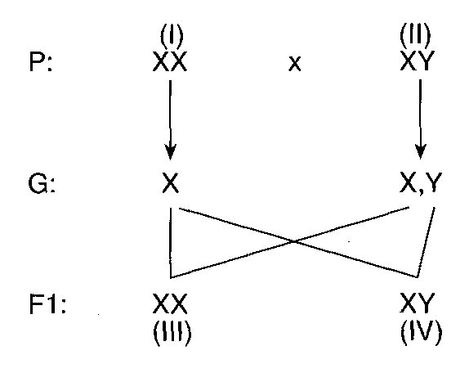
29. Which of the following correctly states the identities of persons (I) and (IV)?
 | (I) | (IV)
A. | mother | son
B. | mother | daughter
C. | father | son
D. | father | daughter

30. Which of the following can be concluded from the genetic diagram above? (1) The gender of daughter is determined by the mother only. (2) The Y chromosome is dominant to the X chromosome. (3)The gender of the son is determined by the father only.
A. (1) and (2) only
B. (1) and (3) only
C. (2) and (3) only
D. (1), (2) and (3)
31. According to the genetic diagram, what is the chance of giving birth to 2 consecutive children of opposite gender?
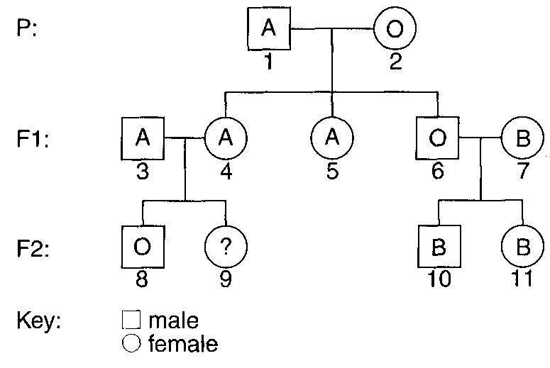
A. 1 B. 1/2 C. 1/4 D. 1 l8 Directions: Questions 32 to 34 refer to the following pedigree which shows the inheritance of blood group in a family over three generations.
32. With reference to the information in the pedigree only, which blood group(s) is/are dominant?
A. A B. B C. O D. A and B
33. Which of the following persons are heterozygous in genotype?
A. Individuals 1, 4 and 10
B. Individuals 1, 7 and 11
C. Individuals 2, 3 and 10
D. Individuals 2, 5 and 11
34. What is the chance for individual 9 being group A?
A. 1/4
B. 1/2
C. 3/4
D. 1
35. The following drawing shows a maize cob with grains of 2 different colours, purple and yellow. The maize cob was produced from crossing 2 maize plants. Which of the following can be concluded from the maize cob? (1) The allele for purple grain is dominant. (2) The phenotypic ratio of purple grain to yellow grain is 3 : 1. (3) Both parents of this maize cob arose from purple grains. A.(1) and (2) only
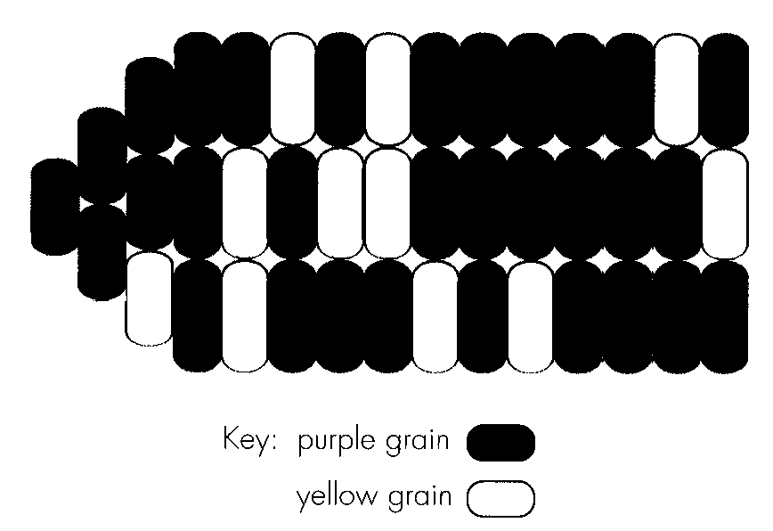
A. (1) and (2) only
B. (1) and (3) only
C. (2) and (3) only
D. (1), (2) and (3)
36. Which of the following are the possible causes of genetic variation in man? (1) Meiosis (2) fertilisation (3) Mutation (4) Environment
A. (1) and (3) only
B. (1), (2) and (3) only
C. (2), (3) and (4) only
D. (1), (2), (3) and (4)
37. Which of the following are examples of characteristics showing continuous variation? (1) ABO blood groups(2) Height (3) Weight A. (1) and (2) only
A. (1) and (2) only
B. (1) and (3) only
C. (2) and (3) only
D. (1), (2) and (3).
38. Which of the following characters can be changed by the environment? (1) Intelligence (2) Eye colour (3) Tongue rolling A.(1) only
A. (1) only
B. (1) and (2) only
C. (1) and (3) only
D. (2) and (3) only
39. Which of the following characteristics cannot normally be changed by the environment?
A. Length of the middle finger B. Body weight
C. Skin colour D. Earlobes
40. Two identical twins may differ in their
A. eye colour. B. ability to taste PTC paper. C. intelligence. D. fingerprint.
41. The histogram below shows the frequency of various forms of a certain character in man. The character is most likely A. height.
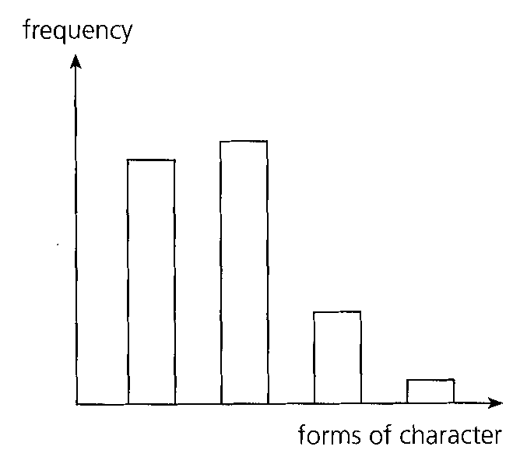
A. height.
B. blood group.
C. weight.
D. intelligence.
42. The frequency of various forms of a human character was investigated and the results were presented in the graph below. The character is most probably
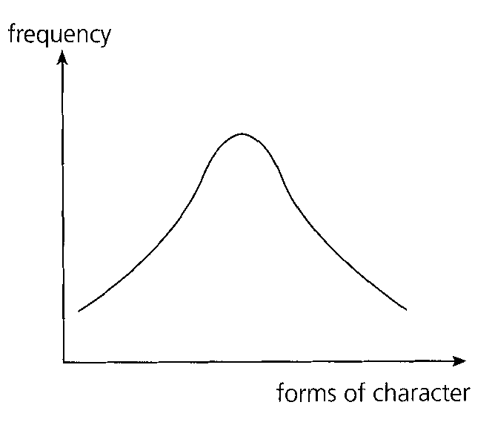
A. pulse rate.
B. gender.
C. eye colour.
D. ear lobe.
43. Which of the following are not hereditary characters? (1) Colourblindness (2) Night blindness (3) Cataract
A. (1) and (2) only
B. (1) and (3) only
C. (2) and (3) only
D. (1), (2) and (3).
44. Which of the following methods of reproduction produce offspring without genetic variations? (1) Vegetative propagation in flowering plants (2) Selffertilization in tapeworm- (3) Seed formation in gymnosperms
A. (1) only
B. (1) and (2) only
C. (1) and (3) only
D. (1), (2) and (3)
45. Nonidentical twins differ from each other in-
(1)their genotypes.
(2) those characters showing continuous variation.
(3)those characters showing discontinuous variation.
 | Samuel | Michael
Tongue rolling | roller | roller
Height (cm) | 170 | 175
Intelligence | 92 | 92
Blood group | AB | O

A. (1) and (2) onlyB. (1) and (3) only C. (2) and (3) only D. (1), (2) and (3) Directions: Questions 46 and 47 refer to the table below which summarizes some of the body characters of a pair of twins, Samuel and Michael.
46. Which of the following correctly states and explains the type of twins exhibited by Samuel and Michael?
 | Type of twins | Reasons
A. | nonidentical- | different height
B. | nonidentical- | different blood group
C. | identical | both are rollers
D. | identical | same intelligence

47. Which of the following correctly states the possible blood groups of their parents?
 | Father | Mother
A. | O | O
B. | AB | B
C. | A | B
D. | A | AB

48. Which of the following are related to the significance of variation within a species? (1)It provides the chances for different individuals of the same species to compete. (2)It leads to the survival and reproduction of those best fitted to their environment. (3) It makes the species more adaptable to the changing environment. A.(1) and (2) only
A. (1) and (2) only
B. (1) and (3) only
C. (2) and (3) only
D. (1), (2) and (3)
49. Which of the following are the possible causes of mutation? (1) Radiation (2) Chemicals (3) Stress
A. (1) and (2) only
B. (1) and (3) only
C. (2) and (3) only
D. (1), (2) and (3)
Part B — HKDSE-style (YKTo)
50. 1Which of the following statements is/are TRUE? (1) Phenotype describes the external appearance of a characteristic of an organism. (2) Alleles are pairs of genes present on the same chromosome. (3) A recessive character is one which definitely will not show out in the offspring when two hybrid parents are crossed. (4) When all hybrids have the same phenotype, they are said to be homozygous.
A. (1) only
B. (4) only
C. (1) and (2) only
D. (3) and (4) only
51. 2Which of the following statements about genotype is/are CORRECT? (1) It is the genetic constitution of the whole population. (2) It is the genetic make-up of an individual. (3) It is the external visible appearance of an individual.
A. (1) only
B. (2) only
C. (3) only
D. (1) and (3) only
52. 3Which of the following matching is INCORRECT?
 | Term | Condition
A. | Heterozygote | A hybrid produced by a cross between two pure strains with contrasting characters.
B. | Recessive gene | The gene present in an individual though its effect cannot be expressed.
C. | Phenotype | The composition of the genetic material in a species.
D. | Dominant gene | A gene which produces its effect even though its allele is present.

B. Monohybrid cross
53. 4Which of the following are reasons for using the garden pea for genetics study? (1) It has many contrasting characters. (2) The peas have high protein content. (3) The structures of their bisexual flowers enhance self-pollination.
A. (1) and (2) only
B. (2) and (3) only
C. (1) and (3) only
D. (1), (2) and (3)
54. Which of the following are reasons for using maize as the tool for genetics study? (1) It has inflorescence of male flowers at its tip and inflorescence of female flowers at the lower part that enhances controlled sexual reproduction. (2) Each maize ear contains 600 kernels (seeds). (3) The life cycle is quite short. (4) Needs simple conditions for its cultivation.
A. (1) and (2) only
B. (3) and (4) only
C. (1), (2) and (3) only
D. (1), (2), (3) and (4)
55. Drosophila (fruit fly) is commonly used in genetics experiments. Which of the following is the most undesirable factor of using the organism?
A. Experience is required to identify the male flies from the female flies.
B. Its life cycle is rather short.
C. One female will lay about 100 eggs after the cross.
D. The culture medium has to be carefully sterilized.
56. Which of the following practice enabled Mendel to develop his theories that was not achieved by the biologists before him?
A. Mendel used pure breeding pea plants.
B. Mendel used pea plants with many contrasting characteristics.
C. Mendel used statistics approach to explain the results of his breeding experiments.
D. Mendel carried out the breeding experiments through three successive generations.
57. The tongue-rolling parents have two non-tongue rolling children. Which of the following statements is CORRECT? (1) Tongue rolling is dominant to non-tongue rolling. (2) One of the parents is homozygous. (3) Both children are homozygous.
A. (1) only
B. (2) only
C. (3) only
D. (1) and (3) only
58. The genotype of a given flowering plant is Rr. The probable ratio of alleles in the pollen grains produced by this plant is
A. all R.
B. all r.
C. 1R : lr.
D. 3R : lr.
59. A dominant allele is represented by T and its recessive allele by t. If the genotypic ratio of the Fl is 1 Tt : 1 tt, the genetic constitution of the parents should be
A. Tt and tt
B. Tt and Tt
C. Tt and TT
D. tt and tt
60. In garden peas, the allele D for tallness is dominant to its allele d for dwarfness. If a cross between tall and dwarf pea plants produces all tall pea plants offspring, the genetic constitution of the parents should be
A. DD and Dd. B. DD and dd. C. Dd and Dd. D. Dd and dd. Directions: Questions 21.12 and 21.13 refer to the description below. A hybrid fruit fly with normal long wings was crossed with a pure strain fruit fly with vestigial wings and produced 320 flies. Both alleles are not sex-linked.
61. Which of the following statements is TRUE?
A. The normal long-winged condition is the recessive character.
B. The vestigial-winged condition is the recessive character.
C. The hybrid fly is homozygous.
D. The fly with vestigial wings is heterozygous.
62. Which of the following results is most likely to be produced with regards to the wing condition among the 320 flies?
A. 150 long-winged males and 170 vestigial winged females.
B. 320 long-winged males.
C. 140 long-winged males, 110 long-winged females, 40 vestigial-winged females and 30 vestigial-winged males.
D. 77 long-winged males, 85 long-winged females, 80 vestigial-winged males and 78 vestigial-winged females. Directions: Questions 21.14 to 21.16 refer to the description below. A spotted rabbit, when mated with a solid-coloured rabbit, produced all spotted offspring. When these Fl rabbits were crossed among themselves, they produced 25 spotted rabbits and 8 solid-coloured rabbits in the F2 generation.
63. How many of the spotted rabbits produced in the F2 generation were homozygous?
A. 25
B. 19
C. 8
D. 5
64. How many of the solid-coloured F2 rabbits were homozygous?
A. 25
B. 19
C. 16
D. 8
65. What phenotypic ratio in F2 would be expected if F1 parents produced large number of progeny?
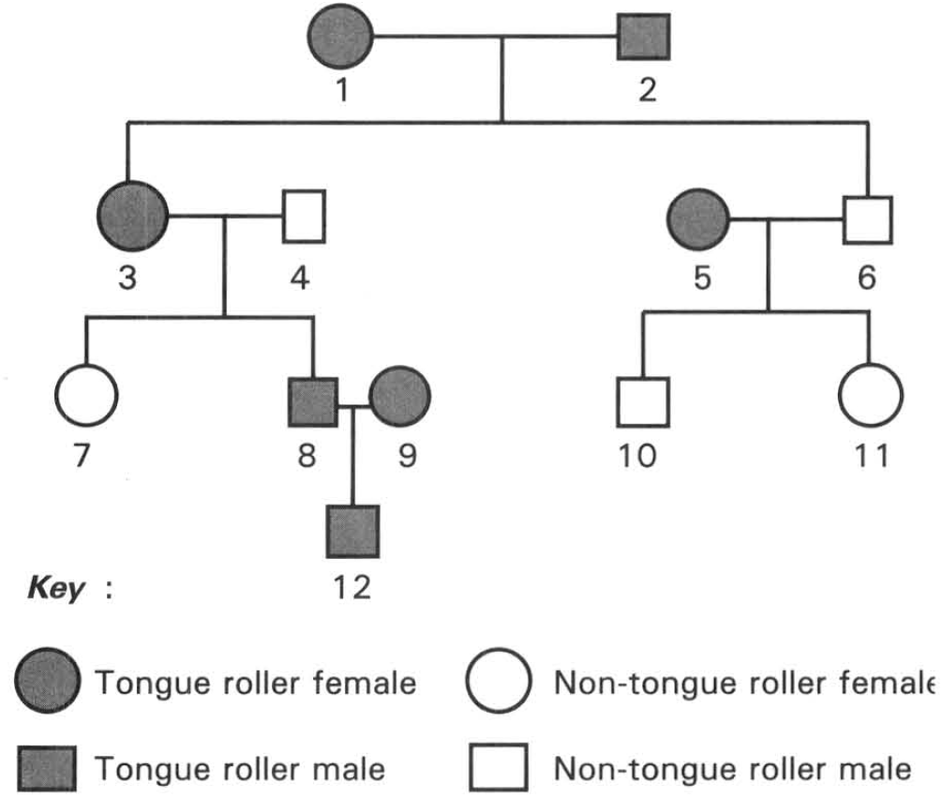
A. 1 spotted rabbits: 1 solid-coloured rabbits B. 3 spotted rabbits: 1 solid-coloured rabbits
C. 1 spotted rabbits: 2 solid-coloured rabbits D. 1 spotted rabbits: 3 solid-coloured rabbits Directions: Questions 21.17 to 21.22 refer to the diagram below, which shows a pedigree with tongue rolling inherited as a dominant character to non-tongue rolling. This character is controlled by a pair of alleles which are not sex-linked.
66. Which of the following individuals is homozygous for the tongue rolling character?
A. 1
B. 3
C. 5
D. None of the above
67. What is the probability that individuals 5 and 6 will have a third child who is a tongue-roller'?
A. 0
B. 1/2
C. 1/4
D. 3/4
68. If the husband of individual 7 is a heterozygous roller, what is the probability that their first child is a roller?
A. 25%
B. 50%
C. 75%
D. 100%
69. Which of the following individuals whose genotype cannot be decided to be in heterozygous or homozygous condition for the character studied?
A. 1
B. 3
C. 5
D. 9
70. What is the probability that individuals 8 and 9 will have a non-roller child?
A. 1
B. 3/4
C. 1/4
D. Uncertain
71. Individual 11 marries a tongue-rolling man whose family includes no nonroller for at least three generations. What- is the probability that they will have a tongue rolling child?
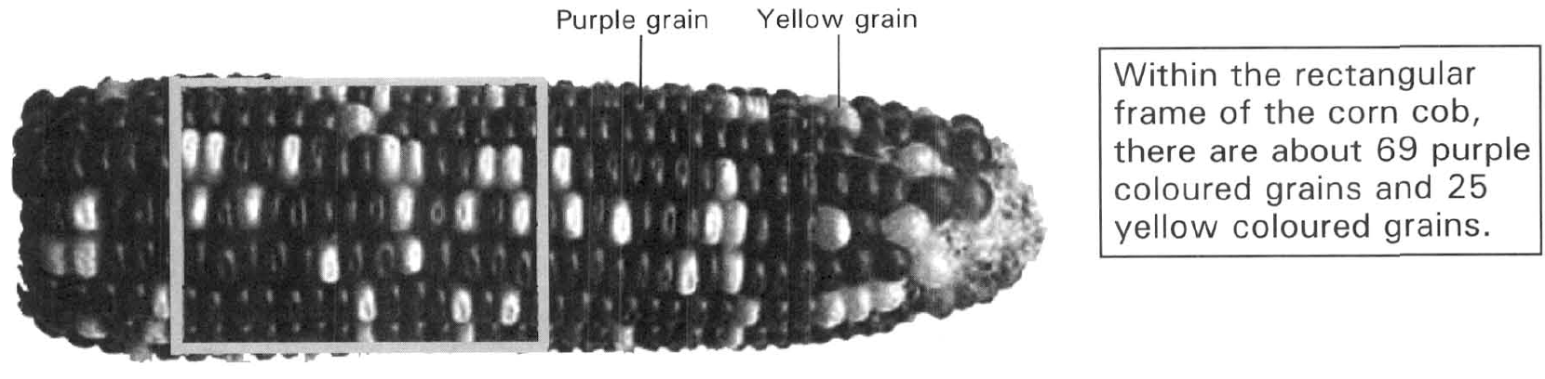
A. 1 B. 1/4 C. 1/2 D. 3/4 Directions: Questions 21.23 to 21.25 refer to the diagram below, which shows the grains with different colours on a corn cob. The cob is the fruit produced by a cross between two maize plants. The grain colour is controlled by a pair of alleles, P and p. The allele for purple grain colour (P) is dominant to the allele for yellow grain colour (p).
72. Which of the following represents the genotypes of the parents?
A. PP x Pp
B. PP x pp
C. Pp x pp
D. Pp x Pp
73. A purple grain is taken randomly from the corn cob and is sown. Then the plant is crossed with the plant developed from a yellow grain. What is the probability that all the grains on the corn cob are purple coloured?
A. 25%
B. 33%
C. 50%
D. 75%
74. According to the cross in the previous question, what is the probability that half of the grains on the corn cob are yellow in colour?
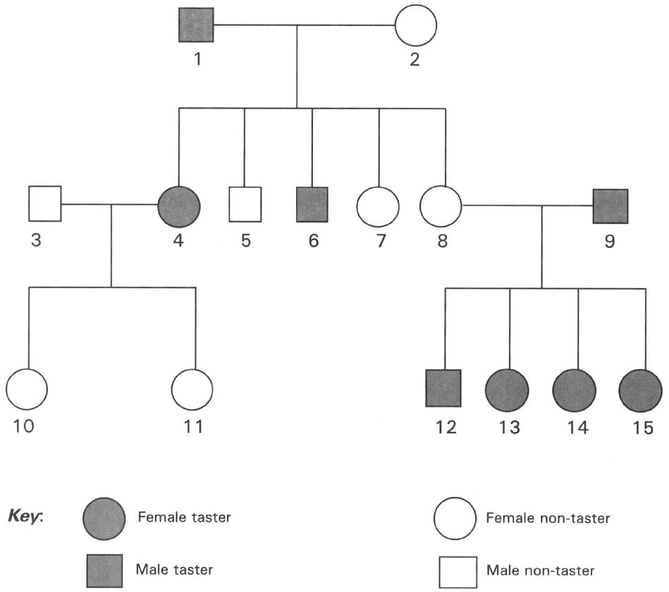
A. 25% B. 33% C. 67% D. 75% Directions: Questions 21.26 and 21.27 refer to the following family pedigree which shows the inheritance of tasting PTC paper. Tasting PTC paper is a dominant character. Non-tasting of PTC paper is a recessive character.
75. If individuals 7 and 8 are twins, which of the following conclusions can be drawn?
A. They must be identical twins.
B. They must be of the same height.
C. If individual 7 has brown eye colour, individual 8 must also have brown eye colour.
D. According to the information given in the pedigree, NO valid conclusion can be drawn.
76. If the genotype of 9 is similar to that of 6, the chance of 8 and 9 to have a child with recessive character is
A. 0% B.25% C.50% D.75% Directions: Questions 21.28 and 21.29 refer to the paragraph below. The hair colour of guinea-pig is controlled by a pair of alleles. The dominant allele B produces black hair and its recessive allele b produces brown hair.
77. If one of the parents of a black guinea-pig is brown, what would be the genotype and phenotype of the other parent?
 | Genotype | Phenotype
(1) | BB | brown
(2) | Bb | black
(3) | bb | brown
(4) | BB | black

A. (1) only
B. (3) only
C. (1) and (3) only
D. (2) or (4)
78. If the above black guinea-pig is crossed with a brown-guinea pig, the phenotypic ratio of their offspring is
 | Black: | Brown
A. | 1 | 0
B. | 0 | 1
C. | 1 | 1
D. | 3 | 1

79. The four pedigrees below show the inheritance of a characteristic in the families of four different couples. Which pedigree can reveal the dominant tract of the characteristic studied?
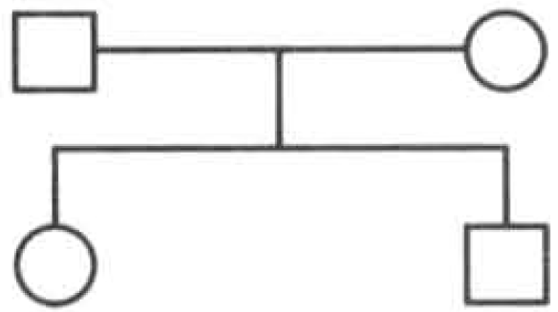
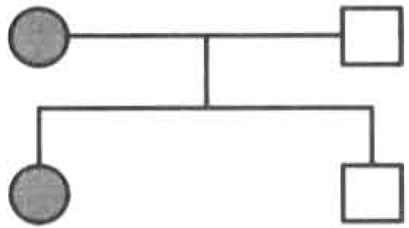
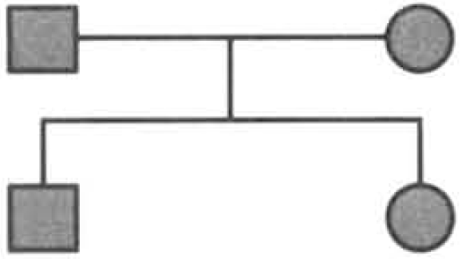
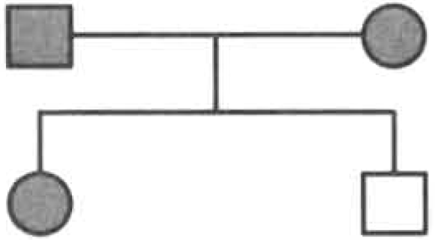
A. | B. | C. | D.

80. Some pure black guinea pigs were mixed with hybrid black guinea pigs. Which of the following is the proper method and expected result of finding out whether a black guinea pig is pure or not?
A. Cross it with a brown guinea pig and all the offspring must be brown.
B. Cross it with a brown guinea pig and all the offspring must be black.
C. Cross it with a known hybrid black guinea pig and all the offspring must be brown.
D. Cross it with a pure black guinea pig and all the offspring must be black. Directions: Questions 21.32 and 21.33 refer to the description below. Brown eye is a dominant character in humans. A blue-eyed man marries a brown-eyed woman. The woman's family includes brown eyed condition for at least three generations.
81. What is the probability that their first child is blue-eyed?
A. 0%
B. 25%
C. 50%
D. 75%
82. What is the probability that their second child is brown-eyed?
A. 25%
B. 50%
C. 70%
D. 100%
83. The gene for yellow seed coat in pea plants is dominant to its allele for green seed coat. Which of the following combinations of cross and the F1 phenotypes is the proper test to identify that the pea plant with yellow seed coat is homozygous?
Directions: Questions 21.35 to 21.37 refer to the genetic experiment studying the inheritance of the body colour of mice. Three groups of mice X, Y and Z, each of which with individuals having the same genotype for body colour, were crossed in the following combinations:
 | Cross the pea plant with yellow seed coat with | F1 phenotypes
A. | Another pea plant with yellow seed coat | All offspring with yellow seed coat
B. | Another pea plant with yellow seed coat | 3 offspring with yellow seed coat : 1 offspring with green seed coat
C. | Another pea plant with green seed coat | All offspring with yellow seed coat
D. | Another pea plant with green seed coat | 1 offspring with yellow seed coat : 1 offspring with green seed coat

Crosses | I | II | III
Parents | XBlack | XBlack | XBlack | YBlack | XBlack | ZBrown
Fl | 92 black and 29 brown | 110 black | 62 black and 57 brown

84. Which cross can effectively distinguish the dominant body colour from the recessive one?
A. Cross I only B. Cross II only C. Cross III only D. Cross I and cross III only
85. Suppose B represents the dominant allele for body colour and b represents the recessive allele. Which of the following matching CORRECTLY describes the genotypes of X, Y and Z?
 | X | Y | Z
A. | Bb | Bb | Bb
B. | bb | Bb | BB
C. | Bb | BB | bb
D. | Bb | BB | Bb

86. Which of the following conclusions is/ are CORRECT? (1) Only 1/4 of the offspring in cross I are homozygous. (2) All the offspring in cross II are heterozygous. (3) Only 1/2 of the offspring in cross III are heterozygous.
A. (1) only
B. (2) only
C. (3) only
D. (1) and (2) only
87. Red is dominant to white in a certain flower. To test whether a red flowered plant is homozygous or heterozygous, one would (1) cross it with a red flowered plant that had a white flowered parent. (2) cross it with a red flowered plant that had two red flowered parents. (3) cross it with a white flowered plant. C. Environmental effects Directions: Questions 21.39 to 21.41 refer to the paragraph below. The colour of corn (Zea mays) is controlled by a pair of alleles: a dominant allele G produces green colour and its recessive allele g produces white colour. Two heterozygous corn plants are crossed to produce 600 seeds. 300 of these seeds are germinated in light and 300 are germinated in dark.
A. (1) only
B. (2) only
C. (3) only
D. (1) and (3) only
88. What would be the genotypes of these two parent plants?
A. GG and GG
B. GG and Gg
C. Gg and Gg
D. gg and gg
89. What would be the genotypic ratio of their offspring?
A. GG : Gg : gg
B. GG : Gg
C. Gg : gg
D. GG : gg
90. What would be the number of seedlings obtained in the two different environmental conditions?
Directions: Questions 21.42 to 21.44 refer to experiments A and B which use pure breeding parents to study the effect of the environmental factor in the inheritance of the wing shape in fruit flies. This character is controlled by a pair of alleles. The allele for normal wing, N, is dominant over the allele for curly wing, n.
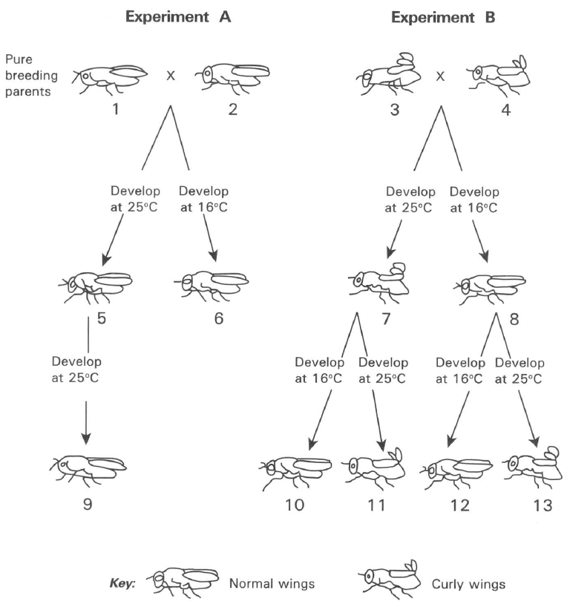
 | Light | Dark
A. | 300 green | 300 white
B. | 200 green, 99 white | 199 green 100 white
C. | 220 green, 78 white | 298 white
D. | 85 green, 215 white | 220 green 80 white

91. Which of the following groups shows the CORRECT genotypes of fruit flies 5, 6, 7 and 8?
 | Fly 5 | Fly 7 | Fly 8 | Fly 11
A. | Nn | nn | NN | Nn
B. | NN | nn | Nn | NN
C. | Nn | Nn | NN | Nn
D. | NN | nn | nn | nn

92. Which of the following conclusions are valid according to the genotypes of flies (1)Temperature has effect on the expression of normal wings. (2)Temperature has effect on the expression of curly wings. (3) Temperature has no effect on the expression of normal wings. (4) Temperature has no effect on the expression of curly wings.
A. (1) and (2) only
B. (1) and (4) only
C. (2) and (3) only
D. (2) and (4) only
93. If fly 9 crossed with fly 11 and their eggs were developed at 25°C, which of the following TRULY represents the genotypes and phenotypes of the offspring obtained?
 | Genotype | Phenotyhpe
A. | Nn | Normal wings
B. | NN, Nn, nn | Normal wings
C. | NN, Nn, nn | Normal wings and curly wings
D. | NN | Normal wings

D. Dihybrid cross
94. In guinea pig the allele for black colour (B) is dominant to the allele for brown colour (b), and the allele for short hair (S) is dominant to the allele for long hair (b). A guinea pig with black, short hairs was crossed with a guinea pig with brown long hairs (bbss).
The F1 phenotypes consist of roughly equal number of black, short hair and black, long hair guinea pigs. What are the genotypes of the parents with black, short hair?
A. BBSS B. BBSs C. BbSS D. BbSs
95. | Tall plant , round seed | 104 | Dwarf plant, round seed | 38 | Tall plant, oval seed | 32 | Dwarf plant, oval seed Tall plant (T) is dominant to dwarf plant (t) Round seed (R) is dominant to oval seed (r) Which of the following are the genotypes of the parents? D. TTRr x ttRr Directions: Questions 21.47 to 21.49 refer to the paragraph below. In maize plants the allele for big leaf (
A. TTRr x ttRR
B. TtRr x ttRR
C. TtRr x ttRr
B. is dominant to small leaf (b) and the allele for smooth leaf (S) is dominant to wrinkly leaf (s). If a maize plant heterozygous for both these two pairs of alleles are self-pollinated and 160 seeds are produced and sown.
96. What would be the expected number of offspring showing wrinkly leaf?
A. 30
B. 40
C. 80
D. 90
97. What would be the expected number of offspring showing both big leaves and smooth leaves?
A. 30
B. 40
C. 80
D. 90
98. What would be the expected number of offspring showing both small leaves and wrinkly leaves?
A. 10
B. 30
C. 40
D. 60
99. In pea plants green seed (G) is dominant to yellow seed (g), and the smooth seed (S) is dominant to the wrinkled seed (s). Which of the following crosses must produce all green, smooth seeds?
A. GgSs x GgSs
B. Ggss x GGSs
C. GgSS x ggSS
D. GgSs x GGSS
100. A plant with serrated leaf and round pollen was crossed with a plant with serrated leaf and angular pollen. The seeds were sown and the following F 1 offspring phenotypes were obtained. 127 Serrated leaf, round pollen 115 Serrated leaf, angular pollen 36 Smooth leaf, round pollen 40 Smooth leaf, angular pollen Which of the following statements about this cross is/are CORRECT? (1) The serrated leaf is dominant to the smooth leaf (2) The round pollen is dominant to the angular pollen. (3) The parent plants in respect to the leaf shape are both heterozygous.
A. (1) only
B. (2) only
C. (1) and (2) only
D. (1) and (3) only
101. In maize plant the allele for tall stem (T) is dominant to the allele for short stem (t), and the allele for green stem (G) is dominant to the allele for red stem (g).
If two maize plants with the genotypes Ttgg and ttGg are crossed, what will be the expected ratio in the Fl offspring?
 | Tall green stem | Tall red stem | Short green stem | Short red stem
A. | 9 | 3 | 3 | 1
B. | 3 | 1 | 3 | 1
C. | 1 | 3 | 1 | 3
D. | 1 | 1 | 1 | 1

102. The dihybrid cross between a pure breeding tomato plant with tall, smooth stem and another tomato plant with short, hairy stem. The F 1 offspring were self-pollinated to produce 290 F2 offspring of which 16 plants had short, smooth stems.
The F2 offspring also consisted of the following three classes of phenotypes :
Tall, hairy stem Short, hairy stem Tall, smooth stem
Which of the following conclusions can be drawn from these results?
A. Both alleles for short and smooth are recessive.
B. The allele for short is recessive and the allele for smooth is dominant .
C. The allele for short is dominant and the allele for smooth is recessive .
D. Both alleles for short and smooth are dominant . E. Multiple alleles
103. IA, IB and i are multiple alleles that determine the blood groups in humans. IA and IB are codominant and both of them are dominant to i. Which of the following parents can produce children with four possible blood groups A,B ,AB and O?
A. IAIA and IBIB B. IAIB and ii C. IAi and IBi D. IAIB and IBi
104. The human ABO blood group system is controlled by three alleles, IA, IB and i. IA and IB are codominant and i is recessive to both alleles IA and IB. How many genotypes are responsible for the expression of the four phenotypes of blood groups A, B, AB and O. D. 6 F. Sex determination and sex linkage
A. 3
B. 4
C. 5
D. 6 F. Sex determination and sex linkage
105. The blood group of a man is A and that of his father is O. The blood group of his wife is B. They have a child with blood group O. What is the probability that their next child has blood group A? C.50%
A. 0%
B. 25%
C. 50%
D. 100%
106. If a man has blood group AB and his wife has blood group O . What is the probability that their child will have either of their blood groups? C.50%
A. 0%
B. 25%
C. 50%
D. 75%
107. If a man has blood group A and his wife has blood group B, what is the probability that their child will have blood group A?
A. 0%
B. 25%
C. 50%
D. Uncertain
108. Which of the following statements about the genotypes of members in a family is CORRECT?
A. A boy with blood group B, one of his parents must have blood group B.
B. A boy with blood group A, one of his parents must have blood group AB.
C. A girl with blood group AB, one of her parents must have blood group AB.
D. A girl with blood group O will not possess an allele IA nor IB.
109. The sex of a human is mainly determined by
A. the genotype of the ovum at the time of fertilisation.
B. the genotype of the sperm at the time of fertilisation.
C. the genotype of the mother.
D. the number of sex chromosomes present in the zygote.
110. A man has two daughters. The body cell of each individual has two sex chromosomes. Which of the following statements about the sex chromosomes of the family individuals concerned is true? (1) All the sex chromosomes of the man are X. (2) All the sex chromosomes of the man's wife are X. (3)Half of the man's sex chromosomes are Y. (4) All the sex chromosomes of the daughters are X.
A. (1) only
B. (3) and (4) only
C. (2), (3) and (4) only
D. (1), (3) and (4) only
111. If a couple have four daughters, what is the probability that the fifth child is a son?
A. 25%
B. 50%
C. 75%
D. 100%
112. Which of the following combinations about the genetic makeup of the gametes is CORRECT?
 | Eggs produced by an ovary | Sperms produced by a testis
A. | Some contain both an X and a Y chromosome. | All contain a Y chromosome.
B. | All contain an X chromosome. | All contain a Y chromosome.
C. | Half contain an X chromosome and half contain a Y chromosome. | All contain an X chromosome.
D. | All contain an X chromosome. | Half contain an X chromosome and half contain a Y chromosome.

113. Which of the following about sex chromosomes is/are CORRECT? (1) Y chromosomes can only be found in sperms inside the testes of a male. (2) X chromosomes cannot be found in any cells of a male. (3) Sex-linked genes are present on the X-chromosome. (4) Males have higher chance to be inherited with the sex-linked genetic disorder.
A. (1) and (2) only
B. (2) and (3) only
C. (3) and (4) only
D. (4) and (1) only
114. The pedigree below shows the inheritance of a sex-linked recessive genetic disorder in a family.
Which of the following is the mode of inheritance shown in the pedigree?
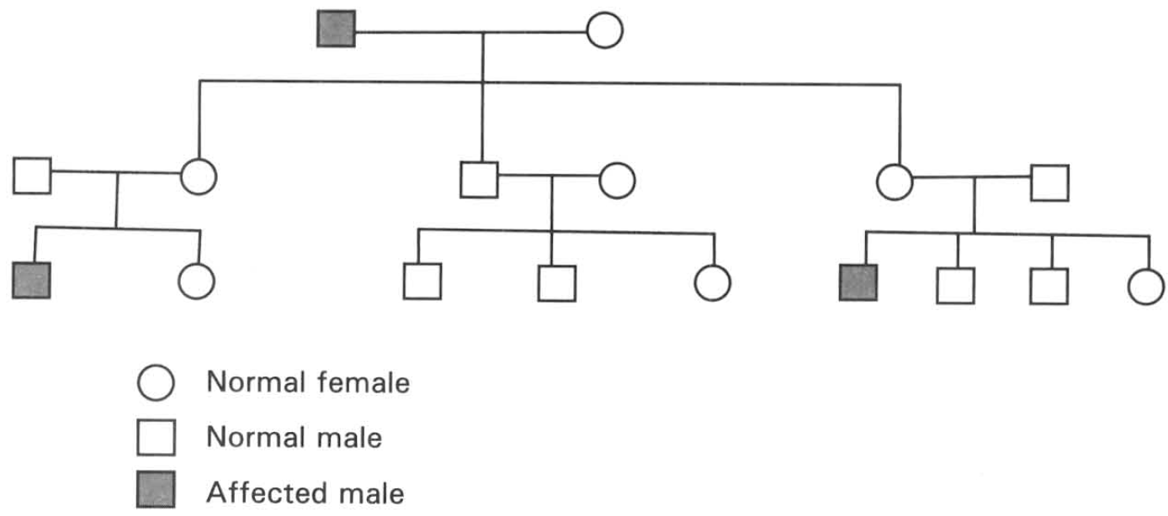
A. Dominant character is controlled by an allele present on sex chromosome.
B. Recessive character is controlled by an allele present on the sex chromosome.
C. Dominant character is controlled by an allele present on an autosome.
D. Recessive character is controlled by an allele present on an autosome.
115. If a sex-linked genetic disorder is caused by a recessive allele located on the X chromosome, a female can be a carrier of this genetic disorder. Which of the following statements about this female is CORRECT?
A. She must receive the recessive sex-linked allele from her father.
B. She must receive the recessive sex-linked allele from her mother.
C. She must pass the recessive sex-linked allele to her son.
D. None of the above statement is valid.
116. Which of the following is the ultimate cause of haemophilia, a genetic disorder, in humans?
A. Independent assortment of chromosomes during meiosis.
B. Crossing over between genetic segments of the homologous chromosomes.
C. Mutation. D. Natural selection.
117. Haemophilia is a genetic disorder caused by a recessive allele located on the X chromosome. Which of the following statements is CORRECT?
A. If a mother has haemophilia, her son must also have haemophilia.
B. If a mother has haemophilia, her daughter must also have haemophilia.
C. If a father has haemophilia, his son must also have haemophilia.
D. If a father has haemophilia, his daughter must also have haemophilia. Directions: Questions 21.69 to 21.71 refer to the inheritance of a hereditary disease, haemophilia. This characteristic is sex-linked. A boy has haemophilia while both of his parents have normal blood.
118. Which of the following statements is CORRECT?
A. Both parents are homozygous. B. The mother must be heterozygous.
C. The father must have the allele causing haemophilia.
D. The boy must be homozygous.
119. What is the chance that the second child is a boy who has haemophilia?
A. 0
B. 1/4
C. 1/2
D. 3/4
120. What is the chance that the second child is a girl who has haemophilia?
A. 0
B. 1/4
C. 1/2
D. 3/4
121. A woman with normal blood, whose father with haemophilia, married a man with haemophilia. What is the probability that their first child is a boy with haemophilia?
A. 100%
B. 75%
C. 50%
D. 25%
122. Colour blindness is caused by a recessive allele located on the X chromosome. Which of the following statements is/are CORRECT?
A. A colour-blind male must have a colour-blind father.
B. A colour-blind female must have a colour-blind father.
C. A colour-blind female must have a colour-blind mother.
D. A colour-blind male must have a colour-blind mother.
123. The recessive allele for red-green colour blindness is located on the X-chromosome. If a man suffering from red-green colour blindness married a non-carrier female with normal colour vision, which of the following about their children is CORRECT?
A. 50% of the females would be carriers; 100% of the males would be affected.
B. 100% of the females would be normal; 50% of the males would be affected.
C. 100% of the females would be carriers; 100% of the males would be normal.
D. 50% of the females would be affected; 100% of the males would be affected.
124. What are the phenotypes of the parents with a colour-blind son and a non-carrier daughter with normal colour vision.
Directions: Questions 21.76 and 21.77 refer to the paragraph below.
Red green colour blindness is a genetic disorder caused by a recessive allele (Xc) present on the X chromosome. The dominant allele controlling normal colour vision is XC. The diagram below shows the pedigree of a family with this genetic disorder.
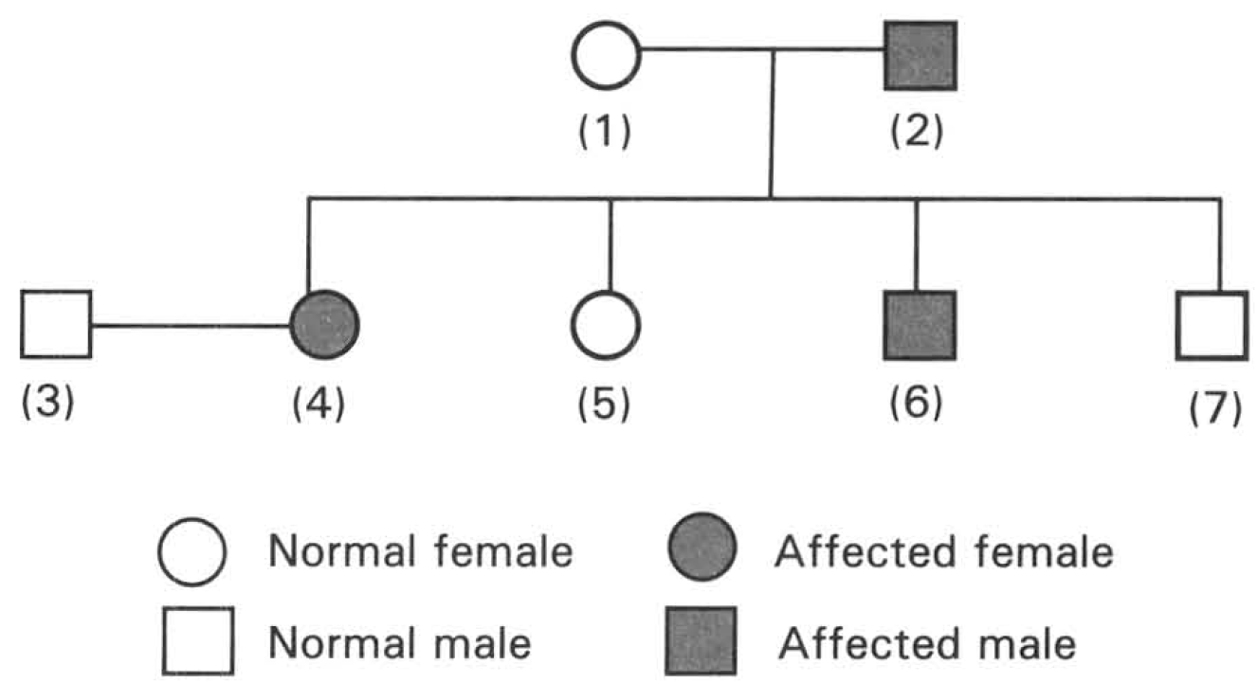
 | Mother | Father
A. | Colour-blind | Colour-blind
B. | Carrier | Colour-blind
C. | Carrier | Normal
D. | Colour-blind | Normal

125. Which of the following combinations of the genotypes of the persons concerned is CORRECT?
 | Person (1) | Person (4) | Person (7)
A. | XC XC | XC Xc | Xc Y
B. | XC Xc | Xc Xc | XC Y
C. | XC XC | XC Xc | Xc Y
D. | XC Xc | XC XC | XC Y

126. Which of the following statements about the children of persons 3 and 4 is INCORRECT?
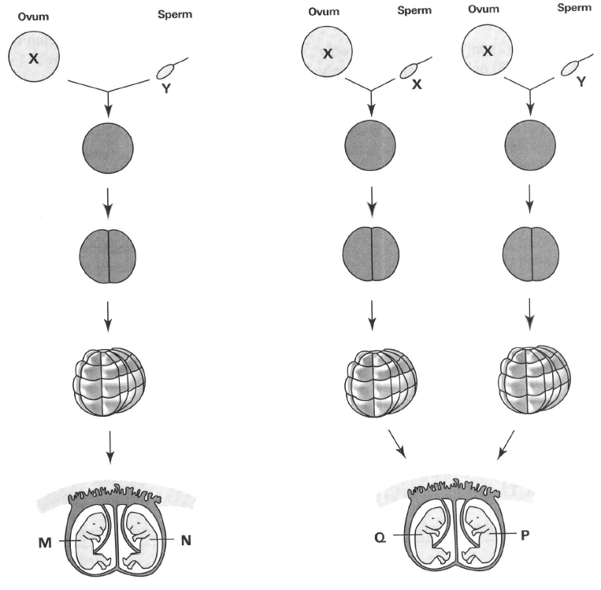
A. All their sons must have colour-blindness.
B. All their daughters must have normal vision.
C. All their daughters are carriers.
D. All their sons must receive a recessive sex-linked gene from their father. G. Twins Directions: Questions 21.78 to 21.81 refer to the diagram below, which shows the formation of two pairs of twins M, N and Q, P.
127. Which of the following matching is CORRECT?
 | M | N | Q | P
A. | Girl | Girl | Boy | Girl
B. | Boy | Boy | Girl | Girl
C. | Girl | Boy | Girl | Girl
D. | Boy | Boy | Girl | Boy

128. Which of the following characters will be the same if M and N develop under different environmental conditions? (1) Eye colour (2) Weight (3) Sex (4) Intelligence
A. (1) and (2) only
B. (1) and (3) only
C. (2) and (3) only
D. (2) and (4) only
129. Which of the following characters may be different even if Q and P develop under the same environmental conditions? (1) Height (2) Weight (3) Sex (4) Intelligence
A. (1) and (2) only
B. (2) and (3) only
C. (2), (3) and (4) only
D. (1), (2), (3) and (4)
130. Which of the following occurrence produces twins with the same genotypes?
A. Two eggs are released from the same ovary into the oviduct of a woman.
B. Two sperms penetrate into the same egg at the same time in the oviduct.
C. A fertilised egg splits and develops into two embryos.
D. Two fertilised eggs develop into two embryos at the same time.
131. The intelligence of identical twins brought up in different environmental conditions is found to have certain degree of differences. This shows that
A. the identical twins have the same genetic constitution.
B. humans have high degree of adaptability to different environmental conditions.
C. the genotypes of the identical twins are different.
D. the expressions of certain genes can be modified by the environmental conditions.
132. For a pair of fraternal (non-identical) twins, which of the following combinations is CORRECT?
Directions: Questions 21.85 and 21.86 refer to the table below, which shows some characteristics of quadruplets. Brown eye is the dominant characteristic.
 | Opposite sex | Chance of having both are boys | Chance of having both are girls
A. | 0% | 50% | 50%
B. | 50% | 25% | 25%
C. | 60% | 20% | 20%
D. | 33.3% | 33.3% | 33.3%

Child | Sex | Blood group | Heart beat rate | IQ | Eye colour
(1) | Boy | B | 72 | 113 | Brown
(2) | Girl | A | 75 | 120 | Blue
(3) | Boy | B | 75 | 112 | Brown
(4) | Girl | A | 75 | 121 | Brown

133. Which of the following conclusions about the type of twins is CORRECT?
A. Children (1) and (3) are identical twins but children (2) and (4) are non-identical twins.
B. Children (2) and (4) are identical twins but children (1) and (3) are non-identical twins.
C. Children (2),(3) and (4) are identical twins but child (1) is not.
D. Children (1),(3) and (4) are identical twins but child (2) is not.
134. What can be implied from the above information?
A. One of their parents must have blood group A and the other must have blood group B.
B. The IQ of their parents must be around 116.
C. Both their parents have blue eyes .
D. Both their parents can have brown eyes.
135. Which of the following characteristics CANNOT be used to determine whether the children are identical twins or not? (1) Blood group (2) Heart beat rate (3) IQ (4) Eye colour (5) Height D. (1),(4) and (5) only H. Variations
A. (1) and (2) only
B. (2) and (3) only
C. (2),(3) and (5) only
D. (1),(4) and (5) only H. Variations
136. Variations are common phenomena in species. Which of the following are causes of variations ? (1) Duplication of chromosomes in cell division. (2) Independent assortment of non-homologous chromosomes (3) Fusion of gametes in fertilisation (4)Exposure to high energy radiations
A. (1) and (2) only
B. (2) and (3) only
C. (1), (2) and (3) only
D. (2), (3) and (4)
137. Which of the following concerned with variations is/are CORRECT? (1) These enable the individuals of the same species to distinguish from each others. (2) Variations increase the ability of the species to explore different resources. (3) Variations acquired during the life time of an organism can be transmitted to its offspring. (4) The accumulation of inherited variations over a very long period of time may lead to the development of a new species.
A. (1) only
B. (2) and (3) only
C. (2) and (4) only
D. (1), (3) and (4) only
138. The following diagram shows the distribution of different blood groups of students in a school. Which of the following is/are valid conclusion(s) that can be drawn from the data above? (1) Blood group is a human character that shows continuous variation. (2) Blood group is controlled by four alleles. (3) Blood group A is the recessive phenotype.
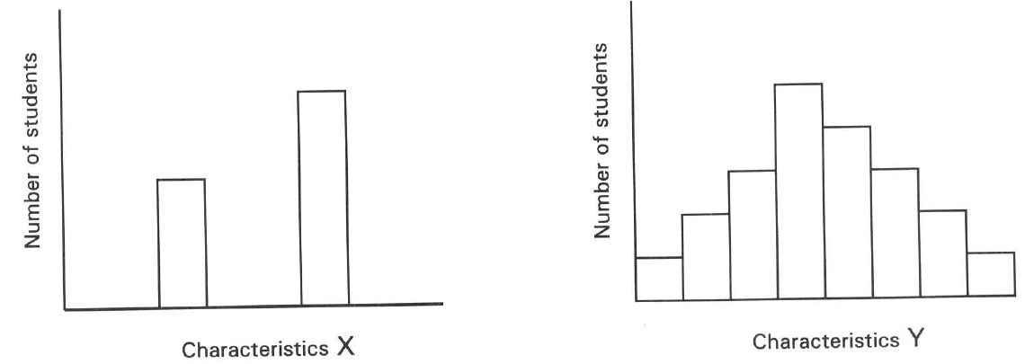
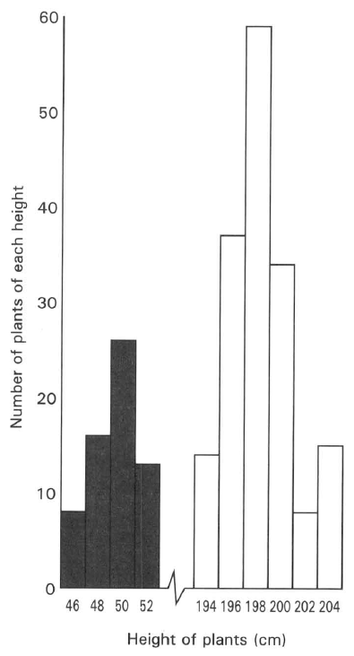
A. (1) only
B. (2) only
C. (3) only
D. None of the above
139. A plant with white flowers is self-pollinated for three generations and all the offspring bear white flowers. However in the fourth generation a plant with purple flowers appeared. Seeds collected from this purple-flowered plant were sown in another farmland. They produced purple-flowered plants. Which of the following explanation about the cause of producing the purple-flowered plant is CORRECT?
A. Environmental effect
B. Mutation
C. Random fertilisation
D. Independent assortment of chromosomes
140. A maize plant with tall stem was self-pollinated and the seeds produced are sown. The graph below shows the F 1 offspring produced in this monohybrid cross.
Which of the following statements about the cross and the characteristics studied is CORRECT?
A. The stem height of the maize plants is a continuous variation.
B. All the Fl offspring are heterozygous.
C. Environmental conditions will affect the expression of the genotypes.
D. Male plants are taller than female plants. Direction: Questions 21.93 to 21.95 refer to the diagram below, which shows the height of a class of students
141. The number of students with heights lie between 160-169 cm is
A. 4.
B. 9.
C. 12.
D. 24.
142. Which of the following can be deduced from the information in the graph?
A. There are 52 students in the class.
B. The height of this class shows discontinuous variation.
C. The average height is 150 - 159 cm.
D. Height can be increased by doing more exercise.
143. 95Which of the following statements related with the variation shown in the diagram is/are CORRECT? (1) Only the external features of the human body belong to this kind of variation. (2) Both genotypes and external environmental conditions affect the expression of this type of variation. (3) This type of variation is distinguished by studying the characteristics of two individuals of the same species.
A. (1) only
B. (2) only
C. (3) only
D. (2) and (3) only
144. A group of students was doing a statistics exercise. They obtained data by recording several human characteristics among themselves. The results could be grouped into the following formats. Which of the following matching of the characteristics to the groups concerned is/are CORRECT?
 | Characteristics X | Characteristics Y
(1) | Tongue rolling ability | Body mass
(2) | Height | Shape of ear lobe
(3) | Eye colour | IQ
(4) | Skin colour | Pulse rate

A. (1) only
B. (2) only
C. (1) and (3) only
D. (2) and (4) only
145. Which of the following comparison between continuous and discontinuous variations is CORRECT?
 | Continuous variation | Discontinuous variation
(1) | Usually controlled by many pairs of genes. | Usually controlled by one or two pairs of genes.
(2) | Many intermediate forms exist. | Seldom have intermediate forms .
(3) | Not affected by environment. | Easily affected by environment.
(4) | Graphical representation does not show a normal distribution curve. | Graphical representation shows a bell- shaped normal distribution curve.

A. (1) and (2) only
B. (2) and (3) only
C. (3) and (4) only
D. (1), (2) and (4) only
146. Which of the following is the significance of variations in a species?
A. More offspring can reach the mature stage to reproduce.
B. Shortens the time to reach the peak level of population.
C. Enables the fittest one to survive in nature.
D. Speeds up the rate of producing mutants.

Answers
Answers are printed in red.
1. D
Class: 67.2% correct (n=125) usual slip A
2. B
Class: 76.3% correct (n=291) usual slip D
3. C
Class: 85.9% correct (n=291) usual slip B
4. C. 47
Class: 73.2% correct (n=291) usual slip A
5. A
Class: 88.7% correct (n=115) usual slip D
6. B
Class: 62.0% correct (n=108) usual slip C
7. D. (1), (2) and (3)

8. ?

9. D. (1), (2) and (3)
Class: 60.6% correct (n=104) usual slip B
10. B. (2) only
Class: 56.9% correct (n=109) usual slip A
11. C. (2) and (3) only
Class: 47.4% correct (n=78) usual slip D
12. ?

13. C
Class: 53.5% correct (n=43) usual slip D
14. D. from both his father and mother.
Class: 85.5% correct (n=69) usual slip A
15. A. immediately after the formation of the zygote.
Class: 62.2% correct (n=90) usual slip C
16. B. The X form of character is dominant to the Y form.

17. ?

18. C
Class: 67.2% correct (n=125) usual slip A
19. ?

20. ?

21. C. (2) and (3) only
Class: 84.1% correct (n=69) usual slip B
22. D. No deduction can be made. Directions: Questions 23 to 25 refer to the effect of industrialization on the evolution of moth in Britain. There are two forms of moth and their genotypes are tabulated below.
Class: 44.2% correct (n=43) usual slip B
23. B
Class: 68.2% correct (n=107) usual slip C
24. D. the black form is poorly camouflaged.
Class: 45.7% correct (n=81) usual slip C
25. A
Class: 58.0% correct (n=81) usual slip B
26. C. (2) and (3) only
Class: 79.1% correct (n=43) usual slip D
27. B. fertilisation of gametes is random.
Class: 23.3% correct (n=43) usual slip D
28. D

29. A
Class: 66.7% correct (n=81) usual slip C
30. C. (2) and (3) only
Class: 86.0% correct (n=43) usual slip B
31. ?

32. C

33. A. Individuals 1, 4 and 10
Class: 86.0% correct (n=43) usual slip D
34. ?

35. D. (1), (2) and (3)
Class: 46.5% correct (n=43) usual slip A
36. B. (1), (2) and (3) only
Class: 44.2% correct (n=43) usual slip D
37. C. (2) and (3) only

38. ?

39. D
Class: 69.8% correct (n=43) usual slip A
40. ?

41. B. blood group.
Class: 62.8% correct (n=43) usual slip A
42. A. pulse rate.
Class: 79.1% correct (n=43) usual slip C
43. C. (2) and (3) only

44. ?

45. D
Class: 81.4% correct (n=43) usual slip A
46. B
Class: 86.3% correct (n=73) usual slip C
47. ?

48. D. (1), (2) and (3)

49. ?

50. D. (3) and (4) only

51. D. (1) and (3) only

52. D

53. D. (1), (2) and (3)

54. D. (1), (2), (3) and (4)
Class: 65.6% correct (n=32) usual slip A
55. D. The culture medium has to be carefully sterilized.
Class: 78.5% correct (n=121) usual slip B
56. C. Mendel used statistics approach to explain the results of his breeding experiments.
Class: 66.7% correct (n=123) usual slip A
57. D. (1) and (3) only
Class: 74.3% correct (n=140) usual slip B
58. C. 1R : lr.
Class: 78.4% correct (n=74) usual slip D
59. A. Tt and tt
Class: 73.1% correct (n=67) usual slip C
60. B
Class: 87.5% correct (n=32) usual slip C
61. B. The vestigial-winged condition is the recessive character.
Class: 87.5% correct (n=32) usual slip C
62. D. 77 long-winged males, 85 long-winged females, 80 vestigial-winged males and 78 vestigial-winged females. Directions: Questions 21.14 to 21.16 refer to the description below. A spotted rabbit, when mated with a solid-coloured rabbit, produced all spotted offspring. When these Fl rabbits were crossed among themselves, they produced 25 spotted rabbits and 8 solid-coloured rabbits in the F2 generation.
Class: 75.2% correct (n=105) usual slip B
63. C. 8
Class: 75.0% correct (n=32) usual slip B
64. D. 8
Class: 86.2% correct (n=58) usual slip C
65. B
Class: 88.0% correct (n=75) usual slip C
66. D. None of the above
Class: 84.4% correct (n=32) usual slip C
67. B. 1/2
Class: 69.6% correct (n=148) usual slip D
68. B. 50%
Class: 75.9% correct (n=58) usual slip A
69. D. 9
Class: 78.1% correct (n=32) usual slip A
70. D. Uncertain

71. A. 1 B. 1/4 C. 1/2 D. 3/4 Directions: Questions 21.23 to 21.25 refer to the diagram below, which shows the grains with different colours on a corn cob. The cob is the fruit produced by a cross between two maize plants. The grain colour is controlled by a pair of alleles, P and p. The allele for purple grain colour (P) is dominant to the allele for yellow grain colour (p).
Class: 46.9% correct (n=32) usual slip C
72. D. Pp x Pp
Class: 83.9% correct (n=31) usual slip B
73. B. 33%
Class: 29.0% correct (n=31) usual slip C
74. C
Class: 35.5% correct (n=31) usual slip A
75. D. According to the information given in the pedigree, NO valid conclusion can be drawn.
Class: 78.9% correct (n=57) usual slip A
76. C
Class: 84.2% correct (n=57) usual slip A
77. D. (2) or (4)
Class: 71.4% correct (n=112) usual slip B
78. C
Class: 90.3% correct (n=31) usual slip A
79. D
Class: 76.8% correct (n=69) usual slip A
80. B. Cross it with a brown guinea pig and all the offspring must be black.
Class: 66.2% correct (n=74) usual slip C
81. A. 0%
Class: 71.0% correct (n=31) usual slip C
82. D. 100%
Class: 80.6% correct (n=31) usual slip B
83. C
Class: 78.4% correct (n=74) usual slip A
84. A. Cross I only B. Cross II only C. Cross III only D. Cross I and cross III only
Class: 80.6% correct (n=31) usual slip D
85. C
Class: 90.3% correct (n=31) usual slip D
86. C. (3) only
Class: 82.4% correct (n=74) usual slip D
87. D. (1) and (3) only
Class: 35.5% correct (n=31) usual slip C
88. C. Gg and Gg
Class: 87.1% correct (n=31) usual slip B
89. A. GG : Gg : gg
Class: 90.3% correct (n=31) usual slip C
90. C
Class: 58.1% correct (n=31) usual slip A
91. D
Class: 51.6% correct (n=31) usual slip B
92. C. (2) and (3) only
Class: 79.7% correct (n=74) usual slip B
93. A
Class: 70.3% correct (n=74) usual slip B
94. B
Class: 66.7% correct (n=30) usual slip D
95. ?

96. B. 40
Class: 86.7% correct (n=30) usual slip C
97. D. 90
Class: 46.6% correct (n=73) usual slip C
98. A. 10
Class: 63.0% correct (n=73) usual slip D
99. D. GgSs x GGSS
Class: 90.0% correct (n=30) usual slip A
100. D. (1) and (3) only
Class: 60.0% correct (n=30) usual slip C
101. D
Class: 73.3% correct (n=30) usual slip A
102. A. Both alleles for short and smooth are recessive.
Class: 73.3% correct (n=30) usual slip B
103. C
Class: 93.3% correct (n=30) usual slip A
104. D. 6 F. Sex determination and sex linkage
Class: 83.3% correct (n=30) usual slip B
105. B. 25%
Class: 100.0% correct (n=30) usual slip A
106. A. 0%
Class: 93.3% correct (n=30) usual slip B
107. D. Uncertain
Class: 96.7% correct (n=30) usual slip B
108. D. A girl with blood group O will not possess an allele IA nor IB.
Class: 90.0% correct (n=30) usual slip A
109. B. the genotype of the sperm at the time of fertilisation.
Class: 90.0% correct (n=30) usual slip D
110. C. (2), (3) and (4) only
Class: 93.3% correct (n=30) usual slip D
111. B. 50%
Class: 100.0% correct (n=30) usual slip A
112. D
Class: 100.0% correct (n=30) usual slip A
113. C. (3) and (4) only
Class: 60.0% correct (n=30) usual slip D
114. B. Recessive character is controlled by an allele present on the sex chromosome.
Class: 70.0% correct (n=30) usual slip A
115. D. None of the above statement is valid.
Class: 86.7% correct (n=30) usual slip C
116. C. Mutation. D. Natural selection.
Class: 80.0% correct (n=30) usual slip A
117. A. If a mother has haemophilia, her son must also have haemophilia.
Class: 90.0% correct (n=30) usual slip D
118. B
Class: 80.0% correct (n=30) usual slip D
119. B. 1/4
Class: 60.0% correct (n=30) usual slip C
120. A. 0
Class: 73.3% correct (n=30) usual slip C
121. D. 25%
Class: 56.7% correct (n=30) usual slip C
122. B. A colour-blind female must have a colour-blind father.
Class: 53.3% correct (n=30) usual slip D
123. C. 100% of the females would be carriers; 100% of the males would be normal.
Class: 90.0% correct (n=30) usual slip A
124. C
Class: 93.3% correct (n=30) usual slip B
125. B
Class: 93.3% correct (n=30) usual slip C
126. D. All their sons must receive a recessive sex-linked gene from their father. G. Twins Directions: Questions 21.78 to 21.81 refer to the diagram below, which shows the formation of two pairs of twins M, N and Q, P.
Class: 70.0% correct (n=30) usual slip A
127. D
Class: 90.3% correct (n=31) usual slip C
128. B. (1) and (3) only
Class: 80.6% correct (n=31) usual slip D
129. D. (1), (2), (3) and (4)

130. D. Two fertilised eggs develop into two embryos at the same time.

131. D. the expressions of certain genes can be modified by the environmental conditions.

132. D

133. D. Children (1),(3) and (4) are identical twins but child (2) is not.

134. D. Both their parents can have brown eyes.

135. D. (1),(4) and (5) only H. Variations

136. D. (2), (3) and (4)

137. D. (1), (3) and (4) only

138. D. None of the above

139. D. Independent assortment of chromosomes

140. D. Male plants are taller than female plants. Direction: Questions 21.93 to 21.95 refer to the diagram below, which shows the height of a class of students

141. D. 24.

142. D. Height can be increased by doing more exercise.

143. D. (2) and (3) only

144. D. (2) and (4) only

145. D. (1), (2) and (4) only

146. D. Speeds up the rate of producing mutants.

