Basic genetics · items under 80% correct
Multiple-choice practice
Name: ________________________ Class: ____________
These items were answered correctly by fewer than 80% of students in class Google Forms, matched by the wording in the source bank and the form answer key. Choose the one best answer.
Part A — HKCEE level (Longman)
1. Which of the following parts of a flower contains cells with haploid number of chromosomes?
A. Ovary wall B. Style C. Filament D. Anther
2. Which of the following cell types of the same person has genotype different from the other three?
A. Corneal cell B. OvumC. Nerve cell D. Mucus secreting cell-
3. How many chromosomes are present in the cheek cell of the same person?
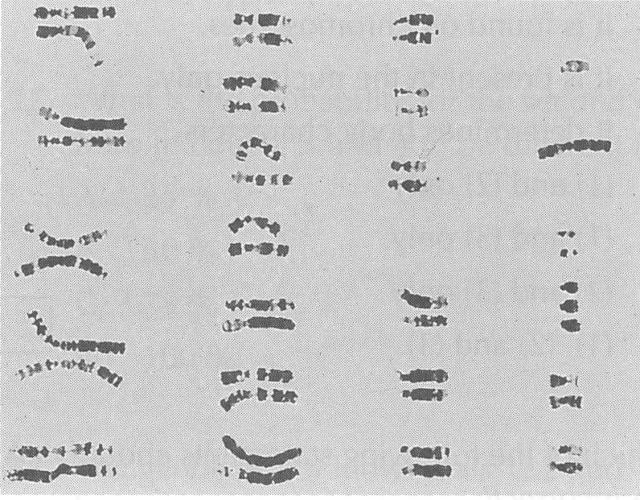
A. 45
B. 46
C. 47
D. 48
4. What genetic disease is this person suffering from?
A. Sickle cell anaemia- B. Down's syndromeC. Haemophilia D. Colourblindness
5. Which of the following substances' formation are controlled by DNA? (1) Enzymes (2) Haemoglobin (3) Hormones
A. (1) and (2) only
B. (1) and (3) only
C. (2) and (3) only
D. (1), (2) and (3)
6. Which of the following substances' formation are not controlled by DNA? (1) Insulin (2) Testosterone (3) Fibrinogen
A. (1) only
B. (2) only
C. (3) only
D. (2) and (3) only
7. Which of the following statements about genes are correct? (1) Different forms of an allele are called genes. (2) Genes are short lengths of DNA on chromosomes. (3) Genes are units determining inherited characters.
A. (1) and (2) only
B. (1) and (3) only
C. (2) and (3) only
D. (1), (2) and (3)
8. Which of the following comparisons between a normal human sperm and a normal human ovum is correct?
 | Human sperm | Human ovum
A. | with one X chromosome | with one X chromosome
B. | with one Y chromosome | with two X chromosomes
C. | with one X or one Y chromosome | with one X chromosome
D. | with one X and one Y chromosome | with two X chromosomes

9. The gender of a person is determined A.immediately after the formation of the zygote. B.immediately after implantation. C.during the development of the embryo. D.during the development of the foetus. Directions: Questions 16 to 18 refer to the pedigree below which shows the inheritance of a certain character with two forms, X and Y. The character is controlled by a single gene (C).
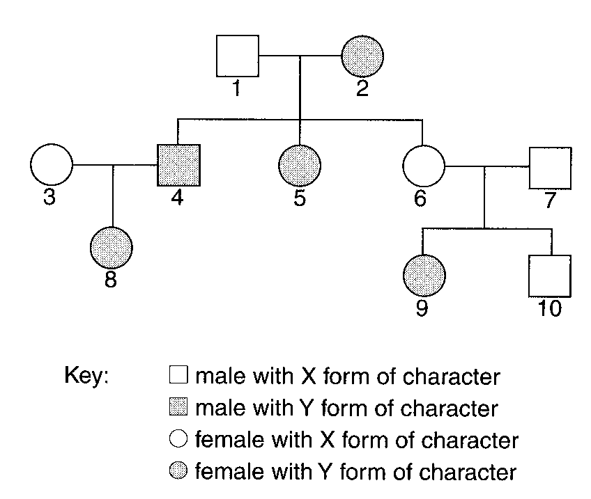
A. immediately after the formation of the zygote.
B. immediately after implantation.
C. during the development of the embryo.
C. .
10. | 2 | 10 | A. | cc | Cc | cc | B. | cc | CC | cc | C. | Cc | cc | CC | D. | CC | cc | Cc
Directions: Questions 19 and 20 refer to the following pedigree which shows the inheritance of body pigmentation in a family. The character is controlled by a single gene (A) which has two forms, the allele for being normal and the allele for being albino.
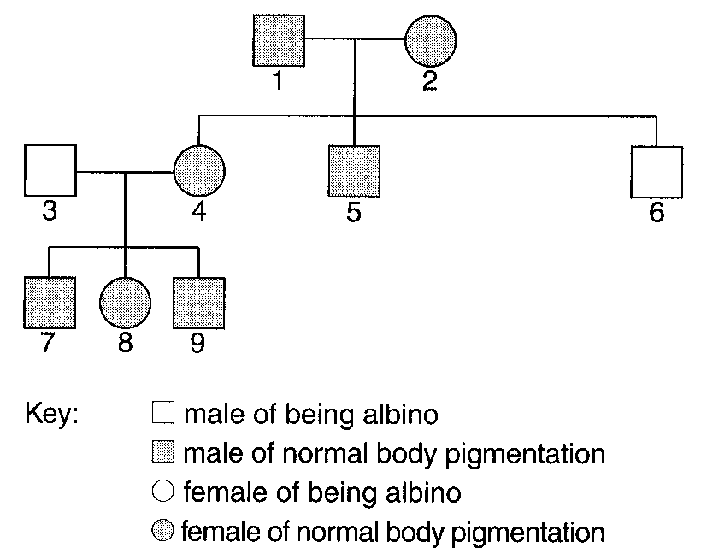
11. In rats, grey fur is dominant to black fur. In a cross, 2 rats with grey fur were mated and their offspring all had grey fur. Which of the following deductions is correct?
 | Genotypes
Black moth | GG'
Grey moth | GG

A. Both parents must be homozygous for grey fur.
B. One of the parents must be homozygous for grey fur.
C. Both parents must be heterozygous for grey fur.
D. No deduction can be made. Directions: Questions 23 to 25 refer to the effect of industrialization on the evolution of moth in Britain. There are two forms of moth and their genotypes are tabulated below.
12. Which of the following correctly describes the two alleles G and G'?
 | Allele | Phenotype determined | Dominant/ Recessive
A. | G | Black | dominant
B. | G | Grey | recessive
C. | G' | Black | recessive
D. | G' | Grey | dominant

13. Before industrialization, there were 85% of grey moths and 15% of black moths in Britain. The grey moths were dominant because
A. the grey form is a dominant character.
B. the grey form is homozygous.
C. the black form is a poorer competitor.
D. the black form is poorly camouflaged.
14. What would be the likely percentages of the two forms of moth 10 years after industrialization?
 | Grey moth | Black moth
A. | 60% | 40%
B. | 85% | 15%
C. | 90% | 10%
D. | 95% | 5%

15. From where in a human body will the gene of mutation be inherited? (1) Uterus (2) Ovary (3) Testis
A. (1) and (2) only
B. (1) and (3) only
C. (2) and (3) only
D. (1), (2) and (3)
16. A brown eyed man married a brown-eyed woman and they gave birth to 3 blue-eyed children. Which of the following can be concluded from the above information? -
A. One of the parents must be heterozygous.
B. fertilisation of gametes is random.
C. Blue eye is dominant to brown eye.
D. The theoretical genotypic ratio of blueeyed to brown-eyed should be 1 : 3.-
17. Which of the following correctly states the identities of persons (I) and (IV)?
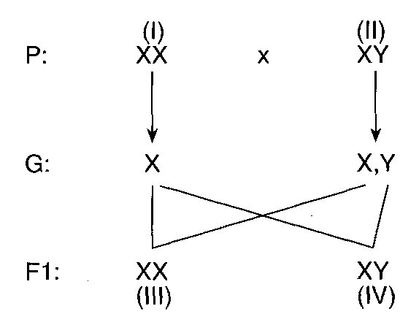
 | (I) | (IV)
A. | mother | son
B. | mother | daughter
C. | father | son
D. | father | daughter

18. The following drawing shows a maize cob with grains of 2 different colours, purple and yellow. The maize cob was produced from crossing 2 maize plants. Which of the following can be concluded from the maize cob? (1) The allele for purple grain is dominant. (2) The phenotypic ratio of purple grain to yellow grain is 3 : 1. (3) Both parents of this maize cob arose from purple grains. A.(1) and (2) only
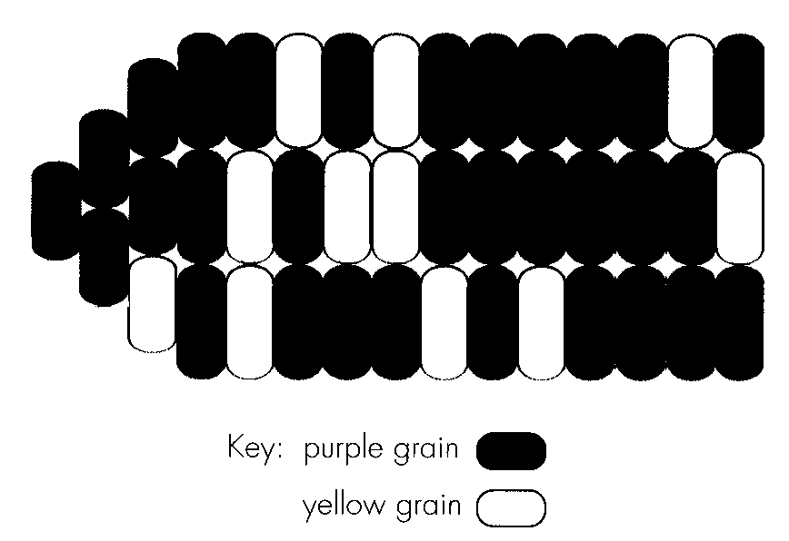
A. (1) and (2) only
B. (1) and (3) only
C. (2) and (3) only
D. (1), (2) and (3)
19. Which of the following are the possible causes of genetic variation in man? (1) Meiosis (2) fertilisation (3) Mutation (4) Environment
A. (1) and (3) only
B. (1), (2) and (3) only
C. (2), (3) and (4) only
D. (1), (2), (3) and (4)
20. Which of the following characteristics cannot normally be changed by the environment?
A. Length of the middle finger B. Body weight
C. Skin colour D. Earlobes
21. The histogram below shows the frequency of various forms of a certain character in man. The character is most likely A. height.
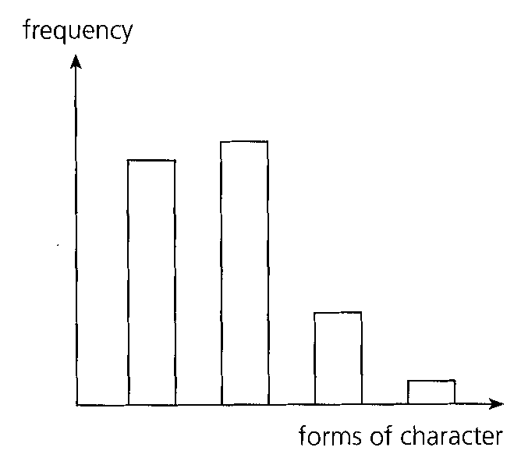
A. height.
B. blood group.
C. weight.
D. intelligence.
22. The frequency of various forms of a human character was investigated and the results were presented in the graph below. The character is most probably
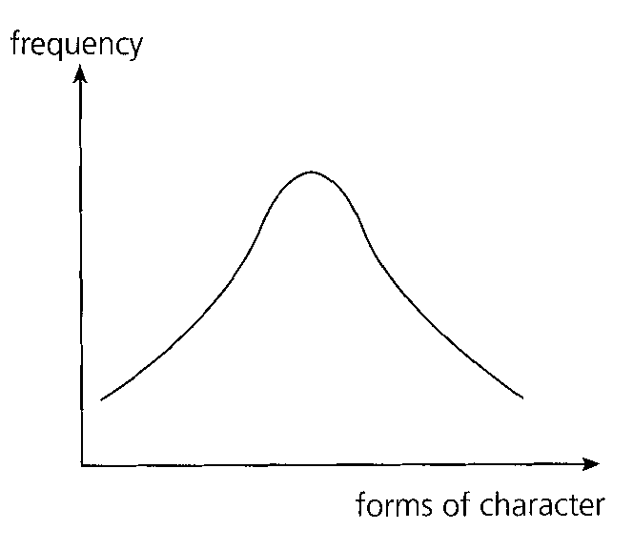
A. pulse rate.
B. gender.
C. eye colour.
D. ear lobe.
Part B — HKDSE-style (YKTo)
23. Which of the following are reasons for using maize as the tool for genetics study? (1) It has inflorescence of male flowers at its tip and inflorescence of female flowers at the lower part that enhances controlled sexual reproduction. (2) Each maize ear contains 600 kernels (seeds). (3) The life cycle is quite short. (4) Needs simple conditions for its cultivation.
A. (1) and (2) only
B. (3) and (4) only
C. (1), (2) and (3) only
D. (1), (2), (3) and (4)
24. Drosophila (fruit fly) is commonly used in genetics experiments. Which of the following is the most undesirable factor of using the organism?
A. Experience is required to identify the male flies from the female flies.
B. Its life cycle is rather short.
C. One female will lay about 100 eggs after the cross.
D. The culture medium has to be carefully sterilized.
25. Which of the following practice enabled Mendel to develop his theories that was not achieved by the biologists before him?
A. Mendel used pure breeding pea plants.
B. Mendel used pea plants with many contrasting characteristics.
C. Mendel used statistics approach to explain the results of his breeding experiments.
D. Mendel carried out the breeding experiments through three successive generations.
26. The tongue-rolling parents have two non-tongue rolling children. Which of the following statements is CORRECT? (1) Tongue rolling is dominant to non-tongue rolling. (2) One of the parents is homozygous. (3) Both children are homozygous.
A. (1) only
B. (2) only
C. (3) only
D. (1) and (3) only
27. The genotype of a given flowering plant is Rr. The probable ratio of alleles in the pollen grains produced by this plant is
A. all R.
B. all r.
C. 1R : lr.
D. 3R : lr.
28. A dominant allele is represented by T and its recessive allele by t. If the genotypic ratio of the Fl is 1 Tt : 1 tt, the genetic constitution of the parents should be
A. Tt and tt
B. Tt and Tt
C. Tt and TT
D. tt and tt
29. Which of the following results is most likely to be produced with regards to the wing condition among the 320 flies?
A. 150 long-winged males and 170 vestigial winged females.
B. 320 long-winged males.
C. 140 long-winged males, 110 long-winged females, 40 vestigial-winged females and 30 vestigial-winged males.
D. 77 long-winged males, 85 long-winged females, 80 vestigial-winged males and 78 vestigial-winged females. Directions: Questions 21.14 to 21.16 refer to the description below. A spotted rabbit, when mated with a solid-coloured rabbit, produced all spotted offspring. When these Fl rabbits were crossed among themselves, they produced 25 spotted rabbits and 8 solid-coloured rabbits in the F2 generation.
30. How many of the spotted rabbits produced in the F2 generation were homozygous?
A. 25
B. 19
C. 8
D. 5
31. What is the probability that individuals 5 and 6 will have a third child who is a tongue-roller'?
A. 0
B. 1/2
C. 1/4
D. 3/4
32. If the husband of individual 7 is a heterozygous roller, what is the probability that their first child is a roller?
A. 25%
B. 50%
C. 75%
D. 100%
33. Which of the following individuals whose genotype cannot be decided to be in heterozygous or homozygous condition for the character studied?
A. 1
B. 3
C. 5
D. 9
34. Individual 11 marries a tongue-rolling man whose family includes no nonroller for at least three generations. What- is the probability that they will have a tongue rolling child?
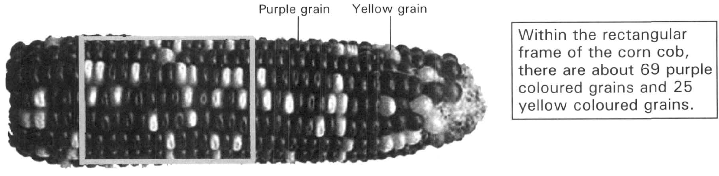
A. 1 B. 1/4 C. 1/2 D. 3/4 Directions: Questions 21.23 to 21.25 refer to the diagram below, which shows the grains with different colours on a corn cob. The cob is the fruit produced by a cross between two maize plants. The grain colour is controlled by a pair of alleles, P and p. The allele for purple grain colour (P) is dominant to the allele for yellow grain colour (p).
35. A purple grain is taken randomly from the corn cob and is sown. Then the plant is crossed with the plant developed from a yellow grain. What is the probability that all the grains on the corn cob are purple coloured?
A. 25%
B. 33%
C. 50%
D. 75%
36. According to the cross in the previous question, what is the probability that half of the grains on the corn cob are yellow in colour?
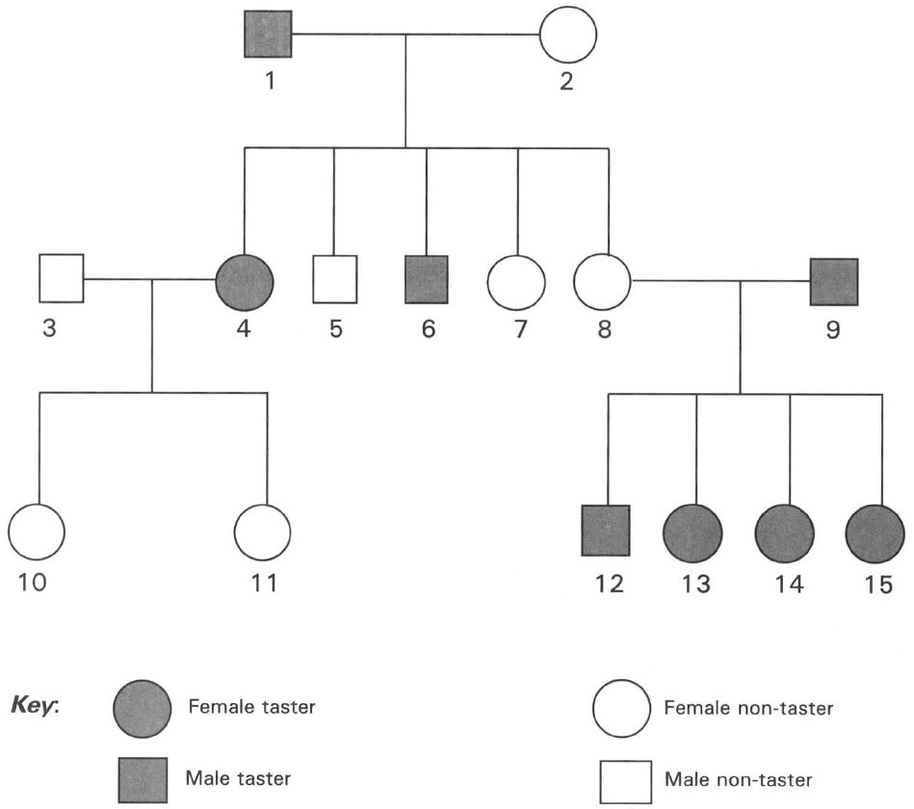
A. 25% B. 33% C. 67% D. 75% Directions: Questions 21.26 and 21.27 refer to the following family pedigree which shows the inheritance of tasting PTC paper. Tasting PTC paper is a dominant character. Non-tasting of PTC paper is a recessive character.
37. If individuals 7 and 8 are twins, which of the following conclusions can be drawn?
A. They must be identical twins.
B. They must be of the same height.
C. If individual 7 has brown eye colour, individual 8 must also have brown eye colour.
D. According to the information given in the pedigree, NO valid conclusion can be drawn.
38. If one of the parents of a black guinea-pig is brown, what would be the genotype and phenotype of the other parent?
 | Genotype | Phenotype
(1) | BB | brown
(2) | Bb | black
(3) | bb | brown
(4) | BB | black

A. (1) only
B. (3) only
C. (1) and (3) only
D. (2) or (4)
39. The four pedigrees below show the inheritance of a characteristic in the families of four different couples. Which pedigree can reveal the dominant tract of the characteristic studied?
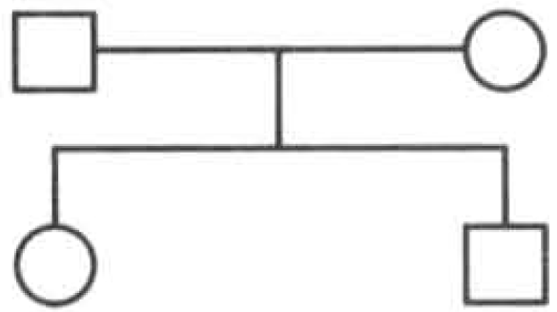
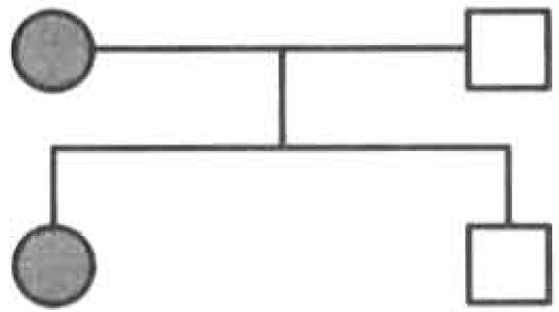
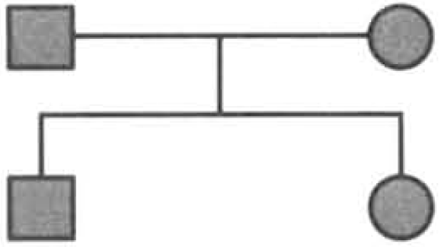
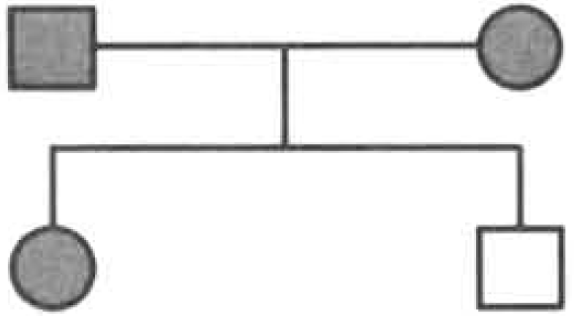
A. | B. | C. | D.

40. Some pure black guinea pigs were mixed with hybrid black guinea pigs. Which of the following is the proper method and expected result of finding out whether a black guinea pig is pure or not?
A. Cross it with a brown guinea pig and all the offspring must be brown.
B. Cross it with a brown guinea pig and all the offspring must be black.
C. Cross it with a known hybrid black guinea pig and all the offspring must be brown.
D. Cross it with a pure black guinea pig and all the offspring must be black. Directions: Questions 21.32 and 21.33 refer to the description below. Brown eye is a dominant character in humans. A blue-eyed man marries a brown-eyed woman. The woman's family includes brown eyed condition for at least three generations.
41. What is the probability that their first child is blue-eyed?
A. 0%
B. 25%
C. 50%
D. 75%
42. The gene for yellow seed coat in pea plants is dominant to its allele for green seed coat. Which of the following combinations of cross and the F1 phenotypes is the proper test to identify that the pea plant with yellow seed coat is homozygous?
Directions: Questions 21.35 to 21.37 refer to the genetic experiment studying the inheritance of the body colour of mice. Three groups of mice X, Y and Z, each of which with individuals having the same genotype for body colour, were crossed in the following combinations:
 | Cross the pea plant with yellow seed coat with | F1 phenotypes
A. | Another pea plant with yellow seed coat | All offspring with yellow seed coat
B. | Another pea plant with yellow seed coat | 3 offspring with yellow seed coat : 1 offspring with green seed coat
C. | Another pea plant with green seed coat | All offspring with yellow seed coat
D. | Another pea plant with green seed coat | 1 offspring with yellow seed coat : 1 offspring with green seed coat

Crosses | I | II | III
Parents | XBlack | XBlack | XBlack | YBlack | XBlack | ZBrown
Fl | 92 black and 29 brown | 110 black | 62 black and 57 brown

43. Red is dominant to white in a certain flower. To test whether a red flowered plant is homozygous or heterozygous, one would (1) cross it with a red flowered plant that had a white flowered parent. (2) cross it with a red flowered plant that had two red flowered parents. (3) cross it with a white flowered plant. C. Environmental effects Directions: Questions 21.39 to 21.41 refer to the paragraph below. The colour of corn (Zea mays) is controlled by a pair of alleles: a dominant allele G produces green colour and its recessive allele g produces white colour. Two heterozygous corn plants are crossed to produce 600 seeds. 300 of these seeds are germinated in light and 300 are germinated in dark.
A. (1) only
B. (2) only
C. (3) only
D. (1) and (3) only
44. What would be the number of seedlings obtained in the two different environmental conditions?
Directions: Questions 21.42 to 21.44 refer to experiments A and B which use pure breeding parents to study the effect of the environmental factor in the inheritance of the wing shape in fruit flies. This character is controlled by a pair of alleles. The allele for normal wing, N, is dominant over the allele for curly wing, n.
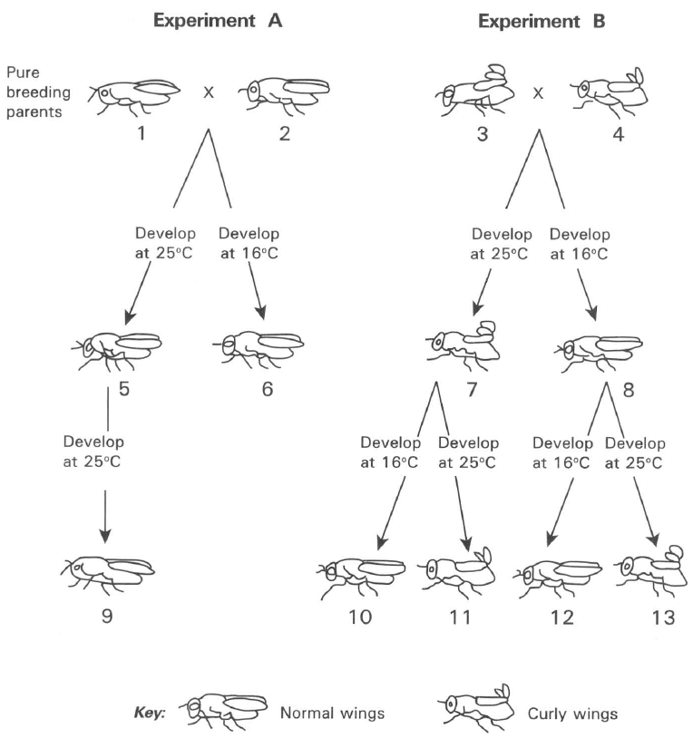
 | Light | Dark
A. | 300 green | 300 white
B. | 200 green, 99 white | 199 green 100 white
C. | 220 green, 78 white | 298 white
D. | 85 green, 215 white | 220 green 80 white

45. Which of the following groups shows the CORRECT genotypes of fruit flies 5, 6, 7 and 8?
 | Fly 5 | Fly 7 | Fly 8 | Fly 11
A. | Nn | nn | NN | Nn
B. | NN | nn | Nn | NN
C. | Nn | Nn | NN | Nn
D. | NN | nn | nn | nn

46. Which of the following conclusions are valid according to the genotypes of flies (1)Temperature has effect on the expression of normal wings. (2)Temperature has effect on the expression of curly wings. (3) Temperature has no effect on the expression of normal wings. (4) Temperature has no effect on the expression of curly wings.
A. (1) and (2) only
B. (1) and (4) only
C. (2) and (3) only
D. (2) and (4) only
47. If fly 9 crossed with fly 11 and their eggs were developed at 25°C, which of the following TRULY represents the genotypes and phenotypes of the offspring obtained?
 | Genotype | Phenotyhpe
A. | Nn | Normal wings
B. | NN, Nn, nn | Normal wings
C. | NN, Nn, nn | Normal wings and curly wings
D. | NN | Normal wings

D. Dihybrid cross
48. In guinea pig the allele for black colour (B) is dominant to the allele for brown colour (b), and the allele for short hair (S) is dominant to the allele for long hair (b). A guinea pig with black, short hairs was crossed with a guinea pig with brown long hairs (bbss).
The F1 phenotypes consist of roughly equal number of black, short hair and black, long hair guinea pigs. What are the genotypes of the parents with black, short hair?
A. BBSS B. BBSs C. BbSS D. BbSs
49. What would be the expected number of offspring showing both big leaves and smooth leaves?
A. 30
B. 40
C. 80
D. 90
50. What would be the expected number of offspring showing both small leaves and wrinkly leaves?
A. 10
B. 30
C. 40
D. 60
51. A plant with serrated leaf and round pollen was crossed with a plant with serrated leaf and angular pollen. The seeds were sown and the following F 1 offspring phenotypes were obtained. 127 Serrated leaf, round pollen 115 Serrated leaf, angular pollen 36 Smooth leaf, round pollen 40 Smooth leaf, angular pollen Which of the following statements about this cross is/are CORRECT? (1) The serrated leaf is dominant to the smooth leaf (2) The round pollen is dominant to the angular pollen. (3) The parent plants in respect to the leaf shape are both heterozygous.
A. (1) only
B. (2) only
C. (1) and (2) only
D. (1) and (3) only
52. In maize plant the allele for tall stem (T) is dominant to the allele for short stem (t), and the allele for green stem (G) is dominant to the allele for red stem (g).
If two maize plants with the genotypes Ttgg and ttGg are crossed, what will be the expected ratio in the Fl offspring?
 | Tall green stem | Tall red stem | Short green stem | Short red stem
A. | 9 | 3 | 3 | 1
B. | 3 | 1 | 3 | 1
C. | 1 | 3 | 1 | 3
D. | 1 | 1 | 1 | 1

53. The dihybrid cross between a pure breeding tomato plant with tall, smooth stem and another tomato plant with short, hairy stem. The F 1 offspring were self-pollinated to produce 290 F2 offspring of which 16 plants had short, smooth stems.
The F2 offspring also consisted of the following three classes of phenotypes :
Tall, hairy stem Short, hairy stem Tall, smooth stem
Which of the following conclusions can be drawn from these results?
A. Both alleles for short and smooth are recessive.
B. The allele for short is recessive and the allele for smooth is dominant .
C. The allele for short is dominant and the allele for smooth is recessive .
D. Both alleles for short and smooth are dominant . E. Multiple alleles
54. Which of the following about sex chromosomes is/are CORRECT? (1) Y chromosomes can only be found in sperms inside the testes of a male. (2) X chromosomes cannot be found in any cells of a male. (3) Sex-linked genes are present on the X-chromosome. (4) Males have higher chance to be inherited with the sex-linked genetic disorder.
A. (1) and (2) only
B. (2) and (3) only
C. (3) and (4) only
D. (4) and (1) only
55. The pedigree below shows the inheritance of a sex-linked recessive genetic disorder in a family.
Which of the following is the mode of inheritance shown in the pedigree?
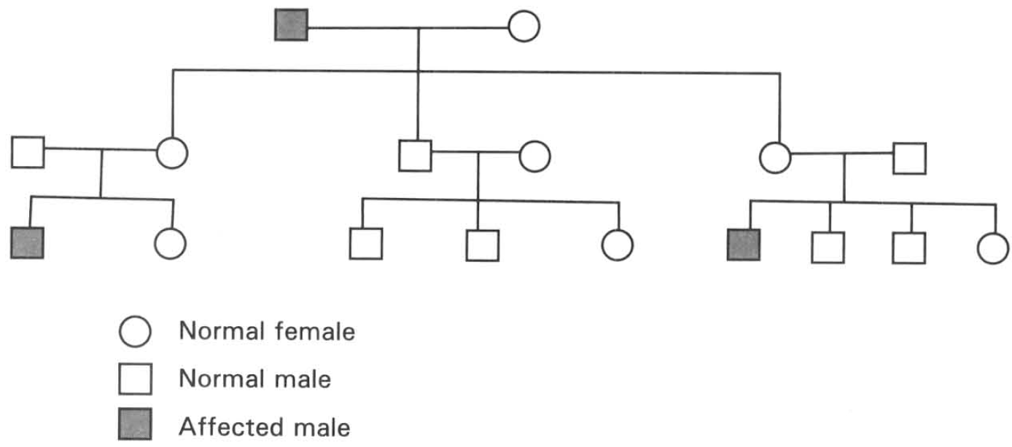
A. Dominant character is controlled by an allele present on sex chromosome.
B. Recessive character is controlled by an allele present on the sex chromosome.
C. Dominant character is controlled by an allele present on an autosome.
D. Recessive character is controlled by an allele present on an autosome.
56. Which of the following is the ultimate cause of haemophilia, a genetic disorder, in humans?
A. Independent assortment of chromosomes during meiosis.
B. Crossing over between genetic segments of the homologous chromosomes.
C. Mutation. D. Natural selection.
57. Which of the following statements is CORRECT?
A. Both parents are homozygous. B. The mother must be heterozygous.
C. The father must have the allele causing haemophilia.
D. The boy must be homozygous.
58. What is the chance that the second child is a boy who has haemophilia?
A. 0
B. 1/4
C. 1/2
D. 3/4
59. What is the chance that the second child is a girl who has haemophilia?
A. 0
B. 1/4
C. 1/2
D. 3/4
60. A woman with normal blood, whose father with haemophilia, married a man with haemophilia. What is the probability that their first child is a boy with haemophilia?
A. 100%
B. 75%
C. 50%
D. 25%
61. Colour blindness is caused by a recessive allele located on the X chromosome. Which of the following statements is/are CORRECT?
A. A colour-blind male must have a colour-blind father.
B. A colour-blind female must have a colour-blind father.
C. A colour-blind female must have a colour-blind mother.
D. A colour-blind male must have a colour-blind mother.
62. Which of the following statements about the children of persons 3 and 4 is INCORRECT?
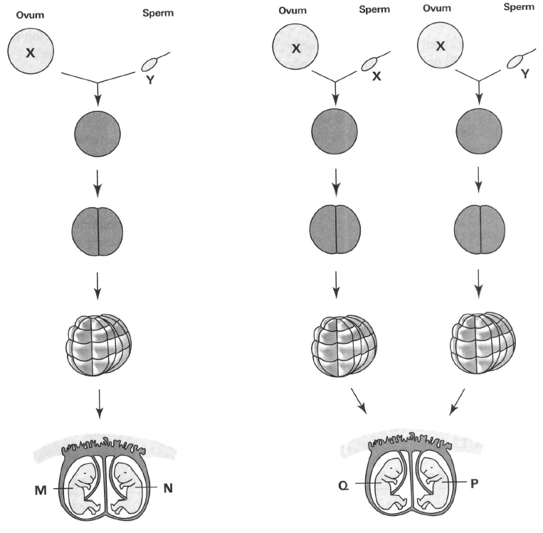
A. All their sons must have colour-blindness.
B. All their daughters must have normal vision.
C. All their daughters are carriers.
D. All their sons must receive a recessive sex-linked gene from their father. G. Twins Directions: Questions 21.78 to 21.81 refer to the diagram below, which shows the formation of two pairs of twins M, N and Q, P.

Answers
Answers are printed in red.
1. D
Class: 67.2% correct (n=125) usual slip A
2. B
Class: 76.3% correct (n=291) usual slip D
3. C. 47
Class: 73.2% correct (n=291) usual slip A
4. B
Class: 62.0% correct (n=108) usual slip C
5. D. (1), (2) and (3)
Class: 60.6% correct (n=104) usual slip B
6. B. (2) only
Class: 56.9% correct (n=109) usual slip A
7. C. (2) and (3) only
Class: 47.4% correct (n=78) usual slip D
8. C
Class: 53.5% correct (n=43) usual slip D
9. A. immediately after the formation of the zygote.
Class: 62.2% correct (n=90) usual slip C
10. C
Class: 67.2% correct (n=125) usual slip A
11. D. No deduction can be made. Directions: Questions 23 to 25 refer to the effect of industrialization on the evolution of moth in Britain. There are two forms of moth and their genotypes are tabulated below.
Class: 44.2% correct (n=43) usual slip B
12. B
Class: 68.2% correct (n=107) usual slip C
13. D. the black form is poorly camouflaged.
Class: 45.7% correct (n=81) usual slip C
14. A
Class: 58.0% correct (n=81) usual slip B
15. C. (2) and (3) only
Class: 79.1% correct (n=43) usual slip D
16. B. fertilisation of gametes is random.
Class: 23.3% correct (n=43) usual slip D
17. A
Class: 66.7% correct (n=81) usual slip C
18. D. (1), (2) and (3)
Class: 46.5% correct (n=43) usual slip A
19. B. (1), (2) and (3) only
Class: 44.2% correct (n=43) usual slip D
20. D
Class: 69.8% correct (n=43) usual slip A
21. B. blood group.
Class: 62.8% correct (n=43) usual slip A
22. A. pulse rate.
Class: 79.1% correct (n=43) usual slip C
23. D. (1), (2), (3) and (4)
Class: 65.6% correct (n=32) usual slip A
24. D. The culture medium has to be carefully sterilized.
Class: 78.5% correct (n=121) usual slip B
25. C. Mendel used statistics approach to explain the results of his breeding experiments.
Class: 66.7% correct (n=123) usual slip A
26. D. (1) and (3) only
Class: 74.3% correct (n=140) usual slip B
27. C. 1R : lr.
Class: 78.4% correct (n=74) usual slip D
28. A. Tt and tt
Class: 73.1% correct (n=67) usual slip C
29. D. 77 long-winged males, 85 long-winged females, 80 vestigial-winged males and 78 vestigial-winged females. Directions: Questions 21.14 to 21.16 refer to the description below. A spotted rabbit, when mated with a solid-coloured rabbit, produced all spotted offspring. When these Fl rabbits were crossed among themselves, they produced 25 spotted rabbits and 8 solid-coloured rabbits in the F2 generation.
Class: 75.2% correct (n=105) usual slip B
30. C. 8
Class: 75.0% correct (n=32) usual slip B
31. B. 1/2
Class: 69.6% correct (n=148) usual slip D
32. B. 50%
Class: 75.9% correct (n=58) usual slip A
33. D. 9
Class: 78.1% correct (n=32) usual slip A
34. A. 1 B. 1/4 C. 1/2 D. 3/4 Directions: Questions 21.23 to 21.25 refer to the diagram below, which shows the grains with different colours on a corn cob. The cob is the fruit produced by a cross between two maize plants. The grain colour is controlled by a pair of alleles, P and p. The allele for purple grain colour (P) is dominant to the allele for yellow grain colour (p).
Class: 46.9% correct (n=32) usual slip C
35. B. 33%
Class: 29.0% correct (n=31) usual slip C
36. C
Class: 35.5% correct (n=31) usual slip A
37. D. According to the information given in the pedigree, NO valid conclusion can be drawn.
Class: 78.9% correct (n=57) usual slip A
38. D. (2) or (4)
Class: 71.4% correct (n=112) usual slip B
39. D
Class: 76.8% correct (n=69) usual slip A
40. B. Cross it with a brown guinea pig and all the offspring must be black.
Class: 66.2% correct (n=74) usual slip C
41. A. 0%
Class: 71.0% correct (n=31) usual slip C
42. C
Class: 78.4% correct (n=74) usual slip A
43. D. (1) and (3) only
Class: 35.5% correct (n=31) usual slip C
44. C
Class: 58.1% correct (n=31) usual slip A
45. D
Class: 51.6% correct (n=31) usual slip B
46. C. (2) and (3) only
Class: 79.7% correct (n=74) usual slip B
47. A
Class: 70.3% correct (n=74) usual slip B
48. B
Class: 66.7% correct (n=30) usual slip D
49. D. 90
Class: 46.6% correct (n=73) usual slip C
50. A. 10
Class: 63.0% correct (n=73) usual slip D
51. D. (1) and (3) only
Class: 60.0% correct (n=30) usual slip C
52. D
Class: 73.3% correct (n=30) usual slip A
53. A. Both alleles for short and smooth are recessive.
Class: 73.3% correct (n=30) usual slip B
54. C. (3) and (4) only
Class: 60.0% correct (n=30) usual slip D
55. B. Recessive character is controlled by an allele present on the sex chromosome.
Class: 70.0% correct (n=30) usual slip A
56. C. Mutation. D. Natural selection.
Class: 80.0% correct (n=30) usual slip A
57. B
Class: 80.0% correct (n=30) usual slip D
58. B. 1/4
Class: 60.0% correct (n=30) usual slip C
59. A. 0
Class: 73.3% correct (n=30) usual slip C
60. D. 25%
Class: 56.7% correct (n=30) usual slip C
61. B. A colour-blind female must have a colour-blind father.
Class: 53.3% correct (n=30) usual slip D
62. D. All their sons must receive a recessive sex-linked gene from their father. G. Twins Directions: Questions 21.78 to 21.81 refer to the diagram below, which shows the formation of two pairs of twins M, N and Q, P.
Class: 70.0% correct (n=30) usual slip A

Class percentage correct
Matched to this paper by question wording in the source bank and the form answer key, not by a shifted paper number.
Q | Answer | % correct | n | Usual slip
1 | D | 67.2% | 125 | A
2 | B | 76.3% | 291 | D
3 | C | 73.2% | 291 | A
4 | B | 62.0% | 108 | C
5 | D | 60.6% | 104 | B
6 | B | 56.9% | 109 | A
7 | C | 47.4% | 78 | D
8 | C | 53.5% | 43 | D
9 | A | 62.2% | 90 | C
10 | C | 67.2% | 125 | A
11 | D | 44.2% | 43 | B
12 | B | 68.2% | 107 | C
13 | D | 45.7% | 81 | C
14 | A | 58.0% | 81 | B
15 | C | 79.1% | 43 | D
16 | B | 23.3% | 43 | D
17 | A | 66.7% | 81 | C
18 | D | 46.5% | 43 | A
19 | B | 44.2% | 43 | D
20 | D | 69.8% | 43 | A
21 | B | 62.8% | 43 | A
22 | A | 79.1% | 43 | C
23 | D | 65.6% | 32 | A
24 | D | 78.5% | 121 | B
25 | C | 66.7% | 123 | A
26 | D | 74.3% | 140 | B
27 | C | 78.4% | 74 | D
28 | A | 73.1% | 67 | C
29 | D | 75.2% | 105 | B
30 | C | 75.0% | 32 | B
31 | B | 69.6% | 148 | D
32 | B | 75.9% | 58 | A
33 | D | 78.1% | 32 | A
34 | A | 46.9% | 32 | C
35 | B | 29.0% | 31 | C
36 | C | 35.5% | 31 | A
37 | D | 78.9% | 57 | A
38 | D | 71.4% | 112 | B
39 | D | 76.8% | 69 | A
40 | B | 66.2% | 74 | C
41 | A | 71.0% | 31 | C
42 | C | 78.4% | 74 | A
43 | D | 35.5% | 31 | C
44 | C | 58.1% | 31 | A
45 | D | 51.6% | 31 | B
46 | C | 79.7% | 74 | B
47 | A | 70.3% | 74 | B
48 | B | 66.7% | 30 | D
49 | D | 46.6% | 73 | C
50 | A | 63.0% | 73 | D
51 | D | 60.0% | 30 | C
52 | D | 73.3% | 30 | A
53 | A | 73.3% | 30 | B
54 | C | 60.0% | 30 | D
55 | B | 70.0% | 30 | A
56 | C | 80.0% | 30 | A
57 | B | 80.0% | 30 | D
58 | B | 60.0% | 30 | C
59 | A | 73.3% | 30 | C
60 | D | 56.7% | 30 | C
61 | B | 53.3% | 30 | D
62 | D | 70.0% | 30 | A

