Growth
Multiple-choice practice
Name: ________________________ Class: ____________
There are 50 questions compiled from Longman HKCEE and/or YKTo papers. Choose the one best answer.
Part A — HKDSE-style (YKTo)
1. 1Which of the following processes is/are involved in growth of plants? (1) Mitosis (2) Cell enlargement (3) Cell differentiation (4) Oxidation of reserved food
A. (1) only
B. (2) and (3) only
C. (1), (2) and (3) only
D. (1), (2), (3) and (4)
2. 2Which of the following statements about growth is/are INCORRECT? (1) Different parts of a human body grow at different rates. (2) The increase in length of the root is mainly due to the activities in the meristematic region, not the elongation region. (3) Growth takes place evenly in all parts of a flowering plant. (4) Only growth in plants is affected by hormones.
A. (1) only
B. (3) only
C. (2) and (3) only
D. (2), (3) and (4) only
3. Which of the following statements concerning growth of individual plant is /are CORRECT? (1) Increase in the number of trees in a community. (2) Increase in the size of the forest. (3) Increase in the complexity of cells in the plant.
A. (1) only
B. (2) only
C. (3) only
D. (1) and (2) only
4. Which of the following statements about the growth in the monocotyledonous flowering plant is INCORRECT?
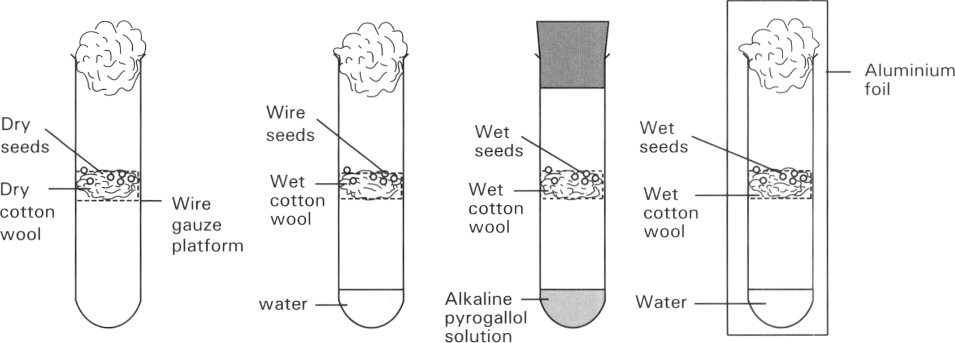
A. It occurs throughout life.
B. Growth in root is mainly apical.
C. The increase of plant tissues is mainly brought about by mitosis.
D. Growth is not affected by light illumination. Directions: Questions 15.5 to 15.8 refer to the diagrams below which show the set up of an experiment to study the conditions needed for germinaton of seeds. The tubes were kept at 30°C. Only seeds in tubes B and D germinated.
5. Which conditions are investigated in this experiment for their need in the germination of seeds? (1) Water (2) Oxygen (3) Light (4) Warmth
A. (1) and (2) only
B. (2) and (3) only
C. (3) and (4) only
D. (1), (2) and (3) only
6. According to the results, what conditions are needed for seeds to germinate.
A. Water and light only
B. Oxygen and light only
C. Water and oxygen only
D. Oxygen and warmth only
7. Which two tubes are used to investigate the need of oxygen for seed germination?
A. Tube A and tube B only B. Tube B and tube C only
C. Tube B and tube D only D. Tube A and tube C only
8. Which of the following graphs CORRECTLY represents the changes in the dry mass of the seeds in tube A throughout the experiment?
Directions: Questions 15.9 to 15.11 refer to the diagram below which shows an experimental setup.
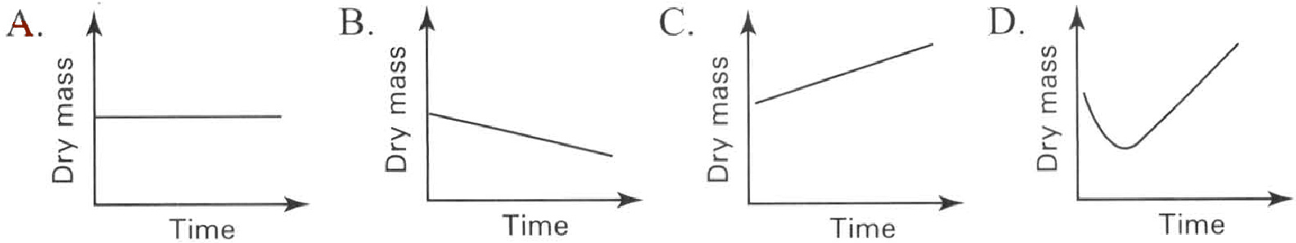
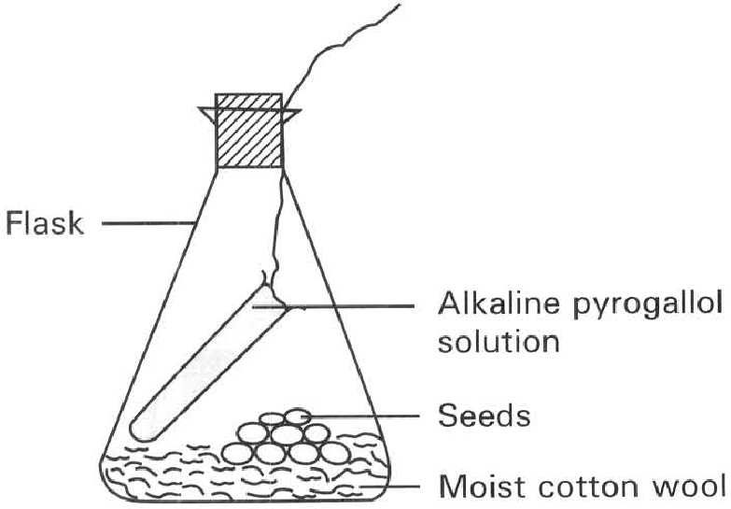
9. 9Which of the following is the probable result of the above experiment?
A. The alkaline pyrogallol solution turns milky.
B. The alkaline pyrogallol solution turns yellow.
C. The alkaline pyrogallol solution turns red.
D. No seed germinates.
10. What is the purpose of the above experiment?
A. To show that carbon dioxide is produced by the living seeds.
B. To show that carbon dioxide is absorbed by the plant tissues in the presence of light.
C. To show that water is essential to germination.
D. To show that oxygen is essential to germination.
11. Which of the following is the method of setting up the control experiment?
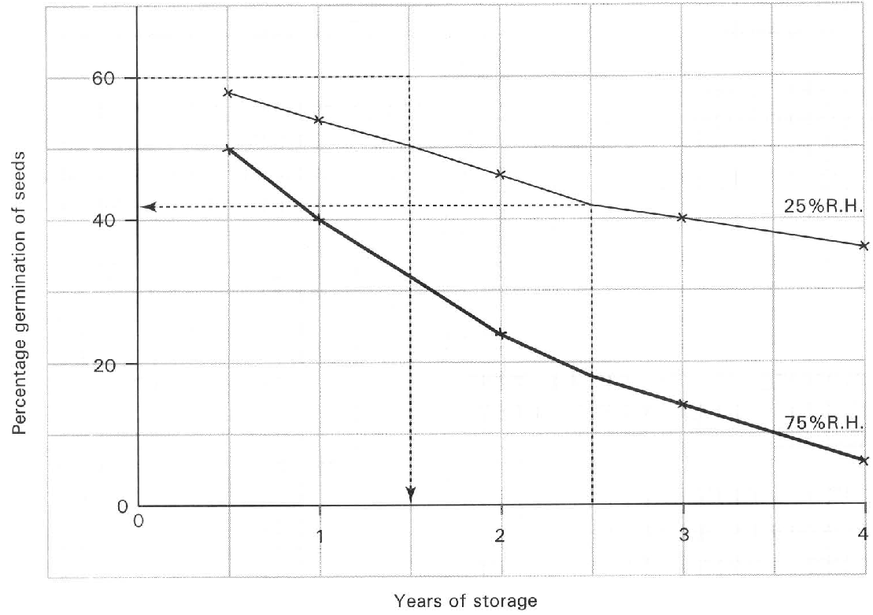
A. Boil the seeds.
B. Replace the alkaline pyrogallol solution with water.
C. Cover the flask with a piece of black cloth to exclude light.
D. Put the flask inside the refrigerator. Directions: Question 15.12 refers to the graph below which shows the effect of the relative humidity and the years of storage of seeds on the percentage of germination of seeds.
12. Which of the following is the conclusion that can be drawn from the above results?
A. The years of storage of seeds do not affect the viability of the seeds.
B. Dry environment is better than moist environment for the storage of seeds.
C. Cold condition is more favourable to warm condition for the storage of seeds.
D. No valid conclusion can be drawn.
13. Broad beans require water to germinate, They absorb water through (1) micropyle. (2) hilum. (3) seed coat.
A. (1) only
B. (2) only
C. (3) only
D. (1) and (3) only
14. Moist germinating seeds are kept inside a thermoflask. After several days the temperature inside the thermoflask compared with that of the control is very high. It indicates that
A. germinating seeds absorb a lot of heat from the surrounding to support their growth and development.
B. the thermoflask is a very good apparatus used to prevent heat loss.
C. the absorption of water by the germinating seeds promotes heat lost from the thermoflask.
D. heat is produced by the germinating seeds as a result of the respiration of the living cells.
15. 15Water is essential for the germination of seeds. It is because water is used (1) to soften the seed coat that facilitates the emergence of the radicle. (2) to activate enzymes. (3) to act as a raw material for photosynthesis. (4) to hydrolyse the stored food.
A. (1) and (2) only
B. (1) and (3) only
C. (2) and (3) only
D. (1), (2) and (4) only
16. When a broad bean seed germinates, the plumule usually penetrates through soil in the shape of a hook.
A. This enables the plumule to emerge out of soil more quickly.
B. The hooked region protects the delicate tissues of the plumule from damage by friction in soil.
C. More food is transported from the cotyledons to the base of the plumule so that the lower part of the plumule is in a hook shape.
D. The basal part of the plumule exhibits stronger positive phototropic response than the plumule tip so that the basal part grows more quickly to produce the hook shape.
17. Which of the following is/are the difference(s) of the embryo of a seed from that of a mammal?
(1) It develops outside the parent's body.
(2) It can remain in a dormant form when the external conditions are unfavourable to its development.
(3) It depends on the nutrients absorbed from the surrounding to support its development.
 | Dry mass(g)
Components | Seeds | Seedlings formed after germination in darkness
Sugars | 6.3 | 18.0
Cellulose | 4.4 | 13.6
Fats | 85.2 | 31.2
Simple proteins | 20.6 | 10.2
Others | 23.9 | 48.1
Total day mass | 140.4 | 121.1

A. (1) only B. (2) only C. (1) and (2) only D. (2) and (3) only Directions: Questions 15.18 to 15.20 refer to the table below which shows the changes in the dry mass of the different components of seeds before and after germination in darkness.
18. Which of the following is the CORRECT reason accounting for the difference in the total dry mass after germination.
A. The seeds carry out photosynthesis to produce food.
B. Destarching occurs in the seedlings growing in darkness.
C. The reserved food is oxidised to support the germination of seeds into seedlings.
D. The activities of parasites living on the seedlings.
19. Which component is the main food reserve in the seeds?
A. Sugar B. Cellulose C. Fats D. Simple proteins
20. The increase in the cellulose content in the seedlings as compared with that of seeds is due to
A. the production of carbohydrates by photosynthesis.
B. the translocation of cellulose from the seeds to the seedlings.
C. the synthesis of more cellulose by the seedlings to build up the cell wall for the increasing number of cells.
D. the formation of flowers and fruits in the seedlings.
21. 21Dry mass is obtained by removing
A. all the food reserve from the organism before measurement.
B. all the fats from the organism.
C. all the water in the organism.
D. all the organic matter from the organism.
22. Dry mass is a more accurate parameter used for measuring growth of an organism. Which of the following reasons is CORRECT?
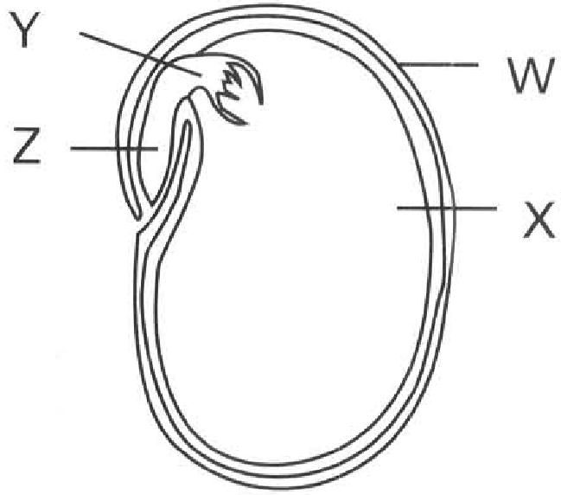
A. All the cells have died so that no further growth occurs to interrupt growth.
B. Growth takes a long period of time to complete. During the measuring period the water content of the organism is easily affected by the environment. Dry mass can remove this unreliable factor.
C. It is a true measurement of all the inorganic substances forming the organism.
D. Only one measurement is needed during the whole experimental period for measuring growth. Directions: Questions 15.23 to 15.27 refer to the diagram below which shows the longitudinal section of a broad bean seed.
23. Which of the following matching of the names of the labelled parts is CORRECT?
 | W | X | Y | Z
A. | Fruit wall | Cotyledon | Radicle | Embryo
B. | Seed coat | Embryo | Pulmule | Cotyledon
C. | Fruit wall | Seed coat | Cotyledon | Embryo
D. | Seed coat | Cotyledon | Plumule | Radicle

24. Which of the following is NOT the function of structure W?
A. Prevents the entry of bacteria and fungi into the seed.
B. Protects the seed content against adverse environmental conditions.
C. Prevents the loss of water from the seed content to air.
D. Promotes the dispersal of the seed.
25. Which of the following is the function of structure X? (1) Promotes the dispersal of seed. (2) Stores food to support the germination of the seed. (3) Prevents the bacterial and fungal invasion.
A. (1) only
B. (2) only
C. (3) only
D. (1) and (3) only
26. Which of the following graphs CORRECTLY shows the changes in the fresh mass of structure X and the total fresh mass of Y and Z?
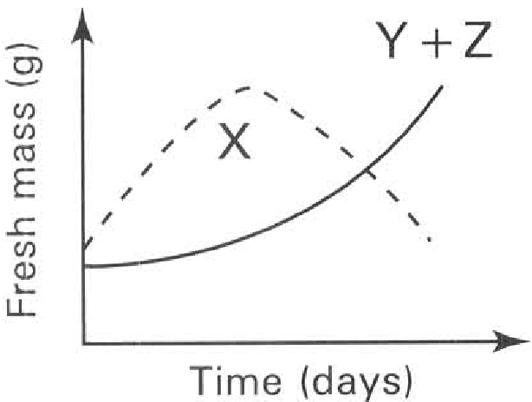
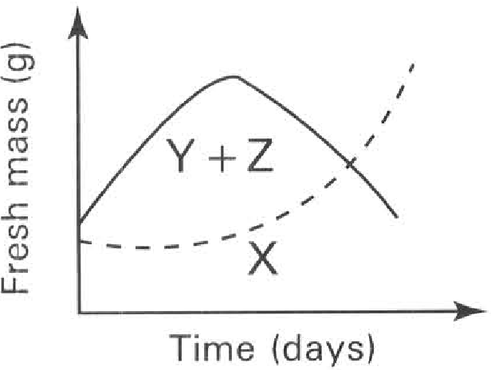
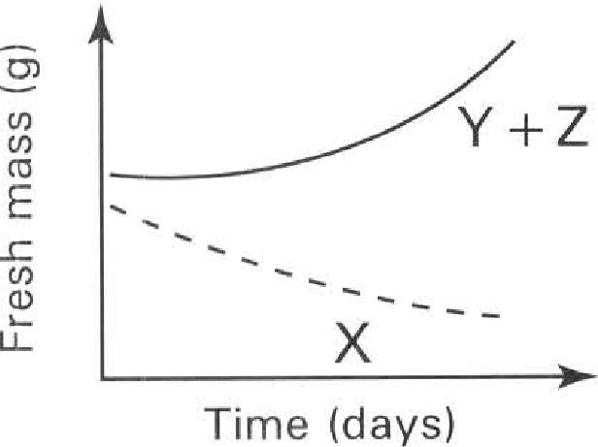
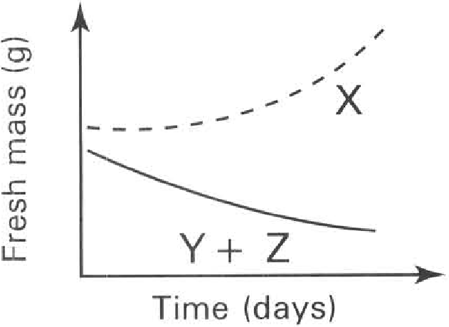
A. | B. | C. | D.

27. Which of the following graphs CORRECTLY shows the changes in the dry mass of the whole seed and its seedling, structure X and the total dry mass of structures Y and Z during the course of germination?
Directions: Question 15.28 refers to the diagrams below which show the different stages of the germination of a seed.
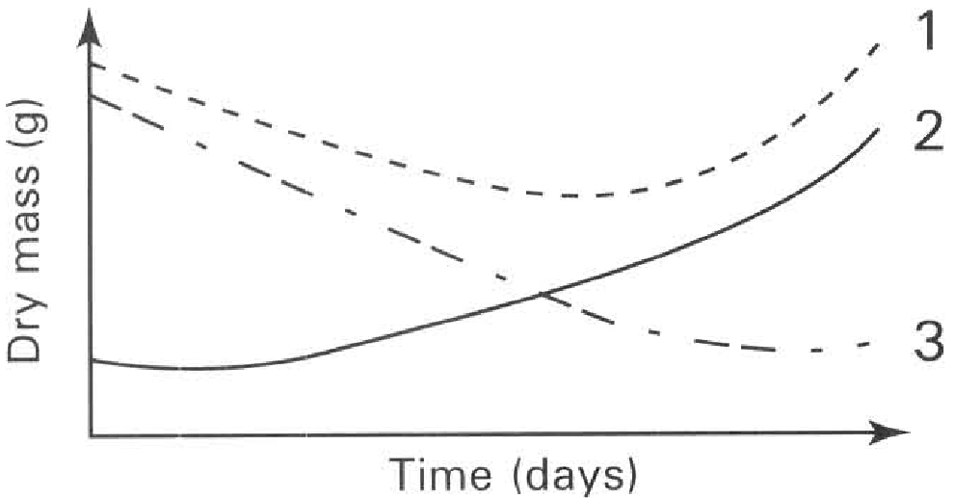
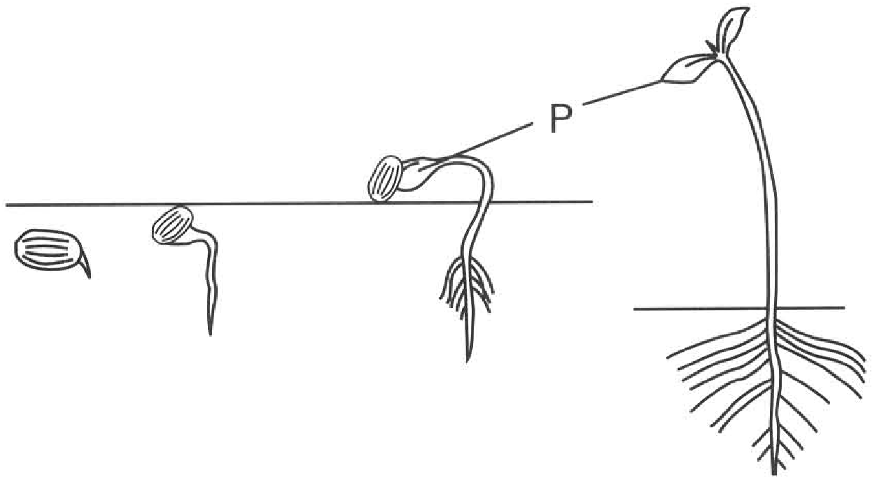
 | Dry mass of the whole seed and its seedling | Dry mass of structure X | Total dry mass of structures Y and Z
A. | 1 | 2 | 3
B. | 3 | 2 | 1
C. | 1 | 3 | 2
D. | 1 | 2 | 3

28. Which of the following is the function(s) of structure P?
(1) It stores food for the germination of the seed.
(2) It protects the young plumule during its emergence through soil.
(3) It turns green once it is emerging into air to carry out photosynthesis.
(4) It protects the seed against adverse environmental conditions.
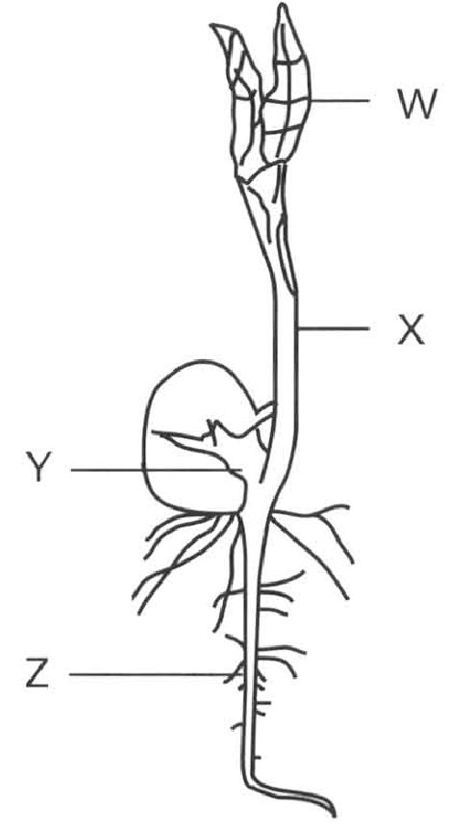
A. (1) and (2) only B. (2) and (3) only C. (3) and (4) only D. (1), (2) and (3) only Directions: Questions 15.29 and 15.30 refer to the diagram below which shows the appearance of a seedling 10 days after the start of germination of the bean seed. W and X are the aerial parts of the seedling and they are green in colour.
29. The development of the seedling up to the stage shown in the diagram initially depends on the food supplied by
A. the absorption of mineral salts from soil by Z.
B. the consumption of the food reserve in Y.
C. the absorption of nitrogen gas from air by X.
D. the photosynthetic activities of W
30. Which of the following graphs CORRECTLY represents the changes in the dry mass and the fresh mass of the seedling from the first day of germination to the stage shown in the diagram?
Directions: Questions 15.31 and 15.32 refer to the experiment described below. Two smaples of seeds, M and N, were germinated under favourable conditions. Sample N was exposed to light while Sample M was kept in darkness. Equal number of seeds/seedings from each sample was removed at equal intervals and their dry mass was measured. The results were shown in the graph below.
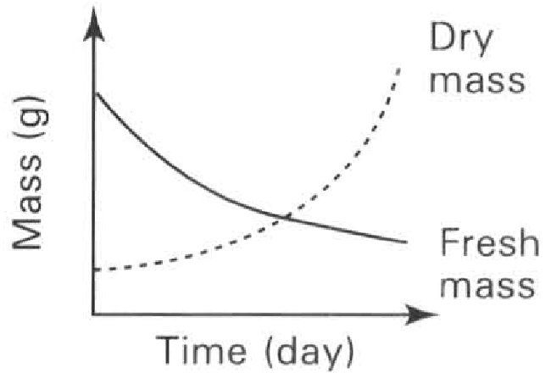
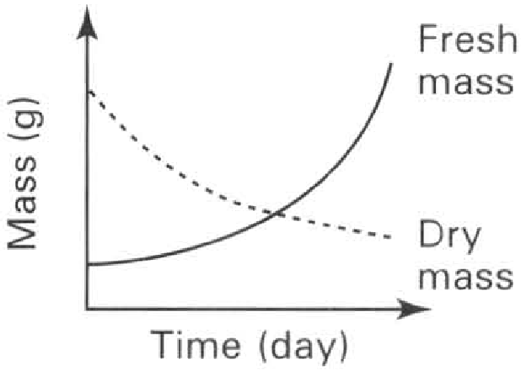
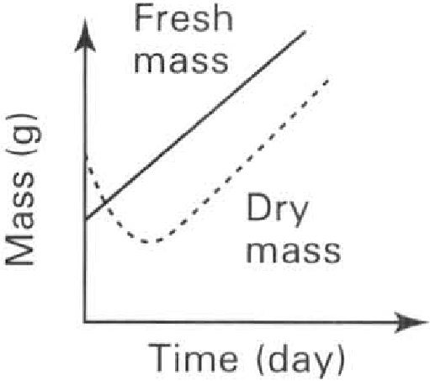
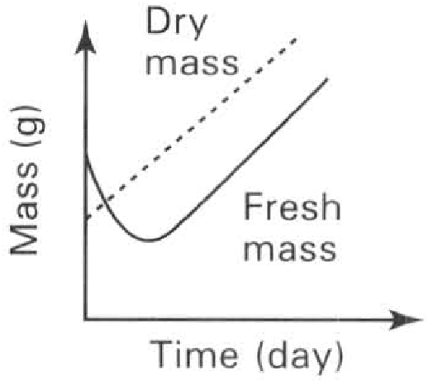
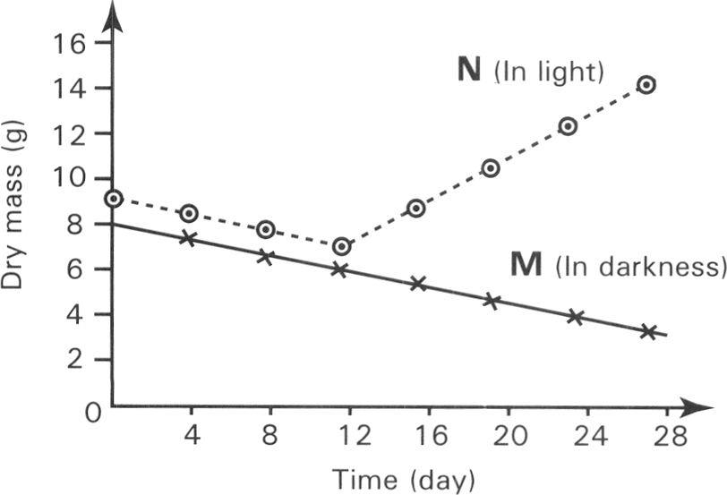
A. | B. | C. | D.

31. The decrease in dry mass of both samples in the first 12 days is probably due to
A. the loss of water through the testa by evaporation.
B. the translocation of food from the storage regions to the plumule and radicle.
C. the respiration of the reserved food during germination.
D. the food stored inside the seeds diffusing out of the seeds.
32. The increase in dry mass of sample N from day 12th to day 28th was due to
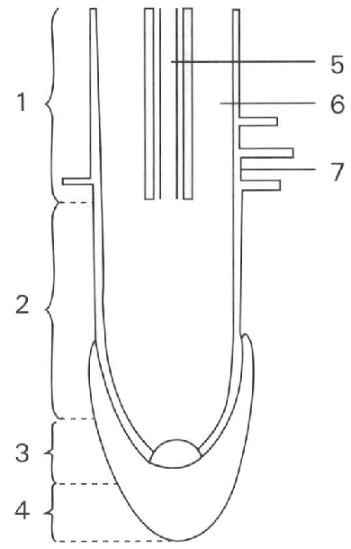
A. the translocation of the reserved food from the storage regions into the plumules.
B. the photosynthetic activities of the foliage leaves just emerging from soil.
C. the absorption of water by the root system of the seedling.
D. the production of new offspring by the seedings. Directions: Questions 15.33 to 15.36 refer to the diagram below which shows the longitudinal section of a root tip.
33. Which of the following matching of regions is CORRECT?
 | Region with the highest complexity of cells | Region with active mitotic cell division | Region with cells bearing the largest vacuoles
A. | 1 | 2 | 3
B. | 3 | 1 | 2
C. | 1 | 3 | 2
D. | 3 | 2 | 1

34. Which of the following matching is CORRECT?
 | Root cap | Region of differentiation | Region of cell division | Region of elongation
A. | 4 | 3 | 2 | 1
B. | 3 | 4 | 1 | 2
C. | 4 | 1 | 3 | 2
D. | 3 | 1 | 2 | 4

35. The following diagrams show the different types of tissues that are present in the root tip.
Which of the following matching of the location of these tissues in the root tip is CORRECT?
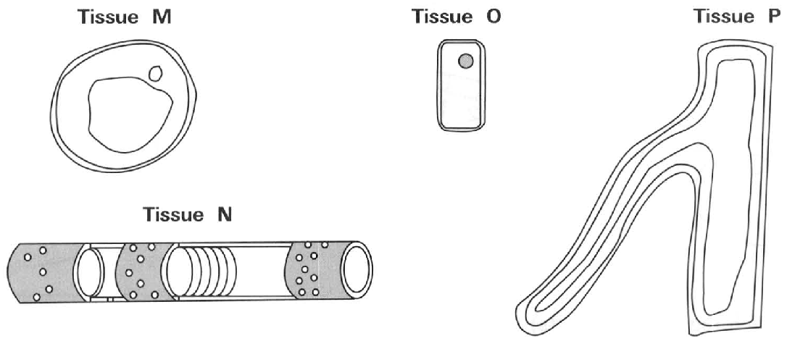
 | Tissue M | Tissue N | Tissue O | Tissue P
A. | 6 | 4 | 3 | 5
B. | 3 | 8 | 4 | 7
C. | 6 | 5 | 3 | 7
D. | 4 | 5 | 6 | 5

36. Which of the following is/are function(s) of the part labelled 4? (1) To protect the growing point (2) To protect the root hair (3) To increase the area for absorbing water and mineral salts
A. (1) only
B. (2) only
C. (1) and (3) only
D. (1) and (2) only
37. 37Which of the following cells in the root tip have completely differentiated?
(1) Xylem vessel (2) Thin-walled cortical cells
(3) Sieve cells (4) Root cap cells
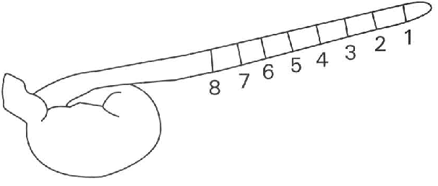
A. (1) and (2) only B. (3) and (4) only C. (1) and (3) only D. (2) and (4) only Directions: Questions 15.38 to 15.41 refer to the diagram below which shows the growth of the radicle of a germinating broad bean seed. The radicle is marked into 8 equal intervals and is placed horizontally.
38. 38Which region(s) exhibit(s) the greatest increase in length after 4 days?
A. 1 only
B. 2 only
C. 2, 3 and 4 only
D. 5, 6 and 7 only
39. Which region(s) has/have the greatest number of actively dividing cells?
A. 1 only
B. 3 only
C. 2 and 3 only
D. 2 and 4 only
40. What is the purpose of this experiment?
A. To find out the growth rate of the whole plant.
B. To find out the region where cell division occurs most actively.
C. To find out the region of differentiation.
D. To find out the region with rapid increase in length.
41. If the radicle is left vertically for two days, the length of each zone was measured again. Which of the graphs below CORRECTLY shows the length of each zone against the zone sequence.
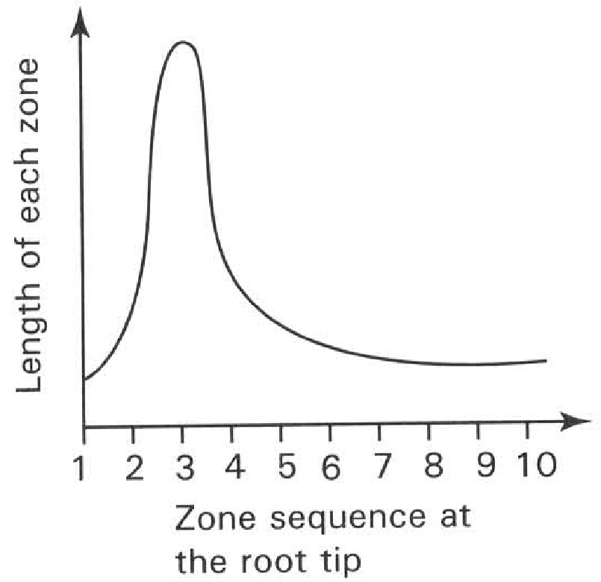
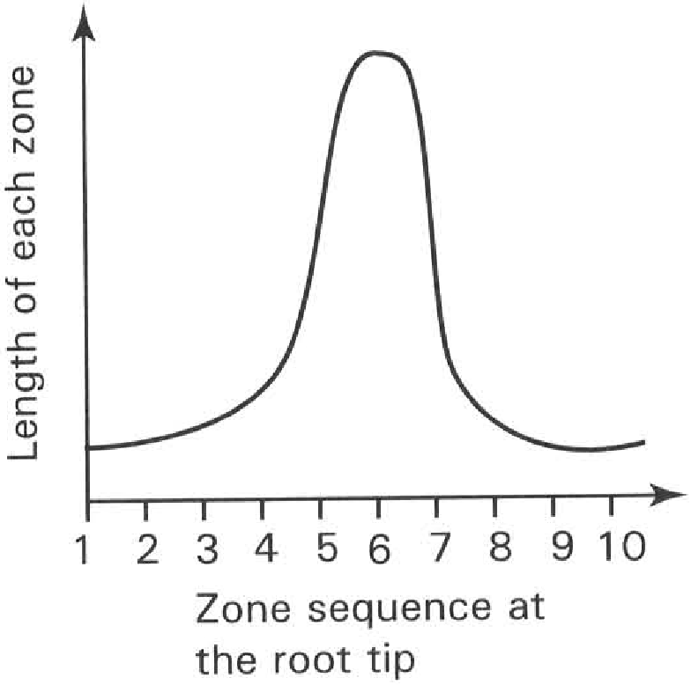
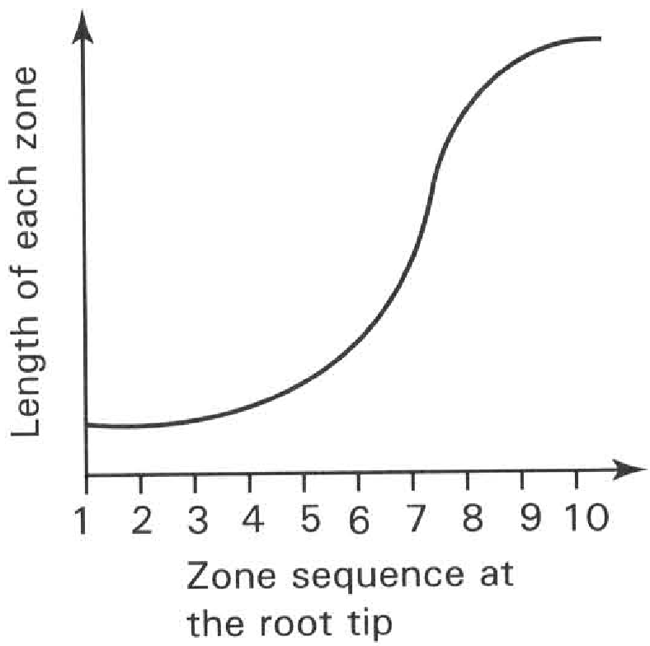
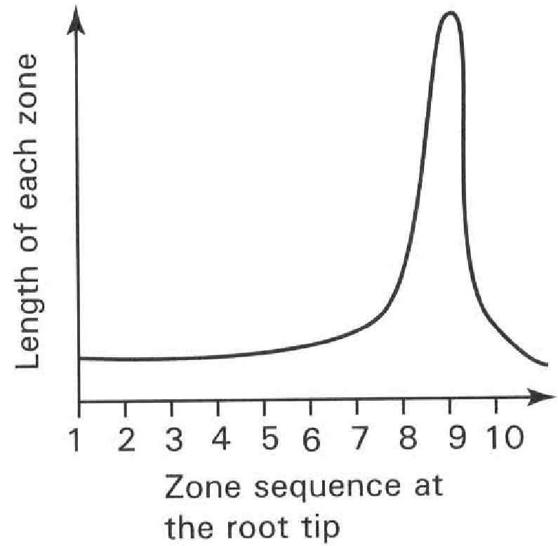
A. | B. | C. | D.

42. Which of the following criteria can be used to measure the rate of growth in flowering plant? (1) Dry mass (2) Wet mass (3) Length (4) Number of cells (5) Area
A. (1), (2) and (3) only
B. (1), (2) and (4) only
C. (1), (3) and (4) only
D. (1), (2), (3) and (5) only
43. The growth rate of a herbaceous flowering plant is most accurately obtained by measuring the change in
A. the height of the plant.
B. the total surface area of the leaves of the plant.
C. the dry mass of the plant.
D. the wet mass of the plant.
44. Which of the following is/are the disadvantage(s) of using fresh mass to measure growth in flowering plants? (1) The plant will be killed in the process. (2) Continuous measurment of the same organism cannot be made. (3) Results easily affected by the environmental conditions.
A. (1) only
B. (3) only
C. (1) and (2) only
D. (2) and (3) only
45. Which of the following is/are the advantage(s) of using dry mass to measure growth in flowering plants? (1) A small number of organisms is used. (2) Accurate measurement of growth. (3) The measurement can easily be completed within a short period of time.
A. (1) only
B. (2) only
C. (1) and (2) only
D. (2) and (3) only
46. Which of the following parameters can be used to measure the growth of a boy from birth to adolescence? (1) Body mass (2) Height (3) Intelligence quotient (IQ) (4) Heart rate
A. (1) and (2) only
B. (2) and (3) only
C. (3) and (4) only
D. (1), (2) and (3) only
47. Which of the following growth curves truly represents the growth pattern of humans?
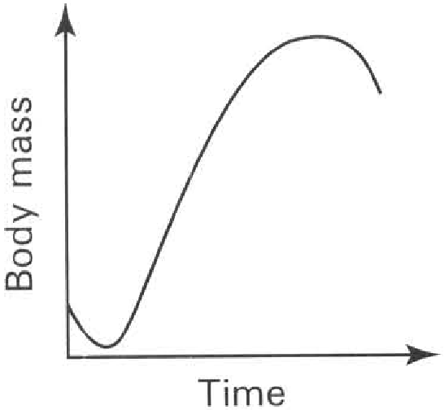
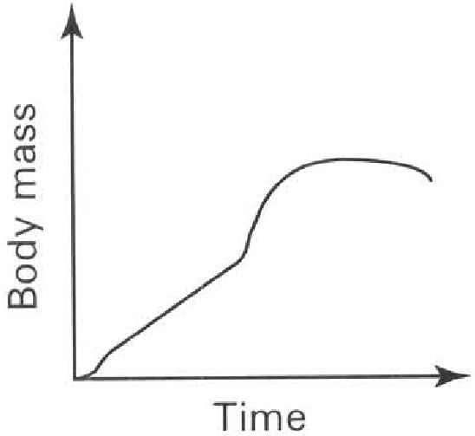
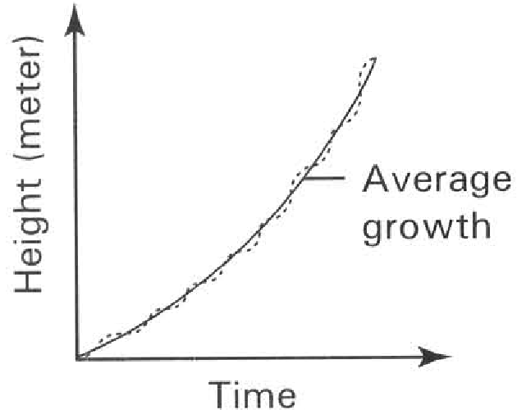
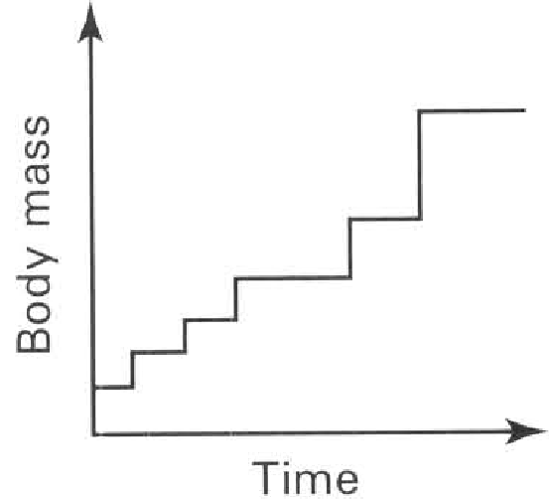
A. | B. | C. | D.

48. The diagram below shows the bodies of a man at different ages drawn to the same scale.
Which of the following interpretation of the diagram is CORRECT?
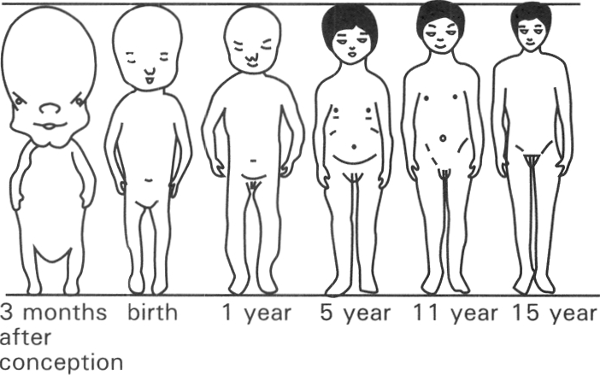
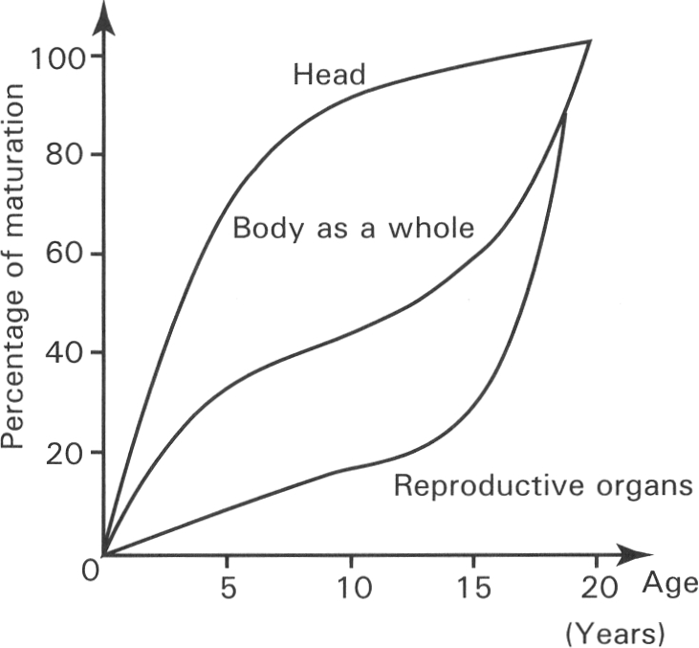
A. The legs grow faster than the arms.
B. The growth rate of different parts of the body is different.
C. The head is decreasing in size with age.
D. The amount of muscles is increasing while the amount of fats is decreasing with age.
49. The graph below shows the relative size of the different organs of the human body at different ages.
Which of the following deductions is CORRECT?
A. The brain stops to grow after age 5.
B. The whole body begins to grow after age 5.
C. The reproductive organs grow rapidly after age 15.
D. The body begins to secrete sex hormones after age 15.
50. The graph below shows the growth curves of boys and girls
Which of the following deductions is CORRECT?
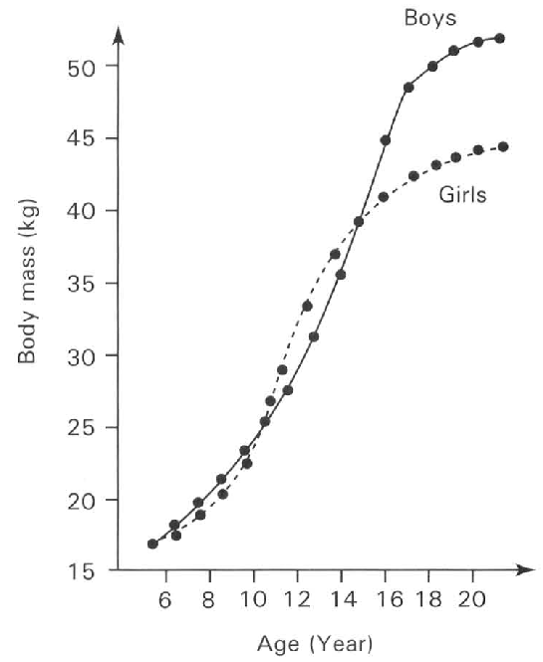
A. The sex organs of both the girls and boys are not yet developed before age 11.
B. The boys are taller than the girls before age 11.
C. The growth rate of the boys is higher than that of the girls between the ages of 18 and 20.
D. The boys are lighter than the girls between the ages of 11 and 15.

Answers
Answers are printed in red.
1. D. (1), (2), (3) and (4)

2. D. (2), (3) and (4) only

3. C. (3) only

4. D. Growth is not affected by light illumination. Directions: Questions 15.5 to 15.8 refer to the diagrams below which show the set up of an experiment to study the conditions needed for germinaton of seeds. The tubes were kept at 30°C. Only seeds in tubes B and D germinated.

5. D. (1), (2) and (3) only
Class: 87.5% correct (n=96) usual slip A
6. C. Water and oxygen only
Class: 66.7% correct (n=96) usual slip B
7. B
Class: 69.2% correct (n=130) usual slip C
8. A
Class: 85.5% correct (n=55) usual slip B
9. D. No seed germinates.

10. D. To show that oxygen is essential to germination.
Class: 61.8% correct (n=55) usual slip A
11. B. Replace the alkaline pyrogallol solution with water.

12. B. Dry environment is better than moist environment for the storage of seeds.
Class: 79.4% correct (n=34) usual slip C
13. D. (1) and (3) only

14. D. heat is produced by the germinating seeds as a result of the respiration of the living cells.

15. D. (1), (2) and (4) only

16. B. The hooked region protects the delicate tissues of the plumule from damage by friction in soil.

17. C
Class: 76.4% correct (n=89) usual slip B
18. C. The reserved food is oxidised to support the germination of seeds into seedlings.

19. C

20. C. the synthesis of more cellulose by the seedlings to build up the cell wall for the increasing number of cells.

21. D. all the organic matter from the organism.

22. B. Growth takes a long period of time to complete. During the measuring period the water content of the organism is easily affected by the environment. Dry mass can remove this unreliable factor.

23. D

24. D. Promotes the dispersal of the seed.
Class: 54.5% correct (n=55) usual slip C
25. B. (2) only

26. A

27. C

28. D
Class: 96.4% correct (n=55) usual slip A
29. B. the consumption of the food reserve in Y.
Class: 50.0% correct (n=34) usual slip D
30. C
Class: 82.4% correct (n=34) usual slip D
31. C. the respiration of the reserved food during germination.

32. B. the photosynthetic activities of the foliage leaves just emerging from soil.

33. C

34. C

35. C

36. A. (1) only
Class: 70.6% correct (n=34) usual slip B
37. D

38. D. 5, 6 and 7 only

39. A. 1 only
Class: 76.5% correct (n=34) usual slip B
40. D. To find out the region with rapid increase in length.

41. A

42. D. (1), (2), (3) and (5) only
Class: 21.8% correct (n=55) usual slip A
43. C. the dry mass of the plant.
Class: 49.1% correct (n=55) usual slip B
44. B. (3) only

45. B. (2) only

46. A. (1) and (2) only

47. B

48. B. The growth rate of different parts of the body is different.

49. C. The reproductive organs grow rapidly after age 15.

50. D. The boys are lighter than the girls between the ages of 11 and 15.

