Health and disease
Multiple-choice practice
Name: ________________________ Class: ____________
There are 55 questions compiled from Longman HKCEE and/or YKTo papers. Choose the one best answer.
Part A — HKDSE-style (YKTo)
1. In recent years the percentage of obese primary school students in Hong Kong is increasing. Which of the following are health risks to them? (1) Coronary heart disease (2) Allergy (3) Diabetes (4) Liver cancer (5) Damages of the knee joints D. (1), (3) and (5) only 3Which of the following are advantages of having regular aerobic exercises? (1) Develops a more efficient respiratory system. (2) Reduces the risk of bone fracture. (3) Gets higher rate of heart beat during exercises compared with those with long term physical inactivity. (4) Helps reduce obesity. D. (1), (2) and (4) only
A. (1) and (2) only
B. (2) and (3) only
C. (3) and (4) only
A. (1) and (2) only
2. Which of the following matching between the components of cigarette smoke and their harmful effects to health is/are CORRECT? D. (2) and (3) only 5 Smoking is a unhealthy life-style .Which of the following health risks will be caused by this habit? (1) Bronchitis (2) Cardio-vascular diseases (3) Diabetes (4) Emphysema (5) Cancers of tongue and throat B. (3) and (4) only C. (1), (3) and (5) only D. (1), (2), (4) and (5) only
 | Components of cigarette smoke | Harmful effects to health
(1) | Carbon | Emphysema monoxide
(2) | Tar | Cancer of throat and tongue
(3) | Nicotine | High blood pressure

A. (1) only
B. (2) only
C. (1) and (2) only
A. (1) and (2) only
3. Which of the following is the effect of carbon monoxide in the cigarette smoke to the smoker? (1) Lower oxygen-carrying capacity of blood. (2) Higher breathing rate at rest. (3) More coughing than normal. (4) Inhibits the beating activity of the cilia in the epithelial cells of the respiratory tract.
A. (1) and (2) only
B. (2) and (3) only
C. (3) and (4) only
D. (1) and (4) only
4. Which of the following is NOT the effect of tar in cigarette smoke to the respiratory system of a person ?
A. Cilia of the respiratory tract are damaged.
B. Damage the respiratory centre in the brain.
C. More mucus is secreted by the epithelial cells of the respiratory tract.
D. Break down of the alveolar wall.
5. Which of the following is NOT the health risk caused by the tar in the cigarette smoke to a person?
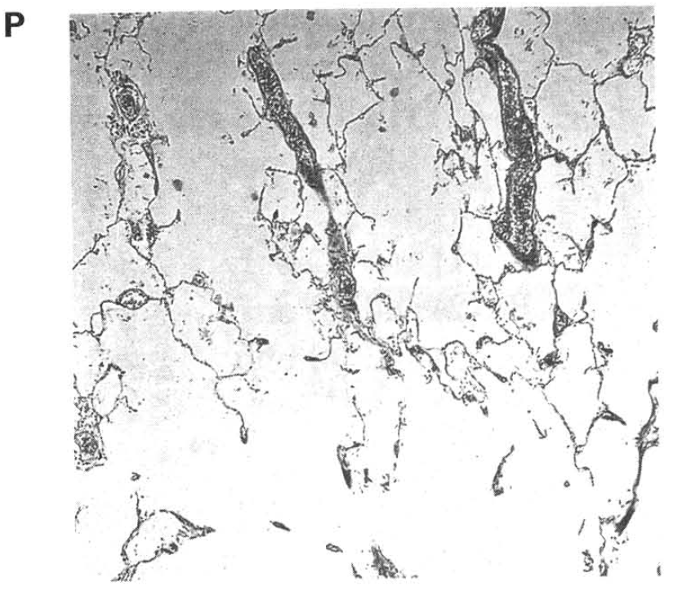
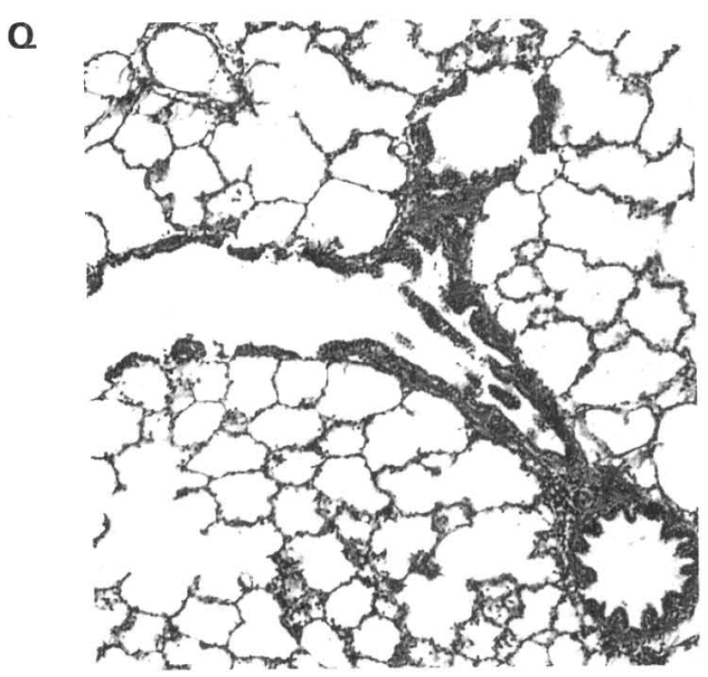
 | Persons | Features of the air sacs | Compared with the rate of breathing at rest
A. | P is a smoker | Air sacs bigger than normal | Higher than normal rate
B. | P is a non-smoker | Air sacs smaller than normal | Lower than normal rate
C. | Q is a smoker | Air sacs smaller than normal | Higher than normal rate
D. | Q is a non-smoker | Air sacs bigger than normal | Normal rate

 | Persons | Features of the air sacs | Compared with the rate of breathing at rest
A. | P is a smoker | Air sacs bigger than normal | Higher than normal rate
B. | P is a non-smoker | Air sacs smaller than normal | Lower than normal rate
C. | Q is a smoker | Air sacs smaller than normal | Higher than normal rate
D. | Q is a non-smoker | Air sacs bigger than normal | Normal rate

A. Liver cancer B. Bronchitis C. Emphysema D. High blood pressure Directions: Question 9 refers to the photomicrographs below, which show the transverse section of the lung tissues of a heavy smoker and a non-smoker. 9Which of the following matching of the persons, the features of the air sacs and their breathing rate compared with condition at rest is CORRECT?
6. Which of the following are the harmful effects of excessive alcohol consumption on the health of a person? (1) Ulcers of the stomach lining (2) Cirrhosis of the liver (3) High blood sugar level (4) Skin cancer B.Infectious diseases
A. (1) and (2) only
B. (2) and (3) only
C. (3) and (4) only
D. (4) and (1) only
7. Which of the following life-styles will affect the healthy foetal development of a pregnant woman? (1) Smoking (2) Excessive alcohol consumption (3) Drug abuse
A. (1) only
B. (2) only
C. (3) only
D. (1), (2) and (3)
8. Which of the following life-styles increase cases of traffic accidents? (1) Excessive consumption of alcohol (2) Drug abuse (3) Heavy smoking (4) Insufficient sleep
A. (1) and (2) only
B. (2) and (3) only
C. (1), (2) and (3) only
D. (1), (2) and (4) only
9. Which of the following is the feature of infectious diseases?
A. They are caused by genetic disorder.
B. They are due to unhealthy lifestyle.
C. They are due to infection by pathogens.
D. They will not be transmitted among people in a community.
10. Which of the following statements about pathogens is CORRECT?
A. All pathogens can trigger allergic responses of the human body.
B. Pathogens will interrupt the metabolic activities of the host cells or directly damaging them.
C. Pathogens can only exert harmful effects inside the host.
D. All pathogens need vectors to enter the host.
11. Which of the following matching between the diseases and the causative agents are CORRECT?
 | Diseases | Causative agents
(1) | Athlete's foot | Fungus
(2) | Cholera | Bacteria
(3) | Tuberculosis | Virus
(4) | Malaria | Mosquito

A. (1) and (2) only
B. (2) and (3) only
C. (3) and (4) only
D. (1) and (4) only
12. Which of the following matching between infectious diseases and the ways of transmission is CORRECT?
 | Infectious diseases | Ways of transmission
(1) | AIDS | Body fluid
(2) | Hepatitis B | Contaminated food and water
(3) | Diarrhoea | Air or droplets
(4) | Dengue fever | Vector

A. (1) and (2) only
B. (2) and (3) only
C. (3) and (4) only
D. (1) and (4) only
13. Which of the following statements about AIDS and hepatitis B are CORRECT?
(1) The causative agents of both diseases are viruses.
(2) Both can be cured by taking antibiotics.
(3) Both can be prevented by taking safe sex, avoiding sharing tooth brushes and needles, and screening blood to be free of the causative agents of AIDS and hepatitis B.
(4) Both can be prevented by injecting vaccines during childhood.
A. (1) and (2) only
B. (1) and (3) only
C. (2) and (4) only
D. (3) and (4) only
14. Which of the following matching between the diseases and the environmental conditions reducing the risks of contracting them are CORRECT?
 | Diseases | Environmental conditions reducing the risks
(1) | Dengue fever | Many breeding grounds of mosquitoes not clear
(2) | Cholera | Proper sewage treatment, well managed water supply system and good hygienic conditions in restaurants
(3) | Avian flu | No live poultry for sale in the poultry market
(4) | AIDS | Furniture, floor, hand rails, toys in the kindergartens are properly sterilized during an influenza outbreak

A. (1) and (2) only
B. (2) and (3) only
C. (3) and (4) only
D. (4) and (1) only
15. Which of the following diseases may be passed from the mother to her infant during pregnancy? (1) Tuberculosis (2) Cholera (3) Haemophilia(4) German measles
A. (1) and (2) only
B. (2) and (3) only
C. (3) and (4) only
D. (1) and (4) only
16. Which of the following preventive methods is effective to reduce the risk of contracting the diseases concerned?
 | Diseases | Preventive methods
A. | Diarrhoea | Remove the breeding grounds of mosquitoes
B. | Hepatitis B | Vaccination
C. | SARS | Safe sex
D. | Tuberculosis | Proper sewage treatment and sterilization of drinking water

17. Personal hygiene CANNOT reduce the risk of which of the following diseases? (1) Tuberculosis (2) Down syndrome (3) Diarrhoea (4) Influenza (5) Cystic fibrosis
A. (1) and (3) only
B. (2) and (5) only
C. (3) and (4) only
D. (1), (3) and (5) only
18. Malaria was once well controlled. But in recent years cases of malaria are increasing. Which of the following is/ are the probable reason(s) of the rise of malaria incidence? (1) Global warming extends the habitats of mosquitoes further north into the temperate zones. (2) Modern transportation enhances people movement between continents. (3) Resistance to the malaria parasites is increasing due to the misuse of drugs against this disease.
A. (1) only
B. (2) only
C. (3) only
D. (1), (2) and (3)
19. Which of the following statements concerning BOTH malaria and dengue fever is/are CORRECT? (1) The causative agents of both diseases are bacteria. (2) Both need mosquitoes as the vector. (3) Both can be transmitted by direct contact between people.
A. (1) only
B. (2) only
C. (3) only
D. (1) and (2) only
20. Which of the following are effective methods to reduce the spread of dengue fever? (1) Isolate all the infected patients from the public. (2) Reduce the breeding grounds of mosquitoes (3) People should put on long-sleeved clothes and trousers for out-door activities. (4) inject all infected people with high dose of antibiotics.
A. (1) and (2) only
B. (2) and (3) only
C. (3) and (4) only
D. (1), (2) and (3) only
21. When the number of white blood cells of a man is above normal, which of the following is the most probable explanation to this condition?
A. He has fully recovered from a disease.
B. He is a diabetes.
C. He has got stroke.
D. He is infected by viral flu.
22. Influenza is a viral disease quite common among people in a city. Which of the following method helps reduce contracting this disease?
A. Staying long hours in crowded places, such as in cinema, restaurants and public transport systems.
B. Seldom wash their hands thoroughly before touching eyes, nose or food.
C. Put on masks particularly in public places.
D. Take antibiotics to kill the pathogens during pandemic.
23. Antibiotics are very effective to act against bacteria by (1) inhibiting the formation of cell wall in bacteria. (2) interrupting the replication of nucleic acids in bacteria. (3) preventing the synthesis of proteins in bacteria.
A. (1) and (2) only
B. (2) and (3) only
C. (3) and (1) only
D. (1), (2), (3)
24. Why antibiotics cannot cure viral diseases?
A. Viruses live inside the host cells that prevent antibiotics passing into the cell to kill the viruses.
B. The high reproductive rate of viruses enables them to produce enough number to replace for those that have been killed by antibiotics.
C. Viruses have very high mutation rate that can produce new strains to act against the antibiotics.
D. Viruses depend on the metabolic activities of the host cells to live so that they do not have their own metabolic activities for antibiotics to act on.
25. Which of the following statements about antibiotics are CORRECT? (1) Antibiotics are produced by the human bodies. (2)Antibiotics are produced by microorganisms. (3) Antibiotics are effective to act against influenza viruses. (4) Antibiotics inhibit the production of bacteria.
A. (1) and (2) only
B. (2) and (3) only
C. (2) and (4) only
D. (1) and (4) only
26. Which of the following features about antibiotics are INCORRECT? (1) They can only be produced by bacteria, not by fungi. (2) They stimulate the defence mechanism of the human body to develop memory against a particular pathogen. (3) They are produced in large amount by the lymphocytes during bacterial infection. (4) They are proteins.
A. (1) and (2) only
B. (2) and (3) only
C. (3) and (4) only
D. (1), (2), (3) and (4)
27. Antibiotics exert their action by
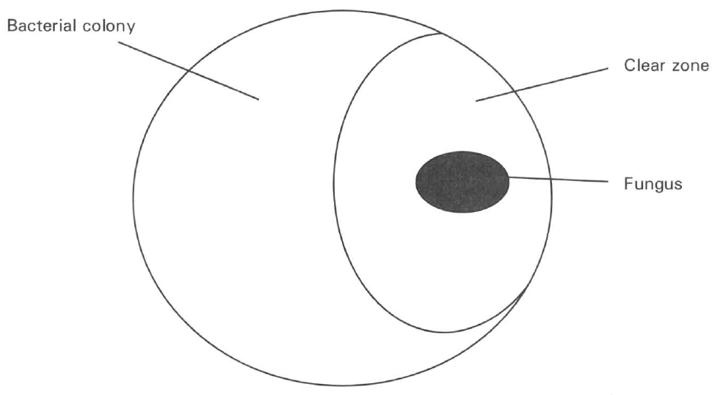
A. inhibiting the human body to produce antibodies.
B. neutralizing the harmful effect of the pathogens inside the human body.
C. inhibiting the growth of certain microorganisms.
D. stimulating the human body to develop memory against certain microorganisms. Directions: Question 32 refers to the diagram below, which shows the appearance of a bacterial culture on an agar plate that has been contaminated by a fungus.
28. Which of the following statements about the clear zone is/are CORRECT?
(1) It is completely occupied by the fungus.
(2) The fungus successfully competes with the bacteria for the nutrients.
(3) The bacteria are inhibited to grow by a substance secreted by the fungus.
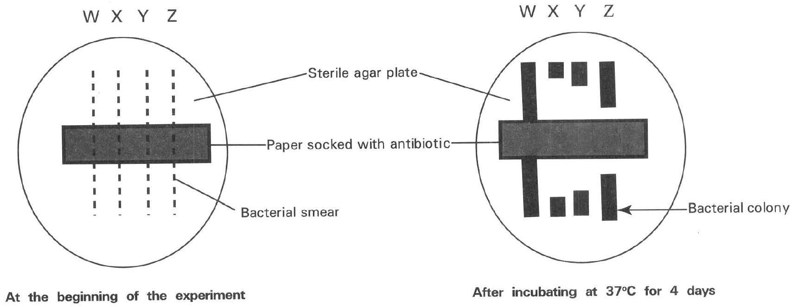
A. (1) only B. (2) only C. (3) only D. ( 1) and (2) only Directions: Questions 33 and 34 refer to the diagram below ,which shows the experiment to find the resistance of four types of bacteria (W, X, Y, Z) against the action of an antibiotic.
29. What is the purpose for incubating the agar plate at 37°C for four days?
A. To provide the optimum temperature for bacterial growth.
B. To sterilize the agar plate.
C. The maximum life span of bacteria is four days.
D. To avoid the fungi to spoilt the experiment.
30. Arrange the bacteria in ascending order according to their resistance to the antibiotic.
A. WYXZ
B. WZYX
C. XYZW
D. XZYW
31. Penicillin was the first antibiotic discovered in the 40s and was very effective to cure bacterial diseases. But in recent years its effectiveness greatly reduces. Which of the following are the probable reasons for this condition? (1) The human body has got use to the action of penicillin. (2) Penicillin is not so frequently used due to the invention of many new antibiotics. (3) Indiscriminate use of penicillin to cure diseases. (4) Many bacteria have evolved penicillin-resistant strains.
A. (1) and (2) only
B. (2) and (3) only
C. (3) and (4) only
D. (4) and (1) only
32. Recently many cases of antibiotic-resistant strains of bacteria are reported in hospitals in Hong Kong. Which of the following statements concerning this finding is CORRECT?
A. The frequent use of antibiotics in the hospitals forces many bacteria to develop resistance against the antibiotics.
B. The simple genetic structures of bacteria enable them to mutate against the action of antibiotic.
C. Antibiotics act as the selecting agent that eliminates the normal bacteria and permits the more tolerate strains of bacteria to survive.
D. Bacteria become use to the action of the antibiotics.
33. Which of the following is the consequence of the indiscriminate use of antibiotics in treating diseases?
A. Antibiotics become less effective to cure diseases caused by viruses.
B. Antibiotics enhance the reproductive rate of bacteria which quickly reach the peak level to damage the human tissues tremendously.
C. Speed up the evolution of bacteria that produce antibiotic-resistant strains.
D. Antibiotics weaken the immune system of the human body that cannot produce enough antibodies against pathogens. 38 Some farmers add some antibiotics in the animal feeds to reduce diseases in poultry. Which of the following is the undesirable effect of this practice ?
A. When people consume these poultry, the residues of antibiotics in the meat may kill all the intestinal bacteria of human.
B. These antibiotics may interrupt the metabolic activities of humans.
C. This will speed up the evolution of the bacteria with resistance against the antibiotics.
D. The price of these antibiotics will rise due to the increased demand of these drugs.
34. Which of the following statements concerning sulpha drugs is INCORRECT?
A. They are synthetic chemicals containing sulphur.
B. They kill viral pathogens.
C. They were used by humans to cure bacterial diseases before the discovery of antibiotics.
D. They exert their effect as enzyme inhibitors.
C. Non-infectious diseases
35. Which of the following are non-infective diseases? (1) SARS (2) Dengue fever (3) Cancers (4) AIDS (5) Allergy (6) Diabetes
A. (1), (2) and (3) only
B. (3), (5) and (6) only
C. (1), (4) and (6) only
D. (2), (4) and (5) only
36. Which of the following are features of non-infective diseases?
(1) They are caused by pathogens. (2) They are transmissible among people.
(3) They are mainly caused by unhealthy life-styles.
(4) Some are hereditary diseases.
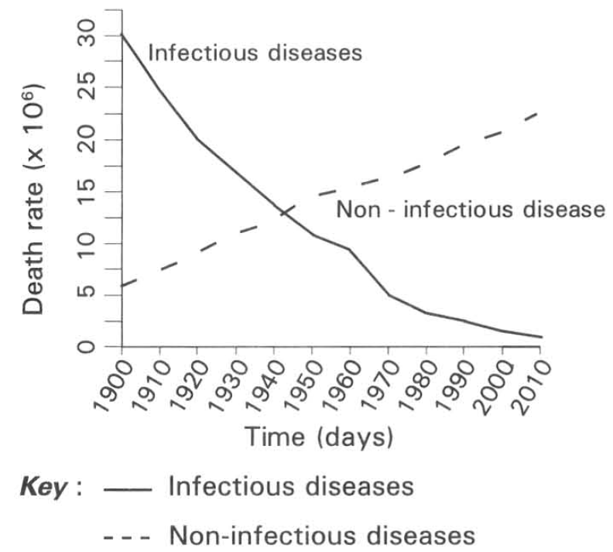
A. (1) and (2) only B. (2) and (3) only C. (3) and (4) only D. (4) and (1) only Directions: Questions 42 refers to the graph below, which shows the death rate of non-infective diseases and infective diseases from 1900 to 2010.
37. Which of the following statements is/are CORRECT according to the information obtained from the graph? (1) The death rate of infective diseases dropped rapidly since 1900 because of the improvement in hygiene and advancement in medical technology. (2) The death rate of non-infective diseases increases from 1900 onwards because more citizens take the western life style. (3) The trend in the change of the death rate of the infective diseases is opposite to that of the noninfectious diseases.
A. (1) only
B. (2) only
C. (3) only
D. (1) and (2) only
38. Which of the following methods can effectively reduce the risks of getting non-infectious diseases? (1) Avoids going to crowded places. (2) Put on masks during the outbreak of a viral disease. (3) Doing aerobic exercises regularly. (4) Taking balanced diet. (5) Inoculating all recommended vaccination since childhood.
A. (1) and (2) only
B. (2) and (3) only
C. (3) and (4) only
D. (3), (4) and (5)
39. Allergy is a condition of a person
A. over-reacting to specific antigens.
B. when his immune system fails to respond to specific antigens.
C. when his body cells are destroyed by specific antigens.
D. who can develop memory against specific viruses that formerly attacked the body.
40. Which of the following statements about allergy is/are CORRECT? (1) Pollen grains and dust mites are allergens. (2)Allergy is caused by the malfunctioning of the respiratory system. (3) Nuts and seafood are diets with good protein that will hot cause allergy.
A. (1) only
B. (1) and (2) only
C. (2) and (3) only
D. (1) and (3) only
41. Which of the following are examples of allergy? (1) Hay fever (2) Dengue fever (3) Anaemia (4) Asthma
A. (1) and (2) only
B. (3) and (4) only
C. (1) and (4) only
D. (2) and (3) only
42. Which of the following are the risk factors of cardio-vascular diseases? (1) Diabetes (2) Obesity (3) Physical inability (4) Heavy smoking
A. (1) and (2) only
B. (2) and (3) only
C. (3) and (4) only
D. (1), (2), (3), (4)
43. In 2011 heart disease is the second leading cause of death in Hong Kong. Which of the following are suggestions that are helpful to reduce the risks of developing heart disease? (1) Eat high-fibre food with low-fat content. (2) Take 30-minute aerobic exercises three times a week. (3) Do not smoke. (4) Reduce the body weight down to the standard value.
A. (1) and (2) only
B. (2) and (3) only
C. (3) and (4) only
D. (1), (2), (3) and (4)
44. Which of the following is/are symptoms of people with coronary heart disease? (1) High glucose level in blood (2) Chest pain (3) High water content in blood (4) High blood pressure
A. (1) and (2) only
B. (2) and (3) only
C. (1) and (3) only
D. (2) and (4) only
45. Which of the following about coronary heart disease is CORRECT?
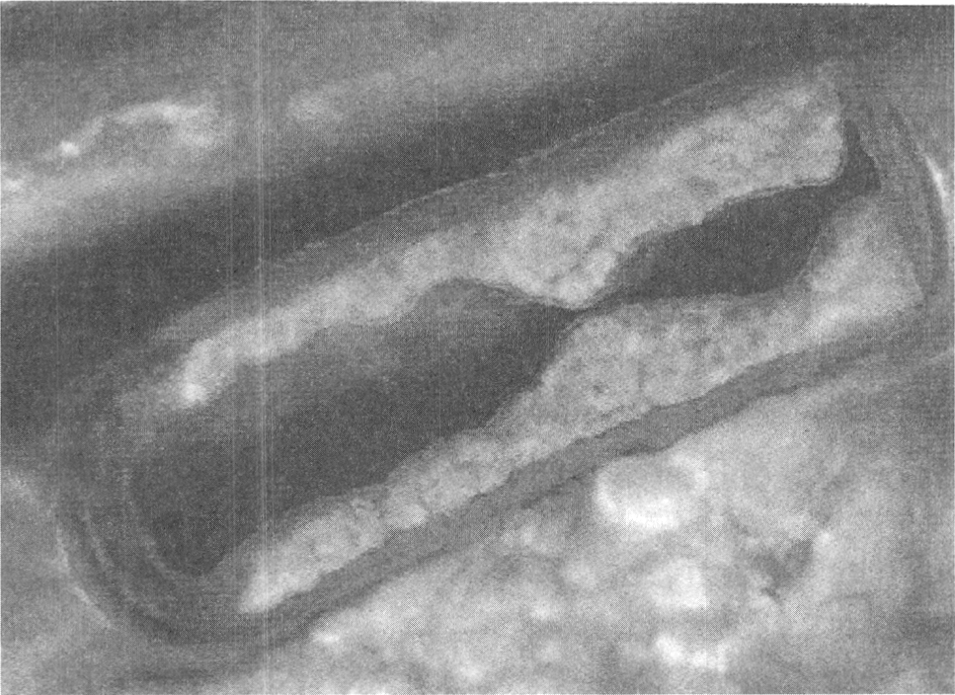
A. It is caused by having plaque formed inside a coronary vein.
B. The heart muscles will die once the important blood vessels supplying the heart are blocked.
C. The surgical method of inflating a balloon-like device inside the plugged section of the coronary blood vessels concerned can permanently cure this disease.
D. Young people will not have coronary heart disease. Directions: Question 51 refers to the diagram below, which shows the longitudinal section of an artery of a cigarette smoker.
46. Which of the following is the cause of narrowing the lumen of the artery of the cigarette smoker?
A. Nicotine stimulates cell division to cause thickening of the artery.
B. Nicotine damages the endothelial cells of the artery that enhances the formation of a plaque at the inner surface of the artery.
C. Carbon monoxide stimulates the aggregation of blood platelets at the inner surface of the artery.
D. Tar deposits at the inner surface of the artery.
47. Which of the following comparisons between type I diabetes and type II diabetes is CORRECT?
 | Type I diabetes | Type II diabetes
A. | Due to insulin resistance | Due to the shortage of insulin
B. | Mainly caused by overweight and physical inactivity | Mainly caused by genetic factor
C. | Starts early in life e.g. in childhood or adolescence | Commonly occurs in adults and obese children
D. | Majority of diabetes belongs to this type | Minority of diabetes belong to this type

48. Diabetic persons are advised by doctors to eat food with low Glycemic Index because
A. more sugars can be stored .
B. the sugar inside these foods can easily be digested to simple diffusible forms.
C. they have higher energy content to meet the metabolic needs of the body.
D. the blood sugar level will not change abruptly.
49. Which of the following comparisons between the two types of tumours are CORRECT?
 | Malignant tumour | Benign tumour
(1) | Not surrounded by a capsule. | Surrounded by a capsule.
(2) | Cells can spread to other parts of the body. | Cells cannot spread to other parts of the body.
(3) | Usually harmless to the body. | Usually quite harmful to the body.

A. (1) and (2) only
B. (2) and (3) only
C. (3) and (1) only
D. (1), (2) and (3)
50. Which of the following statements concerning cancer is CORRECT?
A. It mainly involves meiosis.
B. It is uncontrolled cell division.
C. It only occurs in adults.
D. No cancers can be prevented.
51. Which of the following can reduce the risk of getting caners? (1) Quit smoking (2) Avoids excessive consumption of alcohol (3) Reduces exposure to carcinogens.
A. (1) only
B. (2) only
C. (3) only
D. (1), (2) and (3)
52. Which of the following are risk factors for lung cancers? (1) Smoking (2) High fat diet (3) Working in places with heavily air pollution. (4) High alcohol consumption
A. (1) and (2) only
B. (1) and (3) only
C. (2) and (3) only
D. (4) and (1) only
53. Which of the following are NOT the risk factors of colon cancers? (1) Ageing (2) Hereditary factor (3) High fibre diets (4) Regular exercises
A. (1) and (2) only
B. (2) and (3) only
C. (3) and (4) only
D. (1) and (4) only
54. Which of the following are the risk factors of liver cancer?
(1) Heavy consumption of alcohol (2) Heavy smoking
(3) Carrier of hepatitis B viruses (4) Heavy air pollution
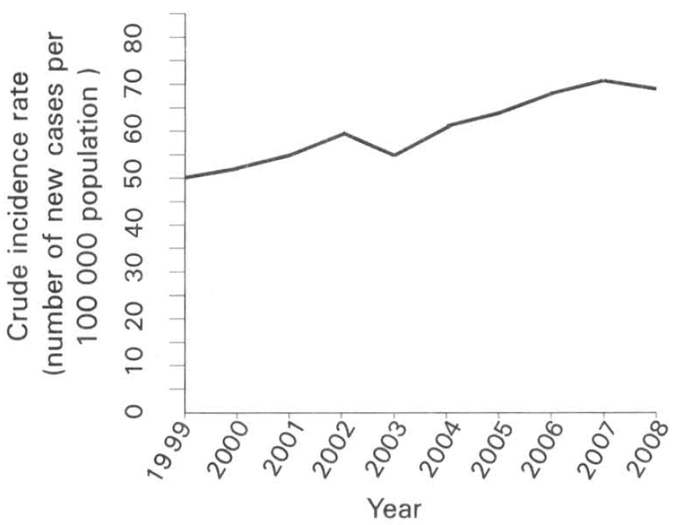
A. (1) and (2) only B. (1) and (3) only C. (2) and (4) only D. (1) and (4) only Directions: Question 60 refers to the graph below ,which shows the crude incidence rate of colorectal cancers in male from 1999 to 2008.
55. Which of the following are the possible reasons for the increase in the incidence rate of colorectal cancers in Hong Kong from 1999 to 2008? (1) More people are taking endoscopy examination of the colon. (2) People take low-fibre and high-fat diet. (3) The increase in the life span of people increases the accumulation of harmful wastes in the colons. (4) Physical inactivity is common in urban life. D. (2), (3) and (4) only Suggested Solutions
A. (1) and (2) only
B. (2) and (3) only
C. (3) and (4) only
D. (2), (3) and (4) only Suggested Solutions

Answers
Answers are printed in red.
1. D
Class: 81.2% correct (n=128) usual slip B
2. D
Class: 67.2% correct (n=128) usual slip C
3. A. (1) and (2) only
Class: 72.7% correct (n=128) usual slip D
4. B. Damage the respiratory centre in the brain.
Class: 66.4% correct (n=128) usual slip C
5. A. Liver cancer B. Bronchitis C. Emphysema D. High blood pressure Directions: Question 9 refers to the photomicrographs below, which show the transverse section of the lung tissues of a heavy smoker and a non-smoker. 9Which of the following matching of the persons, the features of the air sacs and their breathing rate compared with condition at rest is CORRECT?
Class: 76.6% correct (n=128) usual slip D
6. A. (1) and (2) only
Class: 79.7% correct (n=128) usual slip B
7. D. (1), (2) and (3)
Class: 85.8% correct (n=127) usual slip A
8. D. (1), (2) and (4) only
Class: 79.5% correct (n=127) usual slip A
9. C. They are due to infection by pathogens.
Class: 89.8% correct (n=127) usual slip A
10. B. Pathogens will interrupt the metabolic activities of the host cells or directly damaging them.
Class: 66.9% correct (n=127) usual slip A
11. A. (1) and (2) only
Class: 74.2% correct (n=89) usual slip D
12. D. (1) and (4) only
Class: 76.4% correct (n=89) usual slip A
13. B. (1) and (3) only
Class: 91.0% correct (n=89) usual slip D
14. B. (2) and (3) only
Class: 74.2% correct (n=89) usual slip A
15. C. (3) and (4) only
Class: 74.2% correct (n=89) usual slip D
16. B
Class: 74.8% correct (n=115) usual slip A
17. B. (2) and (5) only
Class: 91.0% correct (n=89) usual slip A
18. D. (1), (2) and (3)
Class: 62.9% correct (n=89) usual slip C
19. B. (2) only
Class: 65.2% correct (n=89) usual slip C
20. B. (2) and (3) only
Class: 82.0% correct (n=89) usual slip D
21. D. He is infected by viral flu.
Class: 77.5% correct (n=89) usual slip A
22. C. Put on masks particularly in public places.
Class: 89.9% correct (n=89) usual slip A
23. D. (1), (2), (3)
Class: 85.4% correct (n=89) usual slip B
24. D. Viruses depend on the metabolic activities of the host cells to live so that they do not have their own metabolic activities for antibiotics to act on.
Class: 59.6% correct (n=89) usual slip A
25. C. (2) and (4) only
Class: 75.3% correct (n=89) usual slip D
26. D. (1), (2), (3) and (4)
Class: 75.3% correct (n=89) usual slip A
27. C. inhibiting the growth of certain microorganisms.
Class: 87.6% correct (n=89) usual slip B
28. C
Class: 62.9% correct (n=89) usual slip B
29. A. To provide the optimum temperature for bacterial growth.
Class: 89.7% correct (n=58) usual slip C
30. C. XYZW
Class: 70.7% correct (n=58) usual slip B
31. C. (3) and (4) only
Class: 87.9% correct (n=58) usual slip B
32. C. Antibiotics act as the selecting agent that eliminates the normal bacteria and permits the more tolerate strains of bacteria to survive.
Class: 55.2% correct (n=58) usual slip A
33. C. This will speed up the evolution of the bacteria with resistance against the antibiotics.
Class: 85.2% correct (n=54) usual slip A
34. B. They kill viral pathogens.
Class: 74.1% correct (n=54) usual slip C
35. B. (3), (5) and (6) only
Class: 100.0% correct (n=51) usual slip A
36. C
Class: 90.2% correct (n=51) usual slip A
37. C. (3) only
Class: 82.4% correct (n=51) usual slip A
38. C. (3) and (4) only
Class: 76.5% correct (n=51) usual slip D
39. A. over-reacting to specific antigens.
Class: 96.1% correct (n=51) usual slip B
40. A. (1) only
Class: 82.4% correct (n=51) usual slip D
41. C. (1) and (4) only
Class: 96.1% correct (n=51) usual slip A
42. D. (1), (2), (3), (4)
Class: 88.2% correct (n=51) usual slip A
43. D. (1), (2), (3) and (4)
Class: 88.2% correct (n=51) usual slip B
44. D. (2) and (4) only
Class: 84.3% correct (n=51) usual slip A
45. B. The heart muscles will die once the important blood vessels supplying the heart are blocked.
Class: 78.8% correct (n=80) usual slip A
46. B. Nicotine damages the endothelial cells of the artery that enhances the formation of a plaque at the inner surface of the artery.
Class: 68.6% correct (n=51) usual slip D
47. C
Class: 88.2% correct (n=51) usual slip A
48. D. the blood sugar level will not change abruptly.
Class: 90.2% correct (n=51) usual slip B
49. A. (1) and (2) only
Class: 74.5% correct (n=51) usual slip C
50. B. It is uncontrolled cell division.
Class: 90.2% correct (n=51) usual slip C
51. D. (1), (2) and (3)
Class: 74.5% correct (n=51) usual slip C
52. B. (1) and (3) only
Class: 98.0% correct (n=51) usual slip A
53. C. (3) and (4) only
Class: 86.3% correct (n=51) usual slip D
54. B
Class: 69.0% correct (n=29) usual slip A
55. D. (2), (3) and (4) only Suggested Solutions
Class: 69.0% correct (n=29) usual slip C

