Health and disease · items under 80% correct
Multiple-choice practice
Name: ________________________ Class: ____________
These items were answered correctly by fewer than 80% of students in class Google Forms, matched by the wording in the source bank and the form answer key. Choose the one best answer.
Part A — HKDSE-style (YKTo)
1. Which of the following matching between the components of cigarette smoke and their harmful effects to health is/are CORRECT? D. (2) and (3) only 5 Smoking is a unhealthy life-style .Which of the following health risks will be caused by this habit? (1) Bronchitis (2) Cardio-vascular diseases (3) Diabetes (4) Emphysema (5) Cancers of tongue and throat B. (3) and (4) only C. (1), (3) and (5) only D. (1), (2), (4) and (5) only
 | Components of cigarette smoke | Harmful effects to health
(1) | Carbon | Emphysema monoxide
(2) | Tar | Cancer of throat and tongue
(3) | Nicotine | High blood pressure

A. (1) only
B. (2) only
C. (1) and (2) only
A. (1) and (2) only
2. Which of the following is the effect of carbon monoxide in the cigarette smoke to the smoker? (1) Lower oxygen-carrying capacity of blood. (2) Higher breathing rate at rest. (3) More coughing than normal. (4) Inhibits the beating activity of the cilia in the epithelial cells of the respiratory tract.
A. (1) and (2) only
B. (2) and (3) only
C. (3) and (4) only
D. (1) and (4) only
3. Which of the following is NOT the effect of tar in cigarette smoke to the respiratory system of a person ?
A. Cilia of the respiratory tract are damaged.
B. Damage the respiratory centre in the brain.
C. More mucus is secreted by the epithelial cells of the respiratory tract.
D. Break down of the alveolar wall.
4. Which of the following is NOT the health risk caused by the tar in the cigarette smoke to a person?
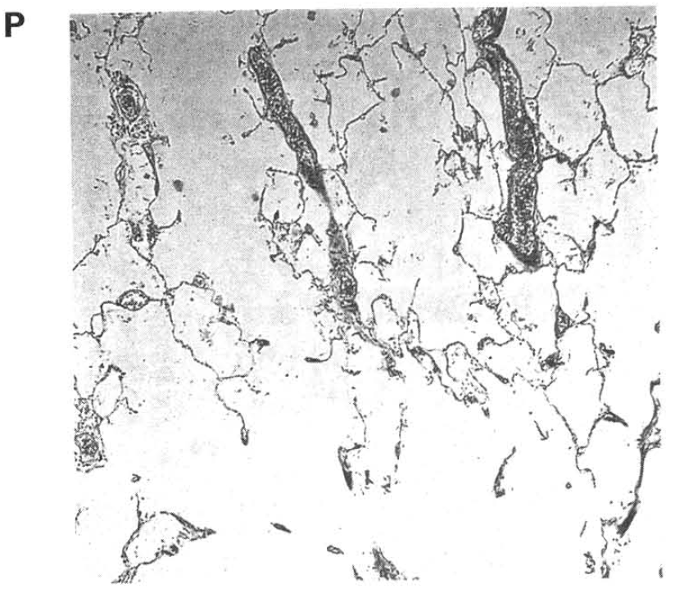
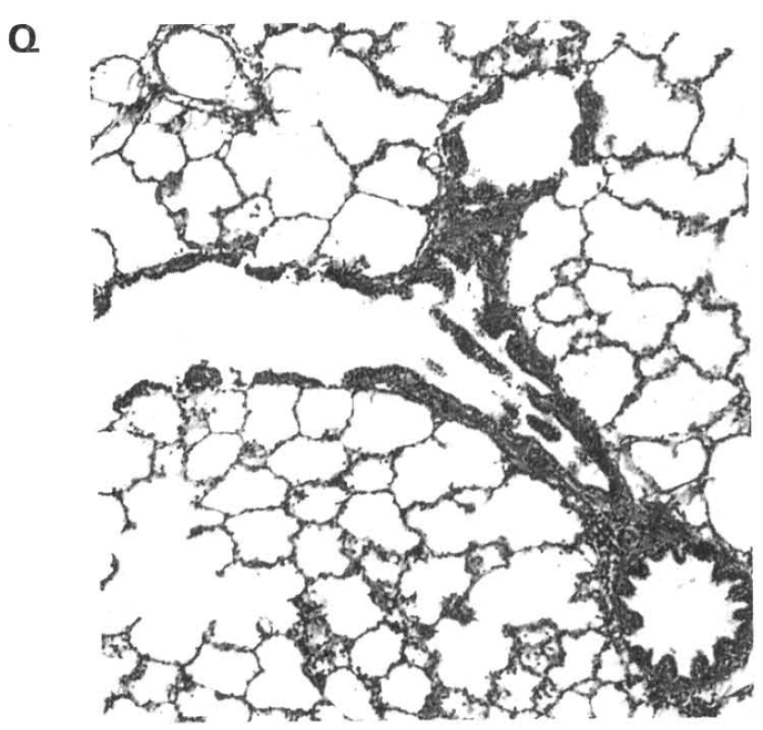
 | Persons | Features of the air sacs | Compared with the rate of breathing at rest
A. | P is a smoker | Air sacs bigger than normal | Higher than normal rate
B. | P is a non-smoker | Air sacs smaller than normal | Lower than normal rate
C. | Q is a smoker | Air sacs smaller than normal | Higher than normal rate
D. | Q is a non-smoker | Air sacs bigger than normal | Normal rate

 | Persons | Features of the air sacs | Compared with the rate of breathing at rest
A. | P is a smoker | Air sacs bigger than normal | Higher than normal rate
B. | P is a non-smoker | Air sacs smaller than normal | Lower than normal rate
C. | Q is a smoker | Air sacs smaller than normal | Higher than normal rate
D. | Q is a non-smoker | Air sacs bigger than normal | Normal rate

A. Liver cancer B. Bronchitis C. Emphysema D. High blood pressure Directions: Question 9 refers to the photomicrographs below, which show the transverse section of the lung tissues of a heavy smoker and a non-smoker. 9Which of the following matching of the persons, the features of the air sacs and their breathing rate compared with condition at rest is CORRECT?
5. Which of the following are the harmful effects of excessive alcohol consumption on the health of a person? (1) Ulcers of the stomach lining (2) Cirrhosis of the liver (3) High blood sugar level (4) Skin cancer B.Infectious diseases
A. (1) and (2) only
B. (2) and (3) only
C. (3) and (4) only
D. (4) and (1) only
6. Which of the following life-styles increase cases of traffic accidents? (1) Excessive consumption of alcohol (2) Drug abuse (3) Heavy smoking (4) Insufficient sleep
A. (1) and (2) only
B. (2) and (3) only
C. (1), (2) and (3) only
D. (1), (2) and (4) only
7. Which of the following statements about pathogens is CORRECT?
A. All pathogens can trigger allergic responses of the human body.
B. Pathogens will interrupt the metabolic activities of the host cells or directly damaging them.
C. Pathogens can only exert harmful effects inside the host.
D. All pathogens need vectors to enter the host.
8. Which of the following matching between the diseases and the causative agents are CORRECT?
 | Diseases | Causative agents
(1) | Athlete's foot | Fungus
(2) | Cholera | Bacteria
(3) | Tuberculosis | Virus
(4) | Malaria | Mosquito

A. (1) and (2) only
B. (2) and (3) only
C. (3) and (4) only
D. (1) and (4) only
9. Which of the following matching between infectious diseases and the ways of transmission is CORRECT?
 | Infectious diseases | Ways of transmission
(1) | AIDS | Body fluid
(2) | Hepatitis B | Contaminated food and water
(3) | Diarrhoea | Air or droplets
(4) | Dengue fever | Vector

A. (1) and (2) only
B. (2) and (3) only
C. (3) and (4) only
D. (1) and (4) only
10. Which of the following matching between the diseases and the environmental conditions reducing the risks of contracting them are CORRECT?
 | Diseases | Environmental conditions reducing the risks
(1) | Dengue fever | Many breeding grounds of mosquitoes not clear
(2) | Cholera | Proper sewage treatment, well managed water supply system and good hygienic conditions in restaurants
(3) | Avian flu | No live poultry for sale in the poultry market
(4) | AIDS | Furniture, floor, hand rails, toys in the kindergartens are properly sterilized during an influenza outbreak

A. (1) and (2) only
B. (2) and (3) only
C. (3) and (4) only
D. (4) and (1) only
11. Which of the following diseases may be passed from the mother to her infant during pregnancy? (1) Tuberculosis (2) Cholera (3) Haemophilia(4) German measles
A. (1) and (2) only
B. (2) and (3) only
C. (3) and (4) only
D. (1) and (4) only
12. Which of the following preventive methods is effective to reduce the risk of contracting the diseases concerned?
 | Diseases | Preventive methods
A. | Diarrhoea | Remove the breeding grounds of mosquitoes
B. | Hepatitis B | Vaccination
C. | SARS | Safe sex
D. | Tuberculosis | Proper sewage treatment and sterilization of drinking water

13. Malaria was once well controlled. But in recent years cases of malaria are increasing. Which of the following is/ are the probable reason(s) of the rise of malaria incidence? (1) Global warming extends the habitats of mosquitoes further north into the temperate zones. (2) Modern transportation enhances people movement between continents. (3) Resistance to the malaria parasites is increasing due to the misuse of drugs against this disease.
A. (1) only
B. (2) only
C. (3) only
D. (1), (2) and (3)
14. Which of the following statements concerning BOTH malaria and dengue fever is/are CORRECT? (1) The causative agents of both diseases are bacteria. (2) Both need mosquitoes as the vector. (3) Both can be transmitted by direct contact between people.
A. (1) only
B. (2) only
C. (3) only
D. (1) and (2) only
15. When the number of white blood cells of a man is above normal, which of the following is the most probable explanation to this condition?
A. He has fully recovered from a disease.
B. He is a diabetes.
C. He has got stroke.
D. He is infected by viral flu.
16. Why antibiotics cannot cure viral diseases?
A. Viruses live inside the host cells that prevent antibiotics passing into the cell to kill the viruses.
B. The high reproductive rate of viruses enables them to produce enough number to replace for those that have been killed by antibiotics.
C. Viruses have very high mutation rate that can produce new strains to act against the antibiotics.
D. Viruses depend on the metabolic activities of the host cells to live so that they do not have their own metabolic activities for antibiotics to act on.
17. Which of the following statements about antibiotics are CORRECT? (1) Antibiotics are produced by the human bodies. (2)Antibiotics are produced by microorganisms. (3) Antibiotics are effective to act against influenza viruses. (4) Antibiotics inhibit the production of bacteria.
A. (1) and (2) only
B. (2) and (3) only
C. (2) and (4) only
D. (1) and (4) only
18. Which of the following features about antibiotics are INCORRECT? (1) They can only be produced by bacteria, not by fungi. (2) They stimulate the defence mechanism of the human body to develop memory against a particular pathogen. (3) They are produced in large amount by the lymphocytes during bacterial infection. (4) They are proteins.
A. (1) and (2) only
B. (2) and (3) only
C. (3) and (4) only
D. (1), (2), (3) and (4)
19. Which of the following statements about the clear zone is/are CORRECT?
(1) It is completely occupied by the fungus.
(2) The fungus successfully competes with the bacteria for the nutrients.
(3) The bacteria are inhibited to grow by a substance secreted by the fungus.
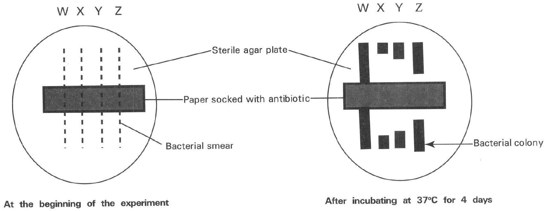
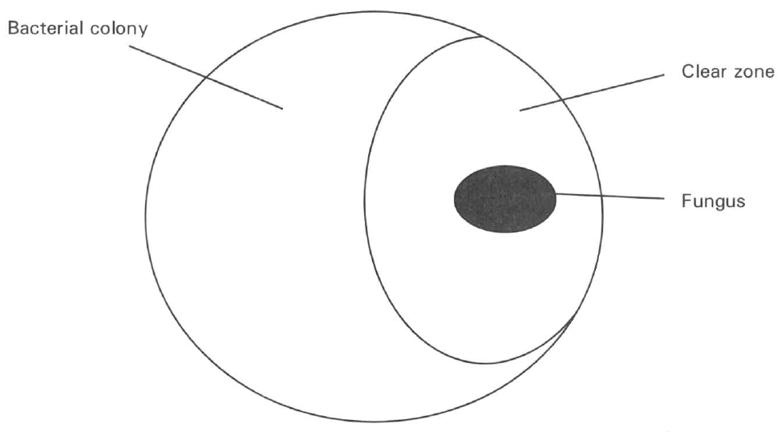
A. (1) only B. (2) only C. (3) only D. ( 1) and (2) only Directions: Questions 33 and 34 refer to the diagram below ,which shows the experiment to find the resistance of four types of bacteria (W, X, Y, Z) against the action of an antibiotic.
20. Arrange the bacteria in ascending order according to their resistance to the antibiotic.
A. WYXZ
B. WZYX
C. XYZW
D. XZYW
21. Recently many cases of antibiotic-resistant strains of bacteria are reported in hospitals in Hong Kong. Which of the following statements concerning this finding is CORRECT?
A. The frequent use of antibiotics in the hospitals forces many bacteria to develop resistance against the antibiotics.
B. The simple genetic structures of bacteria enable them to mutate against the action of antibiotic.
C. Antibiotics act as the selecting agent that eliminates the normal bacteria and permits the more tolerate strains of bacteria to survive.
D. Bacteria become use to the action of the antibiotics.
22. Which of the following statements concerning sulpha drugs is INCORRECT?
A. They are synthetic chemicals containing sulphur.
B. They kill viral pathogens.
C. They were used by humans to cure bacterial diseases before the discovery of antibiotics.
D. They exert their effect as enzyme inhibitors.
C. Non-infectious diseases
23. Which of the following methods can effectively reduce the risks of getting non-infectious diseases? (1) Avoids going to crowded places. (2) Put on masks during the outbreak of a viral disease. (3) Doing aerobic exercises regularly. (4) Taking balanced diet. (5) Inoculating all recommended vaccination since childhood.
A. (1) and (2) only
B. (2) and (3) only
C. (3) and (4) only
D. (3), (4) and (5)
24. Which of the following about coronary heart disease is CORRECT?
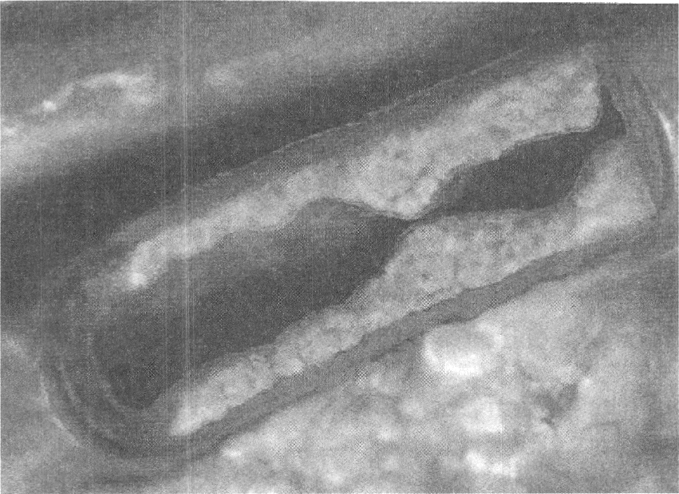
A. It is caused by having plaque formed inside a coronary vein.
B. The heart muscles will die once the important blood vessels supplying the heart are blocked.
C. The surgical method of inflating a balloon-like device inside the plugged section of the coronary blood vessels concerned can permanently cure this disease.
D. Young people will not have coronary heart disease. Directions: Question 51 refers to the diagram below, which shows the longitudinal section of an artery of a cigarette smoker.
25. Which of the following is the cause of narrowing the lumen of the artery of the cigarette smoker?
A. Nicotine stimulates cell division to cause thickening of the artery.
B. Nicotine damages the endothelial cells of the artery that enhances the formation of a plaque at the inner surface of the artery.
C. Carbon monoxide stimulates the aggregation of blood platelets at the inner surface of the artery.
D. Tar deposits at the inner surface of the artery.
26. Which of the following comparisons between the two types of tumours are CORRECT?
 | Malignant tumour | Benign tumour
(1) | Not surrounded by a capsule. | Surrounded by a capsule.
(2) | Cells can spread to other parts of the body. | Cells cannot spread to other parts of the body.
(3) | Usually harmless to the body. | Usually quite harmful to the body.

A. (1) and (2) only
B. (2) and (3) only
C. (3) and (1) only
D. (1), (2) and (3)
27. Which of the following can reduce the risk of getting caners? (1) Quit smoking (2) Avoids excessive consumption of alcohol (3) Reduces exposure to carcinogens.
A. (1) only
B. (2) only
C. (3) only
D. (1), (2) and (3)
28. Which of the following are the risk factors of liver cancer?
(1) Heavy consumption of alcohol (2) Heavy smoking
(3) Carrier of hepatitis B viruses (4) Heavy air pollution
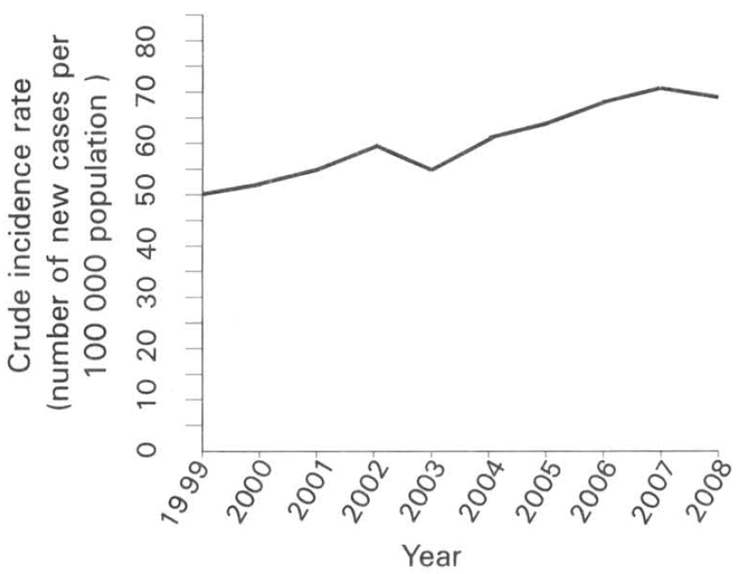
A. (1) and (2) only B. (1) and (3) only C. (2) and (4) only D. (1) and (4) only Directions: Question 60 refers to the graph below ,which shows the crude incidence rate of colorectal cancers in male from 1999 to 2008.
29. Which of the following are the possible reasons for the increase in the incidence rate of colorectal cancers in Hong Kong from 1999 to 2008? (1) More people are taking endoscopy examination of the colon. (2) People take low-fibre and high-fat diet. (3) The increase in the life span of people increases the accumulation of harmful wastes in the colons. (4) Physical inactivity is common in urban life. D. (2), (3) and (4) only Suggested Solutions
A. (1) and (2) only
B. (2) and (3) only
C. (3) and (4) only
D. (2), (3) and (4) only Suggested Solutions

Answers
Answers are printed in red.
1. D
Class: 67.2% correct (n=128) usual slip C
2. A. (1) and (2) only
Class: 72.7% correct (n=128) usual slip D
3. B. Damage the respiratory centre in the brain.
Class: 66.4% correct (n=128) usual slip C
4. A. Liver cancer B. Bronchitis C. Emphysema D. High blood pressure Directions: Question 9 refers to the photomicrographs below, which show the transverse section of the lung tissues of a heavy smoker and a non-smoker. 9Which of the following matching of the persons, the features of the air sacs and their breathing rate compared with condition at rest is CORRECT?
Class: 76.6% correct (n=128) usual slip D
5. A. (1) and (2) only
Class: 79.7% correct (n=128) usual slip B
6. D. (1), (2) and (4) only
Class: 79.5% correct (n=127) usual slip A
7. B. Pathogens will interrupt the metabolic activities of the host cells or directly damaging them.
Class: 66.9% correct (n=127) usual slip A
8. A. (1) and (2) only
Class: 74.2% correct (n=89) usual slip D
9. D. (1) and (4) only
Class: 76.4% correct (n=89) usual slip A
10. B. (2) and (3) only
Class: 74.2% correct (n=89) usual slip A
11. C. (3) and (4) only
Class: 74.2% correct (n=89) usual slip D
12. B
Class: 74.8% correct (n=115) usual slip A
13. D. (1), (2) and (3)
Class: 62.9% correct (n=89) usual slip C
14. B. (2) only
Class: 65.2% correct (n=89) usual slip C
15. D. He is infected by viral flu.
Class: 77.5% correct (n=89) usual slip A
16. D. Viruses depend on the metabolic activities of the host cells to live so that they do not have their own metabolic activities for antibiotics to act on.
Class: 59.6% correct (n=89) usual slip A
17. C. (2) and (4) only
Class: 75.3% correct (n=89) usual slip D
18. D. (1), (2), (3) and (4)
Class: 75.3% correct (n=89) usual slip A
19. C
Class: 62.9% correct (n=89) usual slip B
20. C. XYZW
Class: 70.7% correct (n=58) usual slip B
21. C. Antibiotics act as the selecting agent that eliminates the normal bacteria and permits the more tolerate strains of bacteria to survive.
Class: 55.2% correct (n=58) usual slip A
22. B. They kill viral pathogens.
Class: 74.1% correct (n=54) usual slip C
23. C. (3) and (4) only
Class: 76.5% correct (n=51) usual slip D
24. B. The heart muscles will die once the important blood vessels supplying the heart are blocked.
Class: 78.8% correct (n=80) usual slip A
25. B. Nicotine damages the endothelial cells of the artery that enhances the formation of a plaque at the inner surface of the artery.
Class: 68.6% correct (n=51) usual slip D
26. A. (1) and (2) only
Class: 74.5% correct (n=51) usual slip C
27. D. (1), (2) and (3)
Class: 74.5% correct (n=51) usual slip C
28. B
Class: 69.0% correct (n=29) usual slip A
29. D. (2), (3) and (4) only Suggested Solutions
Class: 69.0% correct (n=29) usual slip C

Class percentage correct
Matched to this paper by question wording in the source bank and the form answer key, not by a shifted paper number.
Q | Answer | % correct | n | Usual slip
1 | D | 67.2% | 128 | C
2 | A | 72.7% | 128 | D
3 | B | 66.4% | 128 | C
4 | A | 76.6% | 128 | D
5 | A | 79.7% | 128 | B
6 | D | 79.5% | 127 | A
7 | B | 66.9% | 127 | A
8 | A | 74.2% | 89 | D
9 | D | 76.4% | 89 | A
10 | B | 74.2% | 89 | A
11 | C | 74.2% | 89 | D
12 | B | 74.8% | 115 | A
13 | D | 62.9% | 89 | C
14 | B | 65.2% | 89 | C
15 | D | 77.5% | 89 | A
16 | D | 59.6% | 89 | A
17 | C | 75.3% | 89 | D
18 | D | 75.3% | 89 | A
19 | C | 62.9% | 89 | B
20 | C | 70.7% | 58 | B
21 | C | 55.2% | 58 | A
22 | B | 74.1% | 54 | C
23 | C | 76.5% | 51 | D
24 | B | 78.8% | 80 | A
25 | B | 68.6% | 51 | D
26 | A | 74.5% | 51 | C
27 | D | 74.5% | 51 | C
28 | B | 69.0% | 29 | A
29 | D | 69.0% | 29 | C

