Homeostasis
Multiple-choice practice
Name: ________________________ Class: ____________
There are 66 questions compiled from Longman HKCEE and/or YKTo papers. Choose the one best answer.
Part A — HKCEE level (Longman)
1. Which of the following are examples of excretory organs? (1) Kidneys (2) Skin (3) Lungs
A. (1) and (2) only
B. (1) and (3) only
C. (2) and (3) only
D. (1), (2) and (3)
2. Which of the following does not have excretory function?
A. Tear gland
B. Liver
C. Skin
D. Lungs
3. Which of the following incorrectly matches the excretory organ and its waste?
 | Excretory organ | Waste
A. | lungs | carbon dioxide
B. | skin | urea
C. | liver | bile salts
D. | kidneys | urea

4. Which of the following has/have osmoregulatory function? (1) Skin (2) Kidneys (3) Colon
A. (1) only
B. (2) only
C. (3) only
D. (1) and (2) only
5. Which of the following contributes most to the maintenance of constant water potential of blood?
A. Reabsorption of salts in the coiled tubules of the kidney
B. Reabsorption of water in the collecting ducts of the kidney
C. Absorption of salts in the small intestine
D. Absorption of water in the colon
6. Which of the following are examples of excretory waste?
(1) Bile pigments (2) Faeces (3) Carbon dioxide
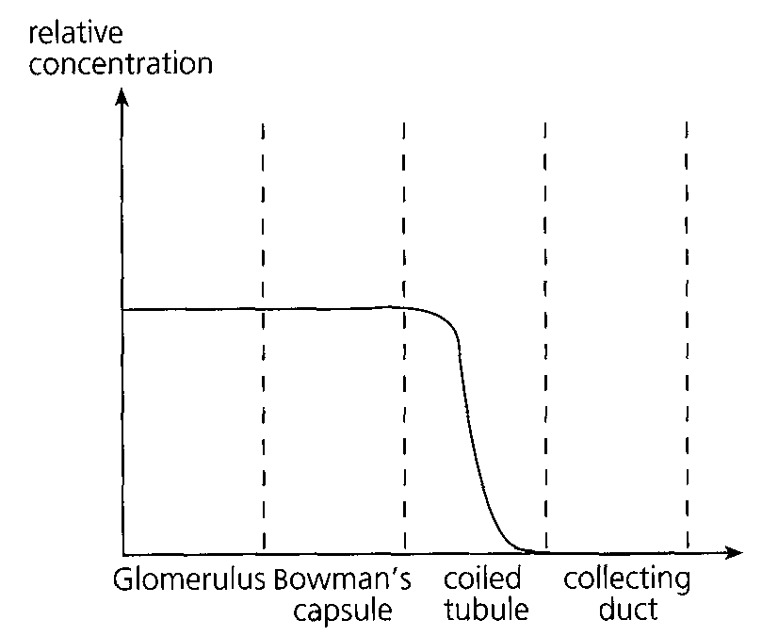
A. (1) and (2) only B. (1) and (3) only C. (2) and (3) only D. (1), (2) and (3) Directions: Questions 7 to 9 refer to the following graph which shows the changes in relative concentration of a certain substance along different parts of a nephron.
7. The substance can be (1)water. (2) glucose. (3) amino acid. . A.(1) and (2) only
A. (1) and (2) only
B. (1) and (3) only
C. (2) and (3) only
D. (1), (2) and (3)
8. What do the relative concentration of the substance in the glomerulus and that in the Bowman's capsule suggest about the nature of filtration in the nephron? A.The filtration is under pressure. C.The filtration occurs in a hypotonic fashion.
A. The filtration is under pressure.
B. The filtration occurs in a hypertonic fashion.
C. The filtration occurs in a hypotonic fashion.
D. The filtration occurs in an isotonic fashion.
9. The decrease in the relative concentration of the substance in the coiled tubule is due to
(1) active transport of the substance. (2) diffusion of the substance. (3) osmosis of water.
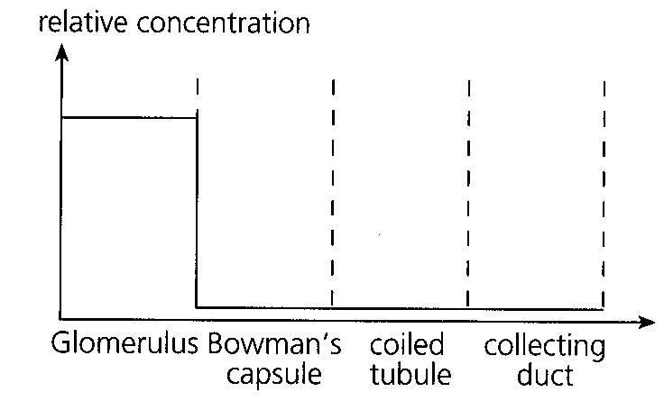
A. (1) only B. (1) and (2) only C. (1) and (3) only D. (2) and (3) only Directions: Questions 10 and 11 refer to the following graph which shows the relative concentration of a certain substance along different parts of a nephron.
10. The substance is probably
A. glucose.
B. salts.
C. urea.
D. fibrinogen.
11. The absence of the substance in the Bowman's capsule is due to
(1) blood pressure. (2) permeability of capillary wall. (3) molecular size of the substance.
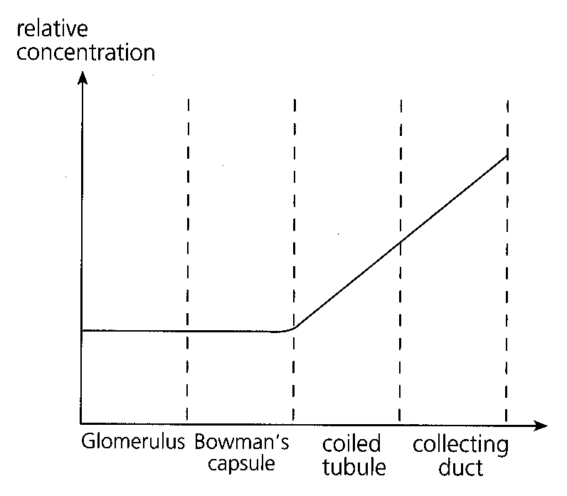
A. (1) and (2) only B. (1) and (3) only C. (2) and (3) only D. (1), (2) and (3) Directions: Questions 12 to 14 refer to the following graph which shows the relative concentration of a certain substance along different parts of a nephron.
12. The substance represented in the graph is probably
A. urea.
B. amino acid.
C. salts.
D. fibrinogen.
13. The increase in the relative concentration of the substance in the coiled tubule is due to (1) secretion of the substance into the coiled tubule. (2) reabsorption of water. (3) impermeability of the coiled tubule to the substance.
A. (1) only
B. (2) only
C. (3) only
D. (1) and (3) only
14. The relative concentration of the substance continues to rise in the collecting duct because
A. the collecting duct reabsorbs less water.
B. the collecting duct reabsorbs more water.
C. the collecting duct reabsorbs a smaller proportion of water.
D. the collecting duct reabsorbs a larger proportion of water.
15. Which of the following correctly states the significance of urination and perspiration?
 | Urination | Perspiration
A. | thermoregulation | excretion
B. | osmoregulation | excretion
C. | regulation of glucose level | thermoregulation
D. | excretion | osmoregulation

16. Which of the following are the functions of mammalian kidneys? (1) Excretion (2) Regulation of glucose level in blood (3) Osmoregulation D. (1), (2) and (3) Directions: Questions 17 to 19 refer to the diagram below which shows the urinary system of man. XXX17. Which of the following correctly shows the glucose concentration in increasing order in X, Y and Z? B. X,Z,Y C. Z, X, Y D. Z,Y,X
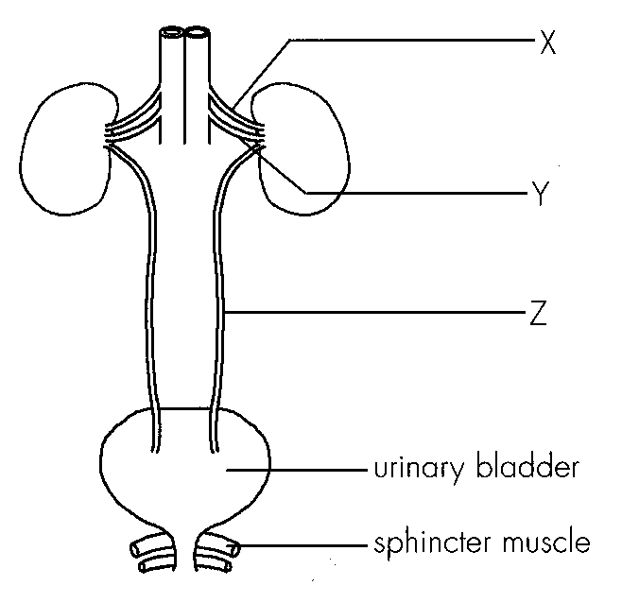
A. (1) and (2) only
B. (1) and (3) only
C. (2) and (3) only
A. X,Y,Z
17. A student feels cold in an air conditioned hall during the Biology examination. Which of the following responses would occur in the skin? -
A. Skin capillaries constrict and sweating decreases.
B. Skin capillaries dilate and sweating increases.
C. Skin arterioles constrict and sweating decreases.
D. Skin arterioles dilate and sweating increases.
18. Which of the following is not performed by skin?
A. Body defence B. Thermoregulation C. Excretion D. Osmoregulation
19. When the air temperature is 40°C, a human body may lose heat by (1) convection. (2) evaporation. (3) radiation.
A. (2) only
B. (3) only
C. (1) and (2) only
D. (1), (2) and (3)
20. Which of the following are the functions of skin? (1) As a sense organ (2) As an excretory organ (3) To synthesize vitamin D (4) As a homeostatic organ
A. (1), (2) and (3) only
B. (1), (2) and (4) only
C. (2), (3) and (4) only
D. (1), (2), (3) and (4)
21. Which of the following is the most important function of skin?
A. Regulation of body temperature
B. Protection
C. Excretion
D. Sensation
22. Which of the following changes will occur in the skin when the room temperature is high? (1) Vasodilation (2) Shivering (3) Hair erection
A. (1) only
B. (1) and (2) only
C. (1) and (3) only
D. (2) and (3) only
23. When doing exercise, vasodilation occurs in the skin so that
(1) more water is supplied to sweat glands for producing more sweat.
(2) more water is supplied to sebaceous glands for producing more sebum.
(3) more heat can be lost from the skin by radiation.
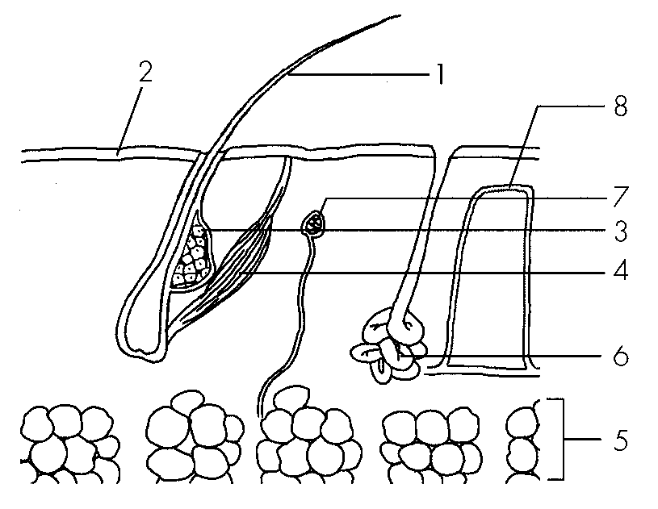
A. (1) and (2) only B. (1) and (3) only C. (2) and (3) only D. (1), (2) and (3) Directions: Questions 27 to 29 refer to the following diagram which shows the transverse section of skin.
24. Which structures are non living?-
A. 1 and 2
B. 2 and 3
C. 3 and 4
D. 4 and 5
25. Which of the following correctly matches different parts of the skin and their corresponding functions?
 | Sensory | Protective | Thermoregulatory
A. | 2 | 3 | 4
B. | 3 | 2 | 6
C. | 7 | 3 | 8
D. | 7 | 5 | 1

26. Which of the following structures can serve as long term adaptations to cold climate?-
A. 1 and 2
B. 1 and 5
C. 2 and 5
D. 6 and 8
27. Which of the following are involved in the thermoregulatory function of the skin? (1) Hair (2) Sebaceous gland (3) Sweat gland (4) Temperature receptors
A. (1), (2) and (3) only
B. (1), (2) and (4) only
C. (1), (3) and (4) only
D. (2), (3) and (4) only
28. In which of the following conditions will evaporation of sweat become the major means of heat loss?
 | Temperature (°C) | Relative humidity (%)
A. | 10 | 60
B. | 20 | 80
C. | 30 | 80
D. | 40 | 60

29. Which of the following are the functions of subcutaneous fat in the skin? (1) As energy reserve (2) As an insulating layer to heat (3) As a protective layer for underlying structures
A. (1) and (2) only
B. (1) and (3) only
C. (2) and (3) only
D. (1), (2) and (3)
30. Which of the following roles are played by the mammalian skin in homeostasis?
(1) Receptor (2) Effector (3) Coordinator
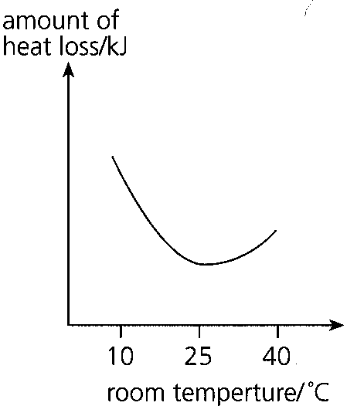
A. (1) and (2) only B. (1) and (3) only C. (2) and (3) only D. (1), (2) and (3) Directions: Questions 34 to 36 refer to the following which shows the changes in the amount of heat loss from a naked person when the room temperature rose form 10°C to 40°C.
31. Which of the following correctly explain the change in the amount of heat loss when the room temperature changed from 25°C to 10°C?
A.Erector muscles contracted to make hair become erect.
B.Sweat glands secreted less sweat.
C.Arterioles constricted to reduce blood flow to the skin.
D.The gradient between body temperature and room temperature increased.
32. Despite the fact that the amount of heat loss was increasing when the air temperature changed from 25°C to 10°C, the body temperature remained more or less the same because A.heat loss from the skin was reduced. B.the metabolic rate was increasing.
A. heat loss from the skin was reduced.
B. the metabolic rate was increasing.
C. the amount of heat loss was negligible.
D. heat loss affected the skin temperature but not the body temperature.
33. When the room temperature rose from 25°C to 40°C, by which of the following methods would the amount of heat loss be increasing?
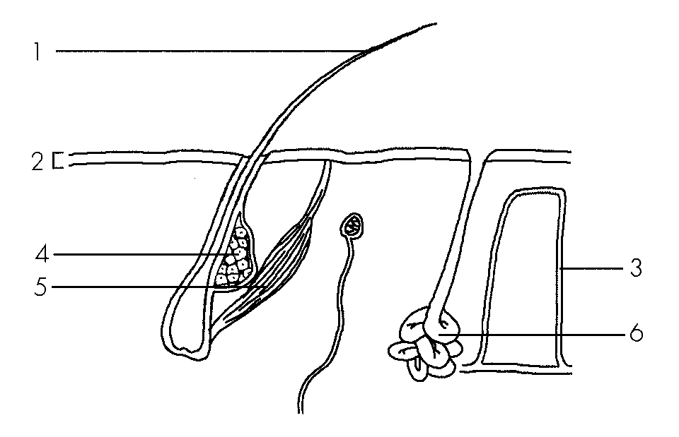
A. Conduction
B. Convection
C. Evaporation
D. Radiation Directions: Questions 37 to 39 refer to the diagram below which shows a section of mammalian skin.
34. Which of the following structures are unique in mammals?
A. 1 and 3
B. 1 and 6
C. 3 and 4
D. 3 and 6
35. Which of the following correctly describes the functions of structures 2, 4 and 6?
36. | 4 | 6 | A. | makes vitamin D | excretion | temperature regulation | B. | excretion | makes hair waterproof | temperature regulation | C. | physical protection | temperature regulation | excretion | D. | makes vitamin D | protection against infection | excretion
37. Which of the following correctly describes the states of 1, 3 and 5 in a hot sunny day?
38. | 3 | 5 |
A. | erect | dilated | contracted |
B. | erect | constricted | relaxed |
C. | flattened | constricted | contracted |
D. | flattened | dilated | relaxed
39. Diabetic patients should not consume insulin orally because
A. it cannot be digested for absorption.
B. it will be egested.
C. it is protein in nature.
D. it takes a longer time for insulin to exert its effects.
40. Which of the following is/are the effect(s) of insulin? (1) It enhances the conversion of glucose into glycogen. (2) It enhances glucose uptake by body cells. (3) It inhibits the reabsorption of glucose in the kidney tubules.
A. (1) only
B. (1) and (2) only
C. (2) and (3) only
D. (1), (2) and (3)
41. The glucose level in the hepatic portal vein is higher than that in the hepatic vein
A. during exercise.
B. during starvation.
C. before a meal.
D. after a meal.
42. The glucose level in the hepatic vein is higher than that in the hepatic portal vein
A. during exercise.
B. during starvation.
C. before a meal.
D. after a meal.
43. Which of the following correctly matches the change in insulin level and glucose level after a meal rich in carbohydrates?
 | Change in insulin level | Change in glucose level
A. | rises and then falls | rises and then falls
B. | rises and then falls | falls and then rises
C. | falls and then rises | rises and then falls
D. | falls and then rises | falls and then rises

44. Which of the following graphs best represents the changes in insulin level after a meal?
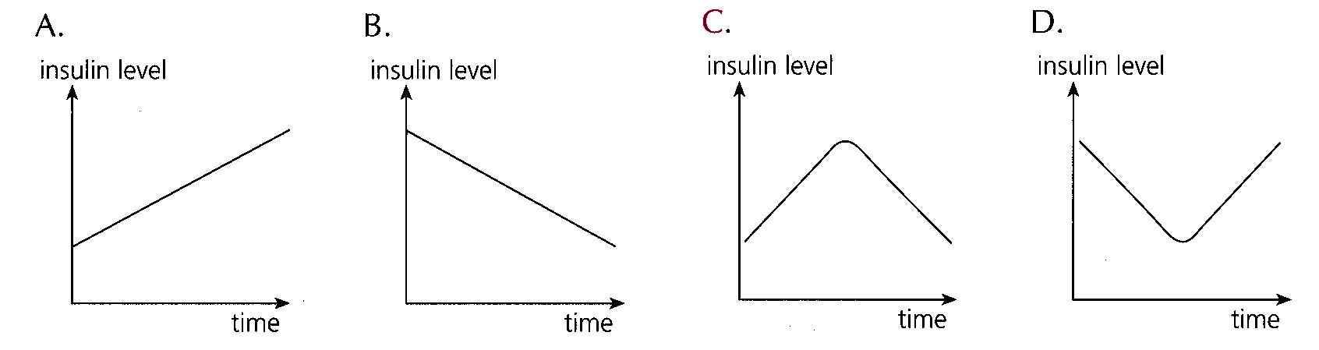
45. Which of the following blood vessels has the highest blood glucose level in a starving person?
A. Posterior vene cava
B. Hepatic artery
C. Hepatic portal vein
D. Hepatic vein
46. The presence of glucose in the urine of diabetic patients can be prevented by intravenous injection of insulin because insulin enhances
A. active transport of glucose in the coiled tubules of the kidney.
B. glucose uptake by body cells.
C. reabsorption of glucose in the collecting ducts of the kidney.
D. breakdown of glucose in the liver.
47. Which of the following statements about insulin is incorrect?
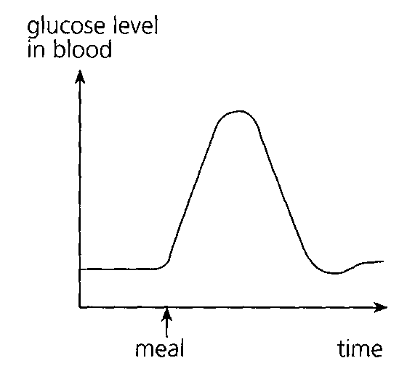
A. It is protein in nature. B. Its medium of transport is blood.
C. It is produced in the pancreas. D. Its site of action is in the liver only. Directions: Questions 49 and 50 refer to the following graph which shows the changes in blood glucose level of a person after a meal rich in starch.
48. Which of the following processes account for the rise in blood glucose level after the meal? (1) Digestion (2) Absorption (3) Assimilation
A. (1) and (2) only
B. (1) and (3) only
C. (2) and (3) only
D. (1), (2) and (3)
49. Which of the following correctly explain the subsequent drop in blood glucose level?
 | Change in insulin level | Effect
A. | falls | enhances conversion of glucose into glycogen
B. | falls | catalyses conversion of glucose into glycogen
C. | rises | enhances conversion of glucose into glycogen
D. | rises | catalyses conversion of glucose into glycogen

Part B — HKDSE-style (YKTo)
50. Which of the following is the CORRECT definition of homeostasis in humans?
A. Removal of metabolic wastes from the body.
B. Maintenance of a steady internal environment.
C. Regulation of the amount of urine discharged from the urinary bladder.
D. Maintenance of constant environmental conditions in the habitat. 2Which of the following organs are involved in homeostasis in human body? (1) Skin (2) Pancreas (3) Kidneys (4) Liver (5) Urinary bladder (6) Smooth muscles of rectum
A. (1), (2), (3) and (4) B. (2), (3), (5) and (6)
C. (3), (4), (5) and (6) D. (1), (2), (3) and (5)
51. Which of the following substances in blood have to be regulated to a steady state inside our body?
(1) Gas content (2) Sugar content (3) Water content
(4) Electrolytes content
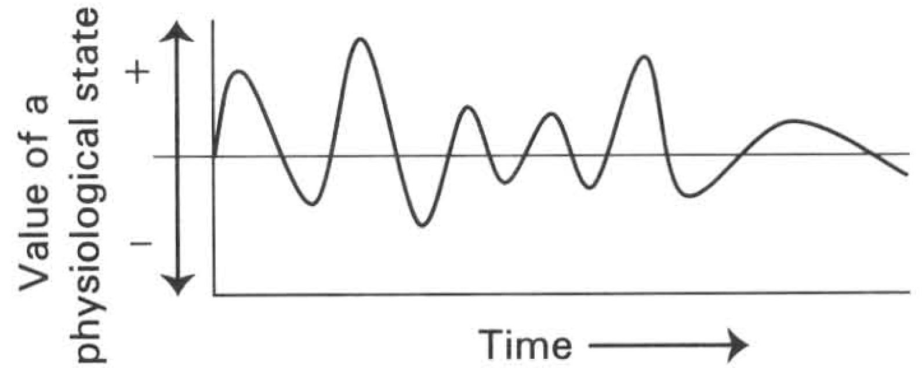
A. (1) and (2) only B . (3) and (4) onlyC . (1), (2) and (3) only D. (1), (2), (3) and (4)
52. The graph below shows the change of a physiological state inside the human body.
This curve illustrates
A. a process that is controlled under nervous coordination.
B. a process that is controlled under hormonal coordination.
C. a process that is under homeostatic control.
D. a growth process. 5Which of the following is a negative feedback mechanism? (1) When the water content of blood is very high, more water passes into the tissue cells and cause them to burst. (2) When the blood glucose level drops below the normal value, the pancreas will secrete more glucagon. (3) When the blood glucose level exceeds the threshold value, the kidney tubules fail to reabsorb glucose into blood. (4) When the body temperature is very high, more sweat is secreted by the sweat glands.
A. (1) only B. (2) only C. (3) only D. (2) and (4) only 6Which of the following illustrates the negative feedback mechanism?
A. The blood glucose level is controlled by insulin but the secretion of this hormone in turn is affected by the blood glucose level.
B. The secretion of oily substance from the sebaceous gland to reduce water lost from the skin surface.
C. The breakdown of the dead organisms by the decomposers into simple substances which can be taken up by producers again.
D. The mother feeds the baby with milk so that the useful nutrients go back to the human body again.
53. After a boy has run a 100-metre race, his rate and depth of breathing and the rate of heart beat remain very high for another 30 minutes. These physiological responses illustrate (1) homeostatic control. (2) negative feedback mechanism. (3) excretion. D. (1), (2) and (3) 8Which of the following is the action of insulin to lower the blood glucose level? (1) Changes glucose to glycogen for storage inside the liver. (2) Excretes glucose in urine out of the body. (3) Promotes the uptake of glucose by body cells. (4) Catalyzes the hydrolysis of glucose in the small intestine. B. (2) and (4) only C. (1) and (3) only D. (3) and (4) only B. Blood glucose level control Directions: Questions 9 to 12 refer to the chart below, which shows the control of the glucose level in blood. 9Which of the following matching is CORRECT?
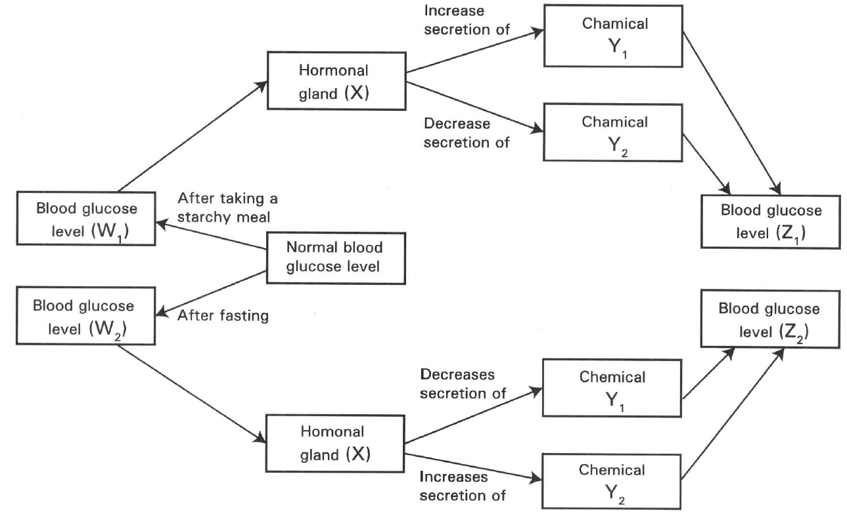
 | Hormonal gland(X) | Chemical Y1 | Chemical Y2
A. | Liver | Glucose | Glycogen
B. | Liver | Glycogen | Glucose
C. | Pancreas | Insulin | Glucagon
D. | Pancreas | Glucagon | Insulin

A. (1) only
B. (2) only
C. (3) only
A. (1) and (2) only
54. Which of the following comparisons between Y1 and Y2 is CORRECT?
11Which of the following matching is CORRECT?
 | Y1 | Y2
A. | It is secreted by the pancreas. | It is secreted by the liver.
B. | It is a hormone. | It is an enzyme.
C. | It decreases the blood glucose level. | It increases the blood glucose level.
D. | It produces its effects in the liver only. | It produces its effects in the muscles only.

Concentration of blood glucose level at
 | W1 | W2 | Z1 | Z2
A.B.C.D. | IncreasesIncreasesDecreasesDecreases | DecreasesDecreasesIncreasesIncreases | IncreasesDecreasesIncreasesDecreases | DecreasesIncreasesDecreasesIncreases

55. In some patients the blood glucose level (Z1) is still very high when chemical Y, has increased to high level two hours after taking a starchy meal. This shows that these patients have the disease called
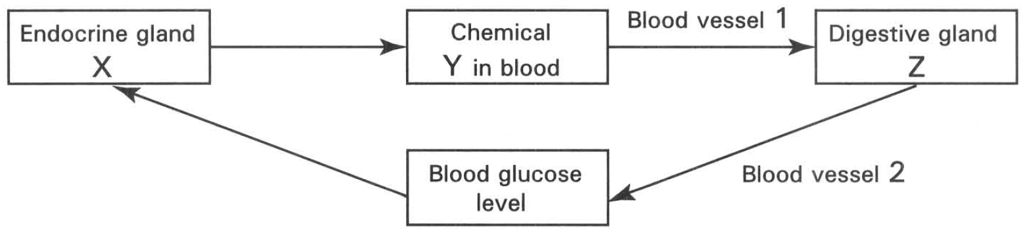
 | Organ X | Chemical Y | Organ Z
A. | Liver | Glycogen | Kidney
B. | Pancreas | Glucose | Liver
C. | Pancreas | Insulin | Liver
D. | Liver | Insulin | Pancreas

A. diarrhoea. B. type I diabetes. C. type II diabetes. D. cirrhoses. Directions: Questions 13 and 14 refer to the diagram below which shows the regulation of glucose level in blood. 13Which of the following matching is CORRECT?
56. After taking a meal rich in carbohydrates, which of the following combinations is CORRECT?
Direction: Questions 15 to 24 refer to the following experiment. Two persons X and Y were starved for 12 hours. They then drank 500m1 of glucose solution. Their blood glucose levels were measured immediately and then at half-hour intervals. The results are shown in the graph below.
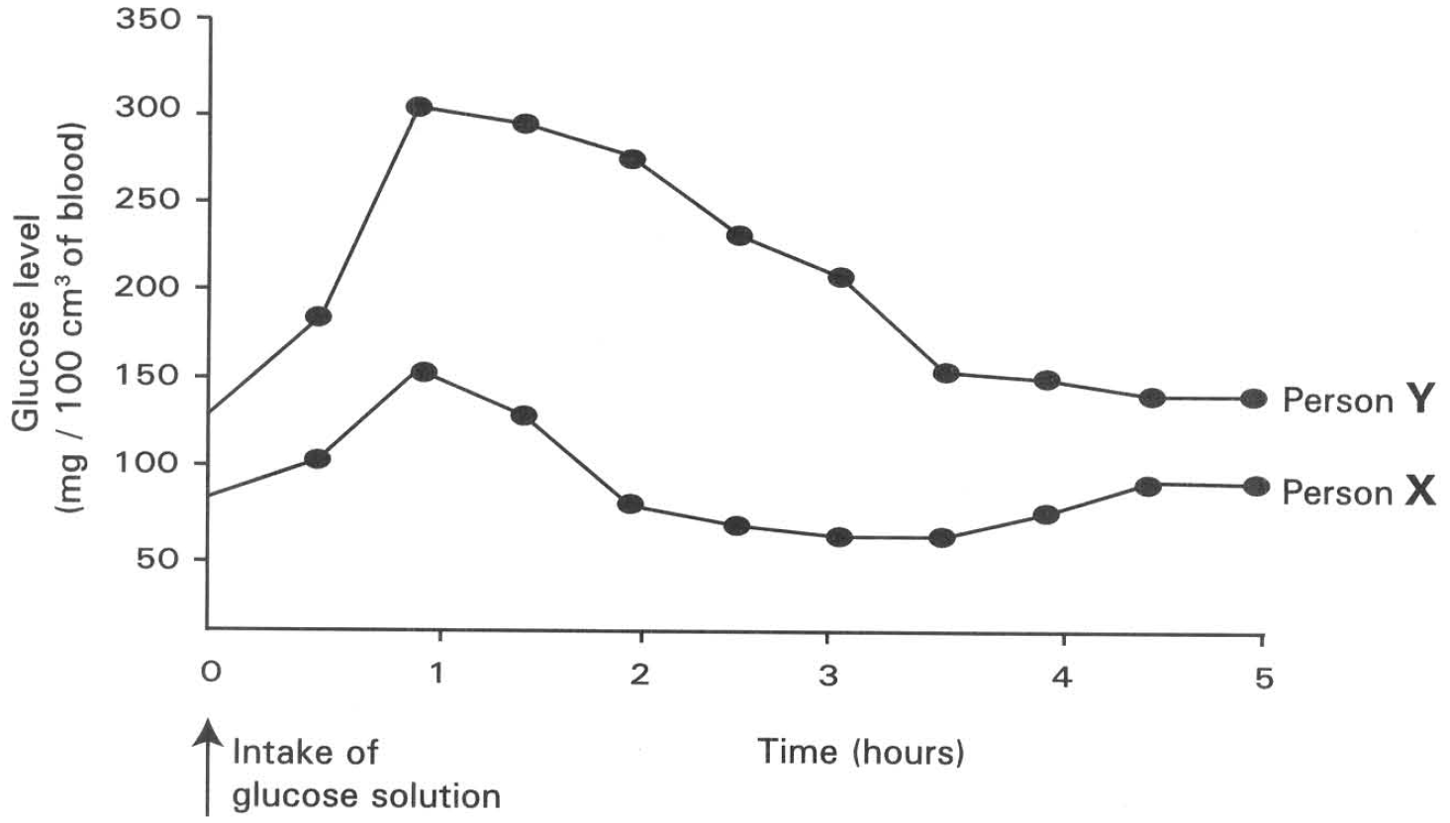
 | Concentration of Y in blood | Amount of glycogen stored in the body | Blood glucose level in blood vessel 2 compared with that in blood vessel 1
A. | Higher | More | Higher
B. | Lower | Less | Lower
C. | Higher | More | Lower
D. | Higher | Less | Higher

57. Which of the following is the reason accounting for the change in the blood glucose level of X in the first hour? (1) It takes time for the carbohydrate to be digested. (2) It takes time for the sugar to be absorbed from the small intestine to the blood stream. (3) The glycogen stored in the liver changes into sugar.
A. (1) only
B. (2) only
C. (3) only
D. (1) and (2) only
58. Which of the following is/are the reason(s) accounting for the rapid change in the blood glucose level of X between the first and second hours? (1) Excretion of glucose through the kidneys. (2) Increased uptake and oxidation of glucose by tissue cells. (3) Rapid conversion of glucose to glycogen.
A. (1) only
B. (2) only
C. (3) only
D. (2) and (3) only
59. Which of the following substances increase in their concentration in X between the first and second hours? (1) Pancreatic juice (2) Intestinal juice (3) Insulin (4) Amylase
A. (1) only
B. (3) only
C. (1) and (2) only
D. (3) and (4) only
60. Which of the following phenomena is exhibited by X during the second and fourth hours?
A. Excretion B. Digestion C. Homeostasis D. Osmoregulation
61. What is the normal blood glucose level in a healthy person?
A. 50 mg per 100 cm3 of blood
B. 80 mg per 100 cm3 of blood
C. 100 mg per 100 cm3 of blood
D. 150 mg per 100 cm3 of blood
62. Y reached a higher blood glucose peak than that of X because
A. Y drank more glucose solution than X.
B. Y used less glucose to support his metabolic activities.
C. Y could not change the glucose to glycogen for storage in the liver and muscles.
D. Y had a defective kidney that could not excrete the glucose properly.
63. What caused Y to have his blood glucose level gradually fallen down to the minimum value?
A. The oxidation of glucose by tissue cells.
B. The conversion of glucose to glycogen in the liver.
C. The excretion of glucose by the kidneys.
D. The hydrolysis of glucose to simpler forms in the small intestine.
64. What defect in Y causes him to have such high blood glucose level compared with that of X ?
A. The liver cannot produce enough bile.
B. The pancreas cannot produce enough pancreatic juice.
C. The intestinal gland cannot produce enough alkaline fluid.
D. The pancreas cannot produce enough insulin.
65. What is the disease of Y that makes him to have such characteristic change in his blood glucose level after drinking 500ml of glucose solution?
A. Diabetes B. Diuresis C. Dialysis D. Diarrhoea
66. This patient is advised NOT to take high GI (glycemic index) foods. Which of the following is/are the reason(s) for this suggestion? (1) High GI foods are easily excreted out in urine. (2) High GI foods take longer time to digest. (3) High GI foods will cause abrupt increase in the blood glucose level.
A. (1) only
B. (2) only
C. (3) only
D. (1) and (2) only

Answers
Answers are printed in red.
1. D. (1), (2) and (3)

2. A. Tear gland

3. C

4. B. (2) only

5. B. Reabsorption of water in the collecting ducts of the kidney

6. B

7. C. (2) and (3) only

8. D. The filtration occurs in an isotonic fashion.

9. ?

10. D. fibrinogen.

11. C

12. A. urea.

13. B. (2) only

14. D. the collecting duct reabsorbs a larger proportion of water.

15. B

16. ?

17. C. Skin arterioles constrict and sweating decreases.

18. D

19. ?

20. D. (1), (2), (3) and (4)

21. ?

22. ?

23. B

24. A. 1 and 2

25. C

26. B. 1 and 5

27. C. (1), (3) and (4) only

28. C

29. A. (1) and (2) only

30. A. (1) and (2) only B. (1) and (3) only C. (2) and (3) only D. (1), (2) and (3) Directions: Questions 34 to 36 refer to the following which shows the changes in the amount of heat loss from a naked person when the room temperature rose form 10°C to 40°C.
Class: 71.5% correct (n=242) usual slip A
31. D

32. B. the metabolic rate was increasing.

33. C. Evaporation

34. B. 1 and 6

35. ?

36. D

37. ?

38. D. | flattened | dilated | relaxed

39. C. it is protein in nature.

40. B. (1) and (2) only

41. D. after a meal.

42. B. during starvation.

43. A

44. ?

45. D. Hepatic vein

46. B. glucose uptake by body cells.

47. D

48. A. (1) and (2) only

49. C

50. B. Maintenance of a steady internal environment.

51. D

52. C. The breakdown of the dead organisms by the decomposers into simple substances which can be taken up by producers again.

53. D

54. C

55. C

56. C

57. B. (2) only

58. D. (2) and (3) only

59. B. (3) only

60. C

61. B. 80 mg per 100 cm3 of blood

62. C. Y could not change the glucose to glycogen for storage in the liver and muscles.

63. C. The excretion of glucose by the kidneys.

64. D. The pancreas cannot produce enough insulin.

65. A. Diabetes B. Diuresis C. Dialysis D. Diarrhoea

66. C. (3) only

