Homeostasis · items under 80% correct
Multiple-choice practice
Name: ________________________ Class: ____________
These items were answered correctly by fewer than 80% of students in class Google Forms, matched by the wording in the source bank and the form answer key. Choose the one best answer.
Part A — HKCEE level (Longman)
1. Which of the following roles are played by the mammalian skin in homeostasis?
(1) Receptor (2) Effector (3) Coordinator
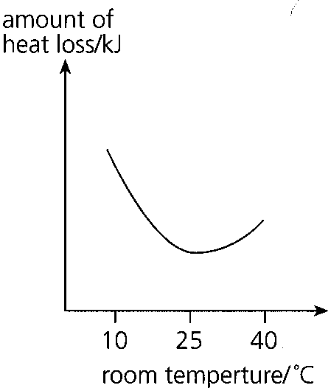
A. (1) and (2) only B. (1) and (3) only C. (2) and (3) only D. (1), (2) and (3) Directions: Questions 34 to 36 refer to the following which shows the changes in the amount of heat loss from a naked person when the room temperature rose form 10°C to 40°C.

Answers
Answers are printed in red.
1. A. (1) and (2) only B. (1) and (3) only C. (2) and (3) only D. (1), (2) and (3) Directions: Questions 34 to 36 refer to the following which shows the changes in the amount of heat loss from a naked person when the room temperature rose form 10°C to 40°C.
Class: 71.5% correct (n=242) usual slip A

Class percentage correct
Matched to this paper by question wording in the source bank and the form answer key, not by a shifted paper number.
Q | Answer | % correct | n | Usual slip
1 | A | 71.5% | 242 | A

