Man's influence on the environment
Multiple-choice practice
Name: ________________________ Class: ____________
There are 59 questions compiled from Longman HKCEE and/or YKTo papers. Choose the one best answer.
Part A — HKCEE level (Longman)
1. Deforestation results in (1) destruction of natural habitats. (2) an increase in oxygen level in atmosphere. (3) soil erosion. A. (1) and (2) only
A. (1) and (2) only
B. (1) and (3) only
C. (2) and (3) only
D. (1), (2) and (3)
2. Which of the following is not a consequence of deforestation?
A. Soil erosion
B. Extinction of species
C. Flooding
D. Ozone depletion
3. Deforestation contributes to global warming because
A. less oxygen is consumed in plant respiration.
B. less carbon dioxide is consumed in photosynthesis.
C. less water evaporates in transpiration.
D. less trees shield the land from the sun.
4. Monoculture may cause the depletion of
A. soil water.
B. soil air.
C. minerals in soil.
D. organic nutrients in soil.
5. Monoculture may lead to (1) an increase in pest population. (2) the destruction of ecosystem.(3) soil erosion.
A. (1) and (2) only
B. (1) and (3) only
C. (2) and (3) only
D. (1), (2) and (3)
6. Which of the following are related to the practice of monoculture? (1) Loss of species(2) Reduction in soil fertility (3) Destruction of ecosystems
A. (1) and (2) only
B. (1) and (3) only
C. (2) and (3) only
D. (1), (2) and (3)
7. Eroded land is not suitable for growing crops because
A. the soil is too dry.
B. no mineral is left in the soil.
C. much of the fertile top soil has been lost.
D. it is impossible for the roots to anchor.
8. Which of the following practices may help to prevent soil erosion? (1) Planting trees (2) Terracing slopes (3) Harvesting crops
A. (1) and (2) only
B. (1) and (3) only
C. (2) and (3) only
D. (1), (2) and (3)
9. Which of the following gases contributes to the greenhouse effect the most?
A. Carbon dioxideB. Methane C. CFCs D. Ozone
10. Which of the following is the main cause of the greenhouse effect?
A. Afforestation B. Burning of fossil fuels
C. Extensive use of aerosols and refrigerants D. Practicing monoculture
11. Which of the following statements about greenhouse effect is incorrect?
A. It is caused by an increase in atmospheric temperature.
B. It will result in a rise in the sealevel. -
C. It will cause plant species to move polewards to survive.
D. It can be reduced by controlling carbon dioxide emissions.
12. CFCs are most likely the agent responsible for the depletion of the atmospheric
A. oxygen.
B. carbon dioxide.
C. ozone.
D. nitrogen.
13. Ozone depletion may lead to (1) increased incidence of skin cancer. (2) increased mutation rate of living organisms. (3) changes in climates.
A. (1) only
B. (1) and (2) only
C. (2) and (3) only
D. (1), (2) and (3)
14. Which of the following pollutants contribute to acid rains? (1) Carbon dioxide (2) Sulphur dioxide(3) Hydrocarbons
A. (1) and (2) only
B. (1) and (3) only
C. (2) and (3) only
D. (1), (2) and (3)
15. Which of the following are harmful effects of acid rain? (1) It damages buildings. (2) It damages plants. (3) It reduces soil fertility.
A. (1) and (2) only
B. (1) and (3) only
C. (2) and (3) only
D. (1), (2) and (3)
16. The problem of acid rain can be lessened by (1) controlling the sulphur content of fuel. (2) limiting the emission of exhaust gases from motor vehicles. (3) the introduction of unleaded petrol.
A. (1) and (2) only
B. (1) and (3) only
C. (2) and (3) only
D. (1), (2) and (3)
17. Lichens are sensitive to air pollution. The graph below shows the number of species of lichens on different substrates at different distance from the city centre. The graph indicates that B.lichens are completely absent in the city centre. C.more lichen species can survive on walls when the air is unpolluted. D.there are no trees in the city centre.
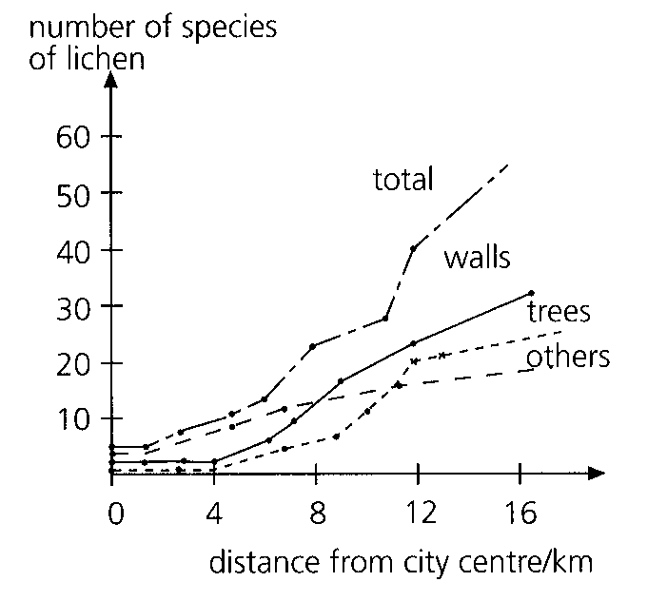
A. the city centre has the cleanest air.
B. lichens are completely absent in the city centre.
C. more lichen species can survive on walls when the air is unpolluted.
D. there are no trees in the city centre.
18. The diagram below shows a map of the distribution of lichens around an industrial area.
Which of the above arrows indicates the prevailing wind direction?
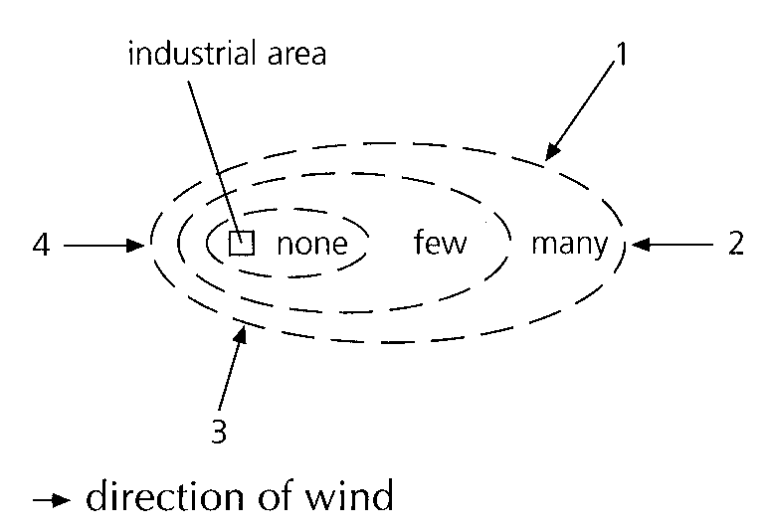
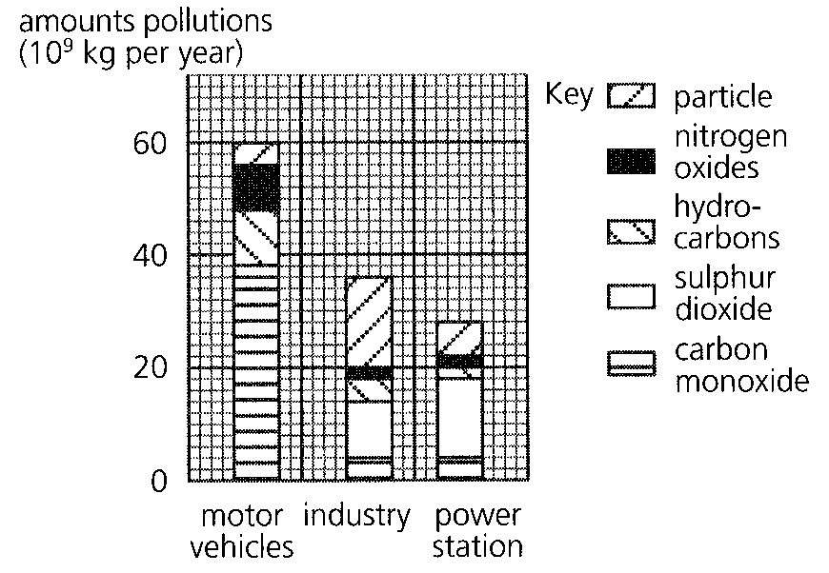
A. 1 B. 2 C. 3 D. 4 Directions: Questions 19 to 21 refer to the bar chart below which shows the amounts of some air pollutants of a city in one year.
19. The mass of hydrocarbons produced from industry in a year is
A. 2.0 x 109 kg.
B. 4.0 x 109 kg.
C. 1.2 x 10 10 kg.
D. 2.0 x 1010 kg.
20. Which pollutant is produced in the greatest amount from the power station?
A. Solid particles B. Nitrogen oxides C. Sulphur dioxideD. Carbon monoxide
21. The most effective way to reduce air pollution in this city is
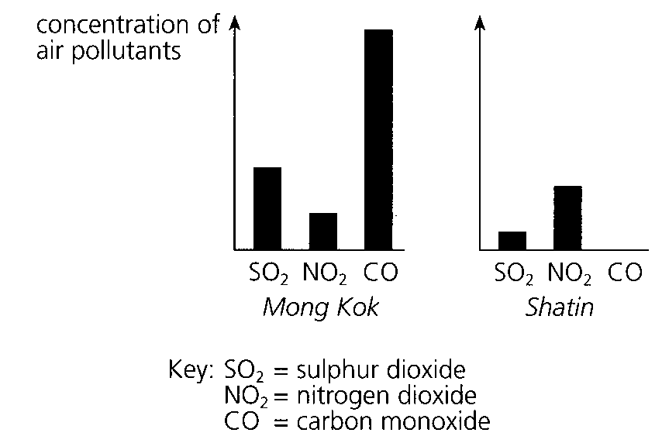
A. to shut down some of the power stations.
B. to reduce the number of motor vehicles.
C. to control the emission of exhaust gases from industry.
D. to relocate the industrial area to remote sites. Directions: Questions 22 and 23 refer to the bar charts below which show the annual average concentrations of some air pollutants in two districts in Hong Kong.
22. Which of the following is a possible reason for the low levels of air pollutants in Shatin?
A. It is a valley.
B. The traffic is less busy.
C. There is a sewage treatment plant.
D. There is less construction work.
23. Which of the following substances will decrease in a compost heap?
A. OxygenB. Carbon dioxide C. Nitrate D. Ammonia
24. Which of the following water pollutants may reduce the level of dissolved oxygen? (1) Hot water from cooling towers (2) Oil from oil tanker leakage (3) Pig and chicken wastes from farms
A. (1) and (2) only
B. (1) and (3) only
C. (2) and (3) only
D. (1), (2) and (3)
25. Which of the following may make the pollution problem more serious at a harbour? (1) The dumping of a huge amount of sewage into the water. (2) The lack of oceanic currents. (3) Strong wave action.
A. (1) and (2) only
B. (1) and (3) only
C. (2) and (3) only
D. (1), (2) and (3)
26. Detergents in domestic sewage stimulates the growth of
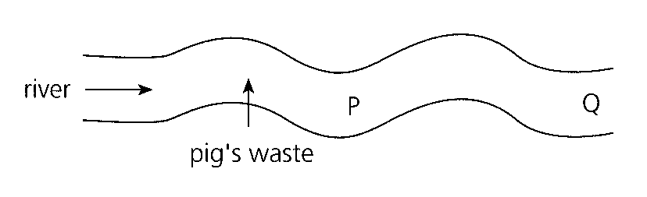
A. bacteria. B. algae. C. fungi. D. aquatic animals. Directions: Questions 28 and 29 refer to the diagram below which shows part of a river and the location where pig's waste is discharged.
27. Which of the following correctly describes the changes at sites P and Q in the river?
 | P | Q
A. | algal bloom | bacterial growth
B. | oxygen depletion | algal bloom
C. | bacterial growth | oxygen depletion
D. | oxygen depletion | bacterial growth

28. Ammonia concentration in water increases to a maximum at P and then gradually falls to its normal level at Q. Which of the following processes can provide the correct explanations for the changes?
 | Rise in ammonia level | Fall in ammonia level
A. | putrefaction | nitrification
B. | putrefaction | denitrification
C. | nitrogen fixation | nitrification
D. | nitrogen fixation | denitrification

29. When a large amount of manure is discharged into a river, which of the following graphs shows the most likely changes in the populations of bacteria and algae along the river?
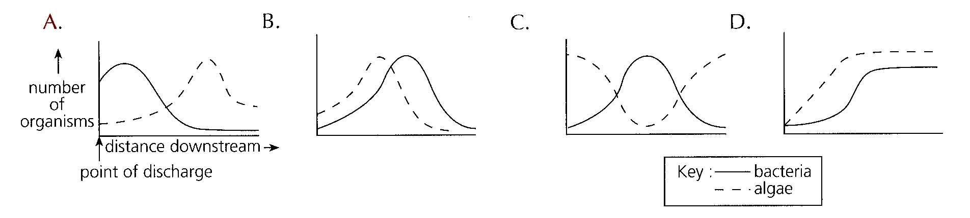
30. If inorganic fertilizer is discharged into the river instead of manure, which of the graphs in No. 30 shows the most likely changes in the populations of bacteria and algae along the river?
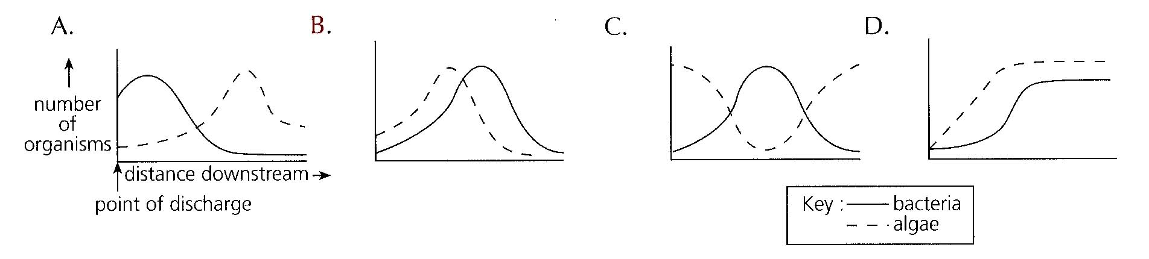
31. Which of the graphs below correctly shows the effect of discharging untreated sewage into a river?
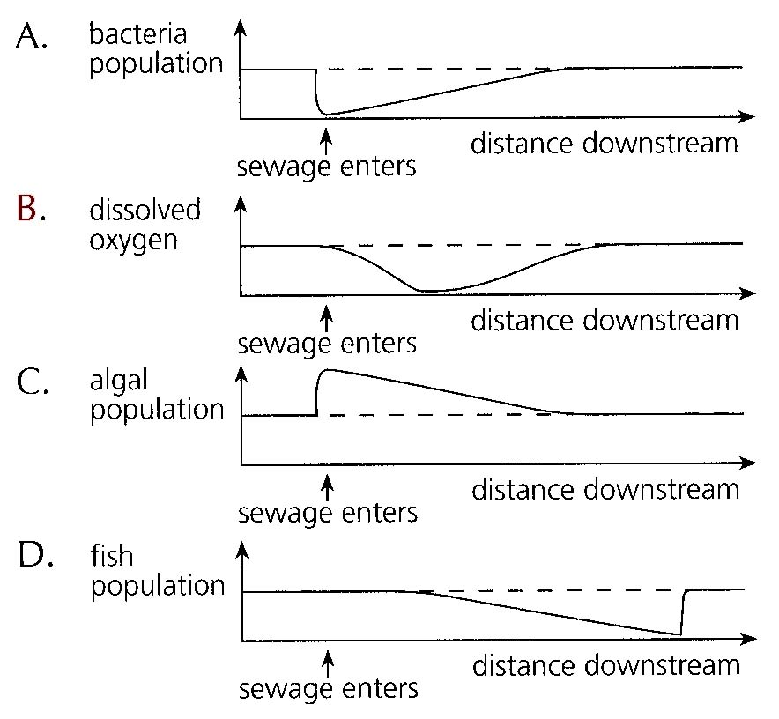
32. If hot water is discharged into a river, which of the following are the possible effects? (1)Oxygen would become less available to the river inhabitants. (2)The demand of oxygen from aquatic organisms would increase. (3)The microorganisms in water would become less active.
A. (1) and (2) only
B. (1) and (3) only
C. (2) and (3) only
D. (1), (2) and (3)
33. The use of the insecticide DDT has been banned in many countries because
A. it accumulates inside the bodies of living organisms.
B. most insects have developed resistance to it.
C. it is harmful to living organisms even at very low levels.
D. it kills crops too.
34. Which of the following may give rise to red tides? (1) An increase in the nitrogen content of the water (2) Dumping of organic wastes into the water (3) A reduction in the oxygen content of the water
A. (1) only
B. (1) and (2) only
C. (2) and (3) only
D. (1), (2) and (3)
35. Which of the following processes adds most nitrogen compounds to the water in a reservoir?
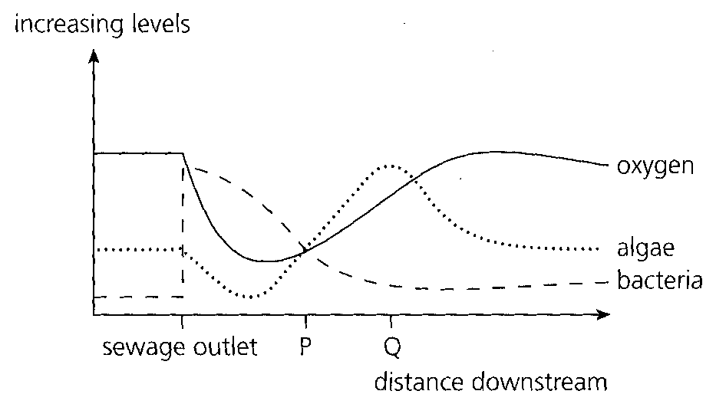
A. Burning of coal in power stations B. Combustion of petrol in motor vehicles
C. Use of fertilizers in farming D. Lightning Directions: Questions 37 and 38 refer to the graph below which shows the effect of sewage on oxygen level, bacterial population and algal population.
36. The oxygen level dropped rapidly at the sewage outlet because A.the suspended solids in the sewage covered the water and prevented dissolution of oxygen. C.the bacteria fed on the algae so that less photosynthesis could take place. D.oxygen was consumed in the oxidation of organic matter in the sewage.
A. the suspended solids in the sewage covered the water and prevented dissolution of oxygen.
B. the sewage carried a lot of bacteria which were respiring aerobically.
C. the bacteria fed on the algae so that less photosynthesis could take place.
D. oxygen was consumed in the oxidation of organic matter in the sewage.
37. Which of the following provides the best explanation for the changes taking place between P and Q? A.The algae were feeding on the bacteria and oxygen was being replenished. B.The food supply for the bacteria was decreasing and oxygen was being replenished. C.The algae and bacteria were competing for oxygen. D.The algae were multiplying but the bacteria were killed by the increasing oxygen level.
A. The algae were feeding on the bacteria and oxygen was being replenished.
B. The food supply for the bacteria was decreasing and oxygen was being replenished.
C. The algae and bacteria were competing for oxygen.
D. The algae were multiplying but the bacteria were killed by the increasing oxygen level.
38. Conservation includes (1)controlling pollution. (2) protecting the environment. (3)wise use of resources.-
A. (1) and (2)
B. (1) and (3)
C. (2) and (3)
D. (1), (2) and (3)
39. Which of the following combinations is correct?
 | Renewable resources | Nonrenewable resources-
A. | coal | metals
B. | marine fish | wood
C. | wood | metals
D. | crude oil | marine fish

40. Which of the following support the principle of conservation? (1) Hunting of eleplants for ivory (2) Sewage treatment (3) Human population control
A. (1) and (2) only
B. (1) and (3) only
C. (2) and (3) only
D. (1), (2) and (3)
41. Birth control is an aspect of conservation because (1) it slows down destruction of natural habitats. (2) it slows down depletion of resources. (3) it limits pollution.
A. (1) and (2) only
B. (1) and (3) only
C. (2) and (3) only
D. (1), (2) and (3)
42. We can help conservation by reducing the use of plastic bags because (1) plastics are mostly nonbiodegradable. - (2) plastics are synthesized from nonrenewable resources. (3) plastics are costly.
A. (1) and (2) only
B. (1) and (3) only
C. (2) and (3) only
D. (1), (2) and (3)
43. Which of the following substances are biodegradable? (1) Manure (2) Paper (3) Foam rubber
A. (1) and (2) only
B. (1) and (3) only
C. (2) and (3) only
D. (1), (2) and (3)
44. Which of the following substances are recycled in Hong Kong? (1) Glass bottles (2) Aluminium cans (3) Paper
A. (1) and (2) only
B. (1) and (3) only
C. (2) and (3) only
D. (1), (2) and (3)
45. Which of the following are correct ways to protect rare wild animals? (1) Stop destroying their habitats (2) Keep them as pets at home (3) Hunt their predators
A. (1) only
B. (1) and (3) only
C. (2) and (3) only
D. (1), (2) and (3)
46. Mai Po reserve area is ecologically valuable because (1)it yields gei wai shrimps for money. (2)it provides a habitat for the wildlife. (3)it provides a resting place for migratory birds.
A. (1) and (2) only
B. (1) and (3) only
C. (2) and (3) only
D. (1), (2) and (3)
47. The diagram below shows the lay out of a sewage treatment plant.-
Microbial activity is essential in
A.the aeration tank only.
B.the aeration tank and the sludge digester only.
C.the sludge digester and the sedimentation tank only.
D.the sedimentation tank and the aeration tank only.
Directions: Questions 49 and 50 refer to the diagram below which shows an underground pit for collecting animal and plant waste.
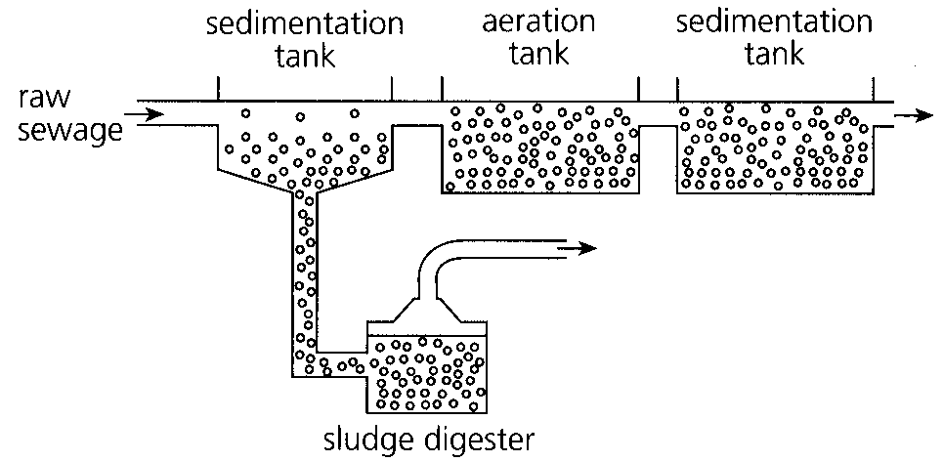
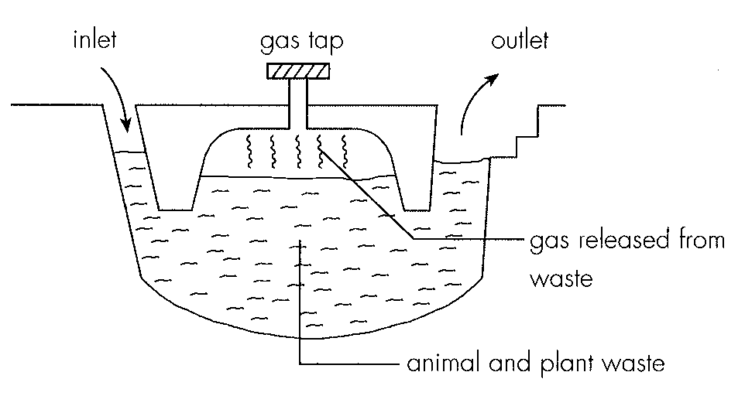
48. The temperature of the waste in the pit can reach 60°C or above. Which of the following is the most likely reason for this? A.Heat is released from aerobic respiration of the microorganisms in the waste. B.The waste absorbs heat from the surrounding rocks. C.The waste is hot before it is poured into the pit. D.Heat released from microbial fermentation is trapped by the pit.
A. Heat is released from aerobic respiration of the microorganisms in the waste.
B. The waste absorbs heat from the surrounding rocks.
C. The waste is hot before it is poured into the pit.
D. Heat released from microbial fermentation is trapped by the pit.
49. This method of waste treatment is a means of conservation. Which of the following support this statement?
(1)The dried waste is used as fertilisers to grow crops.
(2)The gas collected is burnt to release heat energy for cooking.
(3)The solid waste is used in landfill.
A.(1) and (2) only B. (1) and (3) only C. (2) and (3) only D. (1), (2) and (3)
Directions: Questions 51 and 52 refer to the diagram below which shows a component part of a sewage treatment plant.
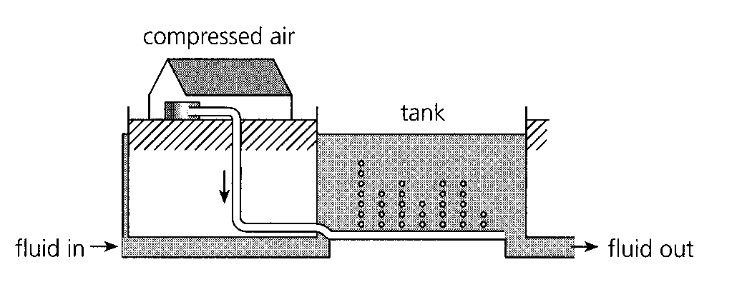
50. The effluent coming out is A.free of pathogens. C.low in mineral content.
A. free of pathogens.
B. useful for irrigating crops.
C. low in mineral content.
D. suitable for discharging into a river.
51. Which of the following domestic waste disposal methods satisfies the requirements of conservation?
A.Waste plastics are burnt.
B.Solid wastes are disposed at landfills.
C.Human sewage is discharged into the water.
D.Waste papers and cans are recycled.
Directions: Questions 54 to 57 refer to the diagram below which shows the major steps for treating pig's waste from a farm.
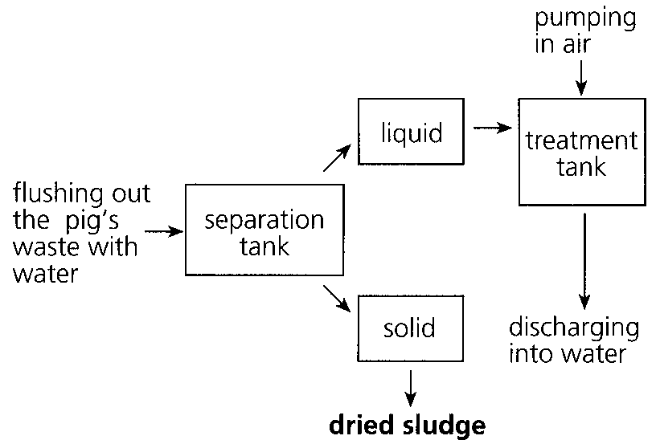
52. Which of the following is not a reason for flushing the pig's waste more frequently?
A. This prevents accumulation of the waste.
B. This helps to keep the farm cleaner.
C. This promotes decomposition of the waste.
D. This reduces foul smell of the waste.
53. Which of the following methods can be used to separate the solid materials from the liquid? (1) Sedimentation (2) Filtration (3) Aeration
A. (1) and (2) only
B. (1) and (3) only
C. (2) and (3) only
D. (1), (2) and (3)
54. Which of the following are possible uses for the dried sludge? (1) Materials for reclamation of land (2) Fuel for cooking (3) Fertilizer for crops
A. (1) and (2) only
B. (1) and (3) only
C. (2) and (3) only
D. (1), (2) and (3)
55. Which of the following biological processes are taking place in the treatment tank? (1) Fermentation (2) Decomposition (3) Nitrification
A. (1) and (2) only
B. (1) and (3) only
C. (2) and (3) only
D. (1), (2) and (3)
56. Discharging large amounts of untreated pig's waste into a river will
A. increase the oxygen content.
B. increase the turbidity.
C. decrease the nitrogen content.
D. increase the fish population.
57. Effluent from sewage treatment plants in Hong Kong
A. contains no organic matter.
B. contains no bacteria.
C. may cause algal bloom.
D. is safe to the environment.
58. Excessive noise may result in (1) mental retardation. (2) mental stress. (3) hearing impairment.
A. (1) and (2) only
B. (1) and (3) only
C. (2) and (3) only
D. (1), (2) and (3)
59. In Hong Kong, fish is kept in reservoirs. The reason is
A to produce fish for harvest.
B. to improve the scenery of reservoirs.
C. to monitor pollution.
D. to study the ecological role of fish in the habitat.

Answers
Answers are printed in red.
1. B. (1) and (3) only

2. D. Ozone depletion

3. B. less carbon dioxide is consumed in photosynthesis.

4. C. minerals in soil.

5. D. (1), (2) and (3)

6. D. (1), (2) and (3)

7. ?

8. A. (1) and (2) only

9. A. Carbon dioxideB. Methane C. CFCs D. Ozone

10. B

11. A. It is caused by an increase in atmospheric temperature.

12. C. ozone.

13. D. (1), (2) and (3)

14. A. (1) and (2) only

15. D. (1), (2) and (3)

16. A. (1) and (2) only

17. C. more lichen species can survive on walls when the air is unpolluted.

18. D

19. B. 4.0 x 109 kg.

20. C

21. B. to reduce the number of motor vehicles.

22. B. The traffic is less busy.

23. A. OxygenB. Carbon dioxide C. Nitrate D. Ammonia

24. D. (1), (2) and (3)

25. A. (1) and (2) only

26. B

27. B

28. A

29. ?

30. ?

31. ?

32. A. (1) and (2) only

33. A. it accumulates inside the bodies of living organisms.

34. B. (1) and (2) only

35. ?

36. B. the sewage carried a lot of bacteria which were respiring aerobically.

37. B. The food supply for the bacteria was decreasing and oxygen was being replenished.

38. D. (1), (2) and (3)

39. C

40. C. (2) and (3) only

41. D. (1), (2) and (3)

42. A. (1) and (2) only

43. A. (1) and (2) only

44. D. (1), (2) and (3)

45. A. (1) only

46. C. (2) and (3) only

47. B

48. D. Heat released from microbial fermentation is trapped by the pit.

49. A

50. B. useful for irrigating crops.

51. D

52. C. This promotes decomposition of the waste.

53. A. (1) and (2) only

54. B. (1) and (3) only

55. C. (2) and (3) only

56. B. increase the turbidity.

57. C. may cause algal bloom.

58. C. (2) and (3) only

59. C. to monitor pollution.

